|  |  |  |
| --- | --- | --- |
|  |  |  |
| **Course Description** | **Grade** |  |

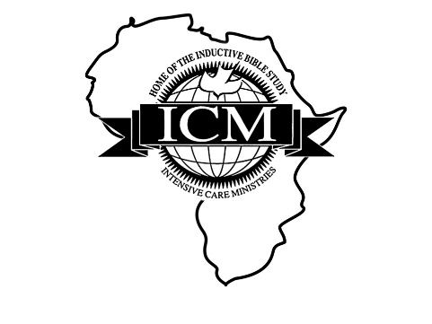

**Session 1: 1-11 January 2023**

|  |  |  |
| --- | --- | --- |
| IBS/Preaching I | A | 3 |
| NT Book Surveys | A | 3 |
| Gospel of Mark Study | B | 3 |
| Overall Session Grade and Total Credits |  |  |

**Session 1a: 12 January-24 May 2023**

|  |  |  |
| --- | --- | --- |
| Independent Study: Sermon Preparation I |  | 3 |
| Overall Session Total Credits |  |  |

**Session 2: 25 May – 6 June 2023**

|  |  |  |
| --- | --- | --- |
| Inductive Bible Study/Preaching II |  | 3 |
| Old Testament History Book Surveys |  | 3 |
| Epistles I (Galatians, James, Philippians, Philemon, Jude) |  | 3 |
| Overall Session Grade and Total Credits |  |  |

**Session 2a: 7 June-11 October 2023**

|  |  |  |
| --- | --- | --- |
| Independent Study: Sermon Preparation II |  | 3 |
| Overall Session Grade and Total Credits |  |  |

|  |  |  |
| --- | --- | --- |
| **Course Description** | **Grade** | **Cr Earned** |

**Session 3: 12-23 October 2023**

|  |  |  |
| --- | --- | --- |
| Inductive Bible Study/Preaching III |  | 3 |
| Old Testament Poetry and Prophecy Books |  | 3 |
| Epistles II (Ephesians, Colossians, 1 Thessalonians, Titus) |  | 3 |
| Overall Session Grade and Total Credits |  |  |

Total Program Credits Attempted: 33

Total Credits Earned:

Cumulative GPA:

**END OF OFFICIAL TRANSCRIPT**

Janice Larson

Registrar