Revenue from operations (₹ cr) by fy · FY22–FY26
As of 2026-10-19 · Source: hrfin_gold.ssot_corporate_annual_360 · Basis: verified · Persona: CMD · Masked: No
Key Highlights — Total Revenue from operations (₹ cr): 674618 | Highest · FY23: 155517.0 | Lowest · FY22: 110345.0
₹674,618 crore across 5 years (FY22–FY26). Highest: FY23 (₹155,517 crore) and FY24 (₹138,402 crore). Context (FY26, unverified snapshot): Full-year zero SAED windfall tax saved ₹3,770 Cr in levies (Statutory Levies down to ₹25,999 Cr), while softer Brent crude ($73.40/bbl vs $78.63/bbl) and higher KG-98/2 & offshore workover operating costs tempered Standalone PAT to ₹32,894 Cr; Consolidated PAT rose to ₹49,793 Cr on strong HPCL/OVL earnings. 10-Yr Context: Across FY17–FY26, Standalone Revenue grew from ₹77,908 Cr (FY17) to a peak of ₹1,55,517 Cr (FY23) and ₹1,32,508 Cr (FY26), while Standalon
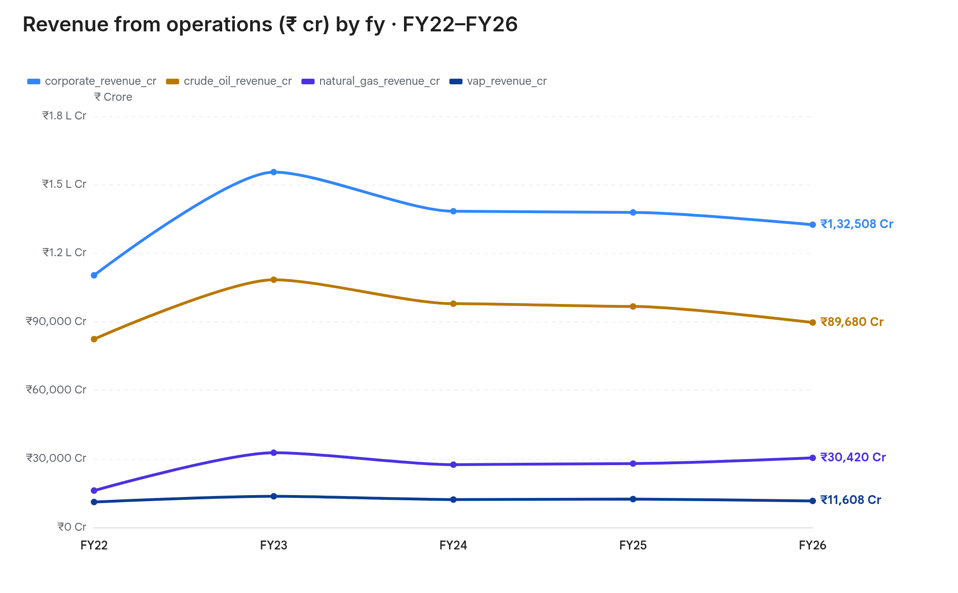
fy | corporate_revenue_cr | crude_oil_revenue_cr | natural_gas_revenue_cr | vap_revenue_cr
FY22 | 110,345 | 82,410 | 16,120 | 11,115
FY23 | 155,517 | 108,420 | 32,680 | 13,617
FY24 | 138,402 | 97,920 | 27,480 | 12,202
FY25 | 137,846 | 96,692 | 27,954 | 12,400
FY26 | 132,508 | 89,680 | 30,420 | 11,608
₹674,618 crore across 5 years (FY22–FY26). Highest: FY23 (₹155,517 crore) and FY24 (₹138,402 crore). Context (FY26, unverified snapshot): Full-year zero SAED windfall tax saved ₹3,770 Cr in levies (Statutory Levies down to ₹25,999 Cr), while softer Brent crude ($73.40/bbl vs $78.63/bbl) and higher KG-98/2 & offshore workover operating costs tempered Standalone PAT to ₹32,894 Cr; Consolidated PAT rose to ₹49,793 Cr on strong HPCL/OVL earnings. 10-Yr Context: Across FY17–FY26, Standalone Revenue grew from ₹77,908 Cr (FY17) to a peak of ₹1,55,517 Cr (FY23) and ₹1,32,508 Cr (FY26), while Standalon

