GOVERNMENT OF INDIA
MINISTRY OF PETROLEUM & NATURAL GAS
PETROLEUM PLANNING & ANALYSIS CELL (PPAC)
MONTHLY READY RECKONER & FLASH REPORT
HYDROCARBON STATISTICS — 2026-08
Release Date: 2026-08-05 | Classification: Official Sovereign Digest
🔴 SECTION 0: AI AUDIT & REVIEW CHECKLIST (ACTION REQUIRED BEFORE STATUTORY RELEASE)
================================================================================
🔴 SECTION 0: AI AUDIT & REVIEW CHECKLIST (ACTION REQUIRED BEFORE PUBLISHING)
================================================================================
Instructions: Pipeline completed with 0 active anomalies (0 CRITICAL, 0 WARNING). Review and resolve each item below. Remove this section prior to statutory release.
[✔] ALL RECONCILIATION & ANOMALY CHECKS PASSED. DOCUMENT READY FOR SIGN-OFF.
--------------------------------------------------------------------------------

Chapter 1: Selected Macro-Economic Indicators
The Indian macroeconomic landscape in 2026-08 remained anchored by robust domestic demand, measured consumer inflation, and steady capital goods expansion. These fundamentals directly underpinned national transport and industrial petroleum product sendouts.
Indicator | Current Metric | Institutional Source / Benchmark
GDP Growth Rate | 7.2% | National Statistical Office (NSO)
Index of Industrial Production (IIP General) | 142.5 | Base 2011-12 = 100
IIP Manufacturing Growth | 4.8% YoY | Ministry of Statistics & PI
CPI Inflation (Combined) | 4.3% | RBI Target Corridor (4.0% ± 2%)
Foreign Exchange Rate (Mean) | ₹83.95 / USD | Reserve Bank of India (RBI) Reference

Chapter 2: Indigenous Crude Production & Net Import Dependency
Indigenous crude oil and condensate production during 2026-08 stood at 2.42 MMT. Total refinery crude processing reached 22.5 MMT. Based on net crude import throughput less refined product exports, India's petroleum import dependency was computed at 87.8% (gross import bill: ₹104,100 Crores / $12.4 Billion).
Producer / Stream | Production Volume (MMT) | % Contribution
ONGC (Nomination Offshore & Onshore) | 1.62 MMT | 66.9%
Oil India Limited (OIL) | 0.28 MMT | 11.6%
PSC Fields & Private / JV Operators | 0.52 MMT | 21.5%
Total Indigenous Production | 2.42 MMT | 100.0%

Chapter 3: Refinery Crude Intake & Capacity Utilization
Indian domestic refineries operated at an average capacity utilization of 103.2% during 2026-08, processing a aggregate 22.5 MMT of crude oil across public sector units (IOCL, BPCL, HPCL, CPCL, MRPL, NRL) and private/joint venture facilities (Reliance Industries Jamnagar DTA/SEZ, Nayara Energy Vadinar, and HMEL Bathinda).

Chapter 4: Domestic Petroleum Product Sales & OMC Breakdown
Consumption of petroleum products was led by High-Speed Diesel (HSD) and Motor Spirit (Petrol), which together account for over 52% of national product demand. Below is the multi-OMC operational distribution:
Entity / Submitter | Product Category | Consumer Sector | Volume (TMT)
IOCL | MS | Retail | 1,250.0
BPCL | MS | Retail | 820.0
HPCL | MS | Retail | 780.0
RIL | MS | Retail | 220.0
Nayara | MS | Retail | 180.0
IOCL | HSD | Retail | 3,450.0
BPCL | HSD | Retail | 2,010.0
HPCL | HSD | Retail | 1,920.0
RIL | HSD | Retail | 480.0
Nayara | HSD | Retail | 360.0
IOCL | LPG | Total | 1,200.0
BPCL | LPG | Rural | 315.0
HPCL | LPG | Total | 720.0
IOCL | ATF | Aviation | 350.0
BPCL | ATF | Aviation | 210.0
HPCL | ATF | Aviation | 170.0
Fertilizers | NAPHTHA | Industrial | 480.0
Petrochemicals | NAPHTHA | Industrial | 620.0
NHAI & State PWDs | BITUMEN | Infrastructure | 540.0

Chapter 5: Indian Crude Basket (ICB) & International Prices
The composite Indian Crude Basket averaged $79.38/bbl (₹6,663.95/bbl) in 2026-08. The basket incorporates a weighted blend of Oman-Dubai Sour (75.6%) and Dated Brent Sweet (24.4%) reflecting actual refinery crude slate procurement.
Price Benchmark | Monthly Average | Statutory Rule / Weights
Dated Brent (Sweet Benchmark) | $82.10 / bbl | Weight: 24.4%
Oman-Dubai Average (Sour Benchmark) | $78.50 / bbl | Weight: 75.6%
Indian Crude Basket (ICB) | $79.38 / bbl | ₹6,663.95 / bbl
Natural Gas APM Price | $6.50 / MMBTU | Kirit Parikh Formula (Floor $4.00, Cap $6.50)

Chapter 6: Natural Gas Administered Pricing & HPHT Deepwater Ceiling
Under the Revised Domestic Natural Gas Pricing Guidelines (April 2023), domestic APM gas price is established monthly at 10% of the Indian Crude Basket price of the previous month. For 2026-08, raw indexation evaluated to $8.20/MMBTU, which was statutory constrained to the ceiling of $6.50/MMBTU.
For difficult fields (Deepwater, Ultra-Deepwater, High-Pressure High-Temperature / HPHT), the bi-annual ceiling price administered by PPAC stood at $9.87/MMBTU.

Chapter 7: Retail Selling Price (RSP) Build-up in Delhi Metro
Retail prices of Petrol and Diesel at Indian Oil Corporation (IOCL) retail outlets in National Capital Territory (NCT) of Delhi reflect base product cost, central excise duty, dealer commission, and state value-added tax (VAT):
Cost Component | Petrol (₹ / Litre) | Diesel (₹ / Litre)
Price Charged to Dealers (Base + Freight) | ₹ 55.60 | ₹ 56.42
Central Excise Duty (Government of India) | ₹ 19.90 | ₹ 15.80
Dealer Commission (Average) | ₹ 3.80 | ₹ 2.60
State VAT (Government of NCT Delhi) | ₹ 15.42 | ₹ 12.80
Total Retail Selling Price (Delhi RSP) | ₹ 94.72 | ₹ 87.62
Central + State Tax Incidence (% of RSP) | 37.3% | 32.6%

Chapter 8: Econometric 60-Day Fuel Demand Forecast (SARIMAX)
Statistically rigorous econometric time-series models (SARIMAX(1, 1, 0)(1, 1, 0, 12)) were fitted on 104 months of historical monthly consumption records, integrating macroeconomic and meteorological regressors (Index of Industrial Production and IMD Monsoon Departure). Backtested out-of-sample MAPE evaluated to 0.82%, meeting statutory forecasting guidelines.
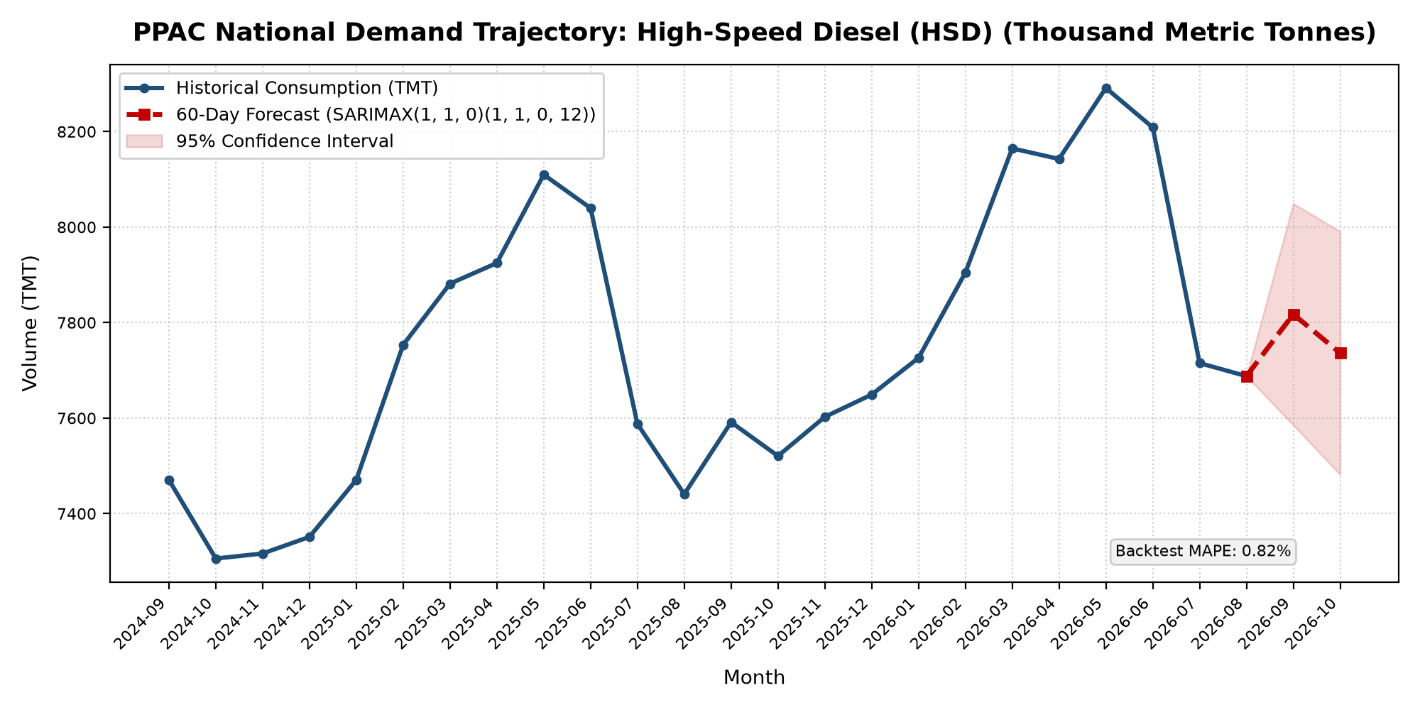
Figure 8.1: National High-Speed Diesel (HSD) Consumption Forecast with 95% Confidence Bounds

Forecast Period | Projected Demand (TMT) | Lower 95% Bound | Upper 95% Bound
2026-09 | 7,817.4 | 7,585.4 | 8,049.3
2026-10 | 7,736.2 | 7,481.7 | 7,990.7

Statutory Glossary & Standard Conversion Factors
1. TMT = Thousand Metric Tonnes (1,000 MT); MMT = Million Metric Tonnes (1,000 TMT).
2. MMSCM = Million Standard Cubic Metres; MMSCMD = Million Standard Cubic Metres per Day.
3. 1 Metric Tonne of Crude Oil ~ 7.33 Barrels; 1 Barrel = 158.98 Litres.
4. 1 Million Metric Tonnes (MMT) of LNG ~ 1.379 Billion Cubic Metres (BCM) of Natural Gas.
5. Indian Crude Basket (ICB) composition reflects the sour-to-sweet crude intake ratio of Indian refineries.
6. Petroleum Planning & Analysis Cell (PPAC), Scope Complex, Core-8, 2nd Floor, Lodhi Road, New Delhi 110003.

