Canonical Landscape Server – Project Handover Document

# 1. Project Overview

Project Title: Canonical Landscape Server Deployment  
Client: [Client Name]  
Prepared By: [Your Name / Organization]  
Handover Date: [DD-MM-YYYY]  
Version: 1.0

# 2. Purpose of Document

This document provides a complete overview of the Canonical Landscape Server deployment, including system architecture, installed components, operational procedures, log file locations, client registration, backup, monitoring, and troubleshooting details.

# 3. System Architecture

The following diagram illustrates the architecture of Canonical Landscape for managing Ubuntu systems:

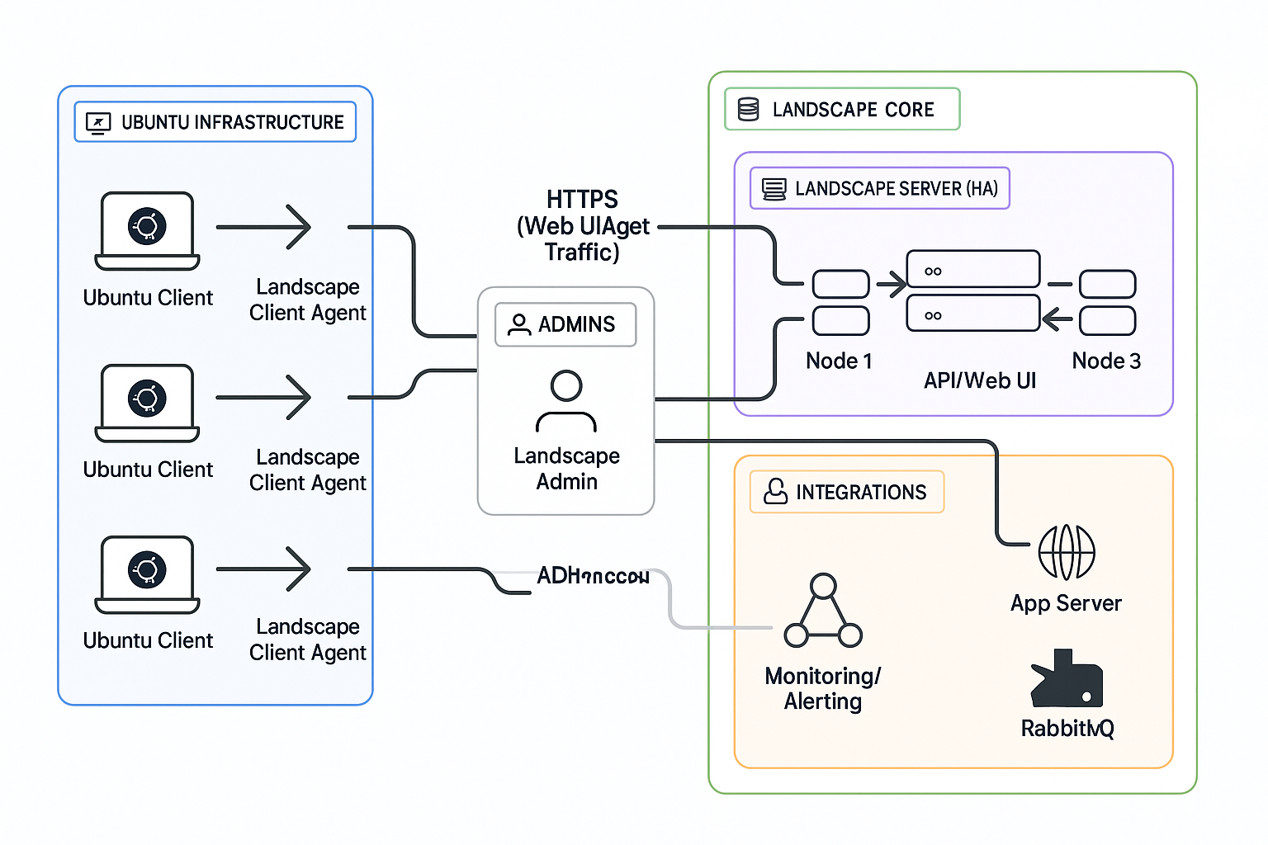

# 4. Deployment Details

OS: Ubuntu 20.04 LTS  
Landscape Type: On-Prem Landscape Dedicated Server  
Hostname/IP: landscape.example.com / 192.168.1.X  
Access URL: https://landscape.example.com  
Database: PostgreSQL (local or external)  
Landscape Version: [e.g., 23.03]

# 5. Server Components

Component: Landscape App Server  
Description: Core web and API service  
Location/Service: landscape-server  
  
Component: PostgreSQL  
Description: Backend data storage  
Location/Service: postgresql  
  
Component: RabbitMQ  
Description: Message queueing  
Location/Service: rabbitmq-server (optional)  
  
Component: Apache/Nginx  
Description: Web server (if reverse proxy used)  
Location/Service: /etc/apache2 or /etc/nginx  
  
Component: SSL/TLS  
Description: Certificates  
Location/Service: /etc/ssl/certs/

# 6. Core Functions

- Centralized Ubuntu systems management  
- Package and patch deployment  
- System monitoring (CPU, RAM, Disk, etc.)  
- User management and roles  
- Scripting and automation execution  
- Tag-based grouping and filtering  
- Update and reboot orchestration

# 7. Client Registration Script

The following script registers an Ubuntu client with the Landscape Server:

#!/bin/bash  
LANDSCAPE_SERVER_URL="https://landscape.example.com"  
ACCOUNT_NAME="standalone"  
COMPUTER_TITLE=$(hostname)  
  
sudo apt-get update  
sudo apt-get install -y landscape-client  
sudo landscape-config --computer-title "$COMPUTER_TITLE" --account-name "$ACCOUNT_NAME" --url "$LANDSCAPE_SERVER_URL/message-system" --ping-url "$LANDSCAPE_SERVER_URL/ping" --silent  
sudo systemctl restart landscape-client  
sudo landscape-client --ping

# 8. Log Files and Paths

Landscape App: /var/log/landscape/landscape-server.log  
Client Logs: /var/log/landscape/  
Web Server: /var/log/apache2/access.log or /var/log/nginx/access.log  
PostgreSQL: /var/log/postgresql/postgresql-*.log  
RabbitMQ: /var/log/rabbitmq/

# 9. Backup & Restore

Backup Includes:  
- PostgreSQL Database  
- Landscape server config files (/etc/landscape/)  
- SSL certificates  
  
Restore Process:  
1. Install Landscape Server fresh  
2. Restore DB using pg_restore  
3. Copy back /etc/landscape configs  
4. Restart services

# 10. Monitoring & Alerts

Monitoring can be done via the internal dashboard or external tools like Prometheus or Nagios. SMTP alerts are optional.

# 11. Troubleshooting

Issue: Client not registering  
Symptom: Times out / Ping fails  
Resolution: Check hostname resolution, ports 443 open  
  
Issue: Web UI not loading  
Symptom: 502 / blank screen  
Resolution: Check Apache/Nginx, app server status  
  
Issue: Package updates failing  
Symptom: “No repositories found”  
Resolution: Validate client access to package mirrors  
  
Issue: DB Connection Error  
Symptom: App fails to connect  
Resolution: Check PostgreSQL is up and creds are correct

# 12. User Access & Roles

Admin: Full Access  
Operator: Read-only  
  
Authentication via local users or LDAP integration if enabled.  
Passwords have been securely shared offline.

# 13. Known Limitations

- Only supports Ubuntu clients  
- Feature disparity between Landscape On-Prem and SaaS  
- Older Ubuntu versions may require legacy client

# 14. Post-Deployment Checklist

System Setup  
✔ Ubuntu LTS installed and updated  
✔ Hostname configured  
✔ NTP/Chrony installed  
  
Security Configuration  
✔ UFW/firewalld configured  
✔ TLS certificate applied  
✔ SSH access restricted  
  
Landscape Components  
✔ PostgreSQL configured  
✔ RabbitMQ or AMQP service running  
✔ Apache/Nginx reverse proxy set  
  
Web Interface  
✔ Admin user created  
✔ Dashboard tested  
✔ SMTP alerting configured  
  
Client Registration  
✔ Script tested on nodes  
✔ Clients appear in dashboard  
✔ Policy syncing verified  
  
Functional Testing  
✔ Package update tested  
✔ Reboot scheduling validated  
✔ Tag filtering tested  
✔ Script dispatch verified  
  
Backup & Documentation  
✔ PostgreSQL backups automated  
✔ /etc/landscape/ config backed up  
✔ Docs and credentials shared

# 15. Handover Acceptance

We confirm that the Canonical Landscape Server and its components have been successfully deployed, tested, and documented.  
  
Sign-Off:  
| Name | Role | Date | Signature |  
|-------------------|----------------|------------|-----------|  
| [Client Name] | IT Manager | [Date] | |  
| [Your Name] | Project Lead | [Date] | |

# 16. Maintenance Tasks and Automation

Canonical Landscape uses scheduled maintenance routines to ensure data consistency, security patch updates, system hygiene, and performance optimizations.

The following scripts and tasks are configured via `/etc/cron.d/landscape-server`:

* - maintenance.sh – Inserts daily monitoring data, purges old graph entries
* - update_security_db.sh – Imports fresh USN/CVE security data
* - update_alerts.sh – Checks for offline clients and updates alert status
* - landscape_profiles.sh – Evaluates client system profiles
* - process_alerts.sh – Triggers and processes alert conditions
* - hash_id_databases.sh – Rebuilds package hash databases
* - meta_releases.sh – Checks for new Ubuntu release versions
* - sync_lds_releases.sh – Detects available Landscape Server version upgrades
* - report_anonymous_metrics.sh – Sends anonymized usage statistics to Canonical

Optional: Add the following cron entries to clean up events and activities older than 90 days:

0 3 * * * landscape /opt/canonical/landscape/cleanup-activities 90  
30 3 * * * landscape /opt/canonical/landscape/cleanup-events 90

To log cleanup output separately, configure `/etc/rsyslog.d/20-landscape.conf` accordingly and restart `rsyslog`.

# 17. Log File Locations

Below are key log files stored under `/var/log/landscape-server/`:

* - api.log, appserver.log, async-frontend.log – UI/API runtime logs
* - broker.log, message_server.log – Client messaging and communication
* - maintenance-script.log, process-alerts.log – Automation task execution
* - update-security-db.log, meta-releases.log – Update monitoring
* - hash-id-databases.log, distributed-lock.log – Backend operations
* - landscape-profiles.log, job-handler.log – Client management
* - anonymous-metrics.log – Usage metrics reporting
* - pingserver.log – Monitors client heartbeat activity

# 18. Updated Maintenance Checklist

✔ /etc/cron.d/landscape-server tasks verified  
✔ Optional activity/event cleanup cron entries reviewed  
✔ rsyslog config created for task-specific logging  
✔ Log rotation and monitoring configured for /var/log/landscape-server  
✔ Security updates and CVE import functionality validated