**Memory Interfacing**

1. EPROM-2732 4Kx8 x4 = 16KB
2. RAM-6116 2Kx8 x2 = 4KB
3. 74LS138 x2 (one for odd and another for even) - A15, A14, A13 FOR CS

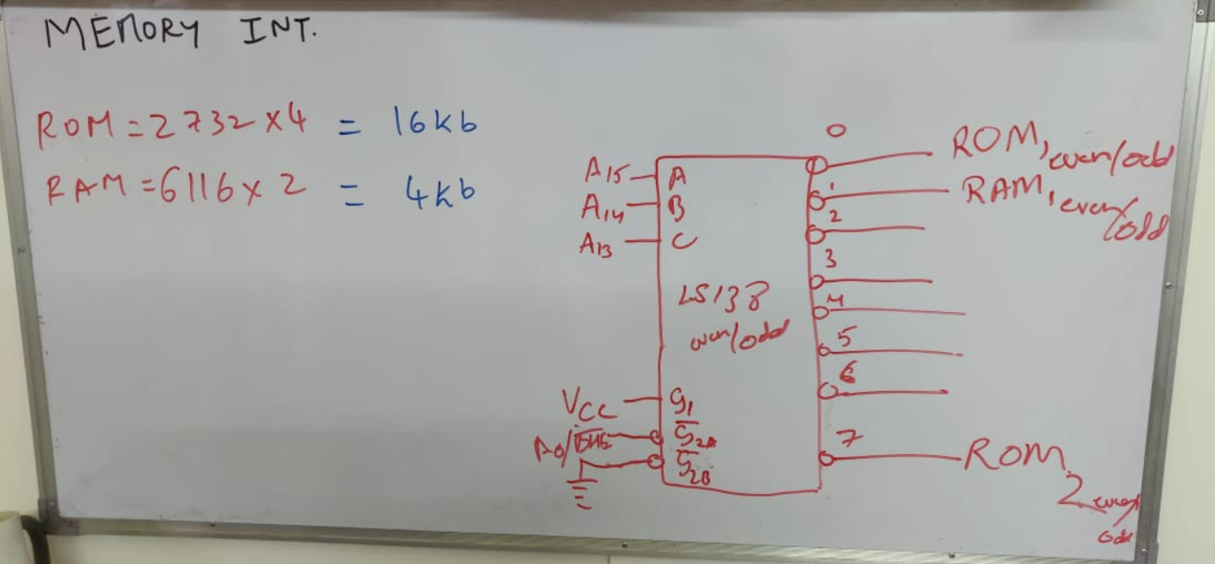

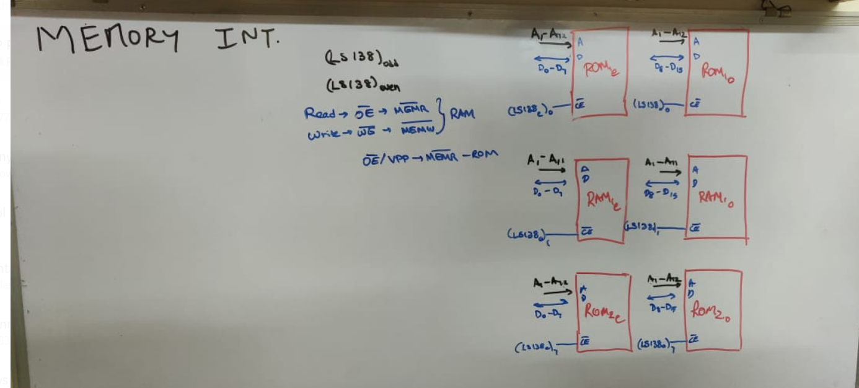

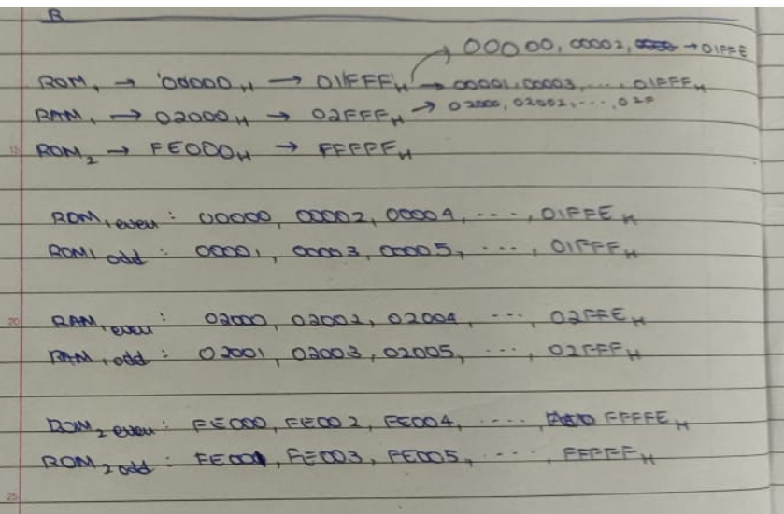

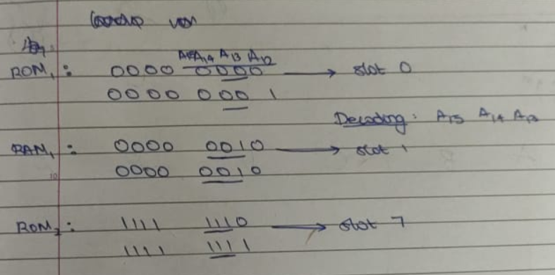

**IO Interfacing**

1. 74LS138 x1 - To distinguish between the 8255s
2. 8255A x2 - One for keyboard + SS-Display and the other for ZIF
   1. Keyboard - 8 pins - 4 in and 4 out - 8255a CL + CU
   2. Seven Segment Display - 8 out (inputs to displays) + 6 out (enables to every display) - 8255a A + B
   3. ZIF socket - 8 in + 4 out - 8255b A(input) + CU(output)
3. Seven segment Displays x6
4. Low power BJT
5. ZIF Socket 8255 :
   1. Port-A i/p and Port-CL o/p for 747266
   2. Port-B i/p and Port-CU o/p for others

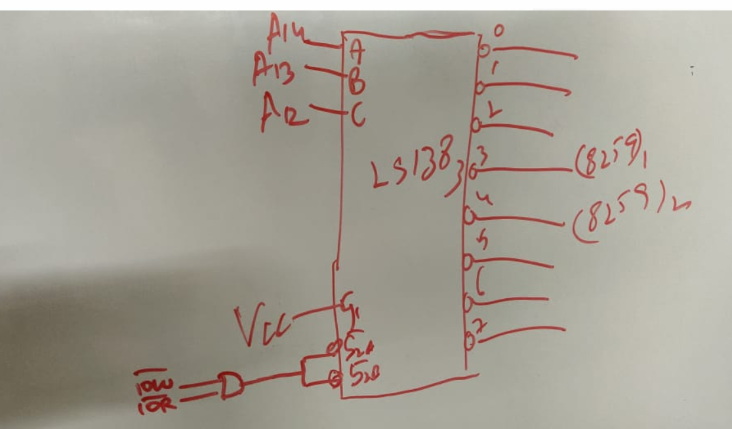

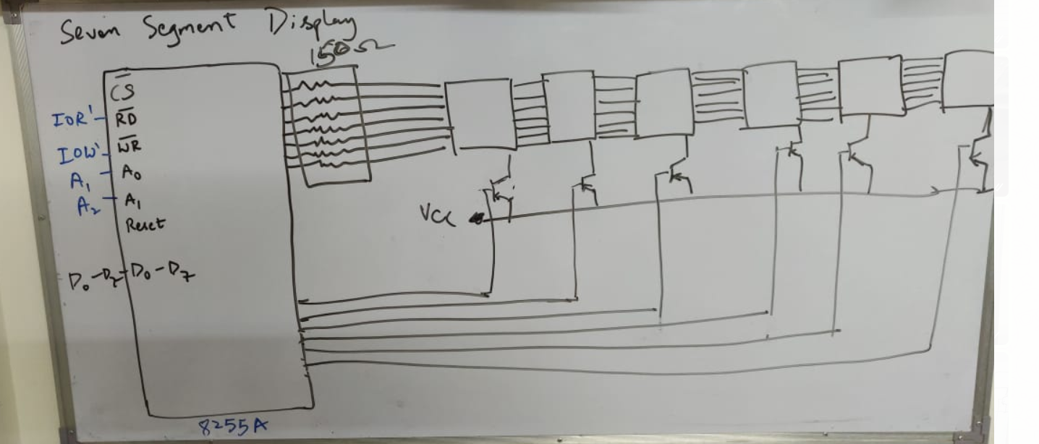

**System Bus for address/data from uP**

1. 74LS373 x3 for address (20)
2. 74LS245 x2 for data lines (16)