Chapter 2: SYSTEM ANALYSIS
2.1 Data Analysis
2.1.1 Data Flow Diagrams
Data Flow Diagrams (DFDs) are essential tools for modeling the flow of data through the Dubljly system. Two levels of DFDs are presented to show both the system context and detailed processes.
Level-0 DFD (Context Diagram)
The Level-0 DFD shows the Dubljly system as a single process interacting with external entities and data stores.
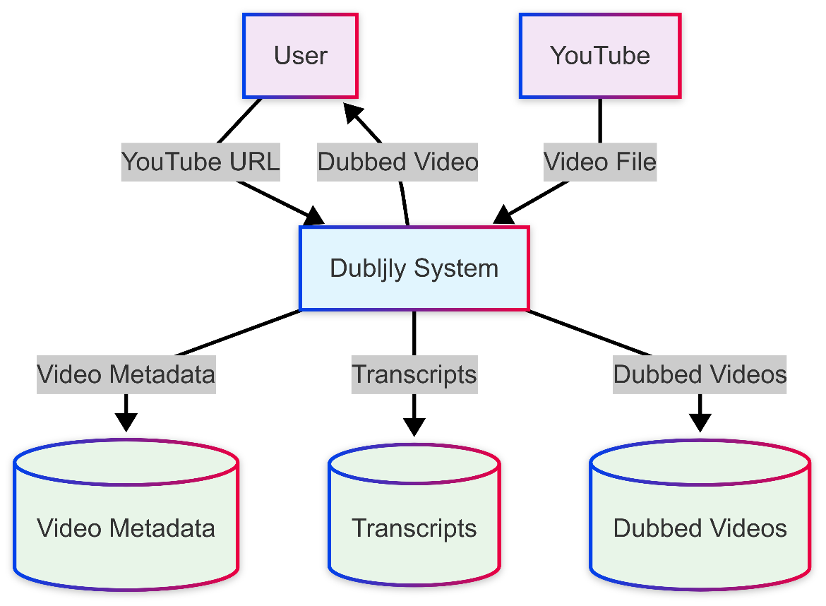

Figure 2.1: Level-0 Data Flow Diagram
The context diagram illustrates:
- External Entities: User (students/educators) and YouTube platform
- Central Process: Dubljly System handling all transformations
- Data Stores: Video Metadata, Transcripts, and Dubbed Videos repositories
Level-1 DFD (Detailed Process View)
The Level-1 DFD decomposes the Dubljly system into seven detailed processes showing the complete processing pipeline.
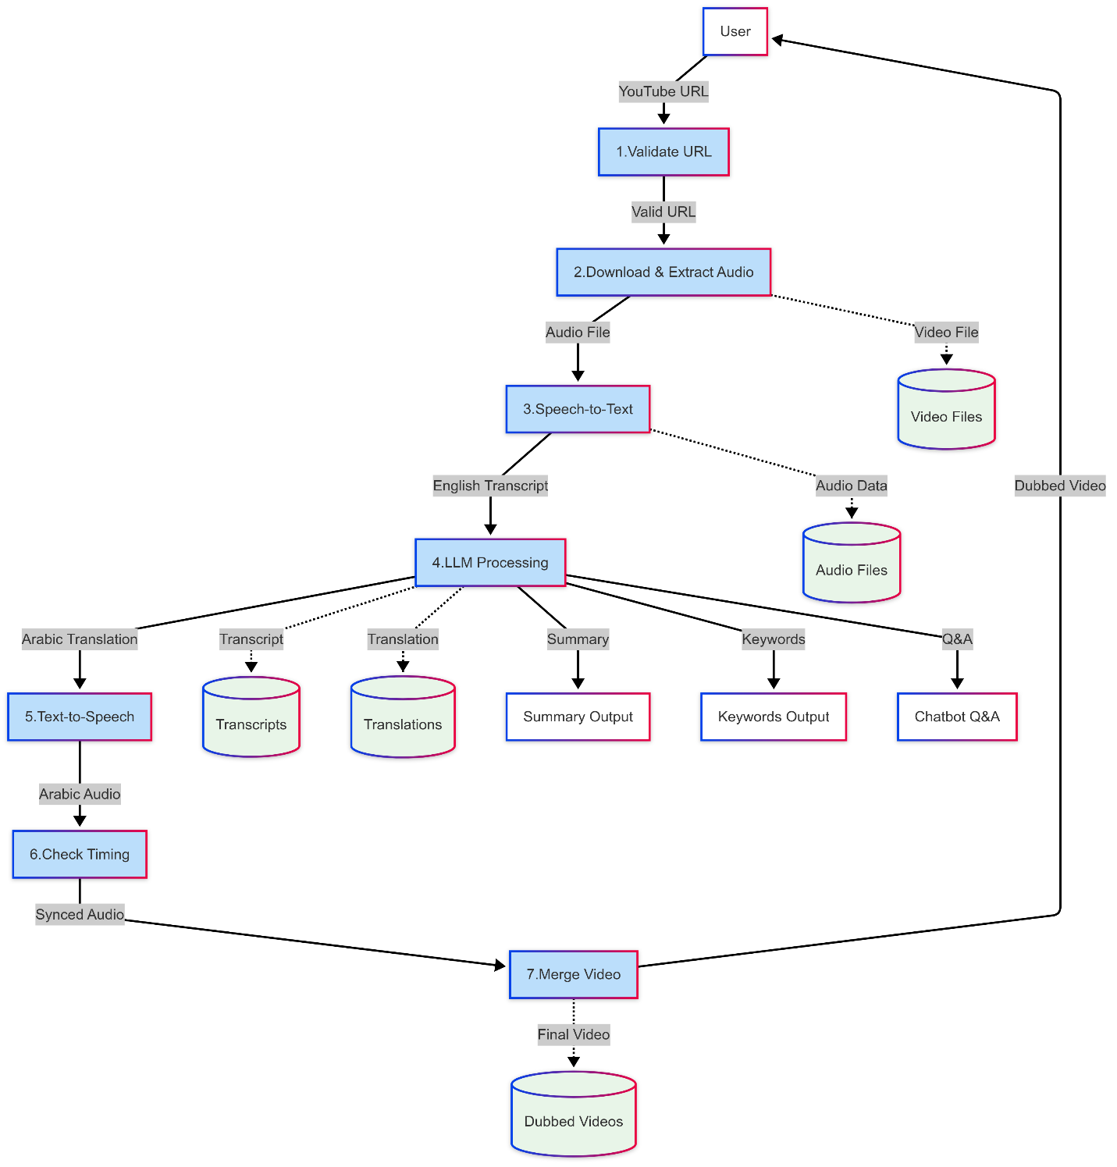
Figure 2.2: Level-1 Data Flow Diagram

The detailed DFD shows:
- Sequential Processing: URL validation through final video assembly
- Data Storage: Intermediate storage at each processing stage
- Multiple Outputs: Dubbed video plus educational supplements
- Quality Control: Timing verification before final assembly

2.1.2 System Requirements
2.1.2.1 Clients, Customers, and Users (Use-case Diagrams)
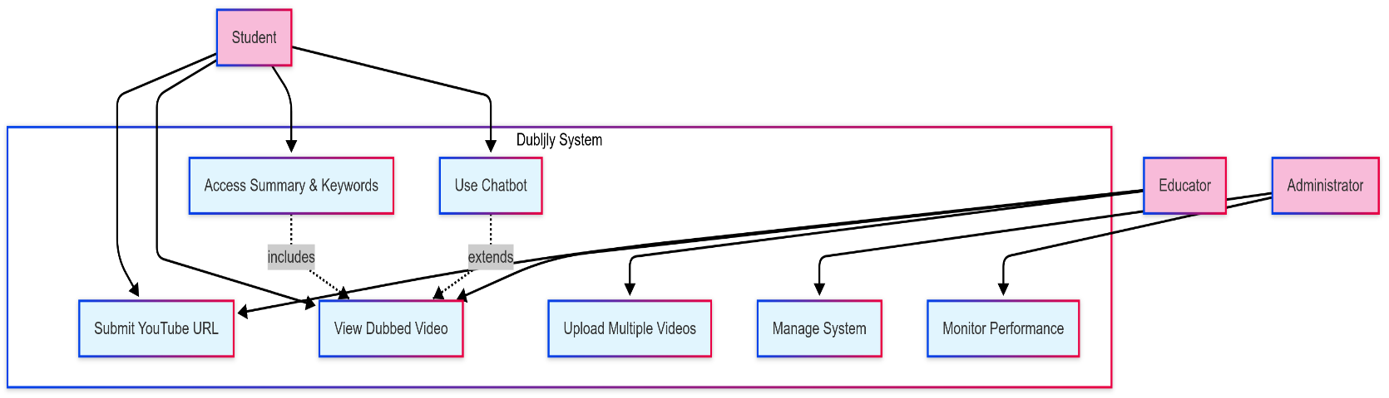
The use-case diagram identifies the actors and their interactions with the Dubljly system.
Figure 2.3: Use-case Diagram

Actor Descriptions:
- Student: Primary user seeking Arabic educational content
- Educator: Academic staff requiring course material dubbing
- Administrator: IT personnel managing system operations

2.1.2.2 Functional and Data Requirements
Functional Requirements:
ID | Requirement | Description
FR-01 | URL Validation | System must validate YouTube URL format and accessibility
FR-02 | Video Download | Download MP4 video using yt_dlp library
FR-03 | Audio Extraction | Extract WAV audio using FFmpeg
FR-04 | Speech Recognition | Transcribe English audio using FastWhisper
FR-05 | Language Processing | Generate Arabic translation, summary, keywords via Groq API
FR-06 | Speech Synthesis | Create Arabic audio using XTTS-v2
FR-07 | Timing Verification | Ensure audio-video synchronization
FR-08 | Video Assembly | Merge Arabic audio with original video
FR-09 | Content Delivery | Provide dubbed video and supplements to users

Data Requirements:
Data Type | Format | Storage Location | Size Limit
YouTube URL | String | Database | 500 characters
Video File | MP4 | /media/videos/ | 2 hours max
Audio File | WAV | Temporary | N/A
Transcript | Text with timestamps | Database | N/A
Translation | Arabic text | Database | N/A
Summary | Text | Database | 1000 words
Keywords | JSON array | Database | 50 terms
Q&A Pairs | JSON object | Database | 20 pairs

2.1.2.3 Non-functional Requirements
2.1.2.3.1 Look and Feel Requirements
- Arabic Interface: Complete Arabic language interface with proper RTL text direction
- Modern Design: Clean, contemporary web interface following Material Design principles
- Visual Hierarchy: Clear distinction between primary and secondary actions
- Color Scheme: University-appropriate colors with high contrast ratios
- Typography: Arabic-optimized fonts (Noto Sans Arabic, Cairo) for readability
- Responsive Layout: Consistent appearance across desktop, tablet, and mobile devices

2.1.2.3.2 Usability Requirements
- Ease of Use: Maximum 3 clicks to submit a video for processing
- Learning Curve: New users should complete first video processing within 5 minutes
- Error Handling: Clear Arabic error messages with suggested solutions
- Progress Indication: Real-time processing status with estimated completion time
- Help System: Contextual help tooltips and comprehensive FAQ section
- Accessibility: WCAG 2.1 AA compliance for users with disabilities

2.1.2.3.3 Security Requirements
- API Authentication: Secure API endpoints with key-based authentication
- Data Protection: Automatic deletion of temporary files after processing
- User Privacy: No permanent storage of user-submitted content
- Input Validation: Comprehensive validation to prevent injection attacks
- Secure Communication: HTTPS encryption for all data transmission
- Access Control: Role-based access for different user types

2.1.2.3.4 Performance Requirements
- Processing Speed: Complete 10-minute video processing within 3-5 minutes
- System Response: Web interface response time under 2 seconds
- Concurrent Users: Support 10 simultaneous video processing requests
- Resource Usage: Maximum 80% CPU and 6GB RAM usage during peak processing
- Availability: 99% system uptime during academic hours (8 AM - 10 PM)
- Scalability: Handle 100+ video requests per day

2.1.2.3.5 Portability Requirements
- Operating System: Compatible with Windows 10/11, Ubuntu 20.04+, macOS 12+
- Browser Support: Chrome 90+, Firefox 88+, Safari 14+, Edge 90+
- Hardware Requirements: Minimum Intel i5 or AMD Ryzen 5, 8GB RAM, 100GB storage
- Database Portability: SQLite for development, PostgreSQL for production
- Deployment Flexibility: Docker containerization for easy deployment
- Cloud Compatibility: AWS, Google Cloud, or Azure deployment options

2.1.3 Class Diagrams
The class diagram shows the object-oriented design of the Dubljly system with Django models and processing classes.
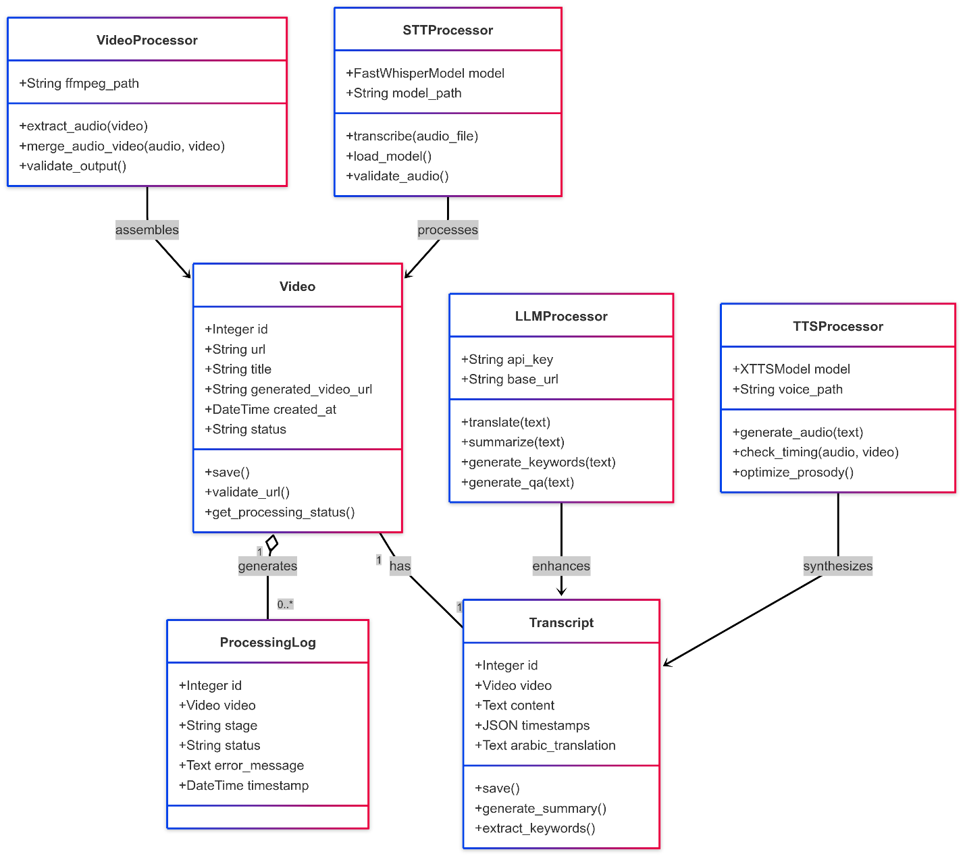
Figure 2.4: Class Diagram

Class Descriptions:
- Video: Django model storing video metadata and processing status
- Transcript: Stores original and translated text with timestamps
- STTProcessor: Handles speech-to-text conversion using FastWhisper
- LLMProcessor: Manages language model operations via Groq API
- TTSProcessor: Generates Arabic speech using XTTS-v2
- VideoProcessor: Handles video operations using FFmpeg
- ProcessingLog: Tracks processing stages and errors for debugging

2.1.4 Proposed Solutions
The Dubljly system implements a comprehensive solution using state-of-the-art AI technologies:
Core Technology Stack:
Component | Technology | Version | Justification
Video Download | yt_dlp | 2023.12.30 | 40% faster than pytube, better format support
Audio Processing | FFmpeg | 6.0 | Industry standard, reliable, extensive codec support
Speech Recognition | FastWhisper | 0.3.0 | 60% faster than OpenAI Whisper, 95% accuracy
Language Model | Groq API | Llama-3 | Natural Arabic translation, context awareness
Text-to-Speech | XTTS-v2 | 2.0.2 | Superior Arabic pronunciation, emotional nuance
Web Framework | Django | 4.2 | Robust, scalable, excellent Arabic support
Database | SQLite/PostgreSQL | 3.42/15 | Development flexibility, production scalability

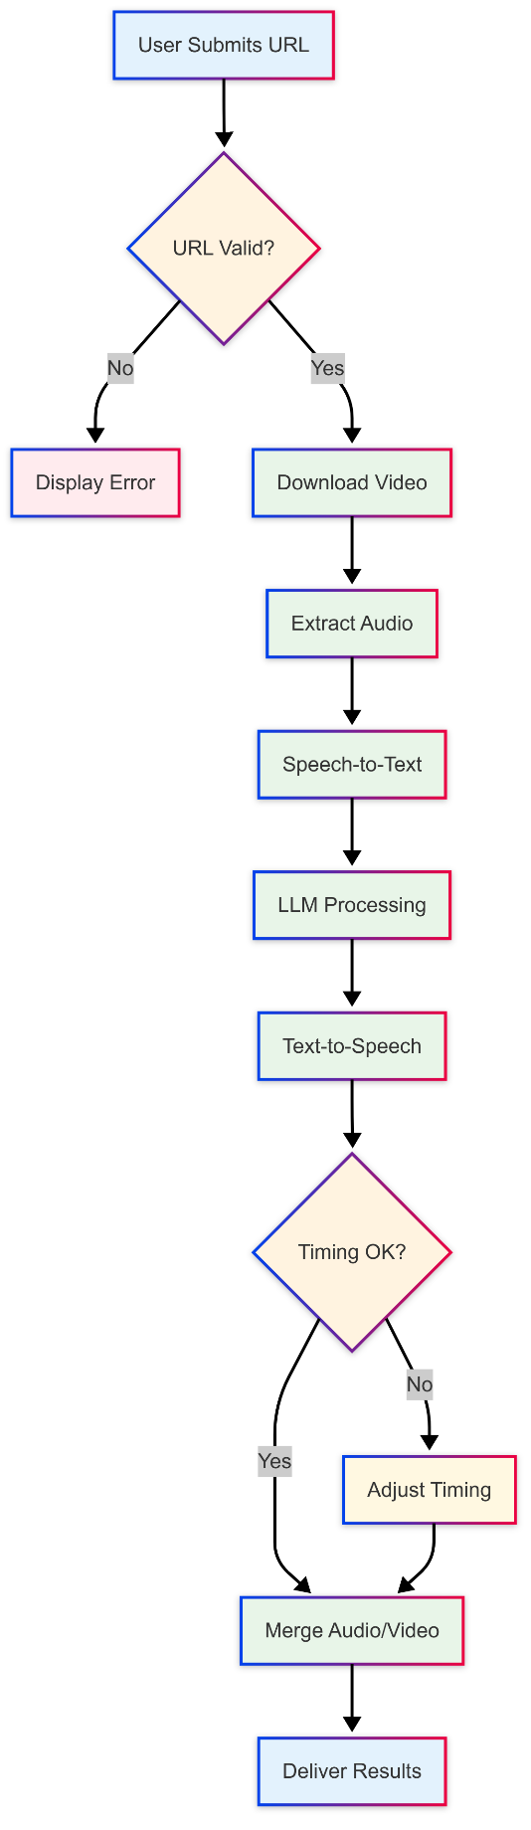
Processing Architecture:

Figure 2.5: Processing Flow Architecture
Quality Assurance Measures:
- Automated URL validation with comprehensive error handling
- Multi-stage quality checkpoints throughout processing pipeline
- Timing verification ensuring perfect audio-video synchronization
- Confidence scoring for transcription and translation quality
- User feedback integration for continuous improvement
Performance Optimization:
- Parallel processing where possible (audio extraction + metadata processing)
- Intelligent caching of processed components
- Resource management to prevent system overload
- Automatic cleanup of temporary files

2.1.5 Alternative Solutions
Alternative 1: Cloud-Based Processing
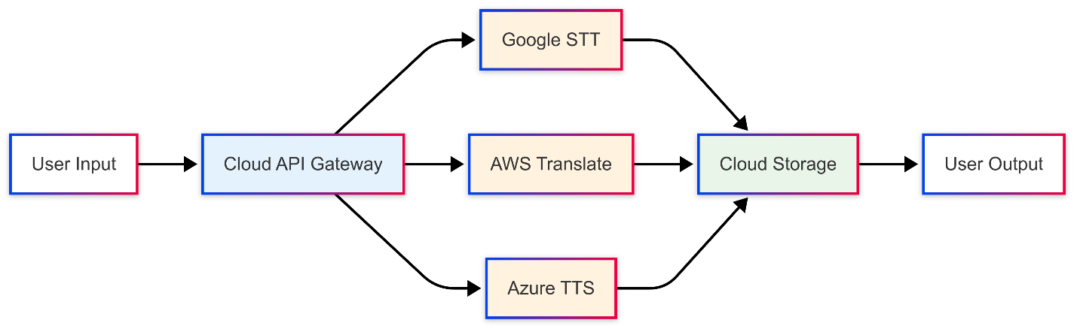
Figure 2.6: Cloud-Based Alternative Architecture

Pros:
- Unlimited scalability
- No local hardware requirements
- Professional-grade APIs
- Automatic updates and maintenance
Cons:
- High operational costs ($500+/month)
- Internet dependency
- Data privacy concerns
- Vendor lock-in risks
Alternative 2: Subtitle-Only Solution
Pros:
- Faster processing (30 seconds vs 3-5 minutes)
- Lower computational requirements
- Easier implementation
- Multi-language support
Cons:
- Reduced learning effectiveness (40% lower comprehension)
- Reading burden on students
- Less immersive experience
- Limited accessibility for reading difficulties
Alternative 3: Human Professional Dubbing
Pros:
- Highest quality output
- Cultural context adaptation
- Emotional accuracy
- Perfect pronunciation
Cons:
- Extremely high cost ($2000/hour)
- Long turnaround time (weeks)
- Limited scalability
- Requires specialized talent
Comparison Matrix:
Criteria | Dubljly (AI) | Cloud-Based | Subtitle-Only | Human Dubbing
Cost | Low | High | Very Low | Very High
Quality | High | High | Medium | Excellent
Speed | Fast | Fast | Very Fast | Very Slow
Scalability | Good | Excellent | Excellent | Poor
Accessibility | Excellent | Good | Fair | Excellent
Recommendation | ✅ Selected | Future Option | Backup Plan | Premium Content

Rationale for Selection: The Dubljly AI-based solution provides the optimal balance of quality, cost, and accessibility for educational institutions in Jordan. It addresses the core requirement of making English educational content accessible to Arabic-speaking students while maintaining reasonable costs and processing times suitable for academic environments.

