Our App and the cart section

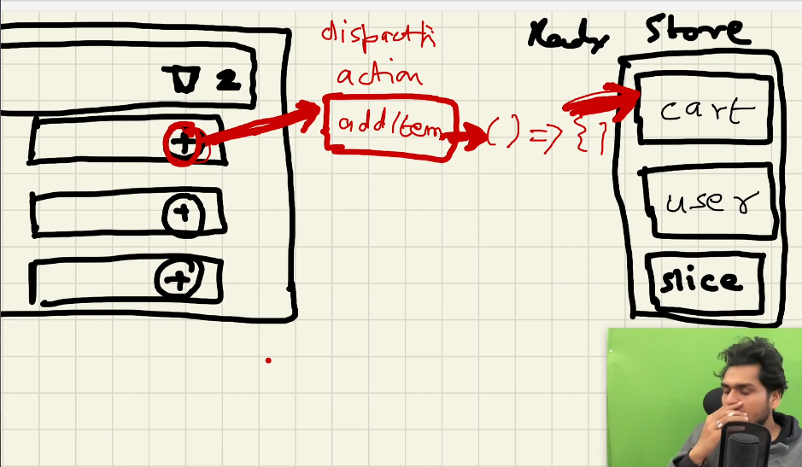

* When we click on this plus button, it dispatches an action which calls a function which modifies the slice of our store.
* This function is known as reducer function
* When we click on the plus button, it dispatches an action which calls the reducer function which updates the slice of store.
* Selector: it is a hook, basically a function, if we want to read the cart, we have to call the selector which will give us the information and update the cart
* 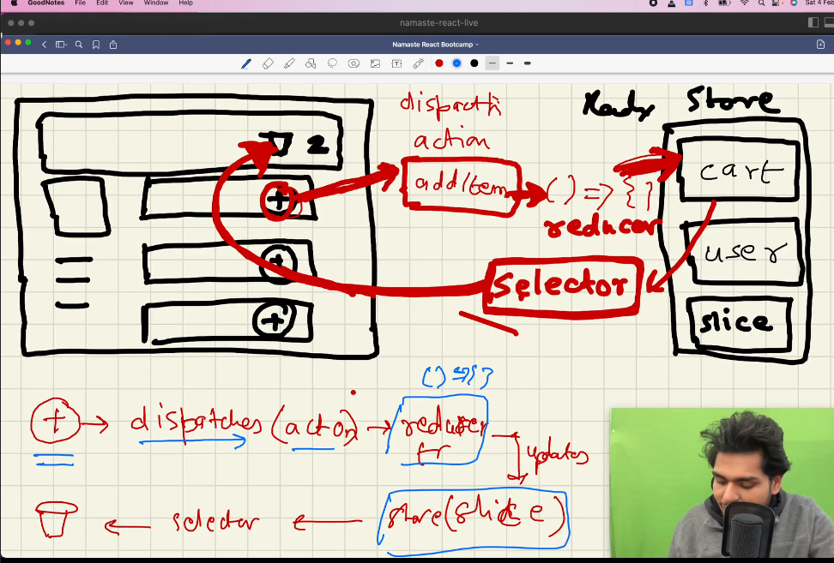
* When we use selector, it is known as subscribing to the store, it means this cart component has subscribed to the store, it means it is reading something from the store, it is like in sync with the store, whenever my store will modify cart will automatically modify in UI
* 