**APACHE KAFKA**

**‘***An open source distributed streaming platform that allows for the development of real time event driven application* **’**

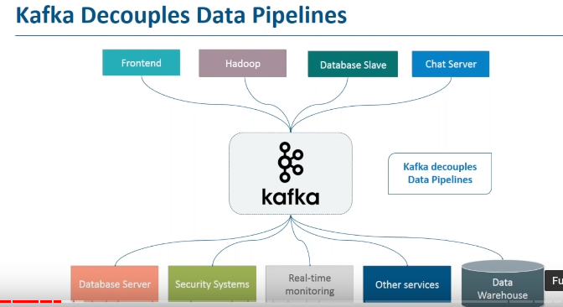

* Kafka is a distributed publish-subscribe messaging system.
* Kafka terminologies:
* producer: who can publish messages to the topic.
* consumer: that subscribe to the topic and consume the messages.
* Partition: topics are broken up into ordered commit logs called partition.
* Broker: kafka cluster is a set of servers, each of which is called broker.
* Topic : a topic is a category or feed name to which records are published.
* Zookeeper: for managing and coordinating kafka broker.

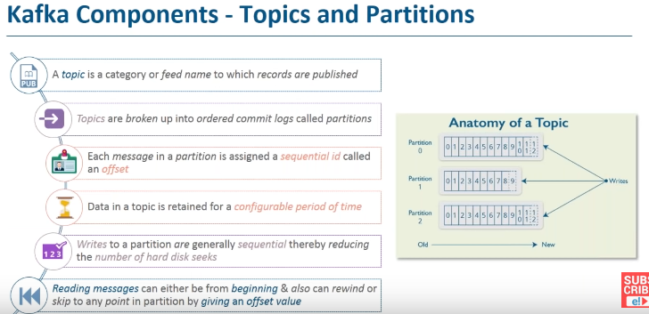

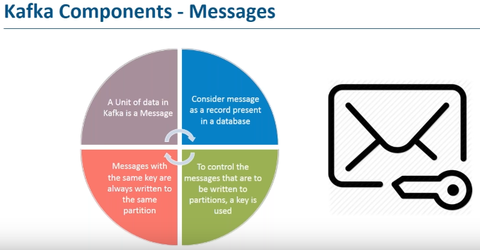

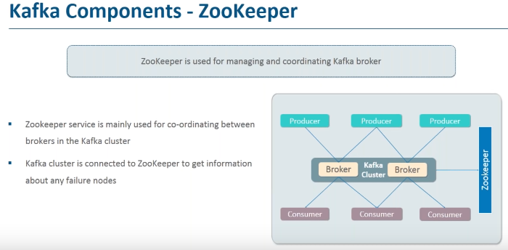

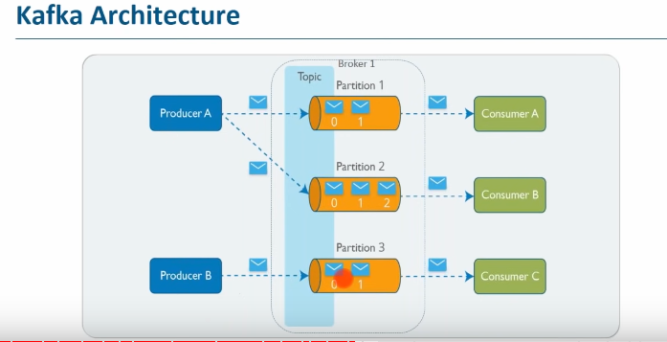

**Install apache kafka:**

* visit <https://www.apache.org/dyn/closer.cgi?path=/kafka/3.0.0/kafka_2.12-3.0.0.tgz>and download apache kafka
* tar:
* set the kafka path:



* run zookeeper:



* run kafka server:

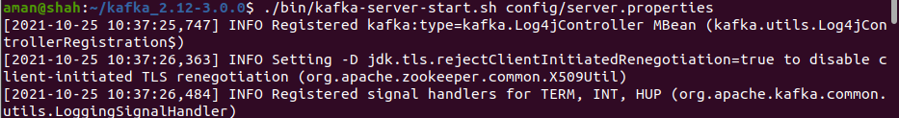

* create topic:

./bin/kafka-topics.sh --create --topic test-aman --bootstrap-server localhost:9092 --replication-factor 1 --partitions 1



* create consumer for messages:

./bin/kafka-console-consumer.sh --bootstrap-server localhost:9092 --topic test-aman –from-beginning

* broker.producer list:

./bin/kafka-console-producer.sh --broker-list localhost:9092 --topic test-aman

