Twitter Bootstrap BASICS

- What is twitter bootstrap?

Bootstrap is the most popular HTML, CSS, and JavaScript framework for developing responsive, mobile-first web sites.
Bootstrap came from two famous guys at twitter, hence sometimes it is called twitter booststrap. Bootstrap 3 is the latest version.

- What are the steps to download bootstrap?

Go to this link http://getbootstrap.com/2.3.2/ and then the bootstrap.zip file will be downloaded. Extract it in the folder you want to use bootstrap.It contains a set of files, namely css, js and img that we need to start building websites with Twitter Booststrap.

- How to create basic html using bootstrap framework?

Copy the html code and write it same in your project.

<!DOCTYPE html>
<html>
<head>
<title>Bootstrap 101 Template</title>
<meta name="viewport" content="width=device-width, initial-scale=1.0">
<!-- Bootstrap -->
<link href="/home/beryl/Desktop/training_and_learning/software/bootstrap/css/bootstrap.min.css" rel="stylesheet" media="screen">
</head>
<body>
<h1>Hello, world!</h1>
<script src="http://code.jquery.com/jquery.js"></script>
<script src="/home/beryl/Desktop/training_and_learning/software/bootstrap/js/bootstrap.min.js">
</script>
</body>
</html>

link href and script src link should be the one where our extracted bootstrap folder is kept.

The above code on execution will show the below output:-

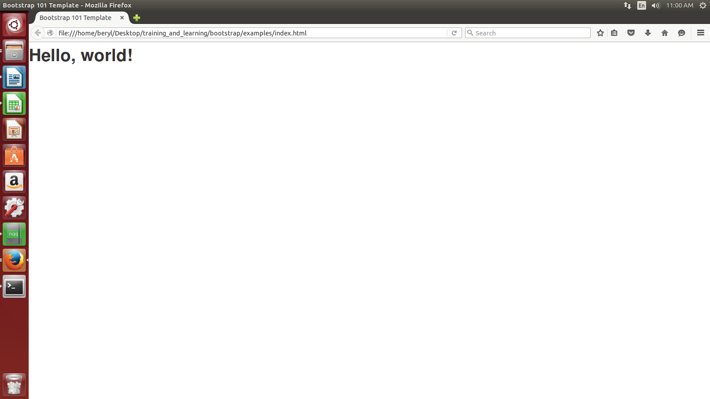
- What are the steps to create different container like header, footer, left side bar, content area, marketing area etc.?

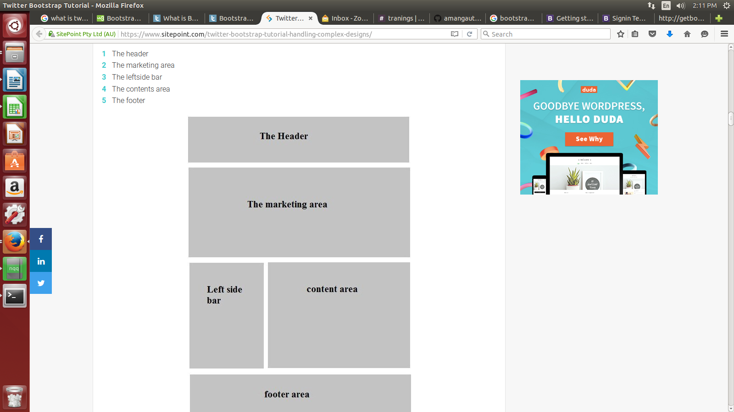

- How to create simple navigation bar using bootstrap?

/home/beryl/Desktop/training_and_learning/bootstrap/examples/21-nov/navbar.html
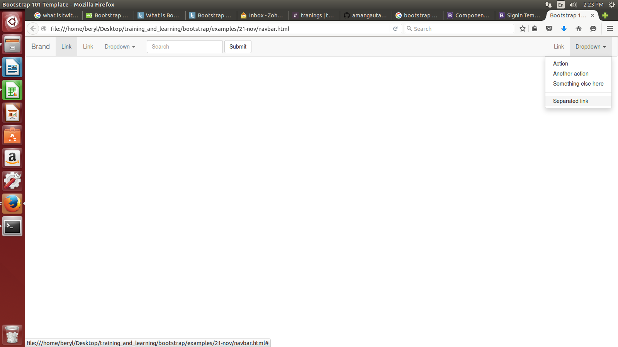

- How to use created templates using getbootstrap.com website?

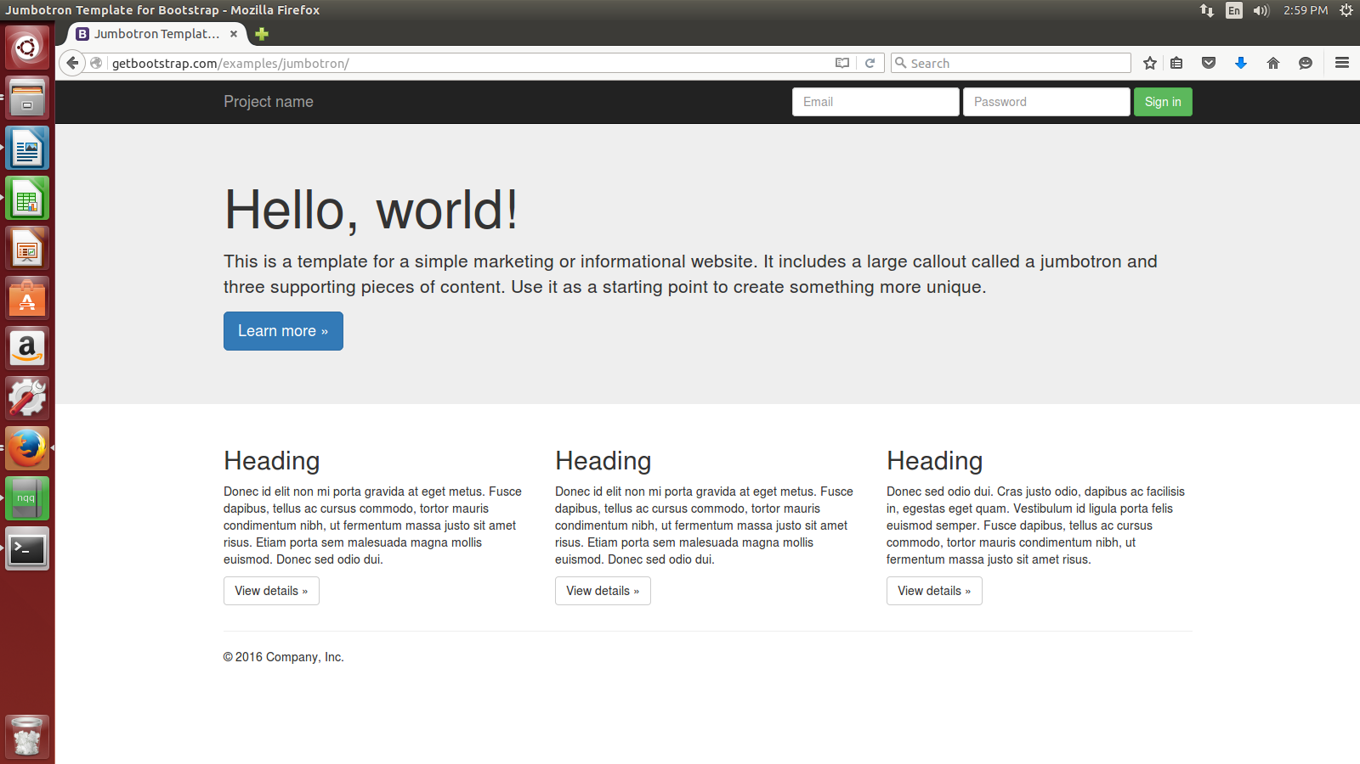

- What are the various class files for buttons in bootstrap?

/home/beryl/Desktop/training_and_learning/bootstrap/examples/21-nov/button.html

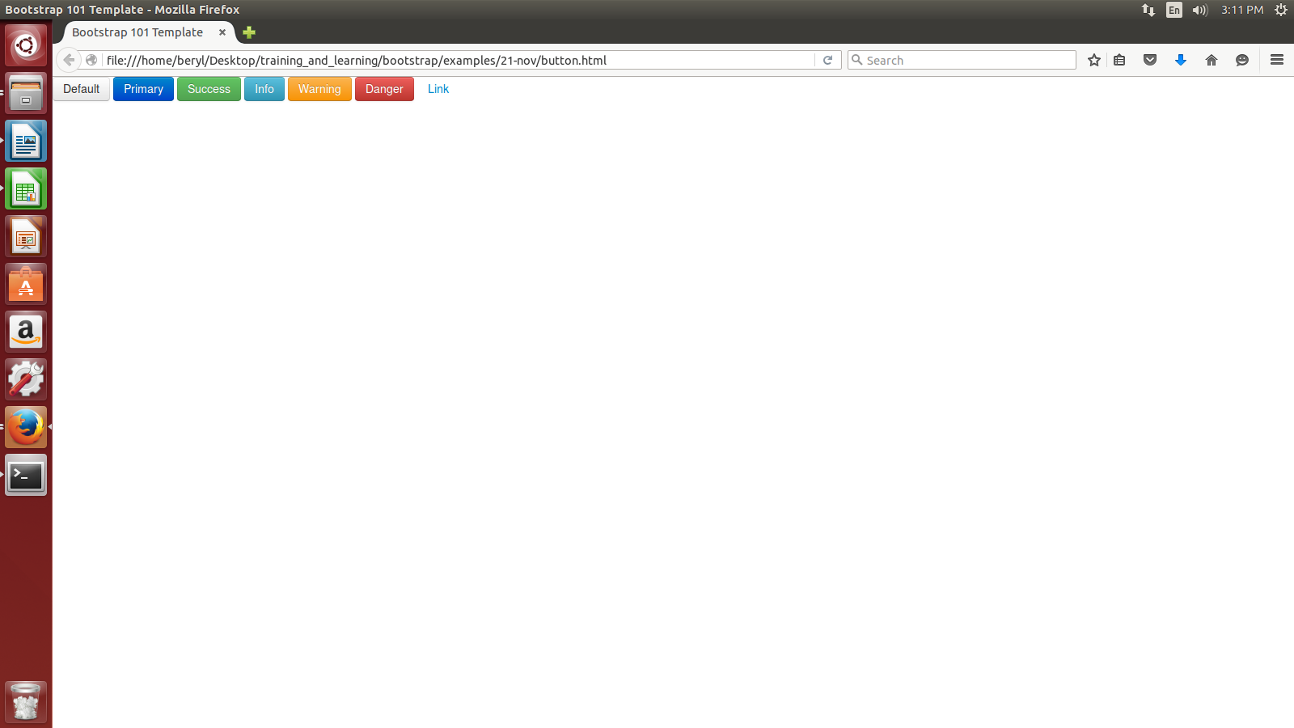

- How to use different shapes for an image?

/home/beryl/Desktop/training_and_learning/bootstrap/examples/21-nov/images.html

