Javascript DOM BASICS

- What is DOM?

DOM stands for Document Object Model.

DOM methods are the actions that we perform and DOM properties are values that we can set and change.

A property is a value that we can get or set (like changing the content of an html element) while a method is an action we perform(like adding or deleting html content).

- How to find an html element?

Method | Description
document.getElementById(id) | Find an element by element id
document.getElementsByTagName(name) | Find an element by tag name
document.getElementsByClassName(name) | Find an element by class name

- How to change an html element?

Method | Description
element.innerHTML = new html content | Change the inner HTML of an element
element.attribute = new value | Change the attribute value of an HTML element
element.setAttribute(attribute, value) | Change the attribute value of an HTML element
element.style.property = new style | Change the style of an HTML element

- How to use document.getElementbyTagName?\

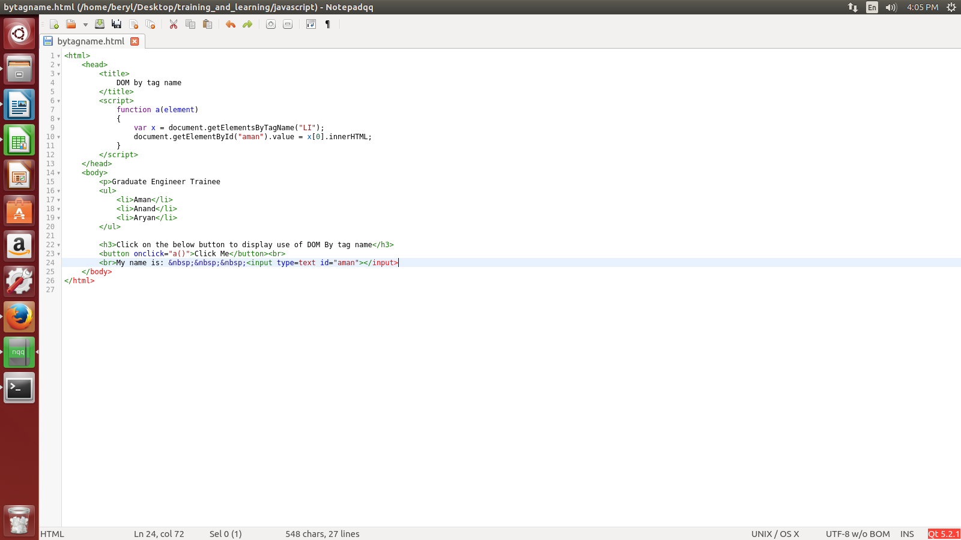
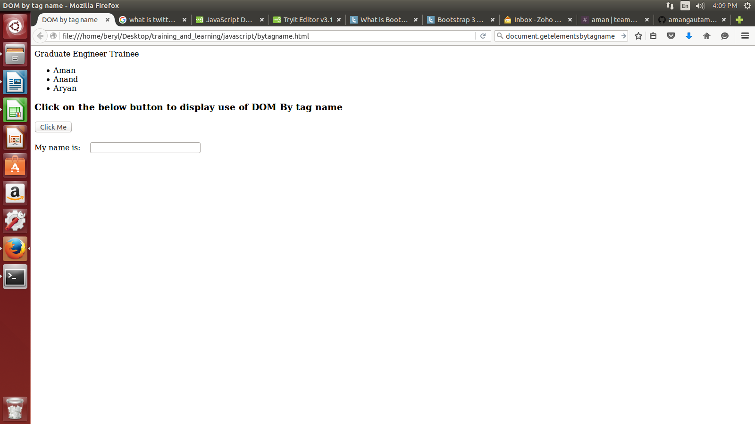
on clicking the button it will show the element at 0th position in the list.

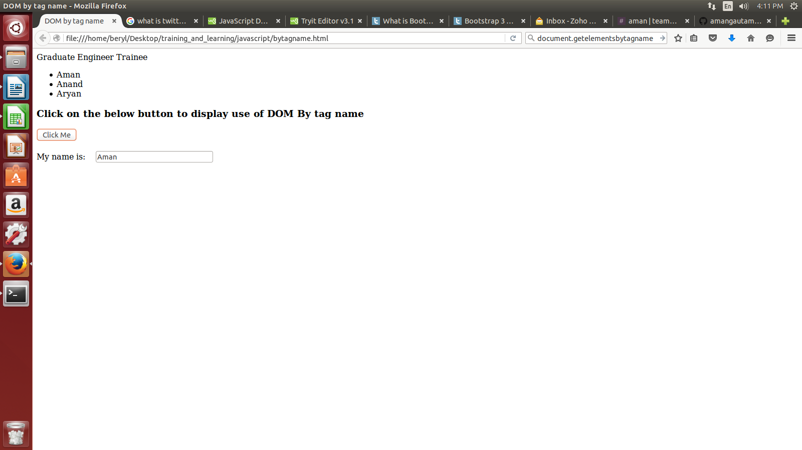
- How to use document.write()?
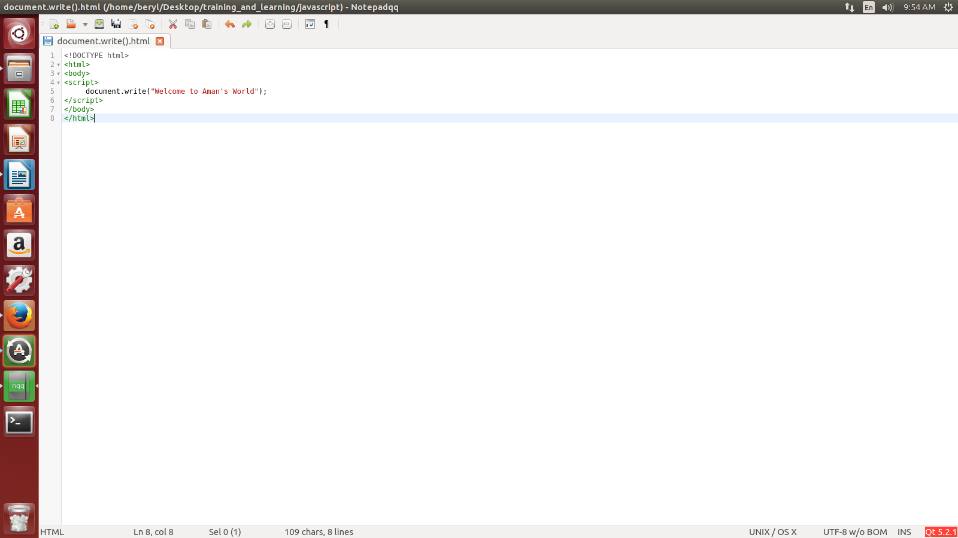

- What is innerHTML property?

- What is innerText property?

- Explain form validation.

- Explain email validation.

- Show with example various DOM events?

Events | Description
onclick | occurs when element is clicked.
ondblclick | occurs when element is double-clicked.
onfocus | occurs when an element gets focus such as button, input, textarea etc.
onblur | occurs when form looses the focus from an element.
onsubmit | occurs when form is submitted.
onmouseover | occurs when mouse is moved over an element.
onmouseout | occurs when mouse is moved out from an element (after moved over).
onmousedown | occurs when mouse button is pressed over an element.
onmouseup | occurs when mouse is released from an element (after mouse is pressed).
onload | occurs when document, object or frameset is loaded.
onunload | occurs when body or frameset is unloaded.
onscroll | occurs when document is scrolled.
onresized | occurs when document is resized.
onreset | occurs when form is reset.
onkeydown | occurs when key is being pressed.
onkeypress | occurs when user presses the key.
onkeyup | occurs when key is released.

