Ruby BASICS

- What is hashing?

Hashing is a collection of key-value pair like “Name”=>”Aman”

- What is the syntax of hashing?

Hash[[key =>|, value]* ]

- Write a simple example using hashing?
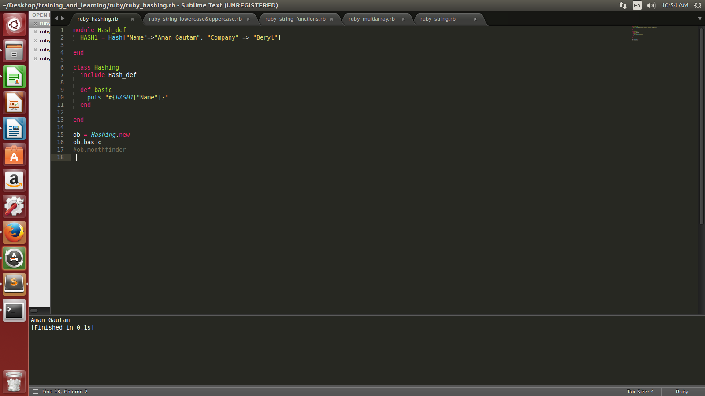
OUTPUT:-

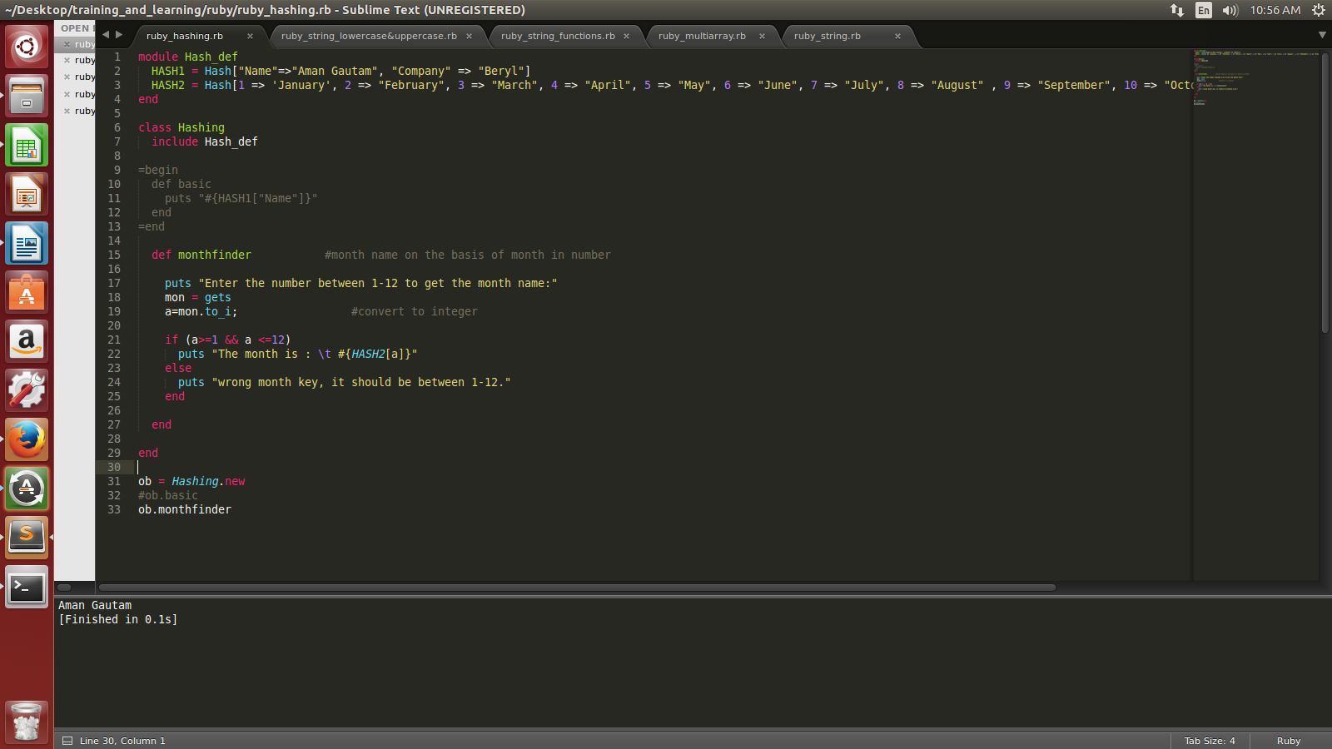

- Write an example using hashing to find the month name using month number (1-12)

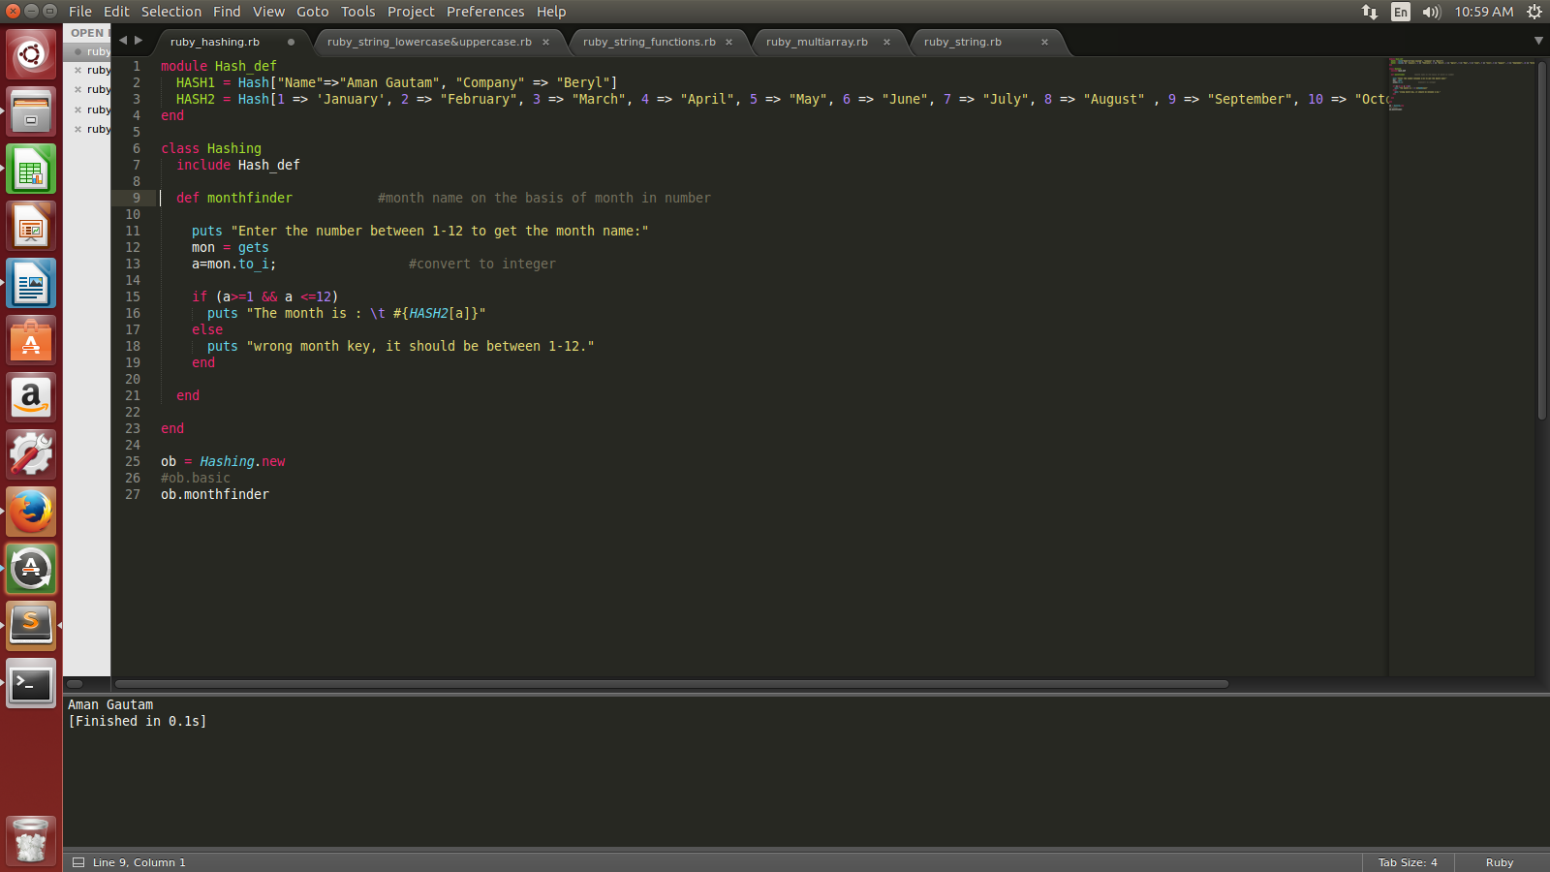
OUTPUT:-

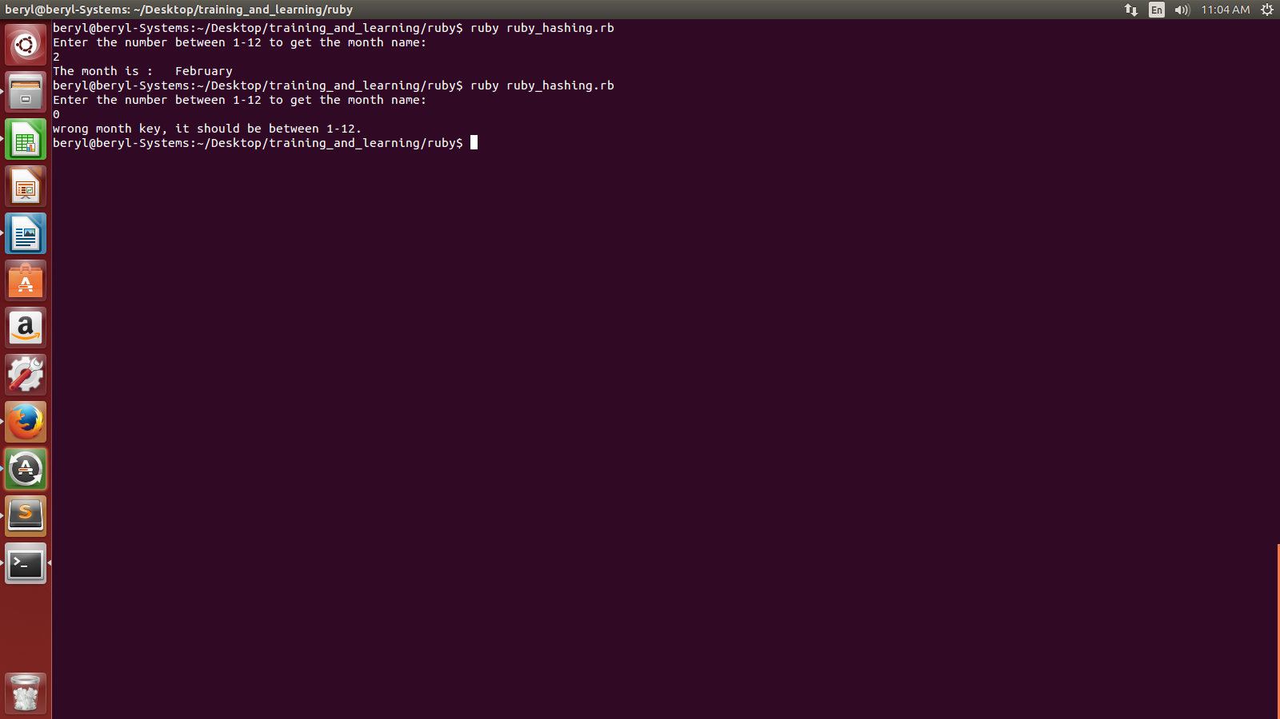
- Write a program using all the functions of hash?

module Hash_def
HASH1 = Hash["Name"=>"Aman Gautam", "Company" => "Beryl"]
HASH2 = Hash[1 => 'January', 2 => "February", 3 => "March", 4 => "April", 5 => "May", 6 => "June", 7 => "July", 8 => "August" , 9 => "September", 10 => "October", 11 => "November", 12 => "December"]
HASH3 = Hash["FirstName" => "Aman", "Last Name" => "Gautam"]
HASH4 = Hash["Name" => "Aman", "Company" => "Beryl Solutions"]
HASH5 = Hash["First Name" => "Aman Gautam", "Company" => "Beryl"]
HASH6 = Hash["Name" => "Aman ", "Company" => "Beryl"]
HASH7 = Hash["Name" => "Aman Gautam", "Company" => "Beryl"]
HASH8 = Hash[1 => "Aman", 2 => "Ravi"]
HASH9 = Hash[]
HASH10 = Hash[]
end

class Hashing
include Hash_def

def basic
puts "#{HASH1["Name"]}"
end

def monthfinder #month name on the basis of month in number

puts "Enter the number between 1-12 to get the month name:"
mon = gets
a=mon.to_i; #convert to integer

if (a>=1 && a <=12)
puts "The month is : \t #{HASH2[a]}"
else
puts "wrong month key, it should be between 1-12."
end
end

def hashequal #checks two hashes are equal or not
puts "Hash1 and hash 3 are equal is : #{HASH1==HASH3}"
puts "Hash1 and hash 4 are equal is : #{HASH1==HASH4}"
puts "Hash1 and hash 5 are equal is : #{HASH1==HASH5}"
puts "Hash1 and hash 6 are equal is : #{HASH1==HASH6}"
puts "Hash1 and hash 7 are equal is : #{HASH1==HASH7}"
end

def hashkey #extract the value on the entered key
puts "#{HASH2[3]}"
end

def hashclear #clear all the key and value of the hash
puts "The value in hash8 are: #{HASH8}"
puts("On clearing the value of hash8, the result now is : #{HASH8.clear}")
end

def hashsetdefaultvalue #set default value
HASH8.default="No record"
puts "The value in hash8 are: #{HASH8[1]}"
puts "The default value if key is not present in hash : #{HASH8['']}"
end

def hashdelete #deletes the value based on entered key
puts "The value in hash8 are: #{HASH8}"
puts "The deleted value is : #{HASH8.delete(2)}"
puts "The value in hash8 are: #{HASH8}"
end

def hashdefault #show default if key not present
puts "The value in hash8 are: #{HASH8}"
puts "Default value of hash8 is : #{HASH8.default()}"
puts "#{HASH8[1]} and #{HASH8[2]}"
puts "#{HASH8[3]}"
end

def hasheach #stores all keys in key and all values in value
HASH8.each { |key,value| puts "The keys is: #{key} and its value is: #{value} "}
end

def hashempty #check if hash is empty or not?
puts "HASH9 is empty: #{HASH9.empty?}"
puts "HASH8 is empty: #{HASH8.empty?}"
end

def hashfetchkey #return value using key and if key is not present we can set default value
puts "#{HASH8.fetch(2)}"
puts "#{HASH8.fetch(2,"sorry wrong key")}"
puts "#{HASH8.fetch(3,"sorry wrong key")}"
end

def hashhaskey #check whether key is present in hash or not
puts "The key = 2 is present in hash2: #{HASH2.key?(2)}"
puts "The key = 13 is present in hash2: #{HASH2.key?(13)}"
end

def hashhasvalue #check whether value is present in hash or not
puts "The value = March is present in hash2: #{HASH2.value?('March')}"
puts "The value = Aman is present in hash2: #{HASH2.key?('Aman')}"
end

def hashindex #return the key for respective value
puts " The key of value April is : #{HASH2.index('April')}"
end

def hashinspect #return string version of hash
puts HASH2.inspect
end

def hashinvert #return string version of hash
puts HASH2.invert
end

def hashhaslength #return the size of array
puts HASH2.length
end

def hashmerge #concatenate hashes
puts HASH7.merge(HASH8)
end

def hashsort #sort the hash by key in alphabetical order and acc to number
print HASH7.sort
end

def hashstore #store element to array
puts "Before storing: #{HASH10}"
HASH10.store("Department","HR")
puts "After storing: #{HASH10}"
end

def hashtoarray #print hash as an array
puts "As hash: #{HASH7}"
puts "As Array: #{HASH7.to_a}"
end

def hashtostring
puts "As hash: #{HASH7}"
puts "As String: #{HASH7.to_s}"
end

def hashvalues
puts "values in hash are: #{HASH2.values}"
end
end

ob = Hashing.new
#ob.basic
#ob.monthfinder
#ob.hashequal
#ob.hashkey
#ob.hashclear
#ob.hashsetdefaultvalue
#ob.hashdefault
#ob.hashdelete
#ob.hasheach
#ob.hashempty
#ob.hashfetchkey
#ob.hashhaskey
#ob.hashhasvalue
#ob.hashindex
#ob.hashinspect
#ob.hashinvert
#ob.hashhaslength
#ob.hashmerge
#ob.hashsort
#ob.hashstore
#ob.hashtoarray
#ob.hashtostring
ob.hashvalues

- Write a program in ruby to print factorial of a number taken by user?
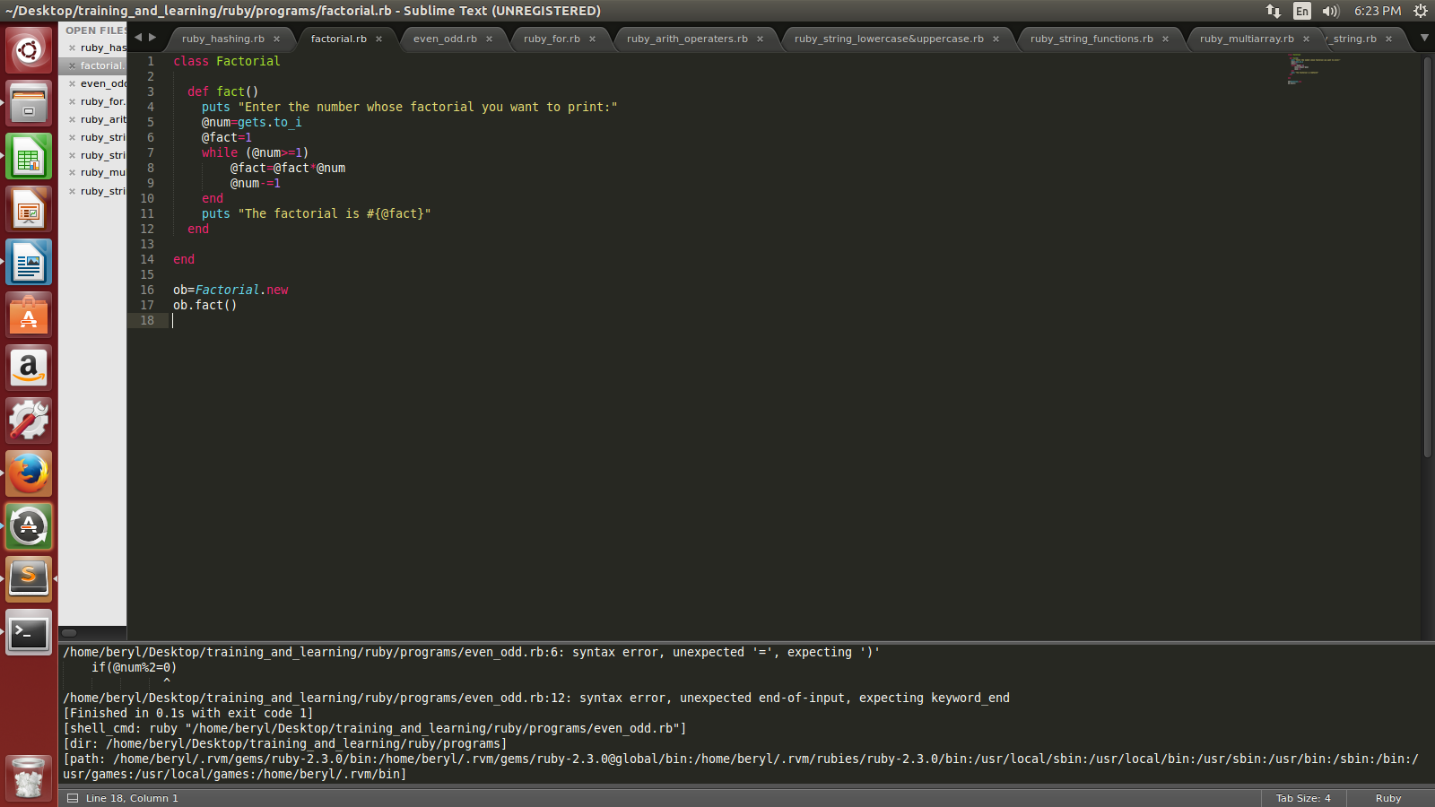
OUTPUT:
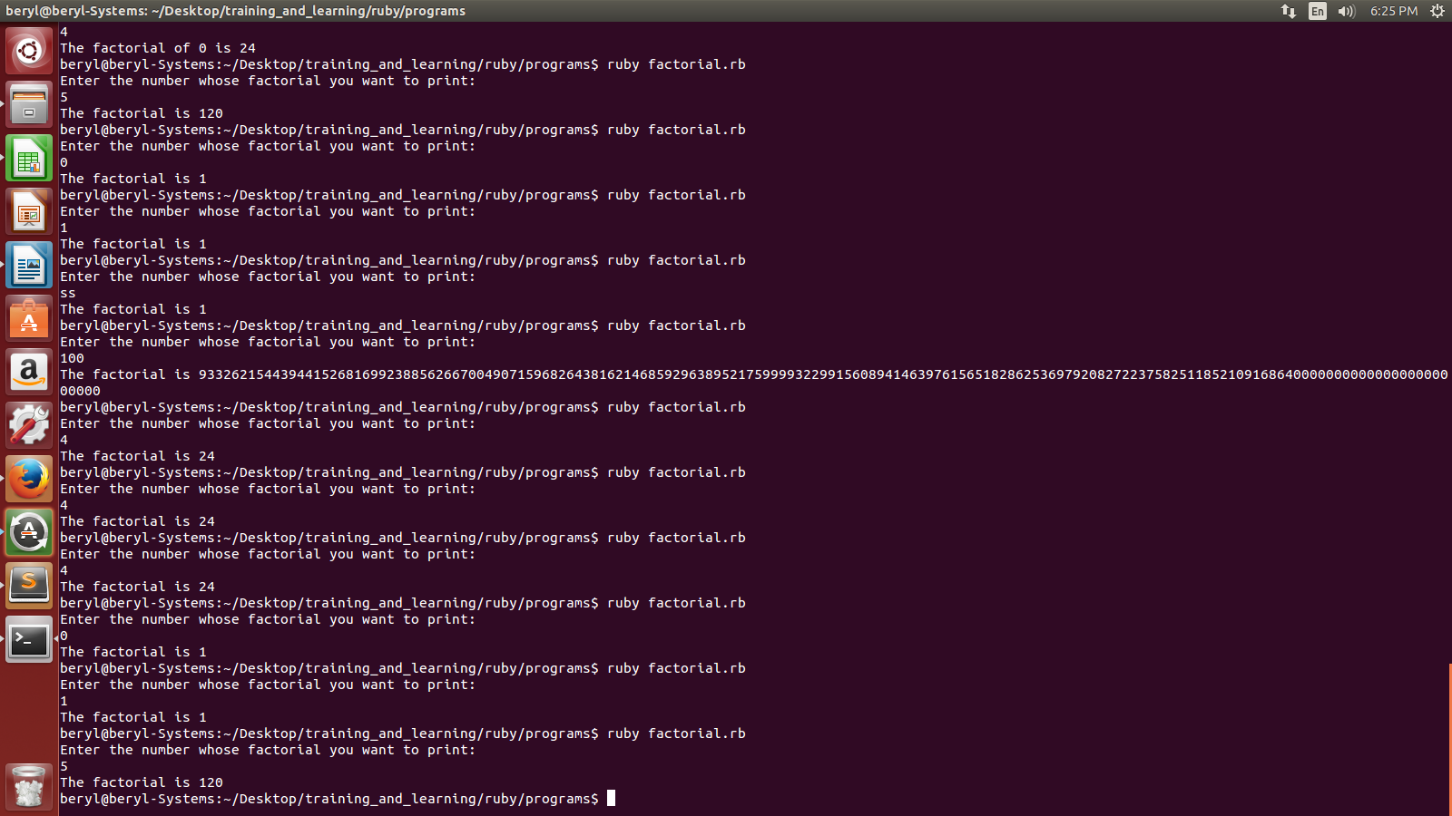

- Write a program in ruby to print even or odd taking number from user?
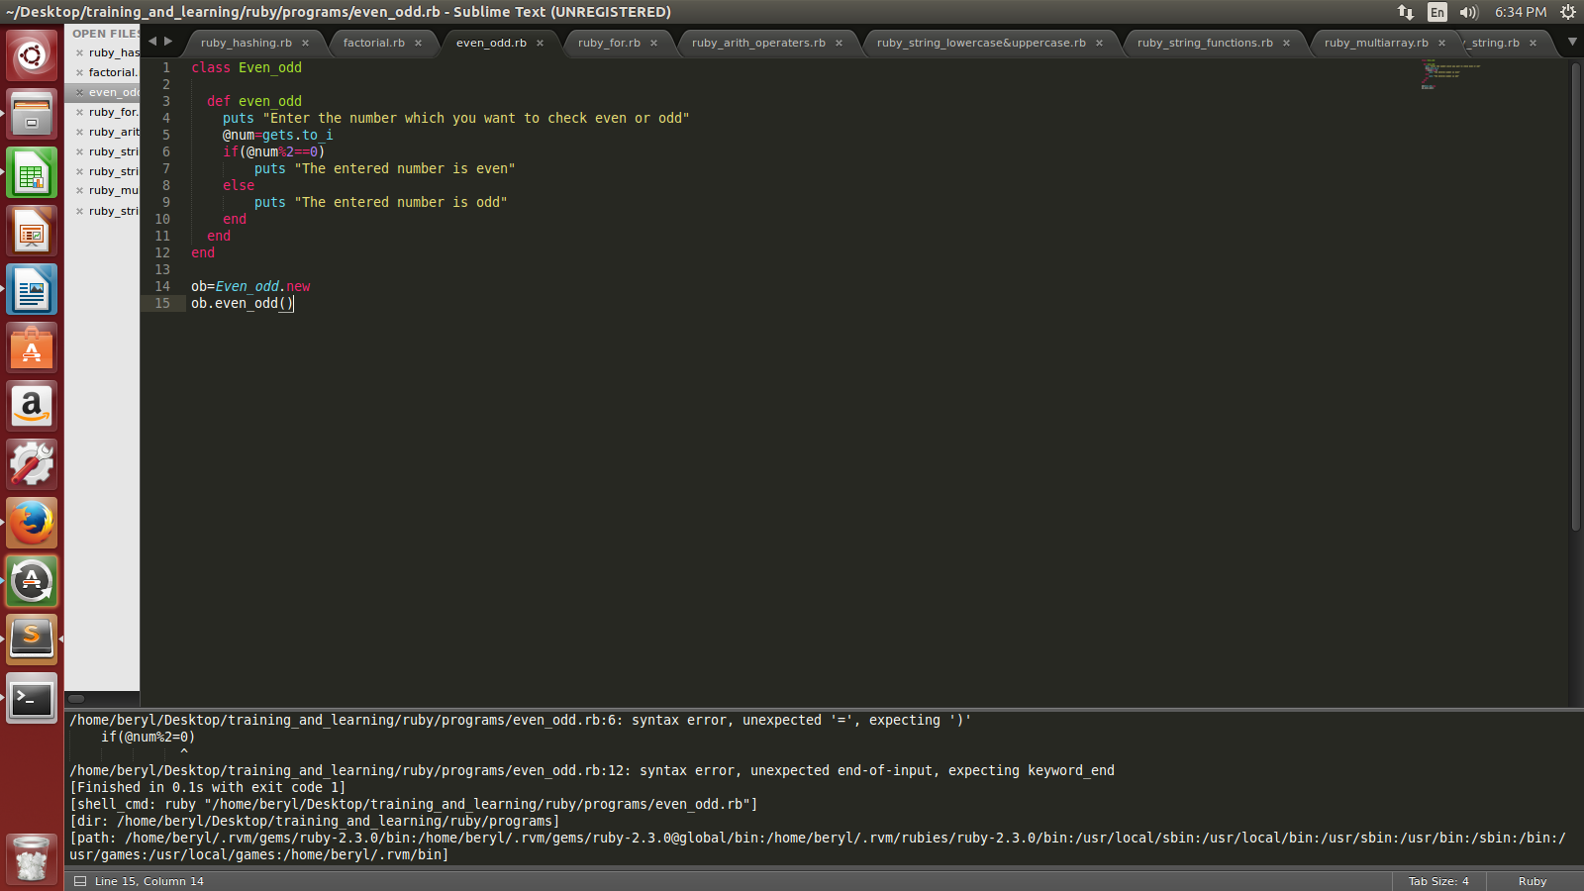
OUTPUT:

