PostgreSQL Project

- Write a query to check the version of postgres.

SELECT Version();

- Write a query to drop a column from a table.

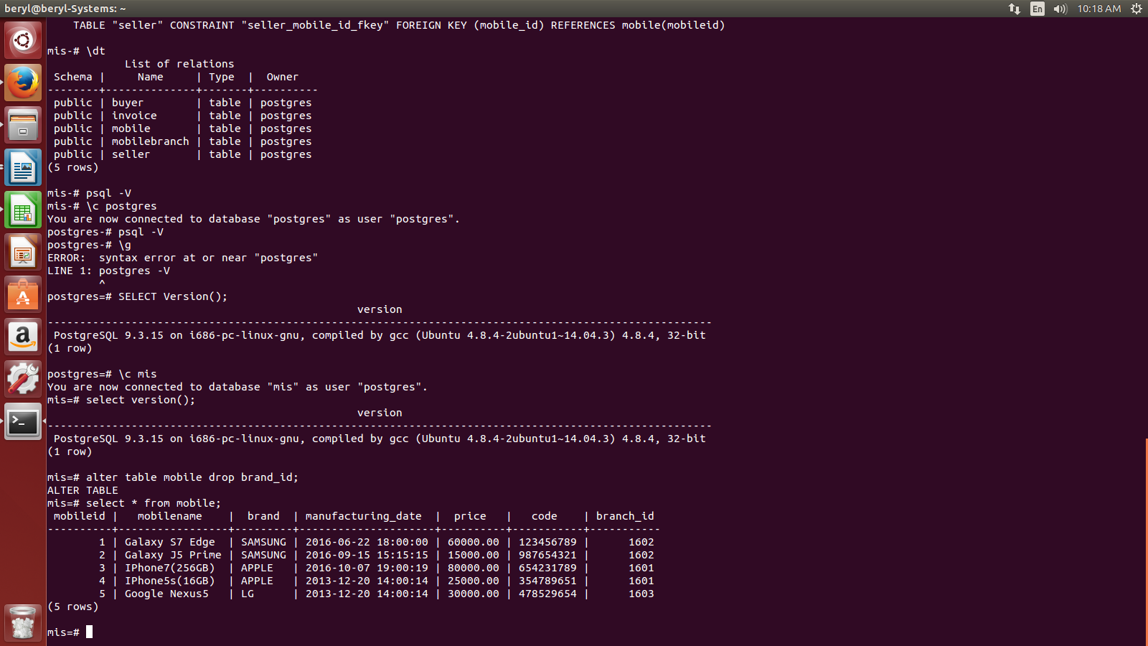
- Write a query to get the payment_description of Google Nexus5.

SELECT t.mobilename, i.payment_details
FROM (SELECT mobile.mobilename, seller.seller_id
FROM mobile, seller
WHERE mobile.mobileid=seller.mobile_id AND mobile.mobilename='Google Nexus5') as t, invoice i
WHERE t.seller_id=i.sellerid;

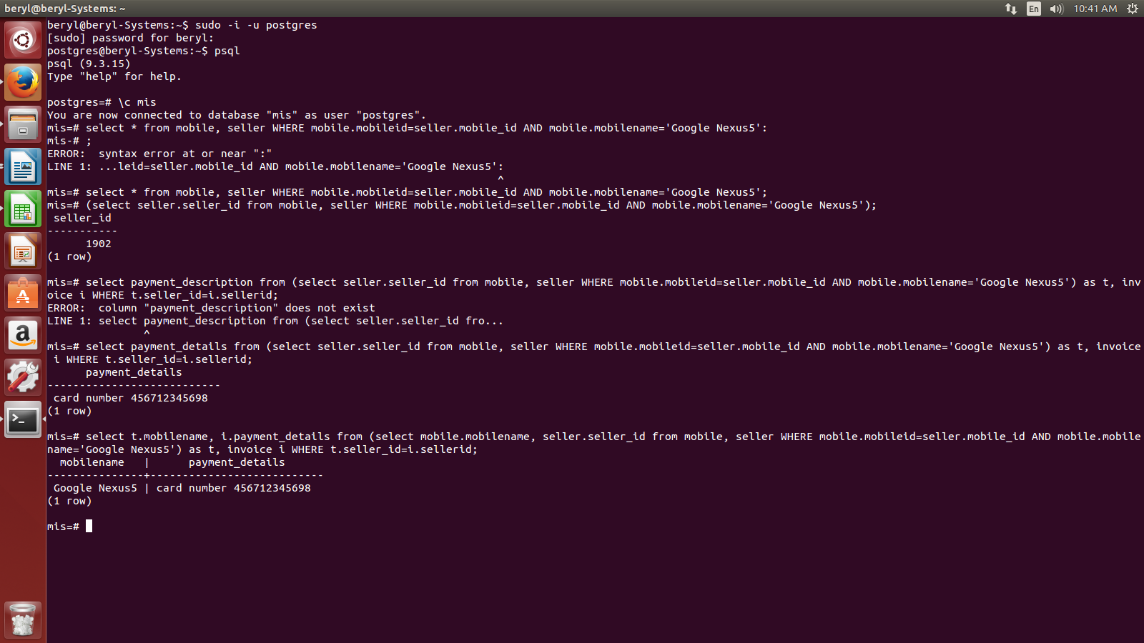

- What is the finalized structure of all the tables along with constraints and keys.

Primary keys are in bold and foreign keys are in italics.

- Mobile

mobileid | mobilename | brand | manufactruing_date | price | imei_code | branch_id
integer | Varchar | varchar | Timestamp | int | int | int

- Seller

seller_id | seller_name | mobile_id | Amount | selleing_date | payment_mode
Int | Varchar | Int | Int | Timestamp | varchar

- Buyer

buyer_id | buyer_name | mobile_id | buyer_address | contact_number
Int | Varchar | Int | Varchar | bigint

- Mobilebranch

branch_id | mobile_brand_name | branch_location

- Invoice

Paymentid | payment_mode | payment_details | Price | sellerid
Int | Varchar | Varchar | Int | Int

- Apply check constraint on buyer table contact number field which should not be greater or less than 10.

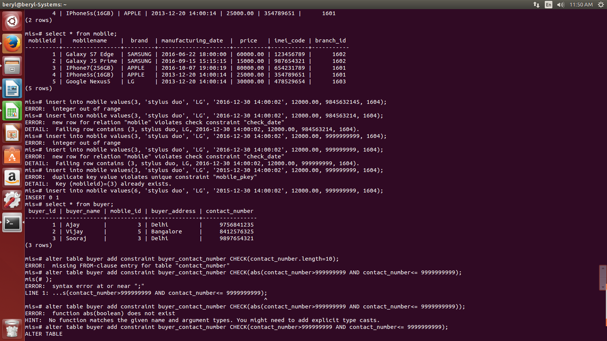
- Apply check constraint on mobile table.
REVIEWED BY SIR AND CHANGED BEING MADE IN THE TABLE

- Added inventory column with constraint set to 0 as default value.

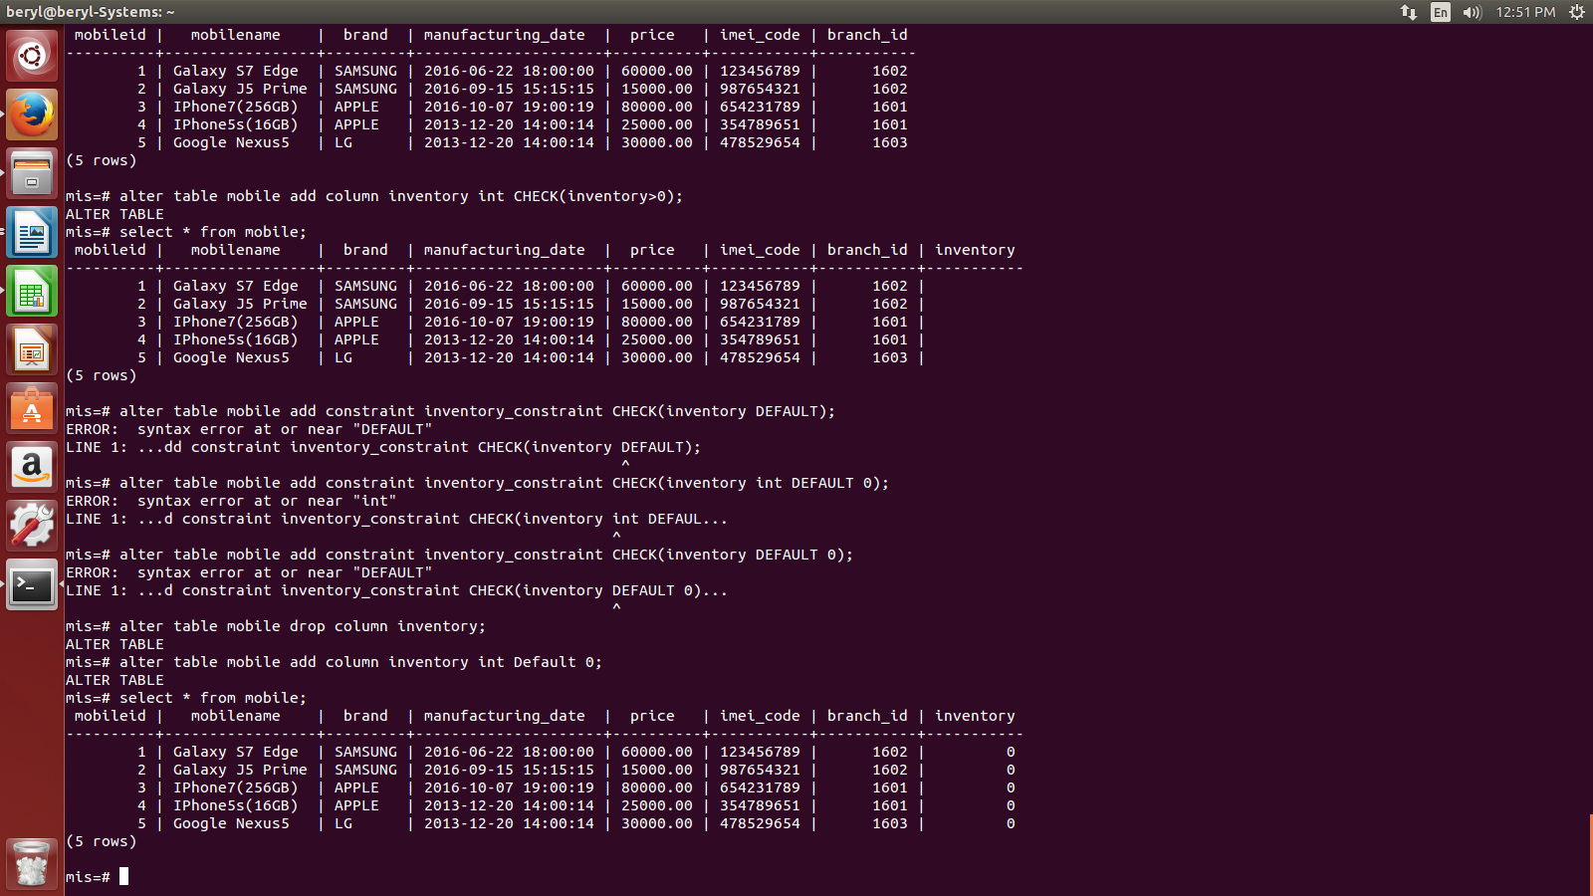
- Add constraint that inventory column should not be less than 0.

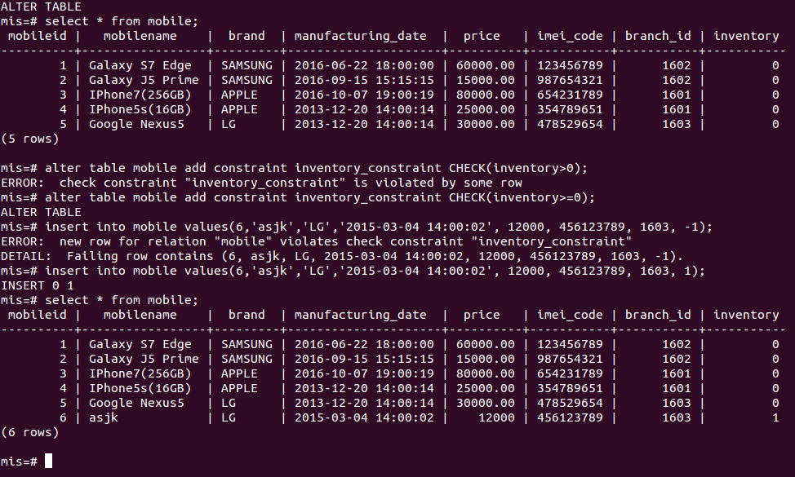

- create table brand:-
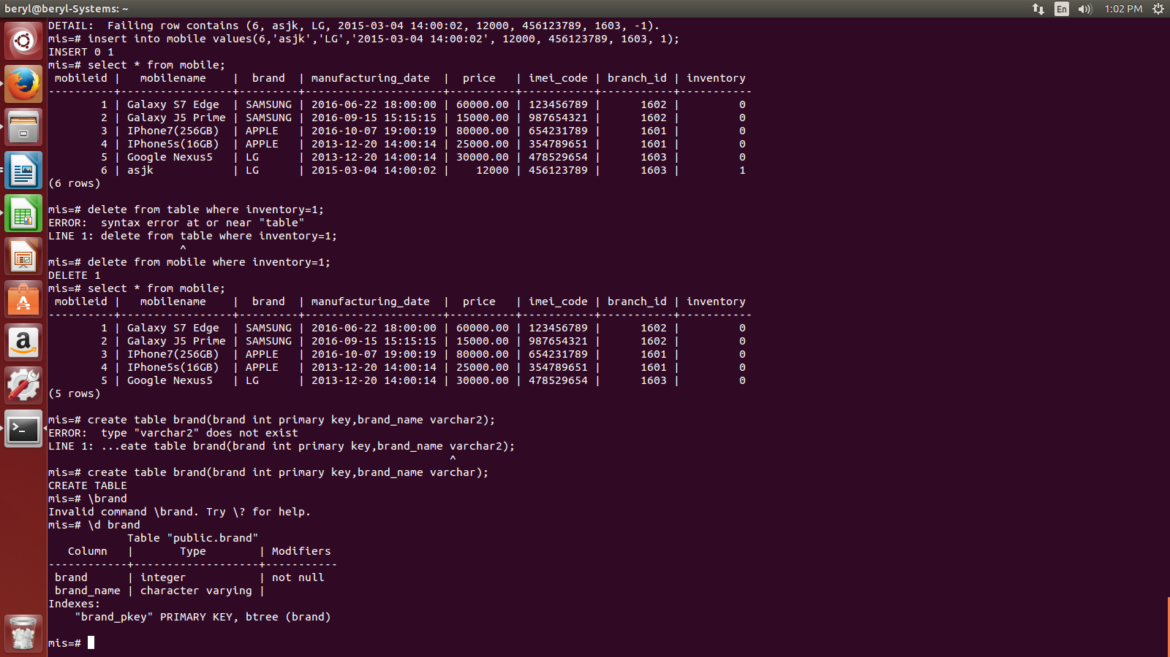

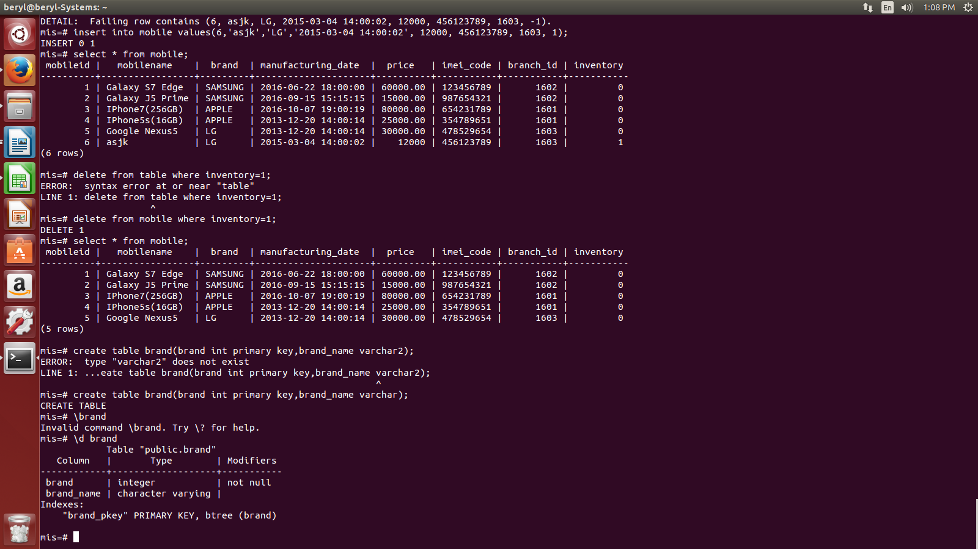
- add brand id column to mobile table.
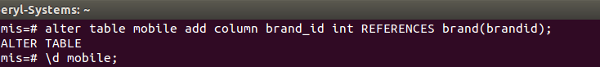
- Add constraint to brand id of mobile table.

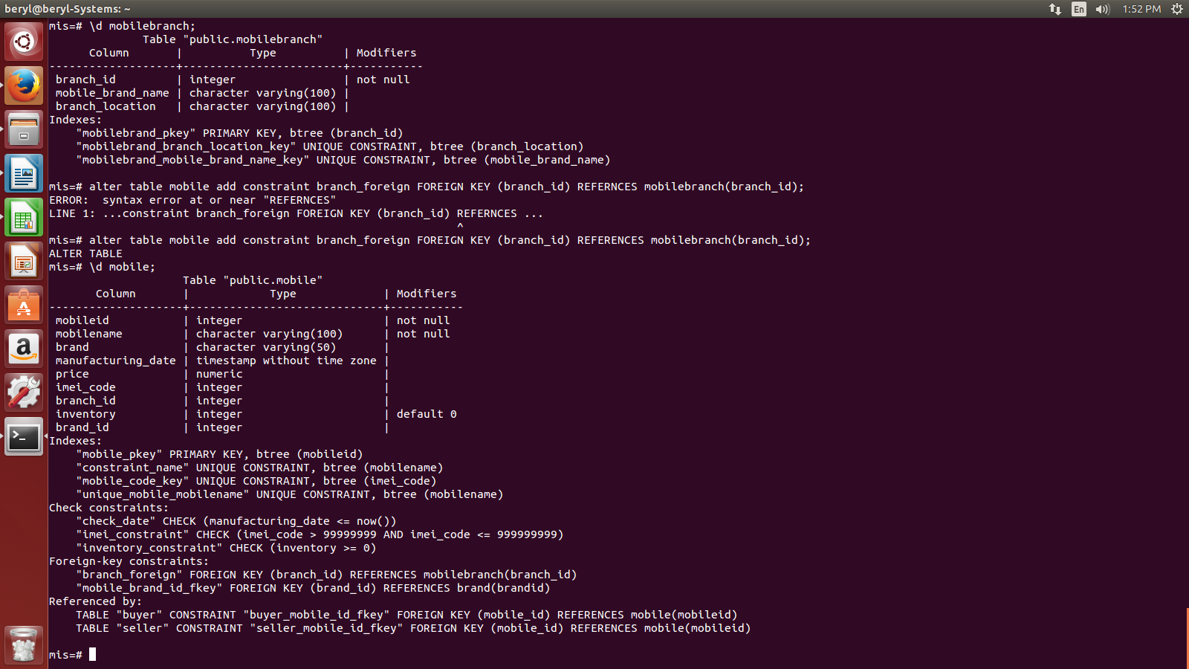

- Drop brand_id column from mobile table.
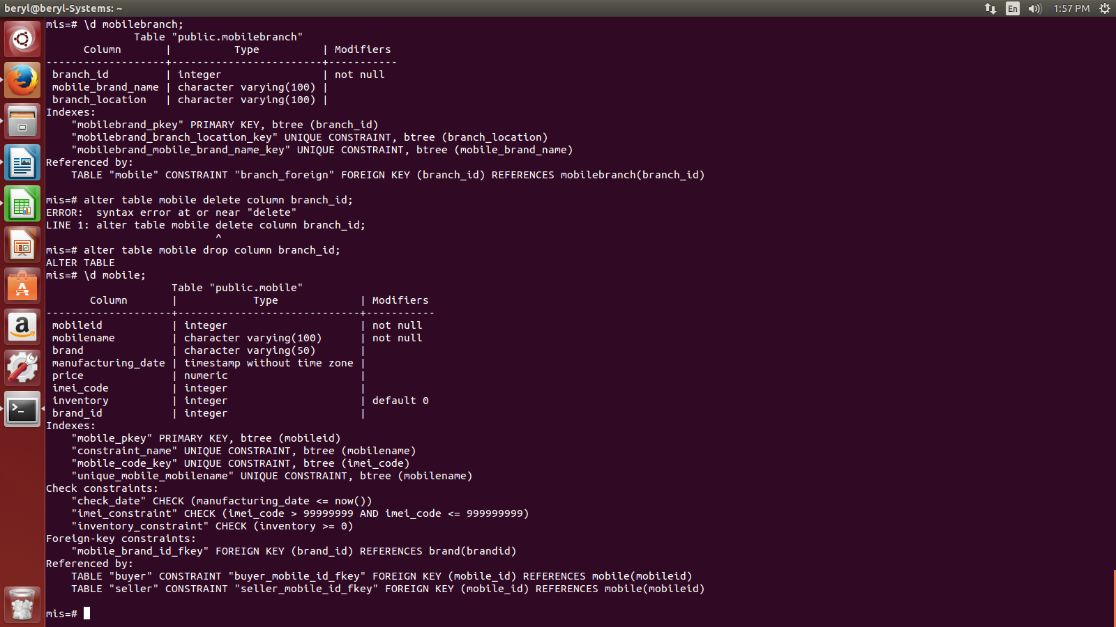

- Add head location column to mobilebranch table.

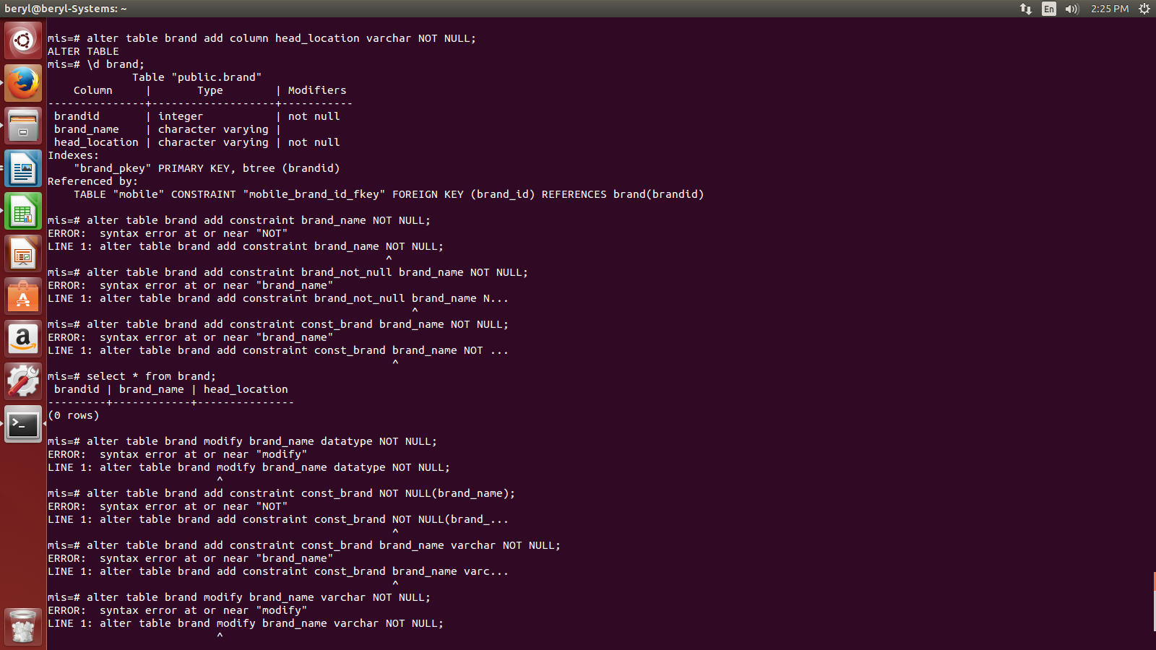

- Add not null constraint using alter command.

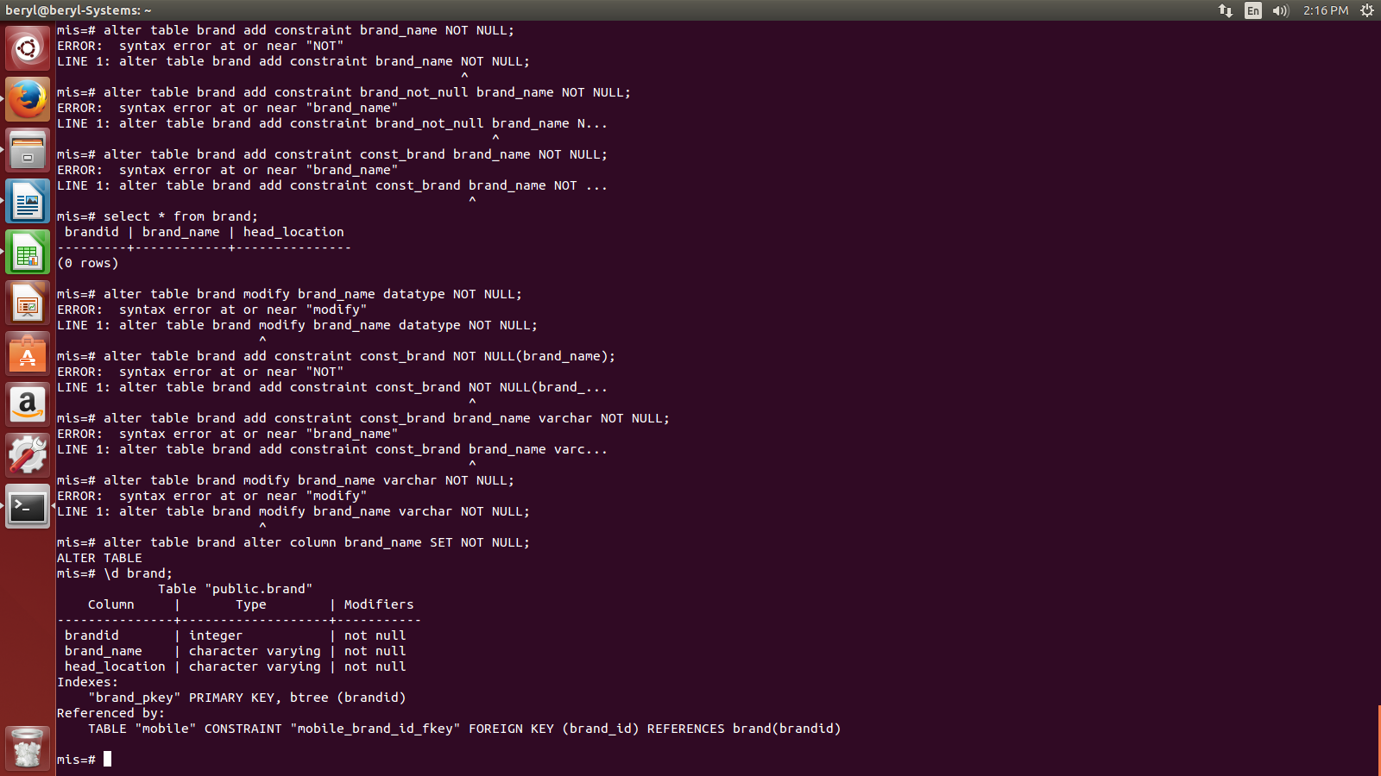
- delete table mobilebranch.
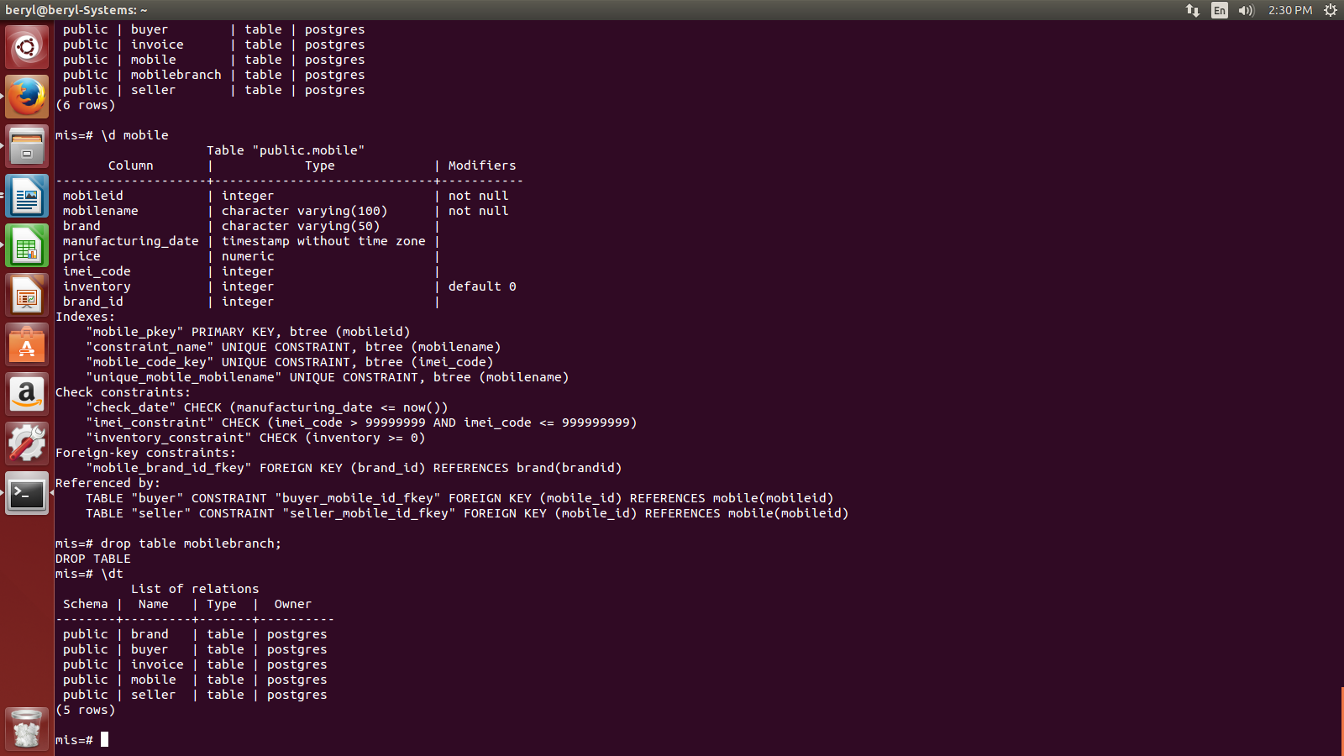

- create table customer_mobile.
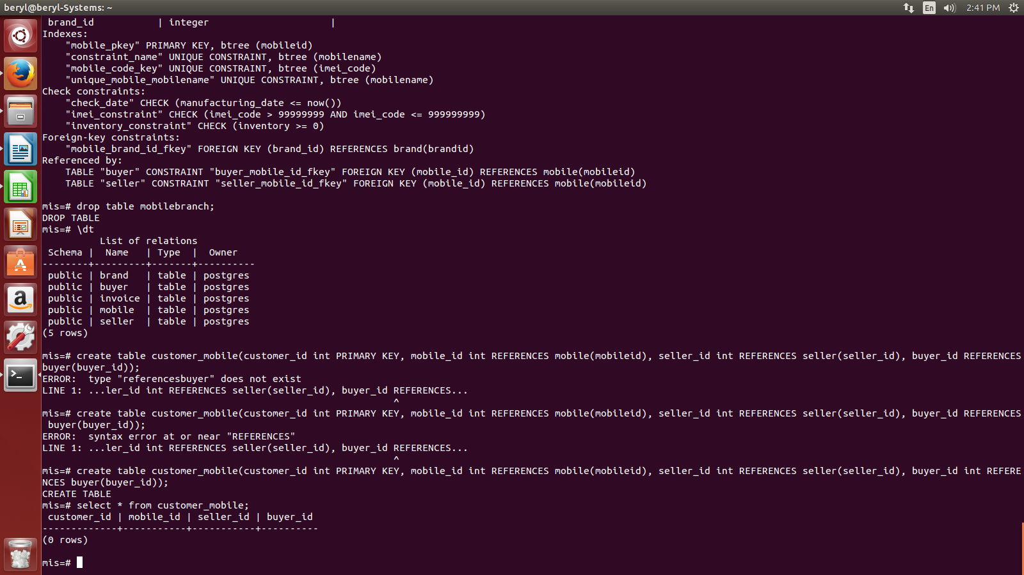

- Insert into customer_mobile.
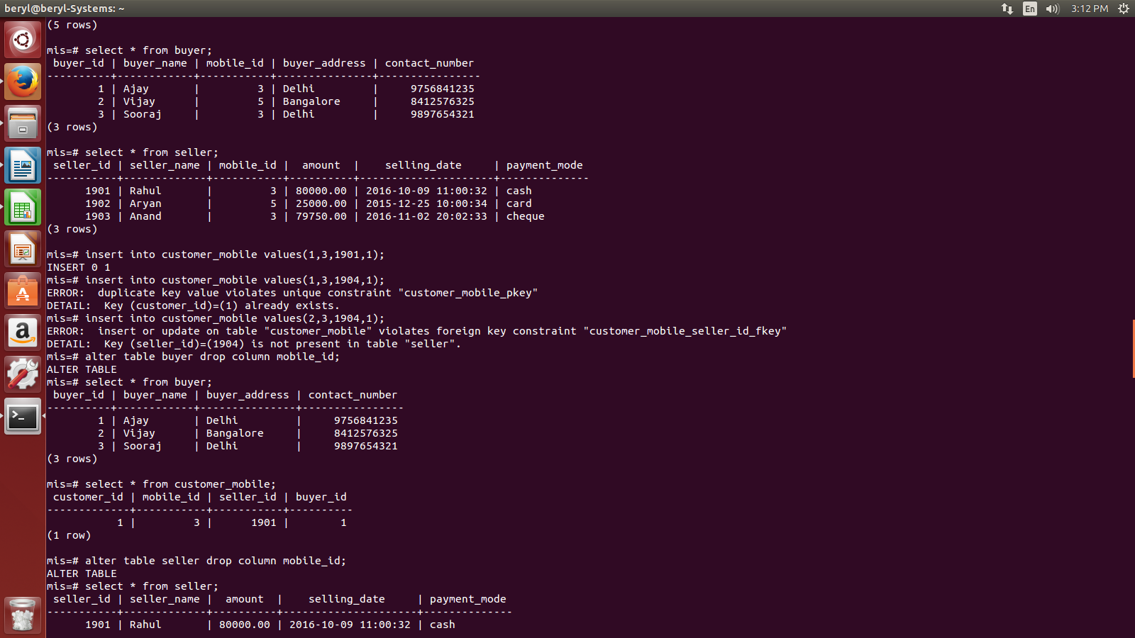
- Delete mobile id column from buyer and seller table.

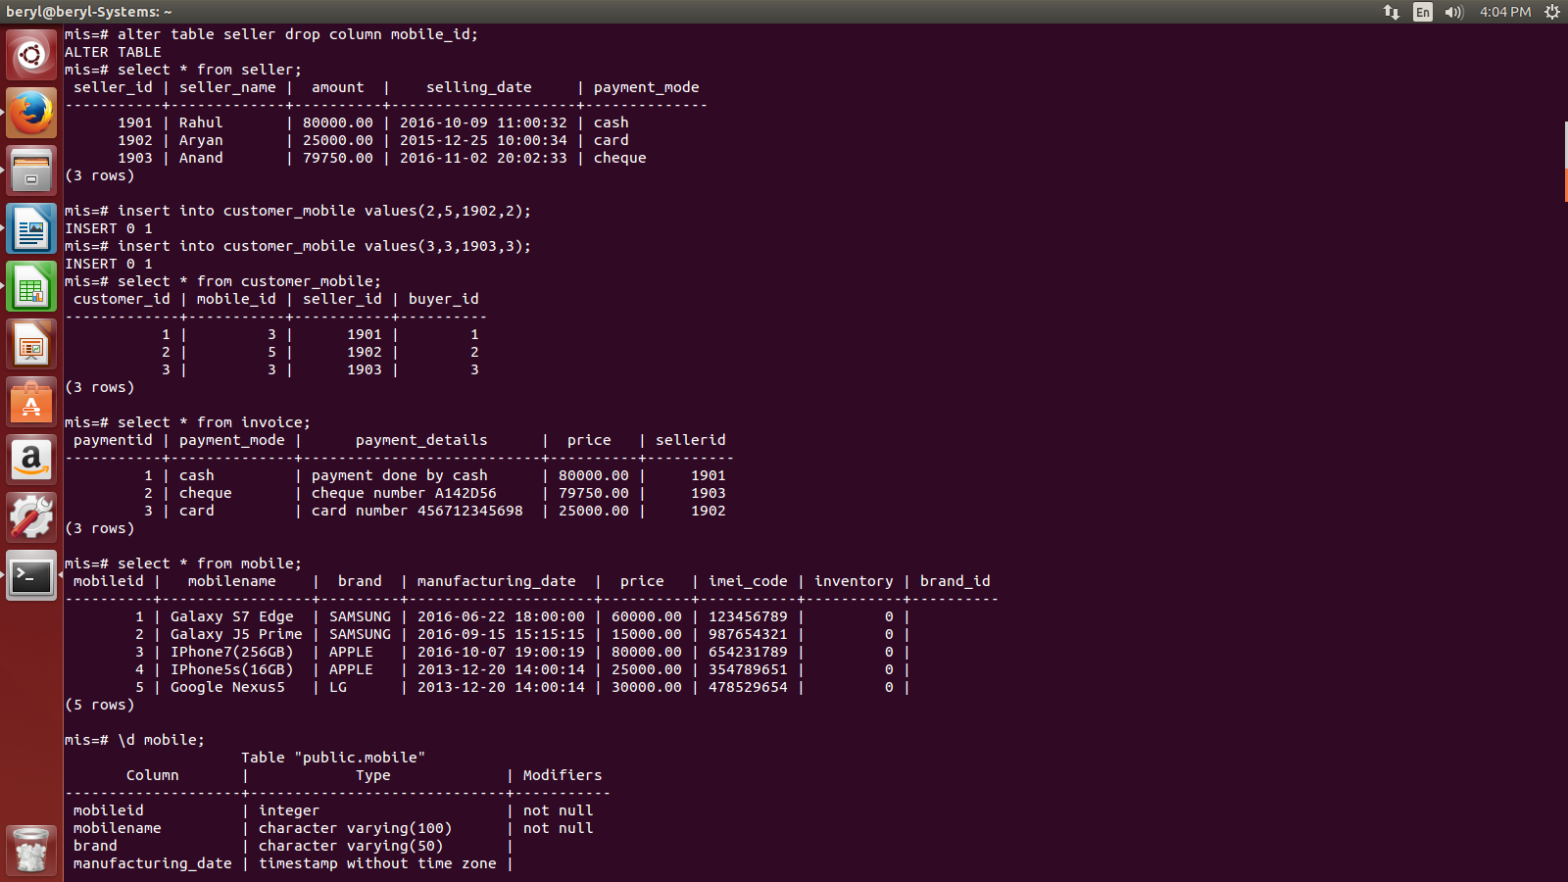
- Update brand id and remove brand column from table.

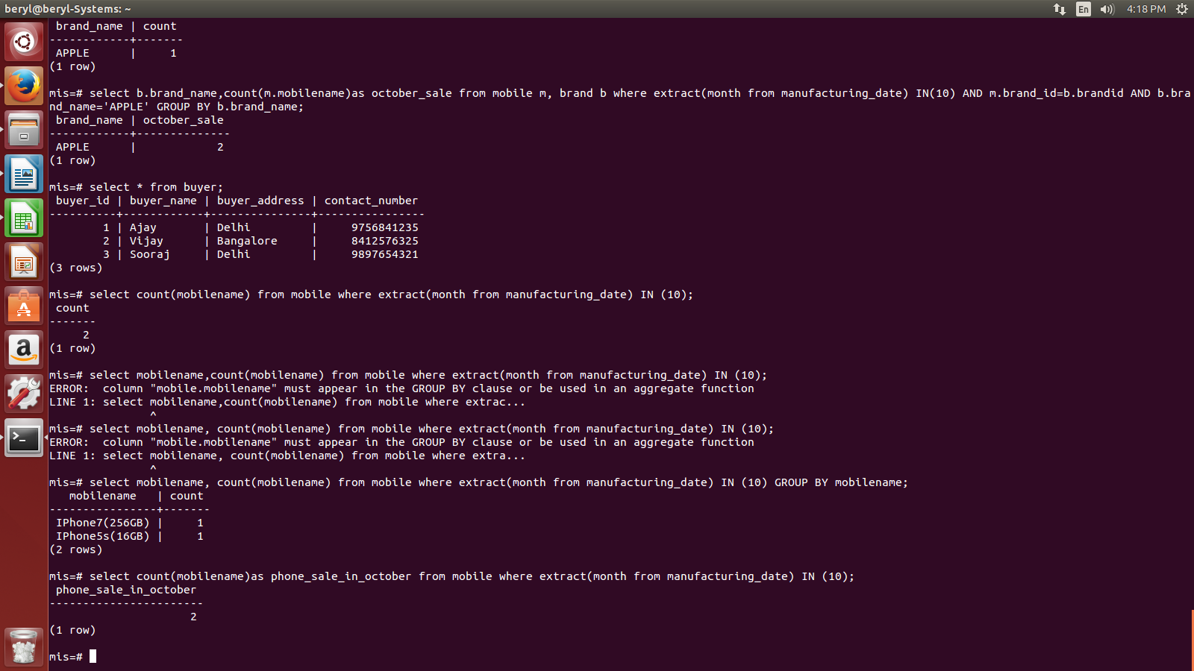
- Write a query to find the total sales in the month of october.

- Write a query to find the sale of APPLE mobiles in a month;

SELECT b.brand_name, count(mobileid)as sale_in_october
FROM mobile m, brand b
WHERE extract(month from manufacturing_date) IN (10) AND m.brand_id=b.brandid AND b.brand_name='APPLE'
GROUP BY b.brand_name;

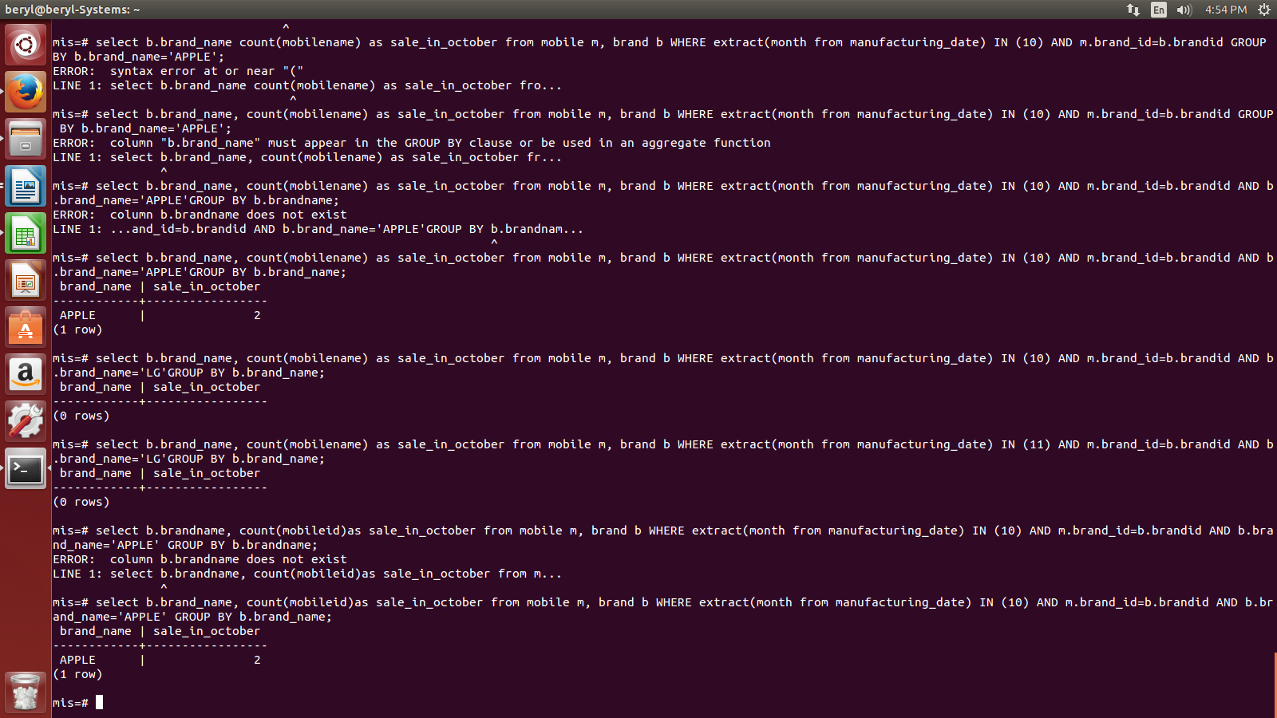

- Write a query to get seller name and buyer name.

SELECT s.seller_name,b.buyer_name
FROM seller s, buyer b, customer_mobile c
WHERE c.buyer_id=b.buyer_id AND c.seller_id=s.seller_id;

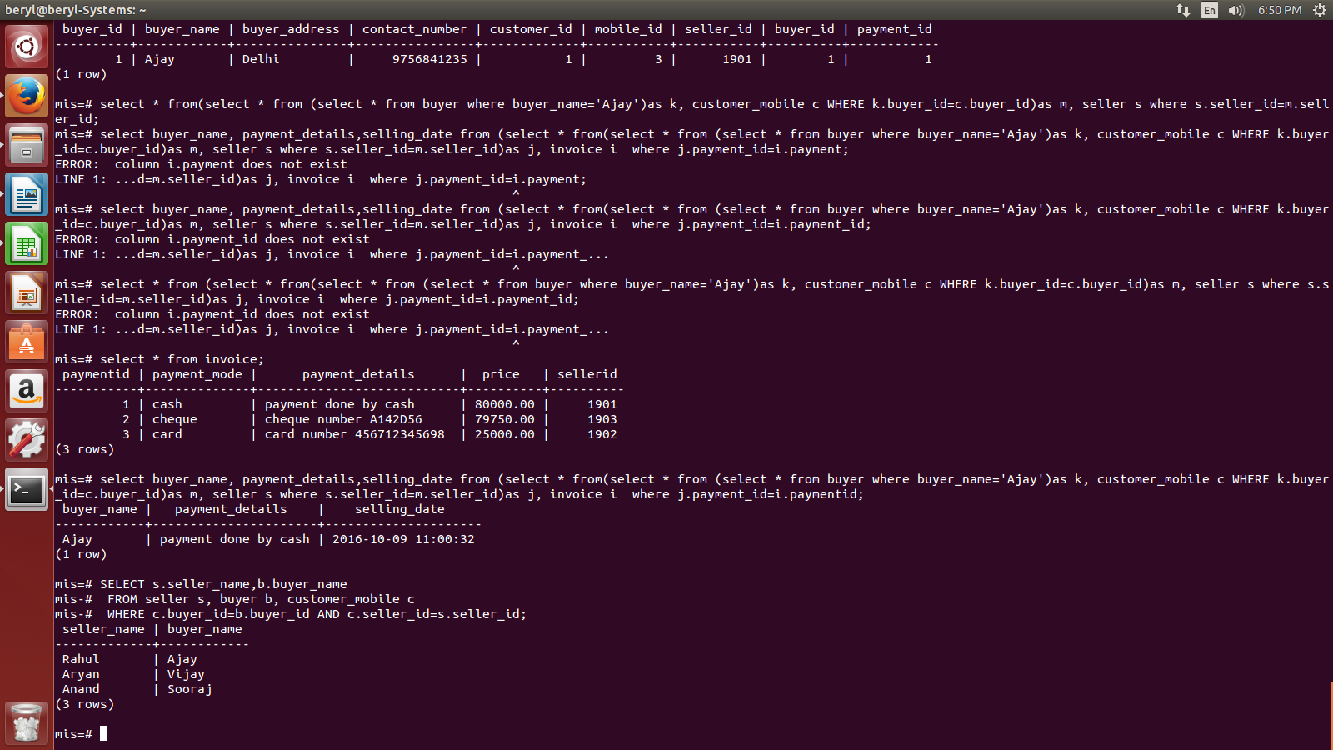

- What is the total revenue generated by APPLE.

SELECT k.brand_name, SUM(i.price)AS total_revneue
FROM (SELECT *
FROM ((SELECT *
FROM (SELECT *
FROM brand b
FULL JOIN mobile m ON m.brand_id=b.brandid) AS t WHERE brand_name='APPLE')
)AS t, customer_mobile c
WHERE t.mobileid=c.mobile_id) AS k, invoice i
WHERE k.payment_id=i.paymentid
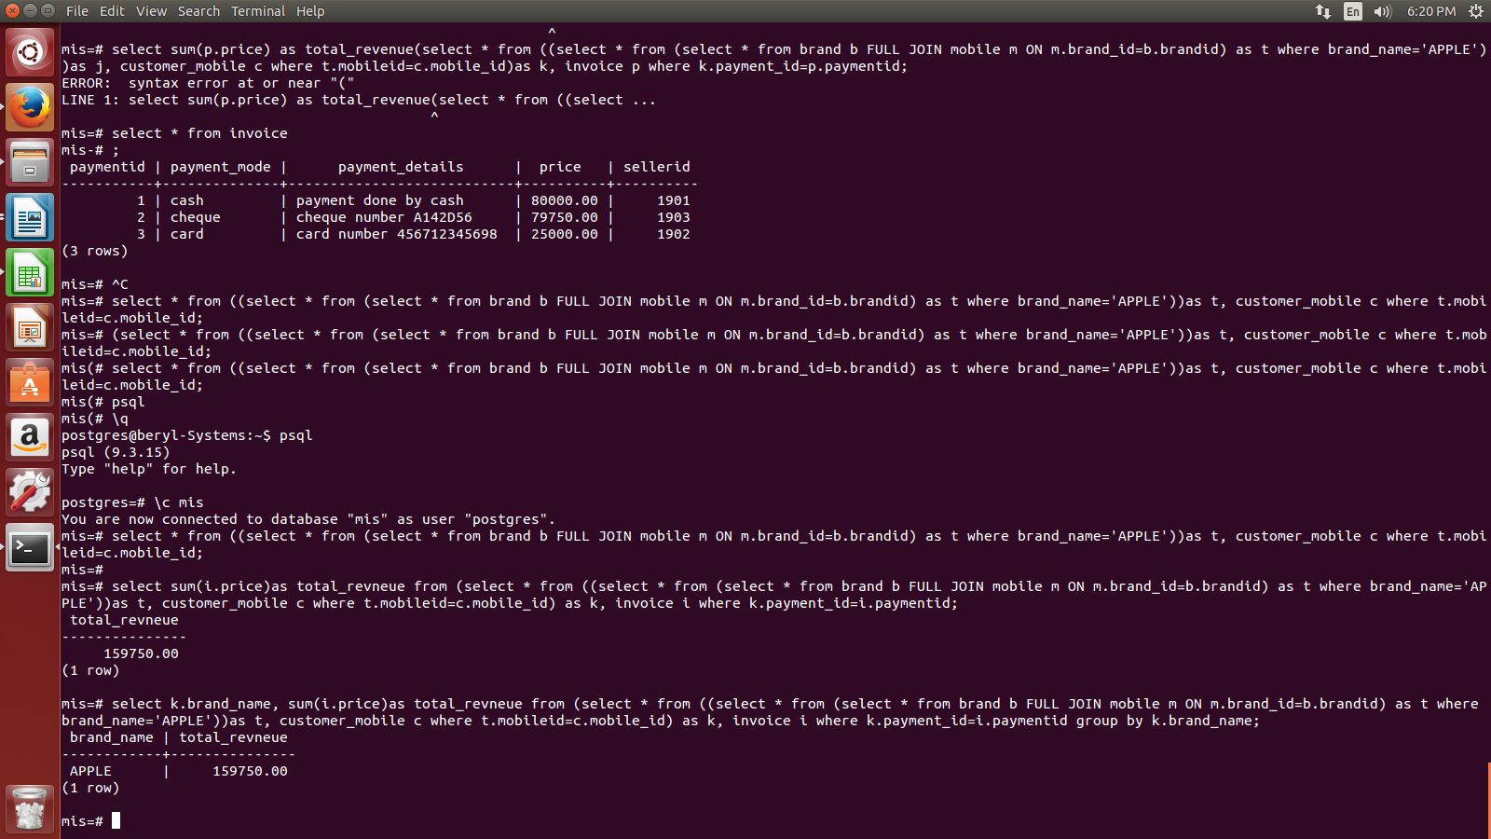
GROUP BY k.brand_name;

- Write a query to get imei code, payment details, selling date of buyer ajay.

SELECT buyer_name, payment_details,selling_date
FROM (SELECT *
FROM (SELECT *
FROM(SELECT *
FROM buyer
WHERE buyer_name='Ajay')
AS k, customer_mobile c
WHERE k.buyer_id=c.buyer_id)AS m, seller s
WHERE s.seller_id=m.seller_id)AS j, invoice i
WHERE j.payment_id=i.paymentid;



