PostgreSQL BASICS

- Write a query to check the version of postgres.

SELECT Version();
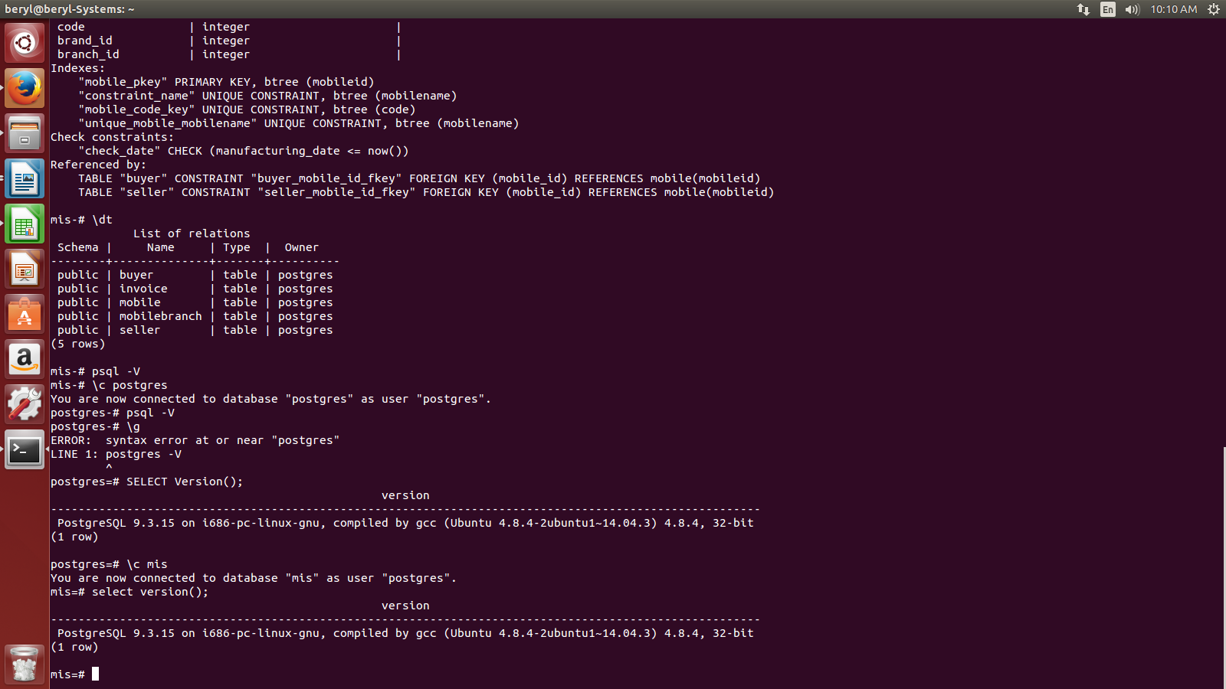

- How to drop column from a table.

ALTER TABLE <table_name> DROP <column_name> WHERE <condition>;

- Add not null constraint using alter command

ALTER TABLE <table_name> ALTER COLUMN <column_name> SET NOT NULL;

- extract and in command.

SELECT <fields>
FROM <tables>
WHERE EXTRACT(<month,year,date,hour,minute,sec> from <that_field>) IN (<value of date/month/ you want to see>) AND <conditions>
GROUP BY <fiedlname>;

e.g.,

SELECT b.brand_name, count(mobileid) AS sale_in_october
FROM mobile m, brand b
WHERE extract(month from manufacturing_date) IN (10) AND m.brand_id=b.brandid AND b.brand_name='APPLE'
GROUP BY b.brand_name;

