GitHub Basics

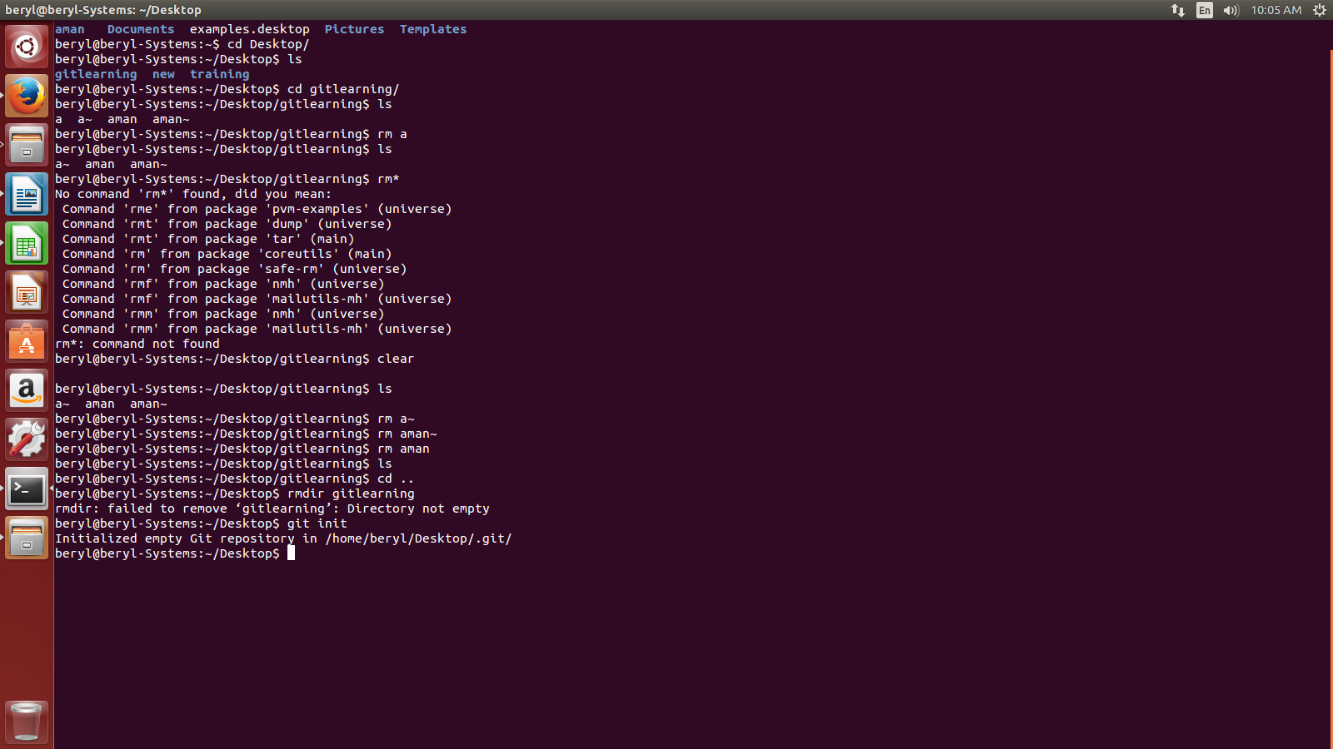
- Git initialization

- folder and file creation:-

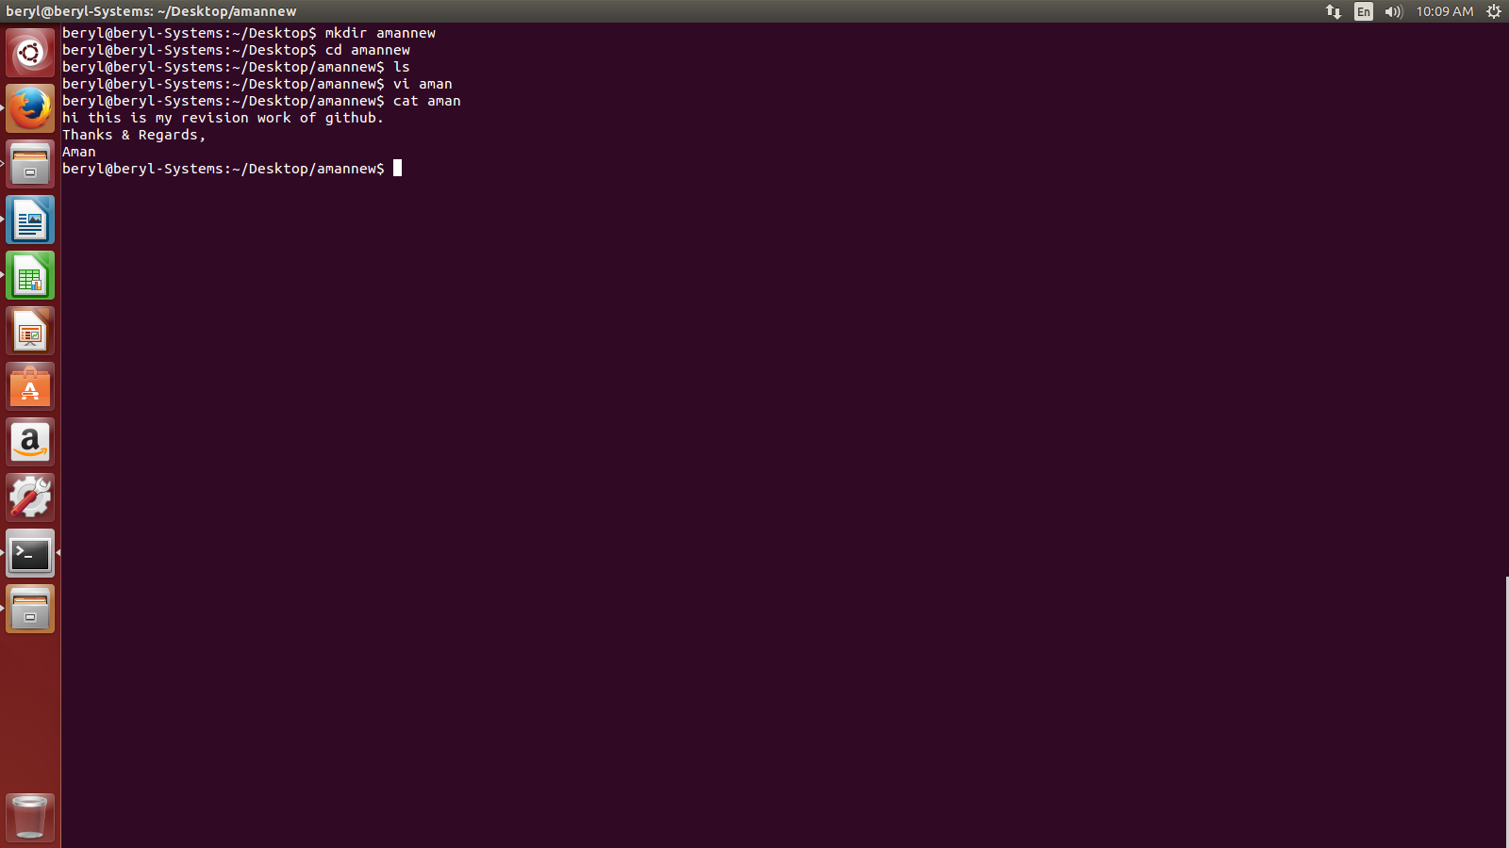
- Git add:-

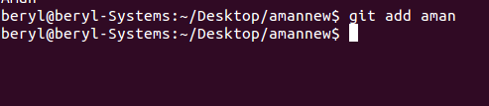

- Git status:-

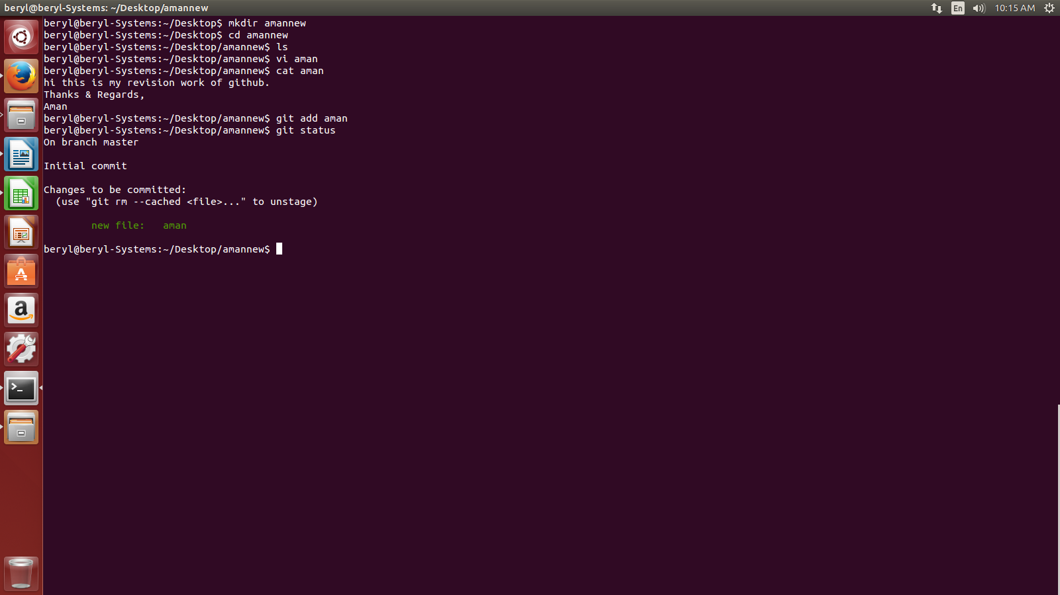

- Git commit:-
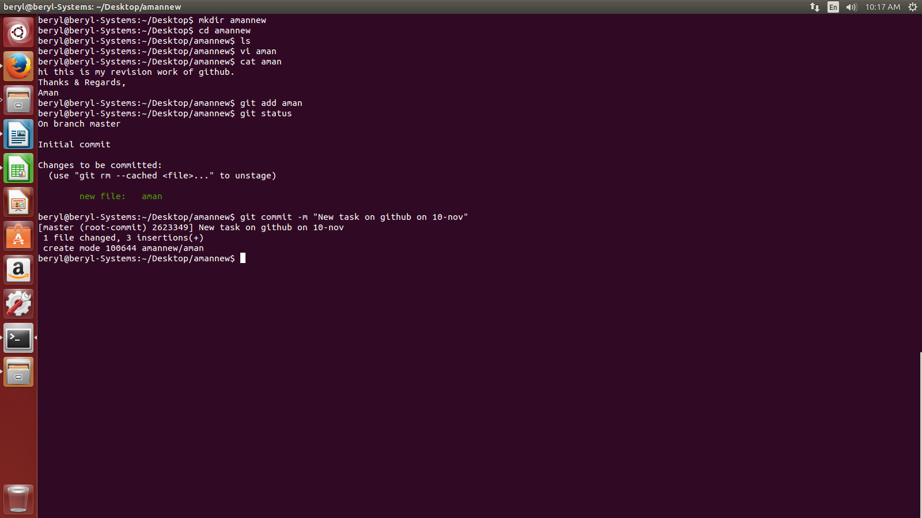

- Git remote origin(for the first time after creating and uploading data on repository):-

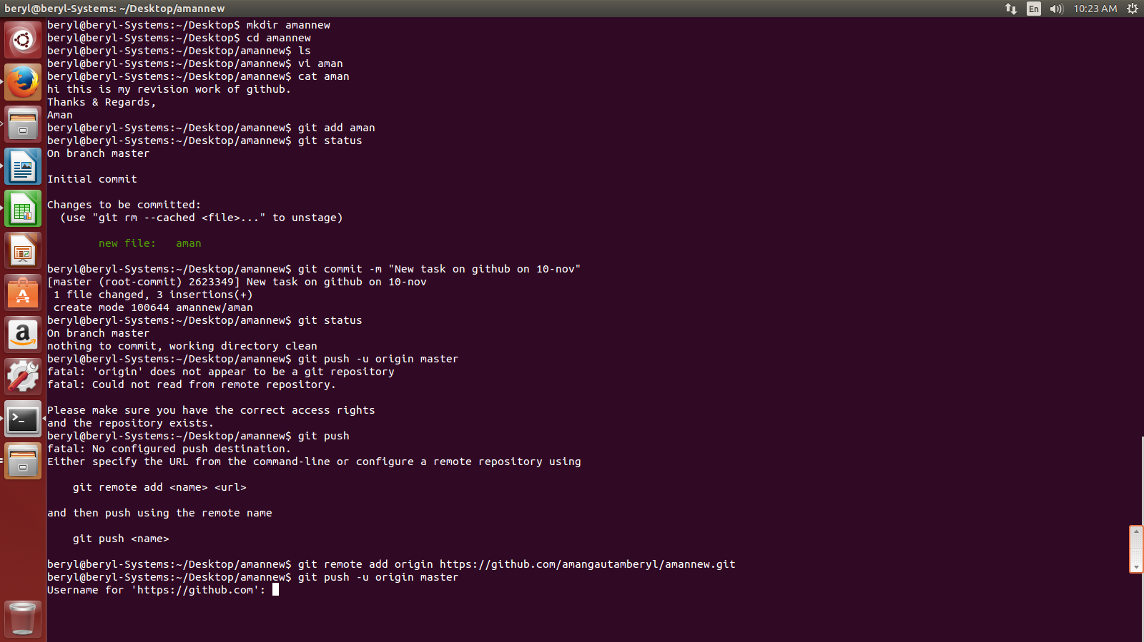

- git push:-

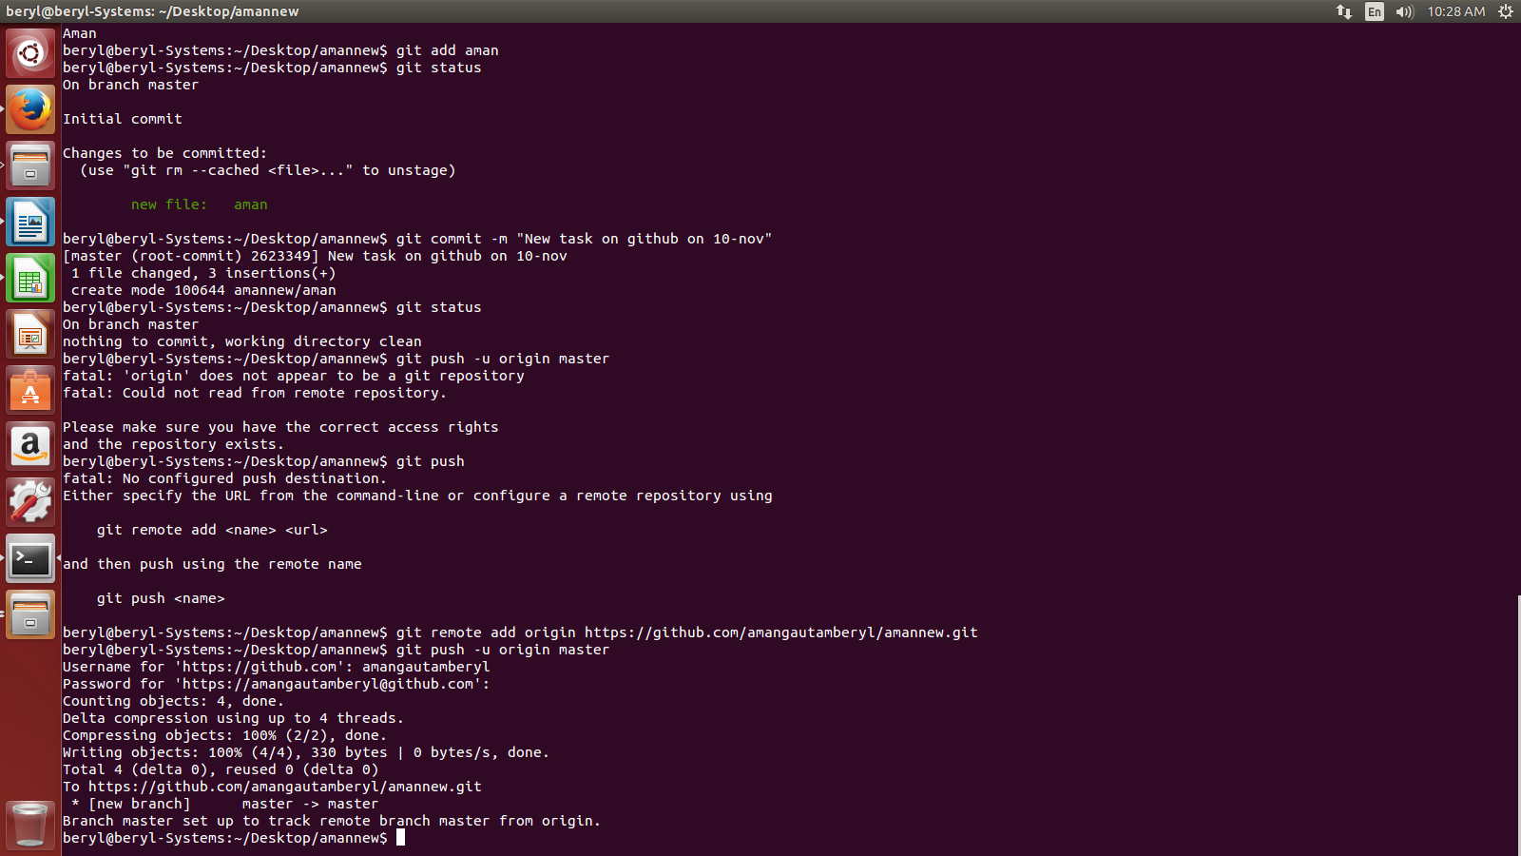

The above process will upload the file on our repository.

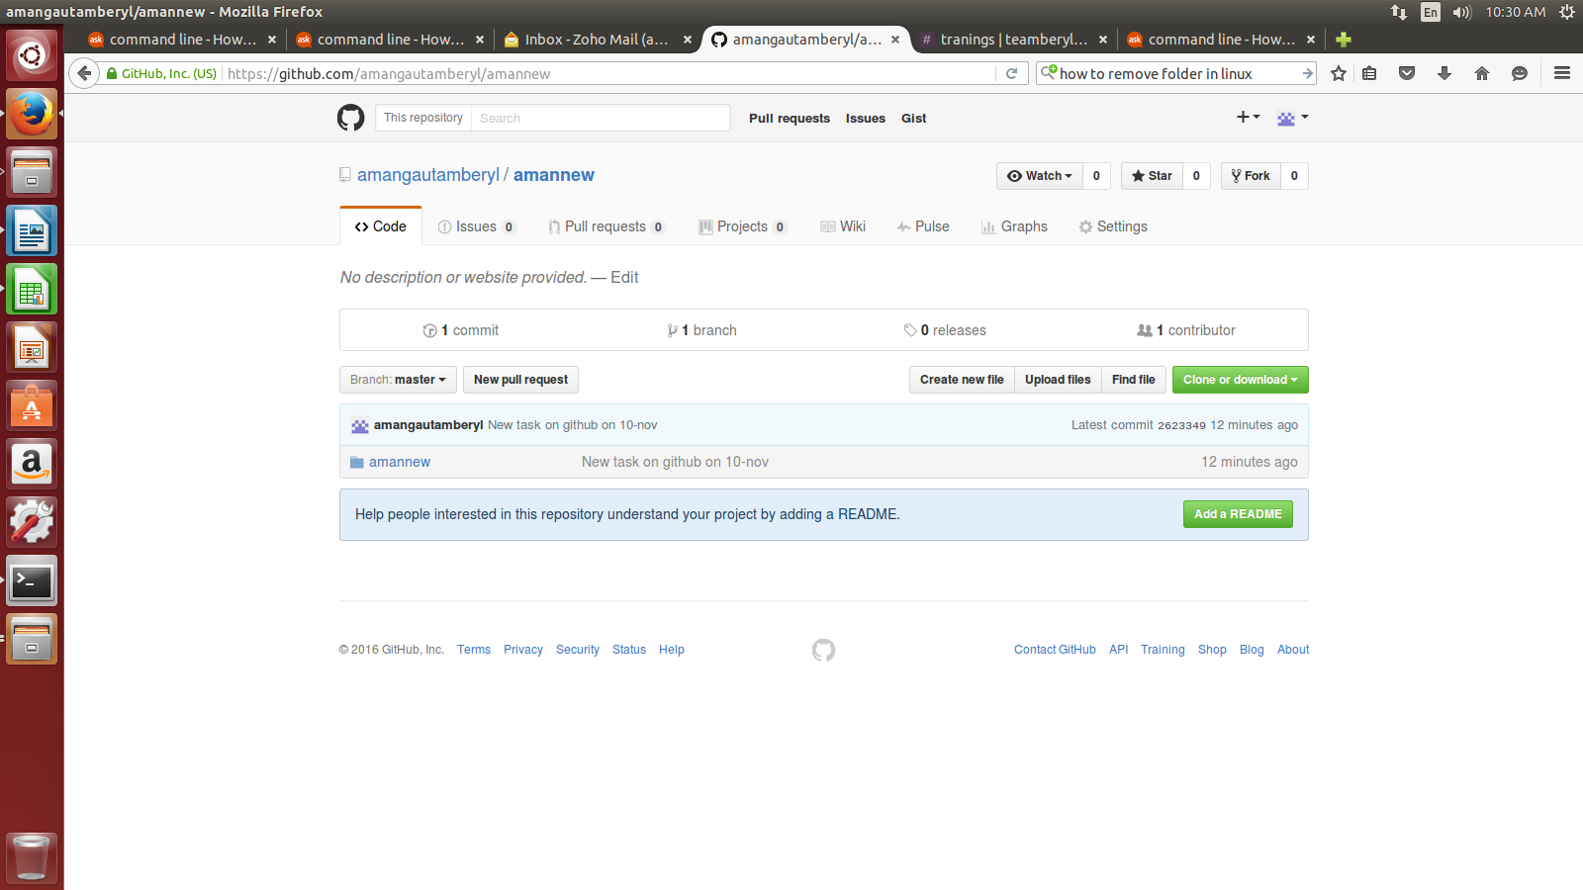

Now, to download it to some other pc we will use clone command.

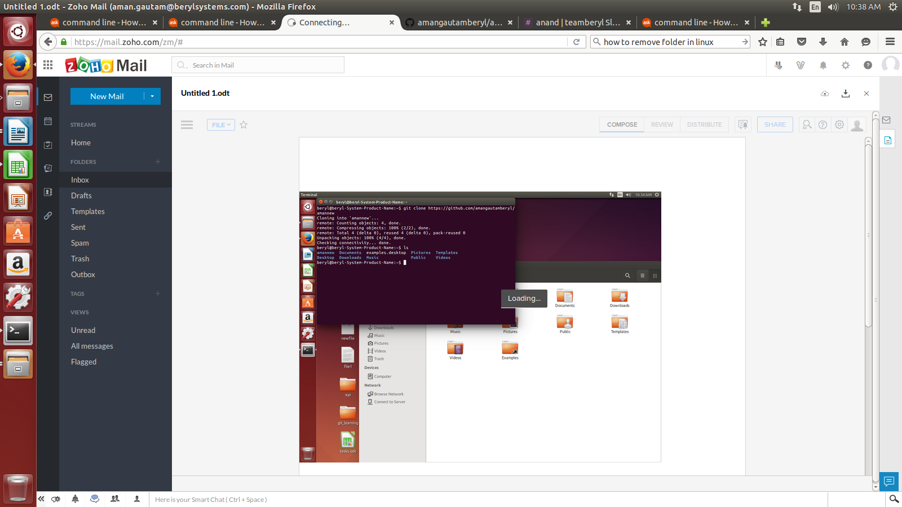

CREATE A NEW REPOSITORY (Training_and_learning) AND ADD THE RELEVANT FOLDERS TO IT

- Creating a repository
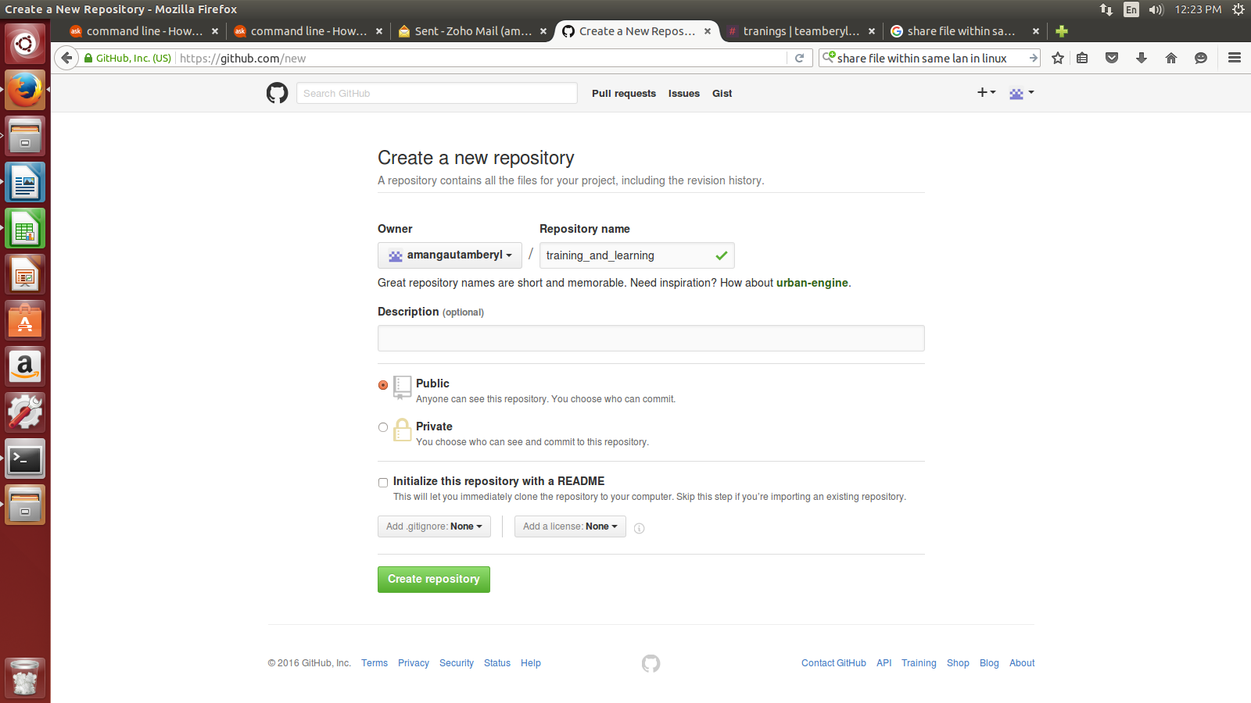

- Create a new folder on desktop naming training_and-learning
- Open terminal window
- Go the folder on you created and initialize git in it using git init.

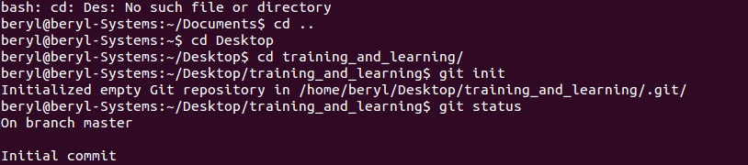

- Now add the file you want to add to repository
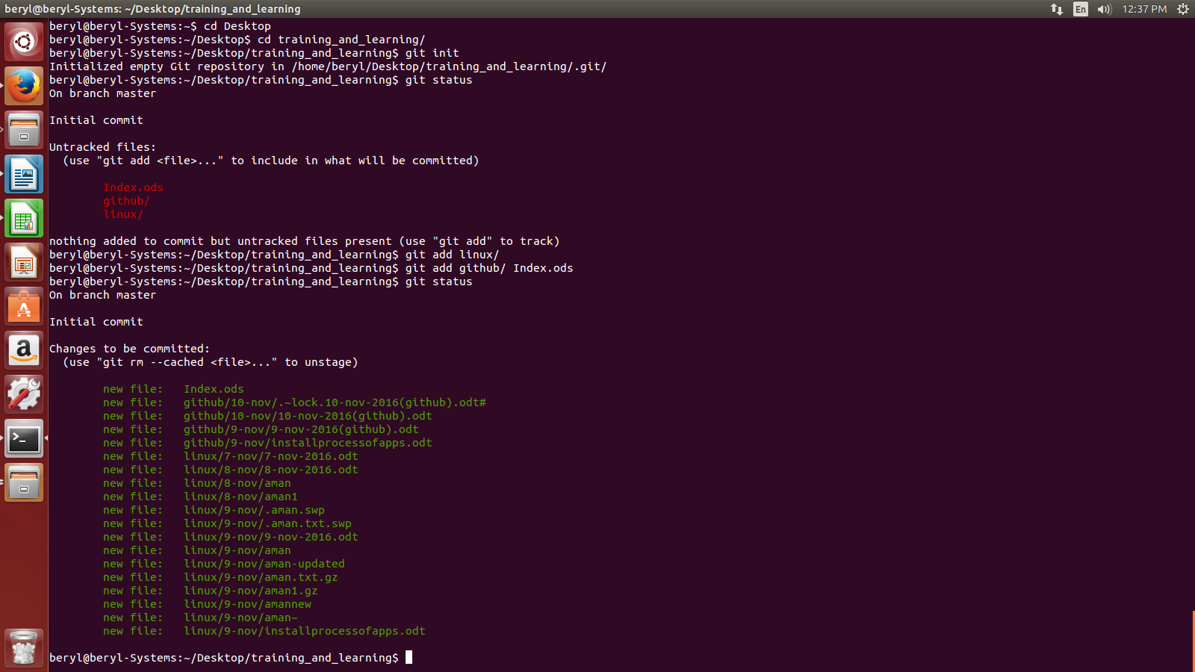
- Use git commit to commit the changes you want.

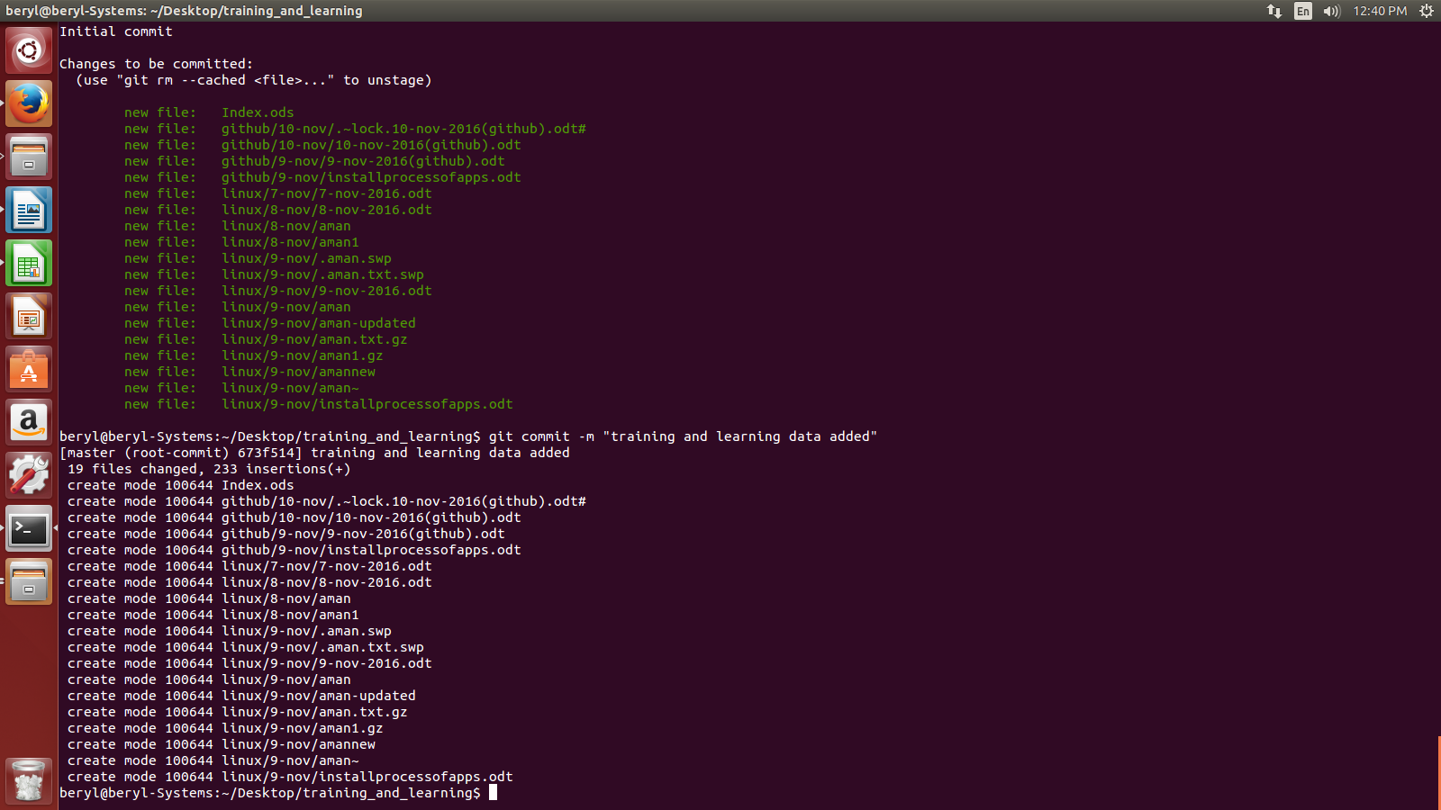

- Use git remote command to add a new remote name. To add a new remote, use the git remote add command on the terminal, in the directory your repository is stored at. The git remote add command takes two arguments: A remote name, for example, origin.

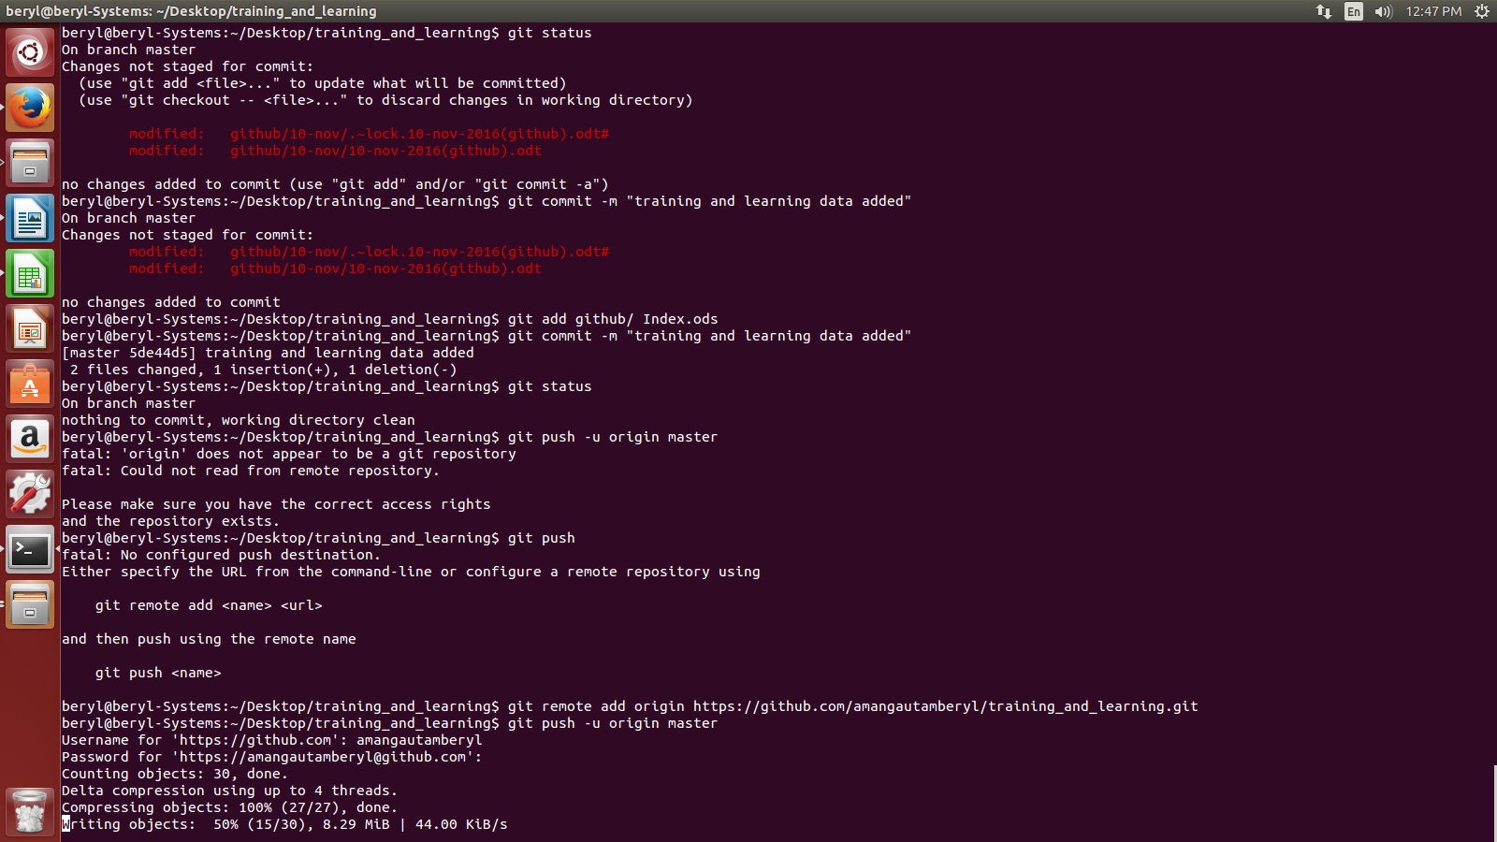

- Now push your data to your repository.
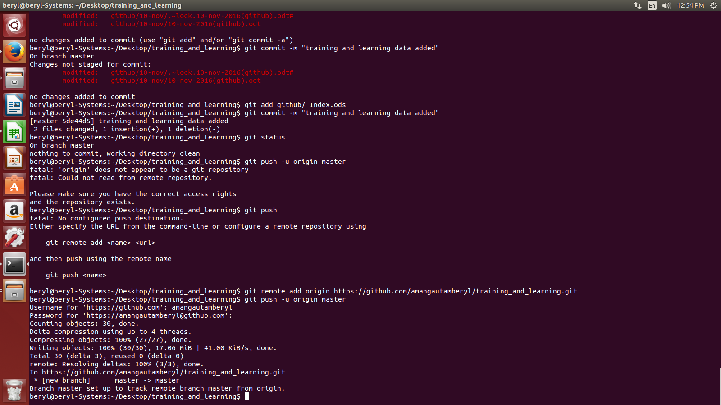

Task-

Commit multiple files at a time and adding multiple files.

