HTML BASICS

- What are the steps to install notepadqq in linux?

The steps to install notepadqq in linux are:-

  - sudo add-apt-repository ppa:notepadqq-team/notepadqq
  - sudo apt-get update
  - sudo apt-get install notepadqq

- What is HTML?

HTML stands for Hyper Text Markup Language. It is a standard markup language used for creating web pages. HTML elements are represented by tags. Browser does not display html code but use it to render web page.

- What is the syntax of creating html document?

<!DOCTYPE html> //defines document to be html5
<html> //root element of html page
<head> //meta inf. About document
<title> //title for document
Webpage title
</title>
</head>
<body> //visible page content
Webpage content
</body>
</html>

- What are html tags and HTML page structure?

HTML tags are element names surrounded by angular brackets:

Syntax:
<tag_name>content goes here</tag_name>

- Write a simple html code to print Aman World as title and content as welcome to the Aman World.

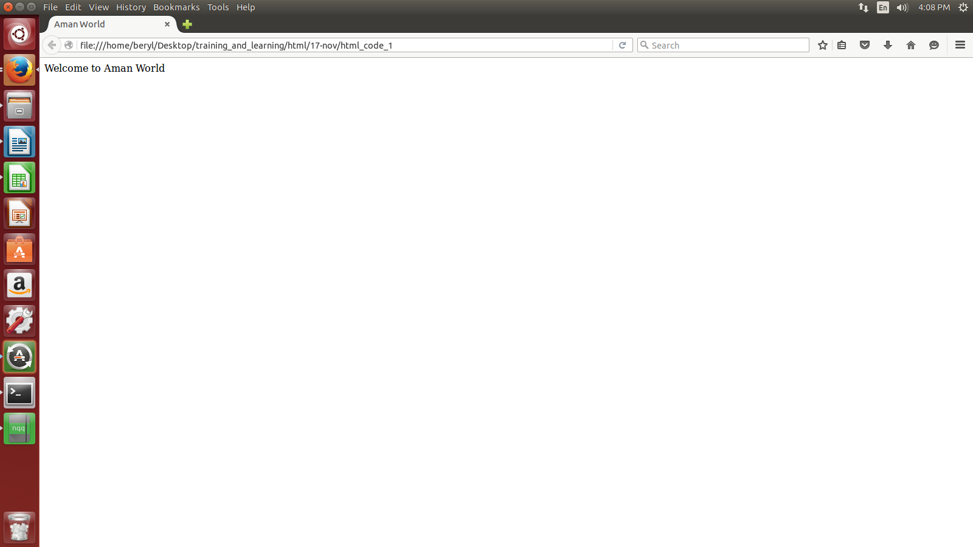

- What are the various html formatting tags.

The various html formatting tags are:-
    - bold- <b>.....</b>
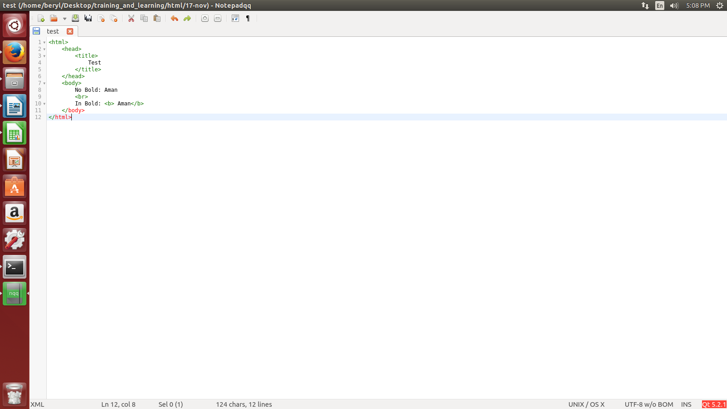
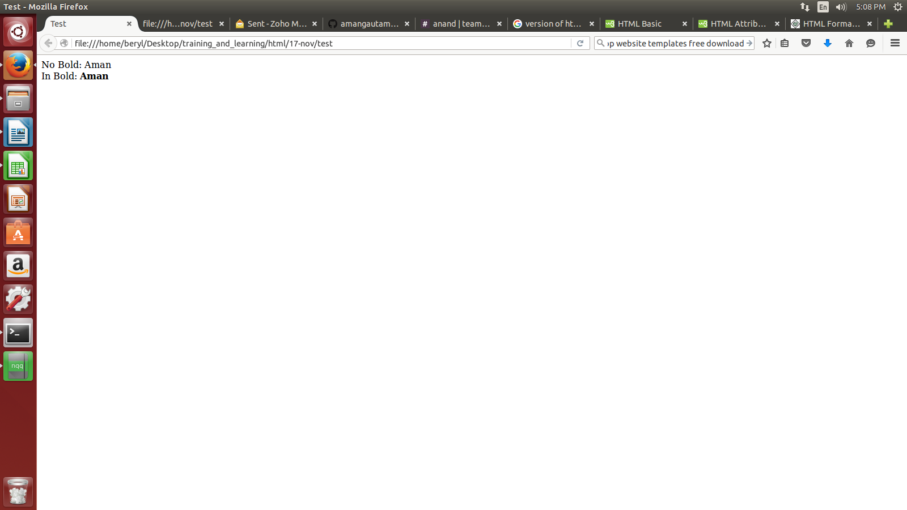

    - italics- <i>......</i>
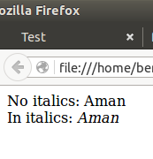
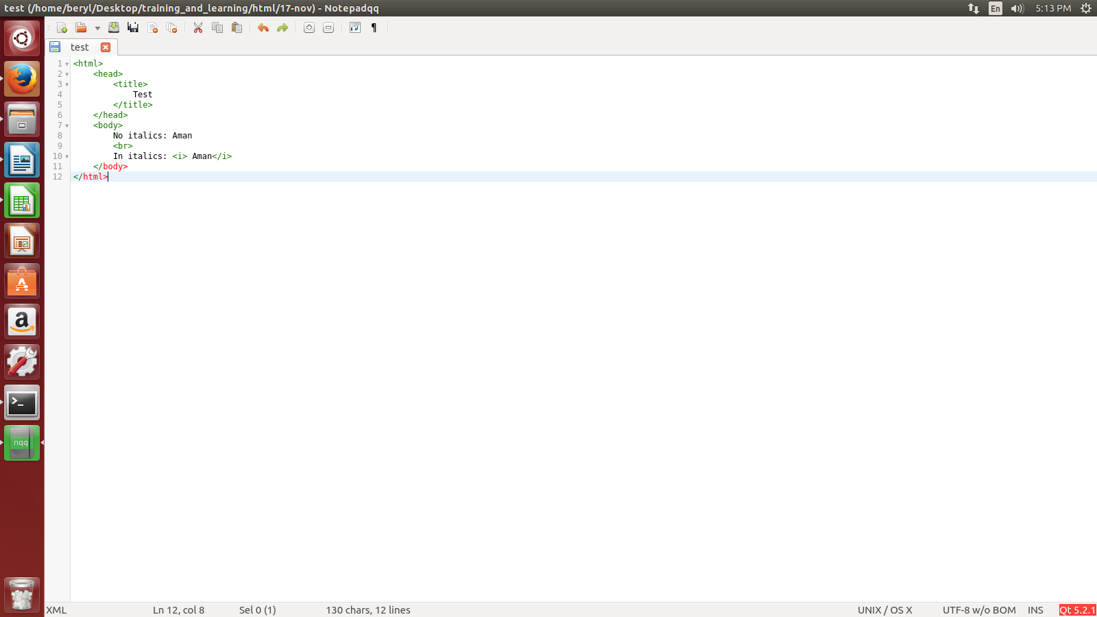

    - underline - <u>.....</u>
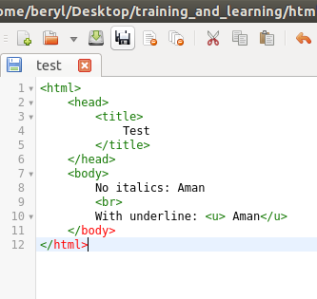
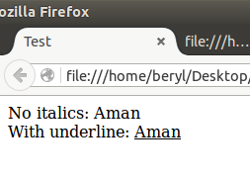

    - strike- <strike>........</strike>

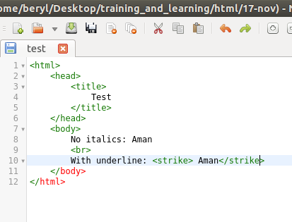
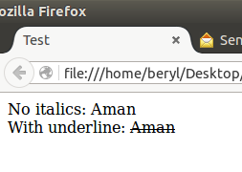

    - monospaced font
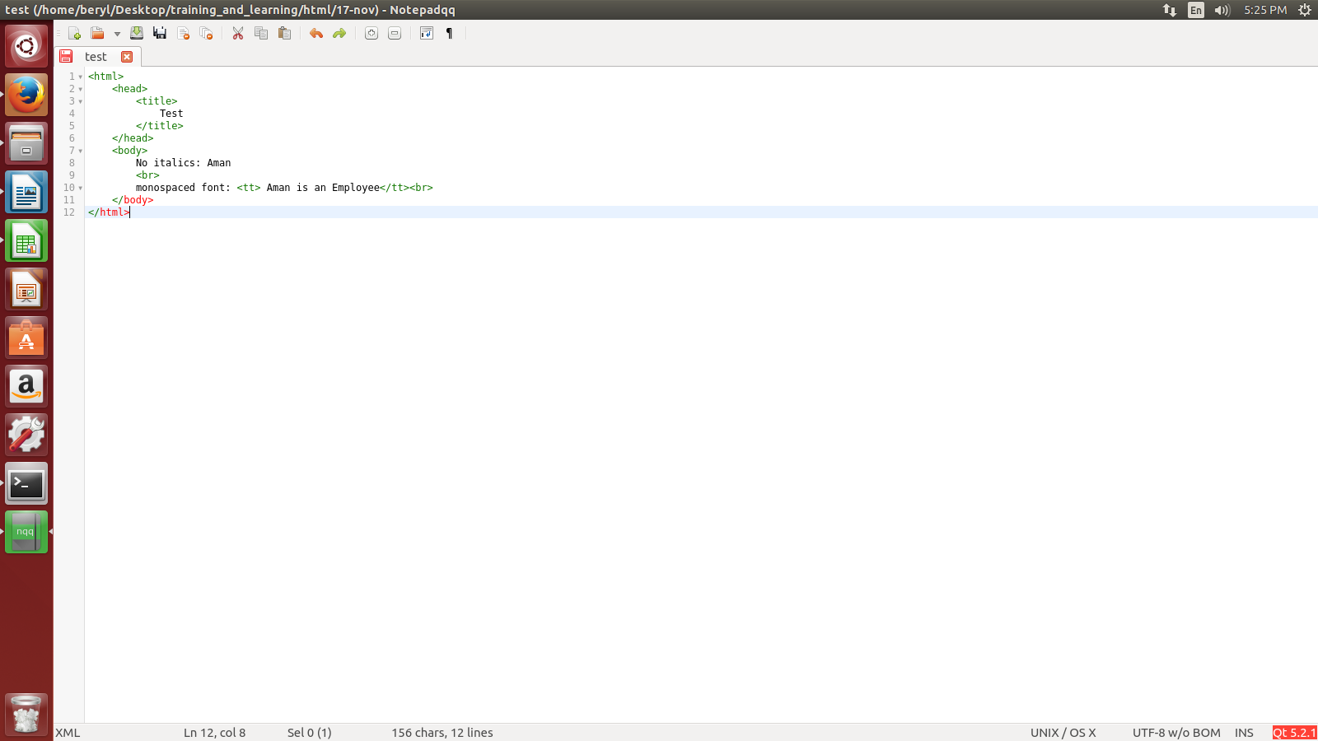
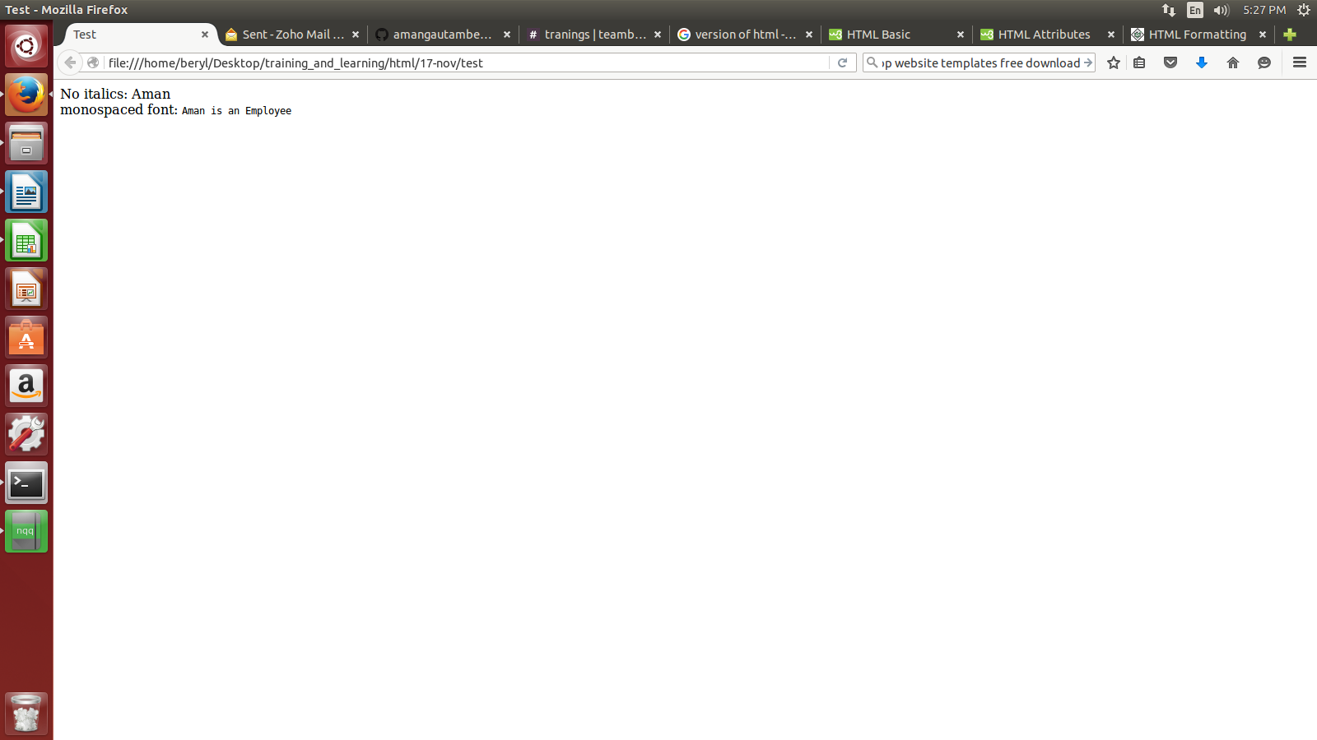

    - superscript:- <sup>......</sup>
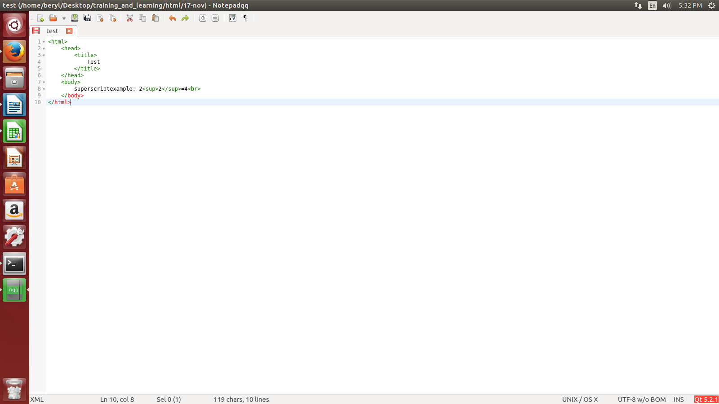
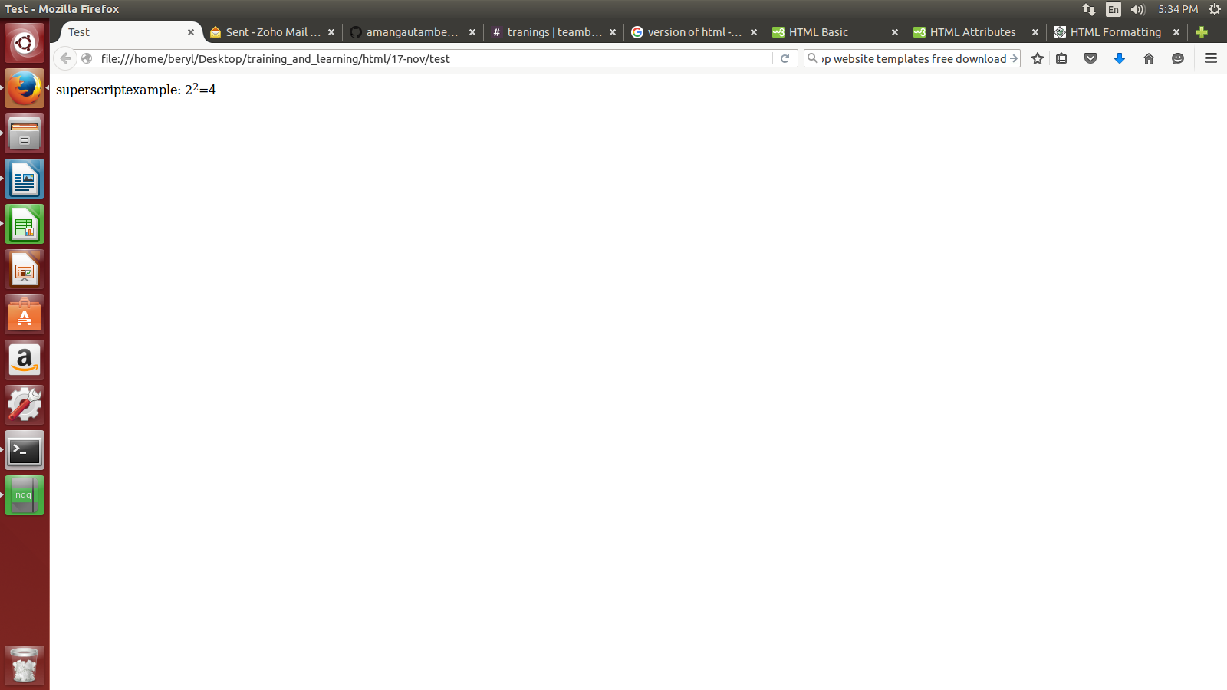

    - subscript: <sub>.......</sub>
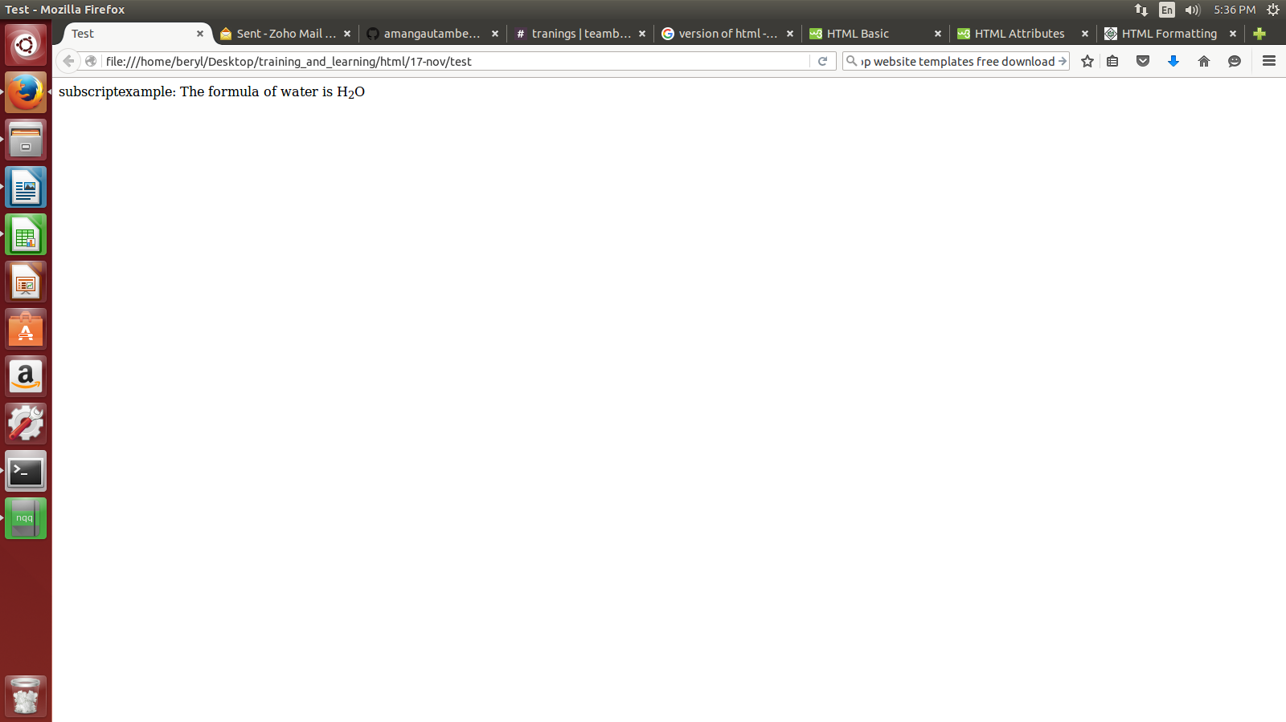
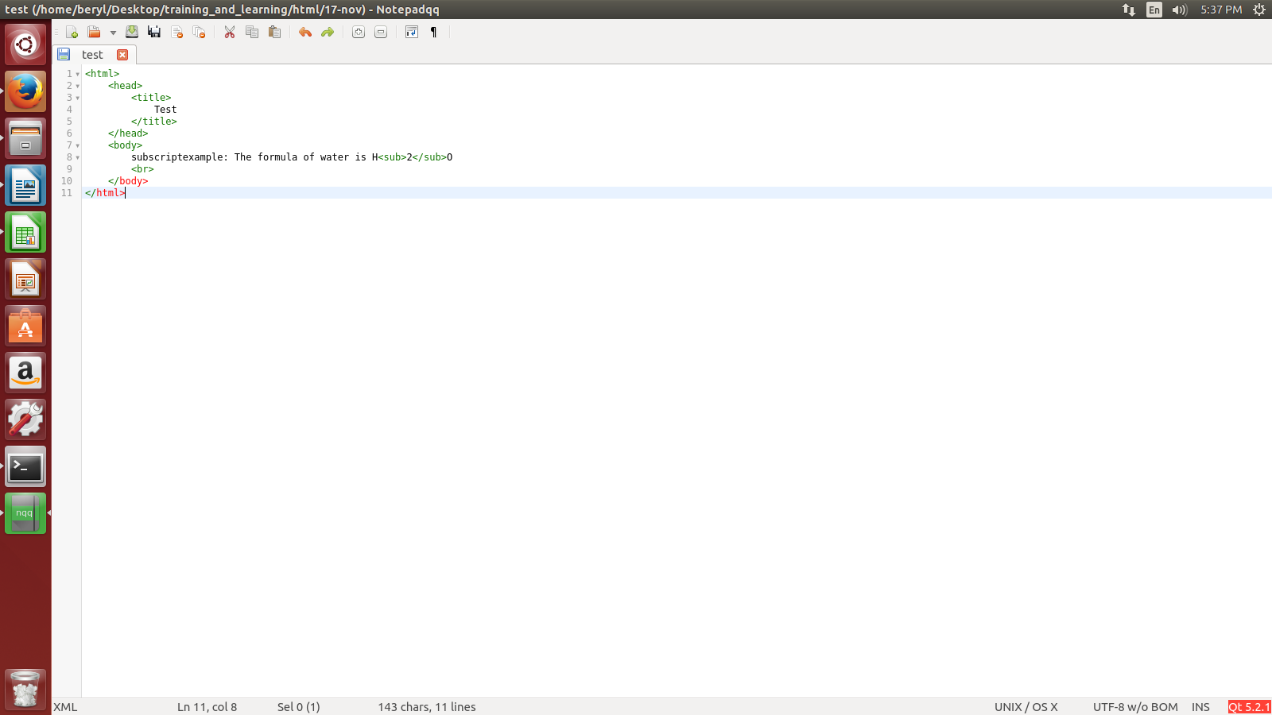

    - insert: <ins>.......</ins>

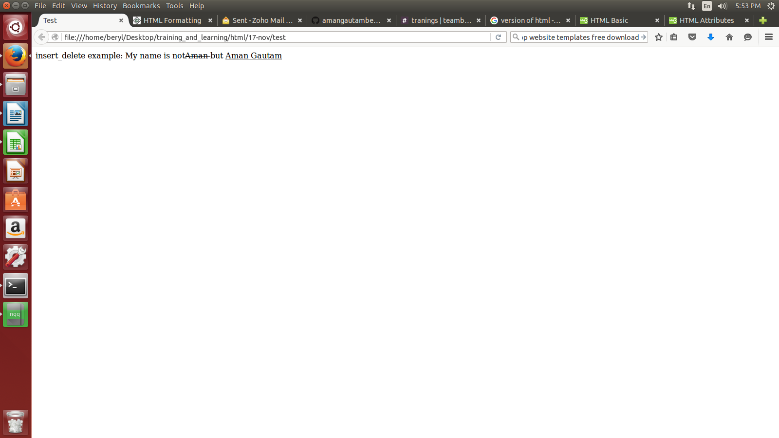
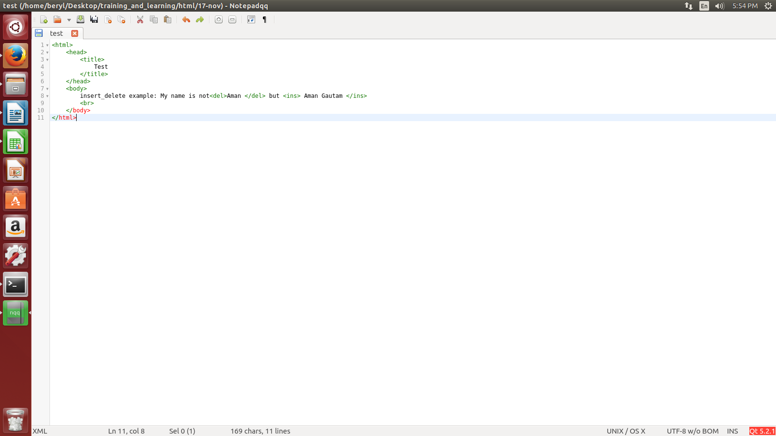

    - delete: <del>.......</del>
example same as above

    - larger: <big>...... </big>
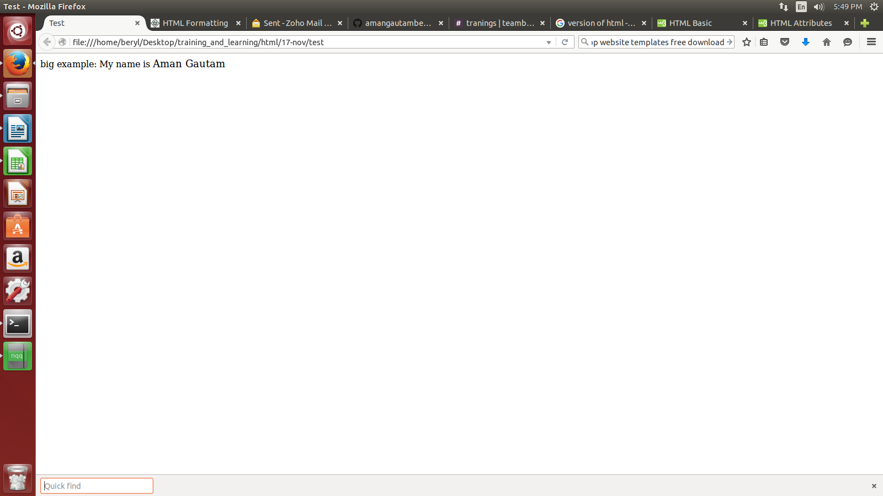
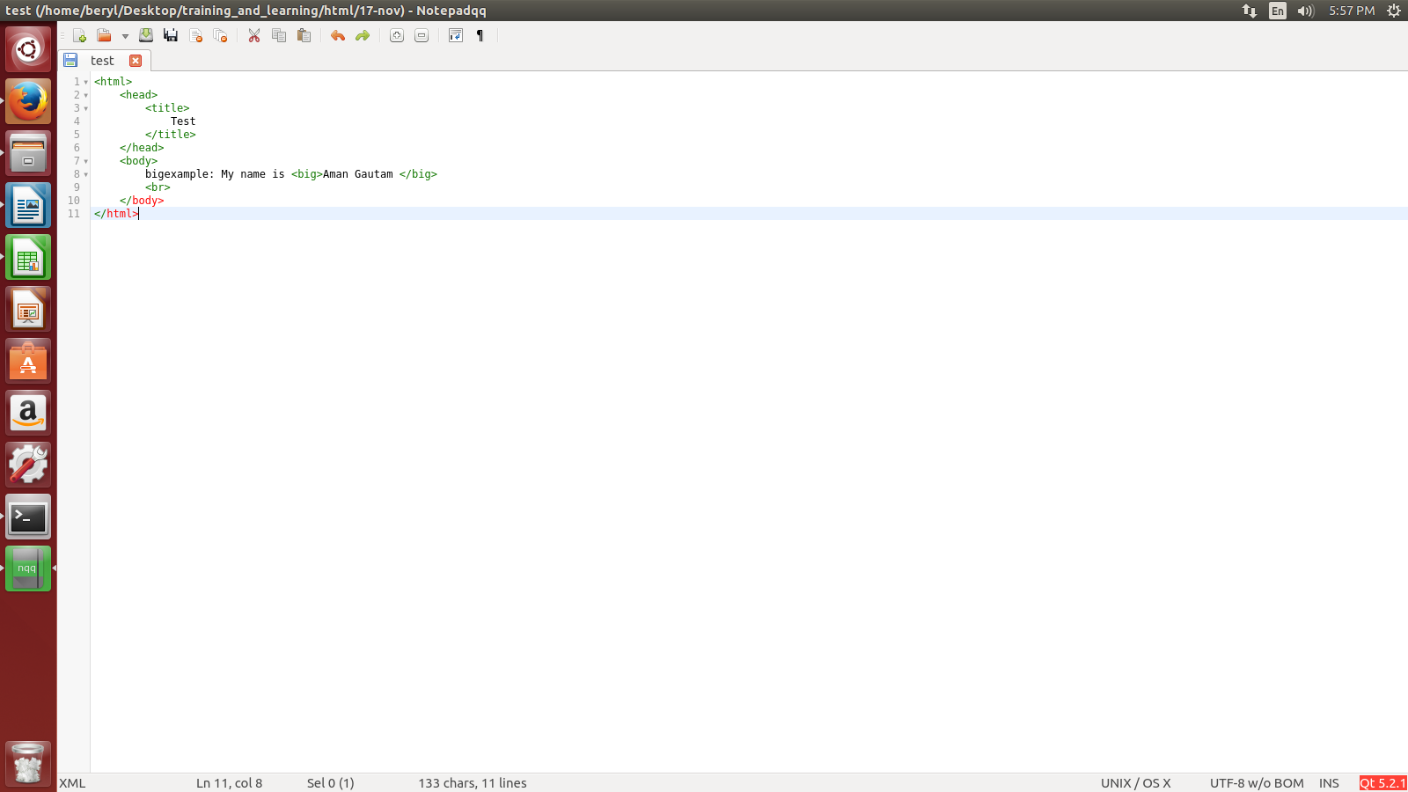

    - smaller: <small>.....</small>
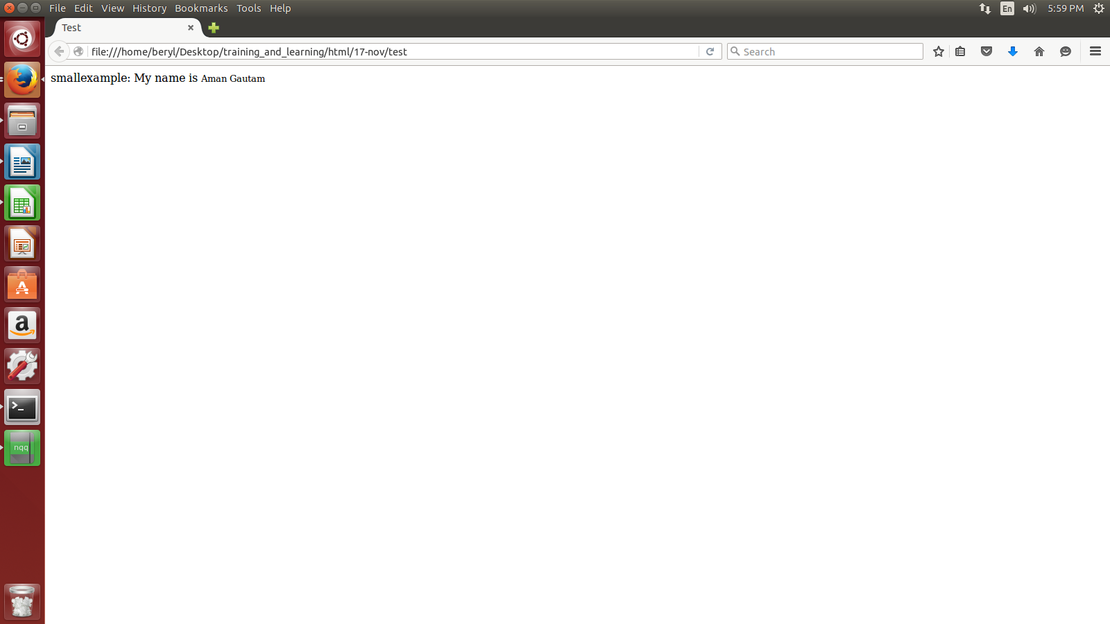
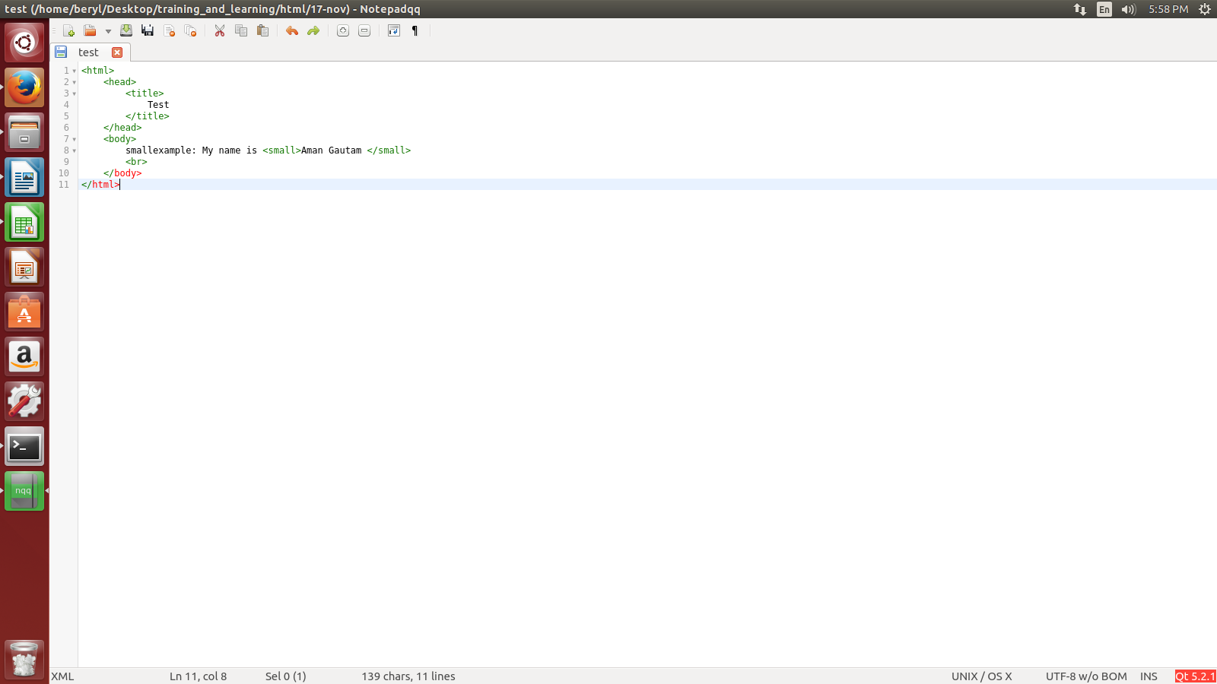

- What are the various html phrase tags.

The various html phrase tags are:-

  - emphasized:- <em>.......</em>
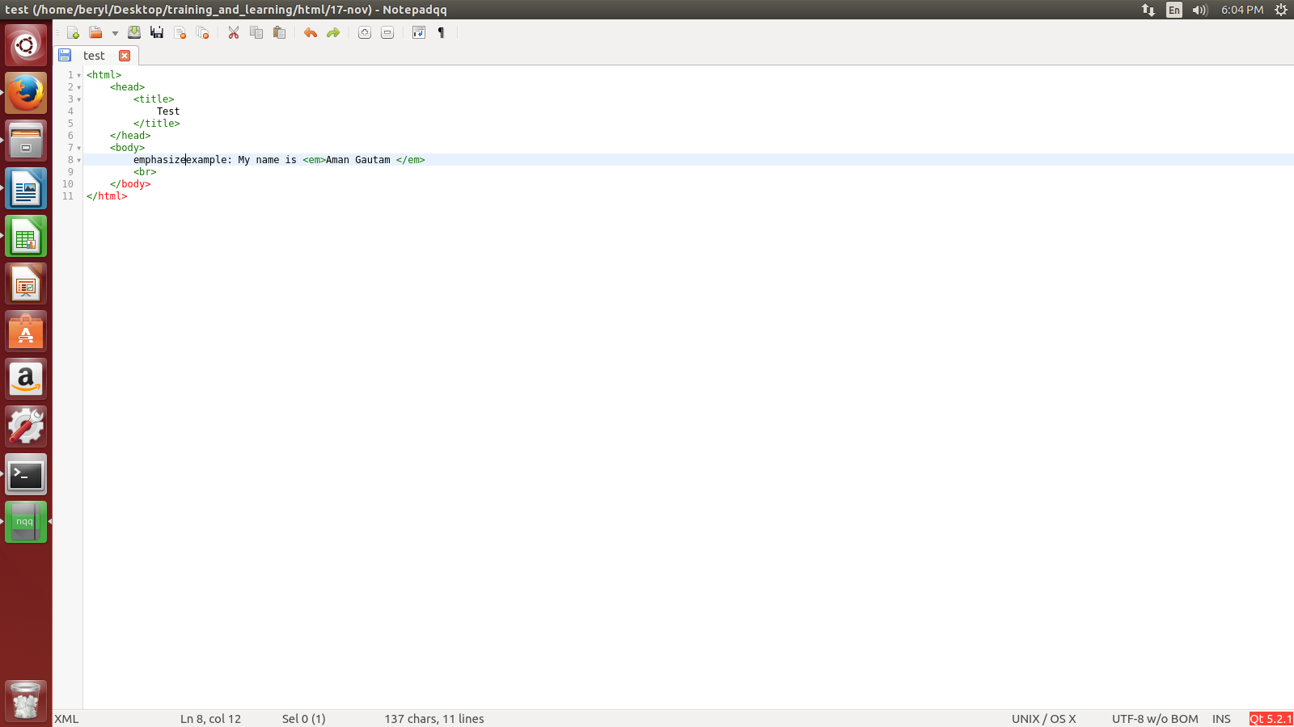
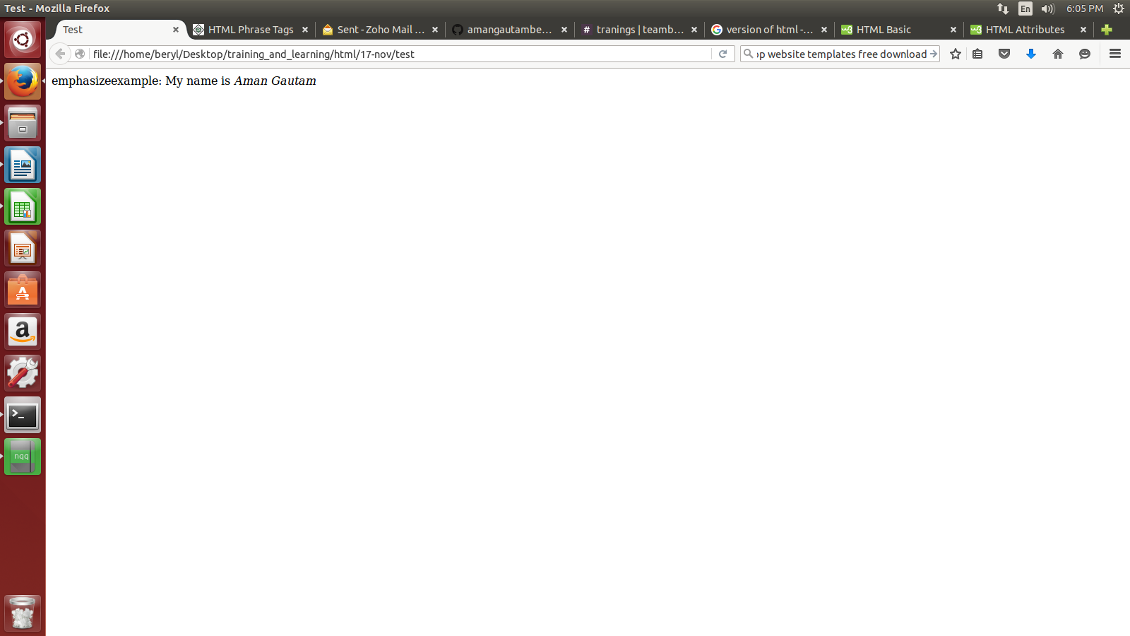

  - marked:- <marked>.........</marked>
  - strong:- <strong>.........</strong>
  - text abbrevation- display the abbrevation name and when we will drag our mouse over it then it will show its description.
Syntax:- <abbr title=”description”.>...

  - Acronym:-
  - text direction
  - special terms
  - quoting text
  - short quotation
  - text citation
  - computer code
  - keyboard text
  - program output
  - address text

