PostgreSQL BASICS

- Insert data into inventory of mobile table.

UPDATE mobile SET inventory=<value> WHERE=<mobile id>;

- Update inventory record whenever some payment is being made.

Inventory before sell:
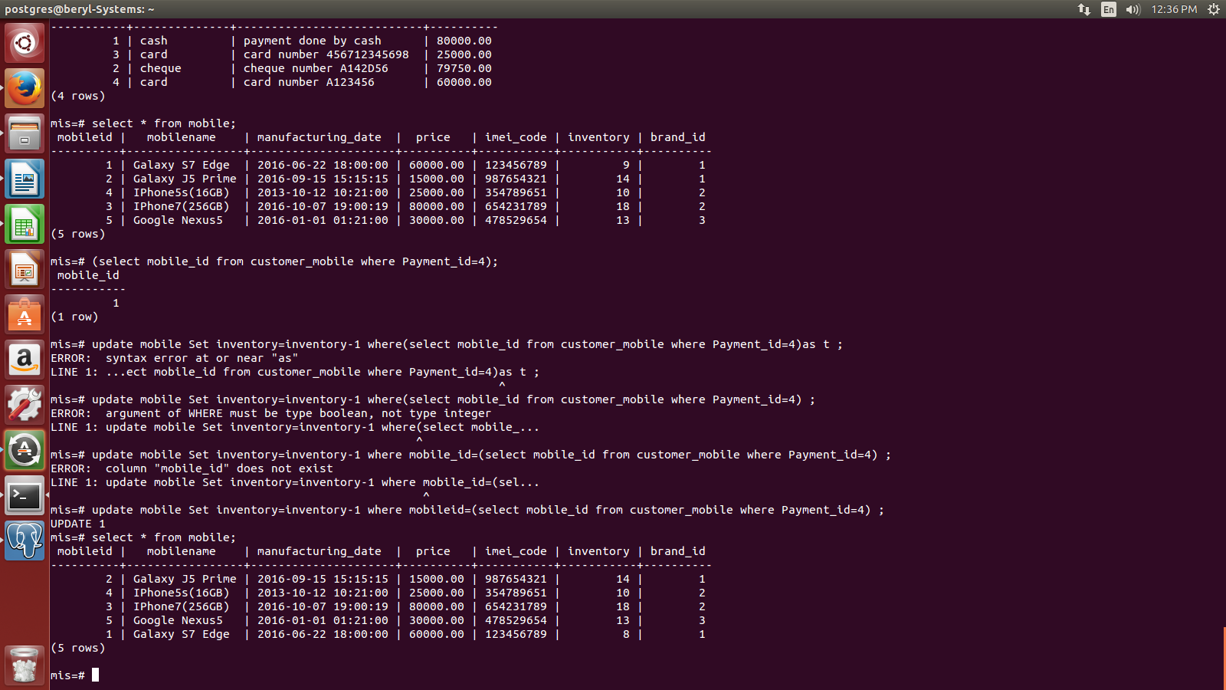
Inventory after selling mobile:

UPDATE
- Install pgadmin

enter sudo apt-get install pgadmin3

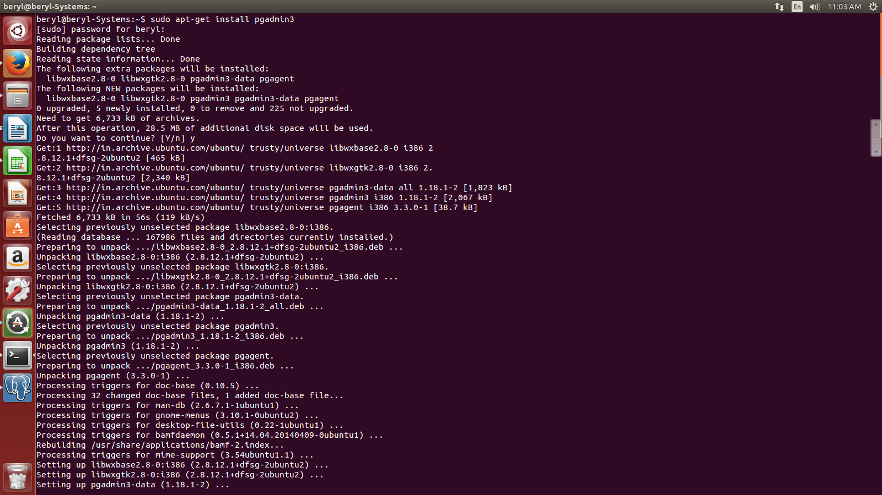
- configure postgres

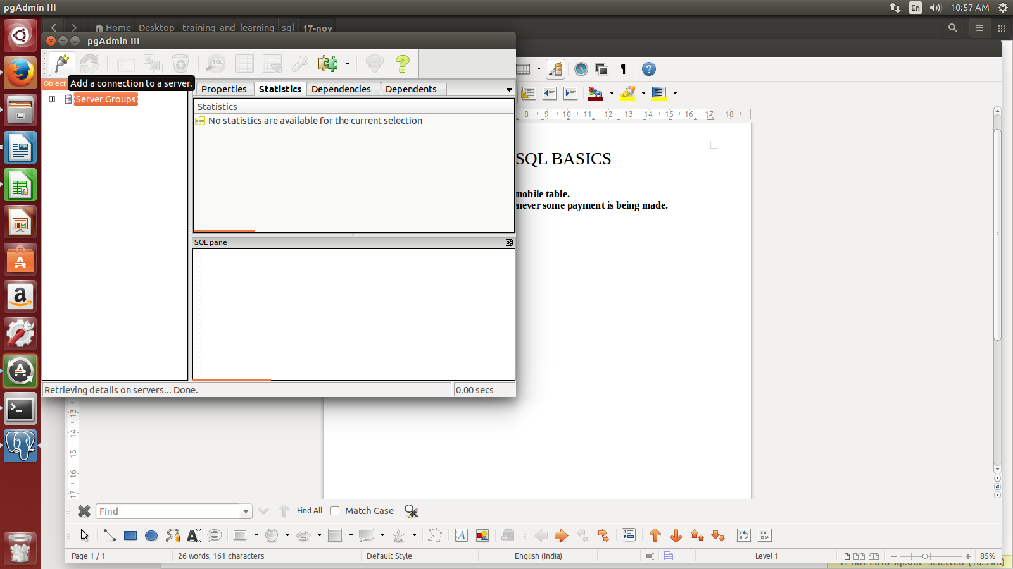
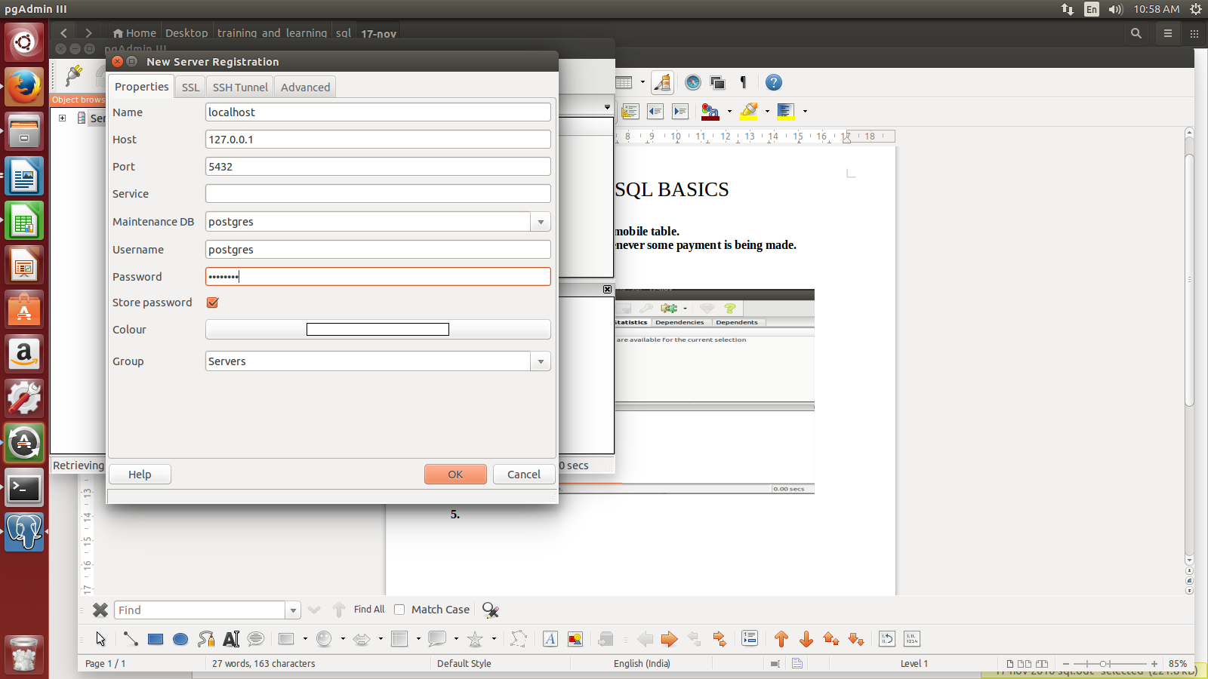
if all the details are correct it will show the databases inside server groups--> servers --> localhost(127.0.0.1)--> Databases--> (all databases)

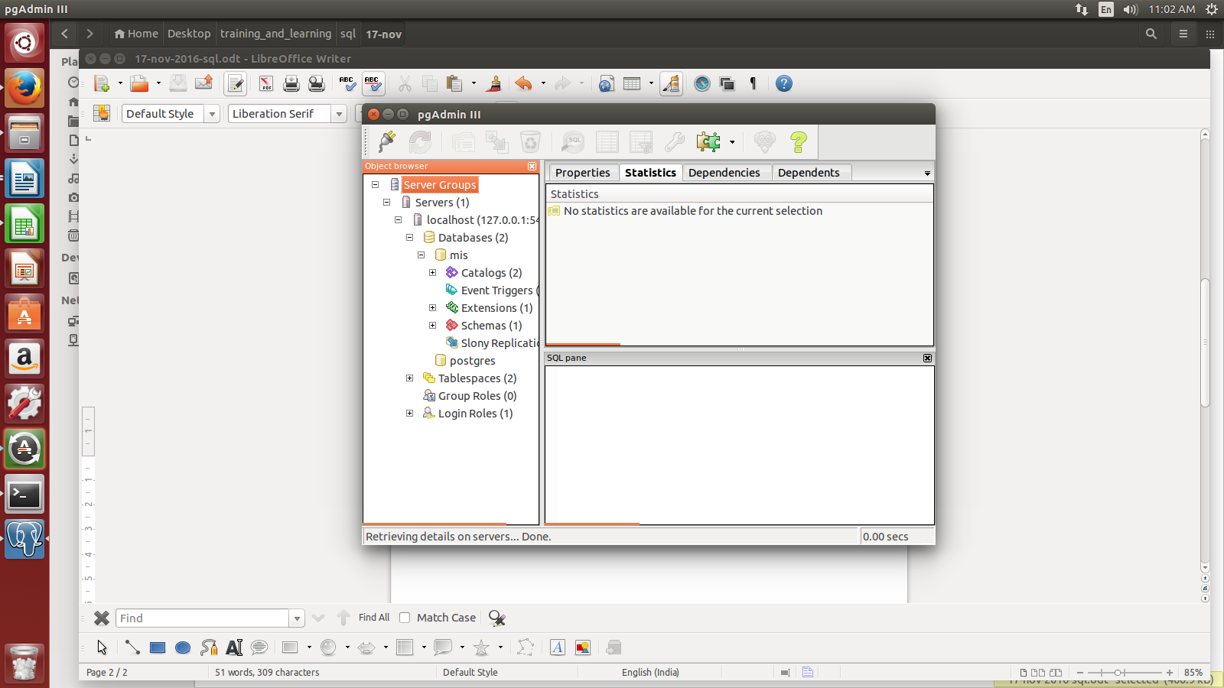

- Finalized table structure after alteration.

mobile table:
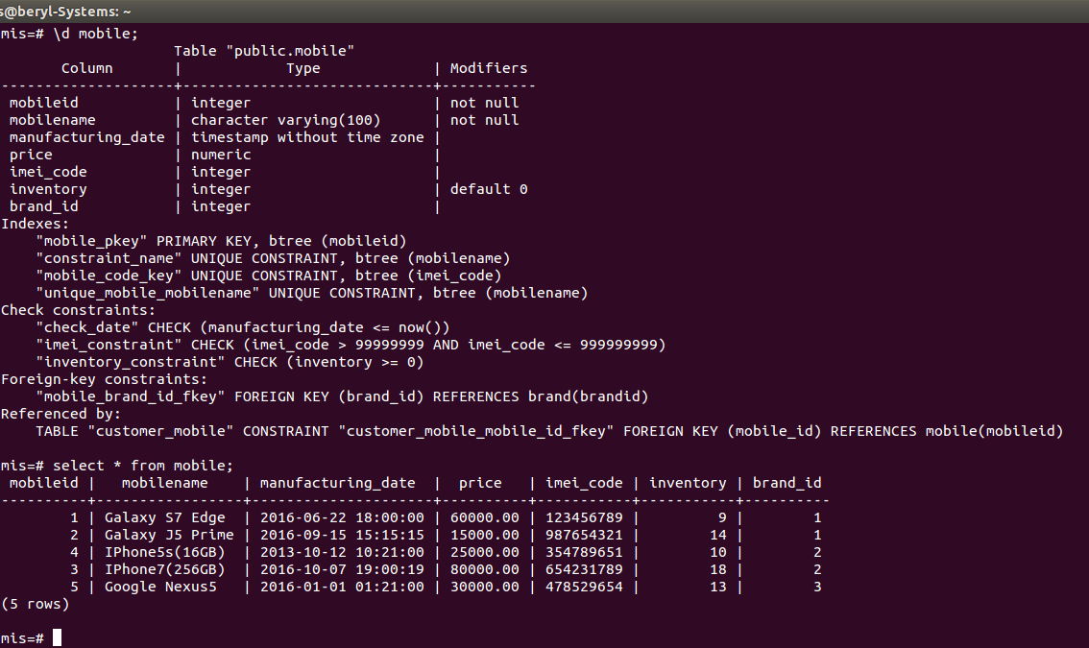

seller table:

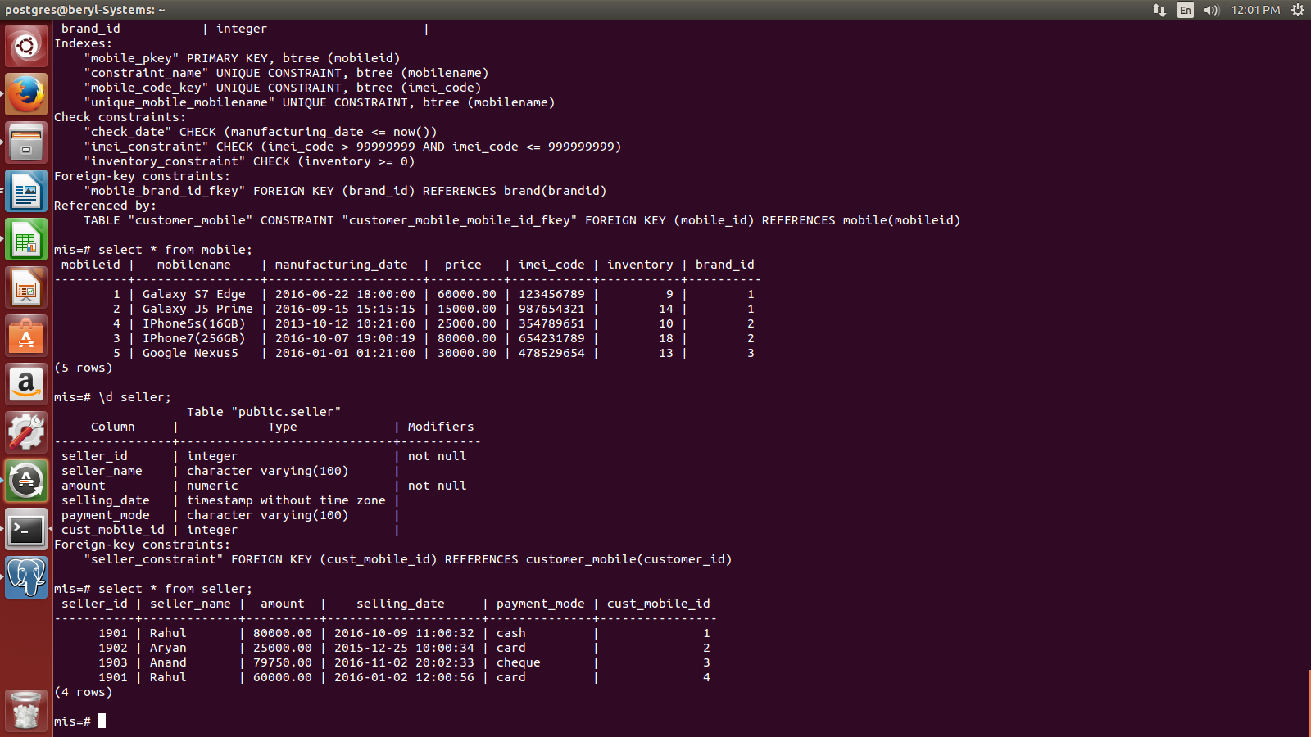

buyer table:
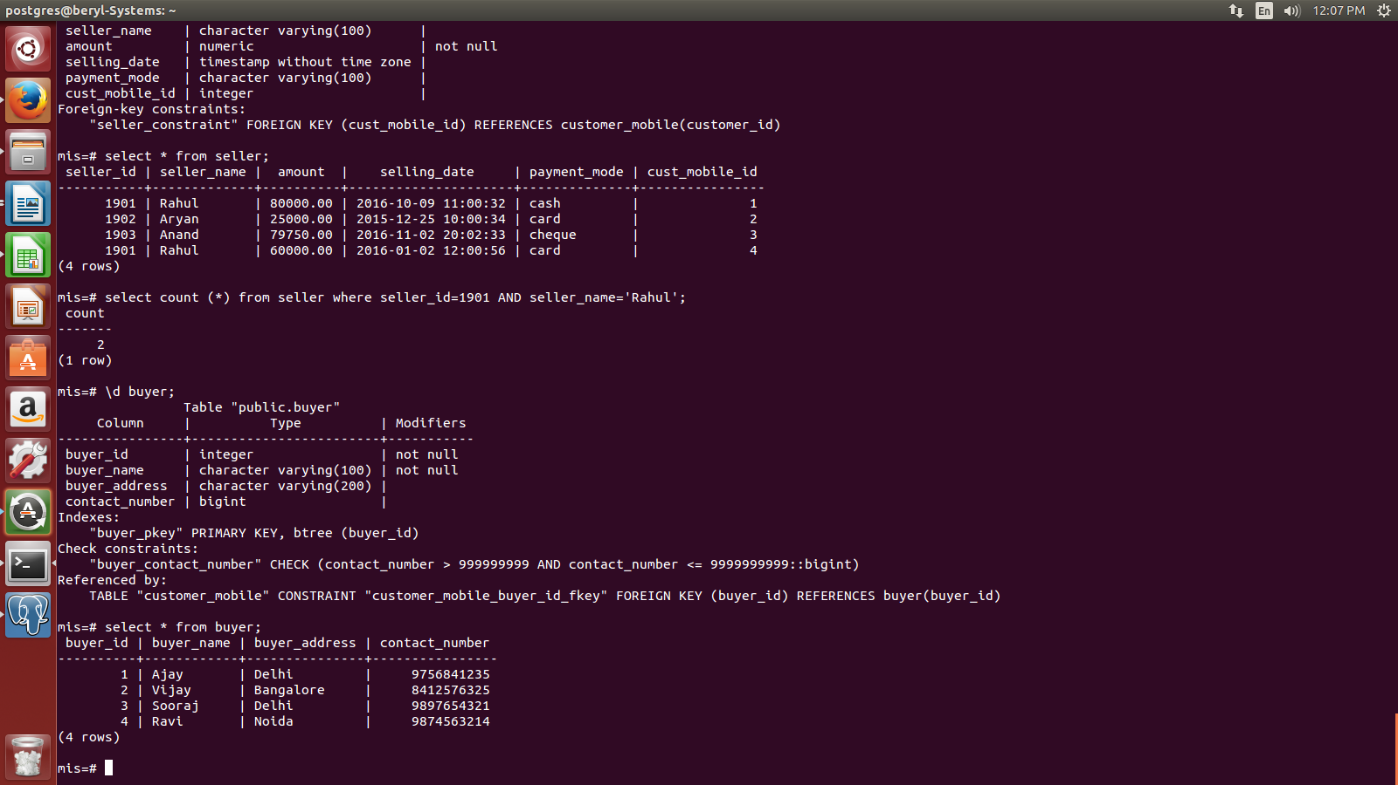
customer_mobile table:

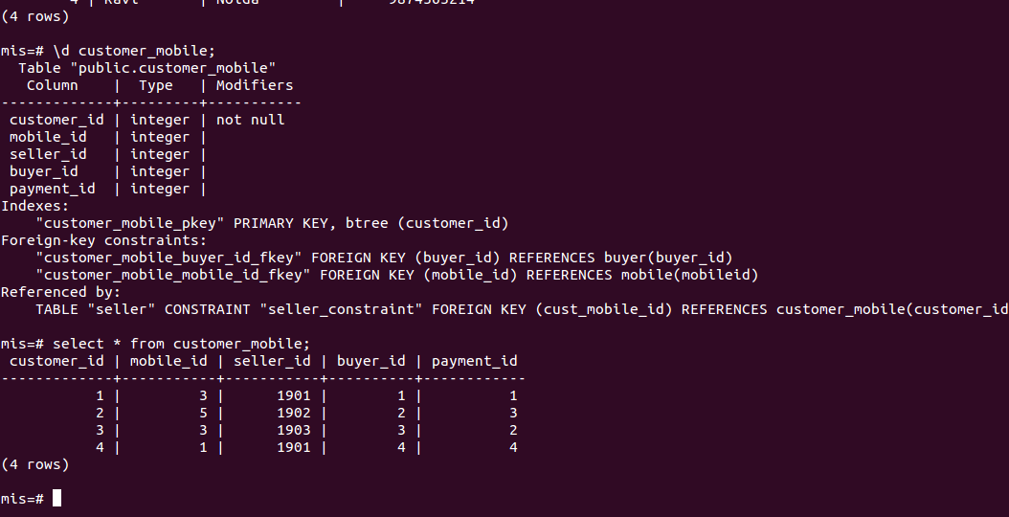

brand table:
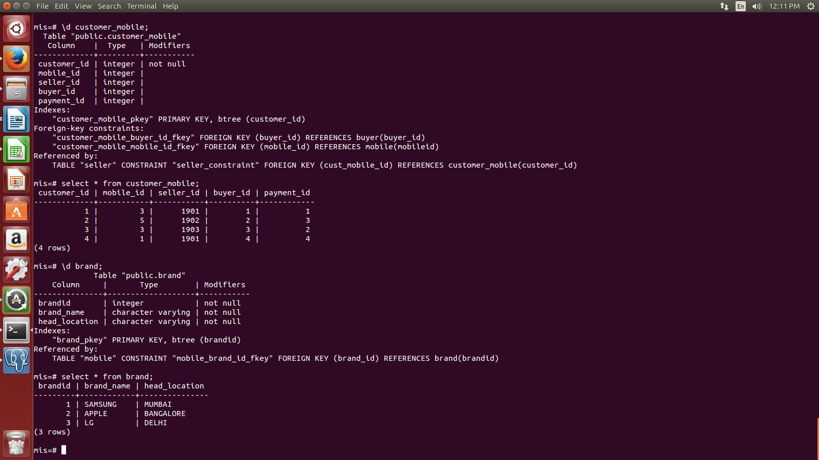

invoice table:

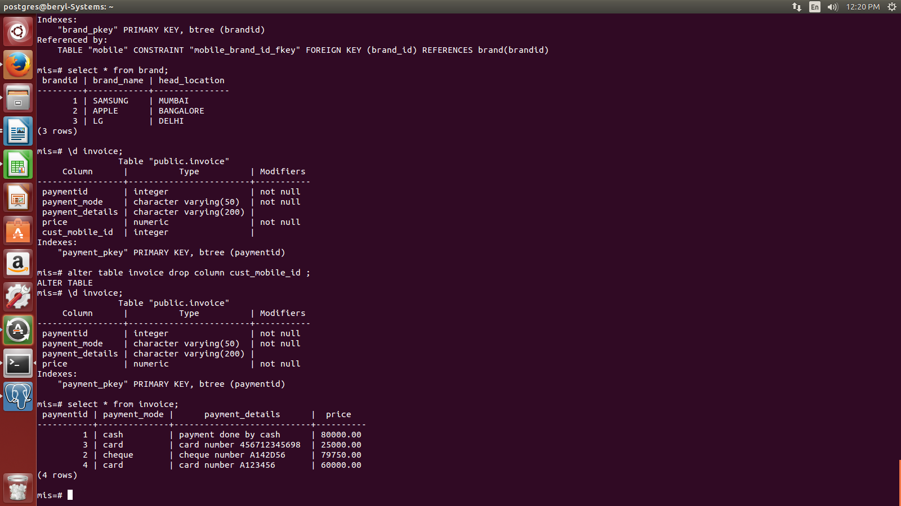
- Write a query to select total number of phones sold by seller Rahul.

SELECT seller_id,seller_name,count(*)
FROM seller
WHERE seller_name='Rahul' AND seller_id=1901 group by seller_id,seller_name;
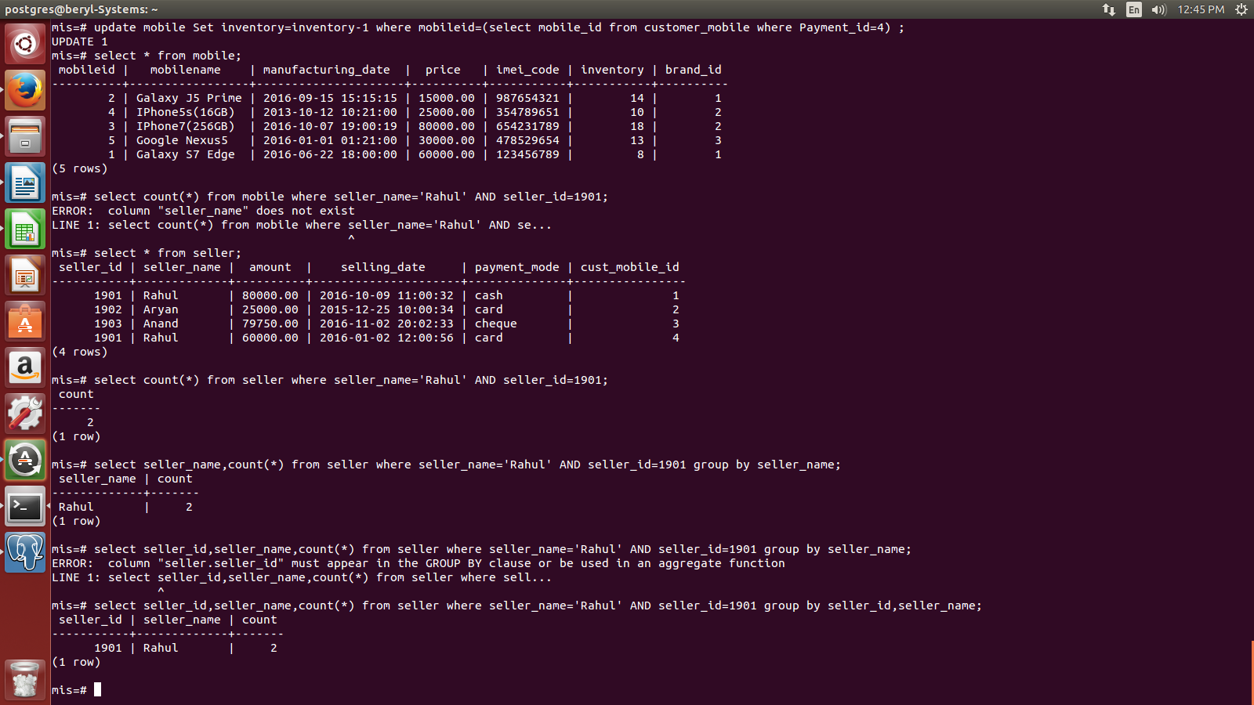

- Write a query to find total selling price in the month of october.

SELECT sum(i.selling_price)
FROM (SELECT c.payment_id
FROM customer_mobile c,(SELECT mobileid
FROM mobile
WHERE EXTRACT (month FROM manufacturing_date) IN (10)) AS t
WHERE c.mobile_id=t.mobileid) AS p,invoice i
WHERE p.payment_id=i.payment_id;

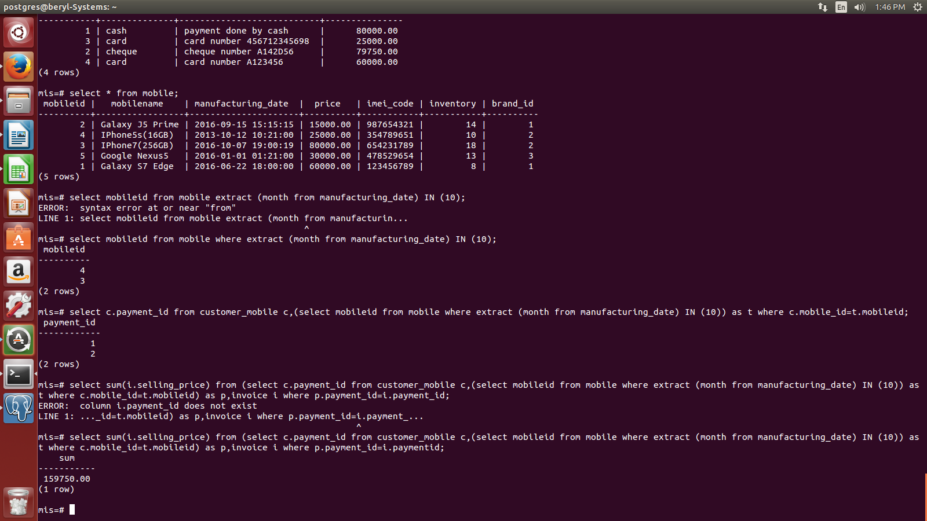

- Write a query to find LG sale in a month, say january.

SELECT count (*)
FROM (SELECT *
FROM brand, mobile
WHERE brand.brandid=mobile.brand_id)AS t
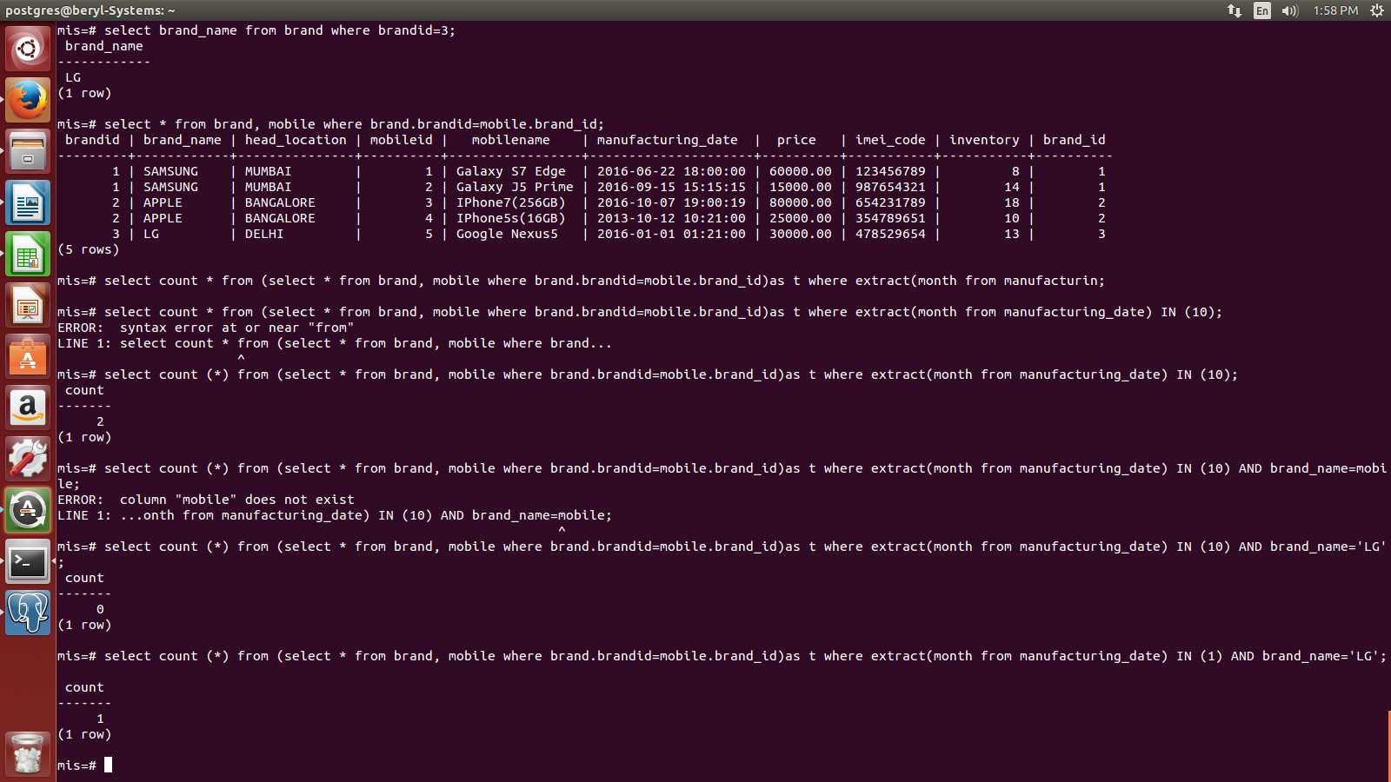
WHERE EXTRACT(month from manufacturing_date) IN (1) AND brand_name='LG';

- What are the steps to create database using this software.

Right click on database and select new database.
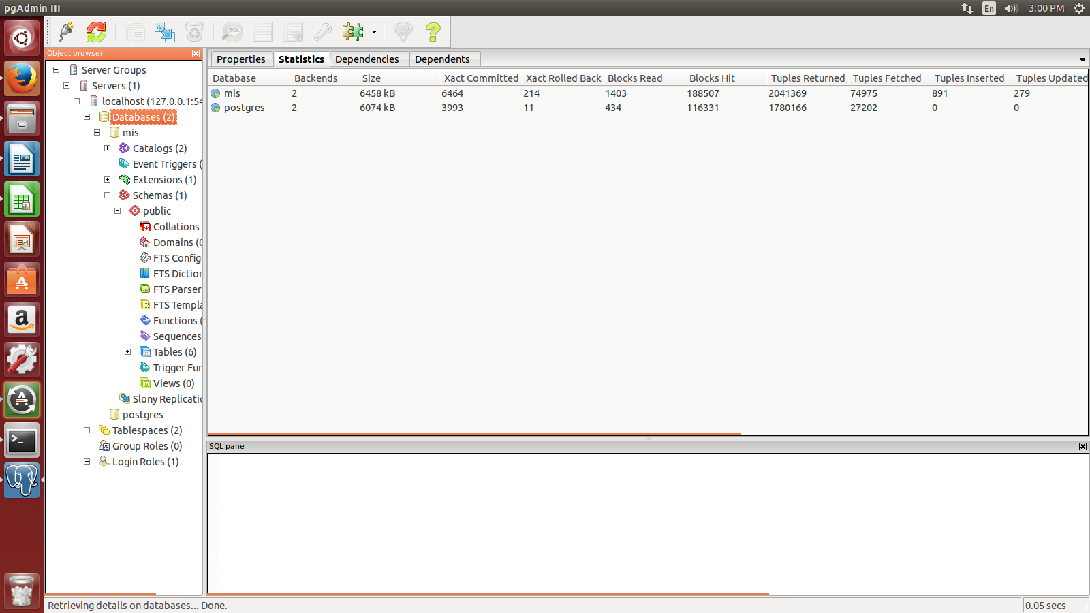
abc database has been created.

- How to create a table using pgadmin software.

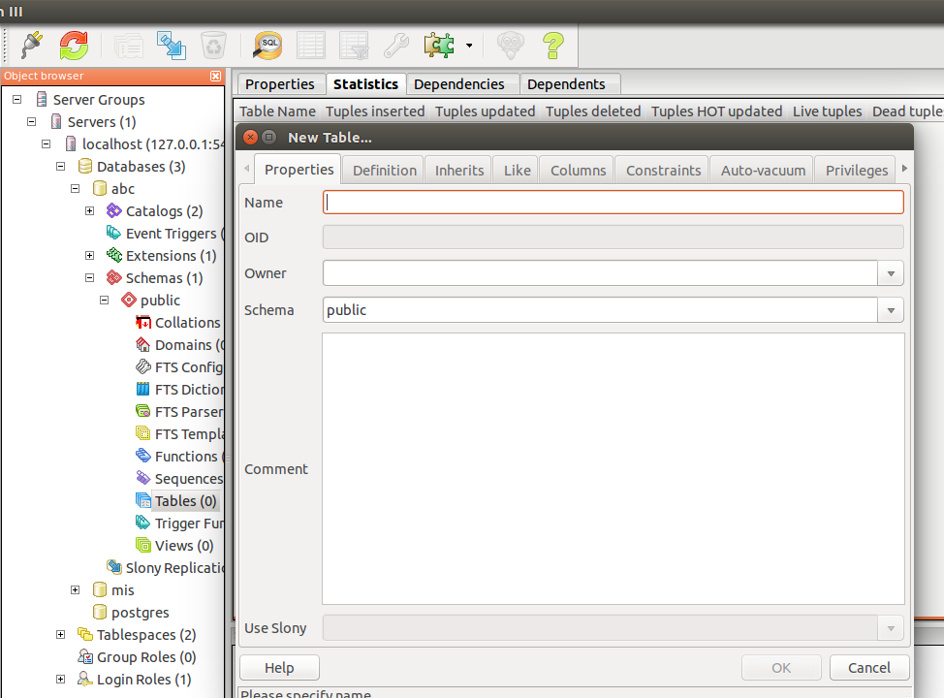

Right click on Tables and select new table option. Give the column name and constraint you wanna apply on them.

The columns will be shown in the <table> menu

- What are the steps to insert, delete data from a table.
To insert data in to table right click on table name --> selet view script option --> views rows --> enter the data in the table or delete the data from the table.

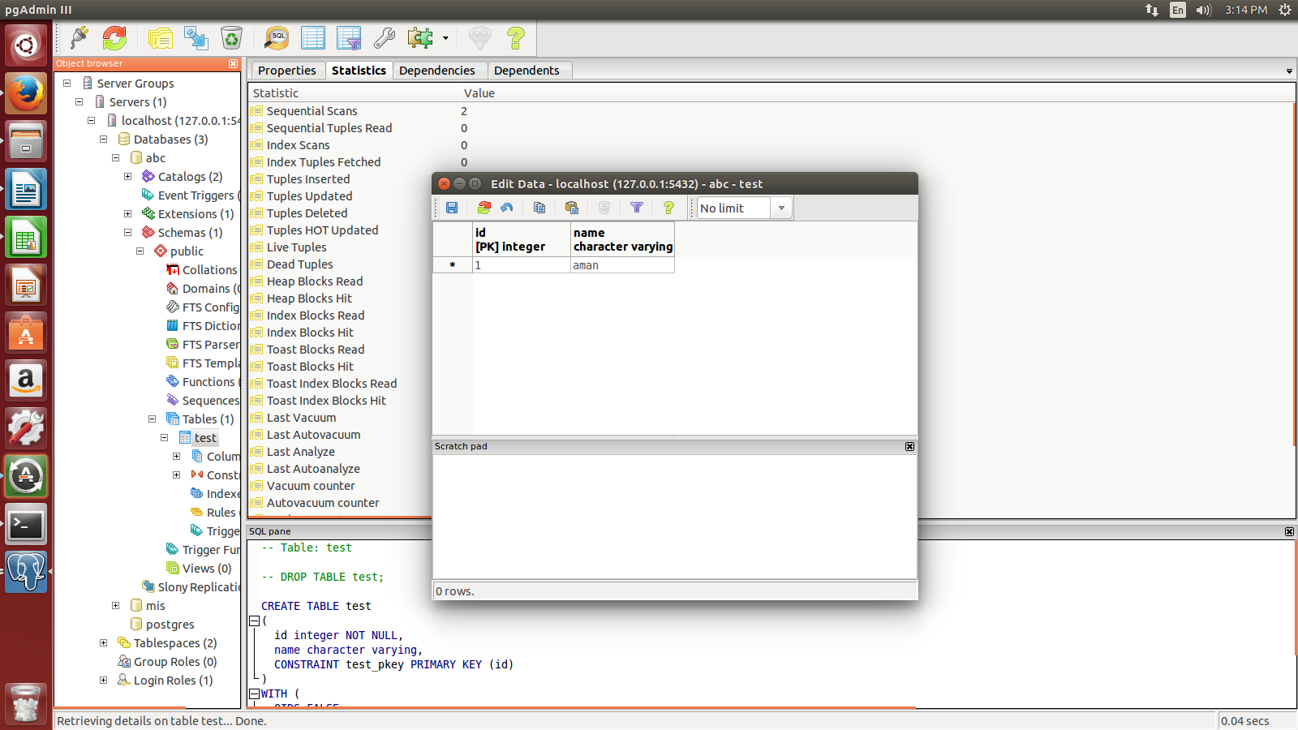
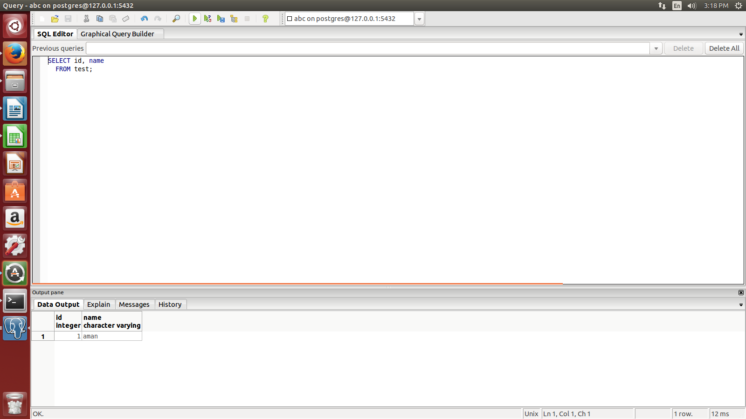
- What are the steps to select data from a table.

Right click on table name go to scripts, click select scripts and then click on the play button in the toolbar to exeute it.

