Ruby BASICS

- What are the various comparison operators in ruby?

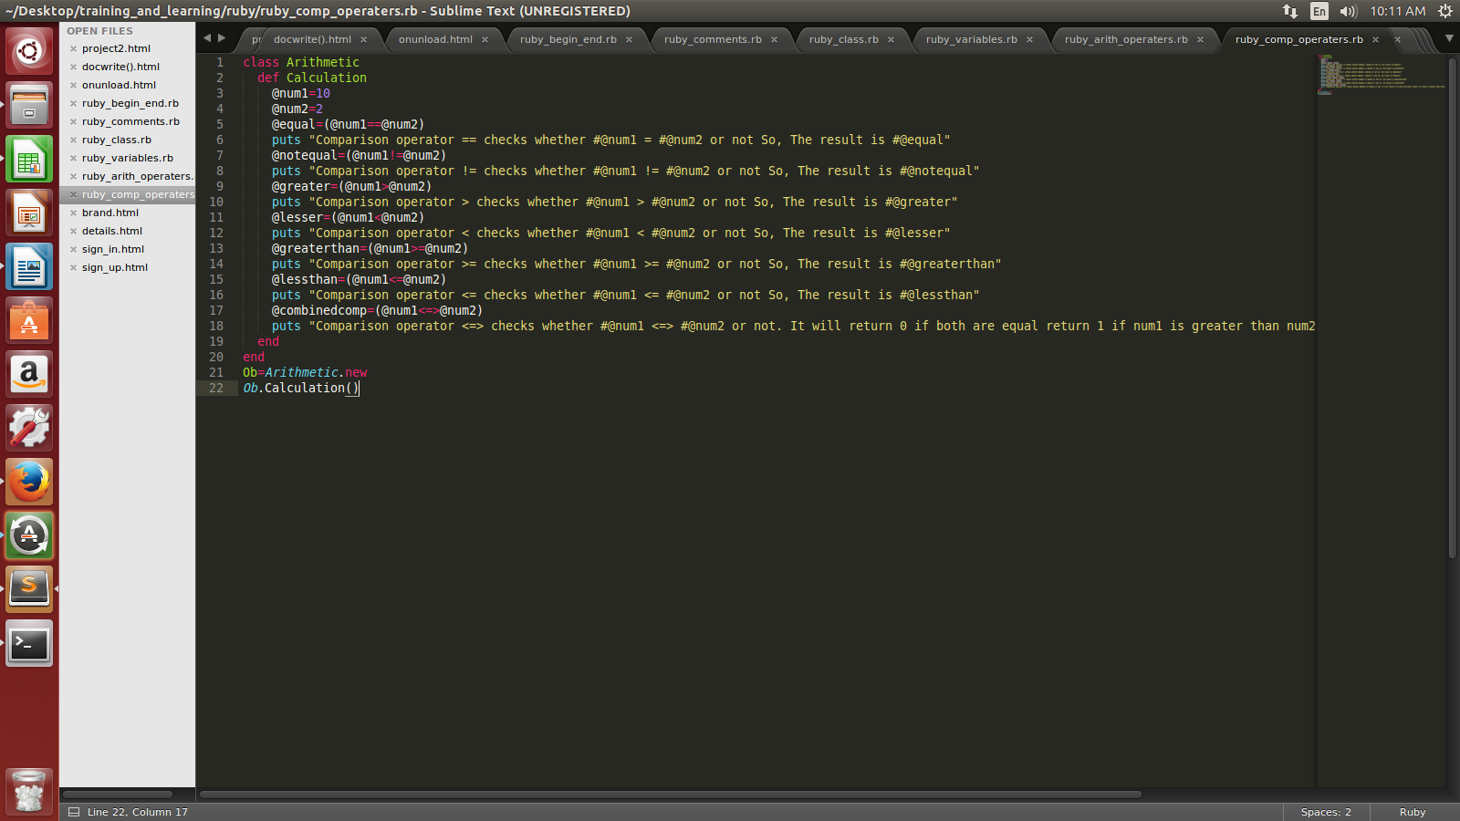
OUTPUT:
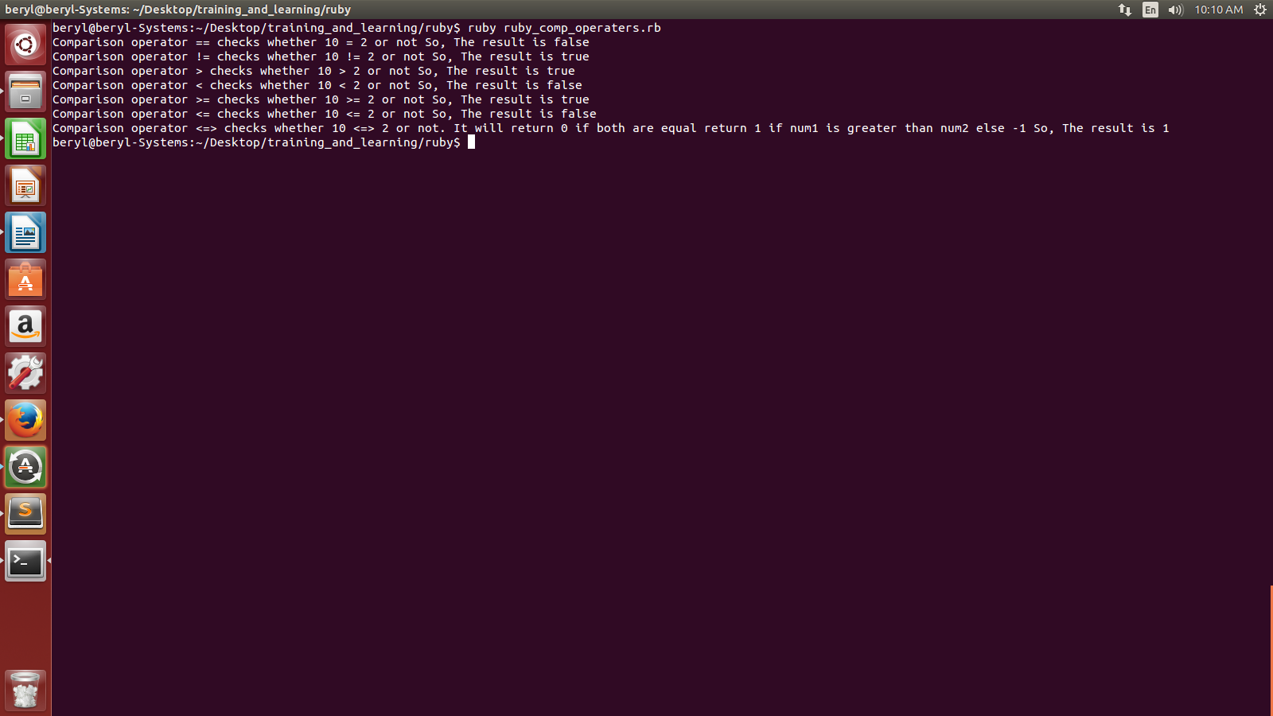

- What are the various assignment operators in ruby?
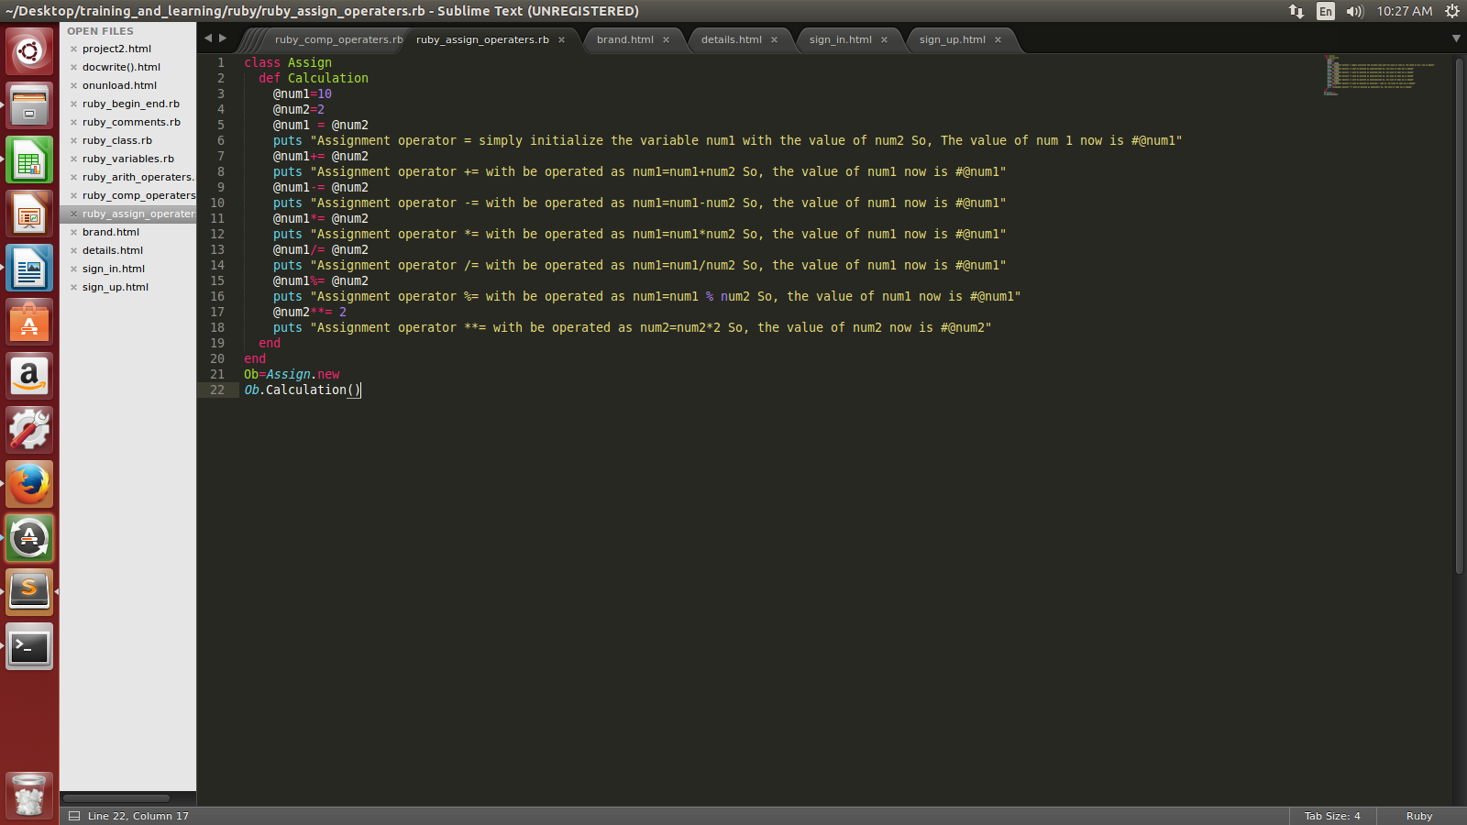
OUTPUT:
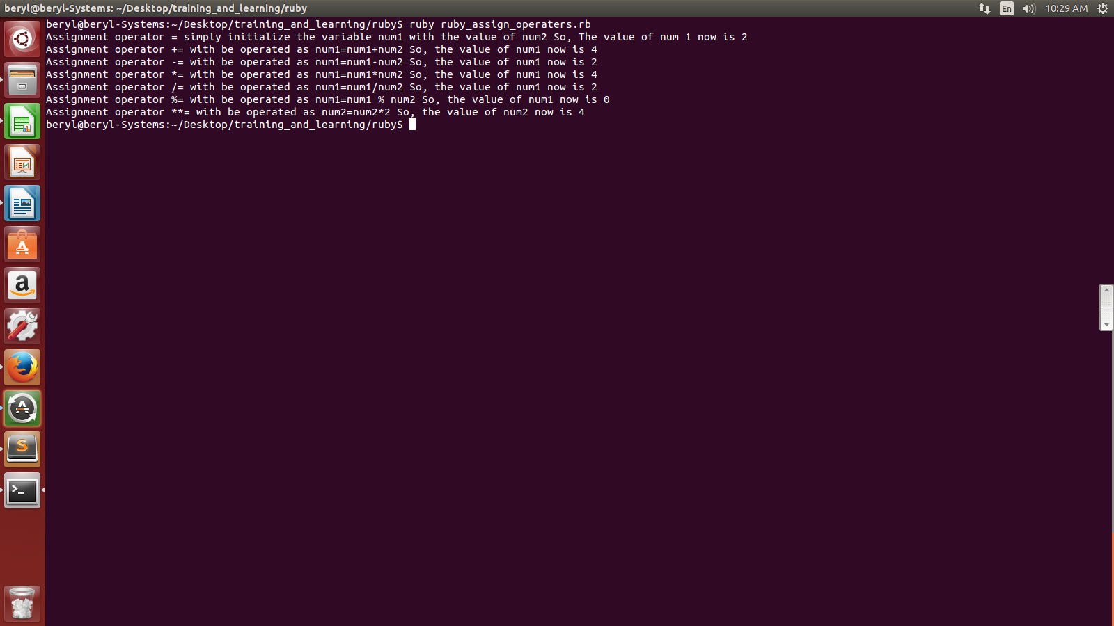
- What is parallel assignment of variables?

Parallel assignment basically initializes multiple variables at one go within a single ruby code.

class Passign
def Calculation
@num1, @num2, @num3 = 10, 2, 5
puts "The value of num1 is: #@num1"
puts "The value of num2 is: #@num2"
puts "The value of num3 is: #@num3"
end
end

Ob=Passign.new
Ob.Calculation()

OUTPUT

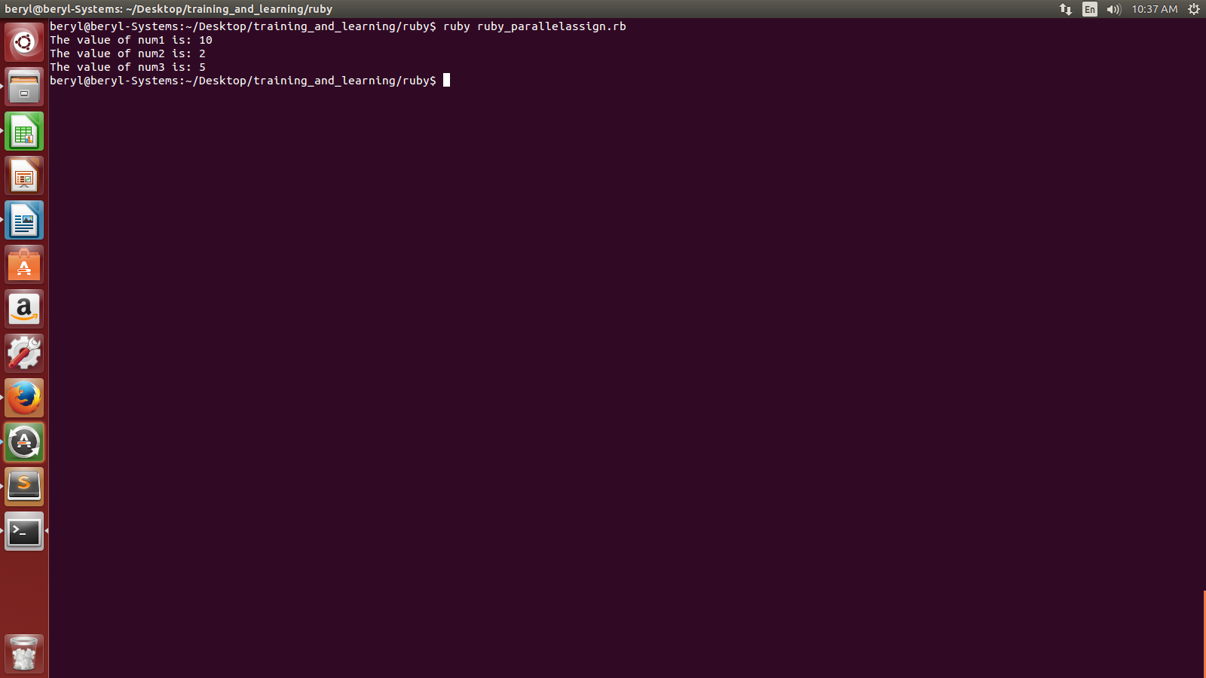
Parallel assignment is also helpful in swapping values. Eg.

class Passign

def Swap
@num1, @num2, @num3= 10, 2, 5
puts "The value of num1 is: #@num1"
puts "The value of num2 is: #@num2"
puts "The value of num3 is: #@num3 \n"
@num1 , @num2 = @num2 , @num3
puts "The value of num1 on swap with num2 is: #@num1"
puts "The value of num2 on swap with num3 is: #@num2"
end
end

Ob=Passign.new
Ob.Swap()
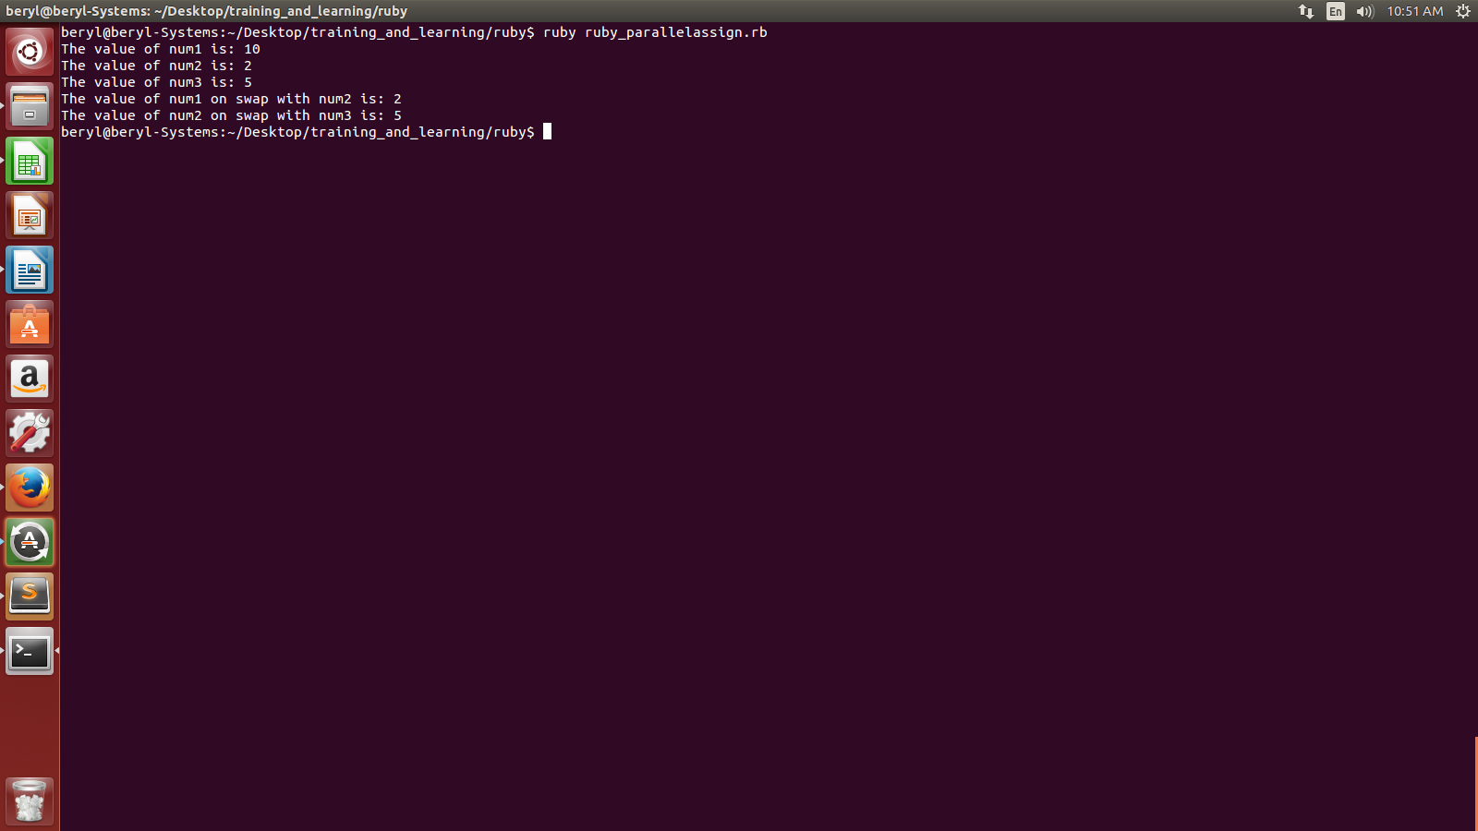

- Explain if...else statement in Ruby?

If....else statement in rubyis used for conditional expressions.

Syntax:

if <condition>
<code>
elsif <condition>
<code>
else
<code>

Eg:- class Conditional
def Check
x=1
if (x>5)
puts "x is greater than 5 "
elsif (x<5)
puts "x is less than 5"
else
puts "x is equal to 5 unless and until it is not decimal"
end
end
end

Ob=Conditional.new
Ob.Check()

Output:

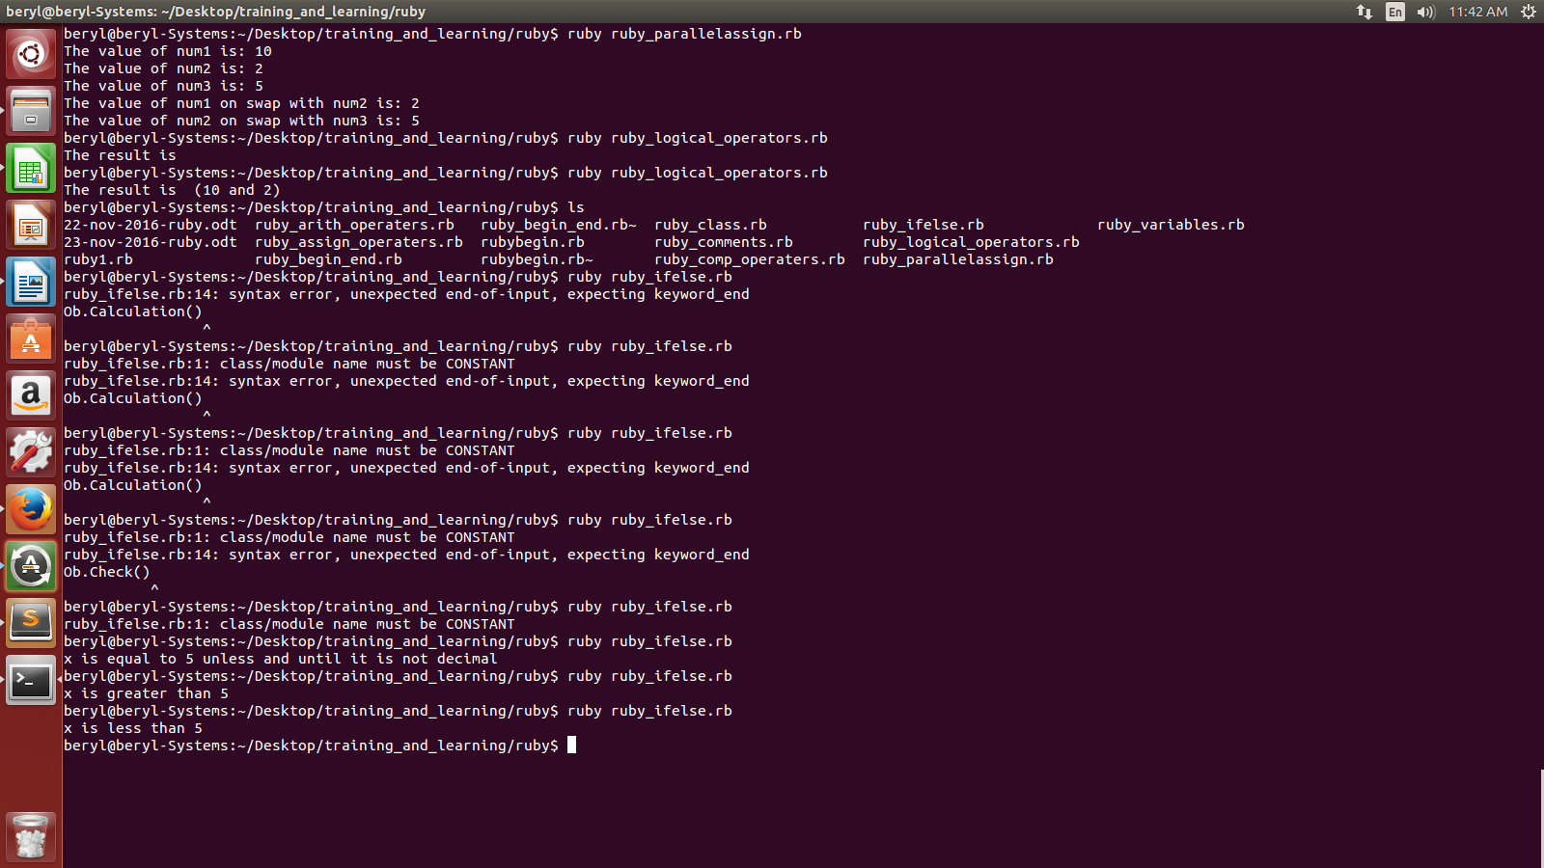

- What is unless modifier?

unless modifier is just the reverse of if else condition statement.

class UnlessTest

def Conditioncheck
@num=1
unless @num>2
print "#@num is less than 2\n"
else @num<=2
print "#@num is greater than 2 or equal to 2\n"
end
end
end

un=UnlessTest.new
un.Conditioncheck()

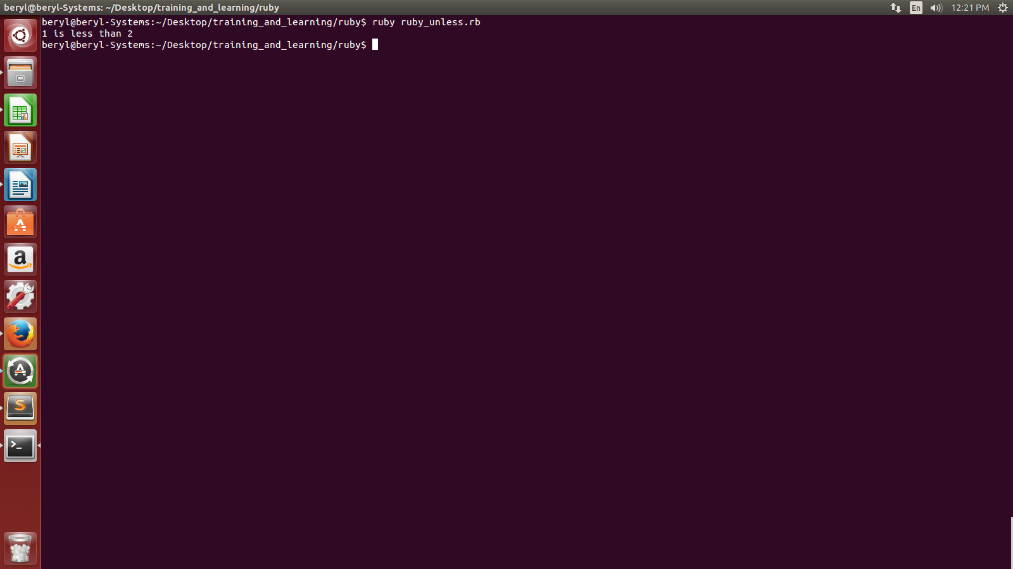

- How to use case statement in Ruby?

Case statement syntax:
case <expression>
when <expression(s)>
statement
when <expression(s)>
statement
.
.
else
statement

Eg.

class CaseTest
def Conditioncheck
@age=10;
case @age
when 0 .. 6
puts "since age is #@age So, you are Baby"
when 7 .. 12
puts "since age is #@age So, you are child"
when 13 .. 18
puts "since age is #@age So, you are youth"
else
puts "since age is #@age So, you are adult"
end
end
end

un=CaseTest.new
un.Conditioncheck()

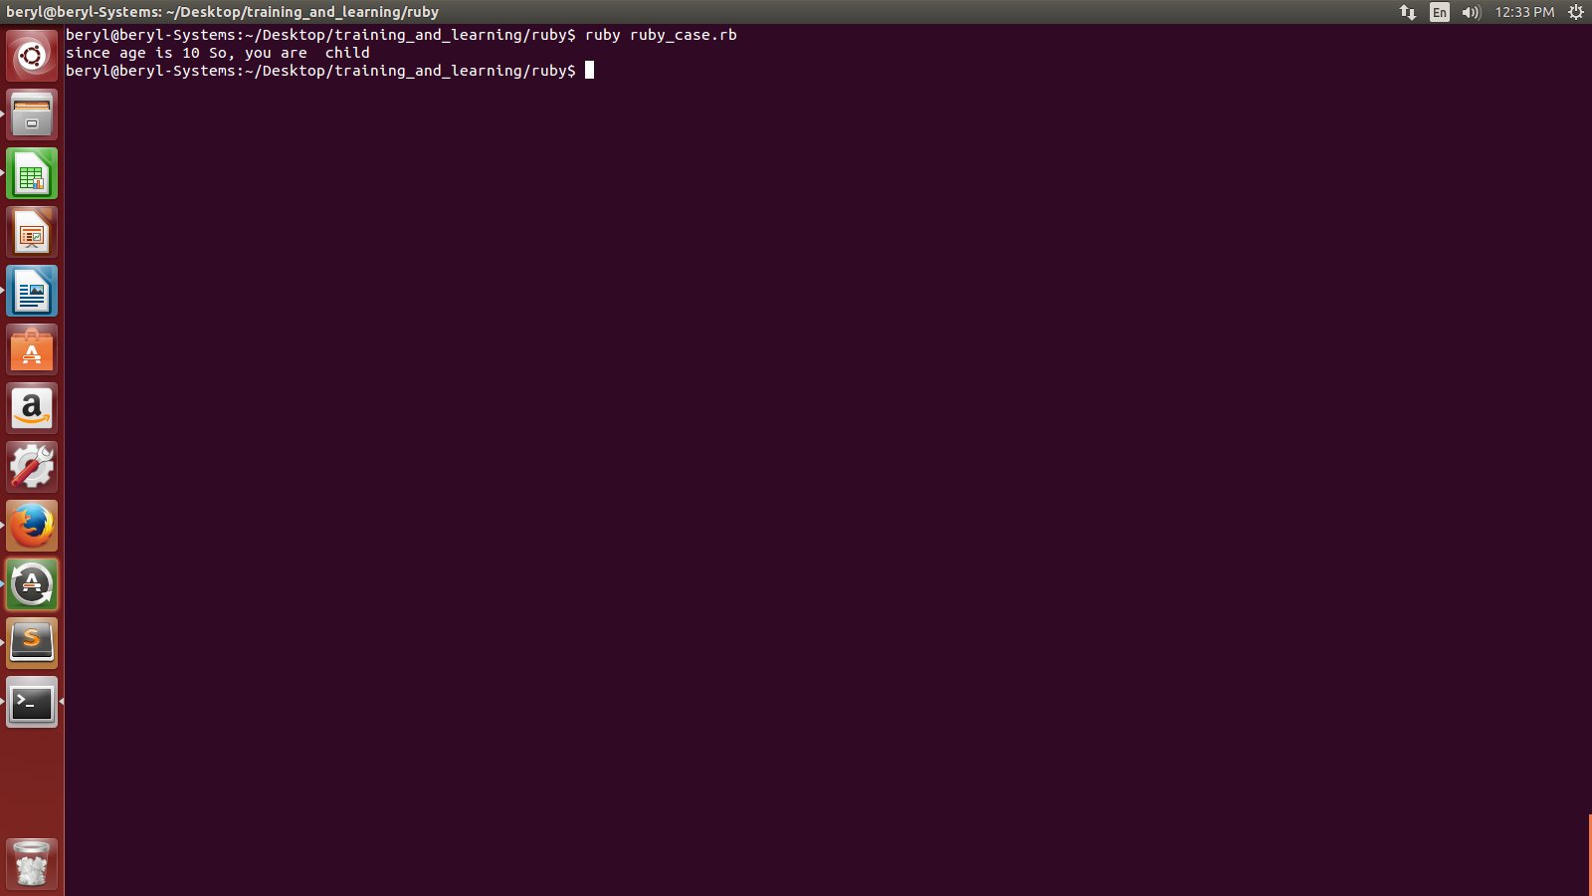
- Explain while loop in ruby?

Syntax:
while <condition> do
code
end

Eg:

class Whileloop

$start = 10
$end = 20
while $end > $start do
puts "The end value is greater than 10 so it will print the end value which is: #$end"
$end =$end-1
end
end

OUTPUT:-

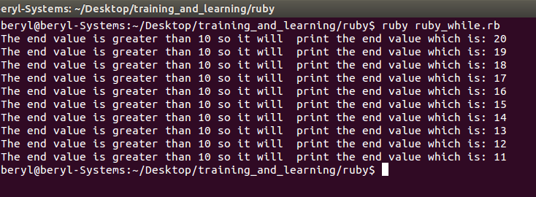
- What is until statement in Ruby?

until modifier is just the reverse of while statement.

class Whileloop
$start = 10
$end = 20
while $end < $start do
puts "The end value is greater than 10 so it will print the end value, using until, which is: #$end"
$end =$end-1
end
end
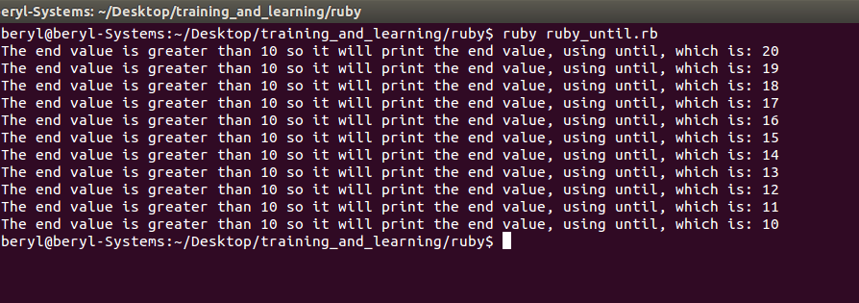
- How to use for loop in Ruby?

The syntax of for loop is:

for <variable> in <expression> do
<code>
end

Eg:
class Forloop
for i in 0 .. 5
for j in 1 .. 3
puts "The value of i and j using for loop is: #{i} j is: #{j}"
end
end
end
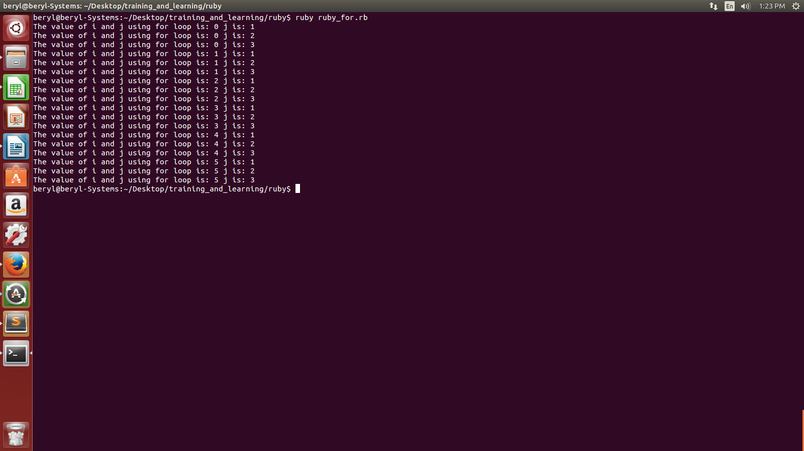

- What is the use of break statement?

This statement terminates the most internal loop and associated block if called within the block.
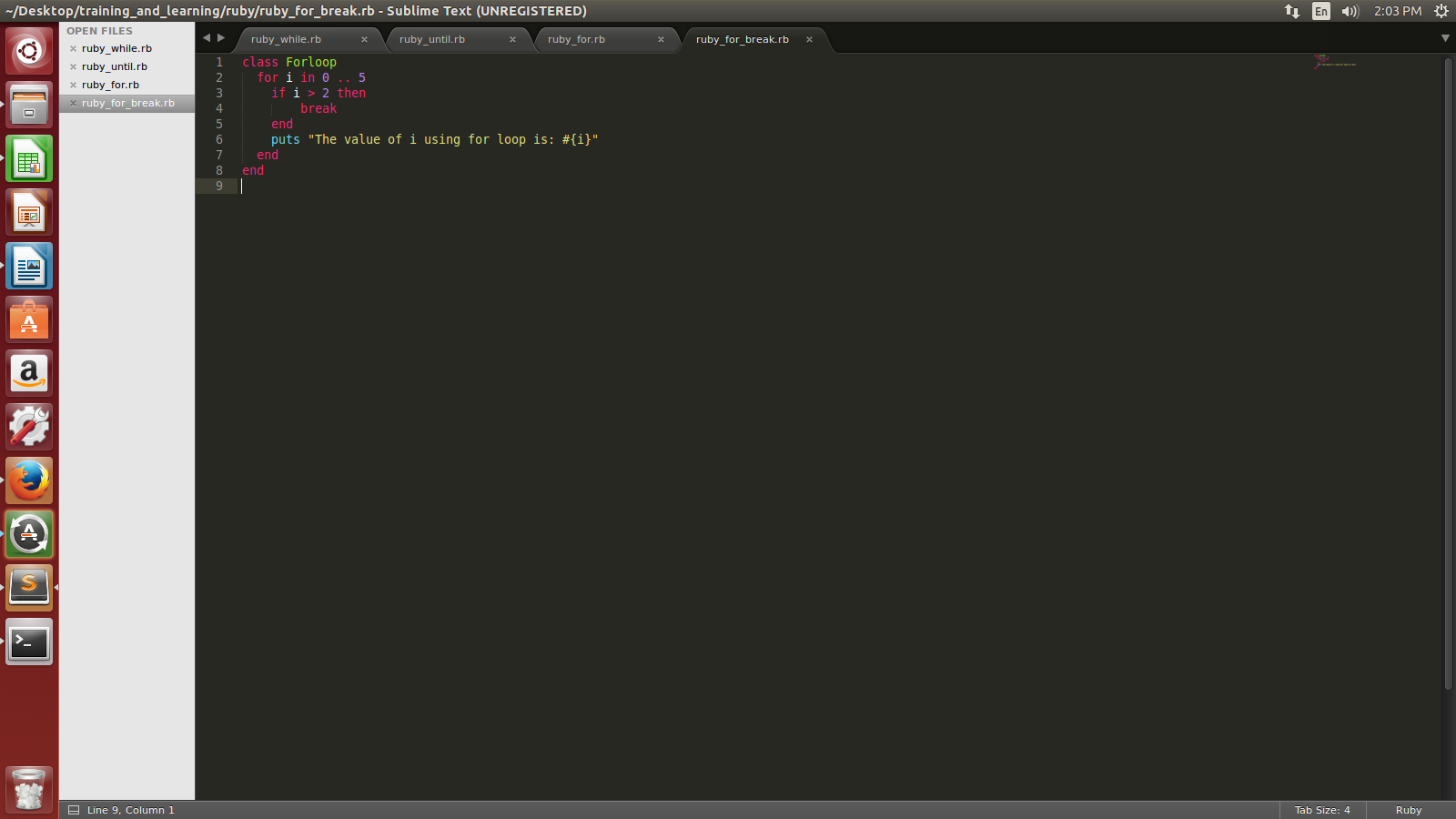
OUTPUT:
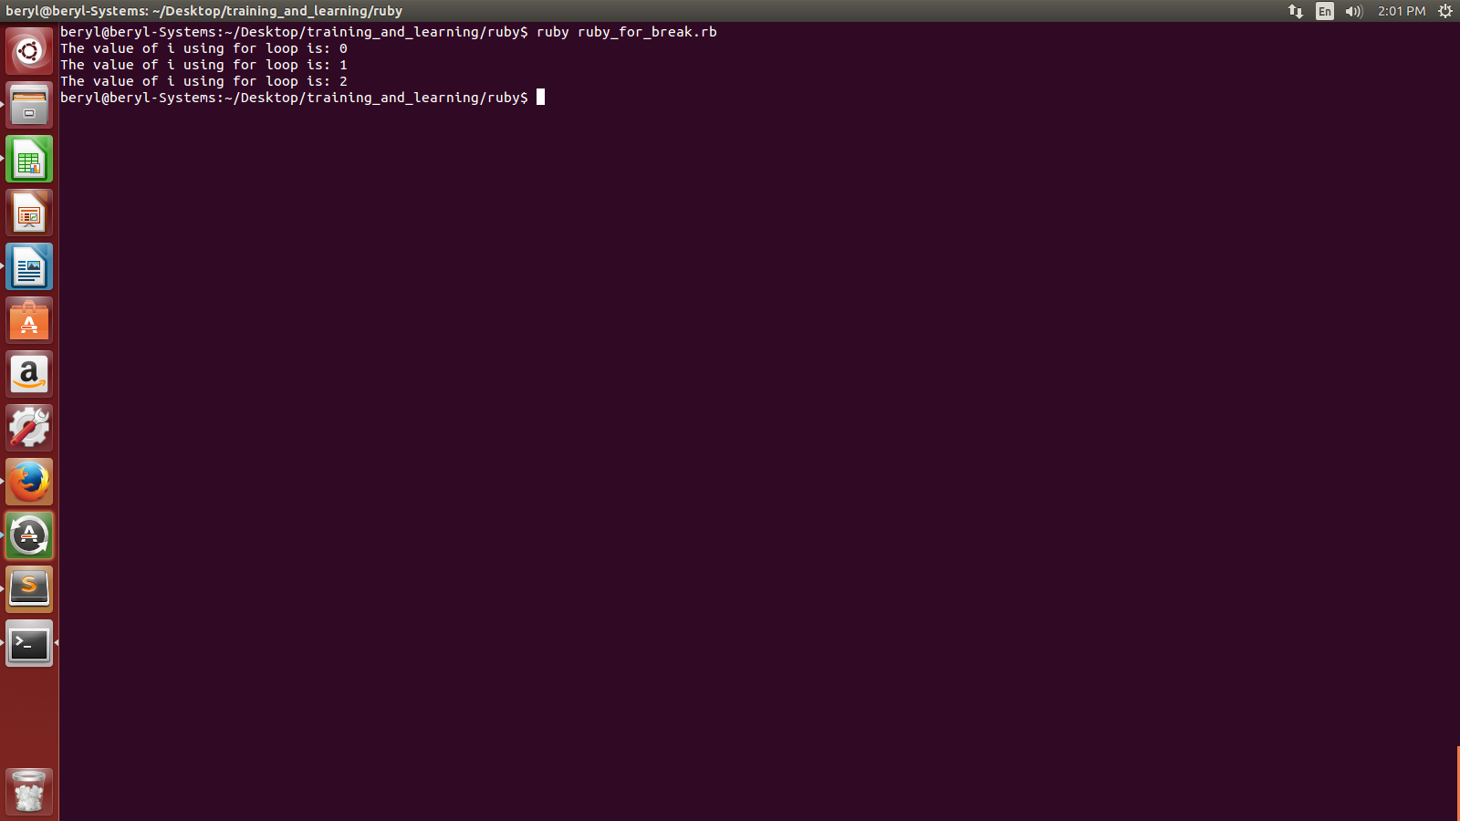
- What is the use of next statement?

The next statement jumps to the next iteration of the most internal loop.

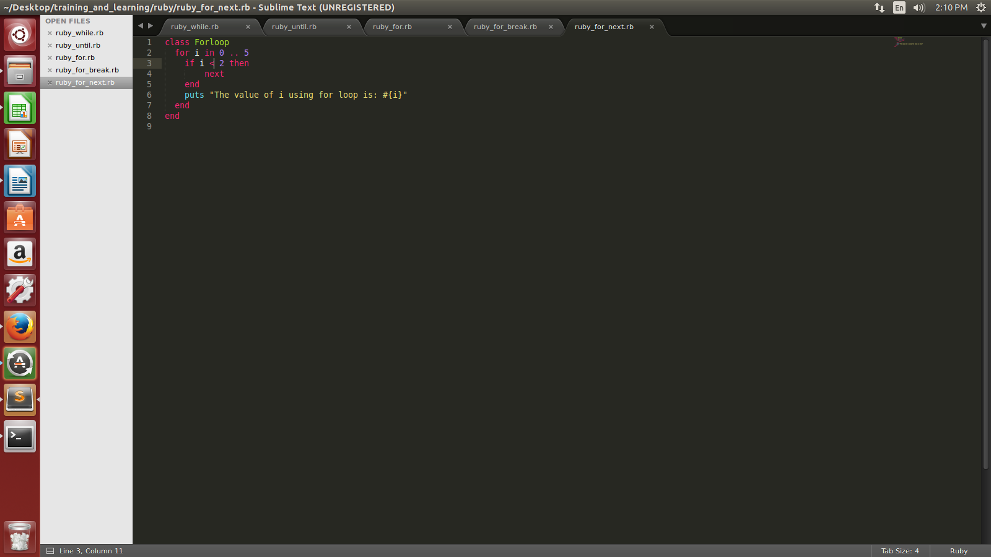

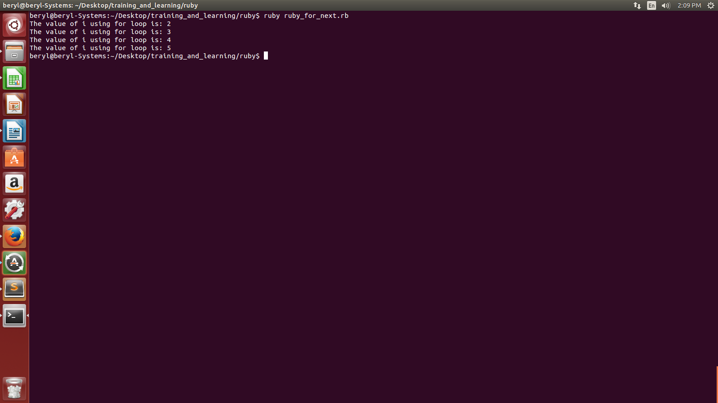
- What are the various ruby methods?

Ruby methods are similar to functions in some other language. They must begin with lowercase letter. If begin with uppercase letter then ruby will think it as a constant and hence can parse the call incorrectly.

Syntax:

def <method-name> (<aruguments>)
<code>
end
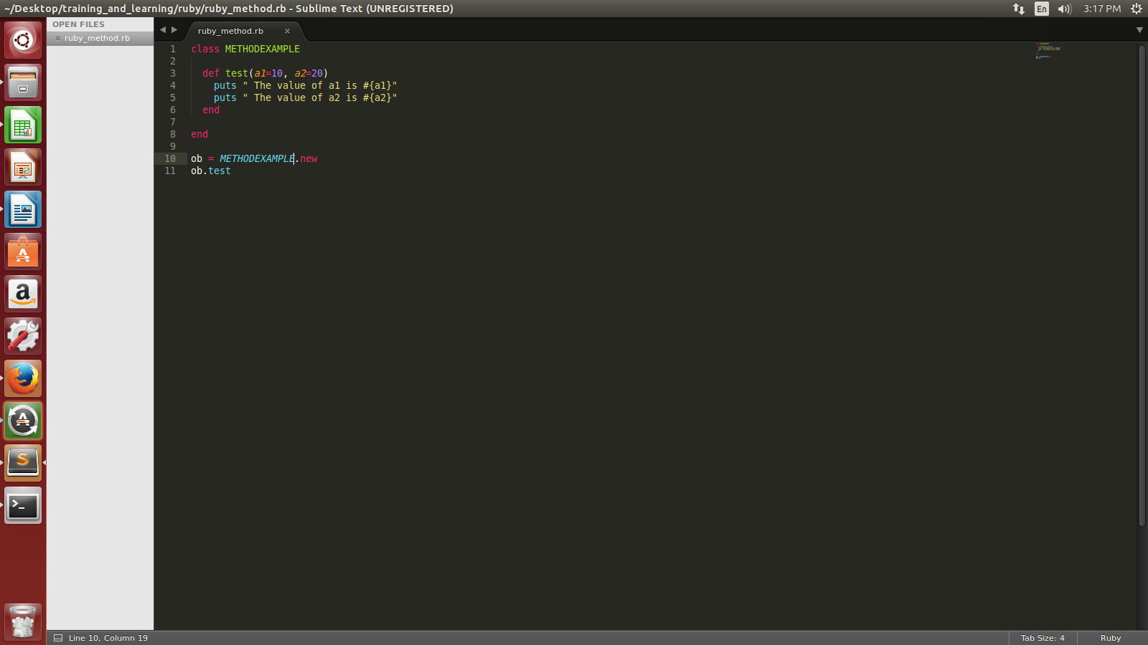
OUTPUT:

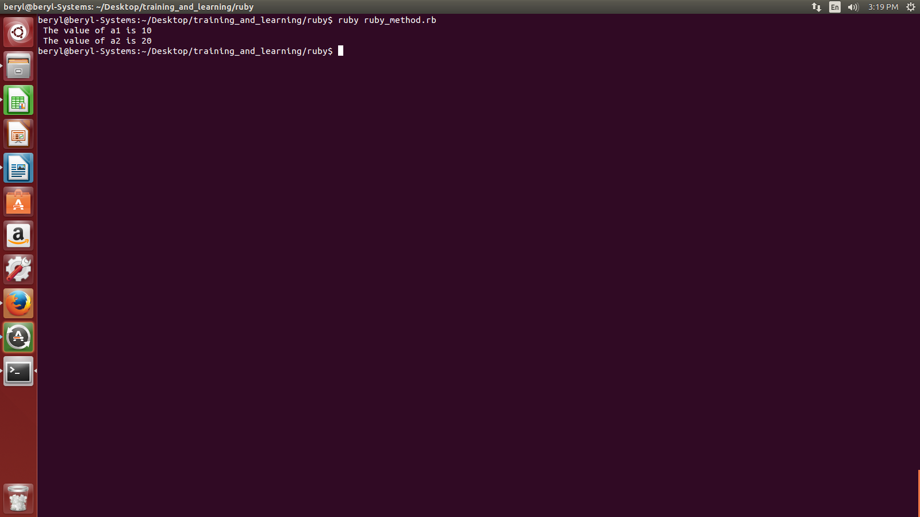

- What is the use of return statement in a method?
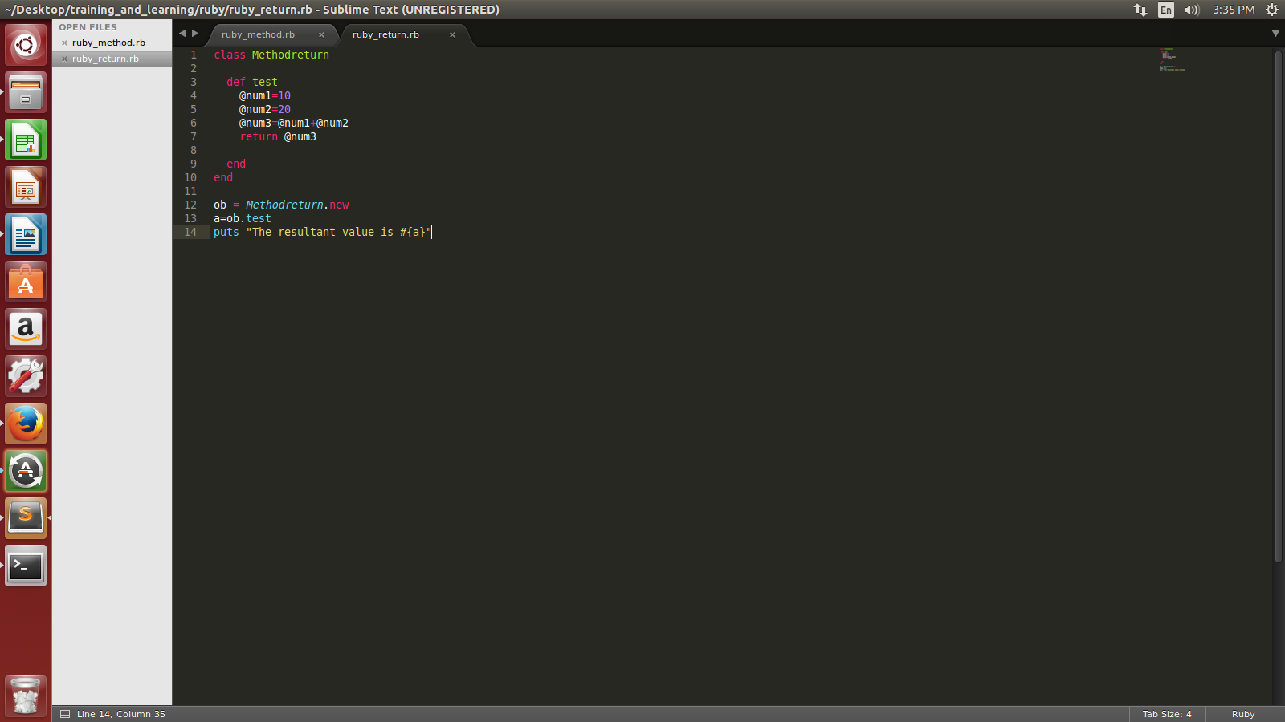

OUTPUT:

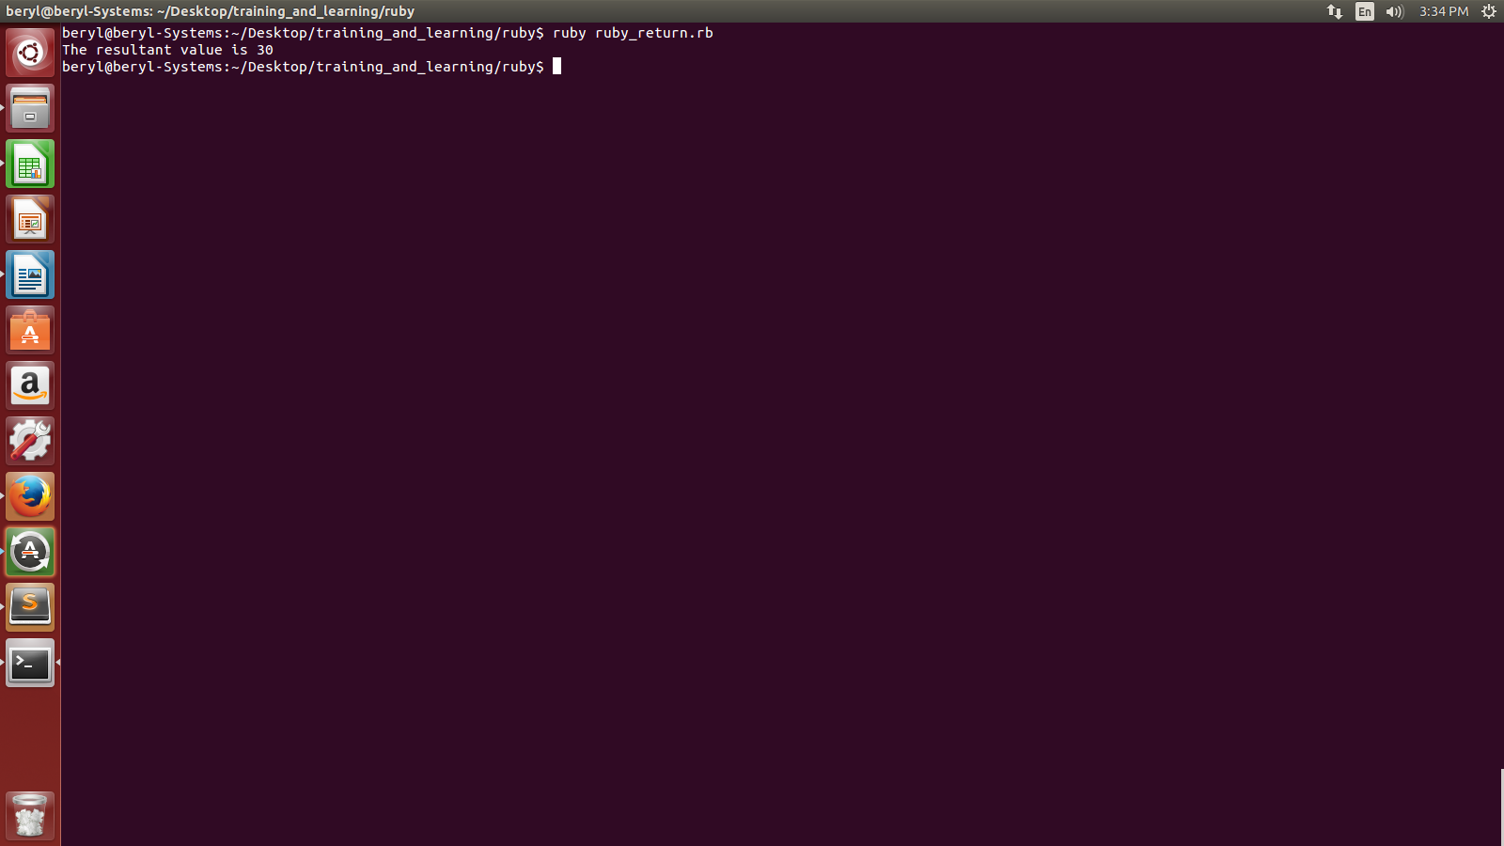
- How can we give variable length parameters?

class MULTIPARAMETER

def test(*number)
puts "The total number of parameters are: #{number.length}"
for i in 0 ... number.length
puts " The value at i position is #{number[i]}"
end
end
end

ob = MULTIPARAMETER.new
ob.test("1", "Aman", "India")
ob.test("2", "Ravi", "Delhi", "India")
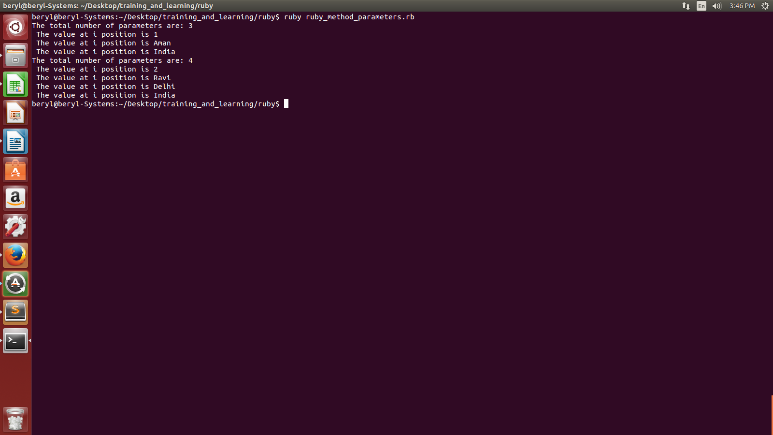

- What are blocks in Ruby?

Blocks consists of chunks of code.
We assign a name to a block
code is enclosed in {}
We invoke a block using yeild keyword.

- What are strings in ruby?

A String object in ruby holds and manipulate arbitrary sequence of one or more bytes, typically representing characters that represent humanm language.

class String1

def test
@str_name= 'Aman Gautam'
@str_comment= 'India\'s most common place is delhi'
puts " Hi #@str_name"
puts " #@str_comment"
end
end

ob = String1.new
ob.test
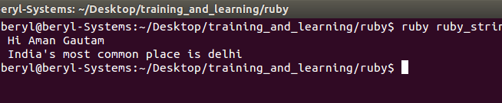
- What are the various string builder functions?
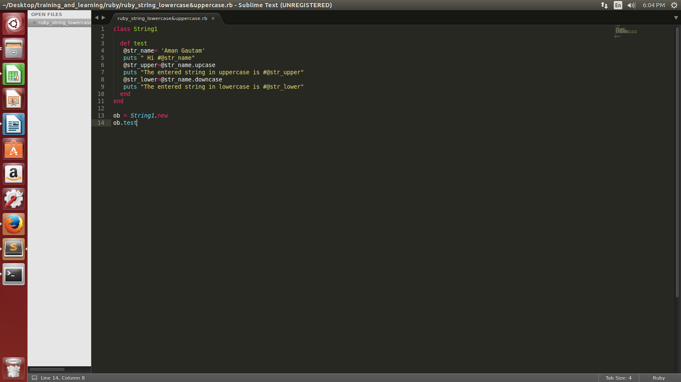
OUTPUT:

