PostgreSQL BASICS

- What are the steps to install MySQL in Ubuntu?

- The steps to install mysql-server are:-

- Installing Mysql:-
  - sudo apt-get update
  - sudo apt-get install mysql-server-5.6

- Configuring Mysql:-
  - sudo mysql_secure_installation

- Check the version of mysql:-
  - Mysql—version

- Testing MySQL:-
  - service Mysql status.
  - mysql start/running, process 2689

- Executing Mysql:-
  - mysql -u “username” -p
e.g., mysql -u root -p

- How to install postgres in Ubuntu?

- The steps to install postgres are:-

- Installing Postgres:-
  - sudo apt-get update
  - sudo apt-get install postgresql postgresql-contrib

- configuring postgres:-
  - sudo -i -u postgres
  - psql

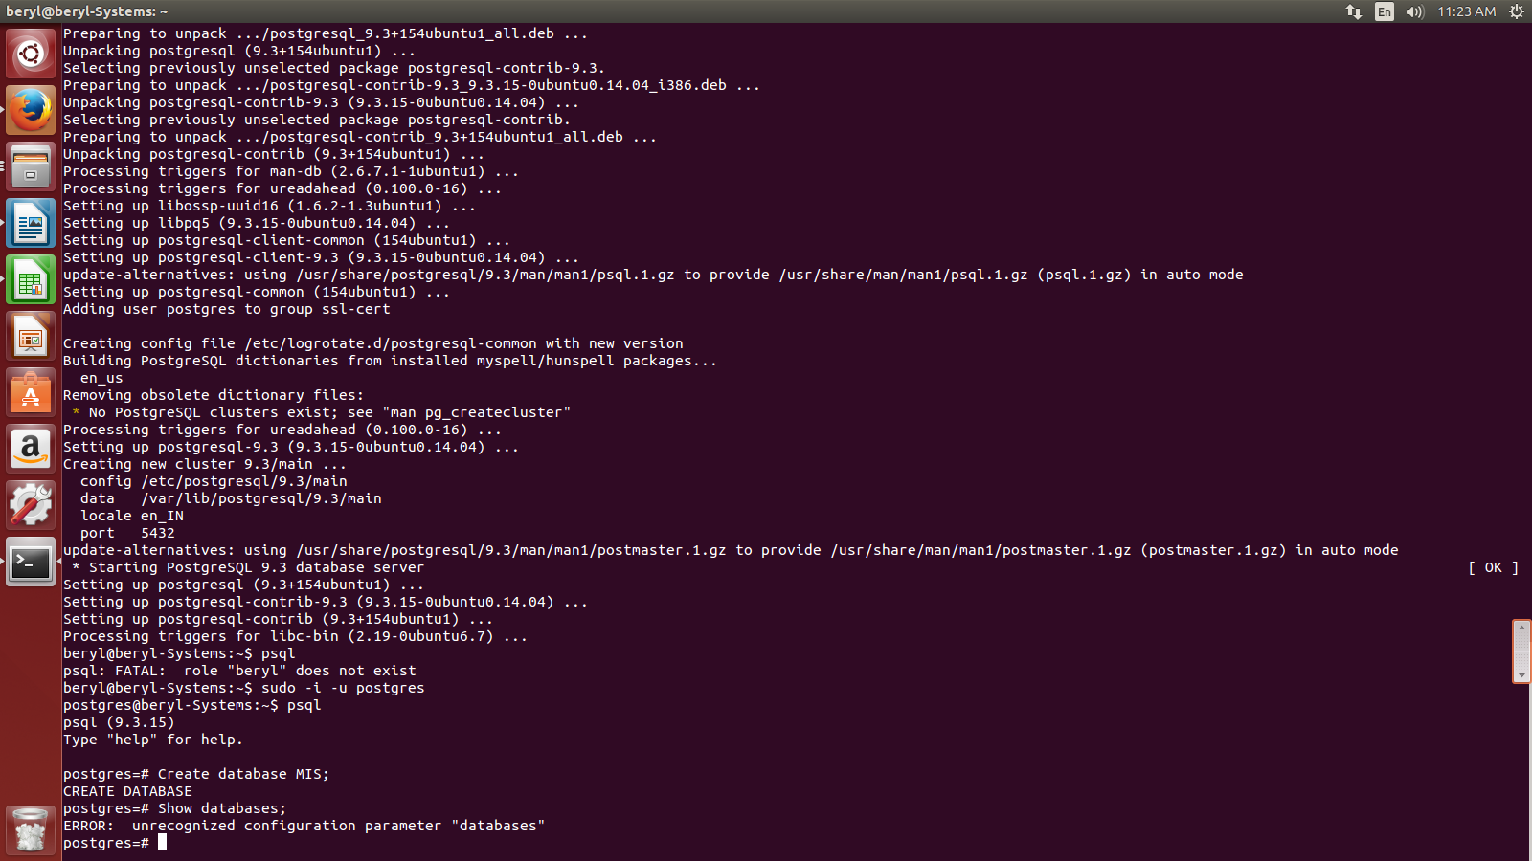

- What is postgresql? What are its features?

Postgresql is powerful, opensource, ordbms. It is used to store data securely supporting best practices and allow them to retrieve whenever the retrieval request is processed.

It is cross-platform and can run on many os such as linux, Misrosoft windows, solaris etc.
It supoorts text, images, sounds, videos and programming interfaces for C/C++, Java, Perl, Python, ruby etc.

- What are datatypes in postgresql?

A datatype basically represents the type of data stored in the relevant field. While we create table, for each column, we use a datatype.

There are basically three main datatype in PostgreSQL:-
- Numeric
- String
- Date/Time

Numeric Datatype:-
Name | Size | Range
Smallint | 2 bytes | -32768 to +32767
Integer | 4 bytes | -2147483648 to +2147483647
decimal | variable | up to 131072 digits before the decimal point; up to 16383 digits after the decimal point.
Double precision | 8 bytes | 15 decimal digits precision

String Datatype:-
Name | Description
char(size) | Size= number of character to store. Fixed length string.
varchar(size) | Size= number of character to store. Variable length string.

Some other datatypes are boolean, money (to represent currency), date/time etc.

- How to create database in PostgreSQL?

The command to create database in postgresql is:

CREATE DATABASE <database_name>;

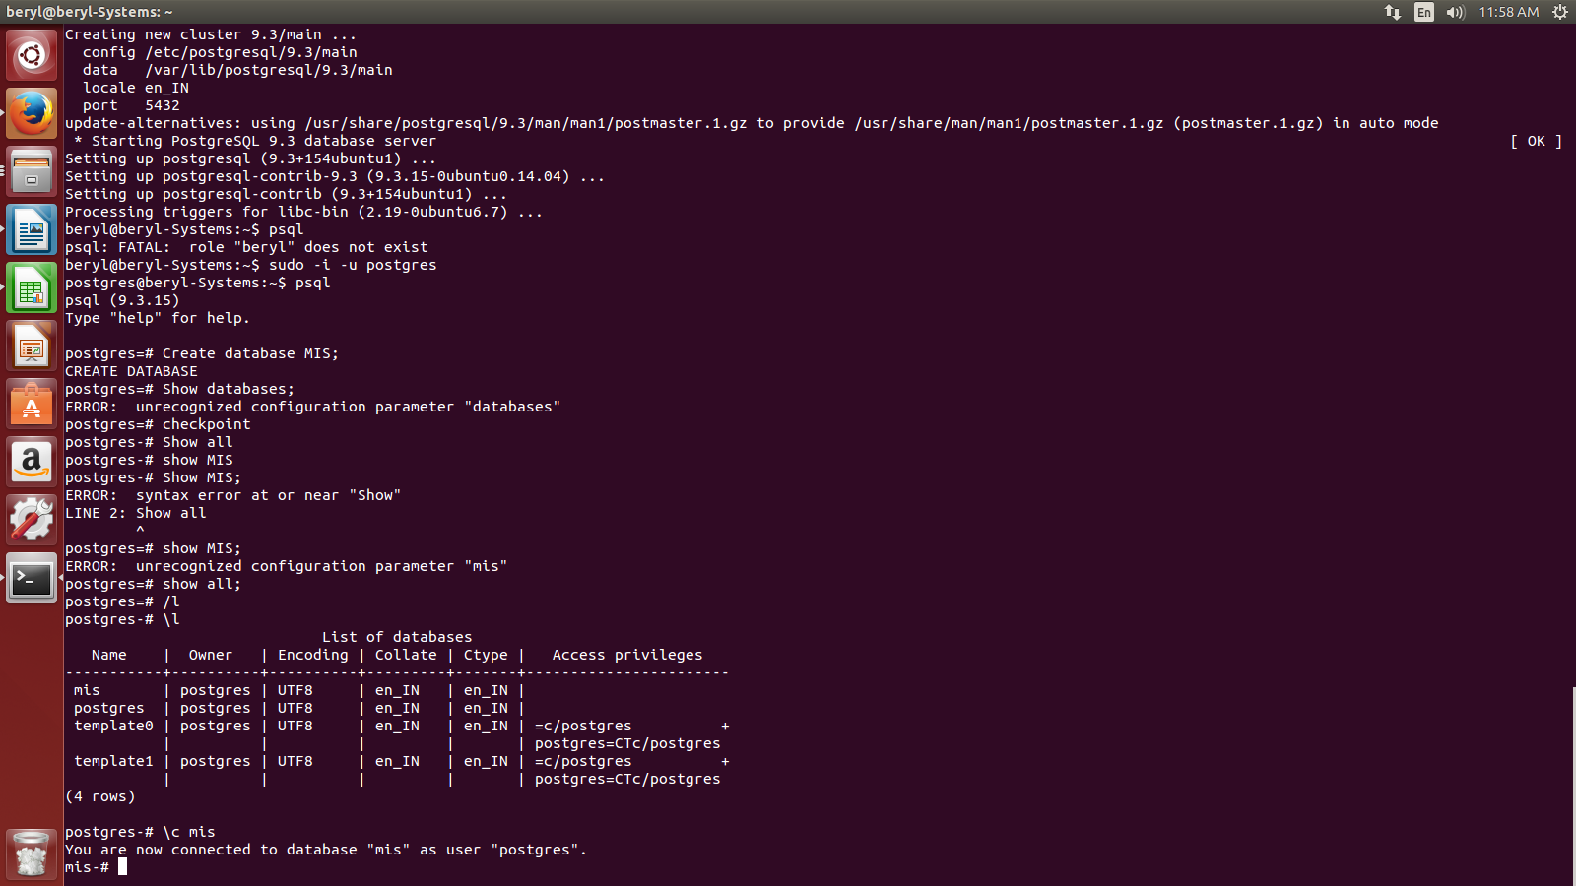

- How to see the database in Postgresql?

The command to see the databases in PostgreSQL is \l
- How to switch between databases?

The command to switch between databases is “\c database name we want to switch to”.

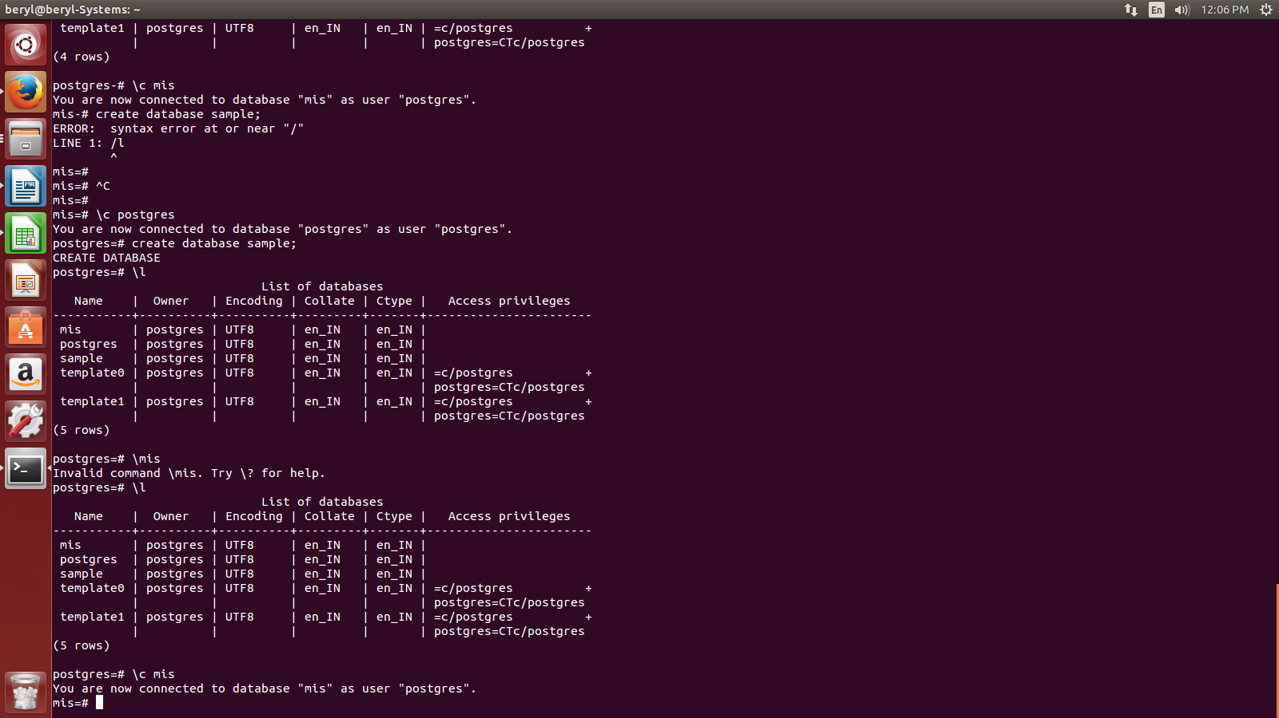
- How to delete databse in PostgreSQL?

The command to delete databse in postgreSQL is

DROP DATABASE <database-name>;

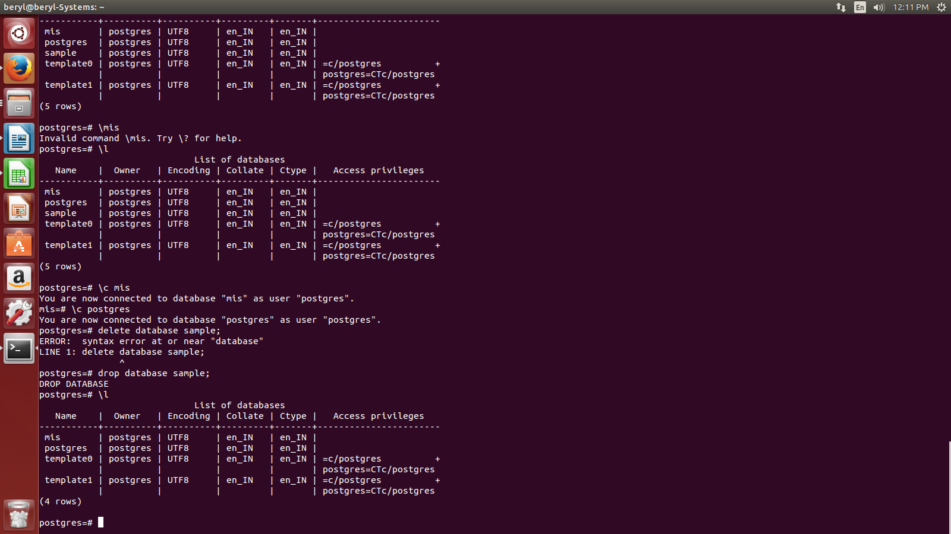
- What is primary key, foreign key and unique key in SQL?

Primary Key is the set of one or more fields/columns that unquely identifies each rows in a table.

Foreign Key is a field in table that represents as primary key in another table.Unlike Primary Key, It can contain multiple Null, duplicate values.

Unique Key is the field that uniquely identifies a record in a table. But the major difference in Primary key and Unique Key is that Primary Key cannot be null but Unique Key can have 1 NULL value. And we can have more than 1 unique key in a table.

- How to create tables in postgreSQL?

The syntax to create table is:-

CREATE TABLE <table_name> (
Field1 Datatype Constraints,
Field2 Datatype Constraints,
Field3 Datatype Constraints);
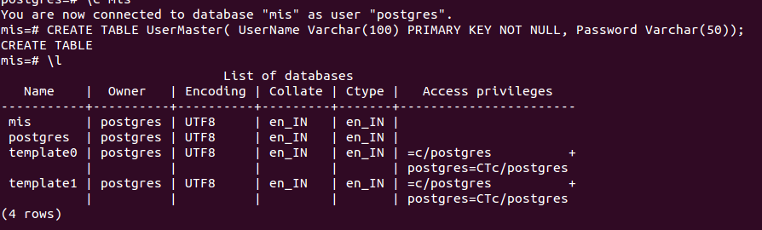
- How to see the list of tables in a database?

The command to see tables in a database in postgresql is \dt
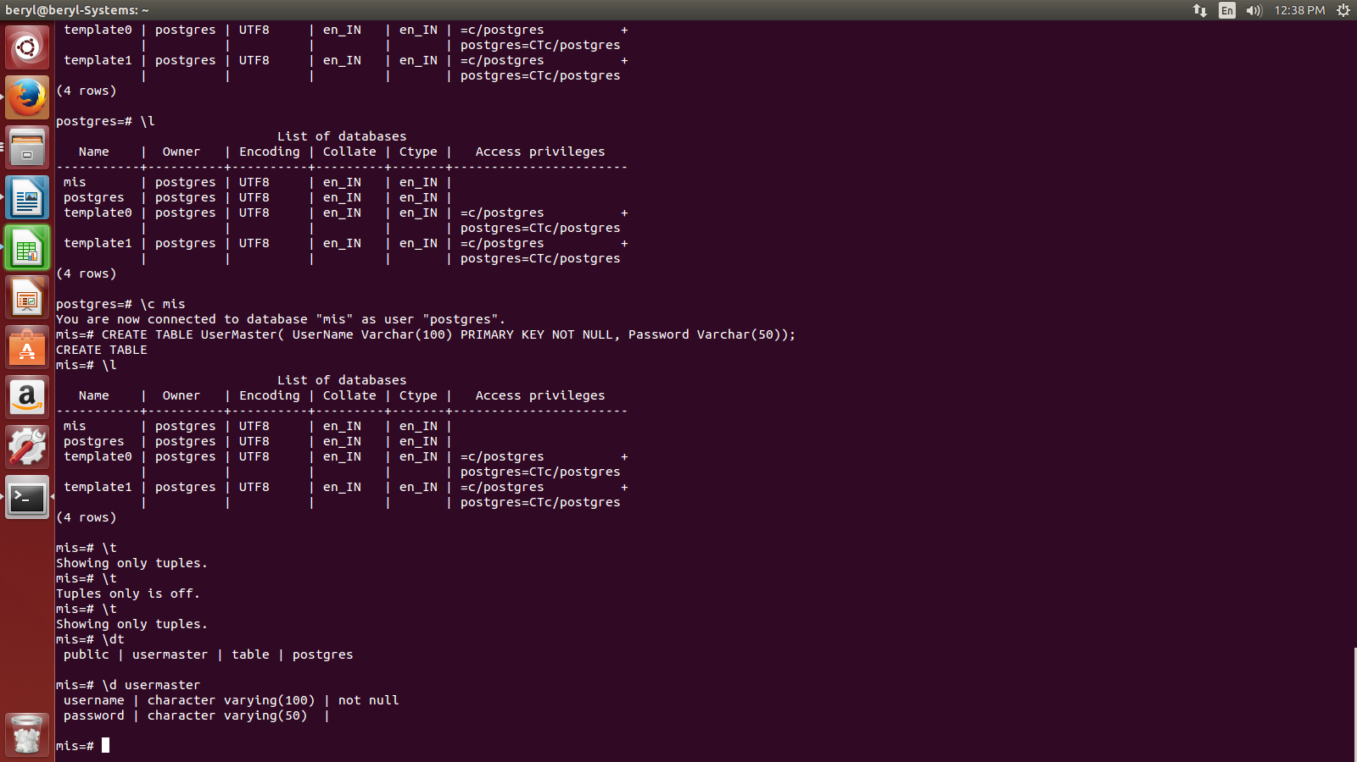

- How to see fields in a table?

The command to see the fields in a table is \d <table_name>

- How to delete a table?

The syntax to delete table is:-

DROP TABLE <table_name>

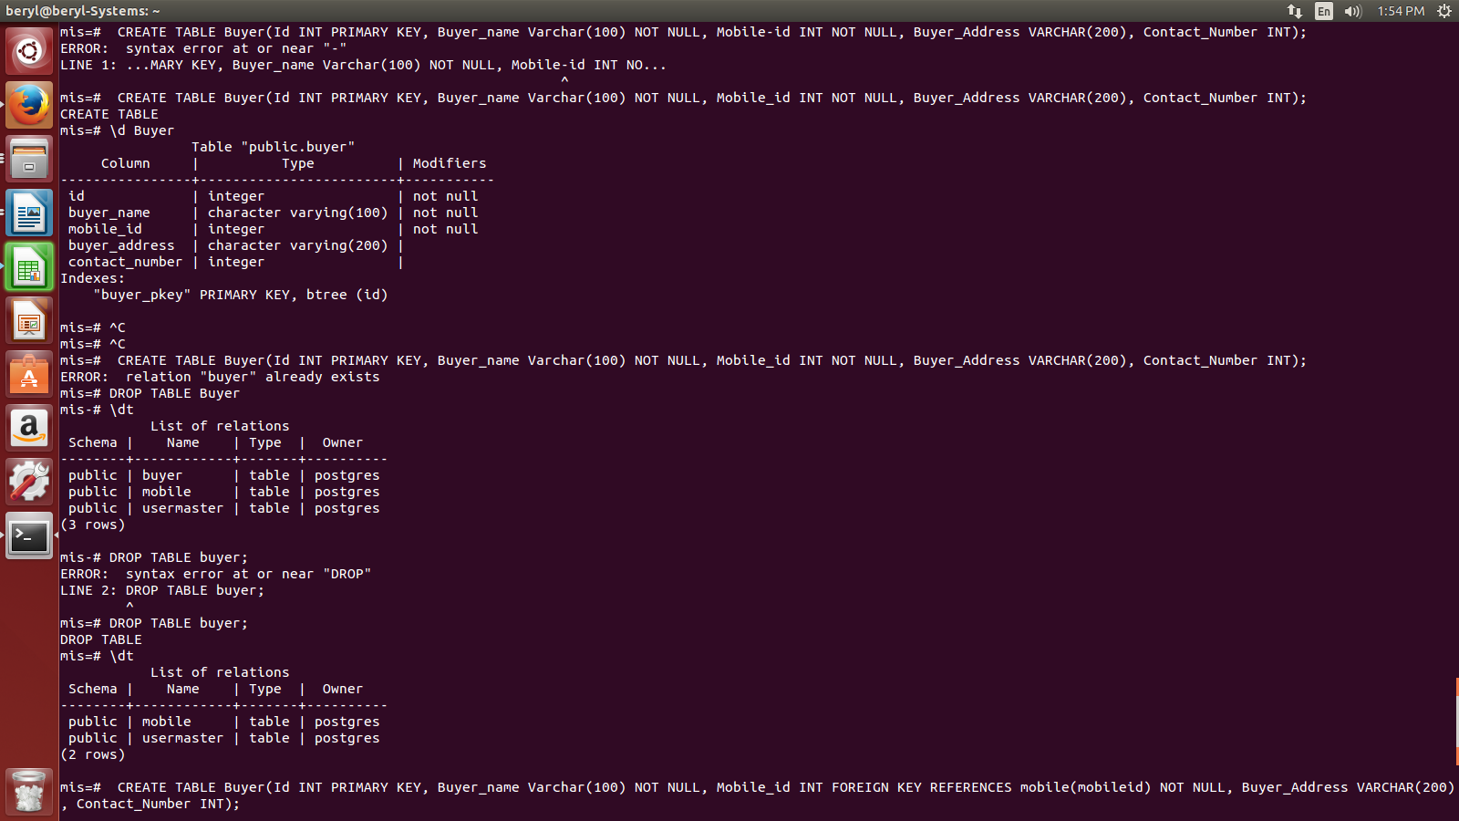

- How to insert data into a table?

To insert data into a table we use the following command as:-

INSERT INTO <tablename> VALUES(field1value, field2value.....);

- How to change the datatype of a column in postgresql?

To change the datatype of column we will use:-

ALTER TABLE <tablename> ALTER COLUMN <column name> TYPE <datatype>;

- How to change the name of the table?

To change the name of table we use:-

ALTER TABLE <old_table_name> RENAME TO <new_table_name>;

- How to change the name of the column in a table?

To change the name of table we use:-

ALTER TABLE <table_name> RENAME <old_column_name> TO <new_column_name>;

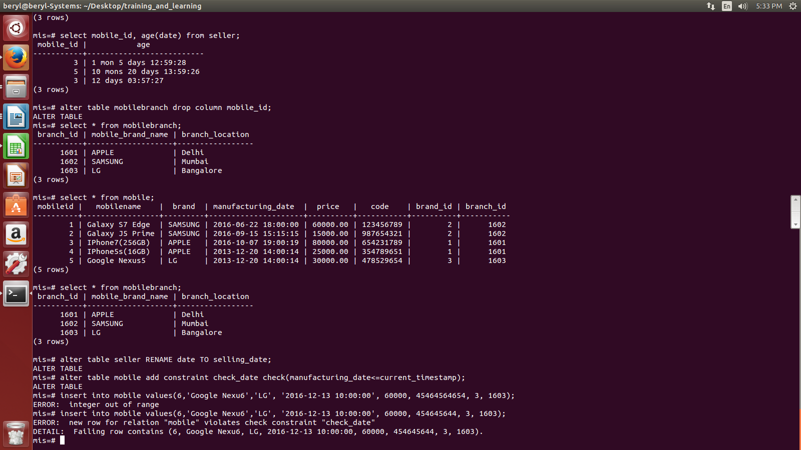

- What are the various SQL functions?

MIN() function gives the minimum value of the mentioned field.
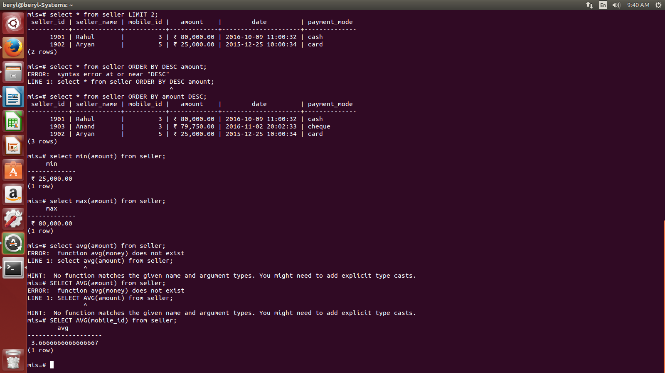
MAX() function gives the maximum value of the mentioned field.
AVG() function gives the average value of the mentioned field.
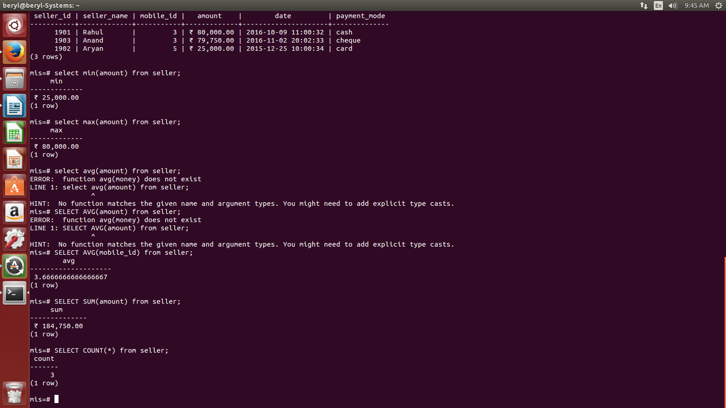
SUM() function gives the sum of the mentioned field.

COUNT() function gives the number of rows of the mentioned field or a table.

- What is orderby clause and limit clause?

ORDER BY keyword is used to sort the rows ascendingly or descendingly in a table.

Ascending order:-
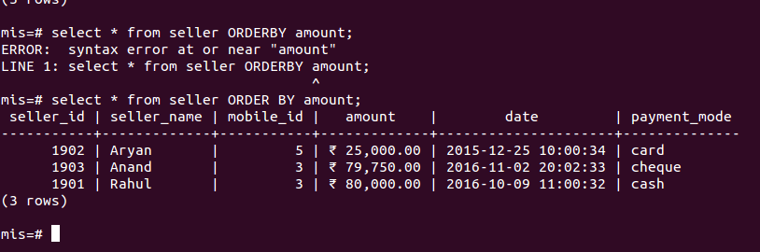
Descending order:-

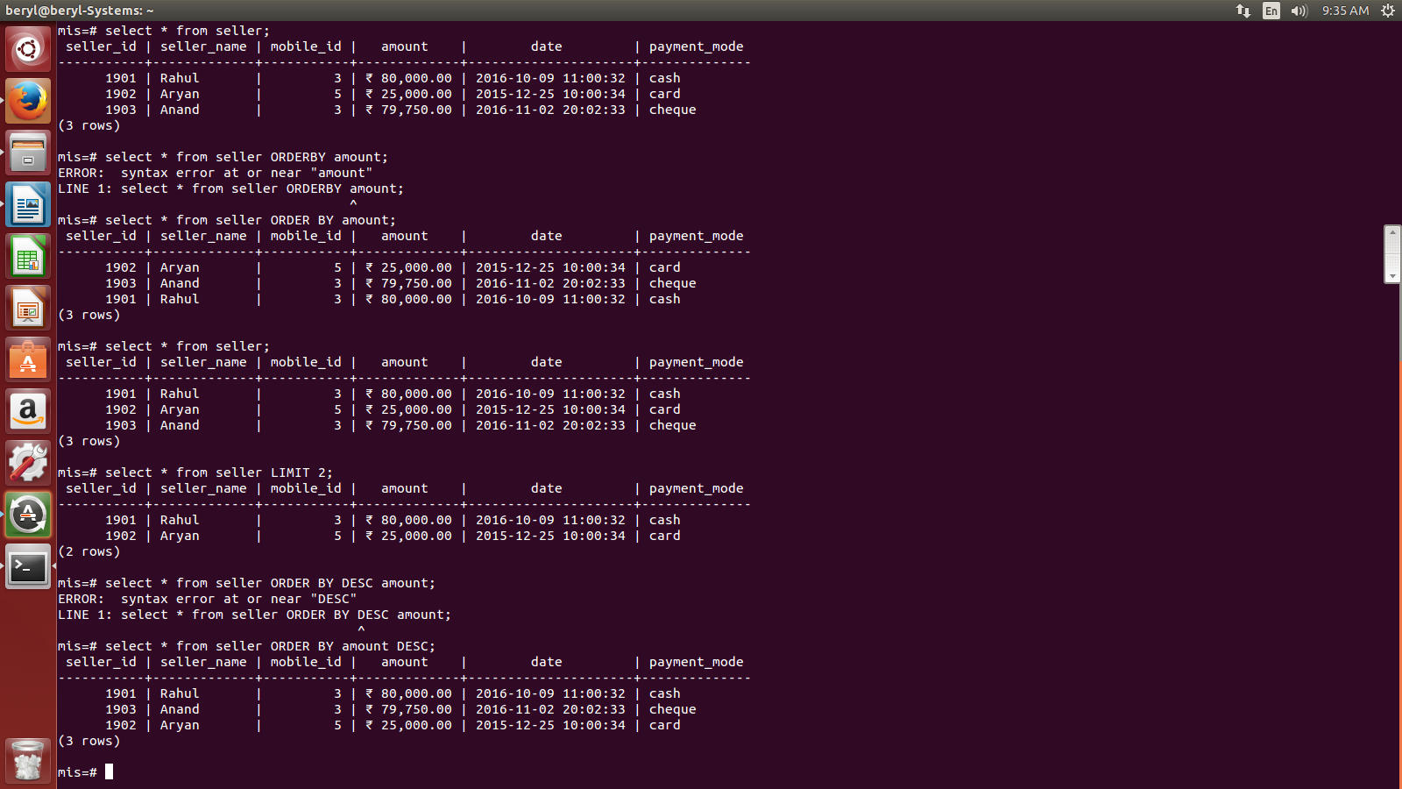

LIMIT keyword is used to limit the number of rows in the resultant query.
