GITHUB

- What are versioning tools?

- Versioning tools or versioning control systems is basically a repository of files, often the files for source code of computer programs, with monitored access. Every change made to the source is tracked, along with who made the change, why they made it, and reference to problems, or enhancements introduced, the change. Here, multiple developer create software saving it to a centralized repository.

Example of versioning tools are github, SourceForge, Google code, CVS, arch etc.

- What is Git? Why it is used?

- Git is an open source version control system that was started by Linus Trovals in 2005. It basically allows us:
  - To revert the file to previous or earlier state.
  - To see who modified what?
  - Compare changes over time.

It is basically a command line tool.

- What is Github?

- Github is basically a cloud based website or a web based graphical tool that runs git software

- What is cloud computing? What are its benefits?

- Cloud computing means storing and accessing over data and programs over the internet insted of our computer's hard disk.

Benefits:-
- Risk minimized
- Storage, server etc. Can be shared
- Scalability
- Pay as you go
- Multitanency

Example of cloud somputing servers are amazon, reckspace, digital etc.

- What is repository?

- A repository is a location where all the files for a particular project are stored, usually abbreviated to “repo”. Each project will have its own repo, and can b e accessed by a unique URL.

There are two types of repository:-
- centalized repository or server
- client repository

- What are the steps to install git?

- From shell, install git using,
sudo apt-get install git
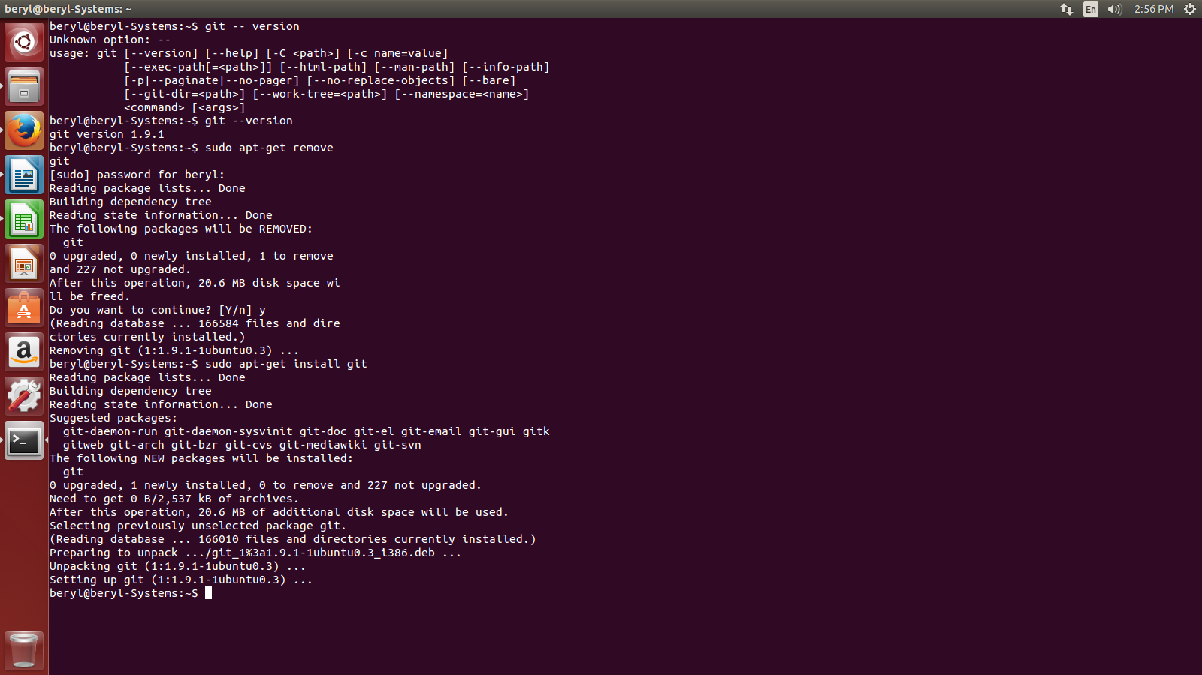

- How to check the version og installed git?

- We use git --version to check the version of installed git.
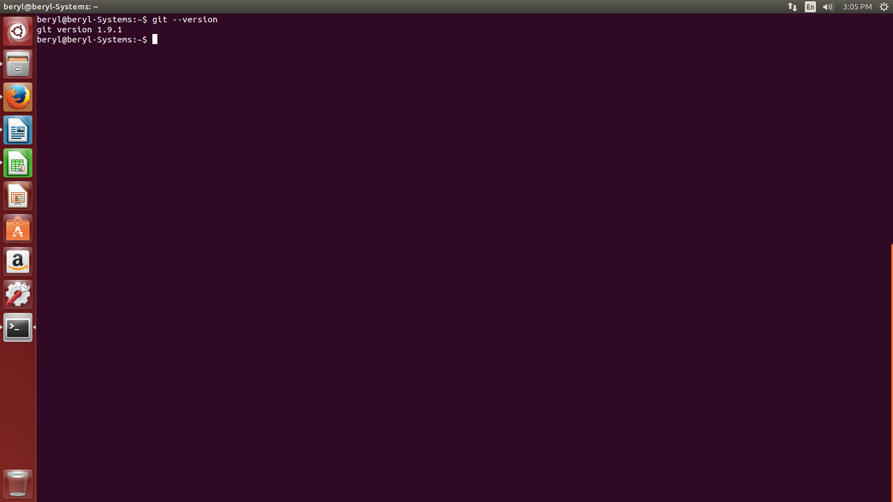
- How to update git version?

- We use sudo apt-get update command to update git.

- What are the steps to create a github account?

- The steps to create github account are as follows:-
  - Go to github.com
  - Click Signup.
  - Enter your username, email and password.
  - Select your plan(free repository)
  - Tailor the experience

Account has been created. Start your project by verifying your email address.

- What are the steps to create repository?

- The steps to create repository are as follows:-
  - Start a project
  - Enter repository name
  - Write description(optional)
  - Select public or private
  - Click create repository

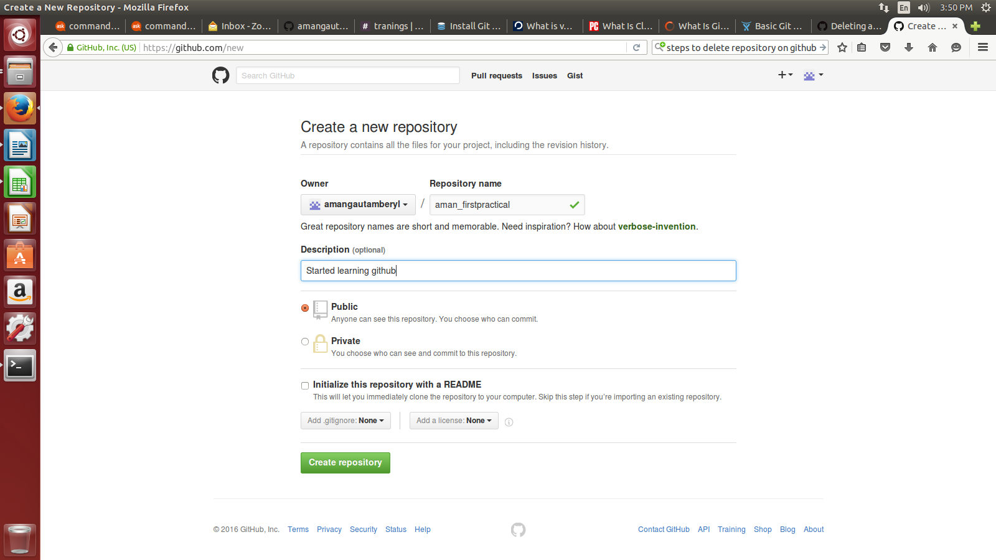

- What are the steps to upload file to repository?

- The steps to upload file to repository are:-

  - git init

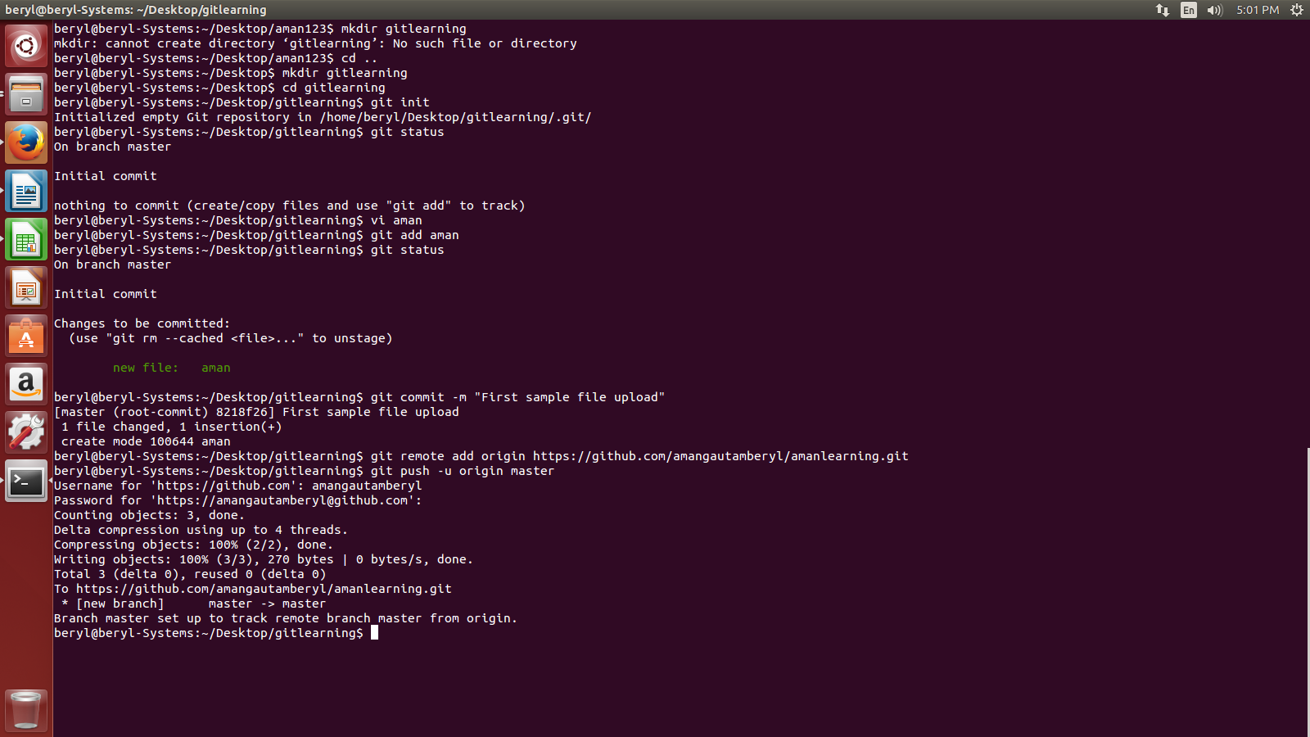
  - git add
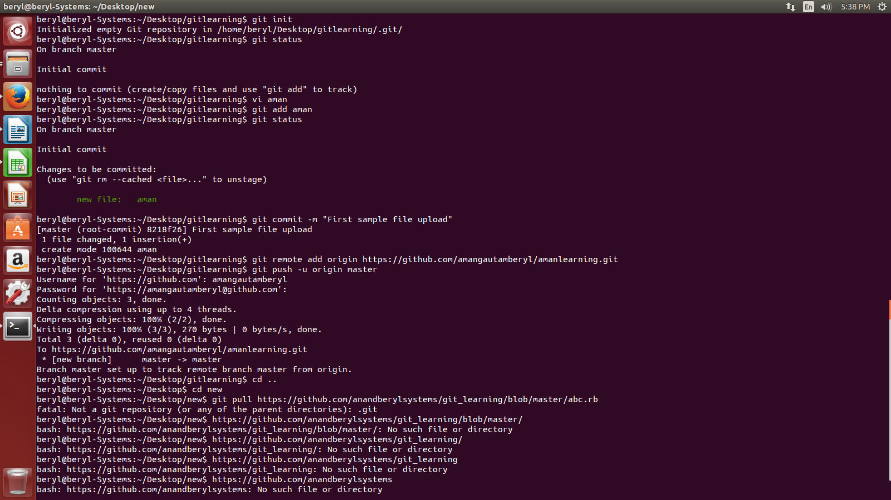

  - git commit -m “Relevant Status”

  - git remote origin
  - git push -u origin master
- How to clone repository data?

- git clone is used to download a file to our pc.

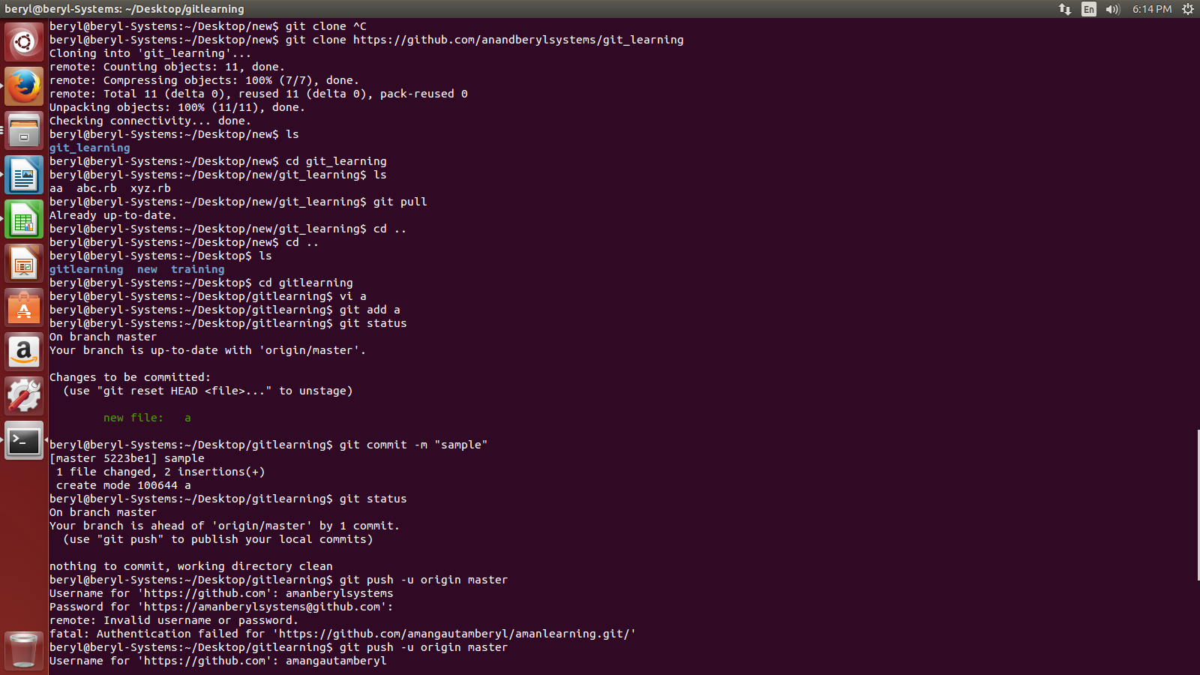

- What does git status command meant for?

- What is pull command in Linux?
