LINUX BASICS

Introduction to Linux:-

(http://www.javatpoint.com/linux-distributions , https://www.digitalocean.com/community/tutorials/an-introduction-to-linux-basics )

- What is linux?

- LINUX is one of the popular version of UNIX OS.
- It is open source as its source code is freely available.
- It is free to use.
- It was designed considering UNIX compatibility.

- Explain the History of LINUX?

- LINUX began in 1991 with the commencement of a personal project by Finnish student Linus Torvalds to create a new free Operating System Kernel.

- What are the benefits of LINUX over other Operating System?

- Portable- Free to use and distribute
- Free Support- through helpsite, blogs and forums
- Reliable
- Live CD/USB- run without installing it directly from CD/USB
- Develop Free Open Source OS
- Security
- Flexibility
- Resistant to malware such as spyware,adware and viruses.
- Multiuser
- Multitasking
- Hierarchical File system
- Shell

- What is a terminal?

- It is an interface in which we can type and execute text based commands.

- Explain the structure of Linux OS?

- An OS is a collection of software, each designed for a specific reason or function.
- LINUX basically has the following components:-
  - Kernel
  - System Libraries
  - System Tools
  - Development Tools
  - End User Tools

- What is a Kernel?

- Kernel is the core of the operating system. It establishes the communication between devices and software. Moreover, it manages the system resources. Its responsibilities are:-
  - Device Management
  - Memory Management
  - Process Management
  - Handling System Calls

- What are System Libraries?

- System Libraries are special programs that helps in accessing the kernel's features.

- Explain Linux Distributions?

- Other Operating Systems like Microsoft combine each bit of code internally & release it as a single package. We have to choose from the version they offer.

But LINUX is different from them, Different part of LINUX are developed by different organizations.https://www.digitalocean.com/community/tutorials/an-introduction-to-linux-basics

LINUX distributors list include Ubuntu, LINUX MINT, Debian, Red Hat Enterprise/Cent OS, Fedora etc.

- How to choose a LINUX Distributor?

- Ubuntu- works like MAC OS and easy to use.
- LINUX Mint- works like Windows & should be use by new corners.
- Desbian- provide stability but not recommended to a new user.
- Fedora- if we want to use RedHat & latest software
- RedHat- to be used commercially
- CentOS- RedHAt without trademark
- OpenSUSE- work same as Fedora but slightly older & more stable
- Arch LINUX- not for beginners beacuase every package has to bes installed by ourself.

- What is LINUX Licensing?

- Linus Torvalds has given license to GNU General Public License (GPL) version 2. It make sure that any software source code licencensed under it have to make originating source code open and freely available to all its users. Here, Freely available means code can be distributed and modified.

LINUX Directories

- What are commands?

- It is instruction given to our computer by us to do whatever we want. In Mac OS & Linux, it is called terminal whereas In Windows, it is called command prompt.

- They are executed by typing in at command line followed by pressing Enter Key. It then passes to the shell which reads the command and execute it.

- It then passes to the shell which reads the command & execute it.

- Shell is a method for the user to interact with the system. The default shell in LINUX is bash( Bourne-Again Shell)

- There are two types of commands:-
  - Built-in
  - External/Linux commands

- What are the various LINUX directory commands?

- CTRL+ALT+ T – to open LINUX terminal

- pwd - stands for print working directory. It is used to show which directory we are presently working in.
eg.

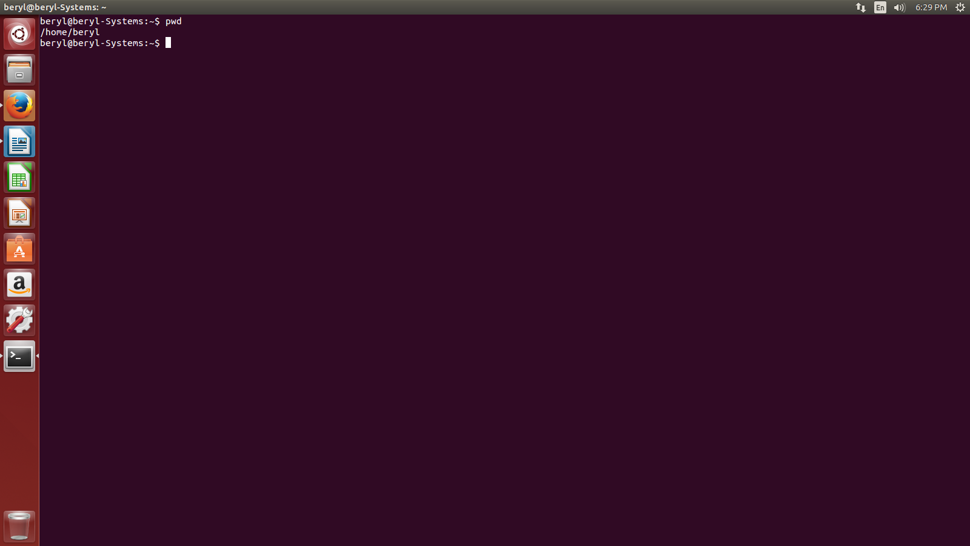

- ls – is used to show the list of folder or to see the files & directories in our current working directory.
eg.

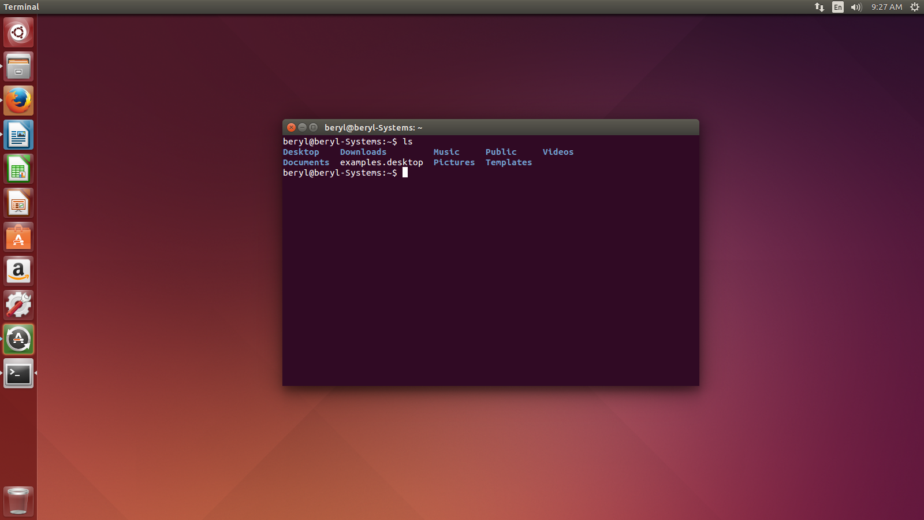

- cd – is used to change the present working directory.
eg.
