LINUX Basics

LINUX Directories:-

- What are the various directory commands?

- mkdir – stands for make directory. It is used to create our own specified directory
eg.

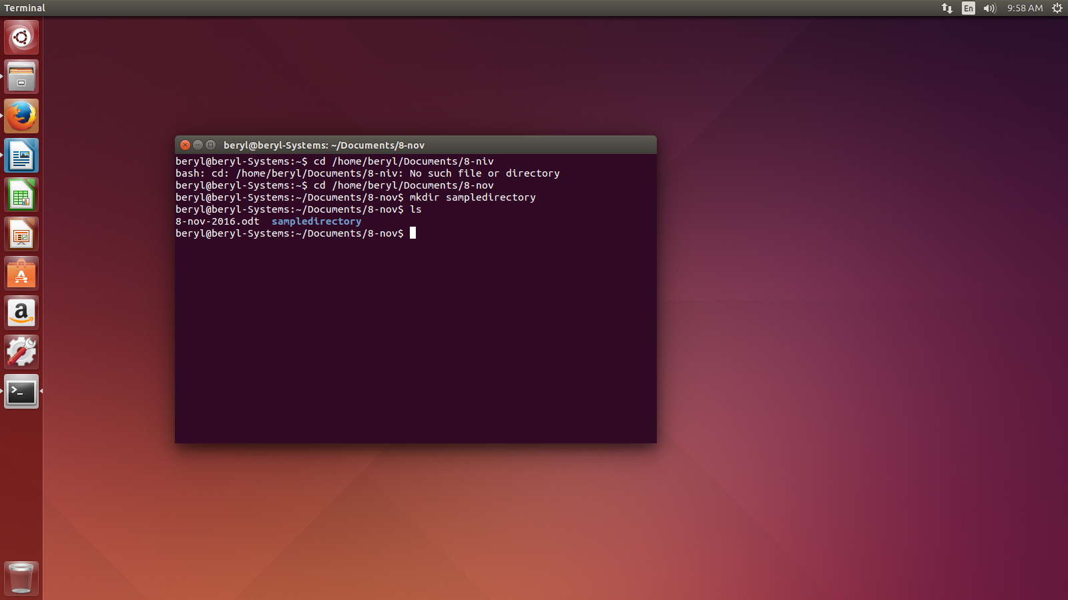
- rmdir – stands for removing directory. It is used to remove the empty directories.
eg.

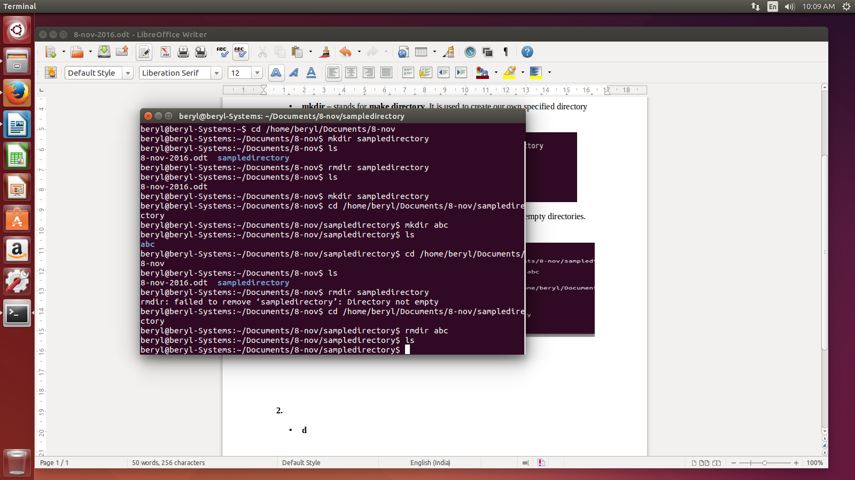

- What are the various options to use cd commands?

- The various options to use cd commands are:-

  - cd ~ - brings us to the home directory. eg.

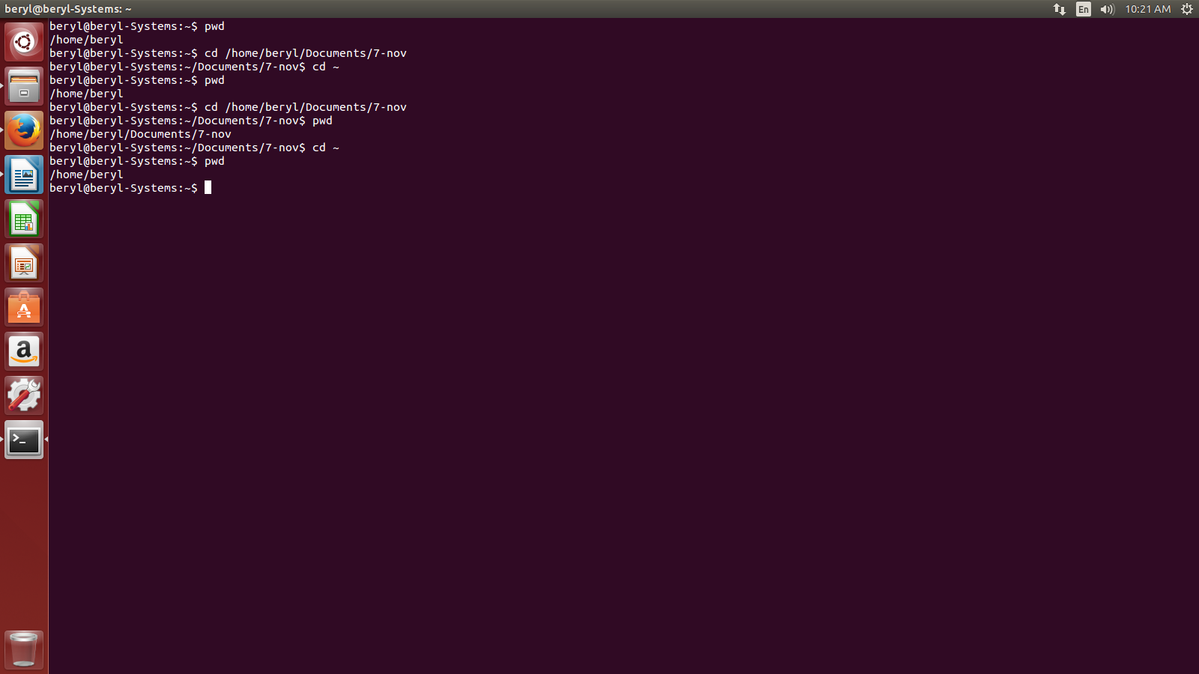

  - cd - - brings us to the previous directory of the current directory. eg.

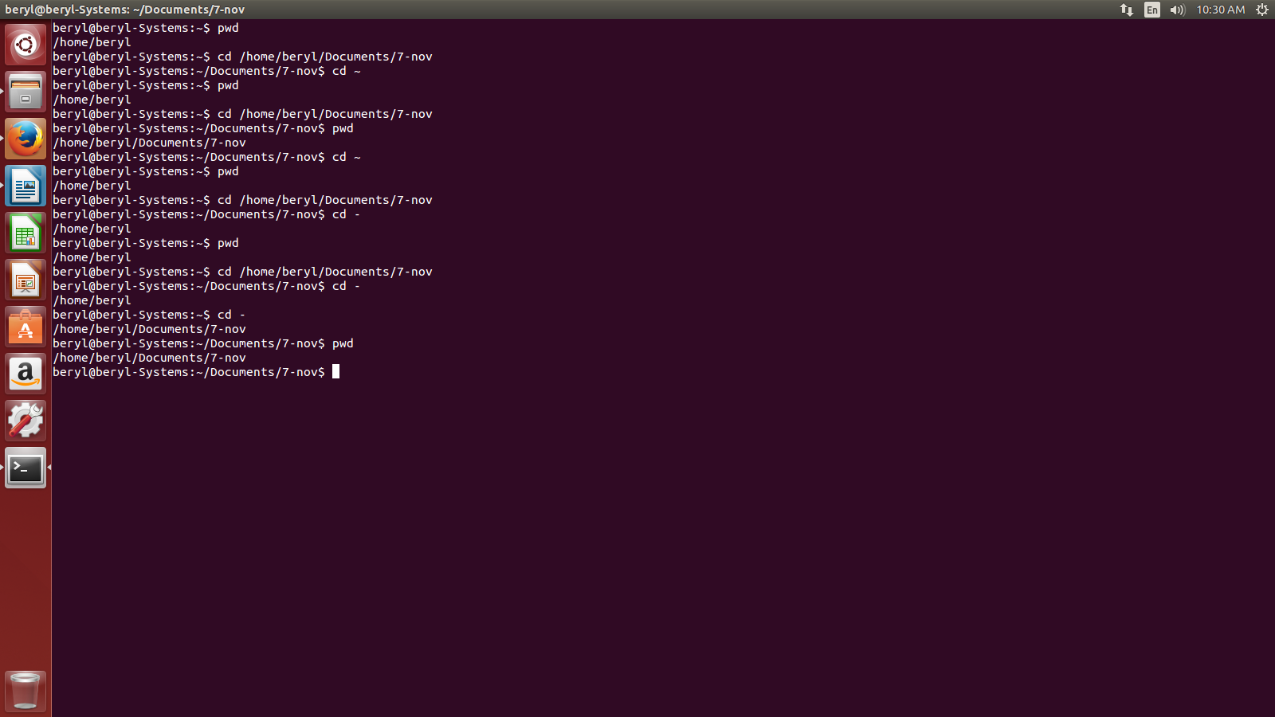

  - cd .. - brings us to the home directory of the current directory.eg.

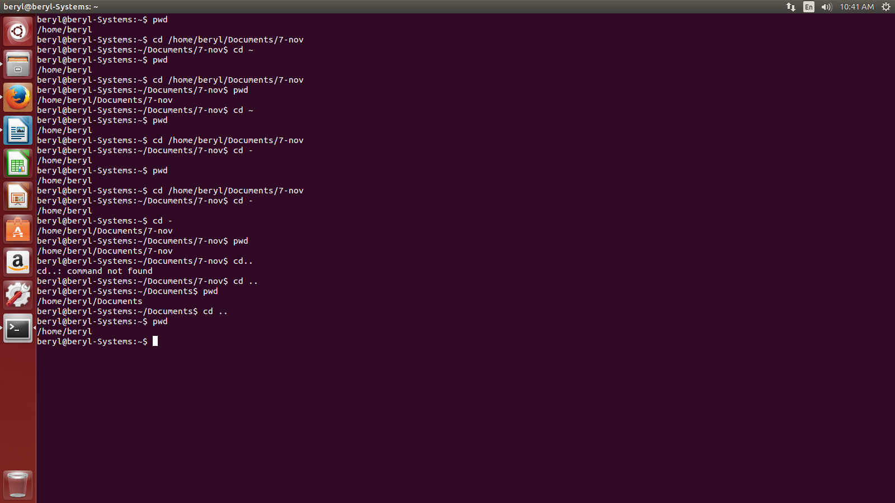
  - cd / - takes us to the entire system root directory. eg.,

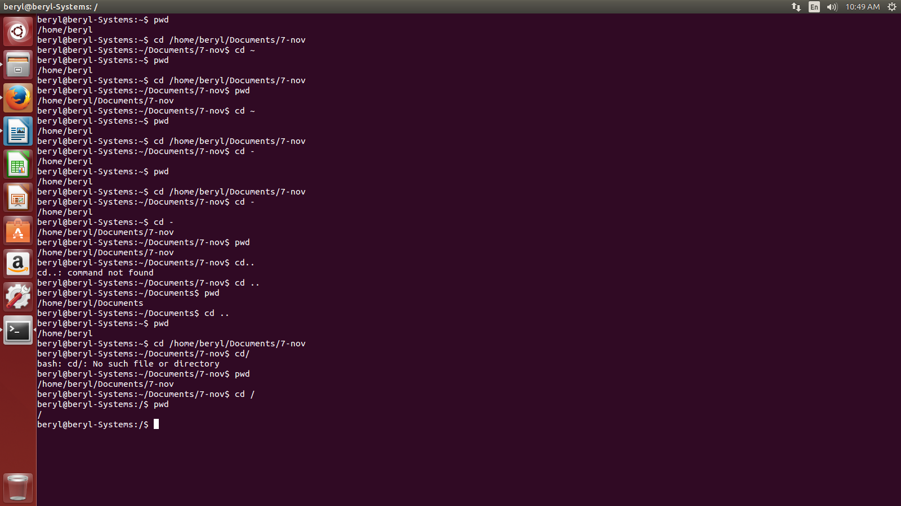

- What is ls command and what are the different options of using ls command?

- ls command is the list command in Linux that show list or content of a directory. The various options to use ls command are:-

  - ls -a – show the list of all the files including the hidden files as well. eg.,
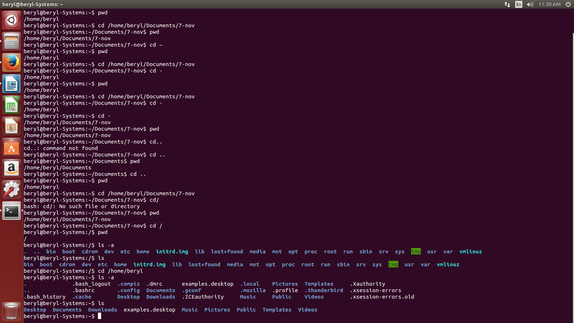
  - ls -l – shows the detailed list of the files in a folder. eg.

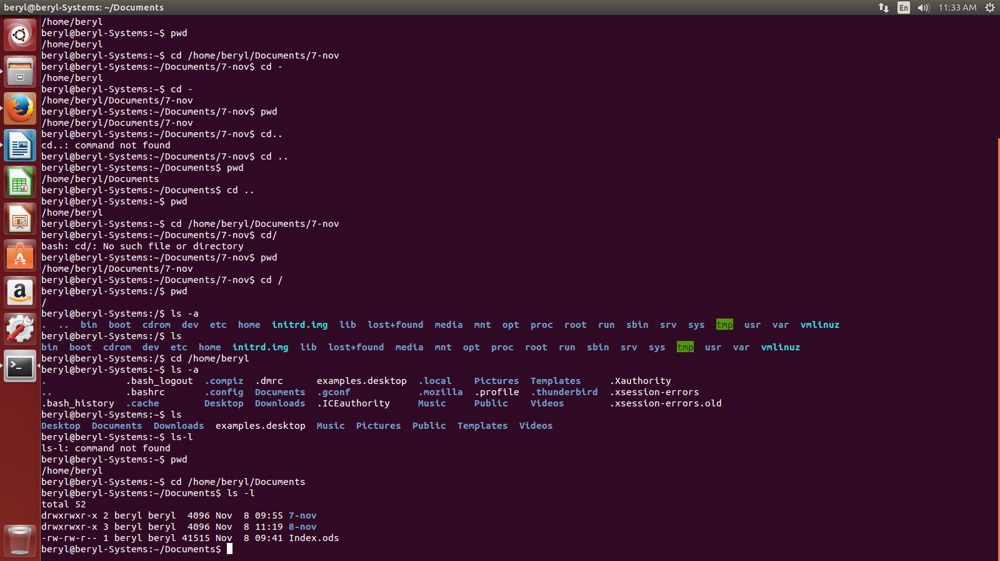
  - ls -lh – show the detailed list of the files in a human readable format. eg.,

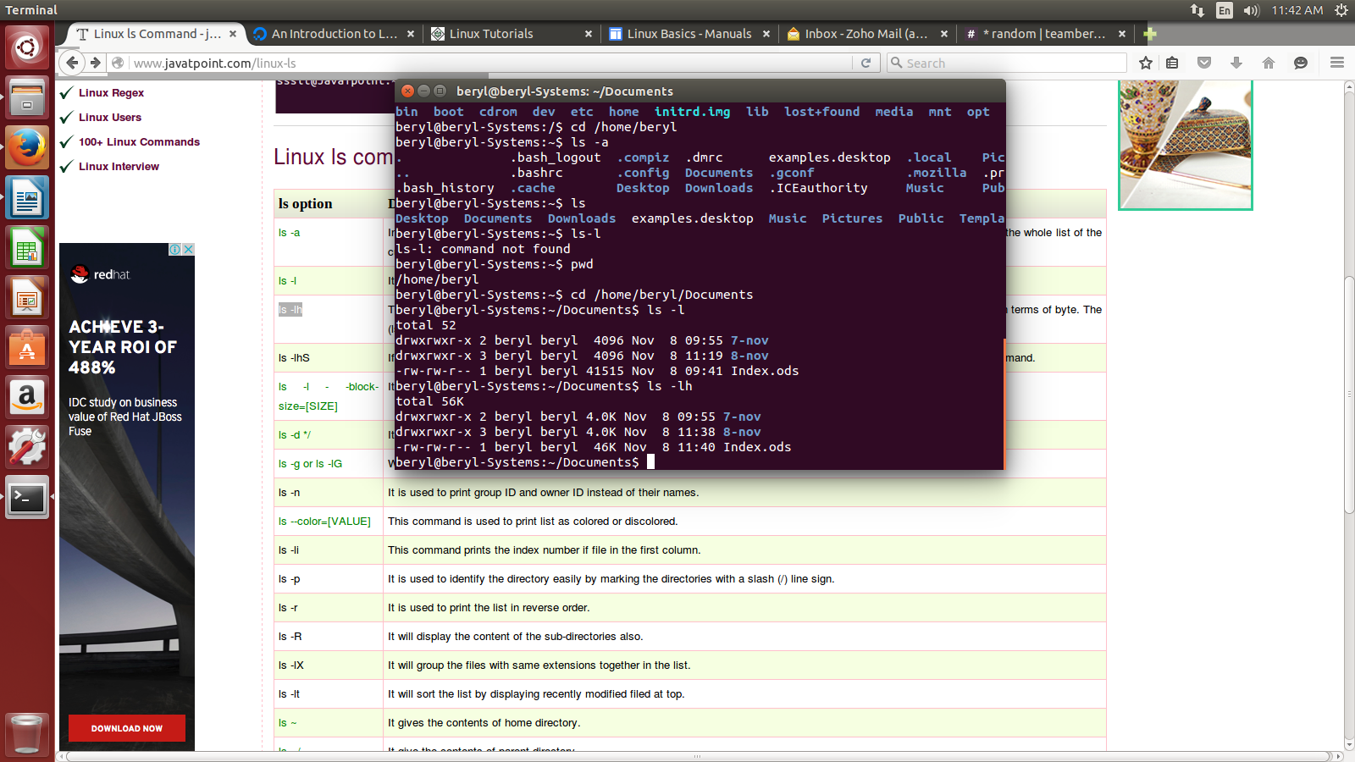

    - ls -lhS and ls -lS – show the detailed list of files according to size in descending order.

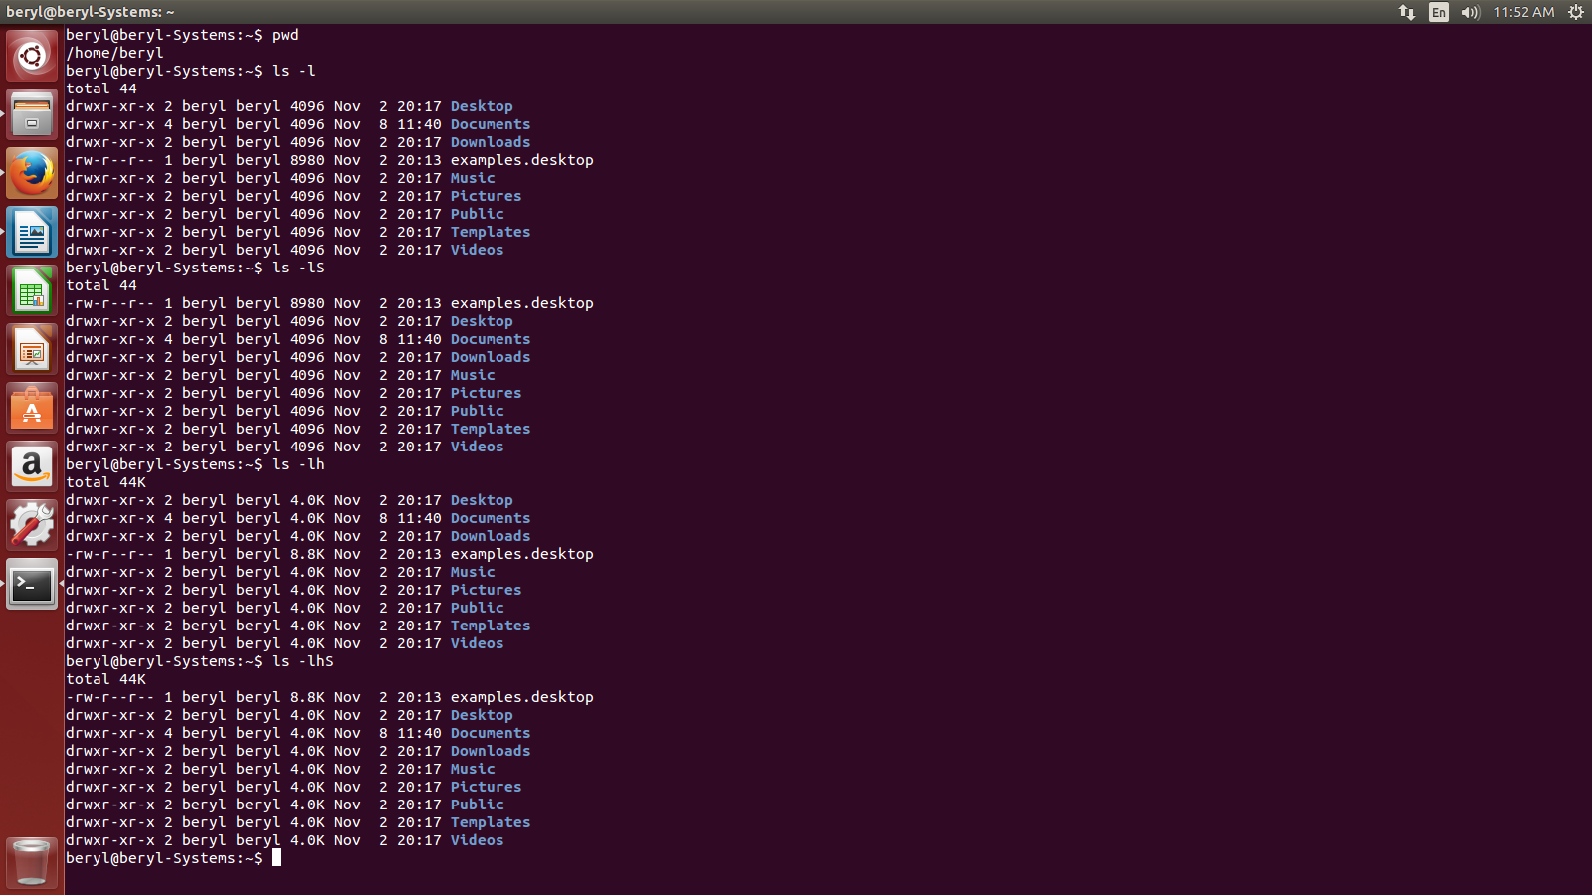

    - ls -d */ - is used to display the subdirectories of a directory.
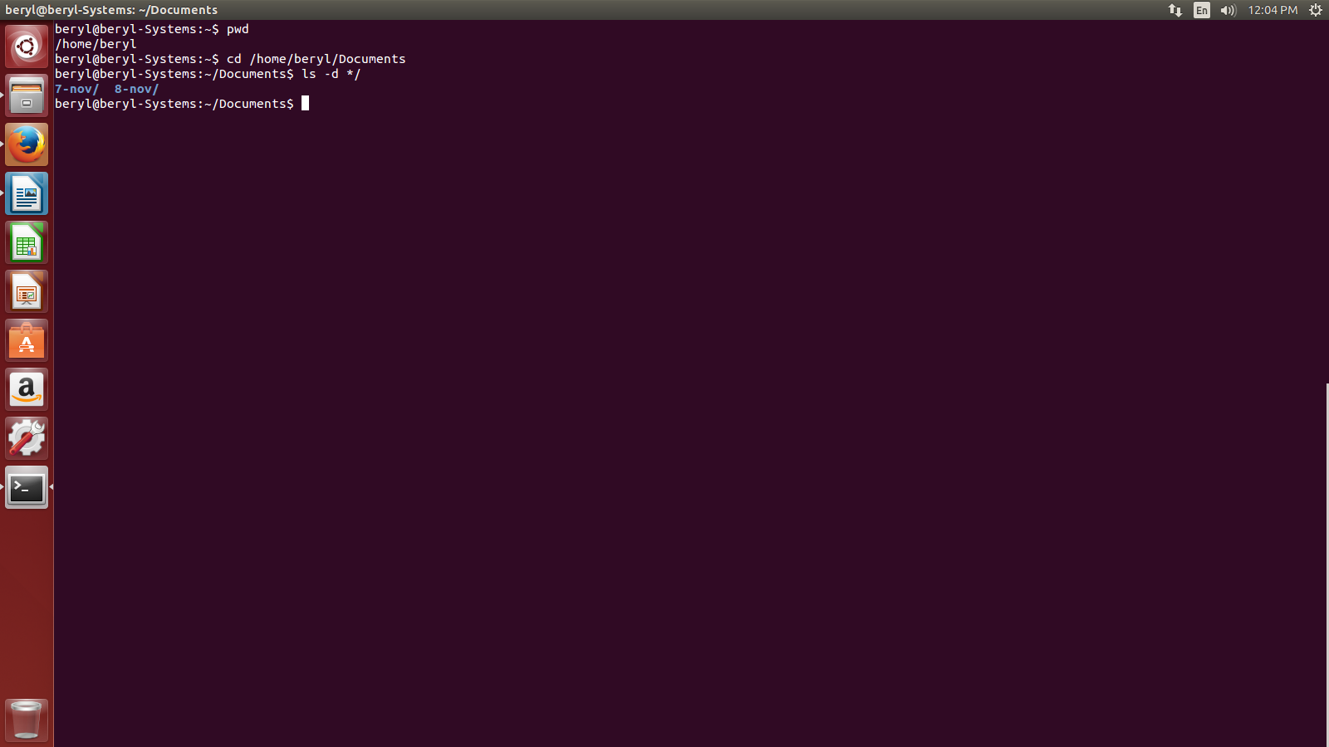

    - ls -g – is used to exclude the column of group information and owner.
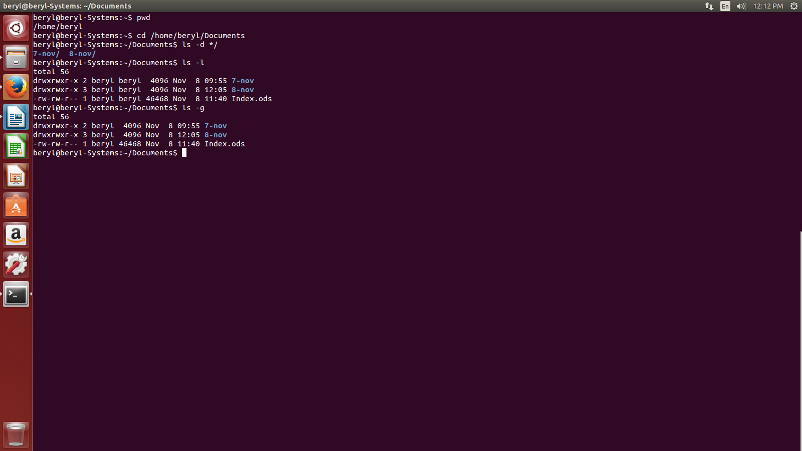

    - ls -n – is used to print the list of files in detail but here it would list the id of owner and groups rather than their names.

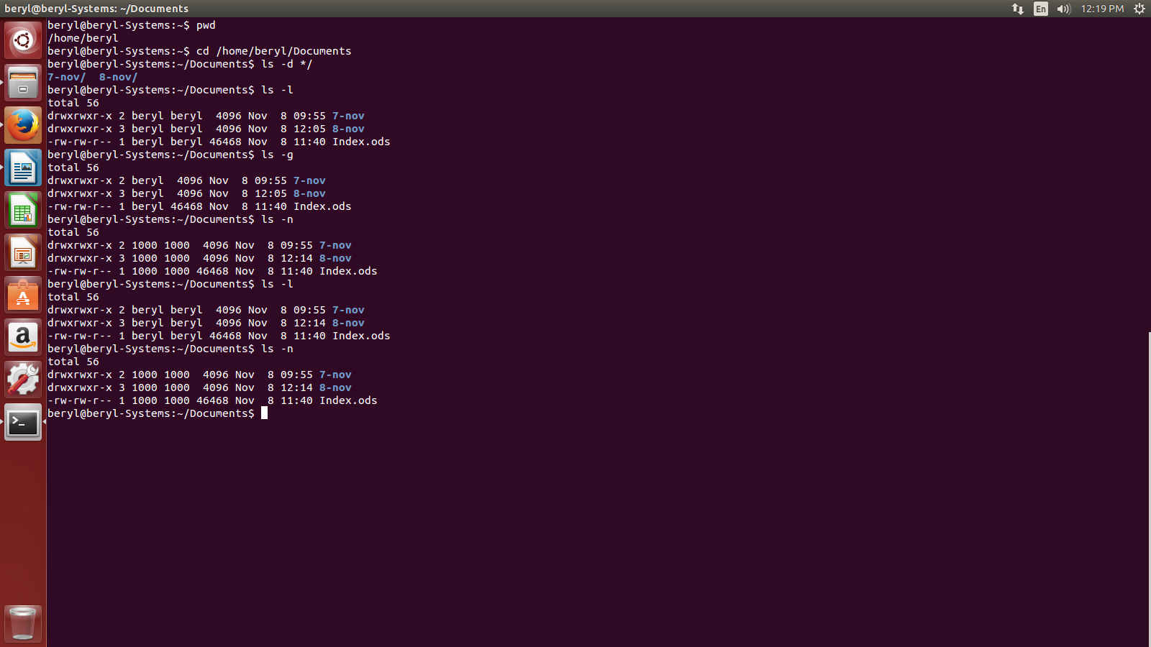

    - ls –color=[value] – is used to the change the color of the font. The value can be never, auto etc.

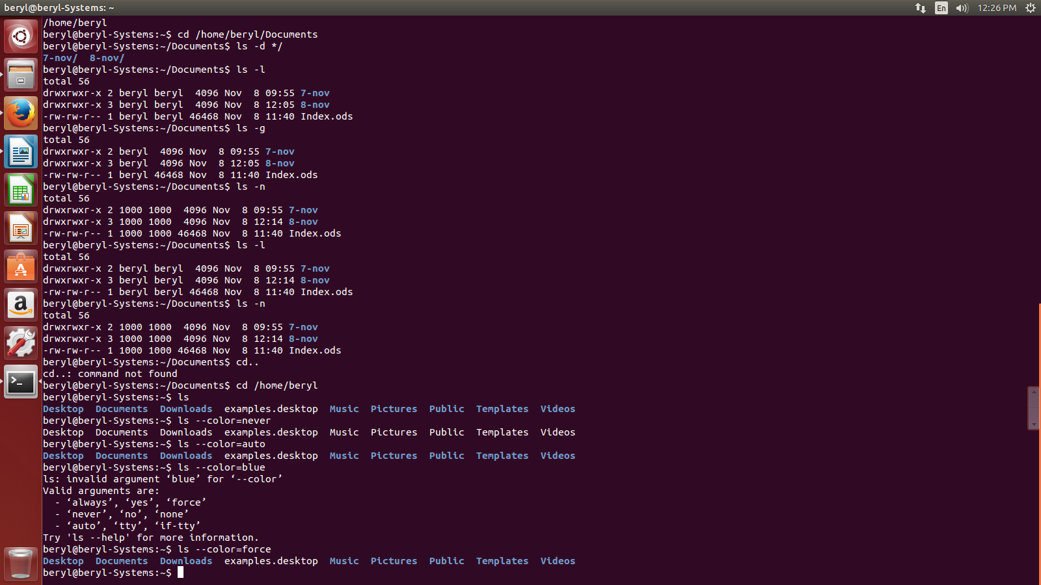
    - ls -li – is used to show the detailed list of files with an index number.eg.,
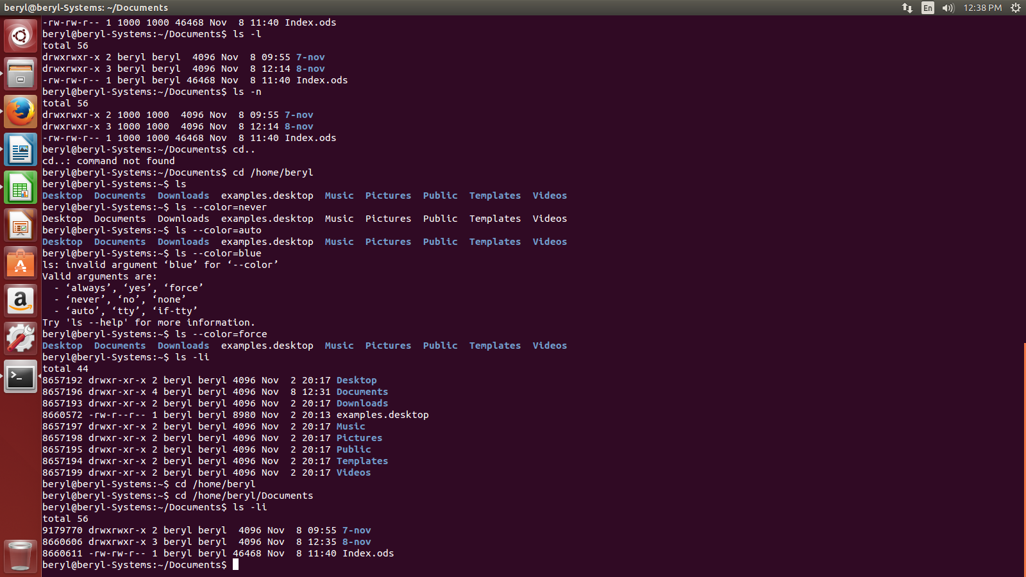
    - ls -r – is used to print the list in reverse order.

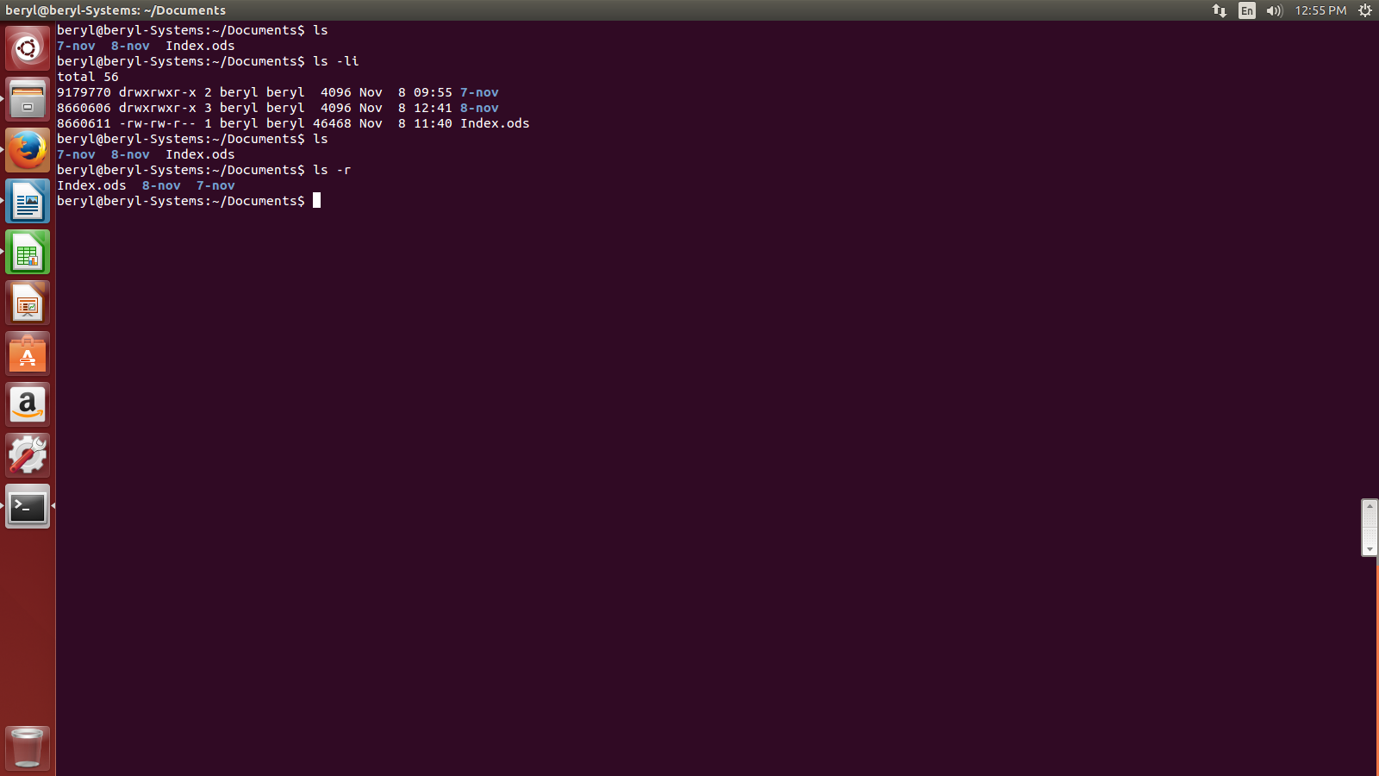

    - ls -R – is used to show the contents of subdirectories as well.eg.,

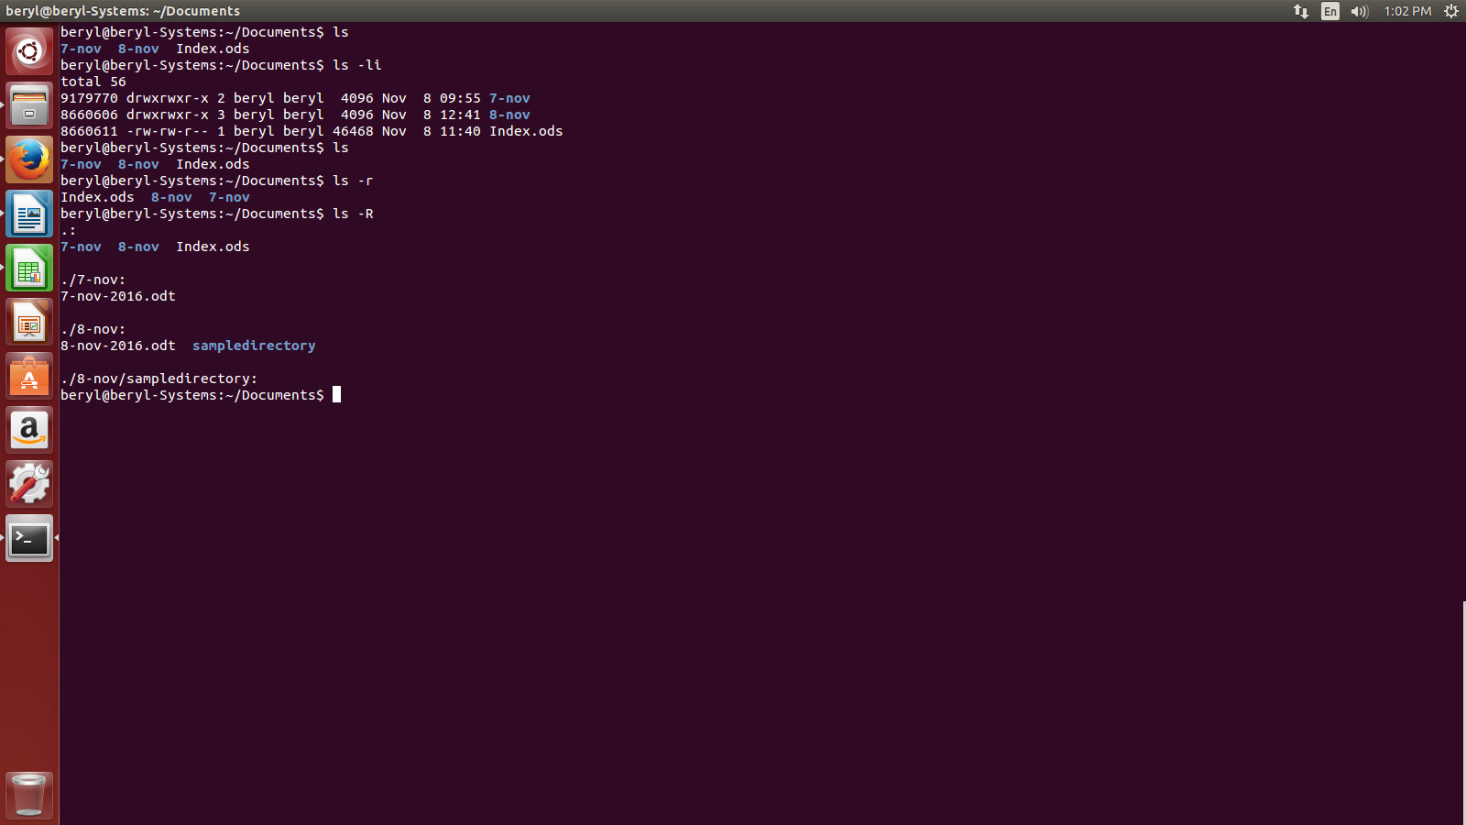

    - ls -lX – is used to show the detailed list of file by putiing the file with same extensions together.

Add directory including its sub directory.

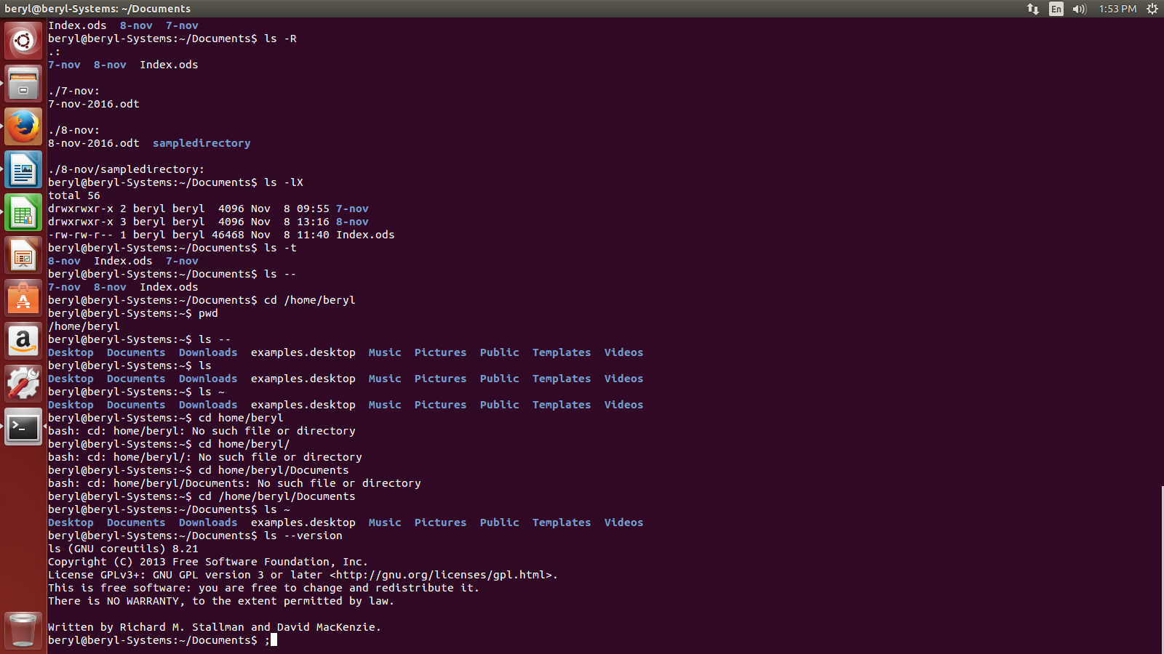
    - ls -lt – is used to show the detailed list of file in the order of recently used apps on the top.

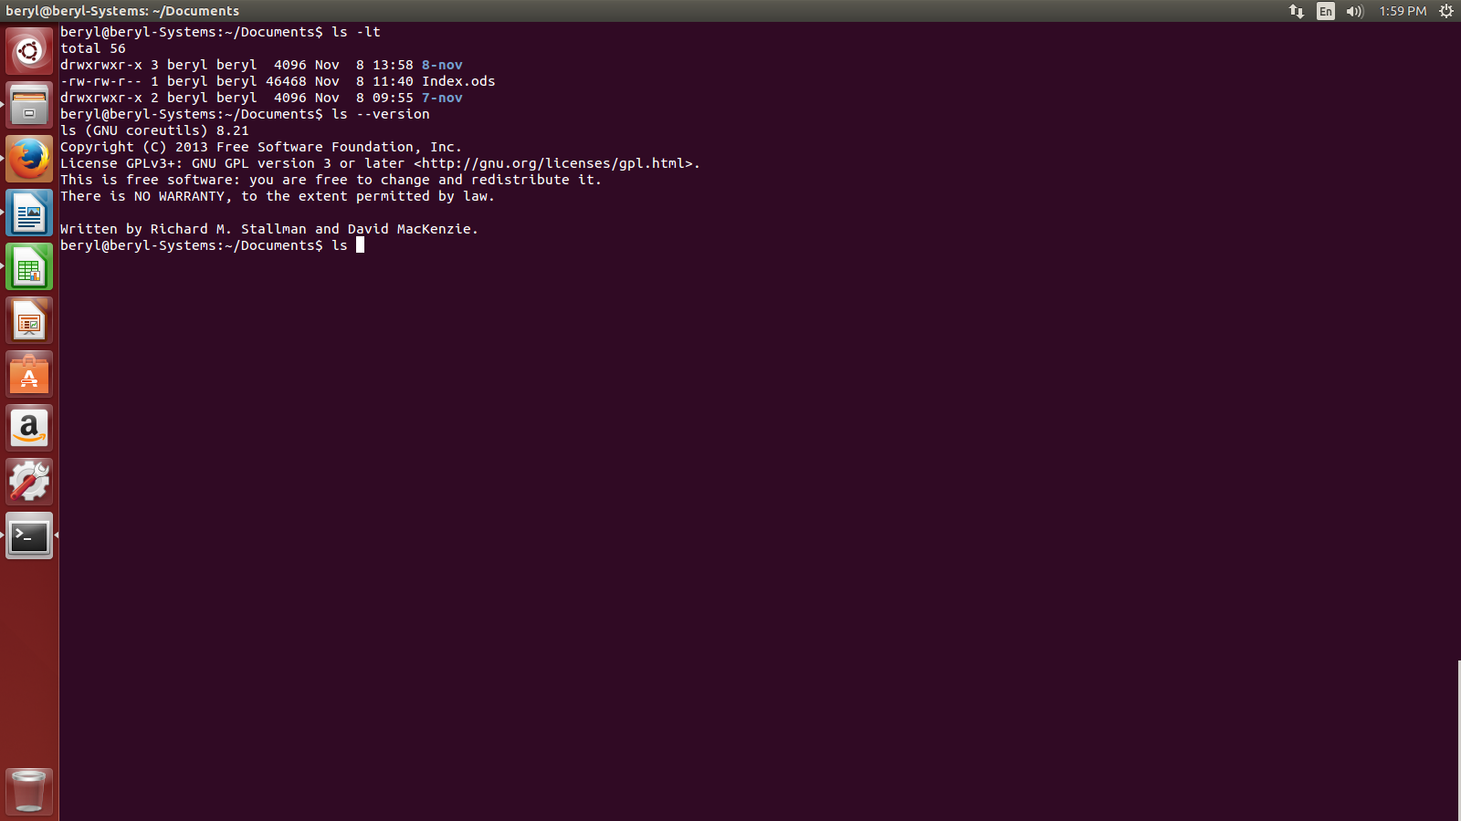
    - ls –version – is used to see the version of the ls command.

- What are the different options of using mkdir command?

- mkdir command is used to create directory.

Syntax :- mkdir <dir name>

The various options of mkdir are:-

- mkdir <dirname1> <dirname2> <dirname3>... - is used to create multiple directories.
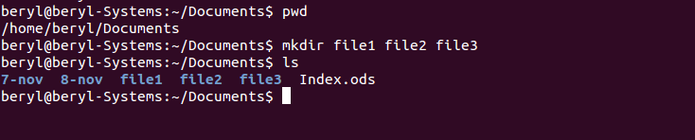

- mkdir -p - is used to create directory inside a directory. eg.,

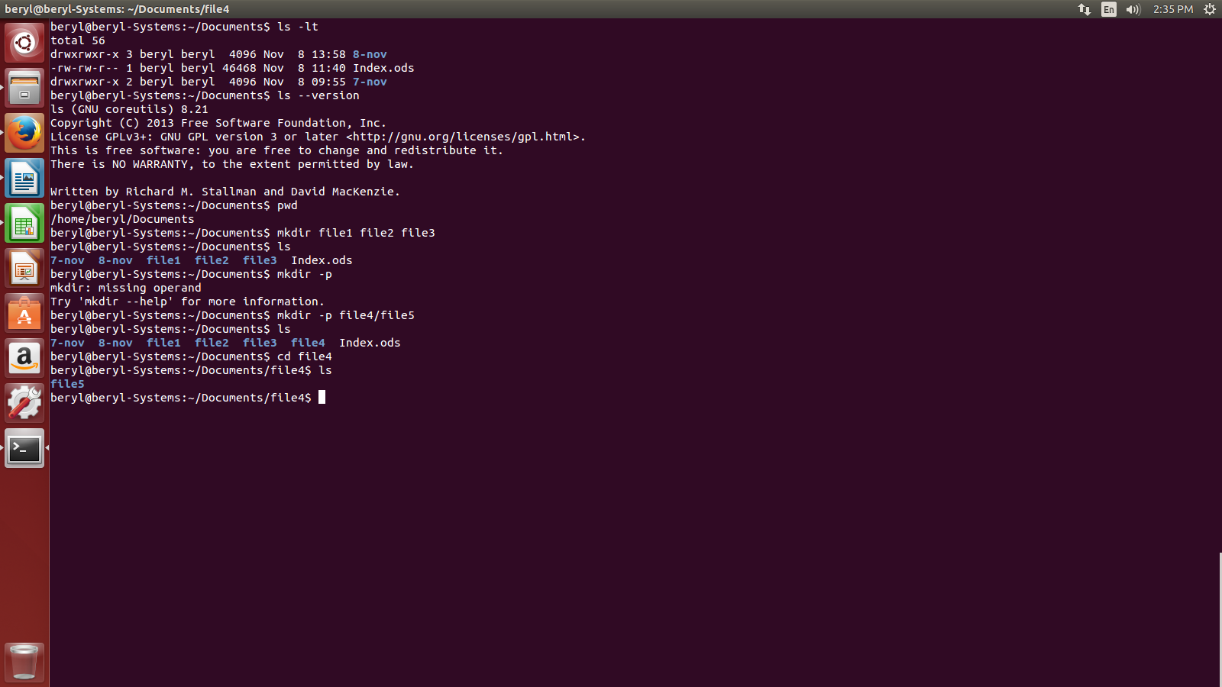

- mkdir -v – is used to create multiple directories with a message of directory creation. If it wont be able to create the directories it will print an error message. We can also use both -p and and -v together as -pv or -vp. eg.,

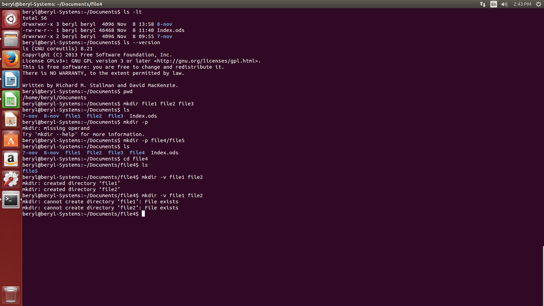

- What are the different options of using rmdir command?

- rmdir command is used to delete directory.

Syntax :- rmdir <dir name>

The various options of rmdir are:-

- rmdir -p – is used to remove directory along with its subdrirectory.

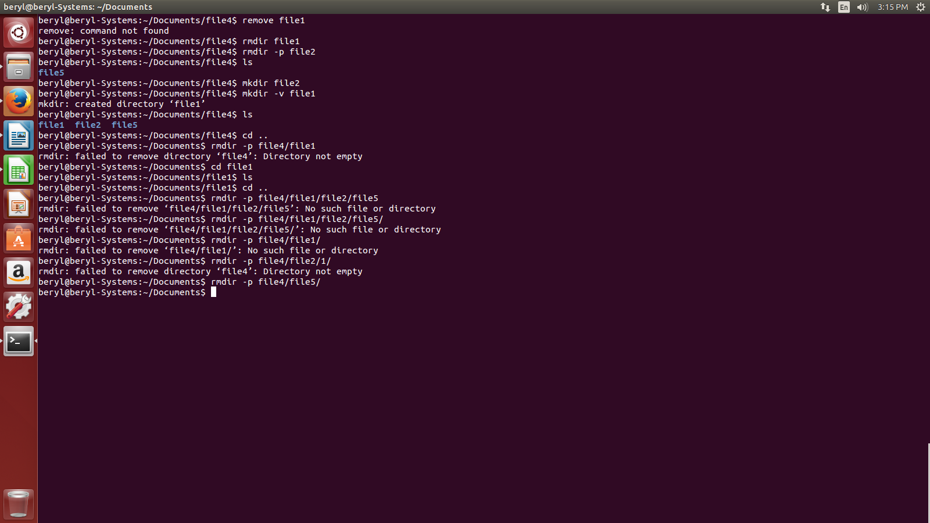

LINUX Files:-

- What are files in LINUX and their types?

- In LINUX, everything is a file. If in case, it is not a file then it is a process. A file doesnt include only text files, images and compiled programs but also include partitons, hardware device drives and directories.

- There are basicsally 3 types of files in LINUX. They are:-
- Regular files (-) - contains programs , text files and executable files.
- Directory files (d) – contains the list of files and is shown in blue color.
- Special files -
  - Block file (b)
  - Character file (c)
  - Named pipe file (p)
  - Symbolic link file (l)
  - Socket file (s)

- What are the various LINUX file commands?

- The various LINUX file commands are:-

- file - determine file type
- touch – used to create a file
- rm – used to remove a file
- cp – used to copy a file
- mv – used to move a file
- rename – used to rename a file

- What is a file command and what are its various options?

- file command is used to see the file type.
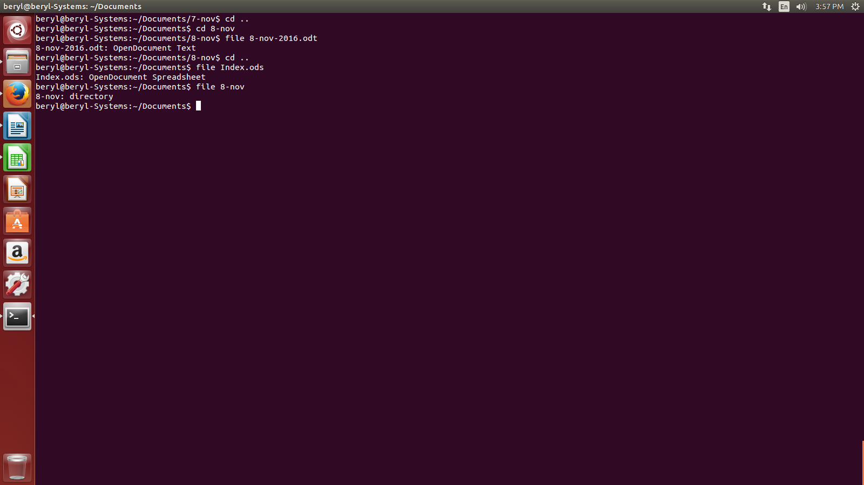

The various options of file command are:-

- file * - is used to see the type of all files in the present working directory. eg.,

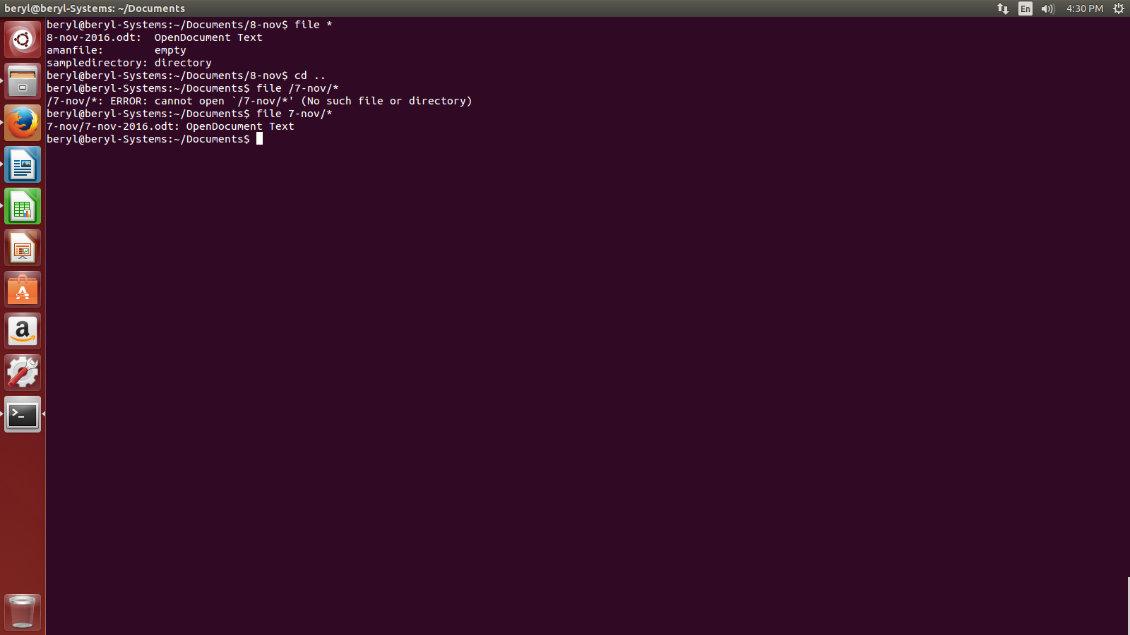
- file /directoryname/* - is used to see the types of file in a particular directory. eg.,

- file [range] – is used to find the types of all the files within a particular alpabhet range. eg.,

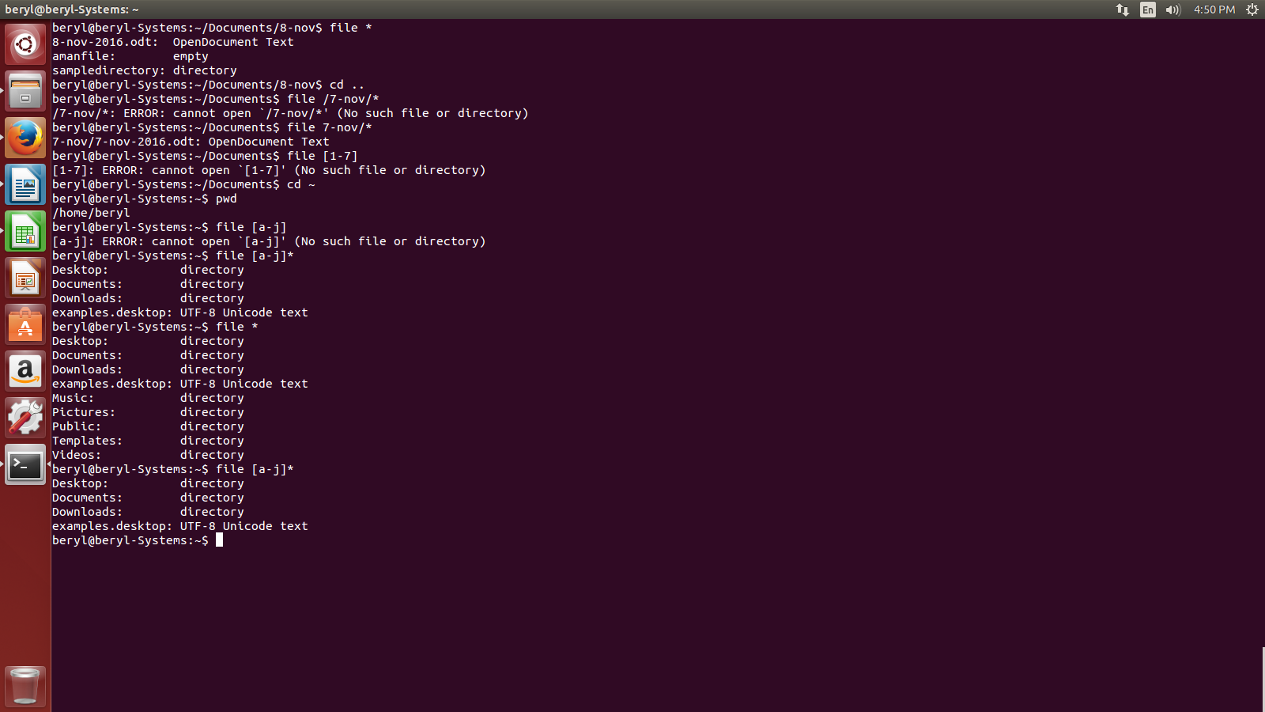
- What is touch command what are its various options?

- Touch command is used to create an empty file. e.g.,
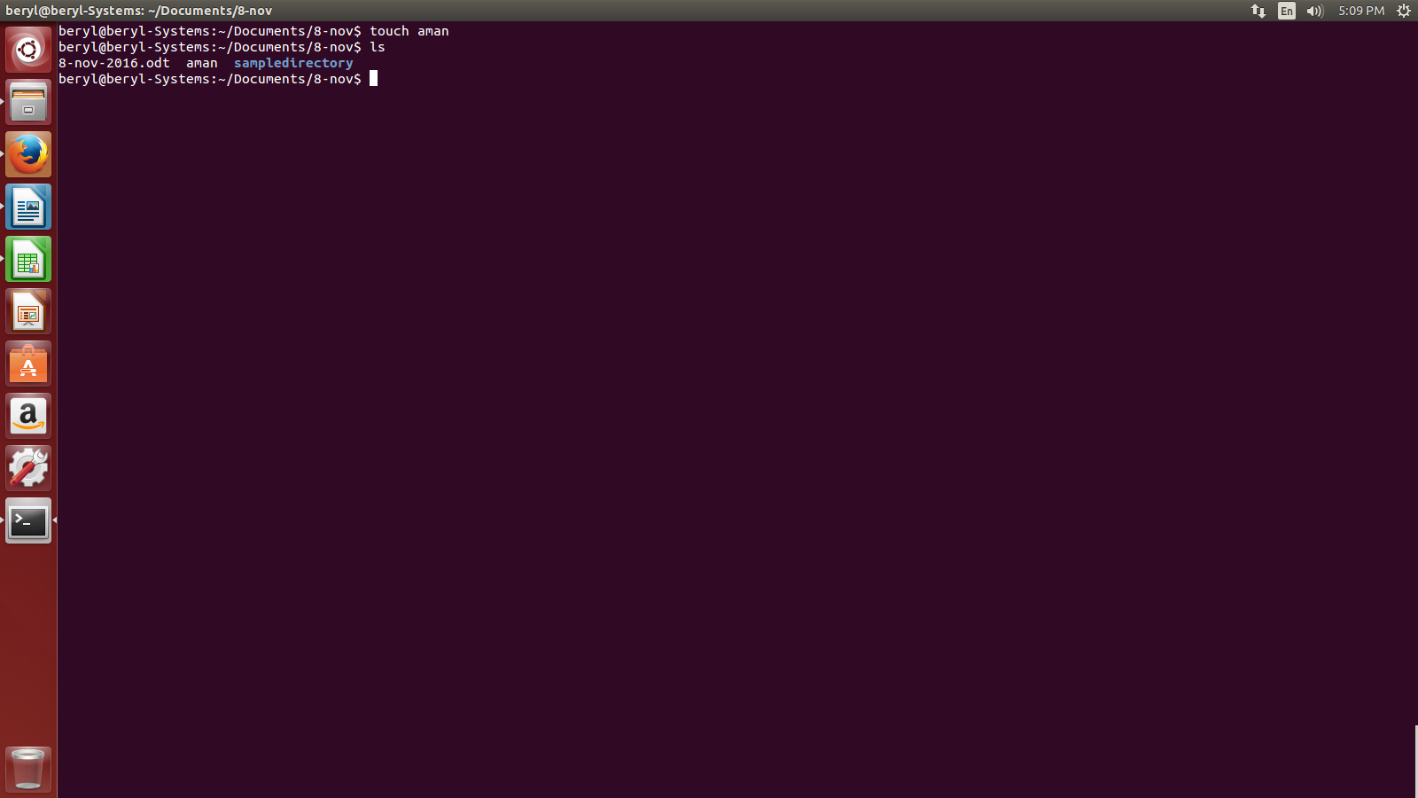
The various options of touch command are:-

    - stat – is used to see the status of a particular file.e.g,
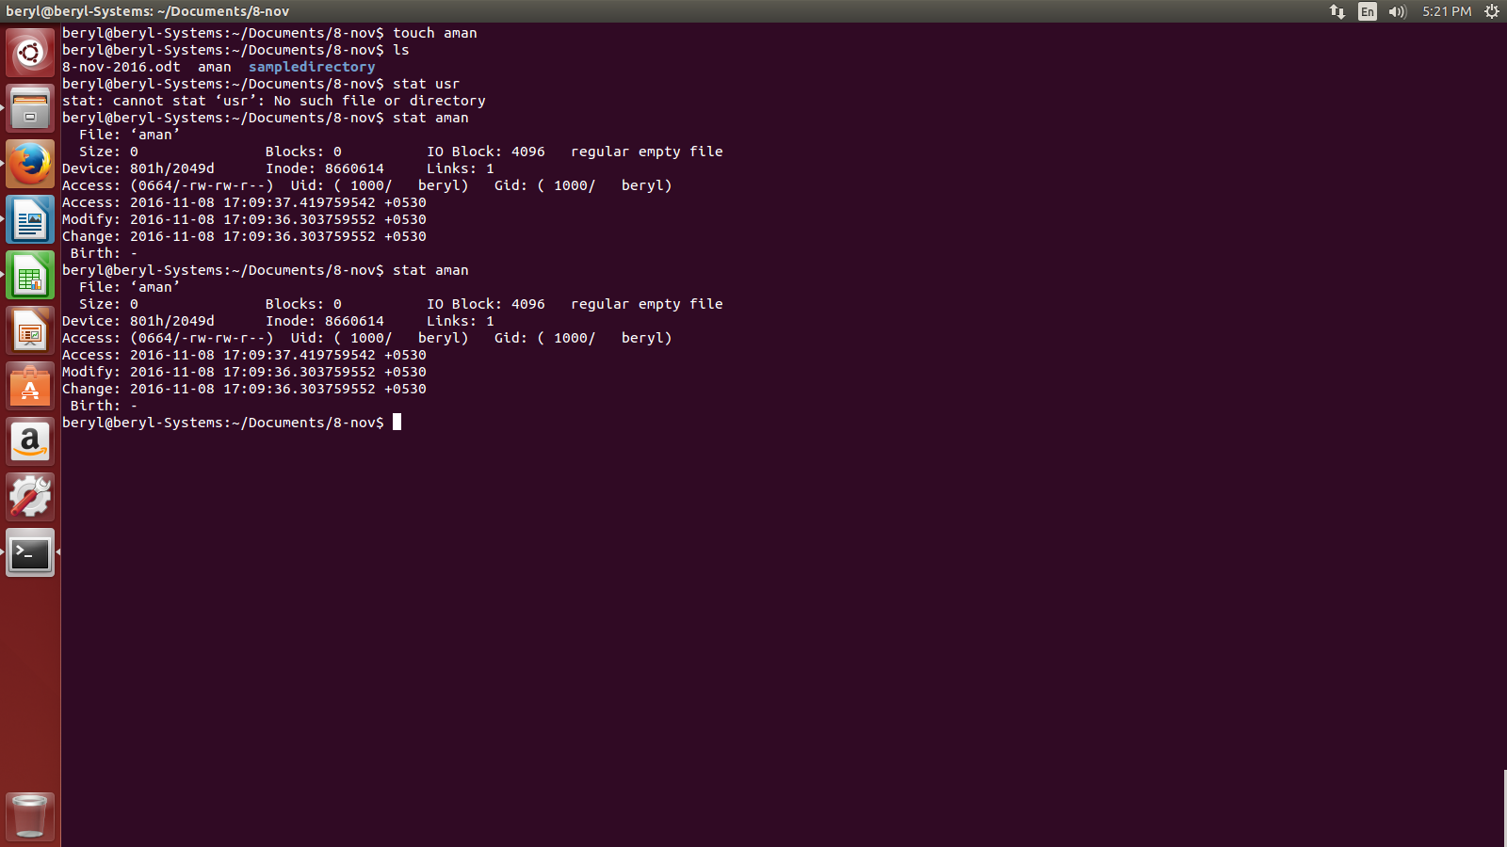

    - touch -a – is used to update the access and change time of a file. eg.,

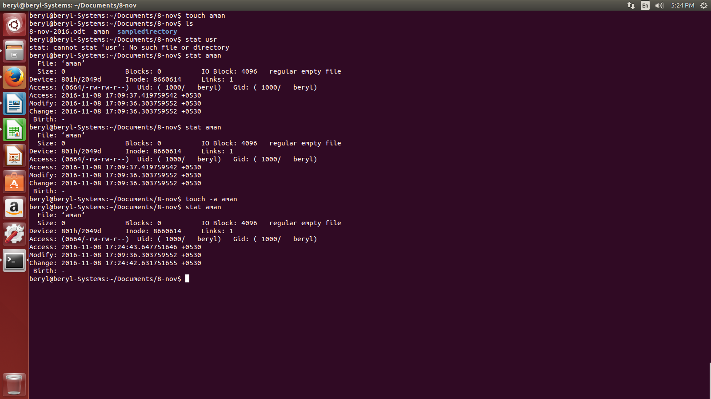
    - touch -m – is used to update only the access time of a file. e.g.,

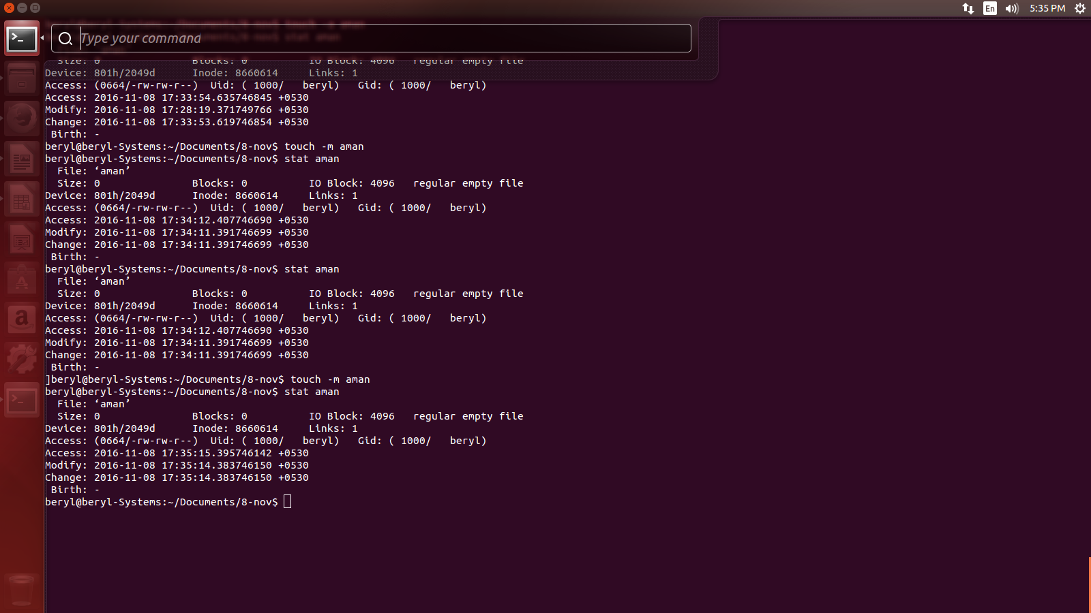
    - touch -t – is used to update the time as specified. e.g.,
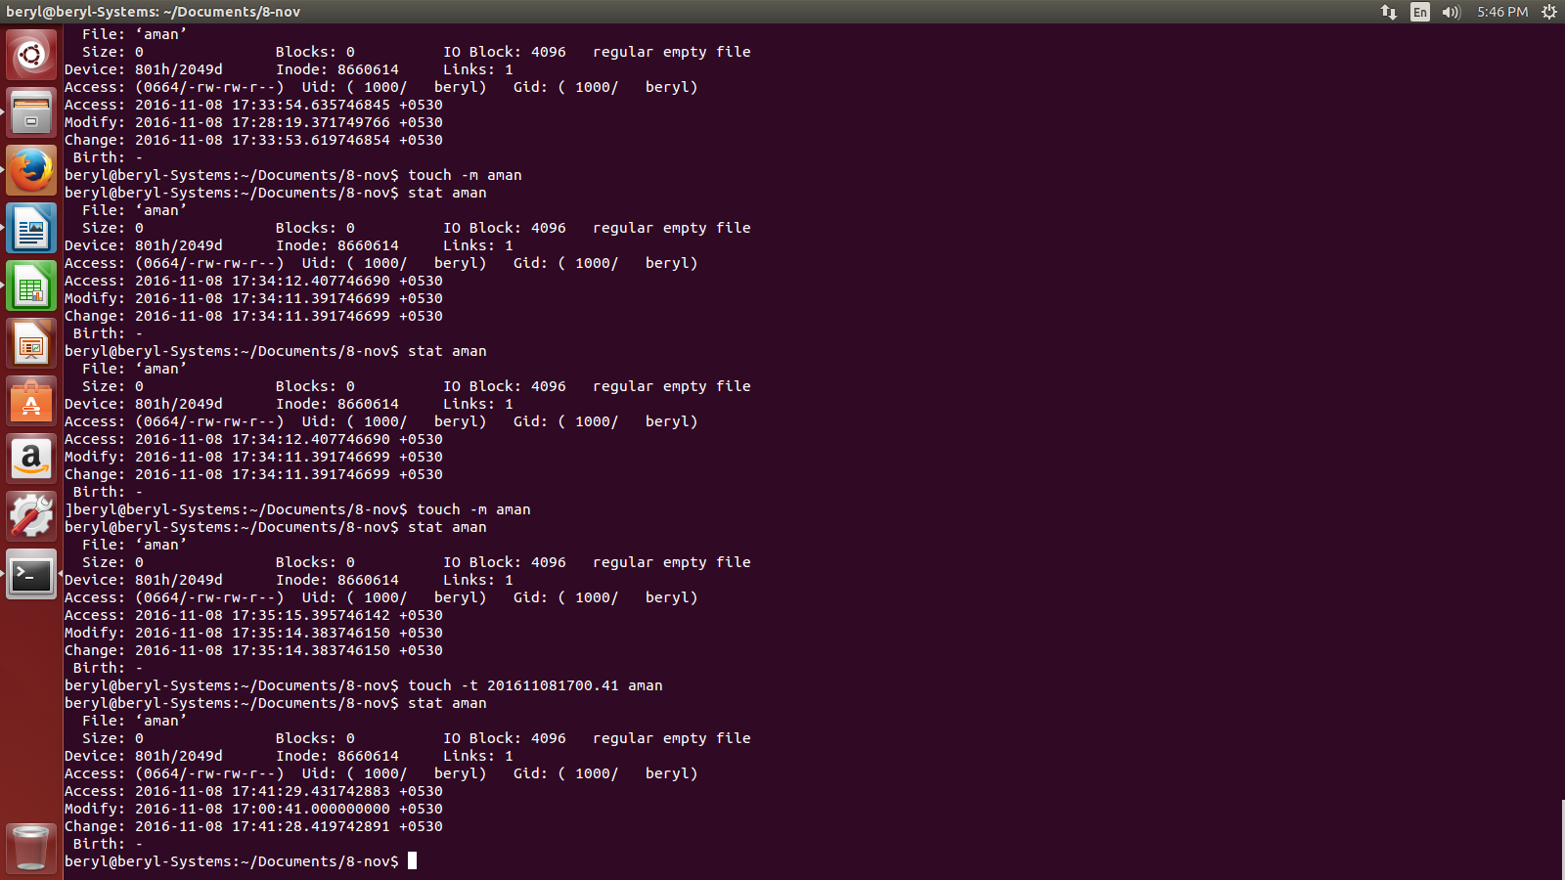

    - touch -c – will not create an empty file if the file already exists with us. e.g.,

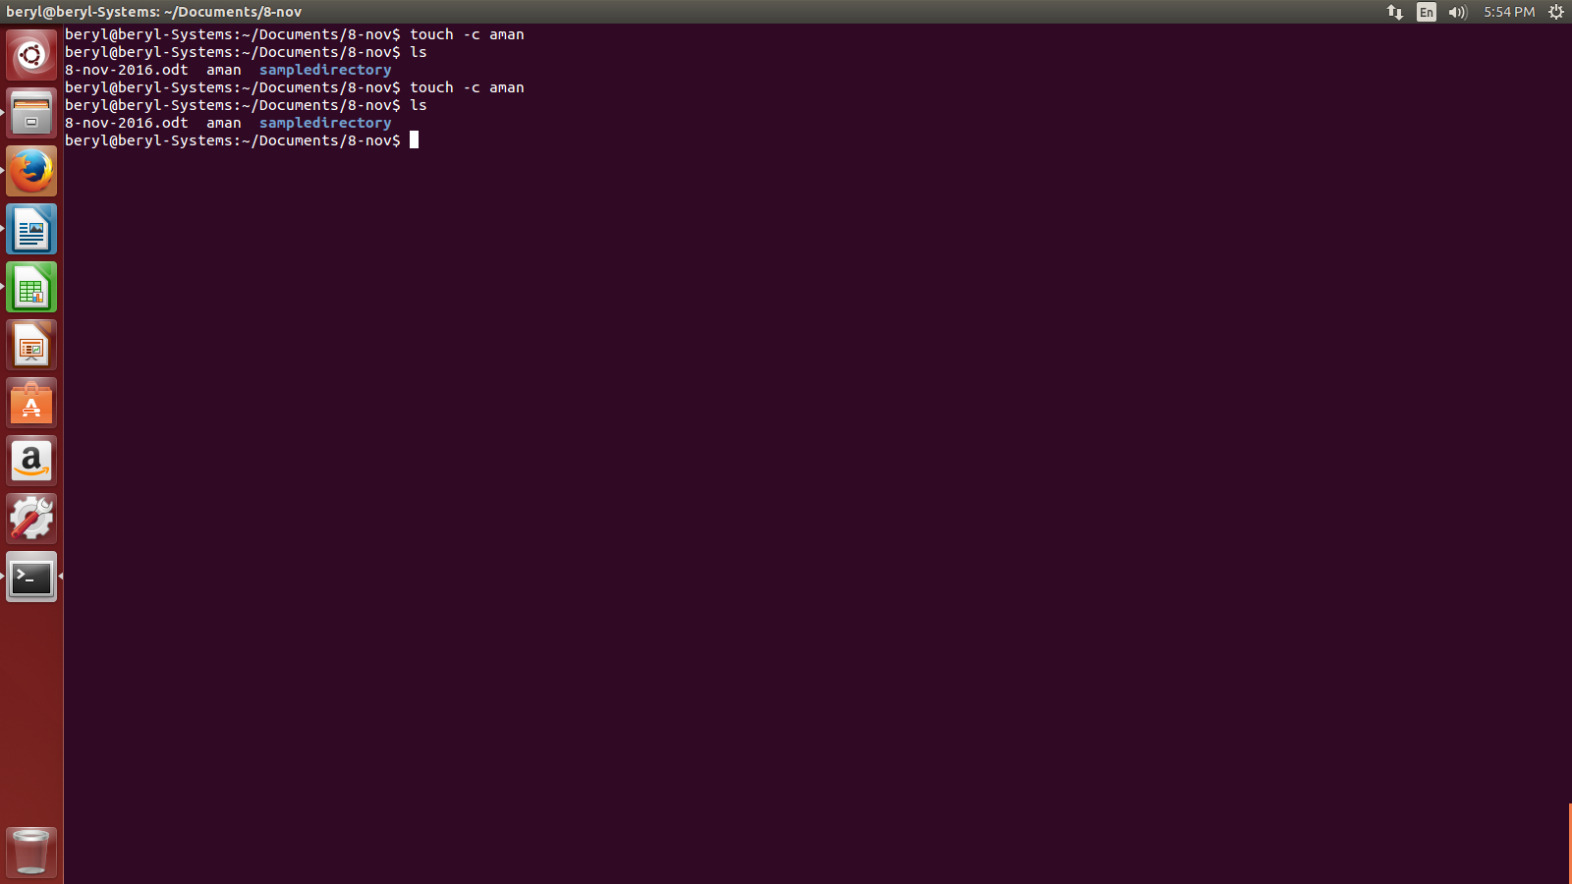
- What is rm command in linux?

- rm command is used to remove a file. Linux does'nt have any recycle bin or trash like other O.S. so be very careful before using this command. e.g.,

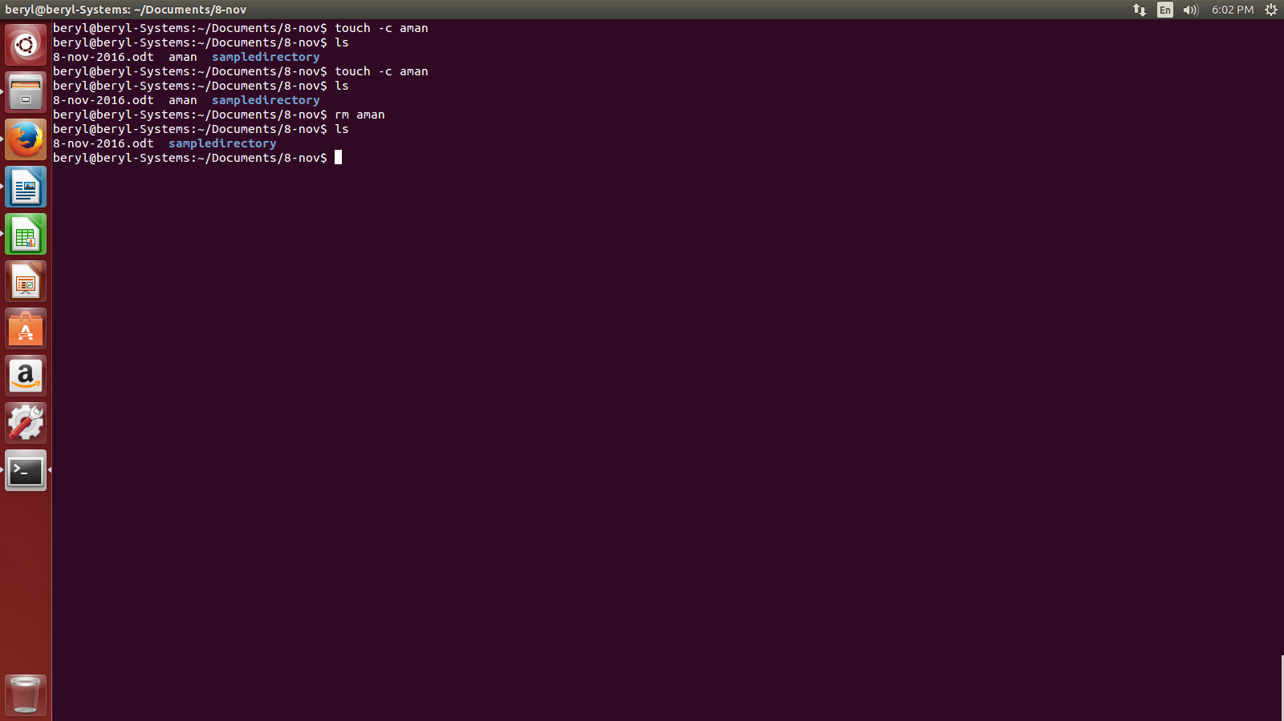
- What is cp file in Linux and what are its various options?

- cp command is used to copy a file.

- What is the current version of ubuntu?


