LINUX BASICS

LINUX Files:-

1. What is cp command in Linux?

- cp command is used to copy a file or directory
Syntax: cp <existing filename> <new file name>

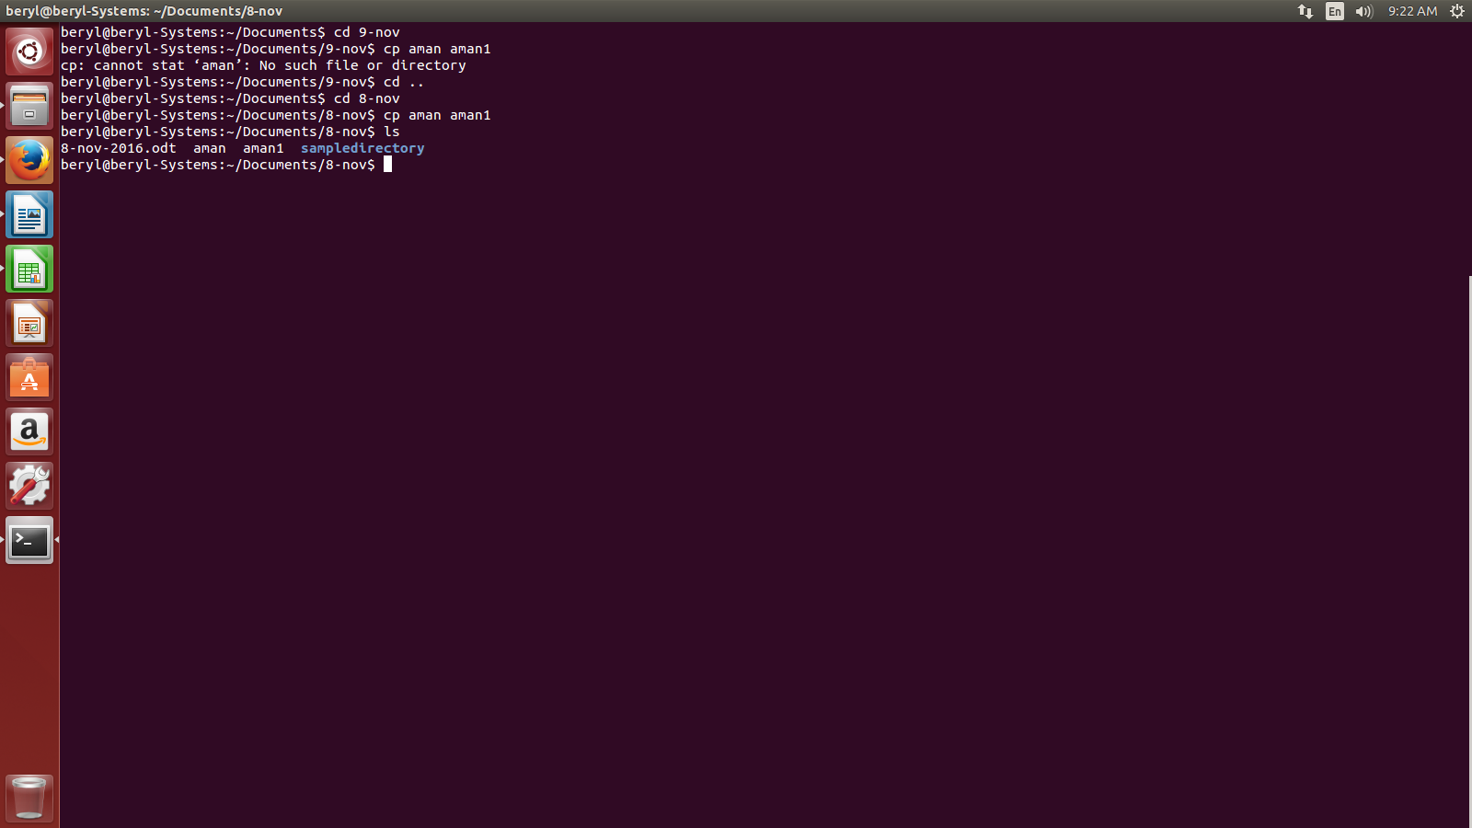
To copy file in the same directory:-

To copy file in different directory:-
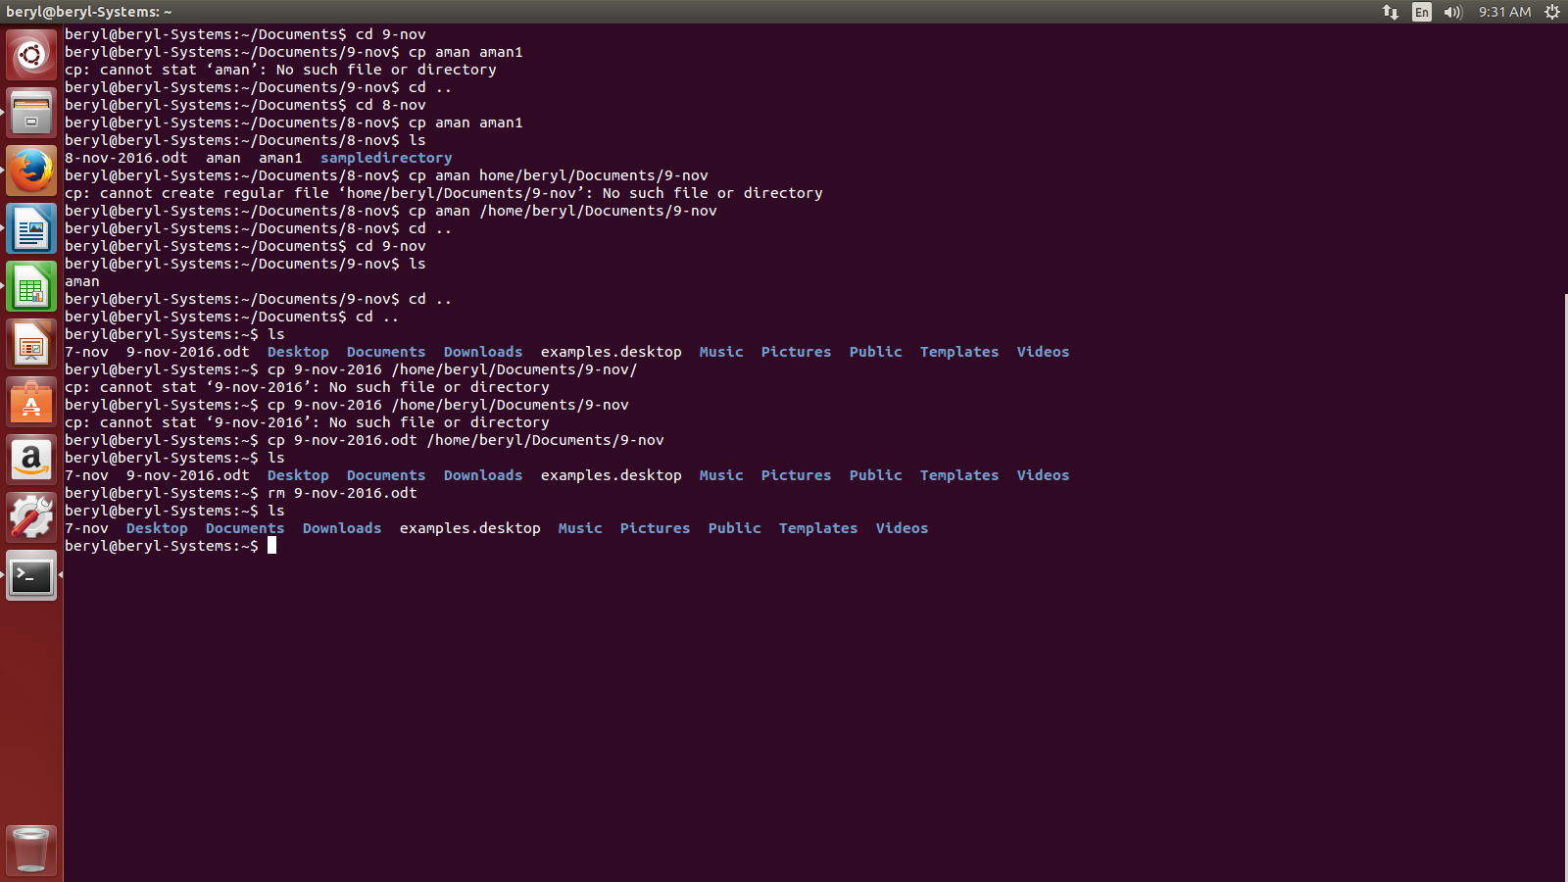

- What is mv command in Linux?

- mv command is used to rename a file or a directory or to move a file or a directory.

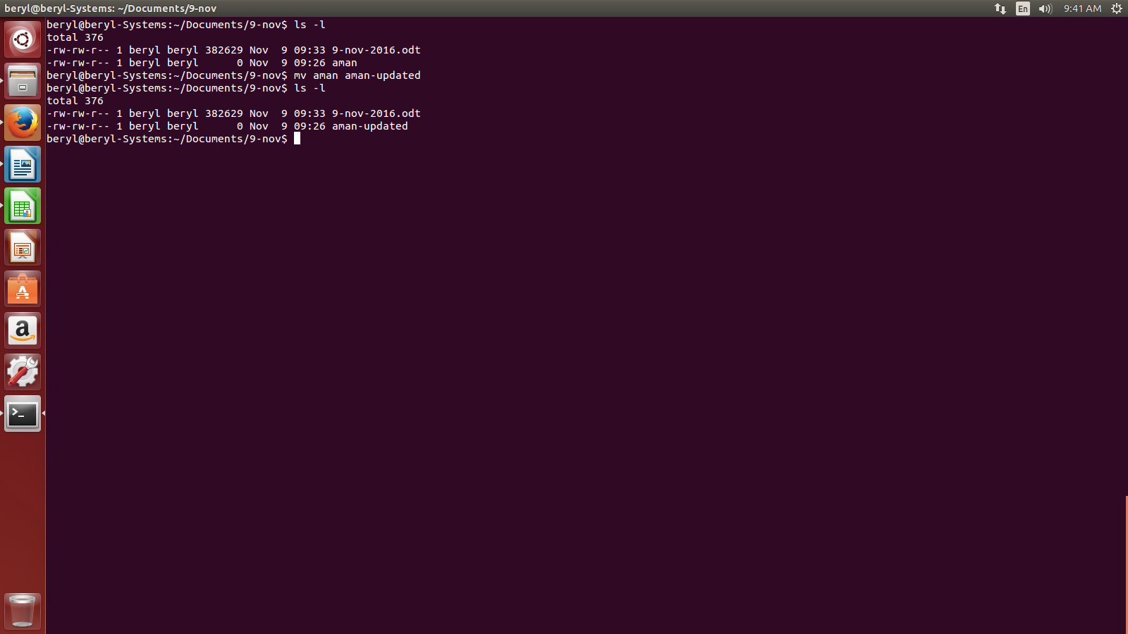

- What is man command in Linux?

- Man command in Linux is used to get the detailed description of any Linux command.
Syntax: man <command name>

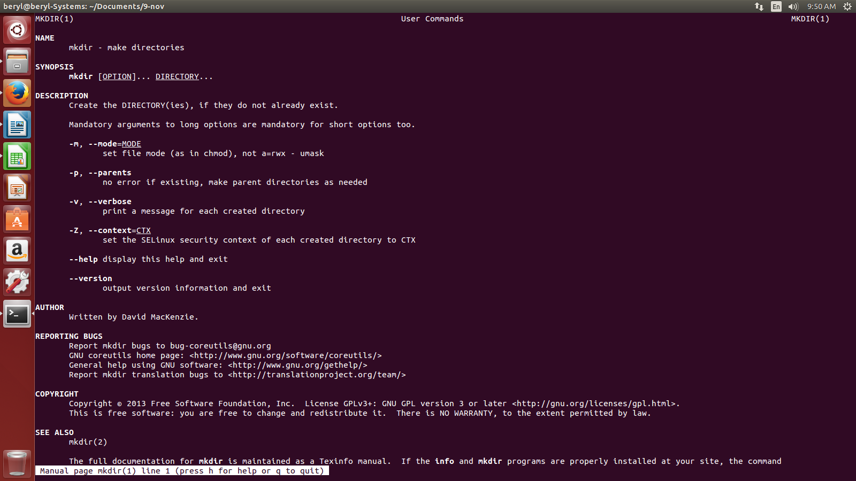

- What is cat command in Linux?

- cat command is used to create or see the content of a file.

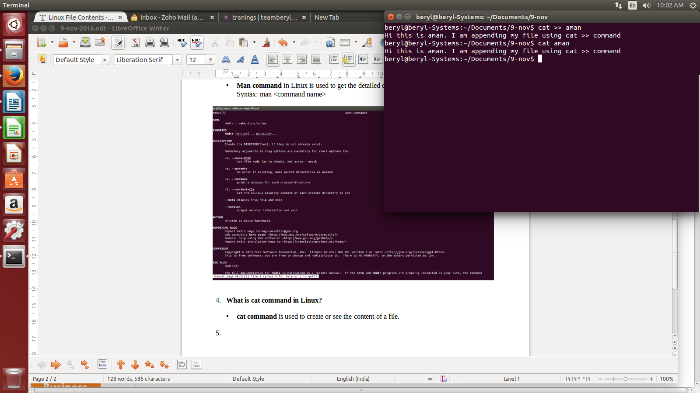

- What is tac command in Linux?

- tac command is the opposite of cat command. It wil show the content of the file in the reverse order.
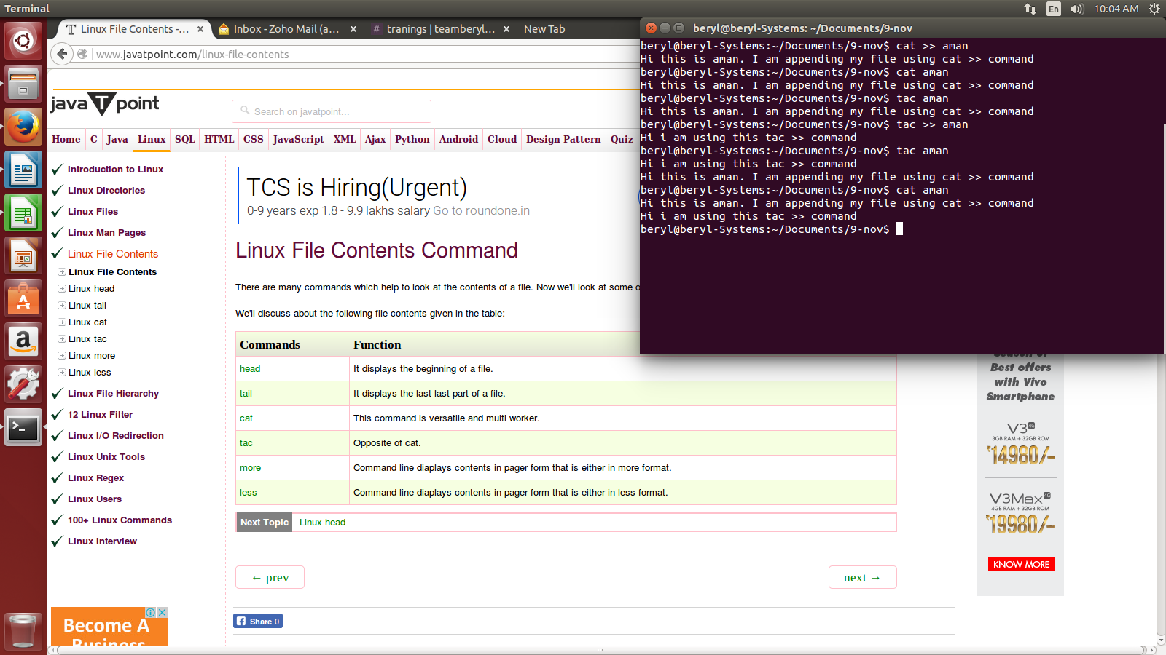

LINUX FILTER:-

- What is grep command in Linux?

- grep command is used to see some particular content of a file.eg.,

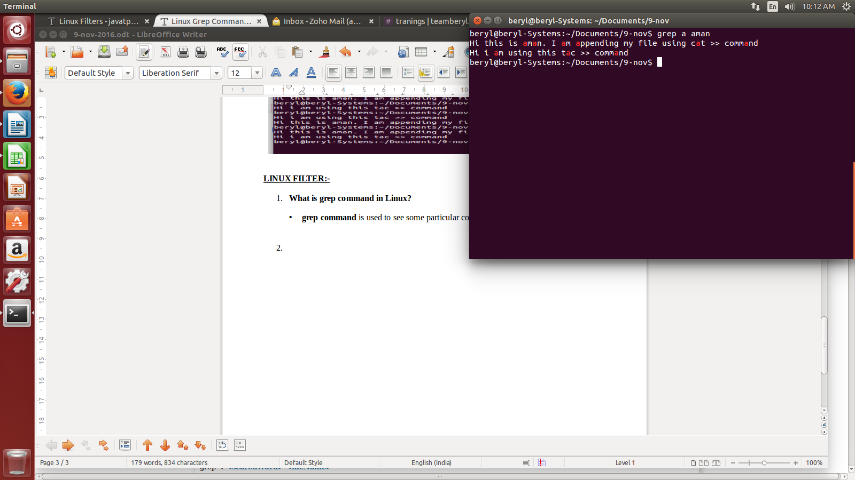

- What is wc command in Linux?

- wc command is used to see the number of lines, words and character is a file in the same order as lines, word and characters. e.g.,

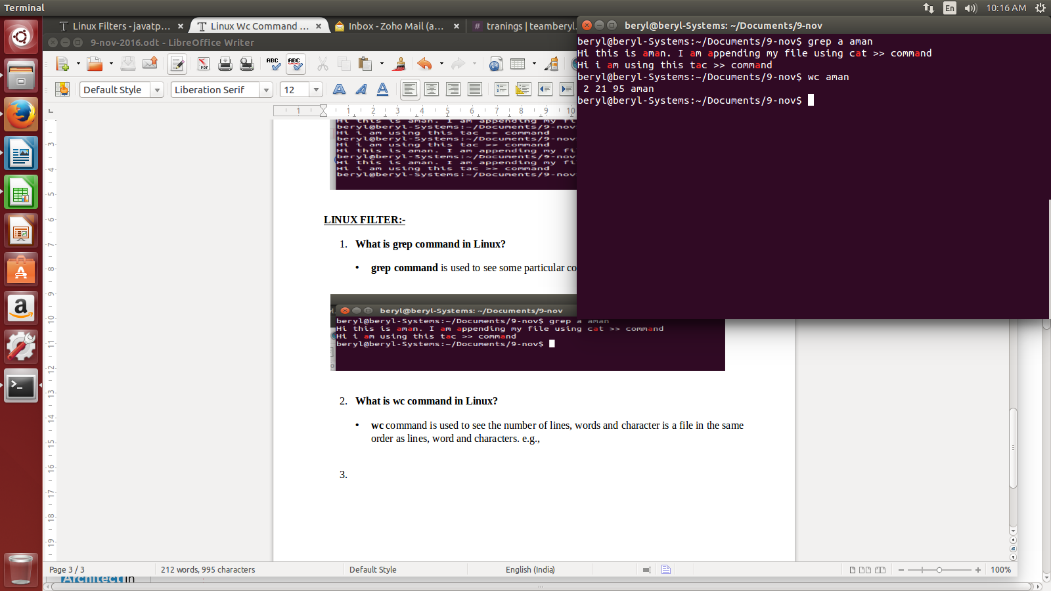

- What is sort command in Linux?

- sort command is used to sort the contents of a file.

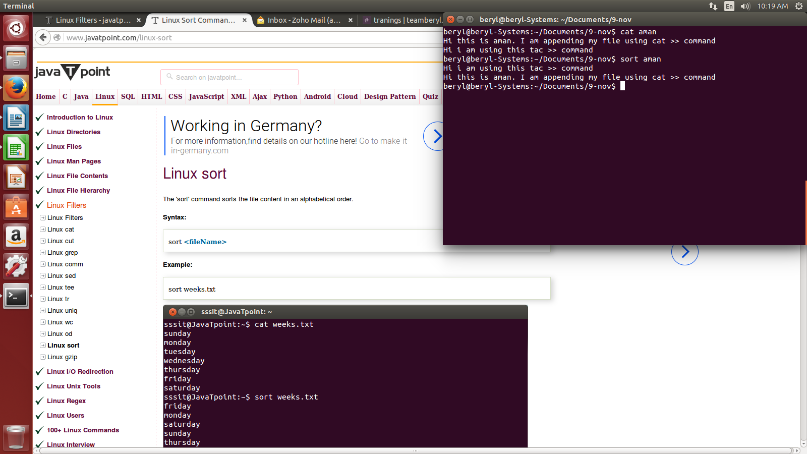
- What is gzip in Linux?

- gzip command is used to compress a file. e.g.,

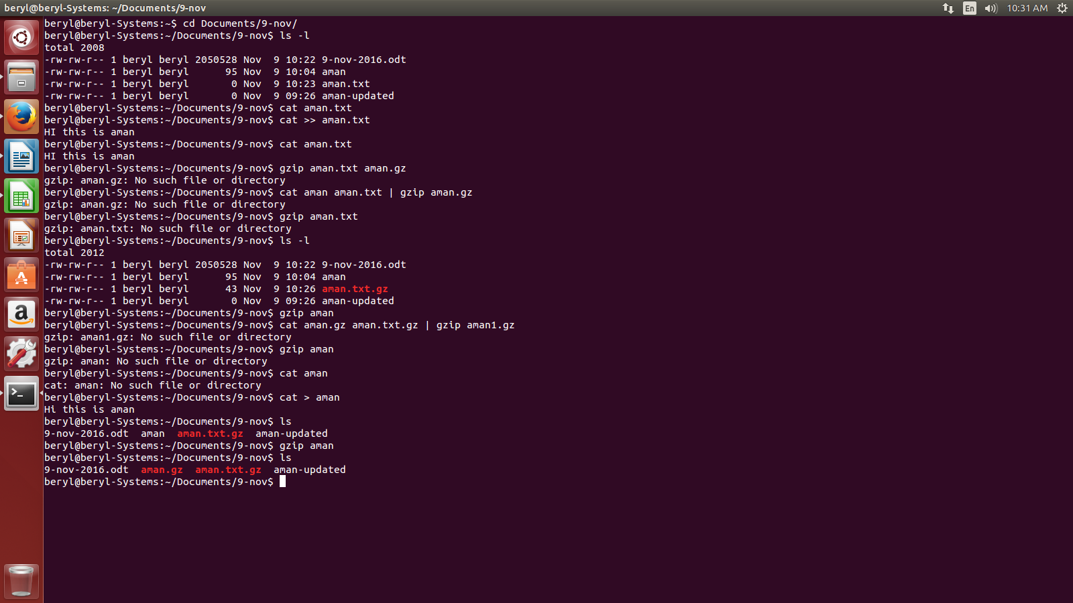
- What is who command in linux?

- who command gives information of user logged in the system.e.g.,

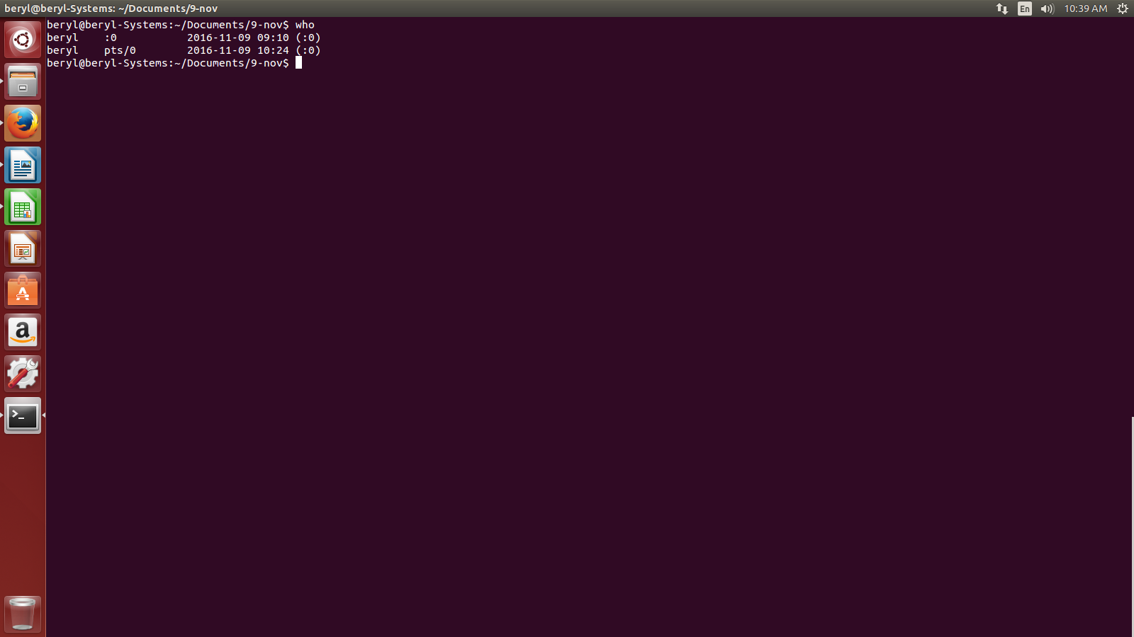

- What is who am i command in Linux?

- who am i command gives the information of current user only.

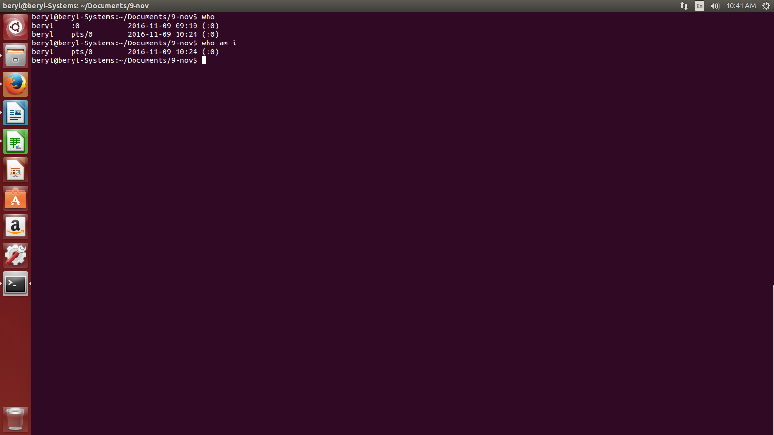

- What is id command in Linux?

- id command tells about the user id, primary group id, and list of groups that have logged in.
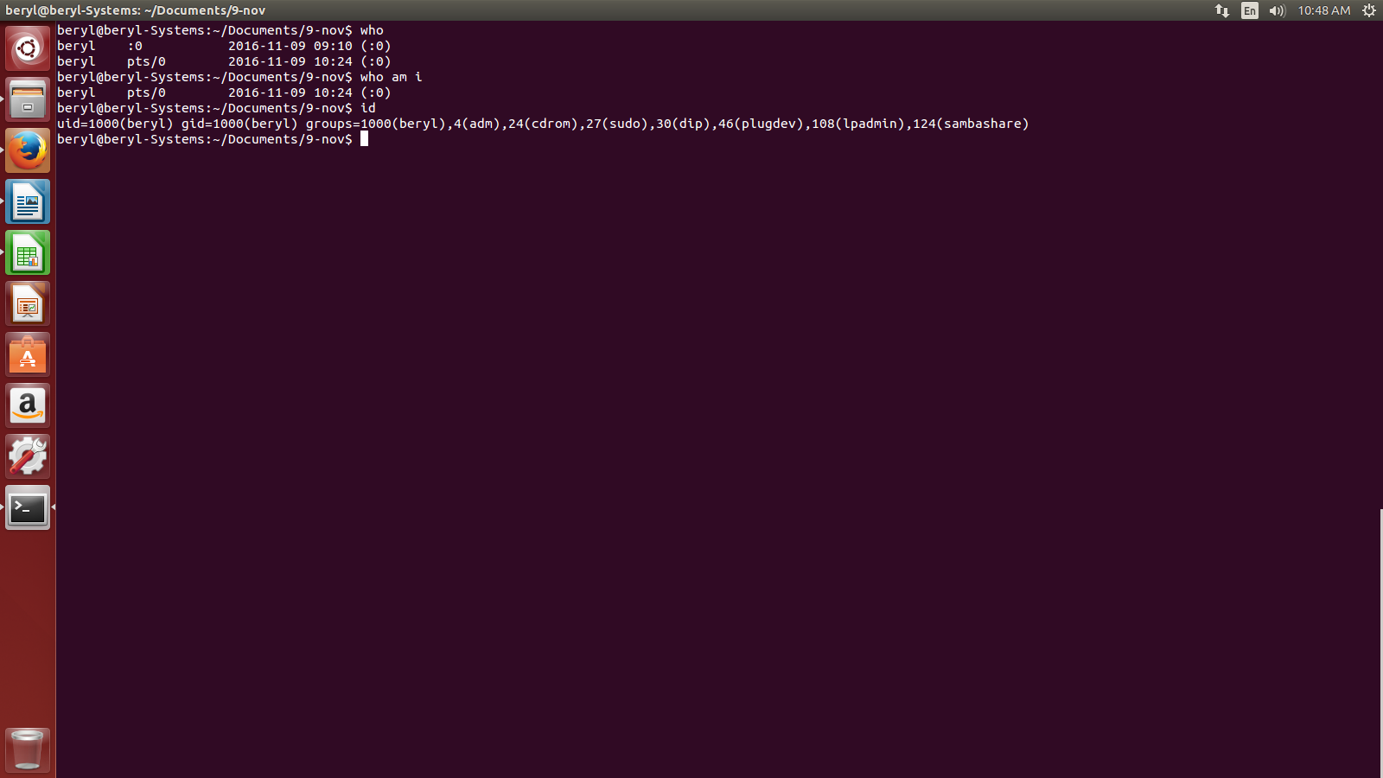
- What is su command in Linux?

- su command allows us to switch user.
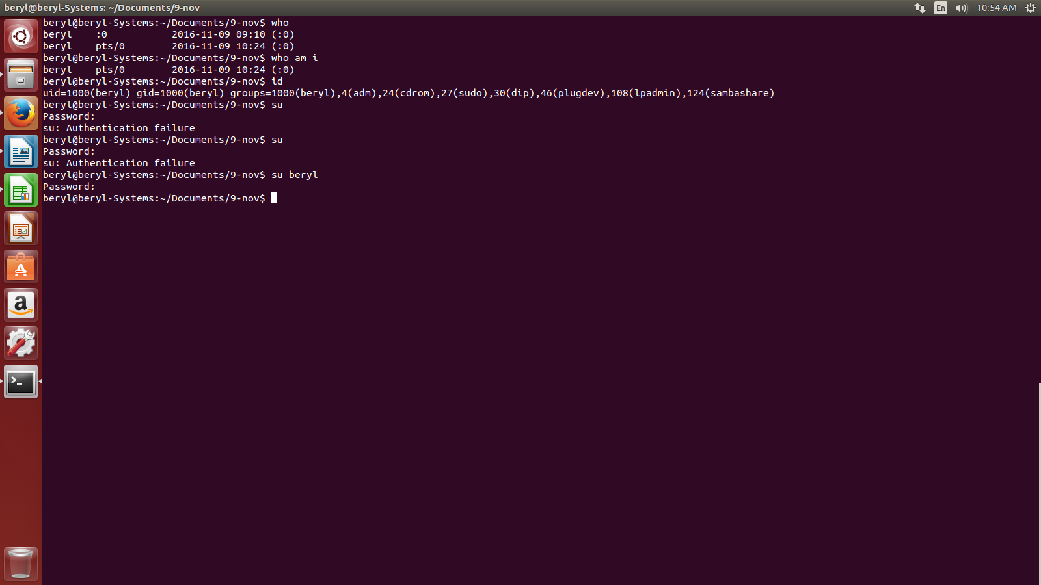

- What is passwd command in LINUX?

- passwd command is used to change the password of the user.
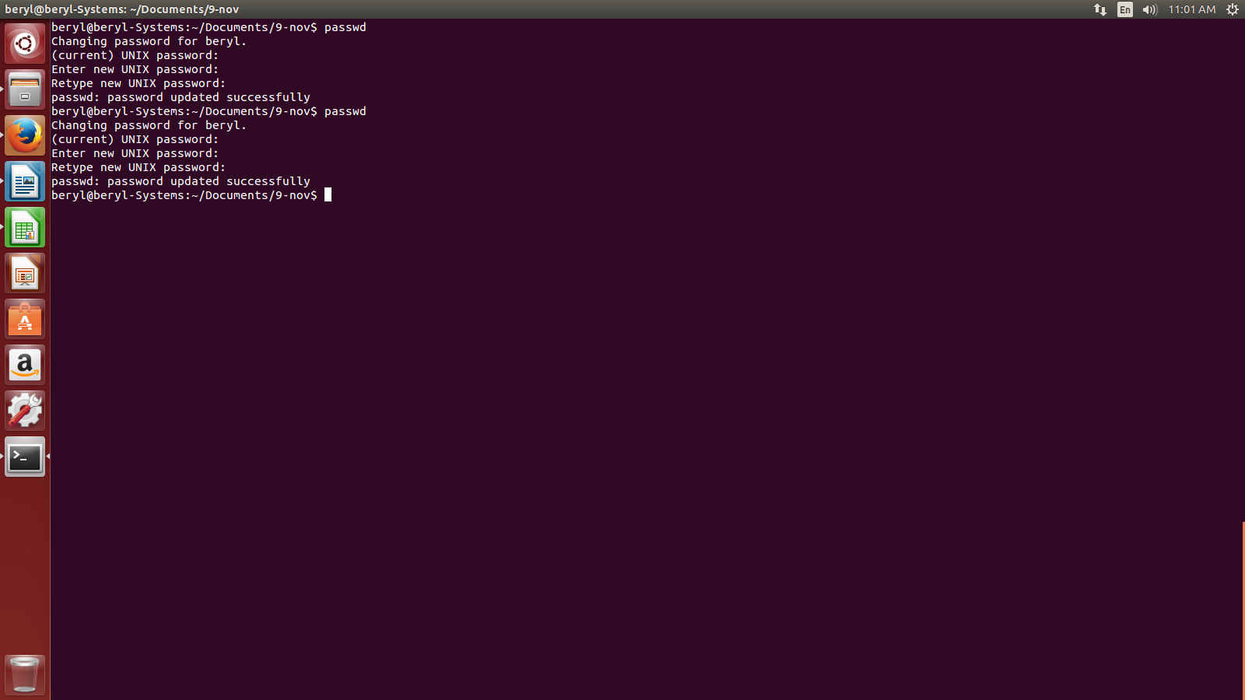

- What is chmod command in Linux?

- chmod command is used to change permissions.
Syntax:
chmod <options> <filename>

Here, options contains permissions given to user, group and all.

read represents 4
write represents 2
execute represents 1
904 down vote accepted | If the unzip command isn't already installed on your system, then run:

So, to give all the read write execute permission to aman.txt by user,groups and anyone.

chmod 777 aman
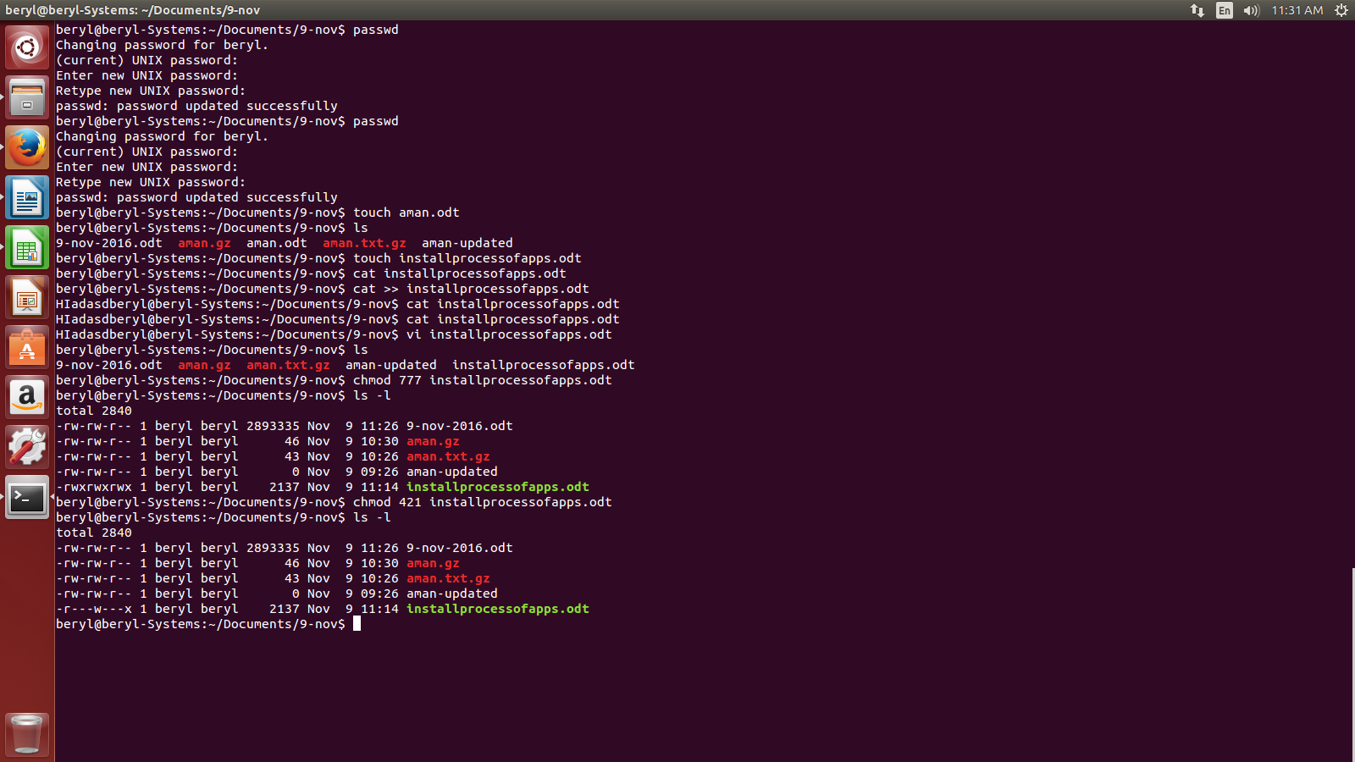

- What is vi command in Linux?

- vi command opens vi editor to write content in a file.
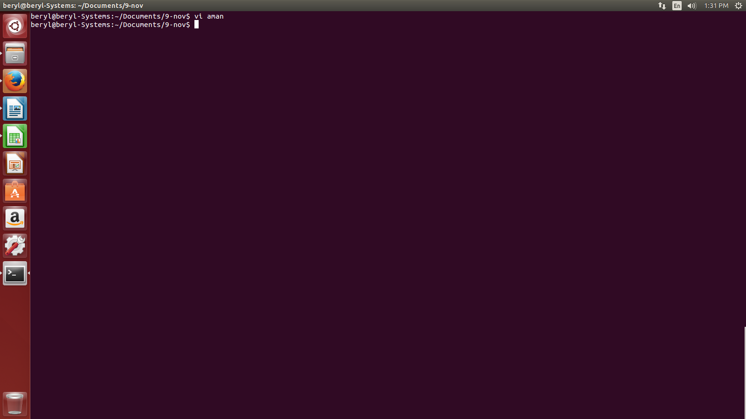

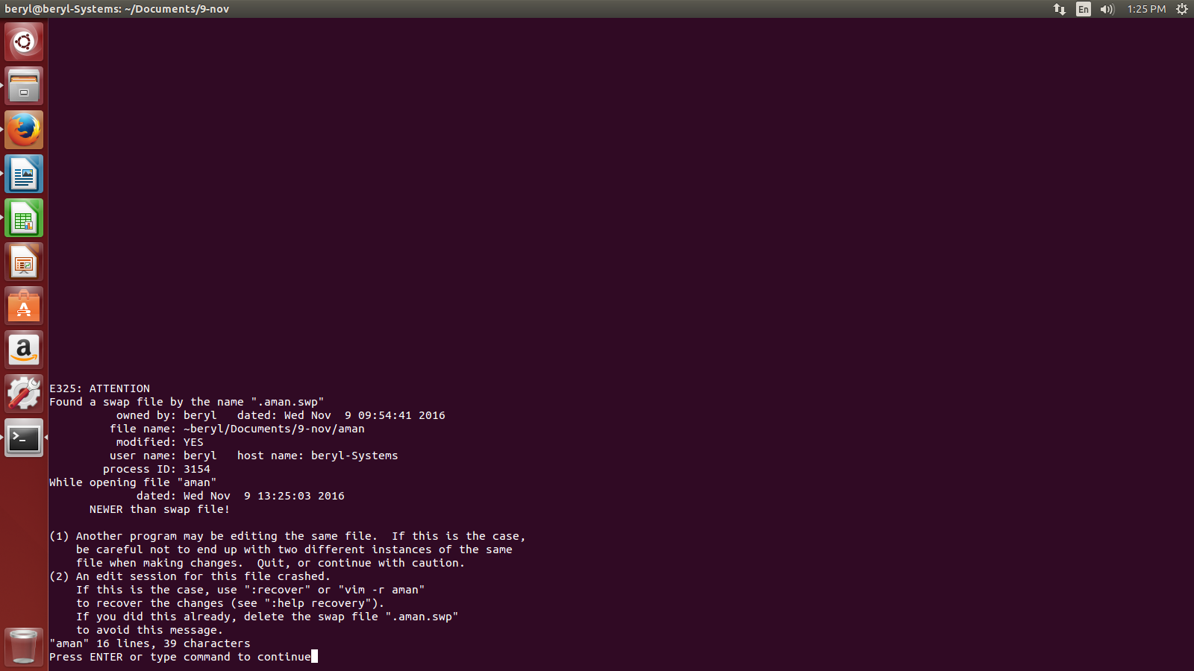
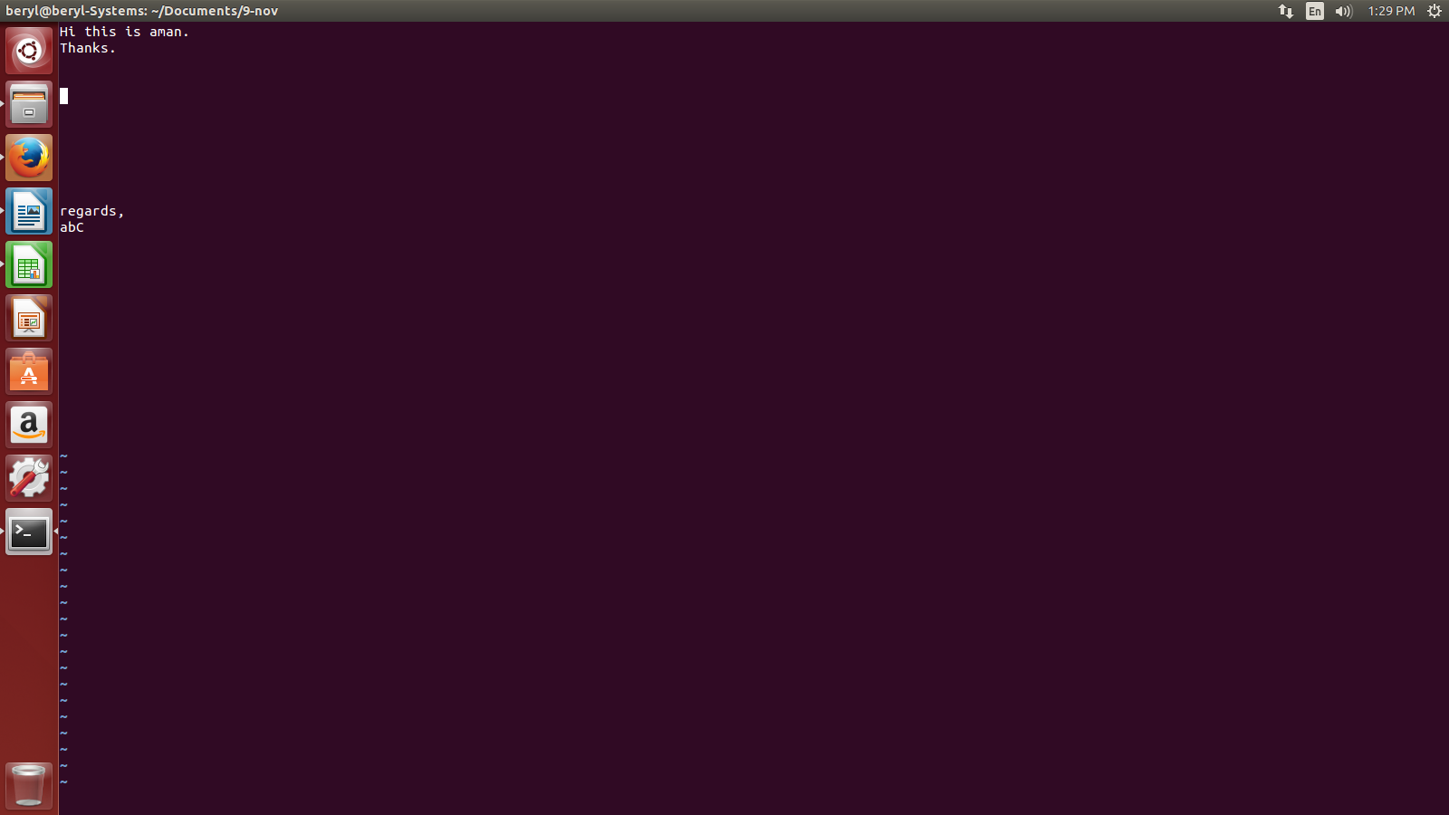

Press escape key, type

:w - to save
:q - quit without saving
:wq – save and quit

- What is free command in Linux?

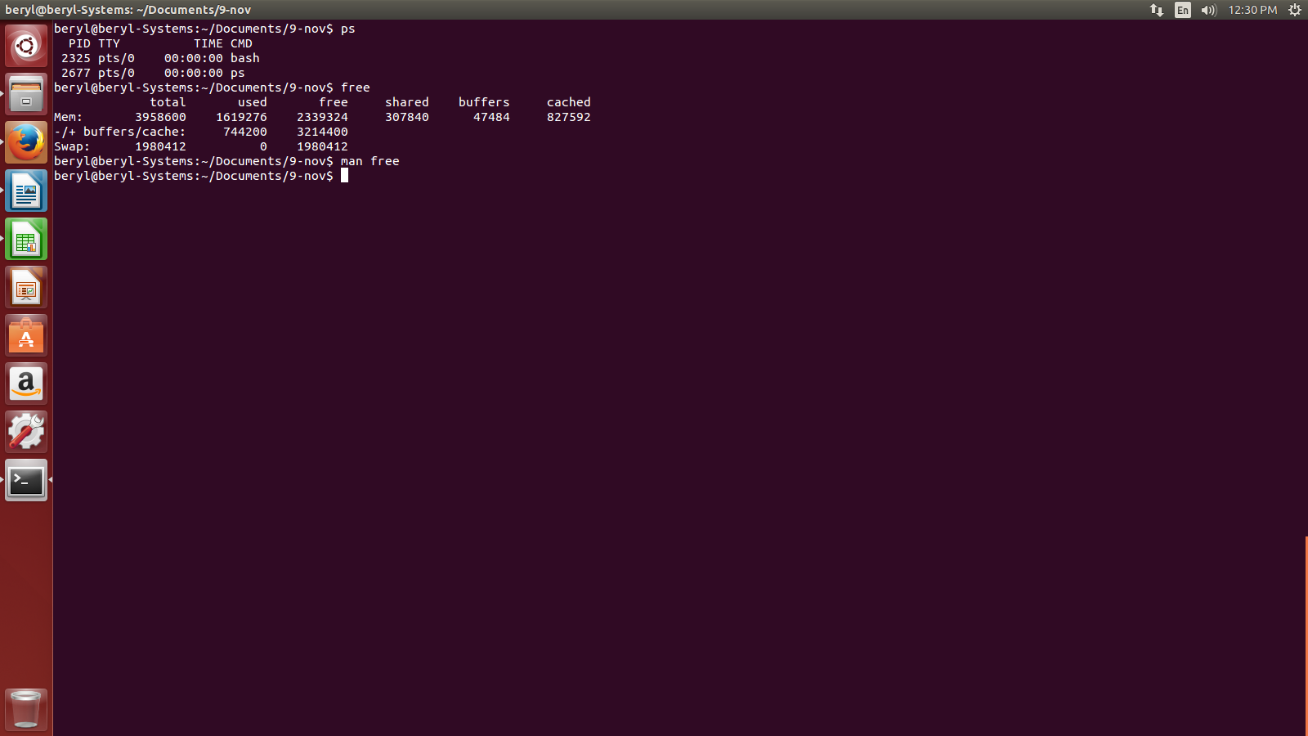
- Free command is used to se the used and free memory of the system.

- What is head command in Linux?

- Head command show the lines of a file from beginning.e.g.,
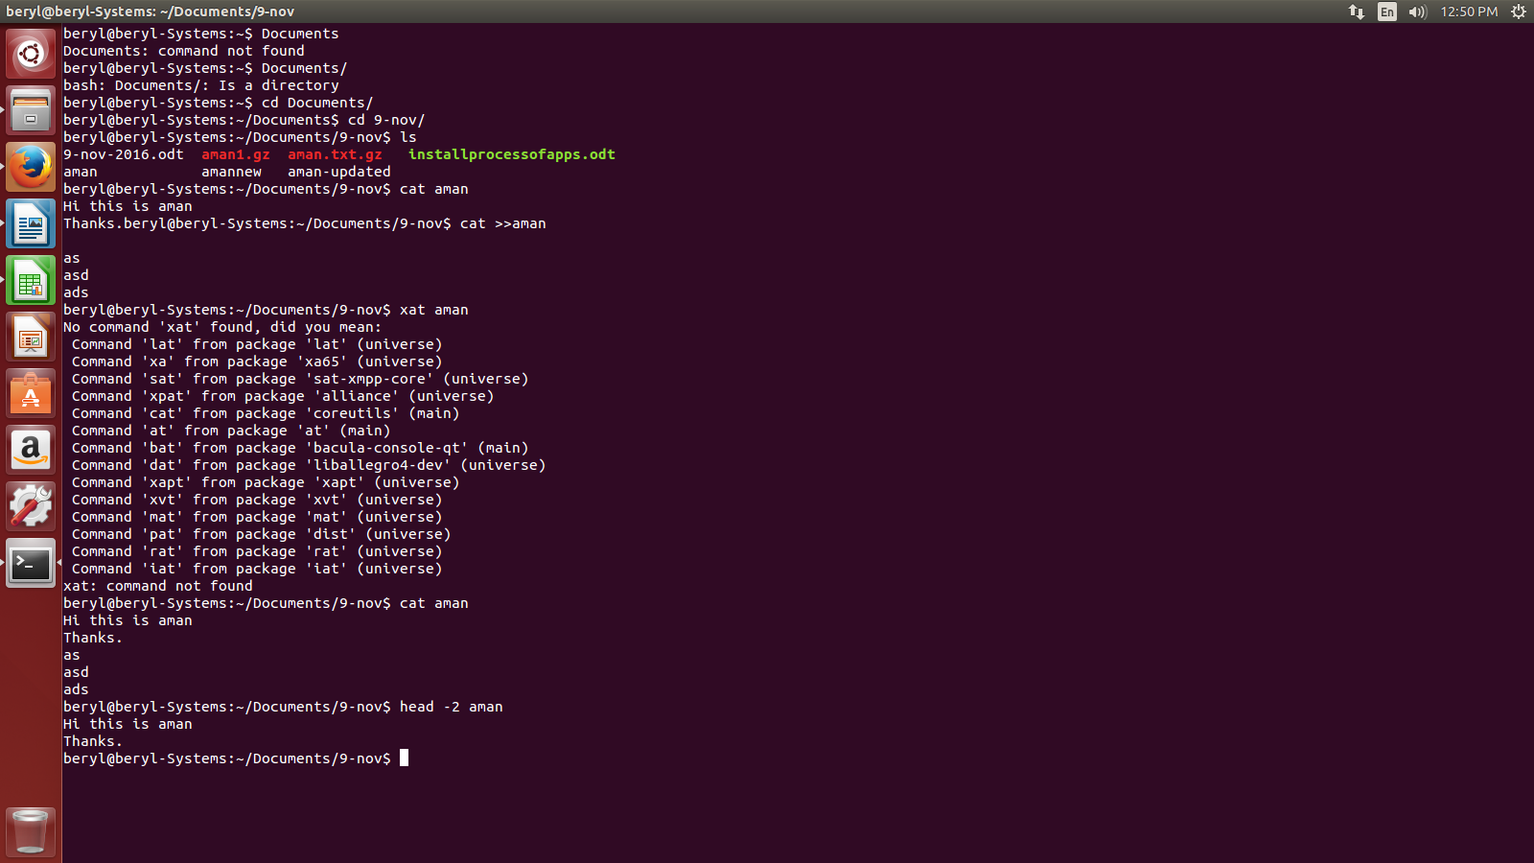

- What is tails commadn in Linux?

- Tail command shows the lines of a file from the end.e.g.,
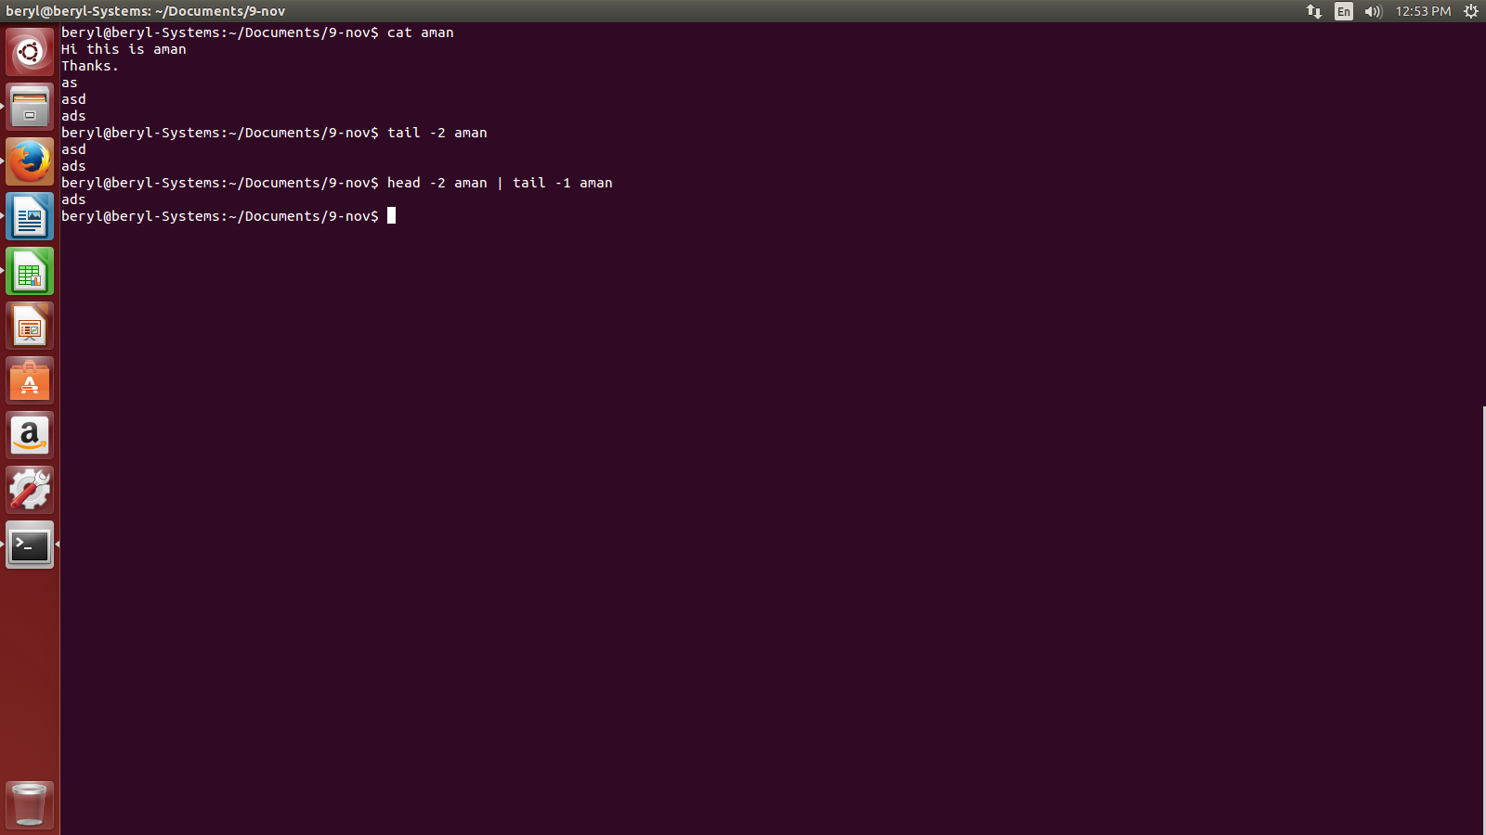

- How to unzip a file in Linux?

- We use gunzip to unzip a file in linux. e.g.,

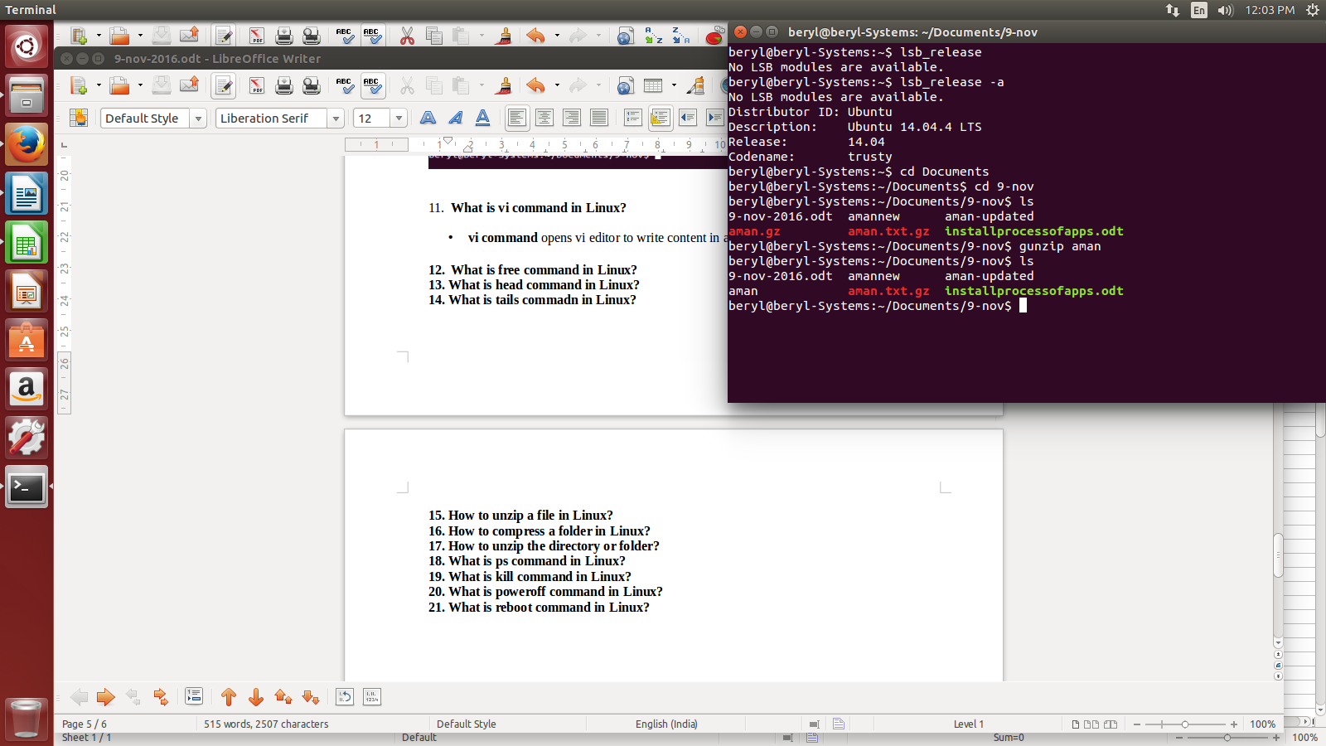

- How to compress a folder in Linux?

- To zip a directory in Linux we use tar -cv <directoryname> | gzip > <compressed directory name>. e.g.,

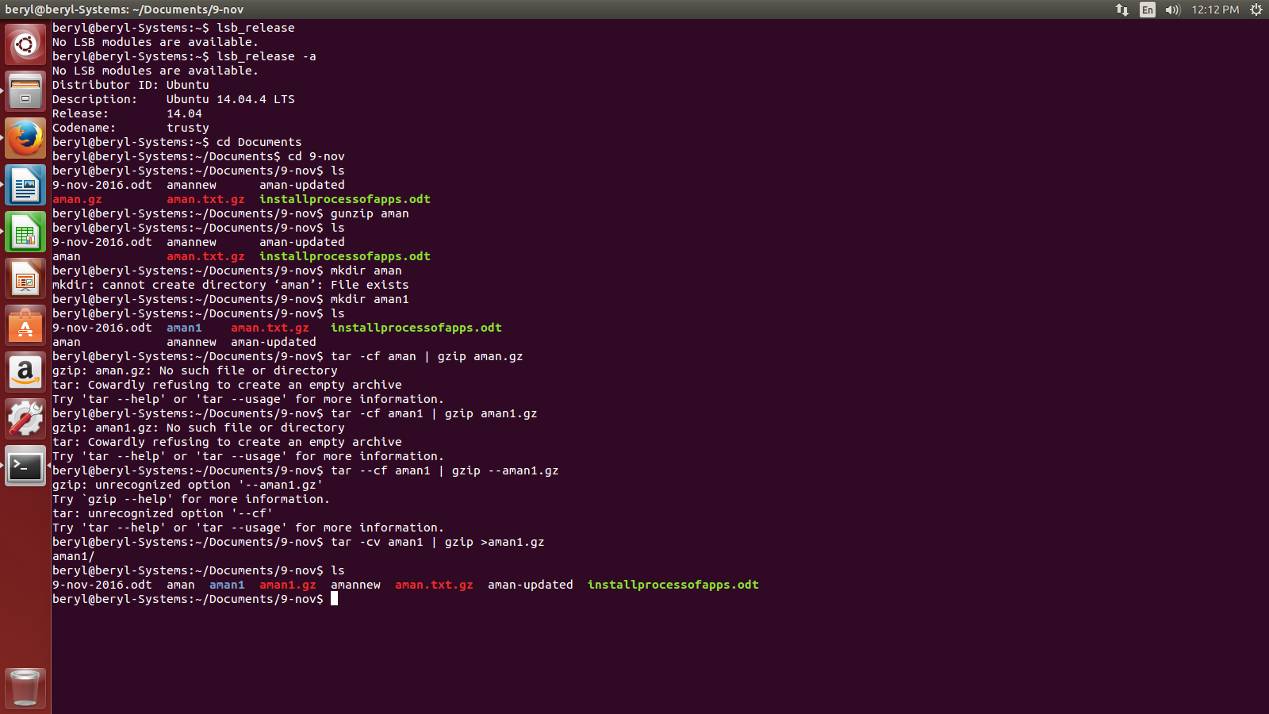

- How to unzip the directory or folder?

- To unzip a directory in Linux we use gunzip command.
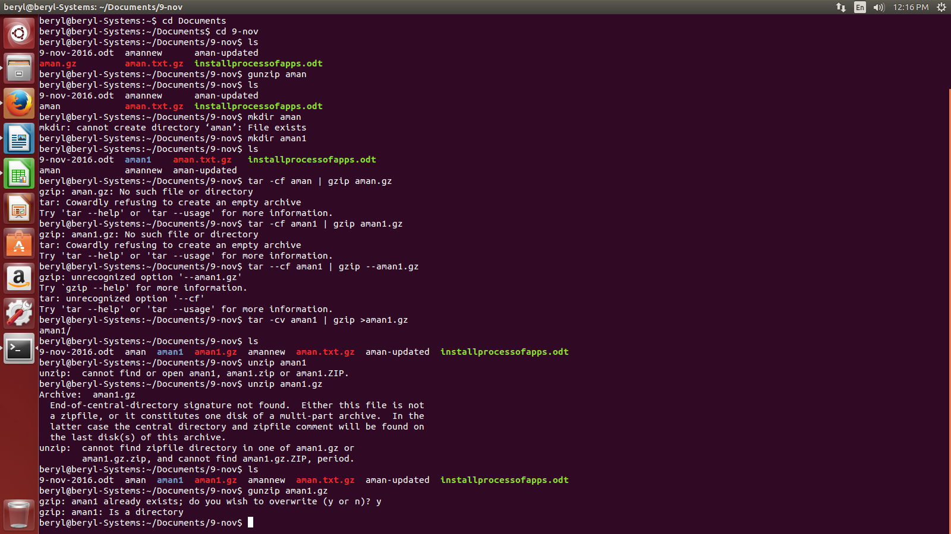
- What is ps command in Linux?

- ps command shows the current state of all the running processes.
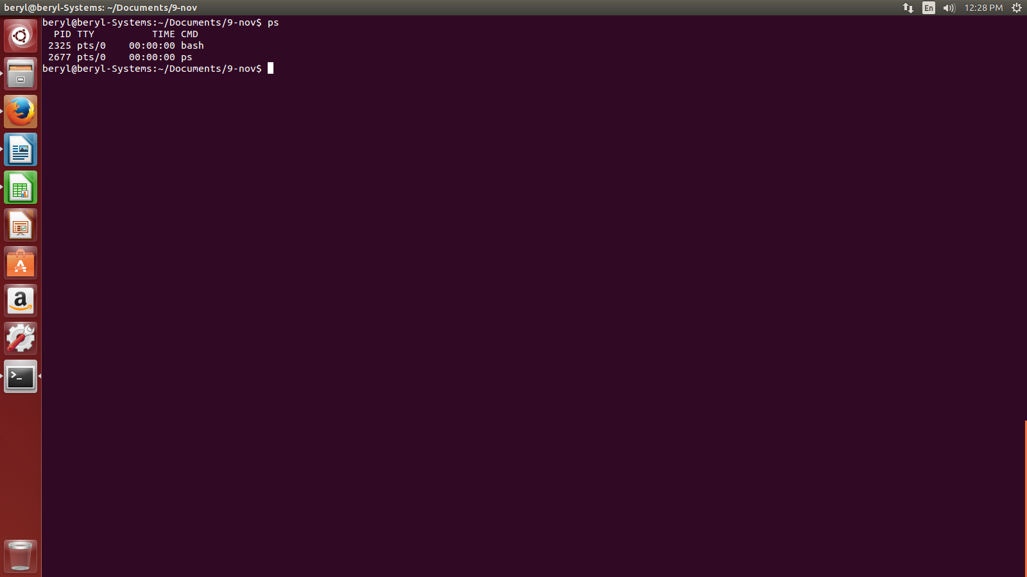

- What is kill command in Linux?

- What is poweroff command in Linux?
- We use poweroff command to shutdown the computer.

- What is reboot command in Linux?
- We use reboot command to restart the computer.

