LINUX BASICS

- What is nano command in Linux?

- Nano is a text editor suited to working in linux. It is not as powerful as Windows text editor, as it does not rely on the mouse but still it has many useful features.
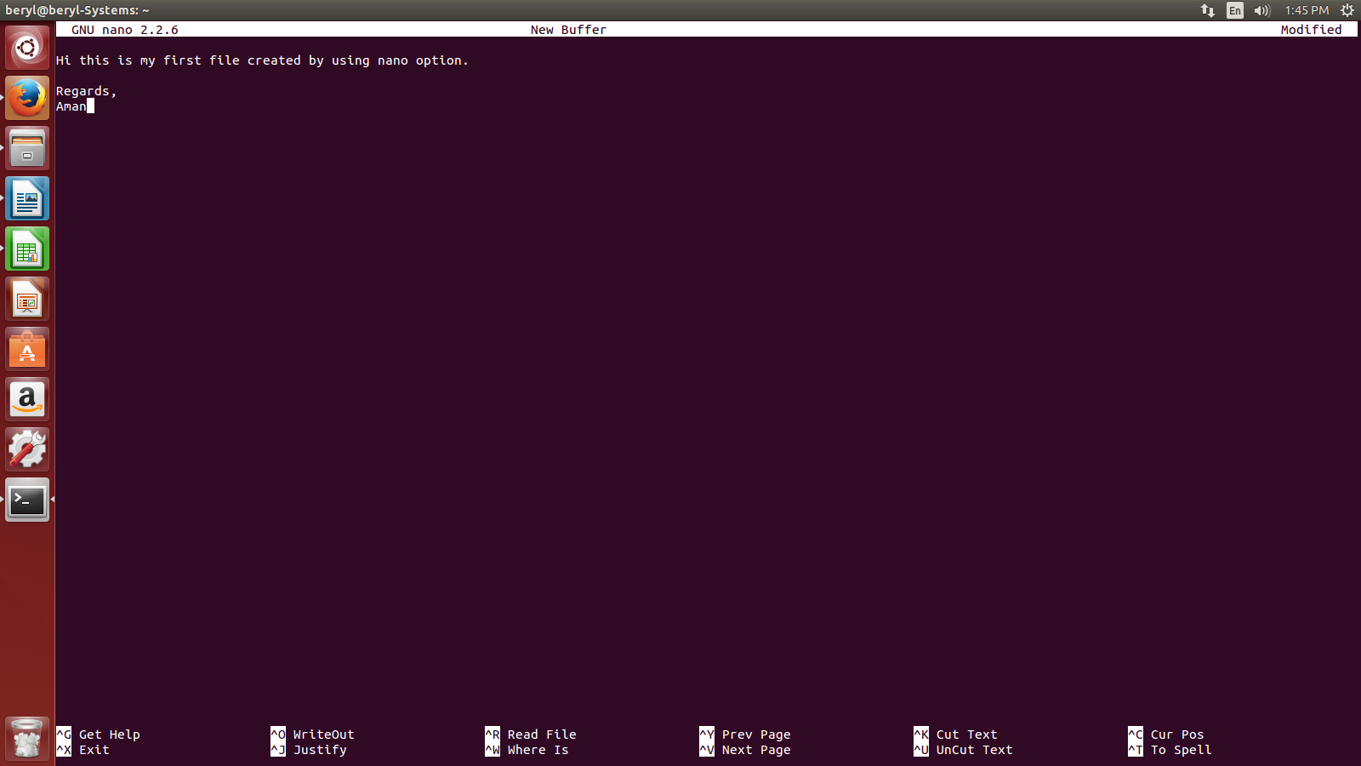

Press Ctrl+X to exit.
Then press Y to save the file
and ave the file with the name you want to save.

