Ruby BASICS

- What is ruby?

Ruby is pure object oriented programming language created in 1993 by Yukihiro Mastsumoto of Japan.

- What are the features of Ruby?

The features of Ruby are:-
- open-source
- interpreted programming language
- truly object oriented programming language
- server side scripting language
- used to write CGI scripts
- can be embedded into html
- clean and easy syntax
- syntax similar to programminglanguages like C++ & perl.
- Scalable and maintainable
- used to create internet and intranet applications
- has many GUI Tools and can be easily connected to MySQL, Oracle etc.

- What is the command to install Ruby in ubuntu?

Execute the command “sudo apt-get install ruby-full” in the ubuntu command prompt

- How to check the version of ruby?

To check the version of ruby we will use:

ruby -v command
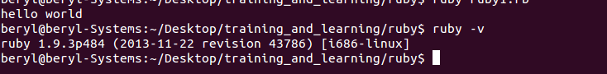

- How to create a simple ruby program?

To execute a simple ruby program in ubuntu we can use vi text editor to write ruby code or otherwise to execute a ruby program we have an interactive shell in linux as well which can be executed using “irb” command.

Write the program as:

def “method_name”
“Variable”= value
puts “variable”
end

now call the method to see the output of above code.
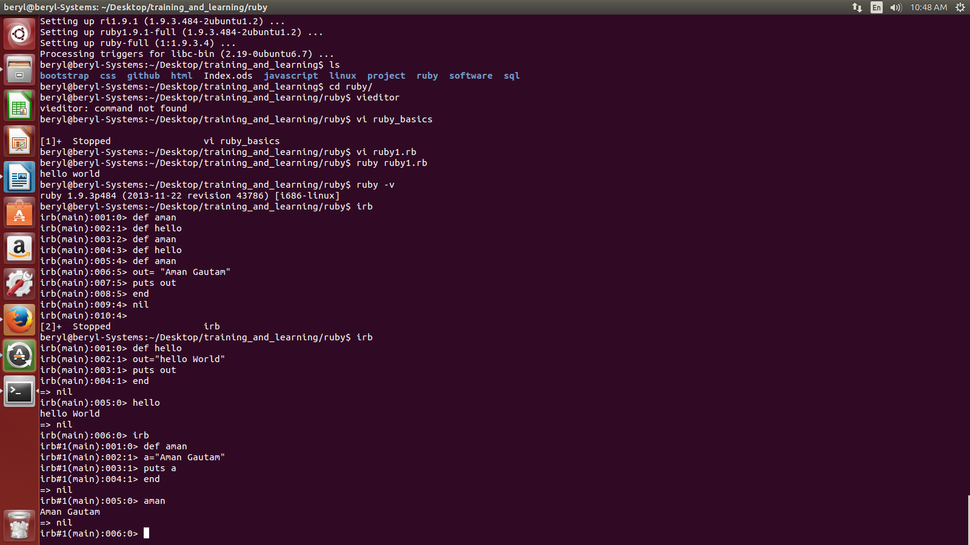
Press CTRL +D to come out of the irb shell.

- What are the various reserve words in Ruby?

BEGIN | do | next | then
END | else | nil | true
alias | elsif | not | undef
and | end | or | unless
begin | ensure | redo | until
break | false | rescue | when
case | for | retry | while
class | if | return | yield
def | in | self | __FILE__
defined | module | super | __LINE__

- What are the various ways to print in Ruby?

The various ways to print in ruby are:

  - print << variable_name //no quotes
“enter the code”
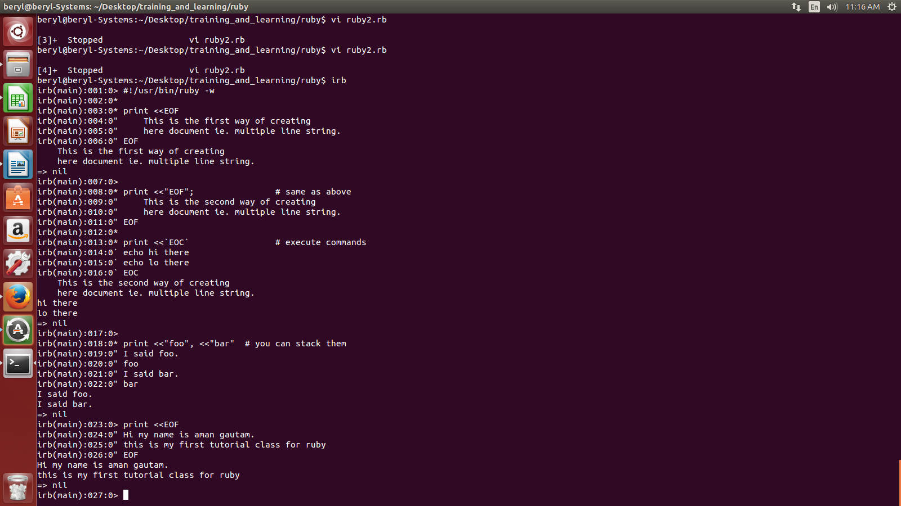
variable_name
  - print <<”variable_name” //in double-quotes
“enter the content(single-line or multi-line)”
variable_name
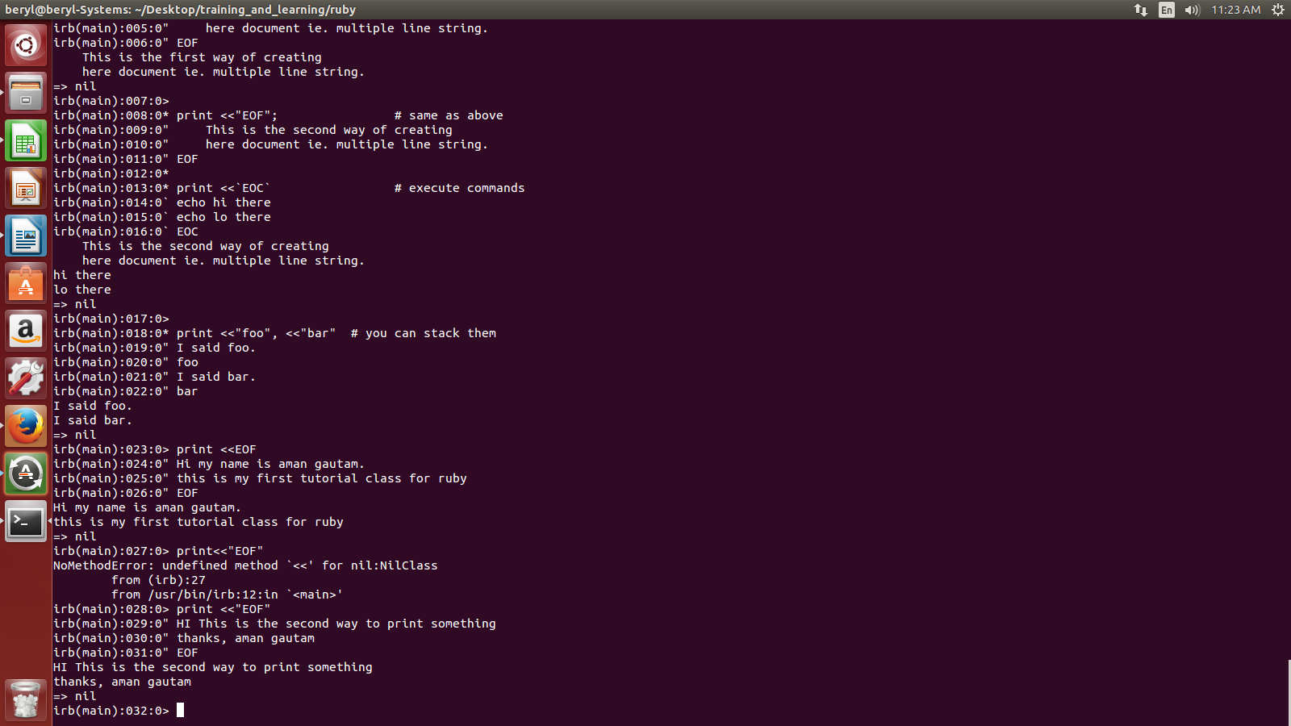
  - print <<'variable_name' //in single-quotes
“enter the content(single-line or multi-line)
variable_name
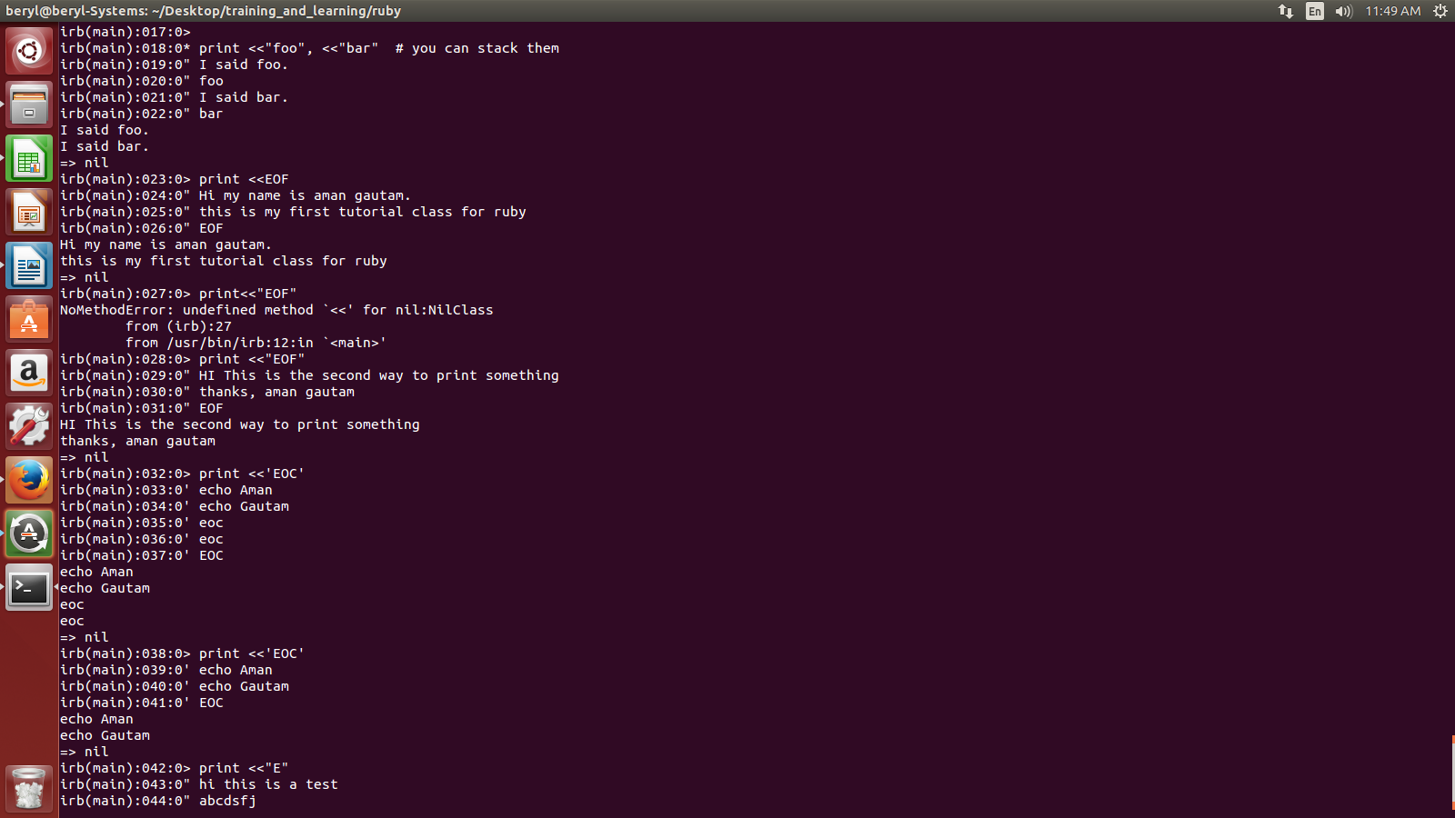
- What are BEGIN and END statements in Ruby?

BEGIN statement is executed before the main body of the ruby code and END statement is excuted after the execution of main body code.
Both these statement BEGIN and END will come outside def method or class.

- What is irb?

Irb stands for Interactive Ruby which provides a shell for experimentation. Within the IRB shell we can immediatley view expression results line by line.

- What are identifiers in Ruby?

Identifiers are names of variables constants and methods. They are case sensitive and can contain alphnumeric characters and underscore(_) character.

- What are BEGIN and END statement in Ruby?

BEGIN statement is the statement that is executed before any statement in the code.
While
END statement is the statement is one that is executed after the excution of all other statments.

If there are multiple BEGIN and END statements in the code then the order of execution will be top to bottom in case of BEGIN statement while BOTTOM to TOP in case of END statement.

Example:

END {
puts "Hi this is end 2"
}
END {
puts "Hi this is end 1"
}
BEGIN {
puts "Hi this is begin 1"
}
puts "main content"
BEGIN {
puts "Hi this is begin 2"
}
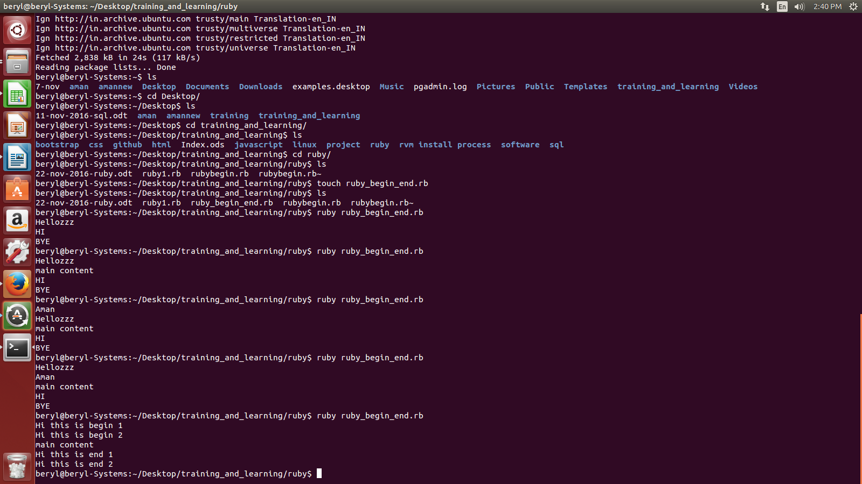

- What are comments in Ruby?

Comments hides a line, part of a line, or several line from the Ruby interpreter.

Example:

puts "This is an example of single line comment" #single line comment

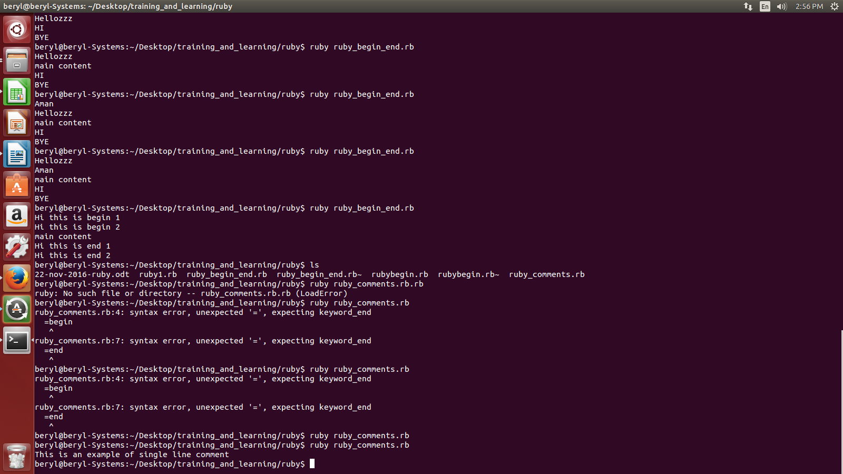

- What are classes in Ruby?

Ruby is perfect object oriented language. The features of object oriented are:-

Encapsulation
Abstraction
Polymorphism
Inheritance

An object oriented program contains classes and objects. A class is a blueprint from which individual objects are created.

A class in ruby always start with the keyword class followed by the name of the class.
The name should always be in Initial Capitals. Example:

class Beryl
end

All the datamembers of the class will be between class defination and endkeyword.

- How to create objects of a class in Ruby?

We will create the object of a class using new keyword.

In the above example we have a class named Beryl. Now the object of this class will be created as:

emp1 = Beryl. new

- Write a simple program creating object of a class?

class Beryl

@no_of_employees=0

def Employee(id,name)
@emp_id=id
@emp_name=name
puts "\nDetails of the employee: \nEmployee id= #@emp_id and Employee name= #@emp_name "
end

end

emp=Beryl.new
emp.Employee("1", "Aman Gautam")

The above code will give the output as:
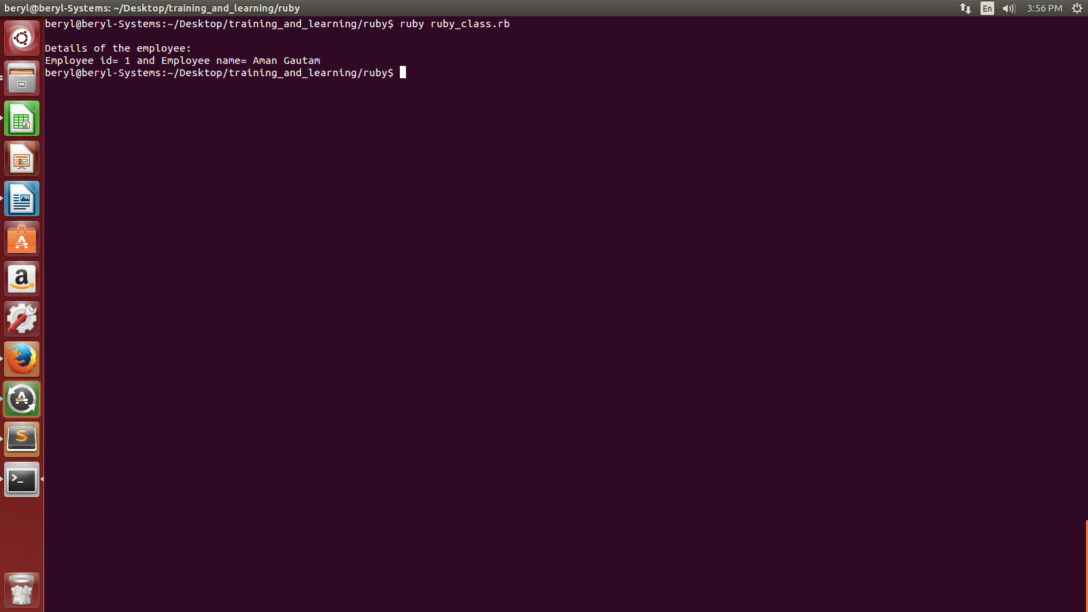
- Which is the default method of a class whose object does not need to be created?

Initialize() is the default method of a class whose object does not need to be created.
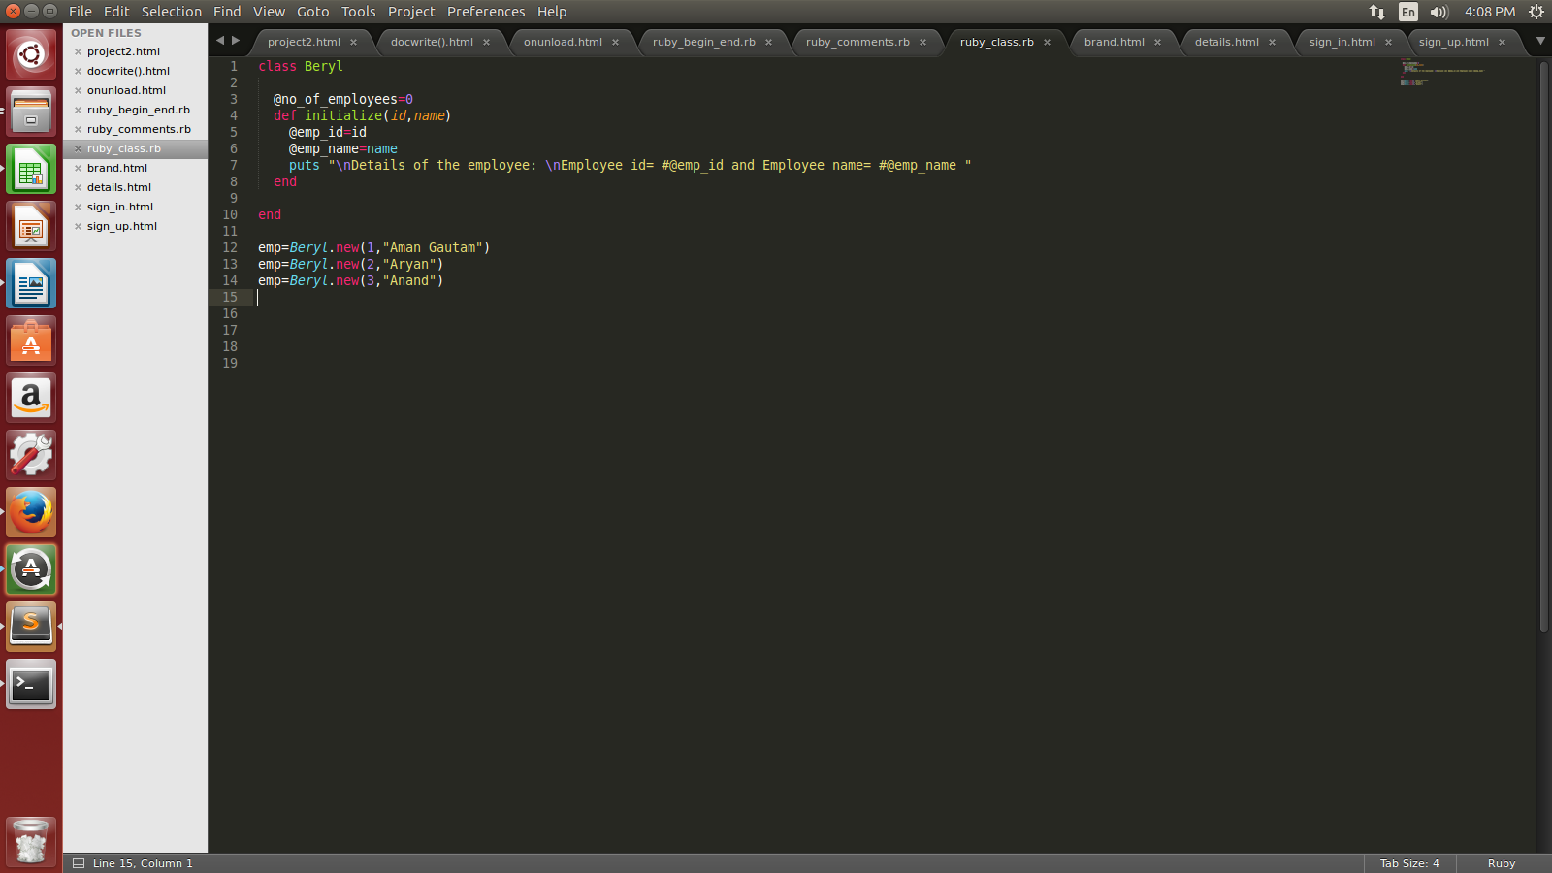

Output:

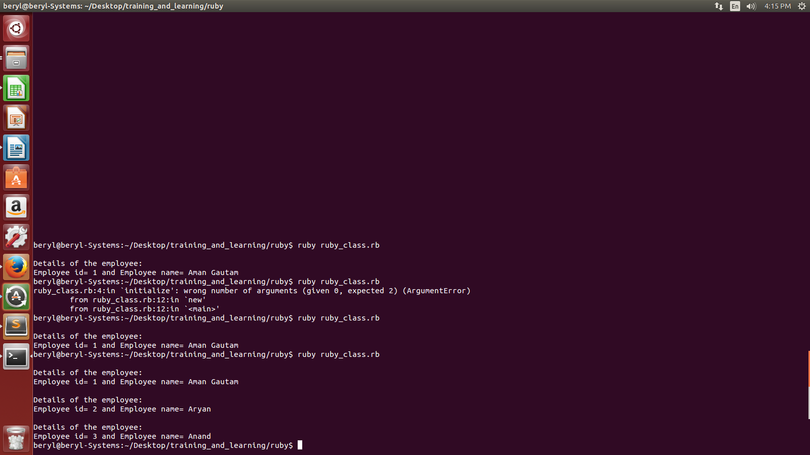

- What are variables in Ruby? What are their types?

Variables are memory locations which hold any data to be used by any program.

There are 5 types of variables in Ruby:-
- Global variables
- Instance variables
- Class variables
- Local variables
- Constants
- Pseudo-variables

- GLOBAL VARIABLES: are initialized outside the class. Global variables start with $ sign.

- INSTANCE VARIABLES: are initialized with @ sign and are placed inside methods.

- CLASS VARIABLES: are initialized with @@ sign and is placed inside class but outside methods

- LOCAL VARIABLES: are initialized inside the parameter of a method.

- CONSTANTS: are initialized by capital letters and can be placed anywhere in a program

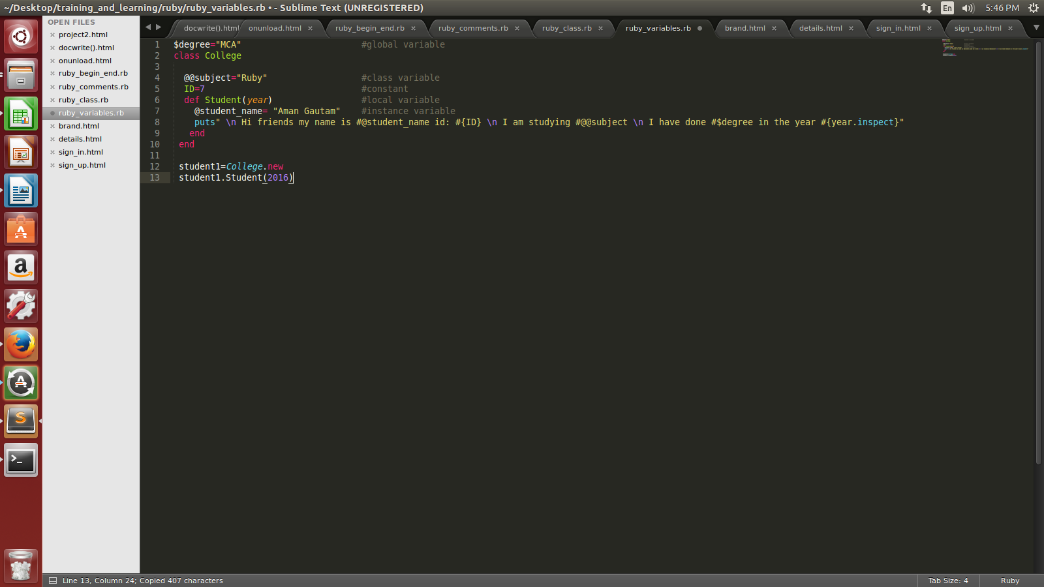
Output:
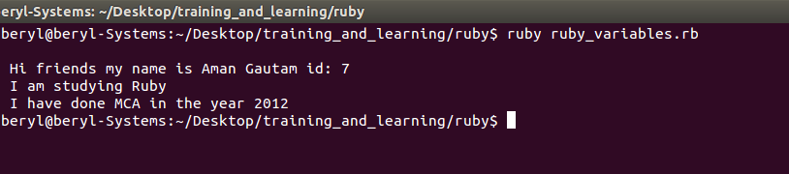
- What are the various literals in Ruby?

We have following basic literals in RUBY:-

Integer Literal- range is : 2^30 to 2^30+1 or -2^62 to 2^62-1. The integer between this range is called Fixnum and integer outside this rrange is called Bignum

Floating- are also numbers but with decimal.

String Literal- is a sequence of 8 bit bytes and objects of class String

- What are the various Arithmetic operators in Ruby?

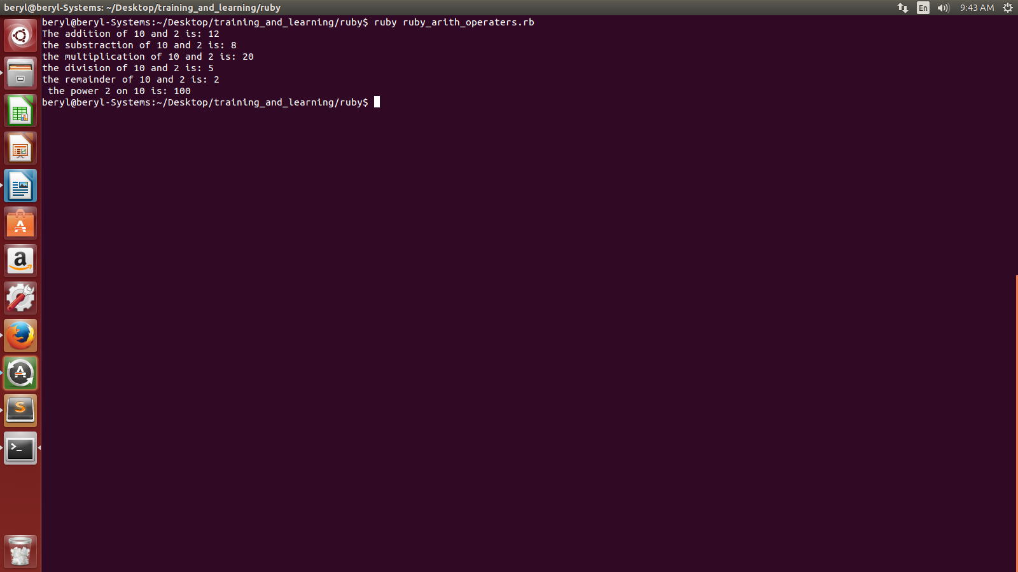
We have following Arithmatic operators in Ruby:

