LINUX BASICS

- What is the command to check ip address of our machine?

- ifconfig command is used to check ip address of our machine.

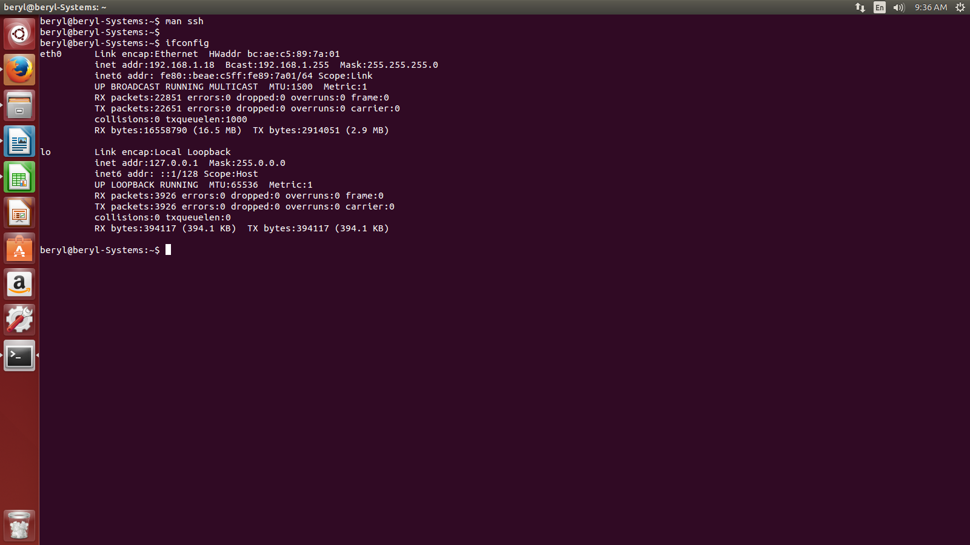
- How to send message to other machine using ip address?

To send messages to another machine we will use iptux software by intsalling it as

sudo apt-get install iptux

The above command will install iptux:

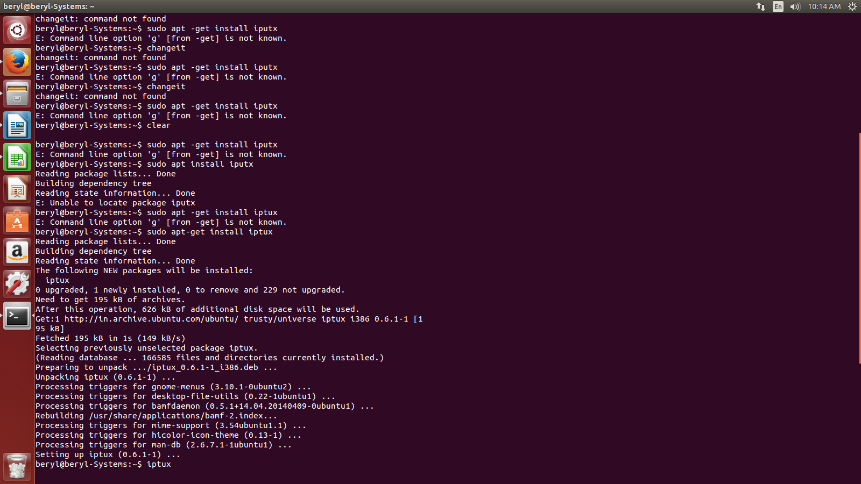

Now execute iptux command in the terminal.

Iptux will be opened and the devices connected on the same lan will show ip address. Select the ip address you want to send message to.

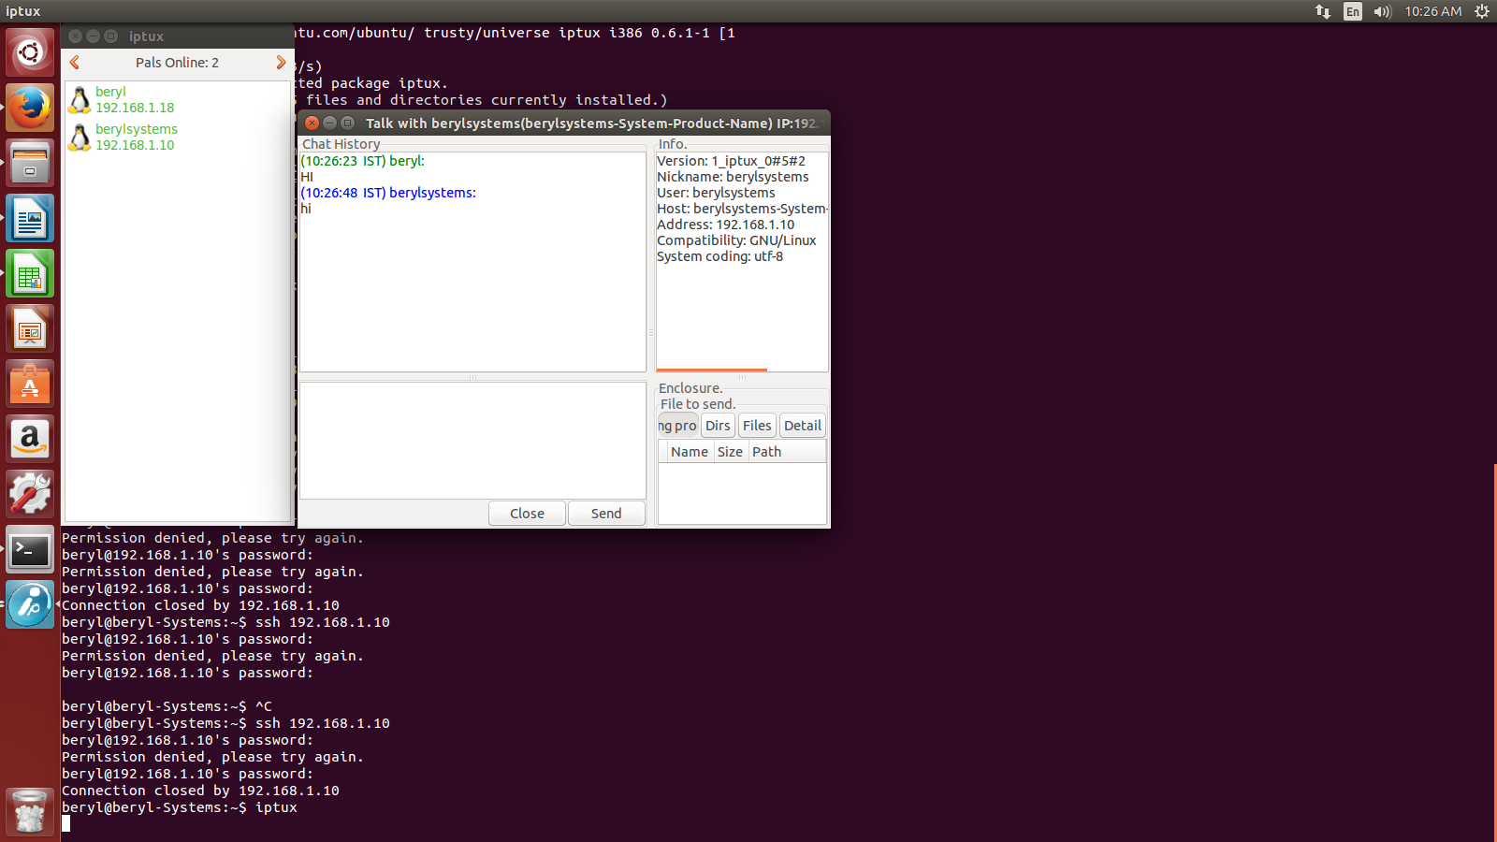
- How to get access to other machine over same lan?

We will get access of other machines using ssh command. SSH stands for Secure Shell, it is a protocol used to securely log onto remote systems.

It is the most common way to access remote LINUX and UNIX-like servers.

Syntax:- ssh “remoteusername@remoteuseripaddress”

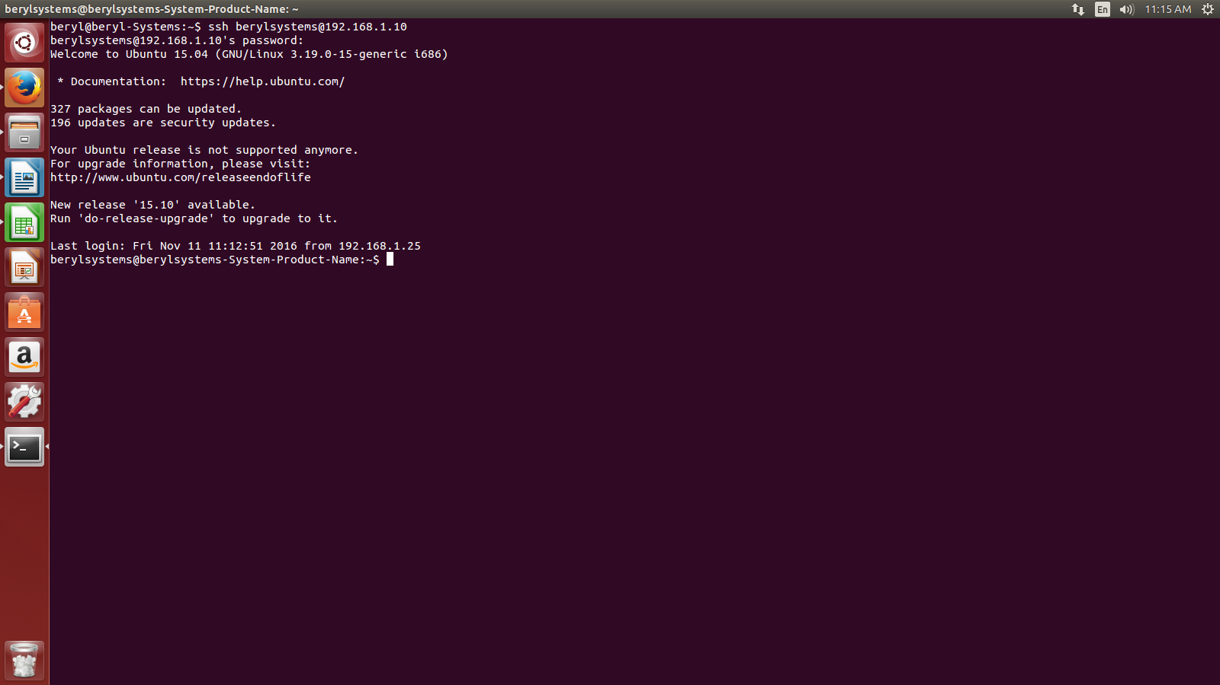

Now we have entered into the remote pc device terminal.
So if we gonna do some changes it will be shown in the remote device.

For example.

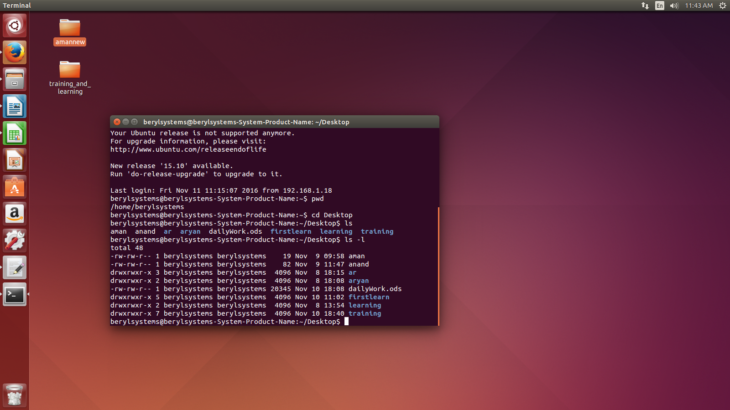
We can see that there are no folders created as named. Since these are remote pc desktop folders.

Now to close connection we will use exit command.

