PostgreSQL Project

Mobile Inventory System

- CREATE DATABASE.

The database is created by the name MIS.

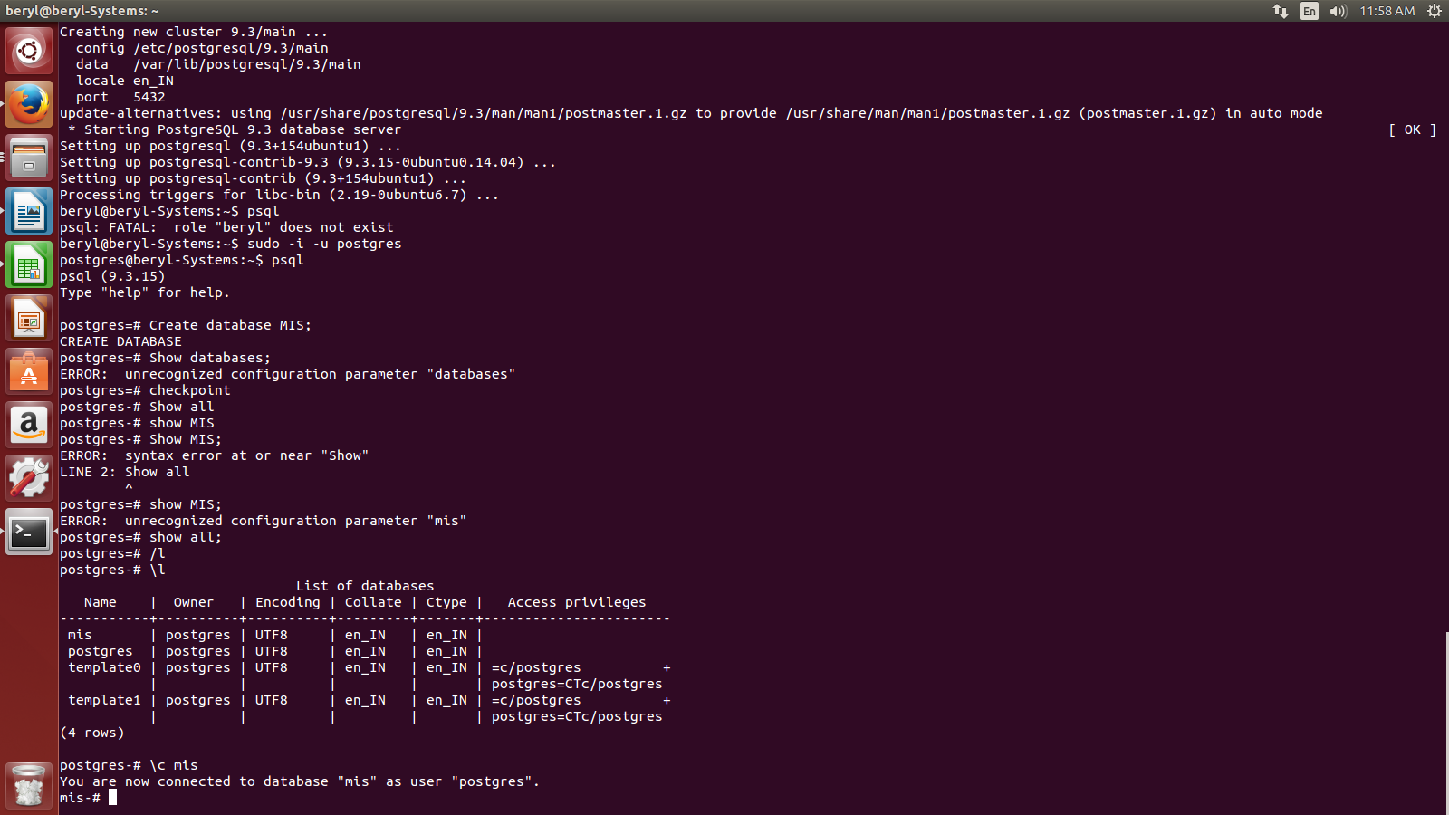

- CREATE TABLES

Table1 :- mobile

CREATE TABLE Mobile(
MobileID INT PRIMARY KEY NOT NULL,
MobileName VARCHAR(100) NOT NULL,
Brand VARCHAR(50),
Manufacturing_Date TIMESTAMP,
PRICE MONEY,
Code INT UNIQUE );
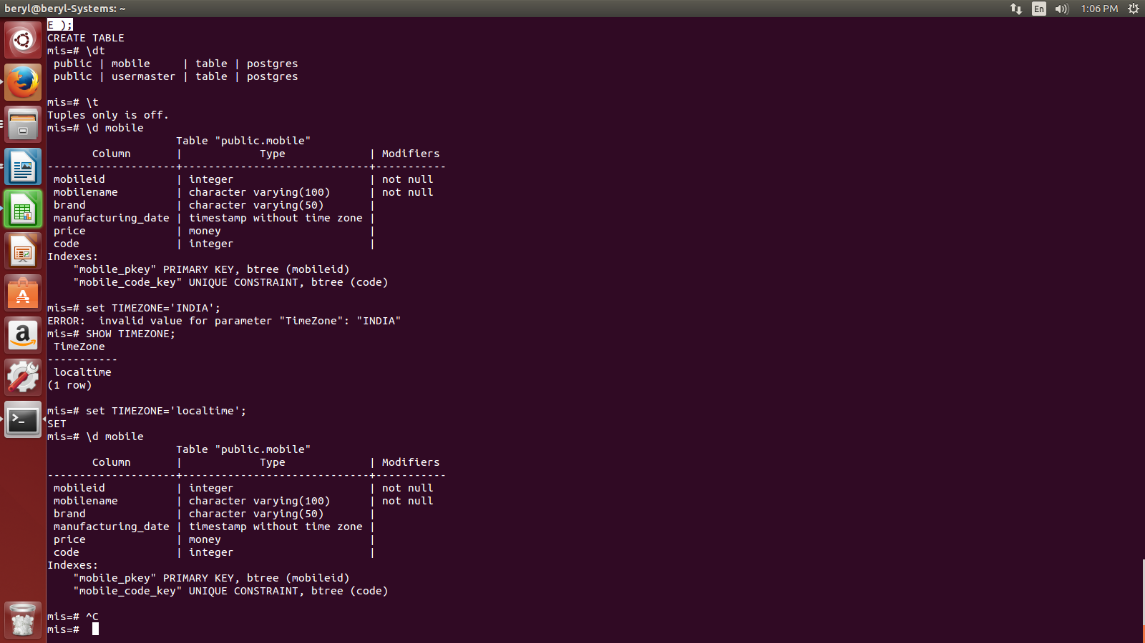

Table 2:- Buyer

CREATE TABLE Buyer(
Id INT PRIMARY KEY,
Buyer_name Varchar(100) NOT NULL,
Mobile_id INT NOT NULL,
Buyer_Address VARCHAR(200),
Contact_Number INT);

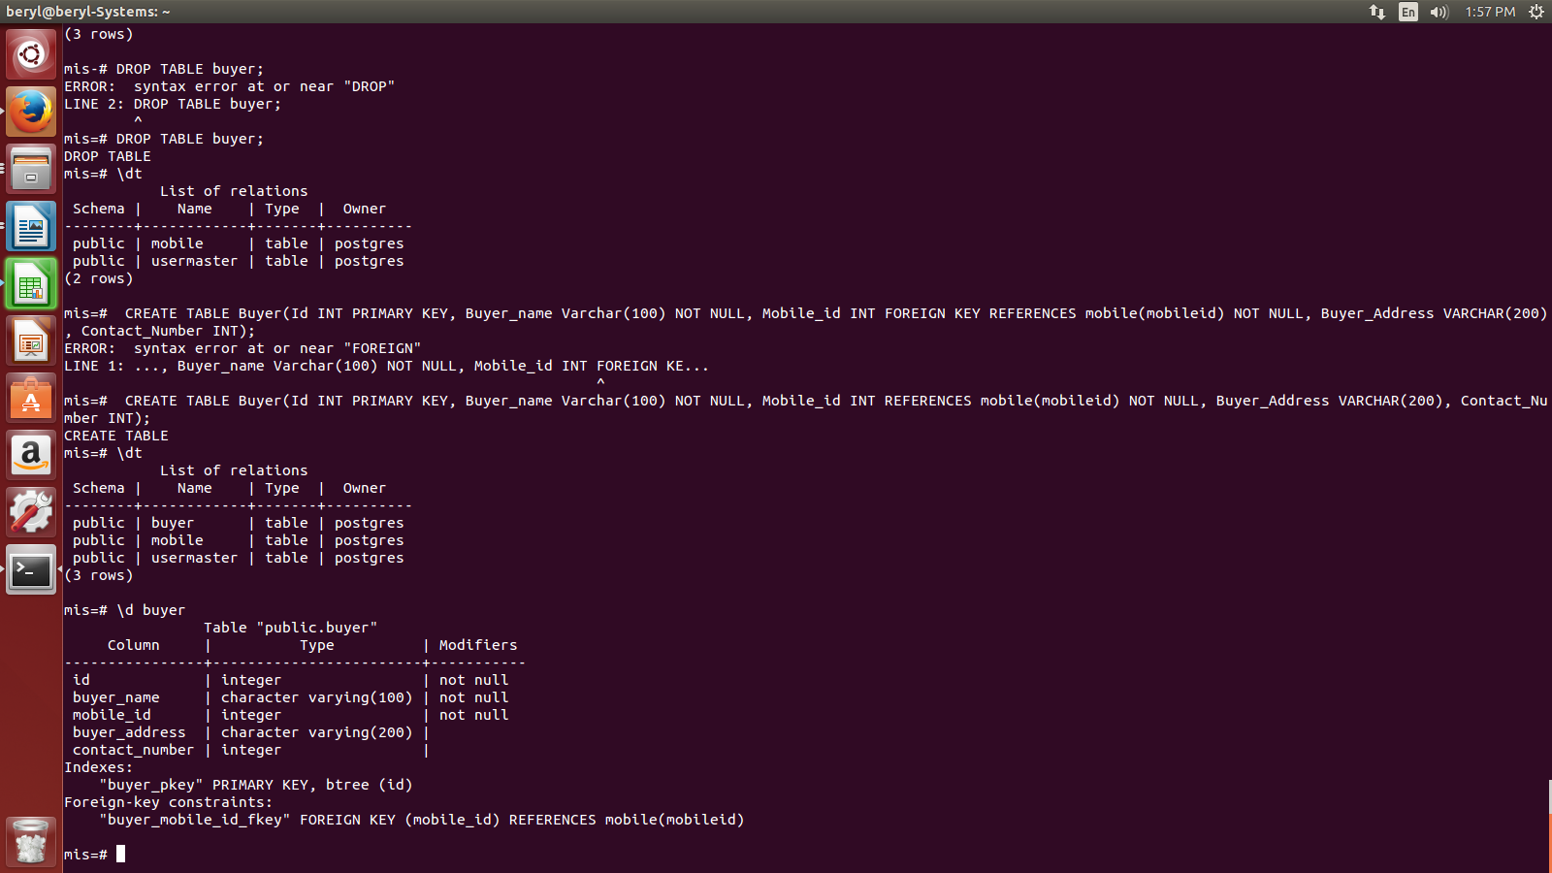

Table3:- Seller

CREATE TABLE Seller(
Seller_id INT PRIMARY KEY NOT NULL,
Seller_name VARCHAR(100),
Mobile_id INT REFERENCES mobile(mobileid) NOT NULL,
Amount INT NOT NULL,
Date TIMESTAMP,
Payment_mode VARCHAR(100));

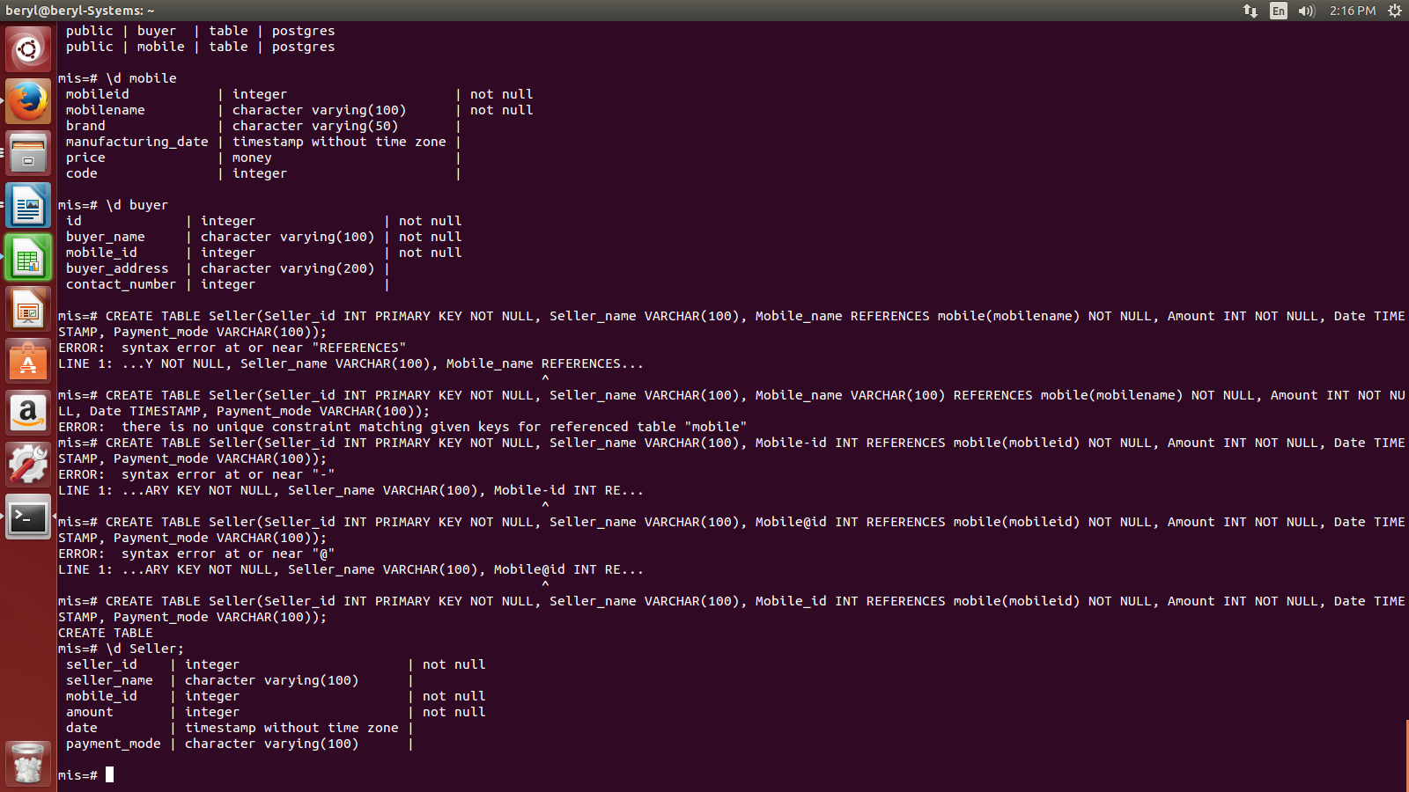
Table 4:- mobilebrand

CREATE TABLE mobilebrand(
mobile_bid INT PRIMARY KEY NOT NULL,
mobile_brand_name VARCHAR (100) UNIQUE,
mobile_id INT REFERENCES mobile(mobileid) NOT NULL,
Branch_location VARCHAR (100) UNIQUE);

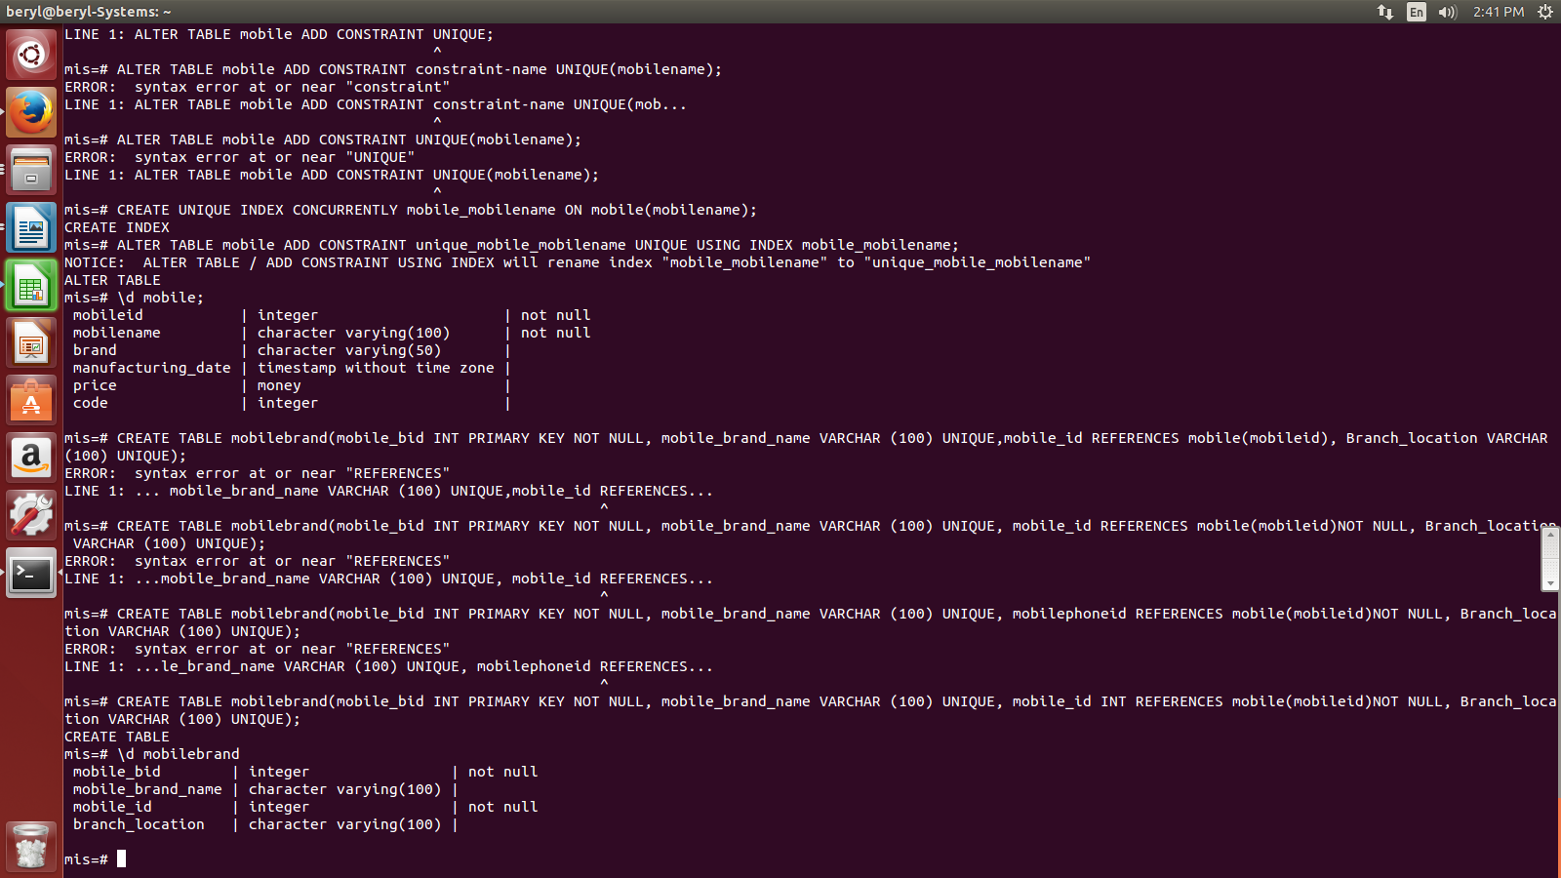

- INSERT DATA INTO TABLES

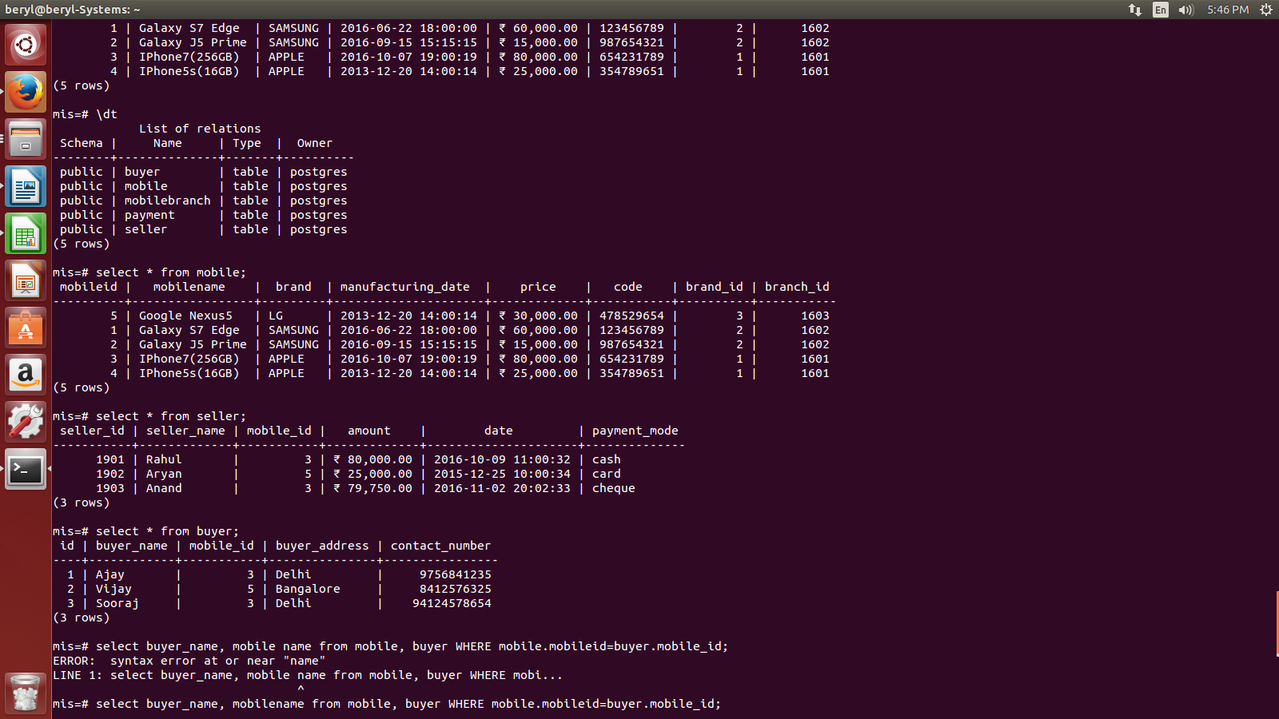

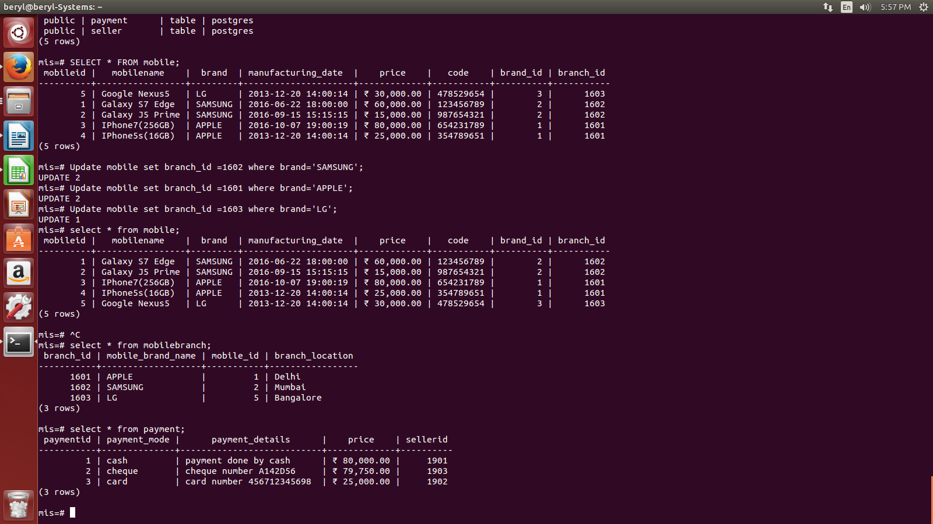

ER-DIAGRAM:-

mobile
Mobileid (primary key)
mobilename
brand
manufacturing_date
Price
code
brand_id
branch_id

Seller
seller_id (primary key)
seller_name
mobile_id (foreign key of mobile)
amount
date
payment_mode

Buyer
Id (primary key)
buyer_name
mobile_id (foreign key of mobile)
buyer_address
Contact number

Mobilebranch
branch_id (primary key)
mobile_branch_name
mobile_id (foreign key of mobile)
branch_location

Payment
Paymentid (primary key)
payment_mode
payment_details
price
seller_id(foreign key of seller)

- Sample queries:-

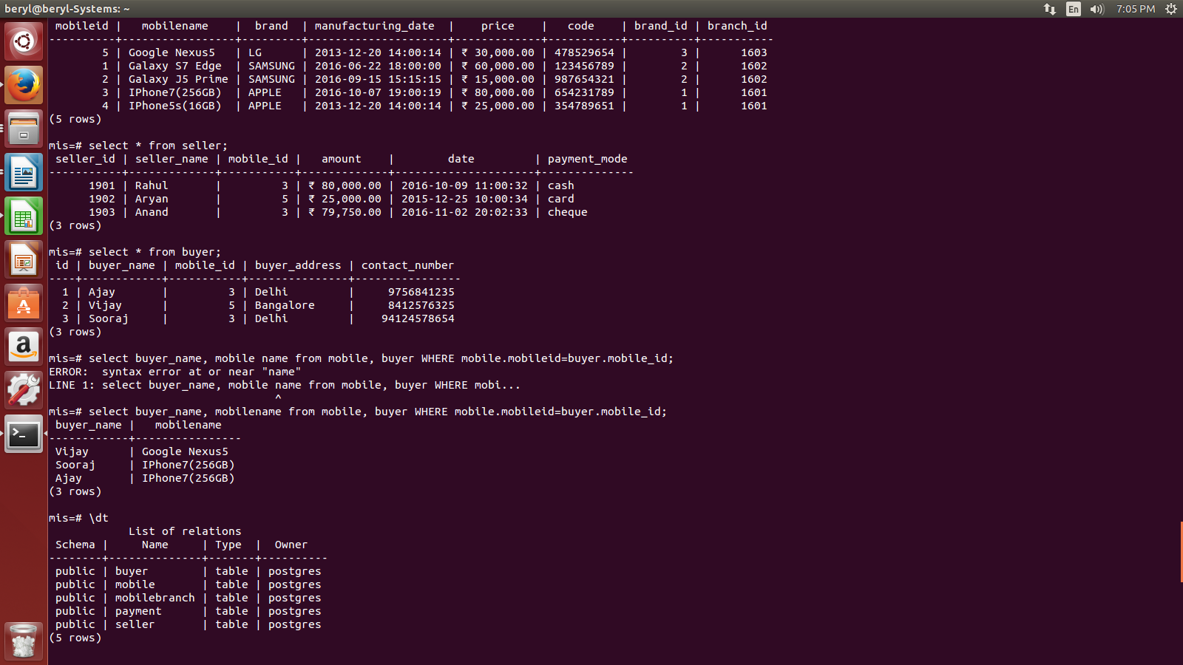
Write a query to print the buyer name with the mobile name they brought.

Write a query to drop column in a table.
