PostgreSQL Project

- Write a query to get buyer name and mobile name from mobile and buyer table :-

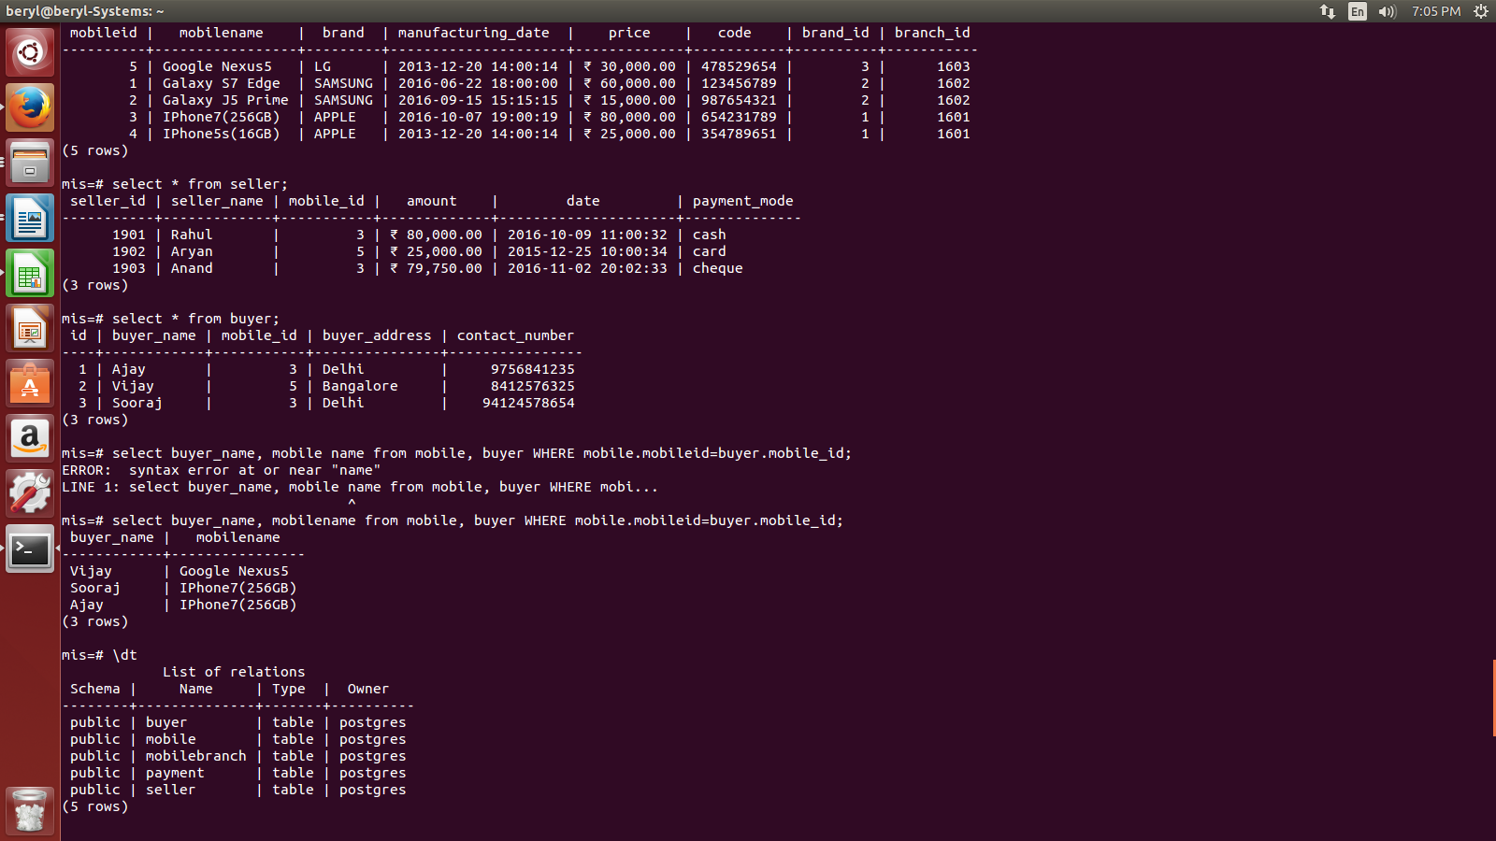
- Write a query to get lowest salary grouped by brands.
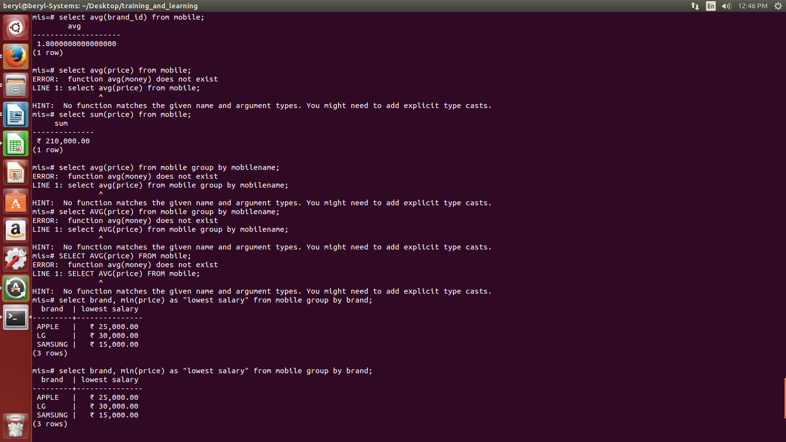
- Write a query to get the last row of the table.

SELECT *
FROM mobile
LIMIT 1
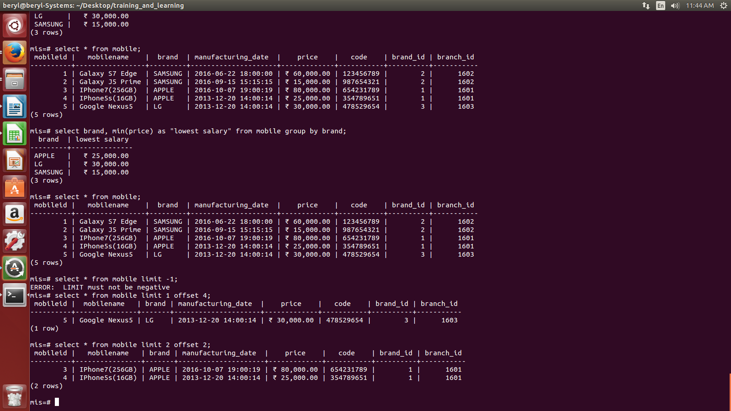
OFFSET 4;

- Write a query using groupby with multiple tables.

SELECT *
FROM (SELECT mobileid ,brand, min(price) as "lowest salary"
FROM mobile
GROUP BY mobileid)as t, seller s
WHERE s.mobile_id=t.mobileid ;
