PostgreSQL BASICS

- What are joins in postgresql?

JOIN is used to basically combine two or more records from one or more tables. The following are the types of joins we have in postgresql:-

- CROSS JOIN- joins each record of table1 with record of table2.

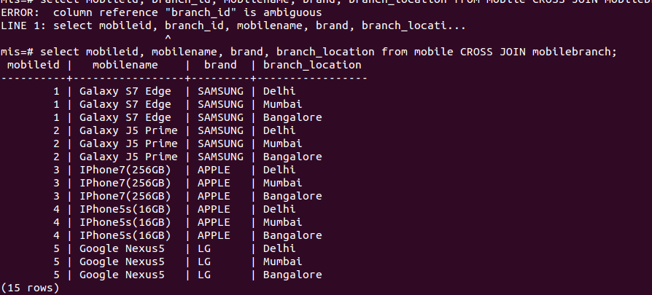
- INNER JOIN-combines columns of two tables based on join-prdeicate.
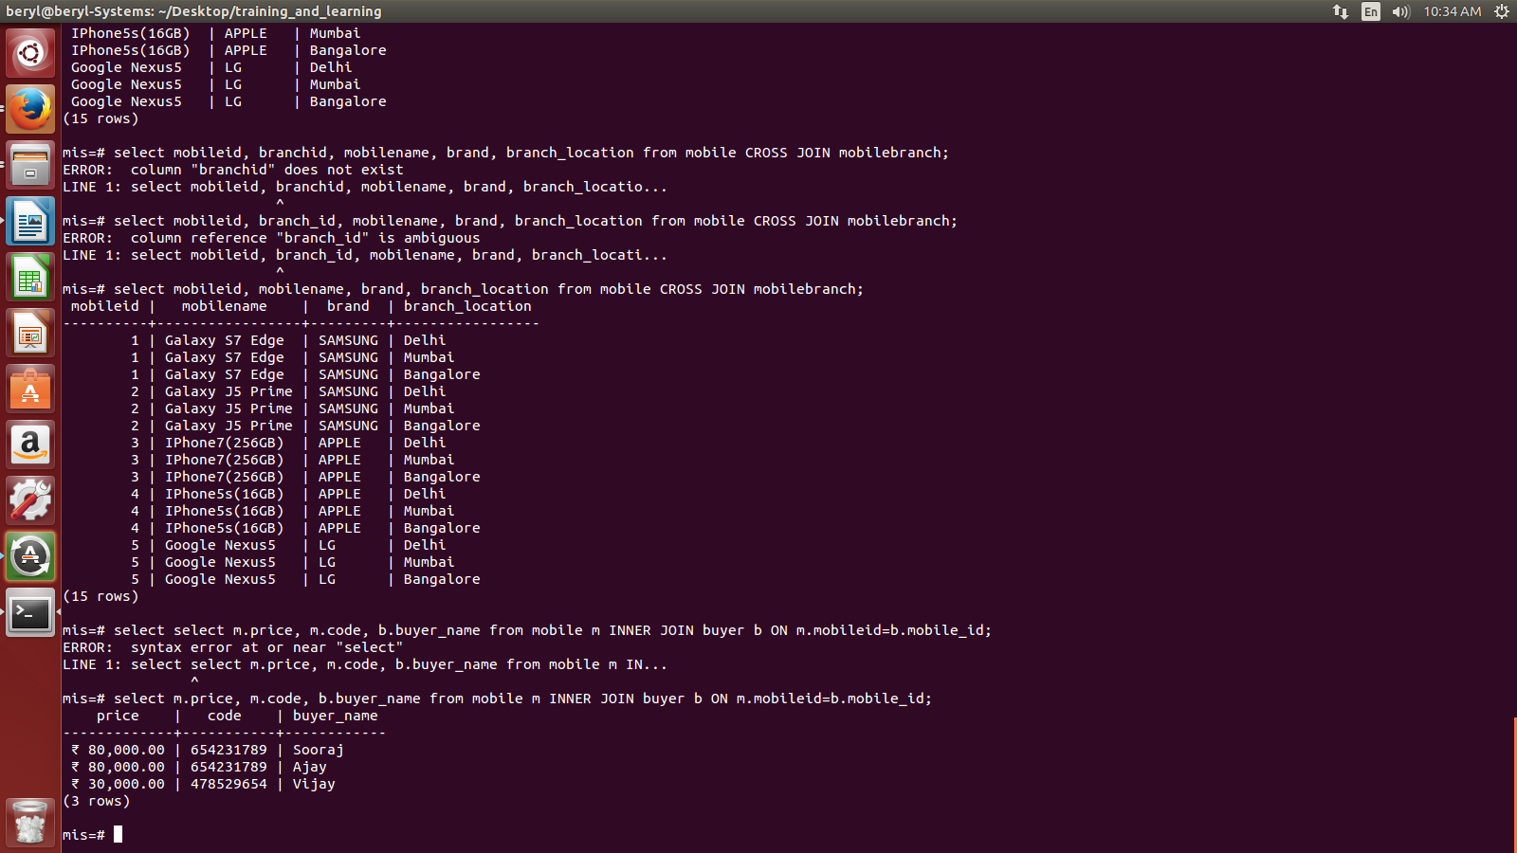

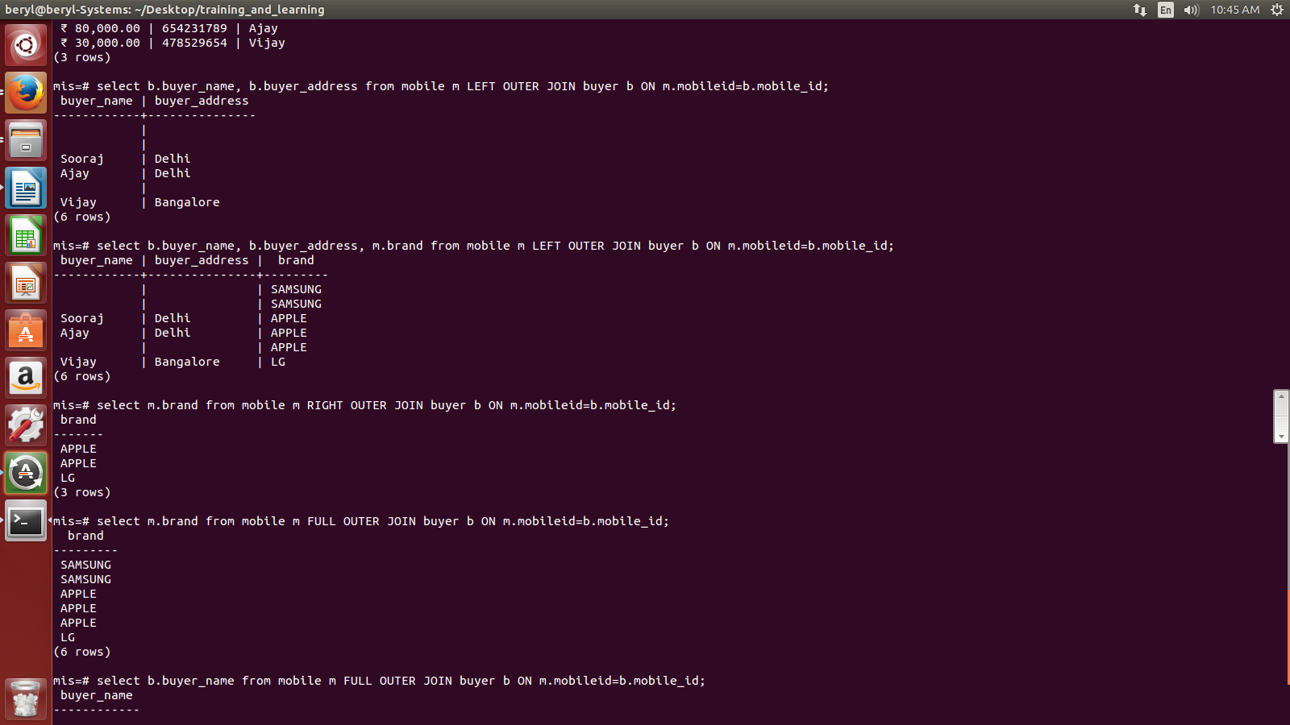
- LEFT OUTER JOIN- combines the fields of left table in the right table.

- RIGHT OUTER JOIN- combines the fields of right table in left table.

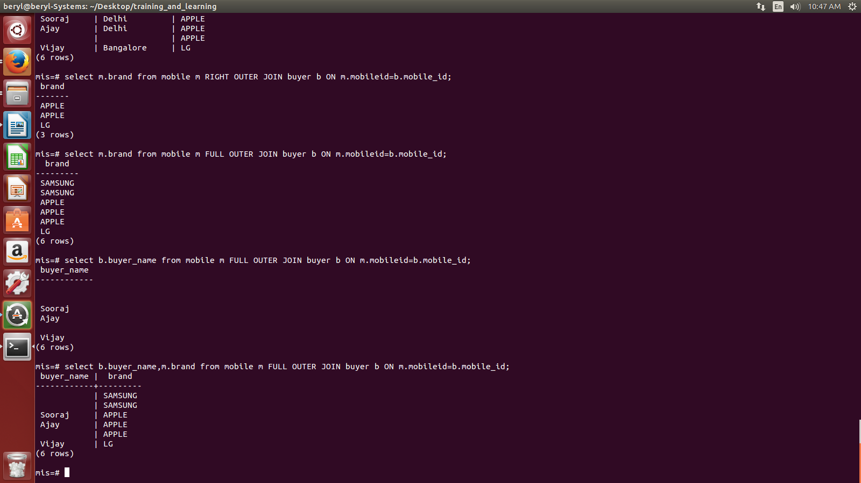
- FULL OUTER JOIN-

- Explain with examples subqueries in posgresql?

  - Write a query to extract payment details of person who buy Google Nexus5.

SELECT *
FROM (SELECT m.mobileid, s.seller_id
FROM mobile m , seller s
WHERE m.mobileid=s.mobile_id
AND m.mobilename='Google Nexus5') as t, payment p
WHERE t.seller_id=p.sellerid;
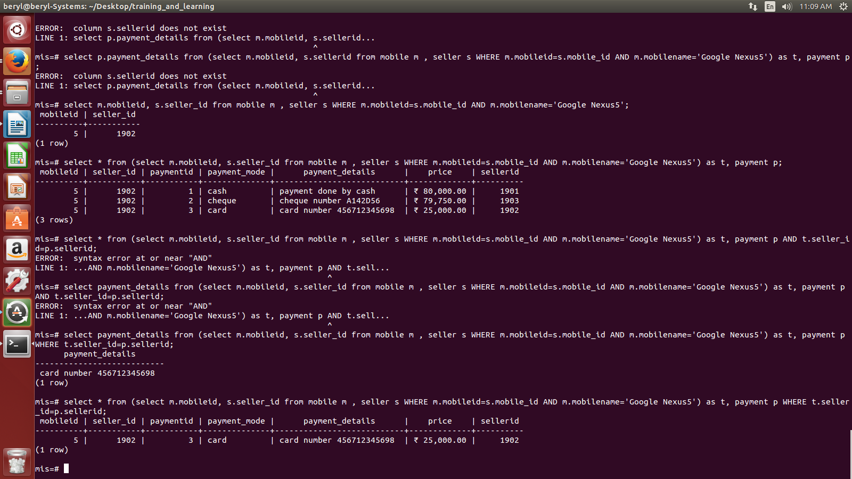

  - Write a query using group by where the brand name groups the table showing the minimum range phone of that particular brand (GROUP BY).

SELECT brand, min(price) as "lowest salary"
FROM mobile
GROUP BY brand;

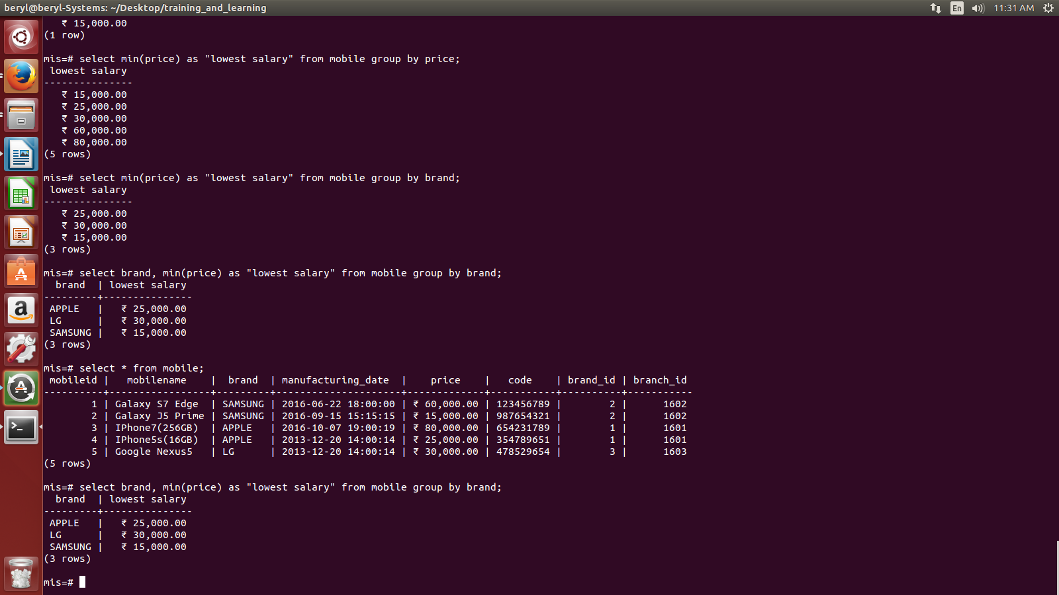

  - Write a query to get the last row of the table (LIMIT and OFFSET).

SELECT *
FROM mobile
LIMIT 1
OFFSET 4;
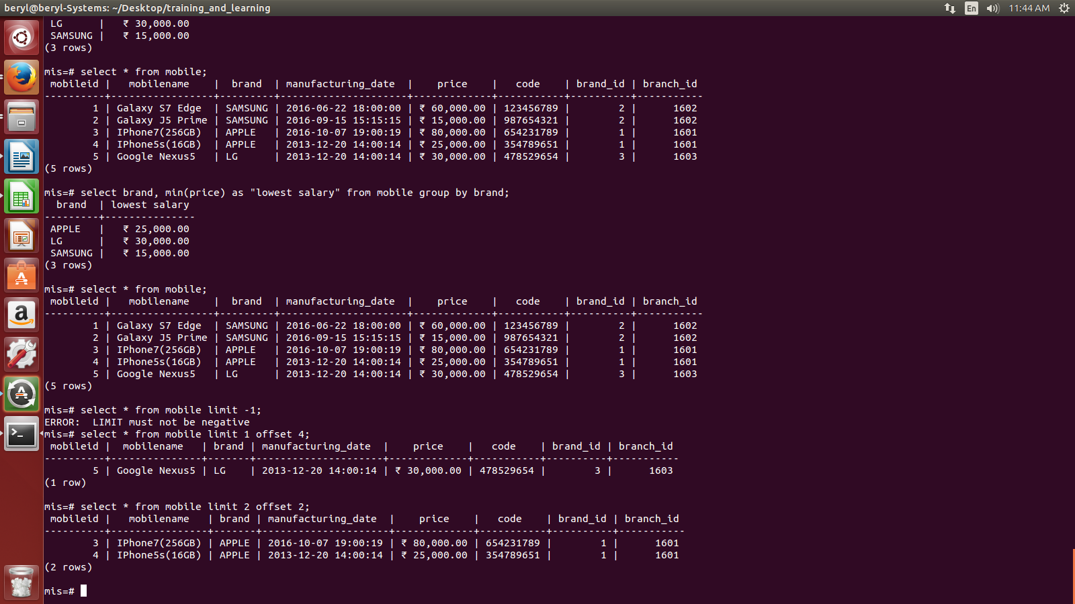

  - Write a query to get mobileid, brand name and the minimum price phone of that brand using having clause.

SELECT mobileid, brand, min(price) as lowest_salary
FROM mobile
GROUP BY mobileid
HAVING brand='APPLE';

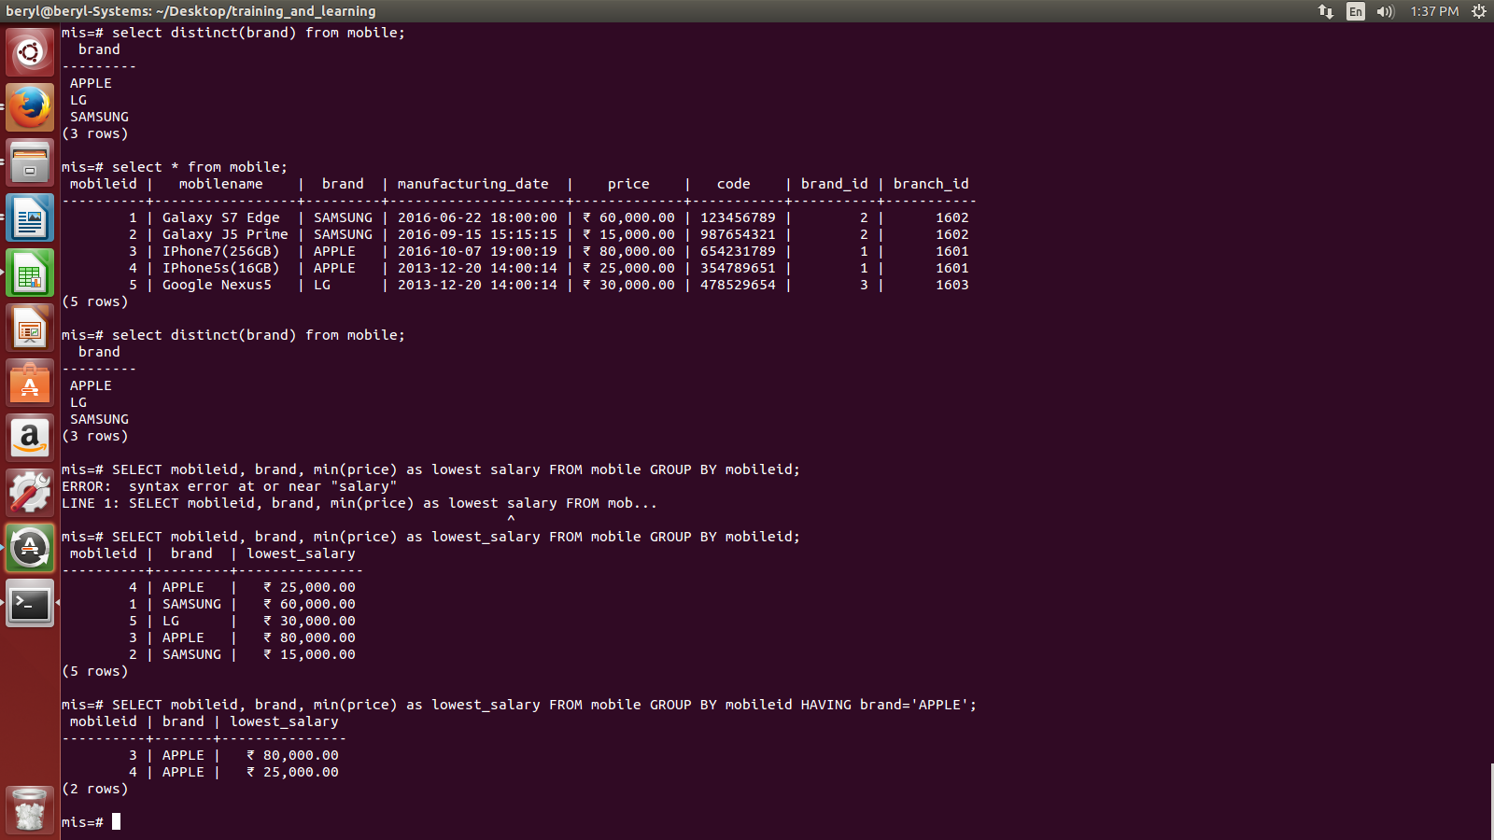

  - Write a query to add constraint using alter table command.

ALTER TABLE <table name> ADD CONSTRAINT <constraint-name> CHECK(condition);
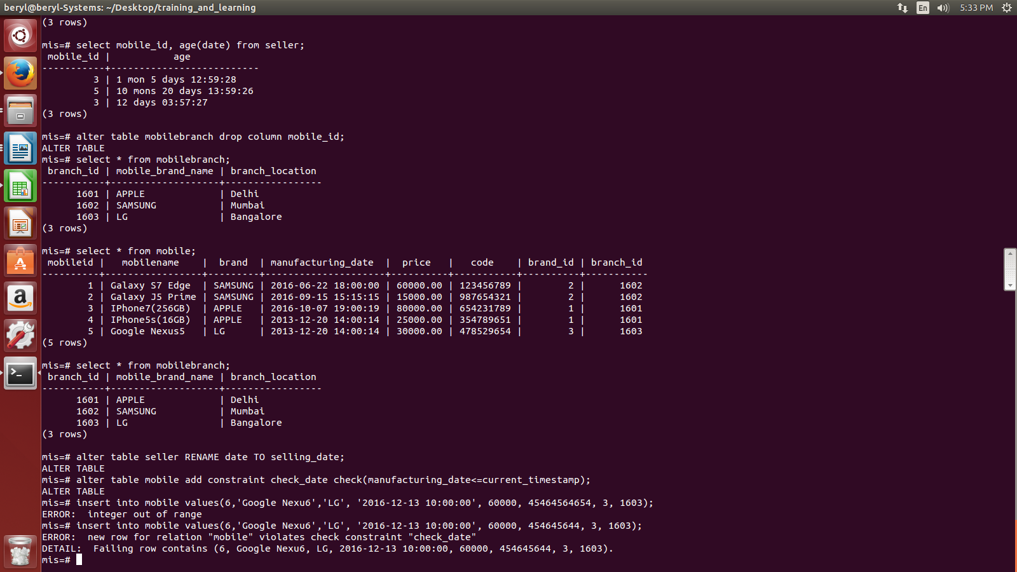
  - Write a query to find the total days (from buy date till current).

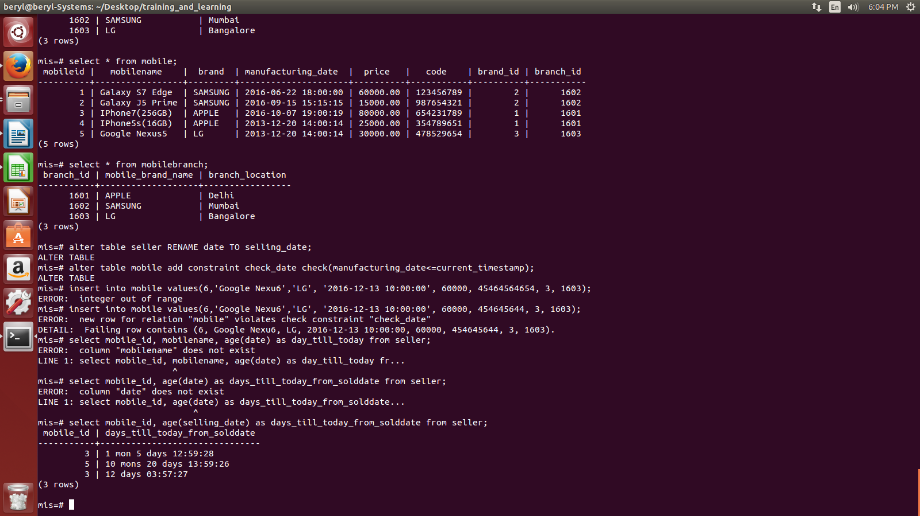
  - How to find difference between two columns?

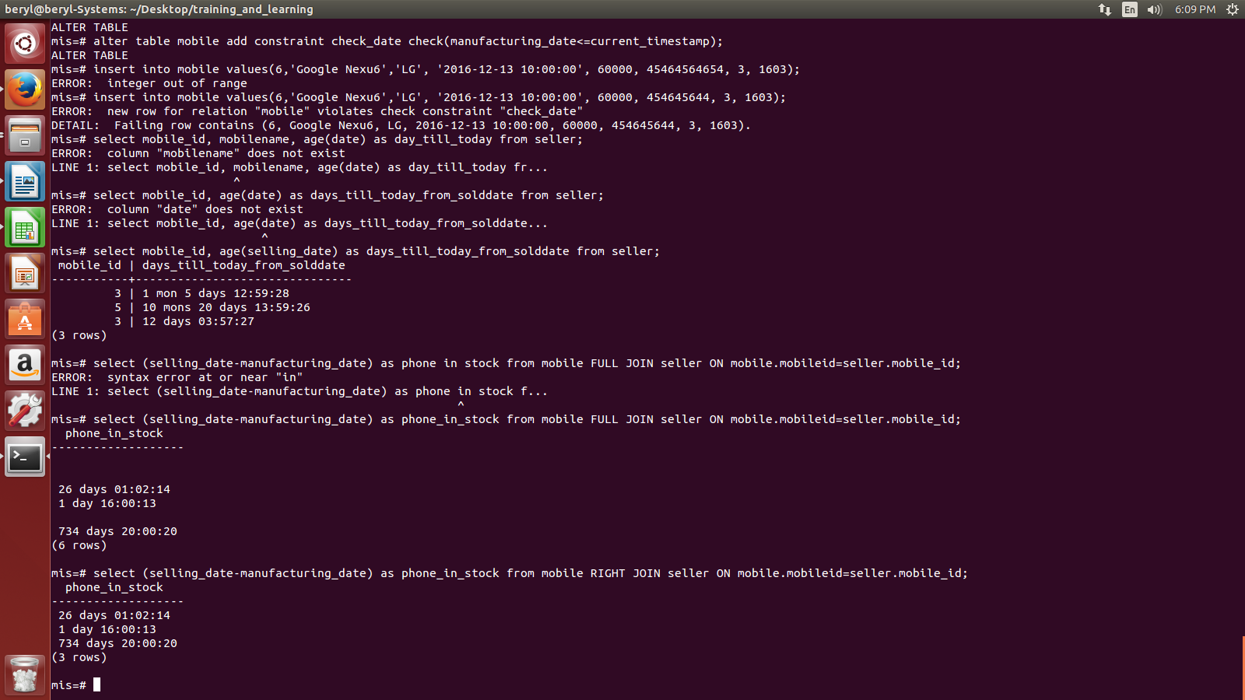

  - How to round off the column to relevant decimal place.

