**ADTA 5550 MIDTERM**

**AMAN GILL 11489675**

**Part One**

**HISTORY OF AI**

Artificial Intelligence has come a long way from its early days, transforming the way we interact with technology and shaping modern innovations. At its core, AI is about creating machines that can think, learn, and solve problems much like humans do. Over the decades, AI has branched into several subfields, including Machine Learning and Deep Learning, each contributing to advancements in computing. The origins of AI date back to the 1950s, when British mathematician Alan Turing explored machine intelligence and introduced the Turing Test, a method to evaluate whether a machine could mimic human intelligence convincingly. In 1956, AI formally emerged at the Dartmouth Conference, where pioneers like John McCarthy and Marvin Minsky laid the foundation for artificial intelligence research. During this early phase, AI heavily relied on rule systems and symbolic reasoning, which aimed to replicate human decision making through predefined logic. However, these methods struggled with the real world complexity and adaptability. Following suit, During the 1960s and 1970s, AI researchers focused on expert systems, which were designed to mimic human decision making using predefined rules. While these systems found success in specialized applications, they lacked the ability to learn and adapt. In addition, computational limitations of that era made AI development slow and expensive. This led to the first AI Winter, a period marked by declining interest and reduced funding due to technology’s limitations. With a comeback, AI saw a resurgence in the 1980s and 1990s, thanks to advancements in computing power and the emergence of Machine Learning Unlike earlier AI systems, ML allowed computers to learn from data instead of relying solely on predefined rules. Algorithms such as decision trees and support vector machines demonstrated that AI could improve through experience, leading to more practical applications in fields like finance and healthcare. One of the biggest breakthroughs came with neural networks, which were inspired by the human brain’s structure. The development of the backpropagation algorithm in the 1980s allowed these networks to adjust their learning process automatically, making them far more effective at identifying patterns and making predictions. This breakthrough ultimately set the pace for AI models made to be much more refined. The early 2000s introduced the debut of Deep Learning, a subfield of ML that introduced multi-layered artificial neural networks capable of analyzing vast amounts of data. Unlike traditional ML models, which require manual feature selection, deep learning automates this process, making it far more efficient and scalable. All in all there are multiple factors that helped facilitate the rise of Big Data. The rise of the internet, social media, and digitalization provided deep learning models with an abundance of training data, allowing them to learn complex patterns effectively. With Computational Power breakthroughs being the development of Graphics Processing Units and Tensor Processing Units, this significantly accelerated neural network computations, making deep learning more accessible and practical. Continuing on with Innovations in Neural Network Architecture, Convolutional Neural Networks essentially revolutionized image processing, while transformers paved the way for advanced Natural Language Processing models such as ChatGPT being a prime reference. As far as impact goes, Deep Learning has taken AI to unprecedented levels, powering innovations across various industries. Today, AI assists in medical diagnostics, self driving vehicles, voice recognition, and fraud detection, and many more uses. As AI continues to evolve, research efforts are following along, such as; improving model transparency, reducing computational costs, and making AI systems more ethical and explainable. The future of AI lies in closing up the gap between deep learning and human like reasoning, as that is its very purpose, and with ongoing efforts to create more generalized AI models capable of handling diverse tasks across industries. What must be regarded is the ethical considerations, regulation, and responsible AI development, which will be key factors in shaping the next generation of artificial intelligence.

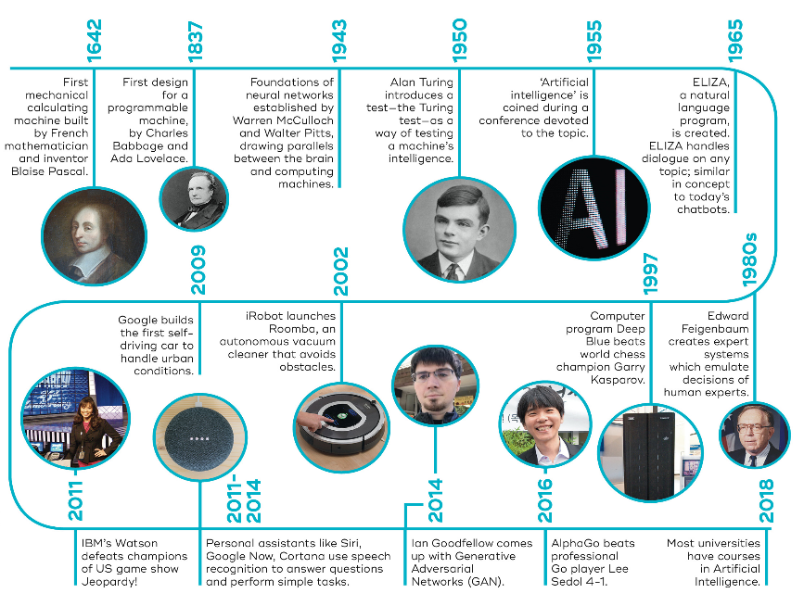

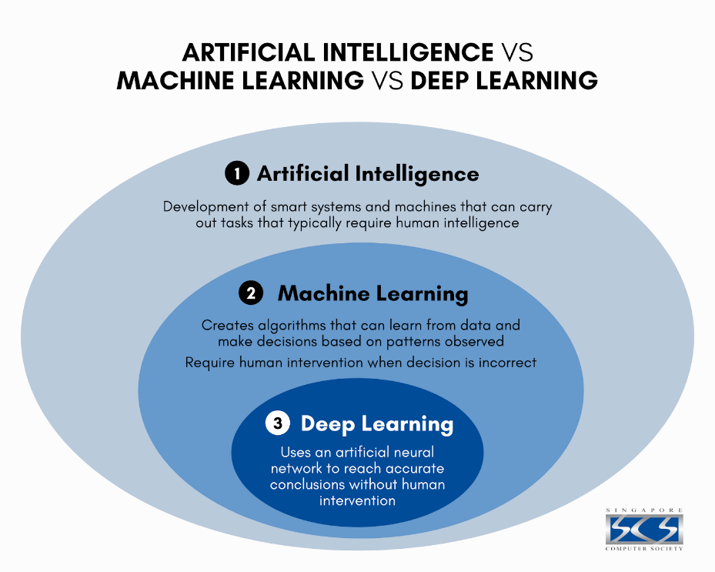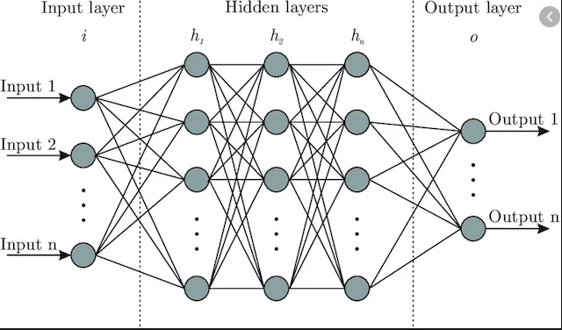

**Deep Learning Overview**

Deep learning has proved to be one of the most exciting and impactful advancements in artificial intelligence. It has completely changed the way machines interpret and process information, allowing computers to learn from vast amounts of data with minimal human input. As a specialized branch of Machine Learning, deep learning relies on artificial neural networks to recognize patterns, make predictions, and solve complex problems. What Deep learning is, is a type of Machine Learning that uses multi layered artificial neural networks to process and analyze large datasets. Unlike traditional machine learning, which often requires manual feature selection and human guidance, deep learning automates this process, making it much more effective for tasks like image recognition, natural language processing, and autonomous systems. Deep learning can be broken down into three essential components. Neural Networks are layers of interconnected artificial neurons that process data, mimicking the way the human brain works. Backpropagation Algorithm is a paramount method that helps to fine tune neural networks by adjusting weights to improve their accuracy over time. Finally, Big Data Processing is necessary in leveraging large datasets to find patterns and make better predictions, since deep learning requires enormous amounts of information. While AI can be described as the broadest field that gives regard to all efforts to create machines capable of intelligent behavior, and Machine Learning encompasses a subset of AI that delves into algorithms that learn and improve from data without being programmed explicitly, Deep learning can be specified as the subset that integrates deep neural networks that asses tasks that are more complex while minimizing human intervention. One of the biggest advantages of deep learning over traditional machine learning is its ability to handle unstructured data such as images, text, and sound without requiring manual feature engineering. This has made deep learning the ultimate solution for speech recognition, medical image analysis, self driving technology, and many more innovative applications. In summarization, Deep learning has showcased great momentum in thanks to key advancements such as Convolutional Neural Networks which revolutionize image and video recognition, Recurrent Neural Networks and Transformers which power modern natural language processing, and Generative Adversarial Networks that enable AI generated content as well deepfake technology and advanced image editing. As a result helpful impacts have been made in Healthcare with AI-driven diagnostics as well as medical imaging and drug discovery, Finance with Fraud detection in addition to automated trading and predictive analytics, and Autonomous Systems As research progresses, deep learning will serve to be the strong core of AI development, driving innovation and expanding the possibilities of what 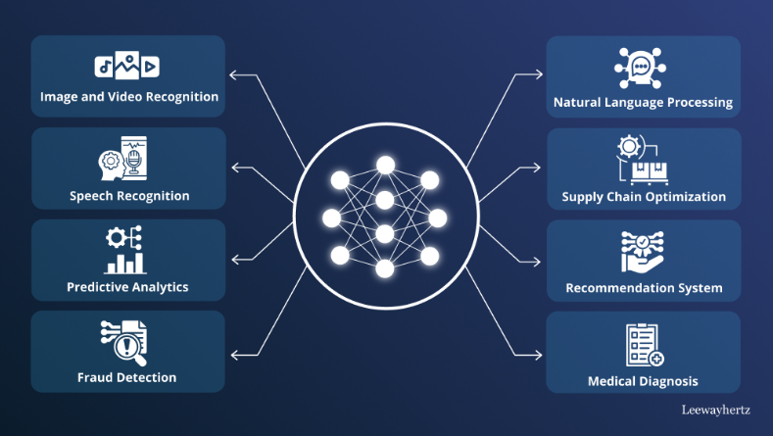machines can do.

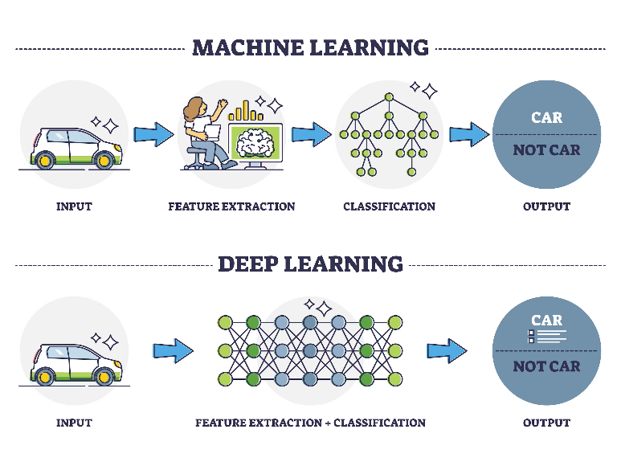

Deep learning has rapidly become one of the most transformative technologies in artificial intelligence. Its popularity has skyrocketed in recent years due to significant advancements in computing power, the availability of vast amounts of data, and improvements in neural network designs. These breakthroughs have allowed deep learning to surpass traditional machine learning methods in many areas, making it perfect for solving complex challenges across various industries. Delving into why it has become so popular, sinc modern deep learning models require enormous datasets to function effectively, the digital age has resulted in an uproar of data from sources such as social media, online transactions, medical imaging, and sensor networks. Unlike traditional machine learning, which often struggles to process unstructured data, deep learning thrives in these environments. It can automatically identify patterns, extract insights, and make accurate predictions with minimal human intervention. This rise has been heavily supported by improvements in computing hardware. Graphics Processing Units and Tensor Processing Units have dramatically sped up the training of deep neural networks. These specialized processors allow deep learning models to analyze data and learn patterns much faster than traditional Central Processing Units making larger scale deep learning projects feasible for businesses and researchers alike. In continuation of reinforcement, the development of advanced neural network architectures has significantly expanded deep learning’s capabilities. Convolutional Neural Networks and Recurrent Neural Networks have proved to enable applications like facial recognition, medical image analysis, and real-time object detection and the latter has drove progress in Natural Language Processing, These architectures have made it possible for deep learning to tackle increasingly complex tasks, from detecting early signs of diseases in medical scans to enhancing automatic speech recognition. Deep learning’s ability to deliver high accuracy and efficiency has led to its widespread adoption across various sectors in Healthcare, Finance, Automotives, Retail, and E-Commerce alike. One of the biggest reasons behind deep learning’s rapid growth is the increasing availability of open-source tools and frameworks. Platforms such as TensorFlow, PyTorch, and Keras have made it easier for developers, businesses, and researchers to build and deploy deep learning models. Additionally, cloud computing services from Google, Amazon, and Microsoft provide scalable AI solutions, thus eliminating the necessity of infrastructure and making deep learninmore accessible than ever before. One can also consider that while deep learning has achieved remarkable success, it also raises ethical concerns. Issues such as data privacy, biases in AI models, and the environmental impact of high computational demands are becoming critical topics of discussion. However, in response, researchers and policymakers are actively working to develop responsible AI practices. In conclusion this popularity is bolstered by big data, computational advancements, and refinements in neural architectures. Deep learning will of course become even more powerful and although challenges remain, continuations in research and ethical considerations will help shape a future where deep learning remains a leading force in artificial intelligence for years to 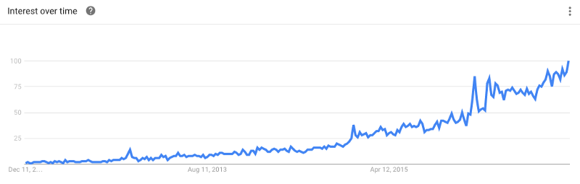come.

**Deep Learning Popularity**

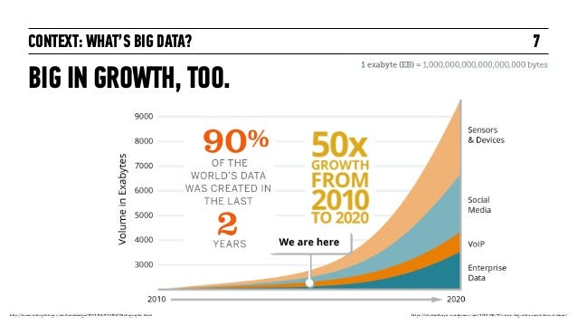**Part Two**

**Diagram Explanation:**

*The diagram has been illustrated to capture the prediction of diabetes in correlation to the Dataset. The input layer showcases 8 neurons in correspondence to the features being Glucose Levels, BMI, Age, and Diabetes Pedigree Function. In following, there is a hidden layer depicting 12 neurons and a second hidden layer depicting 8 neurons, both employing ReLu learning representations, just to specify. Finally, the output layer depicts a single neuron, sigmoid activation function considered, to determine whether a person is diabetic or not in a binary fashion. And of course, feed forward connections bright the layers to make the diagram complete.*

**Accuracy Level Report:**

*This project involved training a Multi-Layer Perceptron model on the pima_diabetes.csv dataset to classify diabetes cases. The model had two hidden layers and a sigmoid output layer for binary classification. To evaluate performance, I used 10-fold cross-validation, achieving an average accuracy of 77.45% and the final test accuracy was 71.43%. The slight drop in test accuracy suggests some level of overfitting, where the model performs well on training data but struggles with unseen examples. This is supported by the training and validation loss curves, where validation accuracy plateaued while training accuracy continued improving. Possible reasons include the limited dataset size and the model becoming too specialized in training patterns. Overall, The model demonstrates promising predictive capabilities and provides a strong foundation for strengthening.*

**Comparison Report:**

*When comparing the accuracy levels of the MLP models trained on the Pima Diabetes and Iris datasets, there are differences due to dataset complexity and feature distribution. The Pima Diabetes model had a cross-validation accuracy of 0.7745 and a final test accuracy of 0.7143, and the Iris model consistently performed above 85%. This is because of the structured and well separated features in the Iris dataset, making classification easier. The Pima Diabetes dataset presents more overlap and noise, making it harder to distinguish between classes. Additionally, the binary classification nature of the Pima dataset increases the challenge of classifying borderline cases. The slight gap between training and validation accuracy suggests some overfitting. Ultimately, while both models followed the same design, dataset characteristics played a significant role in their respective performances. The accuracy of the Pima Model being lower reveals the challenges of real-world medical data. On the contrary, the Iris dataset allowed for a more straightforward classification task.*

**Part Three**

**Redesign Discussion:**

*The redesigned MLP architecture introduced several enhancements to improve model performance. When Compared to the initial model, which had a simpler structure, the new design incorporates additional layers and techniques like batch normalization and dropout. These adjustments essentially help stabilize training, prevent overfitting, and improve generalization. The increased number of neurons in the hidden layers allows for better feature extraction, while the use of dropout regularization ensures that the model does not become overly reliant on specific neurons. All in this redesign aims to create a more robust and efficient model for classifying the dataset. The redesigned MLP is expected to improve performance due to its ability to learn more complex patterns while lessening overfitting. The implementation of batch normalization accelerates training by standardizing activations, leading to more stable gradients and improved convergence. Dropout regularization helps prevent the model from memorizing the training data, making it more adaptable to unseen examples. Finally, the increased depth of the network allows it to capture more intricate relationships within the dataset*

***Redesign Comparisons:***

*The redesigned MLP showcases solid improvement, as the previous architecture, while functional, lacked mechanisms to optimize training stability and prevent overfitting. Since the training accuracy has increased, and the validation accuracy shows more consistency, it reveals that the model is now learning patterns more effectively rather than memorizing the training data. Additionally, the loss curves indicate a smoother convergence, thus reducing the gap between training and validation loss. These enhancements serve to make the redesigned MLP a more robust model for classification tasks.*

