End-user search queries on JSON datasets  
Use-Case: Apply filters on JSON datasets

# Brief Description

This use case describes how users can apply filters on datasets and get the targeted dataset

# Actors

## Web Interface User

# Preconditions

* Backend Server is running
* Web interface is running

# Key Requirements

1. Make a web interface to interact with the user and a backend server to handle queries
2. Take json dataset as input
3. Read column names from metadata and segregate them into primary, secondary or tertiary filters
4. Provide checkbox on every column name to provide filtering functionality
5. Get the targeted dataset from the backend server through API

# Basic Flow of Events

1. The use case begins when the user inputs the JSON dataset onto the web interface
2. Use Case: Verifying dataset format and retrieving metadata
3. The dataset and metadata are sent to the backend server
4. Use Case: The server reads the data and the metadata and segregate them into primary, secondary or tertiary filters
5. The server sends the list of filters with their category to the frontend
6. The web interface displays the filters in 3 sections according to their level with checkbox alongside filters
7. Use Case: User selects the filters using the checkboxes and selects the desired value for the filter
8. After the user has selected their filters, the filter information is sent to the server
9. The server applies the filters on the dataset and sends the targeted dataset back to the interface
10. The targeted dataset is displayed on the web interface
11. Use Case: The user can download the targeted dataset in json and csv formats

# Use Case Diagram

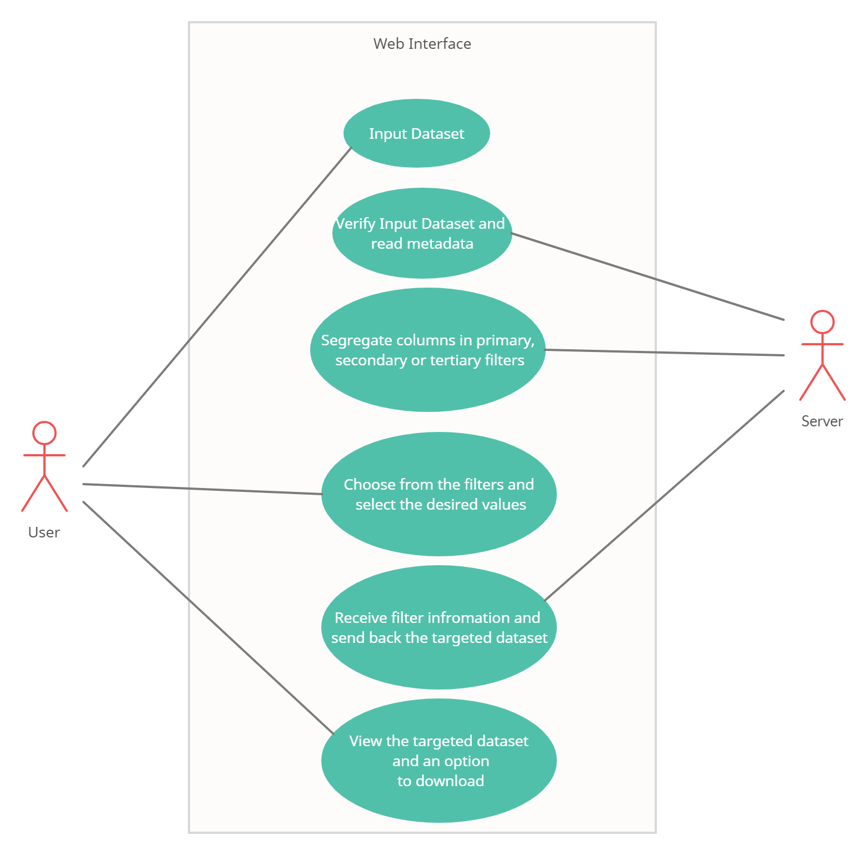

# Alternative Flows

## Invalid Dataset

If in step 2 of the basic flow, the dataset in not a json dataset or metadata is not present

1. the use case ends with a failure condition and error message is displayed

## No Response from Server

If in step 3 of the basic flow, if there is no response from the server then

1. Display error message saying “Network Error”

# Post-conditions

## Successful Completion

The user has received their targeted dataset with the filters applied on the original dataset

## Failure Condition

Error messages were displayed on screen

# Special Requirements

1. The Server stores a user id sent by the web interface to uniquely identify dataset in the backend database