CRITICAL HIT STUDIOS

**Requirement Specifications**

for

Plants Vs Zombies Game

Presented By:

Aman Garg

Avanti Dorle

Apurva Surve

Mayank Nagpurkar

Purva Ekatpure

Shivkumar Patil

**Contents**

1. Problem Statement
2. Introduction
3. Description

3.1. Element Specification

1. Purpose
2. Requirements

5.1. Functional Requirement

5.2. Non-Functional Requirement

6. External Interface Specification

6.1. User Interface

6.1.1 Start screen

6.1.2 Playing screen

7. Technical Specification

7.1 Hardware details

7.2 Operating system details

7.3 Performance

8. Use case diagram

1. **Problem Statement:**

Create a clone of Plants vs Zombies game.

1. **Introduction:**

Plant vs Zombies is a tower defense game where you protect your backyard from hordes of attacking zombies using magical plants.

1. **Description:**

A desktop application in which the user uses different plants to fight zombies which try to attack the house. He must acquire maximum sunlight (which are a source of energy) and buy different plants and form tactical army that fights the zombies.

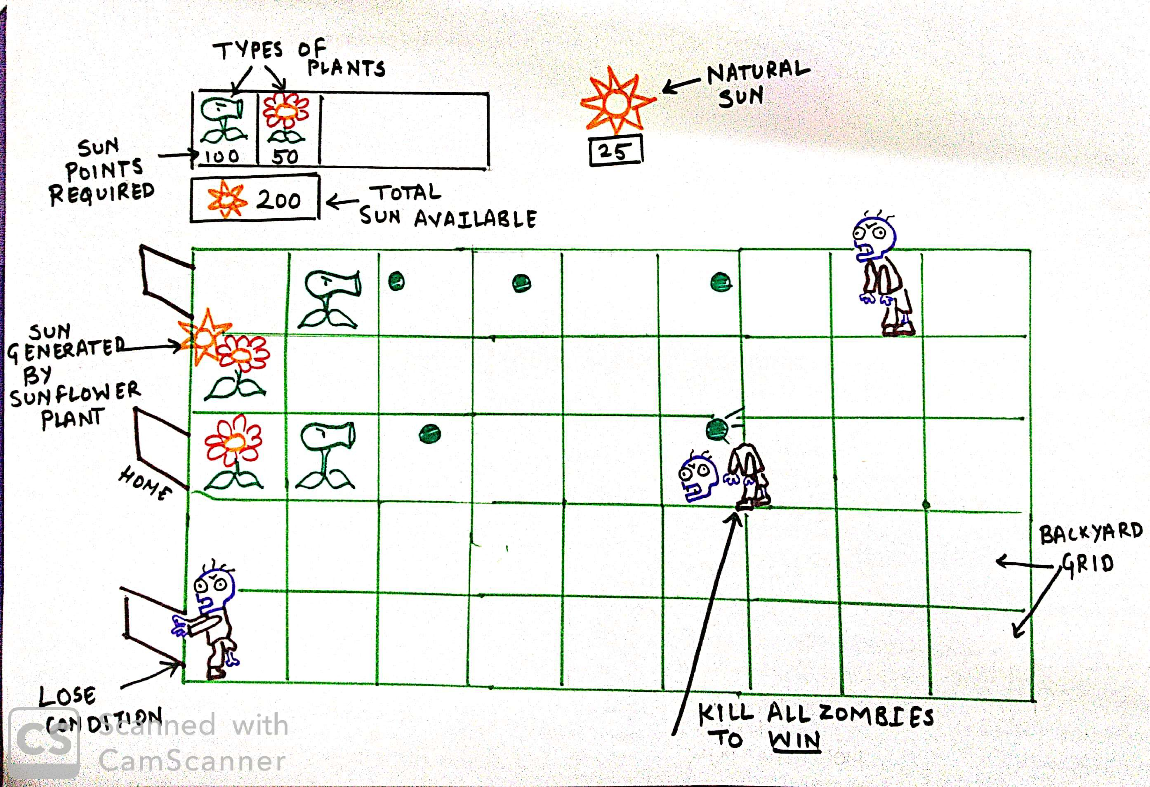

* 1. **Element specifications:**

|  |  |  |  |
| --- | --- | --- | --- |
| **Element** | **Name** | **Points required** | **Power** |
|  | Sun | NA | Helps to grow new plants. Generates 25 points |
|  | Sunflower | 50 | Generates new sun elements |
|  | Peashooter | 100 | Shoots peas constantly as a zombie arrives in its row |
|  | Freeze plant | 150 | Shoots frozen peas constantly as a zombie arrives and slows it down |
|  | Walnut | 25 | Creates an obstacle in zombie’s way. Eventually keeps him busy |
|  | Regular zombie | NA | Can eat all plants and obstacles in his way |
|  | Football zombie | NA | Can eat all plants and obstacles in his way. Has more health level than regular zombies |

1. **Purpose:**

Game should be fair, rewarding and entertaining

1. **Requirements**
   1. **Functional Requirements:**

|  |  |  |
| --- | --- | --- |
| Sr. No. | Requirement | Required/Desired |
| 1 | Start UI Screen will have Play Button | Required |
| 2 | Start UI Screen will have Quit Button | Required |
| 3 | 5 x 9 layout grid | Required |
| 4 | Panel to select different plant seeds | Required |
| 5 | Panel to display sun count | Required |
| 6 | Placing Plants on grid | Required |
| 7 | Zombies should enter from one side of layout | Required |
| 8 | Sun should drop | Required |
| 9 | User uses sun to place plant in grid | Required |
| 10 | Sunflower plant should generate sun regularly | Required |
| 11 | Different types of plant should attack zombies | Required |
| 12 | Zombies take damage on projectile impact | Required |
| 13 | Zombies die when health is zero | Required |
| 14 | Zombies will destroy everything in their path including plants | Required |
| 15 | Level completion Bar | Required |
| 16 | Win condition is when all zombies are killed | Required |
| 17 | Lose condition is when a zombie reaches the home line | Required |
| 18 | Background music | Required |
| 19 | Minimum **1 level**:  Elements included (Refer table 3.1) -   1. Peashooter plant 2. Sunflower plant 3. Sun 4. 15 Regular zombies   Win condition- Kill all zombies | Required |
| 20 | **Level 2**:  Elements included (Refer table 3.1)-   1. Peashooter plant 2. Sunflower plant 3. Sun 4. Freeze plant 5. Walnut 6. 20 Regular zombies 7. 5 Football zombies   Win condition- Kill all 25 zombies | Desired |
| 21 | Playing Screen will have Pause Button | Desired |
| 22 | Playing Screen will have Resume Button | Desired |
| 23 | Start Screen will have Credits Button | Desired |
| 24 | Info Tooltip | Desired |

* 1. **Non-Functional Requirement:**

|  |  |  |  |
| --- | --- | --- | --- |
| Sr. No. | Parameter | Requirement | Required/Desired |
| 1 | Reliability | Should not hang/crash | Required |
| 2 | Availability | Should be available offline | Required |
| 3 | Usability | User friendly  Interactive | Required |

1. **External Interface Specification**
   1. **User Interface**

User Interface should have 2 screens: Start Screen & Playing Screen

* + 1. **Start Screen**

The expected start screen is:

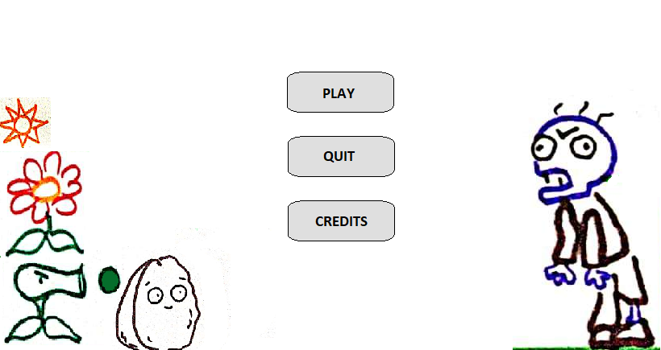

* + 1. **Playing Screen**

The expected playing screen is:

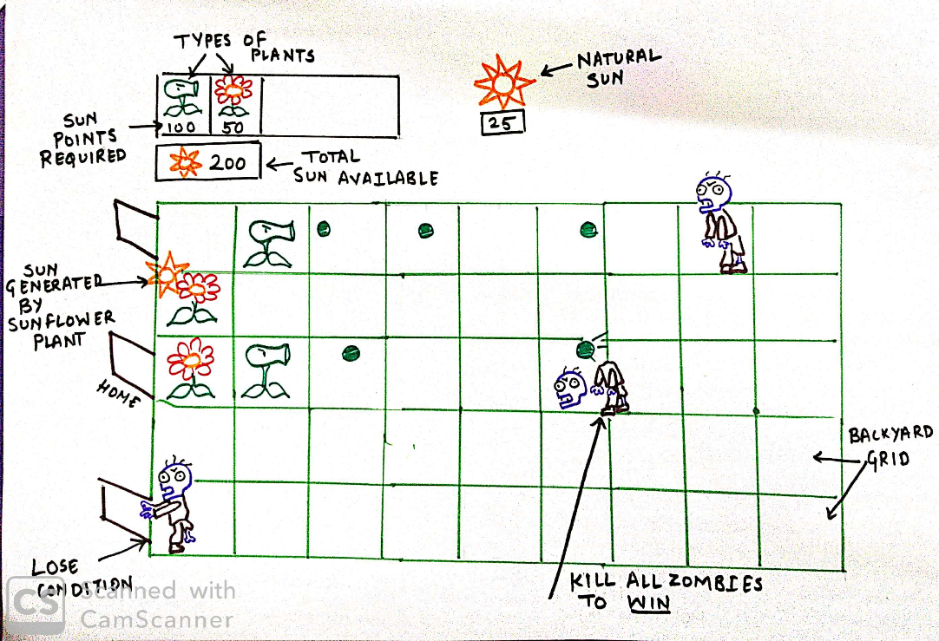

1. **Technical Specification**
   1. **Hardware details**

|  |  |  |
| --- | --- | --- |
| Sr. No. | Requirement | Required/Desired |
| 1 | Efficient space utilization. Approximately 500mb HDD | Required |
| 2 | 2GB RAM | Required |
| 3 | Graphics card with DX10 (shader model 4.0) capabilities | Required |

* 1. **Operating System**

|  |  |  |
| --- | --- | --- |
| Sr. No. | Requirement | Required/Desired |
| 1 | Desktop application should support Windows 7 and above | Required |

* 1. **Performance**

|  |  |  |
| --- | --- | --- |
| Sr. No. | Requirement | Required/Desired |
| 1 | Should not lag, Give quick responses. Less than 0.25 sec for each event. | Required |

1. **Use-Case Diagram**

