
UNIVERSITY INSTITUTE OF COMPUTING

PROJECT REPORT City Heal Hospital - Patient Admission & Treatment Records (2024)
Program Name: BCA
Subject Name/Code: Data Interpretation Lab
(23CAP-357)

Submitted by: Submitted to:

Name: Aman Gupta Name: Harkamal Kaur
UID: 23BCA10158. Designation: Professor
Section: BCA – 5’A

INDEX

Sr. | Title | Page
01 | Introduction | 03
02 | Aim | 03
03 | Objectives | 03-04
04 | Scope of the Project | 04
05 | Problem Definition | 05
06 | Research Gap / Existing Gaps | 05-06
07 | Excel Formulas & Output | 06-08
08 | Conclusion | 09
09 | References | 10

01 | Introduction
In today's world, data is generated in every sector — and healthcare is no exception. Hospitals record hundreds of patient entries every day covering personal information, treatments, billing, and ward details. Manually analysing this data is both time-consuming and error-prone. This is where tools like Microsoft Excel become incredibly valuable. Microsoft Excel offers a wide range of functions and formulas that allow users — even without programming knowledge — to analyse structured data quickly and accurately. Functions like SUM, AVERAGE, VLOOKUP, SUMIF, and COUNTIF can be applied to raw datasets to produce summaries, comparisons, and insights in seconds. This project is built around a fictional hospital named City Heal Hospital. A dataset of 18 patient records from January to September 2024 has been created, covering five departments: Cardiology, Gynaecology, Orthopaedics, Paediatrics, and Neurology. Three ward types are included: General, Private, and Cubby applying 10 different Excel functions, this project demonstrates how raw patient admission data can be turned into a comprehensive analysis — including total hospital revenue, average patient stay, department-wise billing, ward-wise comparisons, and individual patient lookup.

02 | Aim
To apply Microsoft Excel functions on a structured hospital patient dataset in order to perform data interpretation and extract meaningful insights regarding patient admissions, billing patterns, ward performance, and departmental analysis at an intermediate level.
03 | Objectives
The following objectives were set for this project:
- Design a structured Excel table containing 18 rows of hospital patient data with 11 columns.
- Apply SUM to find the total revenue generated by the hospital from all patients.
- Use AVERAGE to compute the mean number of days patients stayed in the hospital.
- Use MAX and MIN to find the most and least expensive patient billing records.
- Apply COUNT to confirm the number of valid numeric entries in the dataset.
- Use COUNTIF to count admissions for a specific department (Cardiology).
- Apply SUMIF to find the total billing from ICU ward patients only.
- Use IF to check whether the average patient stay exceeds a critical 5-day threshold.
- Apply VLOOKUP to retrieve billing details of a specific patient using their Patient ID.
- Use AVERAGEIF to calculate the average hospital stay for Neurology patients specifically.
- Create a Summary Dashboard with KPI cards and a department-wise performance table.

04 | Scope of the Project
The scope of this project is defined and limited to the following boundaries:
- City Heal Hospital is a hypothetical hospital created purely for academic purposes. No real patient data has been used.
- Microsoft Excel 2016 or later was used. All formulas and functions used are compatible with Excel 2010 and above.
- Only 10 intermediate-level Excel functions are covered. Advanced tools like Pivot Tables, Macros, or VBA are outside the scope.
- The dataset contains 18 patient records spanning 9 months (January to September 2024).
- Departments covered: Cardiology, Gynaecology, Orthopaedics, Paediatrics, and Neurology.
- Ward types covered: General Ward, Private Ward, and ICU.
- The project includes three Excel sheets: Patient Data (raw), Analysis & Formulas, and Summary Dashboard.

05 | Problem Definition
Hospitals collect enormous amounts of patient and financial data daily. However, in many mid-sized healthcare facilities, this data is stored in basic spreadsheets or paper registers without any analytical framework. This makes it impossible to quickly assess how much revenue a specific ward generated, which department has the longest average patient stay, or what the billing looks like for a particular patient.

"How can hospital patient admission and treatment data stored in Excel be analysed using built-in formulas to generate meaningful insights — such as total revenue, average stay, ICU billing, department performance, and patient-level record retrieval — without the need for specialized software?"

The specific challenges this project addresses are listed below:
- No quick way to view total hospital revenue across all departments without manually adding each row.
- Difficult to identify which department contributes the most or least to total billing.
- ICU and private ward revenue cannot be separated from general ward revenue without conditional formulas.
- No automated system to alert management when average patient stay exceeds a safe threshold.
- Searching for a specific patient's billing data in a large register requires time-consuming manual lookup.

06 | Research Gap / Existing Gaps
Gap 1 — Poor Data Structure
In most hospitals, patient records lack a uniform structure. Columns are inconsistently named, data types are mixed, and important fields like ward type or department are missing. This project demonstrates how to set up a clean, well-structured Excel table right from the start.

Gap 2 — Only Basic Calculations Are Used
Most users limit themselves to SUM and basic addition. Functions like COUNTIF, SUMIF, VLOOKUP, and AVERAGEIF — which are essential for segmented and conditional analysis — are almost never used in small hospital settings. This project bridges that gap.
Gap 3 — Data and Calculations Mixed Together
A widespread problem is keeping raw data and analysis in the same worksheet. This makes the file messy and hard to audit. This project follows a three-sheet design principle: Sheet 1 for raw data, Sheet 2 for formula-based analysis, and Sheet 3 for the dashboard.
Gap 4 — No Ward-Level Financial Tracking
ICU care is typically the most expensive. Yet most hospitals do not separately track ICU revenue from other wards. Using SUMIF in this project demonstrates how to isolate ward-specific billing.
Gap 5 — No Alert System for Patient Stay Duration
Long patient stays increase hospital costs and impact bed availability. There is usually no automated flag for when average stay duration crosses a threshold. This project introduces an IF-based logic check that produces a real-time text alert.
07| Excel Formulas & Output
Sheet 2 (Analysis & Formulas) of the workbook contains all 10 Excel functions applied to the patient dataset. The table below lists each function with the exact formula written, the output produced, and what it means for hospital administration.

# | Function | Formula | Output | What It Means
1 | SUM | =SUM('Patient Data'!J4:J21) | Rs.7,79,500 | Total revenue collected from all 18 patients
2 | AVERAGE | =AVERAGE('Patient Data'!G4:G21) | 5.6 days | Average number of days patients were admitted
3 | MAX | =MAX('Patient Data'!J4:J21) | Rs.1,08,000 | Highest total bill — most expensive patient case
4 | MIN | =MIN('Patient Data'!J4:J21) | Rs.7,500 | Lowest total bill — least expensive case
5 | COUNT | =COUNT('Patient Data'!G4:G21) | 18 | Confirms all 18 records have valid day entries
6 | COUNTIF | =COUNTIF('Patient Data'!E4:E21,"Cardiology") | 5 patients | Total admissions in the Cardiology department
7 | SUMIF | =SUMIF('Patient Data'!F4:F21,"ICU",'Patient Data'!J4:J21) | Rs.3,52,000 | Total bills collected from ICU ward only
8 | IF | =IF(AVERAGE('Patient Data'!G4:G21)>5,"HIGH STAY","NORMAL STAY") | HIGH STAY | Flags that average stay is above 5-day threshold
9 | VLOOKUP | =VLOOKUP("P009",'Patient Data'!A4:J21,10,FALSE) | Rs.93,000 | Retrieves the bill of patient P009 – Arun Kumar
10 | AVERAGEIF | =AVERAGEIF('Patient Data'!E4:E21,"Neurology",'Patient Data'!G4:G21) | 10.7 days | Average stay of patients in Neurology dept

Analysis Sheet — Excel Screenshot
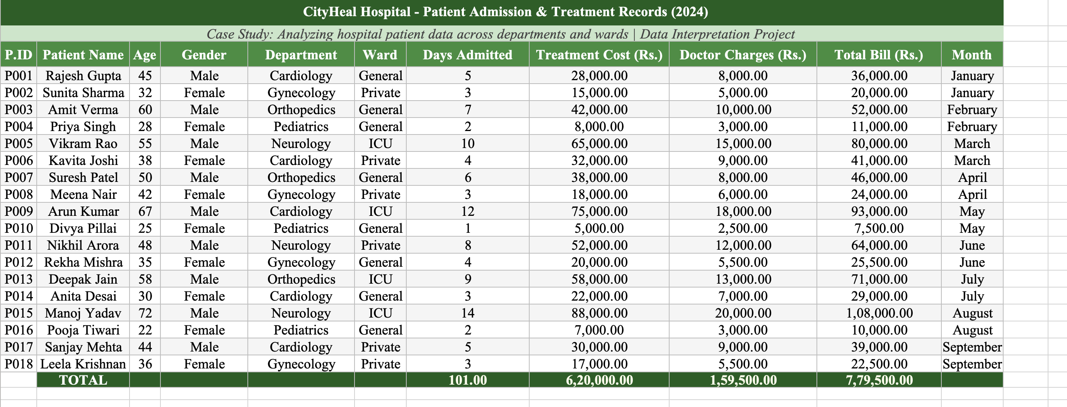
Fig 1.1 Patient Data Table (Sheet 1) showing all 18 patient records with billing details
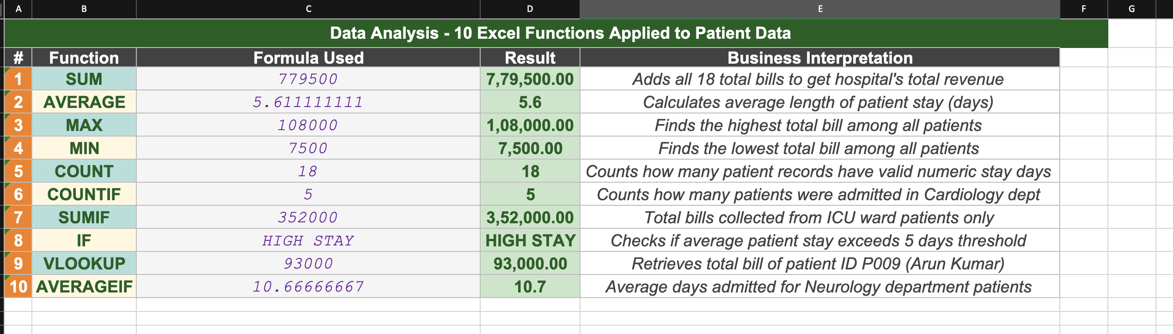
Fig 2.1 — Analysis & Formulas Sheet (Sheet 2) showing all 10 functions with outputs

10 | Conclusion
This project successfully demonstrates that Microsoft Excel is a powerful and practical tool for data interpretation in a hospital setting. Using only 10 intermediate-level formulas, the City Heal Hospital dataset was transformed from raw patient records into a comprehensive analytical report.
The key takeaways from this project are as follows:
- Excel's built-in functions eliminate the need for expensive or specialized software to analyse structured hospital data.
- Descriptive functions like SUM, AVERAGE, MAX, and MIN give a quick numerical overview of any dataset.
- Conditional functions — COUNTIF, SUMIF, AVERAGEIF — allow us to filter and analyse data for specific groups like a particular ward or department.
- The IF function enables a simple but powerful rule-based alert system, such as flagging unusually long patient stays.
- VLOOKUP proves that Excel can serve as a basic patient database, enabling fast record retrieval by ID.
- The Summary Dashboard consolidates all insights into a single view, ideal for quick decision-making by hospital administrators.

In conclusion, this project illustrates the real-world relevance of data interpretation skills and builds a strong foundation for exploring more advanced tools such as Pivot Tables, conditional formatting, Excel charts, and healthcare data visualization in future projects.

11 | References
- Microsoft Support. (2024). Overview of Excel formulas. Retrieved from https://support.microsoft.com
- Dodds, E. (2020). Excel for Healthcare Professionals. Productivity Press.
- Frye, C. (2021). Microsoft Excel Step by Step (Office 2021 and Microsoft 365). Microsoft Press.
- Excel Jet. (2024). Excel Function Guide. Retrieved from https://exceljet.net

