**Assignment 4.2**

**// Show Databases**

**//use myDatabase**

**//create database**

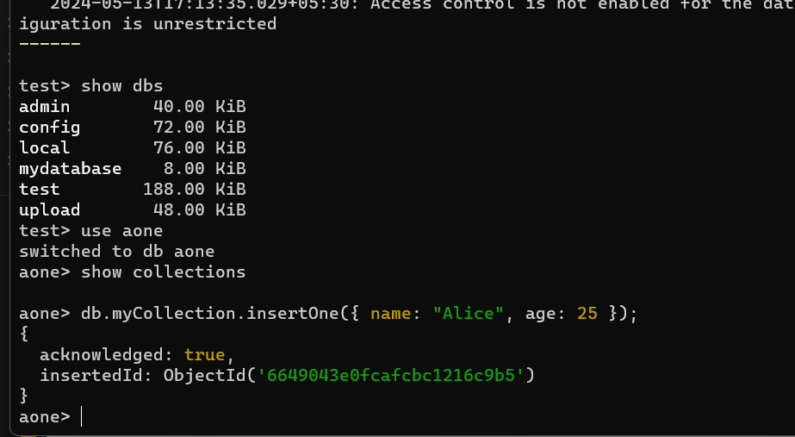

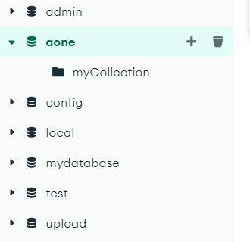

**//insert documents**

1. **insert one:** 

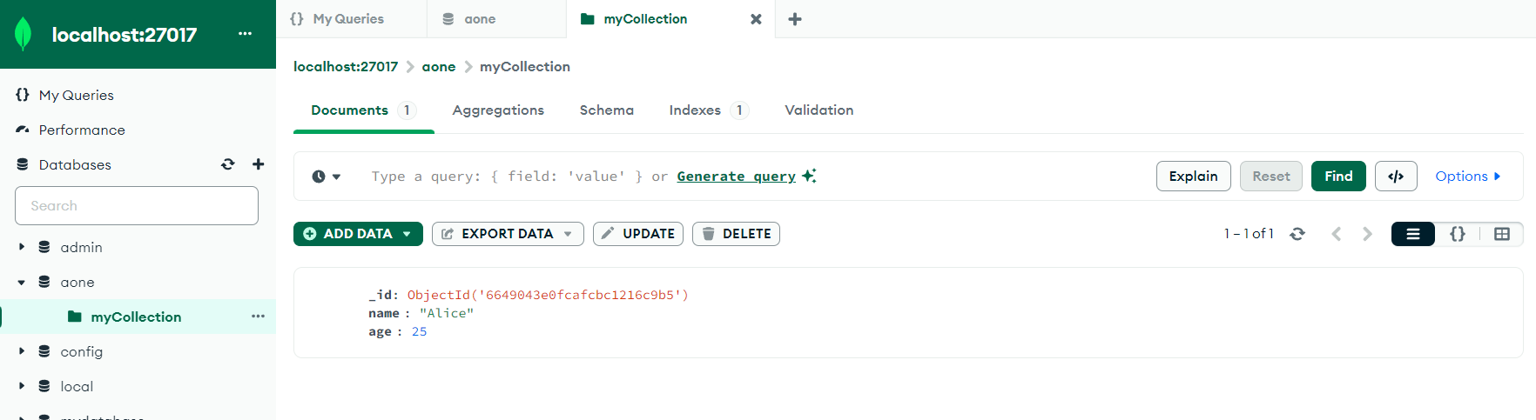

**2.) insert many:**

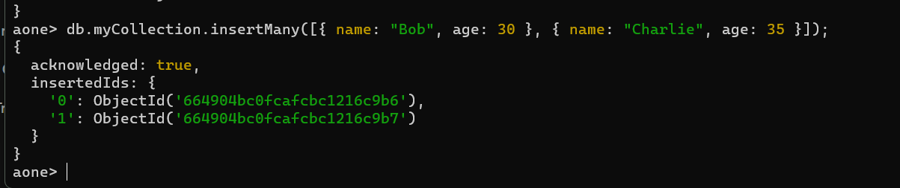

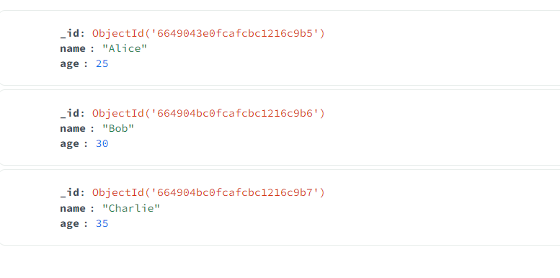

**// Find Documents**

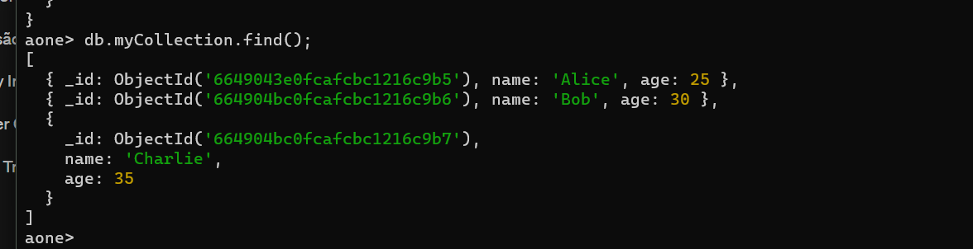

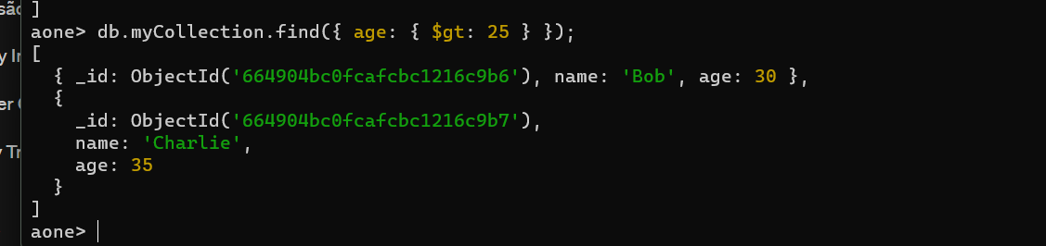

**//Update Documents**

1. **update one**

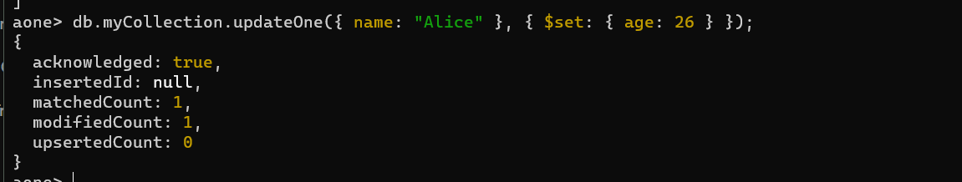

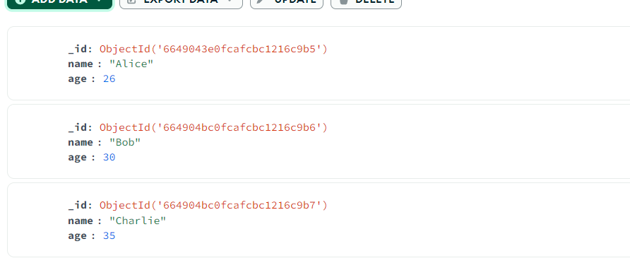

**2.)update many:**

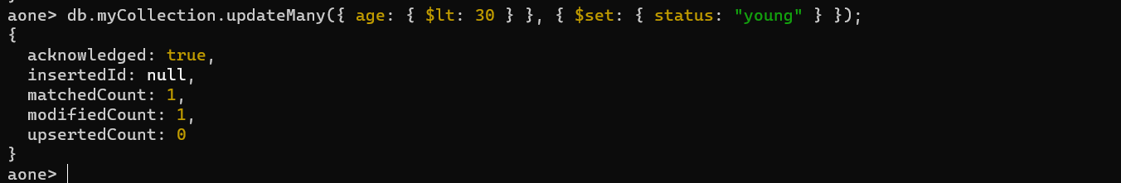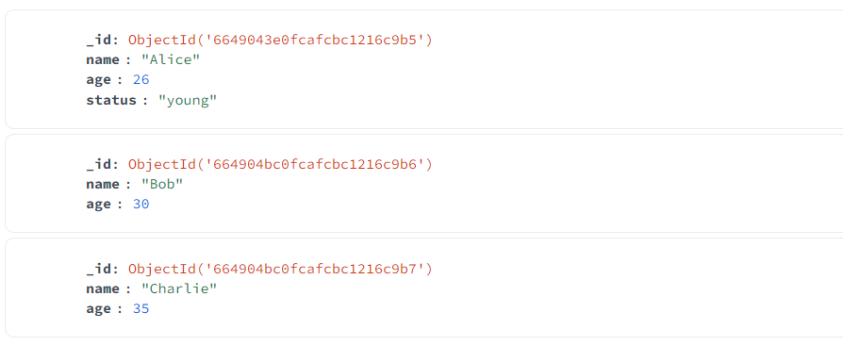

**//delete Document**

**1.)delete one:**



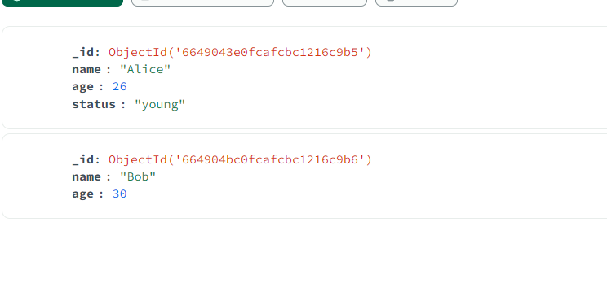

**2.)delete many:**

