

Project Interim Report

On

Global Currency Converter (Using Core Java & OOP Concepts)
RU-100-01-00012
Object Oriented Programming with Java

SESSION: 2025-26

Submitted By Aman Kumar
Erp : RU-25-11751

Bachelor of Technology in Computer Science & Engineering with AI and ML in association with IBM

Under the Guidance of Mr. Ashish Shivhare

SCHOOL OF COMPUTER SCIENCE AND ENGINEERING RUNGTA INTERNATIONAL SKILLS UNIVERSITY
BHILAI, CG

(April 2026)

Abstract
Currency conversion is a fundamental financial operation required in global trade, travel, and economic analysis. The Global Currency Converter is a console-based Java application designed to convert foreign currencies into Indian Rupees (INR) efficiently and accurately. This project demonstrates the practical application of Object-Oriented Programming (OOP) principles, with a specific focus on static variables and static methods to eliminate unnecessary object creation and optimise memory usage.
The application accepts a currency type and amount from the user, applies predefined exchange rates stored as static final variables, and outputs the equivalent INR value. By housing all conversion logic within a utility class called ConverterEngine, the system avoids instantiation, reducing overhead and improving performance. The design reflects clean, modular Java programming suitable for academic demonstration and real-world extension.
This project is relevant in today’s globalised economy, where currency awareness is essential. It serves as a strong foundation for future enhancements such as live API integration, graphical user interfaces, and support for additional international currencies.

Introduction
A currency converter is a software tool that translates monetary values from one currency to another using predefined or real-time exchange rates. In modern software development, such tools are widely integrated into banking applications, e-commerce platforms, and financial dashboards. This project implements a simplified yet well-structured version of such a system using Core Java and OOP concepts.
The Global Currency Converter operates through a command-line interface. The user enters an amount and selects a source currency (USD, EUR, or GBP), and the system displays the converted equivalent in INR. The application is built around a single utility class, ConverterEngine, which stores exchange rates as static final variables and exposes a static convert() method. This design ensures that the application is memory-efficient and does not rely on object instantiation for its core functionality.
Key Features:
• Console-based, lightweight Java application
• Supports USD, EUR, and GBP to INR conversion
• Uses static members for efficient, object-free design
• Encapsulates conversion logic in a utility class
• Handles invalid input gracefully with error messages
Objectives:
• Convert international currencies (USD, EUR, GBP) to INR accurately
• Demonstrate the use of static members (static variables and methods) in Java OOP
• Avoid unnecessary object creation through utility class design
• Apply core OOP concepts including encapsulation and modular design

Scope
This project is suitable for use as a basic financial tool in academic settings, demonstrations, and entry-level software applications. In its current form, it supports conversion of three major foreign currencies — US Dollar (USD), Euro (EUR), and British Pound (GBP) — to Indian Rupees (INR) using fixed exchange rates defined at the class level.
The project can be meaningfully extended in several directions. Integration with live currency exchange APIs (such as Open Exchange Rates or the Reserve Bank of India API) would enable real-time rate updates. A Graphical User Interface (GUI) built using JavaFX or Swing could replace the console interaction, making the tool more accessible to non-technical users. Support for additional global currencies such as JPY, AUD, CAD, and CHF would broaden its utility. Furthermore, the application could be packaged as a mobile application for Android using appropriate Java frameworks, significantly increasing its reach and usability.

System Requirements
Hardware Requirements:
• Computer or laptop with a minimum of 4 GB RAM
• Processor: Intel Core i3 or equivalent (or higher)
• Sufficient disk space for the Java Development Kit and IDE installation
Software Requirements:
• Java Development Kit (JDK 8 or above)
• Integrated Development Environment (IDE): Visual Studio Code, Eclipse, or EditPlus
• Operating System: Windows 10/11, macOS, or Linux

Methodology
The development of the Global Currency Converter followed a structured, step-by-step approach:
1. Creating the ConverterEngine Class: A dedicated utility class named ConverterEngine was designed to serve as the central unit of the application. This class encapsulates all conversion logic and is never instantiated directly.
2. Defining Static Exchange Rates: Exchange rates for USD, EUR, and GBP to INR were declared as static final double variables inside ConverterEngine. Being static, they belong to the class itself rather than any instance, and being final, they cannot be altered at runtime.
3. Creating the Static convert() Method: A static method named convert() was implemented to receive the currency type and amount as arguments and return the INR equivalent. Being static, this method can be called directly on the class without creating an object.
4. Applying Conversion Logic: Inside the convert() method, a conditional structure evaluates the currency string provided by the user. Based on the match (USD, EUR, or GBP), the corresponding static exchange rate is multiplied by the given amount to compute the INR value.
5. Handling Invalid Input: If the user enters an unrecognised currency code, the method returns a value of -1 as an error indicator. The main class then detects this sentinel value and prints an appropriate error message to the console.
6. Calling the Method Without an Object: In the main class, the convert() method is invoked as ConverterEngine.convert(...), demonstrating that static methods are accessed through the class name, not through an instance reference.
7. Displaying the Result: The converted amount is formatted and displayed to the user in a clear, readable format on the console, showing the original amount, the source currency, and the INR equivalent.

Flowchart
Program Flowchart:
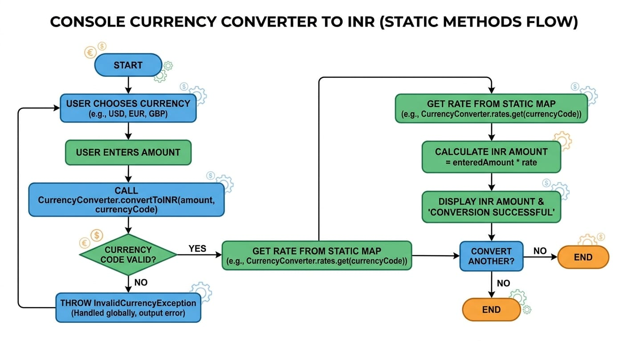

Class Diagram:
The class diagram for this project contains a single utility class: ConverterEngine.

ConverterEngine
Variables (Static Final):
• static final double USD_TO_INR = 83.0
• static final double EUR_TO_INR = 90.0
• static final double GBP_TO_INR = 105.0
Method (Static):
• static double convert(double amount, String currency) — returns the INR equivalent or -1 for invalid input

Implementation
Static Variable Usage:
The exchange rates are stored as static final class-level constants in ConverterEngine. Since these values are fixed (they do not change between different conversions or sessions), declaring them as static final is both semantically correct and memory-efficient. They are shared across the entire class and loaded into memory only once at class loading time.
Static Method Working:
The convert() method is declared as static, which means it can be called directly using the class name (ConverterEngine.convert(...)). No object of ConverterEngine is ever created. This approach is aligned with the utility class design pattern commonly used in Java, where a class provides helper methods without requiring instantiation.
Conversion Logic:
When the convert() method is called, it checks the currency string using conditional statements. If the string matches “USD”, the method multiplies the input amount by USD_TO_INR and returns the result. Similarly, “EUR” triggers multiplication by EUR_TO_INR, and “GBP” triggers multiplication by GBP_TO_INR. The comparison is performed case-insensitively to improve robustness.
Input Validation:
If the user provides an unrecognised currency code, the method returns -1 as a sentinel value. The main application class checks for this value and, if detected, prints an informative error message: “Invalid currency code. Please enter USD, EUR, or GBP.” This approach ensures the application does not crash or produce misleading output.
Sample Output:
Enter Amount: 100
Enter Currency: USD
Converted Amount in INR: 8300.0

Future Enhancements
The following enhancements are planned for future iterations of the project:
• Real-Time Exchange Rates via API: Integration with a live currency exchange API (e.g., Open Exchange Rates or Fixer.io) to fetch and display up-to-date conversion rates dynamically, replacing the static hardcoded values.
• Graphical User Interface (GUI): Development of a JavaFX or Swing-based GUI with dropdown menus for currency selection, input fields for amounts, and a results panel for displaying converted values in a visually appealing layout.
• Support for More Currencies: Extending the ConverterEngine to include a broader set of currencies such as JPY, AUD, CAD, CHF, CNY, and AED, enabling truly global conversion capability.
• Mobile Application: Porting the application to Android using Java and Android SDK, allowing users to perform currency conversions on mobile devices from anywhere in the world.

Gantt Chart
The following Gantt chart summarises the project timeline across four major phases:
• Phase 1 — Planning (Week 1): Define project scope, identify requirements, select programming approach, and design the class structure on paper.
• Phase 2 — Design (Week 2): Create the class diagram for ConverterEngine, define the static variables and method signatures, and outline the program flow with a pseudocode or flowchart.
• Phase 3 — Coding (Weeks 3–4): Implement the ConverterEngine utility class with static variables and the convert() method. Develop the main driver class to handle user input/output and error handling.
• Phase 4 — Testing (Week 5): Test the application with valid currency inputs (USD, EUR, GBP), boundary cases (e.g., 0.0, very large amounts), and invalid inputs to verify that error handling functions correctly. Finalise documentation and prepare the project report.

Conclusion
The Global Currency Converter successfully demonstrates the design and implementation of a practical Java application using core Object-Oriented Programming principles. The project achieves its primary objectives: it accurately converts USD, EUR, and GBP to INR, uses static members to eliminate the need for object instantiation, and encapsulates all conversion logic within a dedicated utility class.
The use of static variables and methods is a fundamental concept in Java OOP that is often underutilised or misunderstood. This project illustrates their importance clearly: static variables allow shared data to be maintained at the class level without redundant copies, while static methods provide functionality that is independent of object state. Together, they enable the creation of lean, efficient utility classes.
This project lays a solid foundation for more advanced financial tools. With the enhancements outlined in the Future Enhancements section, particularly live API integration and a GUI, it could evolve into a production-ready application. Overall, the project successfully bridges academic OOP theory with practical software development, providing a meaningful learning experience.

References
Books:
[1] H. Schildt, Java: The Complete Reference, 12th ed. New York: McGraw-Hill, 2022.
[2] E. Gamma, R. Helm, R. Johnson, and J. Vlissides, Design Patterns: Elements of Reusable Object-Oriented Software. Boston: Addison-Wesley, 1994.
Websites:
[3] Oracle, “Java SE Documentation,” Oracle Corporation. [Online]. Available: https://docs.oracle.com/en/java/
[4] GeeksforGeeks, “Static Methods in Java,” GeeksforGeeks. [Online]. Available: https://www.geeksforgeeks.org/static-methods-in-java/

