Hardware Tutorial

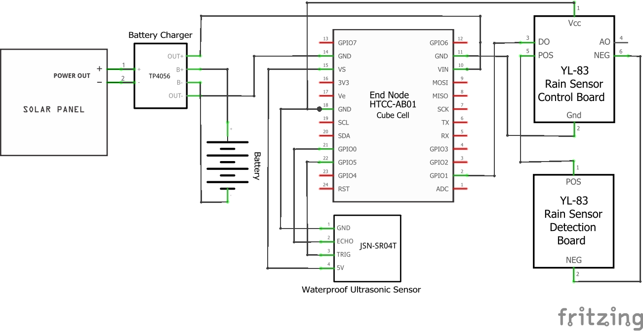

Fig 1

|  |  |
| --- | --- |
| Fig 2 (a) | Fig 2 (b) |
| Fig 2 (c) | Fig 2 (d) |
| Fig 2 | |