Study Notes: Statement & Income

Key thoughts
- Income statement related information and revenue recognition.
- Bottom line, in any income statement, net income is measured based on all revenues and gains in a period, less expenses and losses incurred to generate those revenues.
- In other words, the income statement is useful because it provides investors and creditors with information that helps them predict the amounts, timing and uncertainty of future cash flows.
- We can therefore say the income number is capturing the same information about future cash flows as that captured in prices.
- That is, reported income helps us meet the objective of financial reporting.

Definitions
- Statement: One of the primary financial statements.
- Why: Information reported in the income statement important?
- Information in the income statement: Directly related to that goal because revenues and expenses capture the effects of transactions in the past, which many times can be used to predict future operating results.

Concepts
- Future: Predicting future cash flows.
- Financial: It measures a company's financial results, usually referred to as its profitability, over a period of time.
- Period: Bottom line, in any income statement, net income is measured based on all revenues and gains in a period, less expenses and losses incurred to generate those revenues.
- Flows: In other words, the income statement is useful because it provides investors and creditors with information that helps them predict the amounts, timing and uncertainty of future cash flows.

Figures
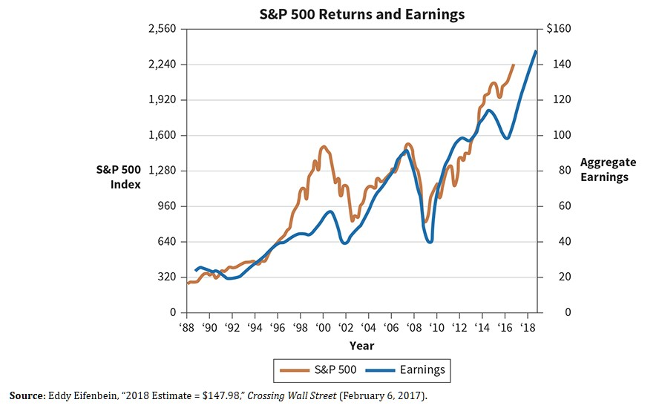
Figure 1

