Practical Task – 1
PRACTICAL TASK: L1 — Observe Organic vs Paid Results on Google
1.Open Google Chrome on your phone or laptop.
2.Search for: 'best jeans for men in India' and take a screenshot.
3.Circle / highlight all results that show the 'Sponsored' label — these are PAID ads.
4.Count: How many organic results appear on Page 1? (Usually 7-10)
5.Now search: 'apply for Aadhaar card online' — observe if any paid ads appear and why/why not.
6.Do this for 3 more searches of YOUR choice (something you searched this Module).
7.Submit: A screenshot of each search with labels identifying organic vs paid results.
8.Bonus: Check the same keyword on Bing — are the results similar or different?
- Answer 1,2,3

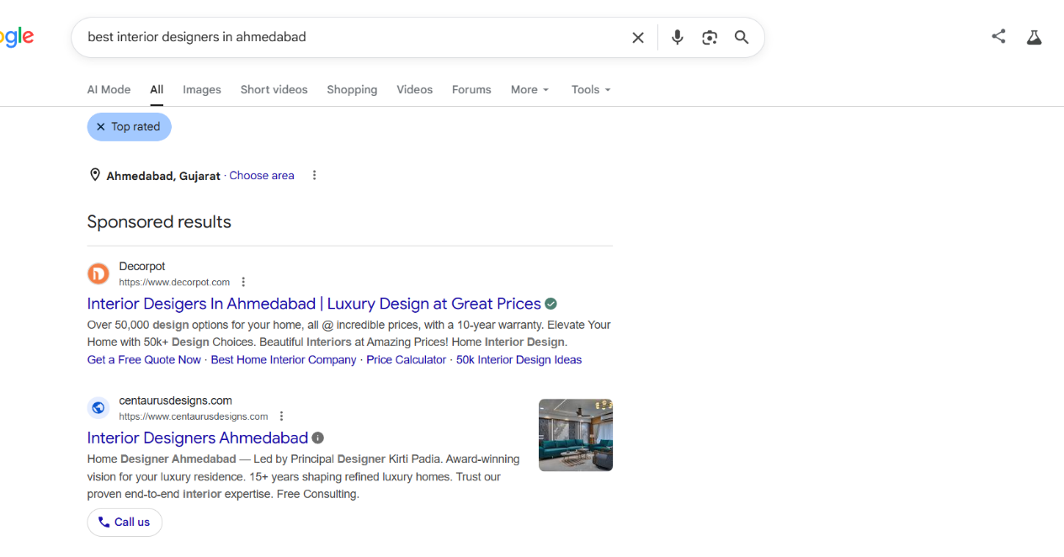


5.Now search: 'apply for Aadhaar card online' — observe if any paid ads appear and why/why not

Answer: No paid ads appeared for the search query "apply for Aadhaar card online". This is because Aadhaar card services are provided by the government through Unique Identification Authority of India. Google considers the official government website to be the most relevant and trustworthy source for this query. Since it is a government service and not a commercial product, advertisers usually do not run ads for this keyword. Therefore, only organic search results were shown.

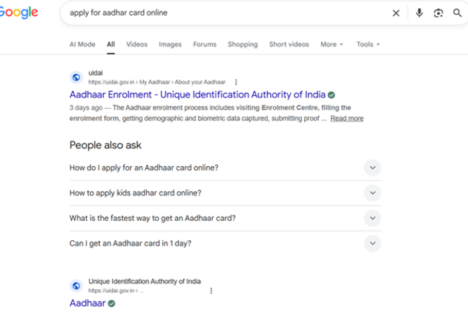

6.Do this for 3 more searches of YOUR choice (something you searched this Module).
7.Submit: A screenshot of each search with labels identifying organic vs paid results.
- Answer:

Search 1: Best AI Learning Course in Ahmedabad
- Paid Ads: No
- Organic Results: Yes
- Observation: This search showed an AI Overview and organic search results. No paid advertisements were visible on the page. The Weltec Institute result appeared as an organic result.

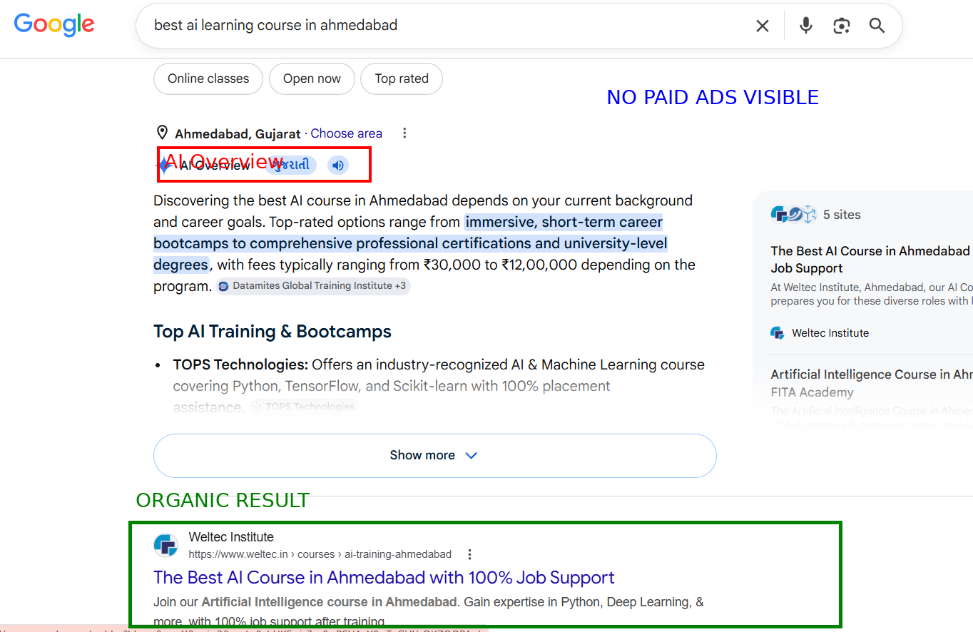

Search 2: Best Digital Marketing Course in Ahmedabad
- Paid Ads: Yes
- Organic Results: No
- Observation: This search displayed sponsored (paid) advertisements at the top of the page. The ASDM Institute result was marked as a sponsored result. Organic results appeared below the paid advertisements.

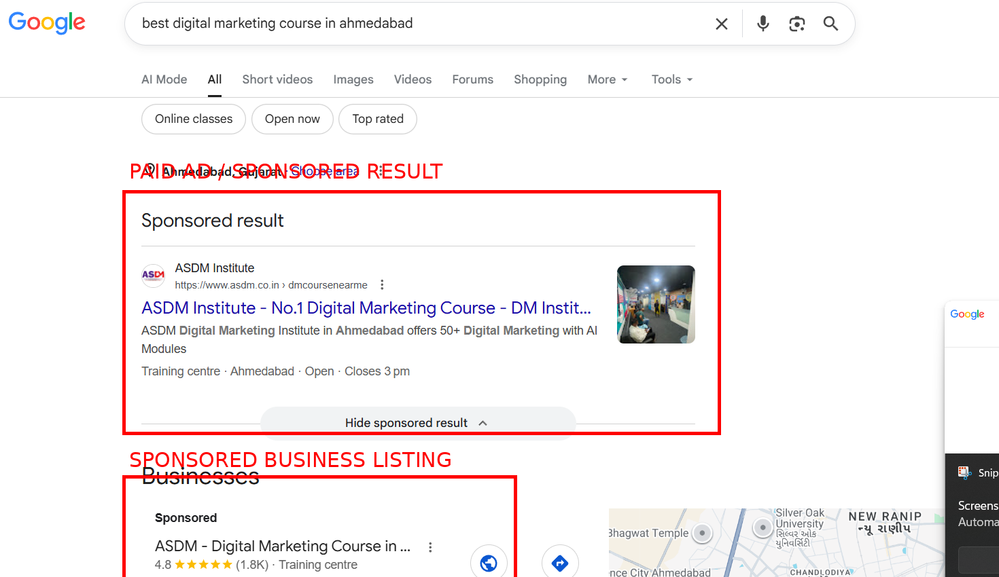

Search 3: Best Graphic Design Institute in Ahmedabad
- Paid Ads: Yes
- Organic Results: Not visible in the screenshot
- Observation: This search showed a sponsored result from Rathore University at the top of the page. The keyword is competitive, so advertisers are using Google Ads to promote their courses.

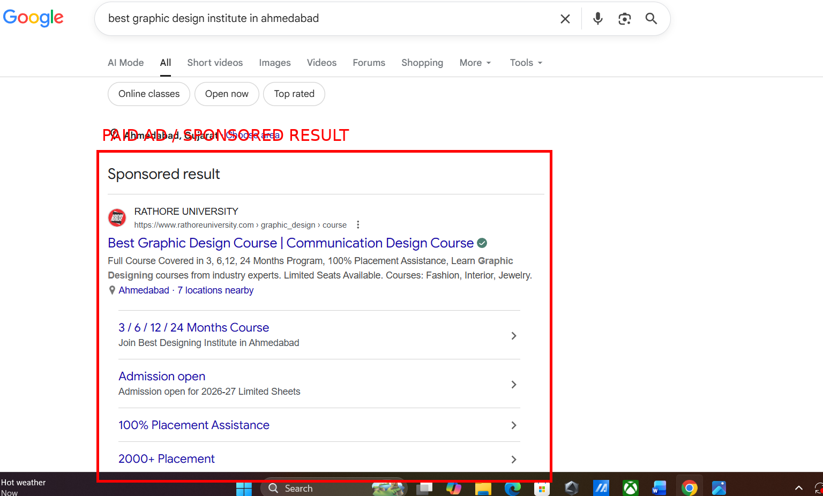

8.Bonus: Check the same keyword on Bing — are the results similar or different?
- I searched the same keywords on Bing and compared them with Google results.
- Keyword 1: Best AI Learning Course in Ahmedabad
- Google: Showed AI-related course results and organic websites. No sponsored advertisements were visible.
- Bing: Displayed sponsored advertisements and AI course providers.
- Result: Different — Google showed mainly organic results, while Bing displayed paid advertisements for AI courses.

- Keyword 2: Best Digital Marketing Course in Ahmedabad
- Google: Displayed sponsored digital marketing course advertisements.
- Bing: Also displayed sponsored results from course providers such as Coursera and Kraftshala.
- Result: Similar — both search engines prioritized paid advertisements and course providers.

- Keyword 3: Best Graphic Design Institute in Ahmedabad
- Google: Showed sponsored graphic design course advertisements.
- Bing: Also displayed sponsored graphic design course advertisements.
- Result: Similar — both search engines showed paid ads related to graphic design courses.
- Conclusion
- The Bing results were mostly similar to Google results. However, for the keyword "Best AI Learning Course in Ahmedabad," Google showed organic results without visible paid advertisements, while Bing displayed sponsored ads. For the other two keywords, both search engines showed paid advertisements and course-related websites. The order of results and advertisers may vary slightly between search engines.

Practical Task – 2
PRACTICAL TASK: L2 — Analyse 3 SEO Job Descriptions on LinkedIn
1.Open LinkedIn on your phone or laptop and search: 'SEO Specialist India'.
2.Filter by: Location = India, Experience Level = Entry Level / Associate.
3.Open 3 different job descriptions from 3 different companies.
4.For each JD, note down: (a) Company Name & Industry, (b) Required Skills Listed, (c) Tools mentioned (Ahrefs, SEMrush, Google Analytics?), (d) Salary range if mentioned.
5.Identify: Which skill is mentioned in all 3 job descriptions? That is your priority skill to learn.
6.Write a 100-word reflection: 'What gap exists between my current skills and the job requirements?'
7.Bonus: Use LinkedIn's 'Easy Apply' feature to bookmark jobs you'd like to apply for in 6 months.

- Company Name & Industry: ChimpLab (Advertising Services / Digital Marketing)
Required Skills Listed: SEO Fundamentals, Website Optimization, Search Visibility, WordPress, Shopify
Tools Mentioned: WordPress, Shopify
Salary Range: Not Mentioned
- Company Name & Industry: ISK Technologies (IT Services & IT Consulting)
Required Skills Listed: SEO, Website Optimization, SEO Executive Skills, Freshers Can Apply
Tools Mentioned: WordPress
Salary Range: Not Mentioned
- Company Name & Industry: i3 Corporation (Information Technology & Services / Digital Marketing)
Required Skills Listed: SEO, Digital Marketing, Customer Satisfaction, Website Optimization
Tools Mentioned: Not Mentioned
Salary Range: Not Mentioned
- Common Skill Found in All 3 Job Descriptions: SEO (Search Engine Optimization)
- Priority Skill to Learn: SEO, especially Website Optimization and Keyword Research.

- Write a 100-word reflection: 'What gap exists between my current skills and the job requirements?'
- After checking three SEO job descriptions on LinkedIn, I found that SEO is the most important skill required by companies. Most jobs need knowledge of website optimization, search visibility, and digital marketing. Right now, I know the basic concepts of SEO, but I do not have much practical experience. I need to improve my skills in keyword research, on-page SEO, and WordPress. I also need more practice using SEO tools and working on real websites. In the next six months, I will learn these skills, practice regularly, and gain hands-on experience so that I can become ready for an SEO job.

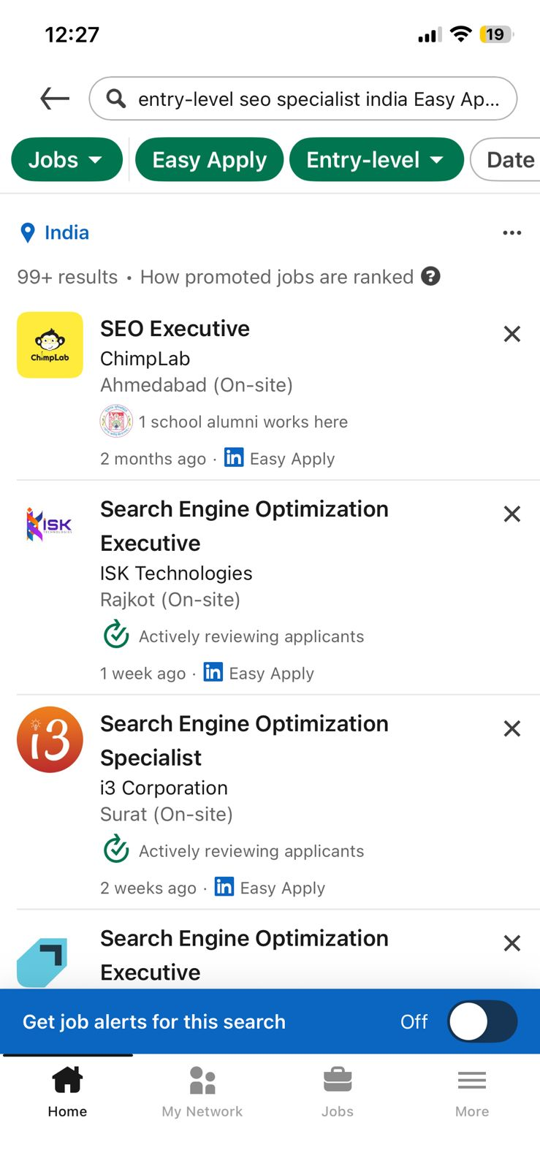

Practical Task – 3
PRACTICAL TASK: L3 — Product Search Observation on Amazon India
1.Open Amazon.in on your browser.
2.Search for any product you've purchased recently (e.g., 'running shoes for men', 'protein powder', 'laptop bag').
3.Observe the TOP 3 organic results (not 'Sponsored'). For each, note: (a) Product Title — how many keywords are in it? (b) Number of ratings and average star rating, (c) Price and delivery promise, (d) Whether it has 'Amazon's Choice' badge.
4.Now search the SAME product on Google. Do the same Amazon listings appear? Or different ones?
5.Try Google Lens: Point your phone camera at any product around you. See what Google finds.
6.Search a question by voice: Ask 'Hey Google, what is the best WiFi router under 2000 rupees in India?'. Observe the spoken answer Google gives.
7.Document: Take screenshots of Amazon results, Google results, and Google Lens output.
8.Write 5 observations: What differences do you notice between how Amazon and Google rank products?

- Answer: 1,2,3,4
Product 1: SPARX Women Shoes
- Keywords in Title: 3
- Rating: 4.2★
- Number of Ratings: 9,913
- Price: ₹780
- Delivery Promise: Free Delivery Tue, 9 Jun / Tomorrow Delivery
- Amazon's Choice: No
Product 2: Campus Women Camp Eloy Walking Shoes
- Keywords in Title: 5
- Rating: 4.3★
- Number of Ratings: 2.3K
- Price: ₹949
- Delivery Promise: Free Delivery Thu, 11 Jun
- Amazon's Choice: No
- Product 3: ASIAN Stella-02 Women's Sneakers
- Keywords in Title: 4
- Rating: 4.0★
- Number of Ratings: 55
- Price: (Not Visible)
- Delivery Promise: (Not Visible)
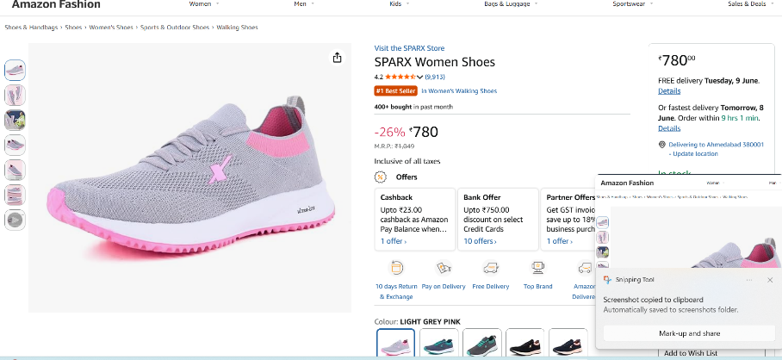
- Amazon's Choice: Yes

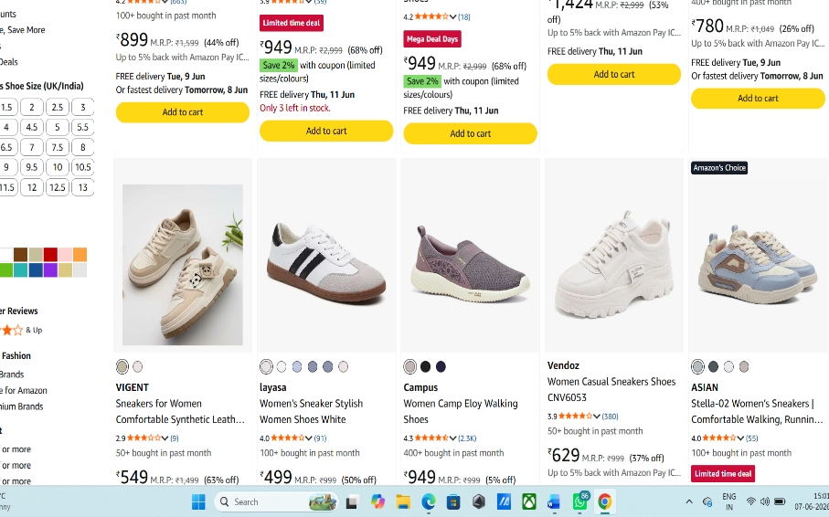

- Same Product Search on Google
Observation:
When I searched "Shoes for Women" on Google, the results were different from Amazon. Google showed products from multiple websites such as Decathlon, AJIO, Myntra, and Nike. Amazon mainly displayed products available on its own platform. Google also showed product ratings, prices, and delivery information from different online stores.

- Amazon vs Google Comparison
- Amazon showed products only from Amazon sellers.
- Google showed products from multiple websites and brands.
- Amazon ranked products based on customer reviews, ratings, and sales.
- Google displayed products from different shopping websites in one place.
- Product prices and ratings varied across different websites shown by Google.
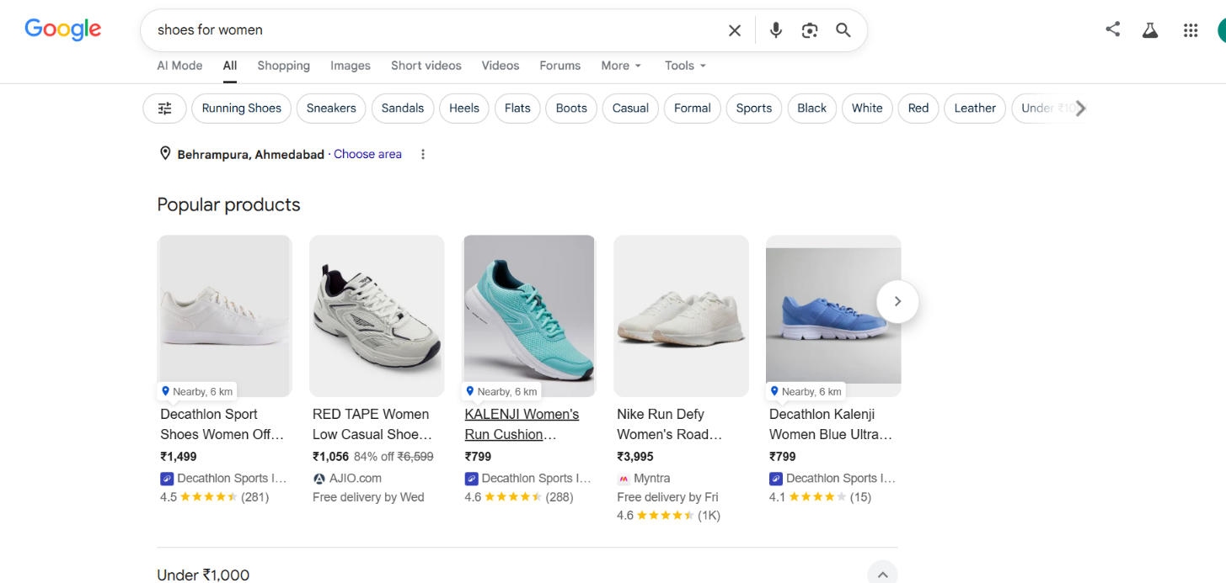

- Answer: 5
- I scanned a product using Google Lens. Google identified the product and showed similar products and related information from different websites. This made it easy to search using an image.
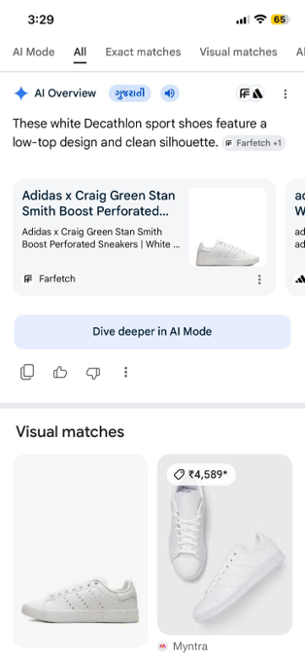

- Answer- 6.
Voice Search Observation
- I used Google Voice Search and asked: "What is the best Wi-Fi router under 2000 rupees in India?"
- Google provided a spoken answer and suggested several Wi-Fi routers under ₹2000, including TP-Link Archer C54, Mercusys AC1200, TP-Link TL-WR845N, and D-Link DIR-811IN. The answer included router speed, features, antenna details, and approximate prices. Google also displayed related search results and product recommendations on the screen.

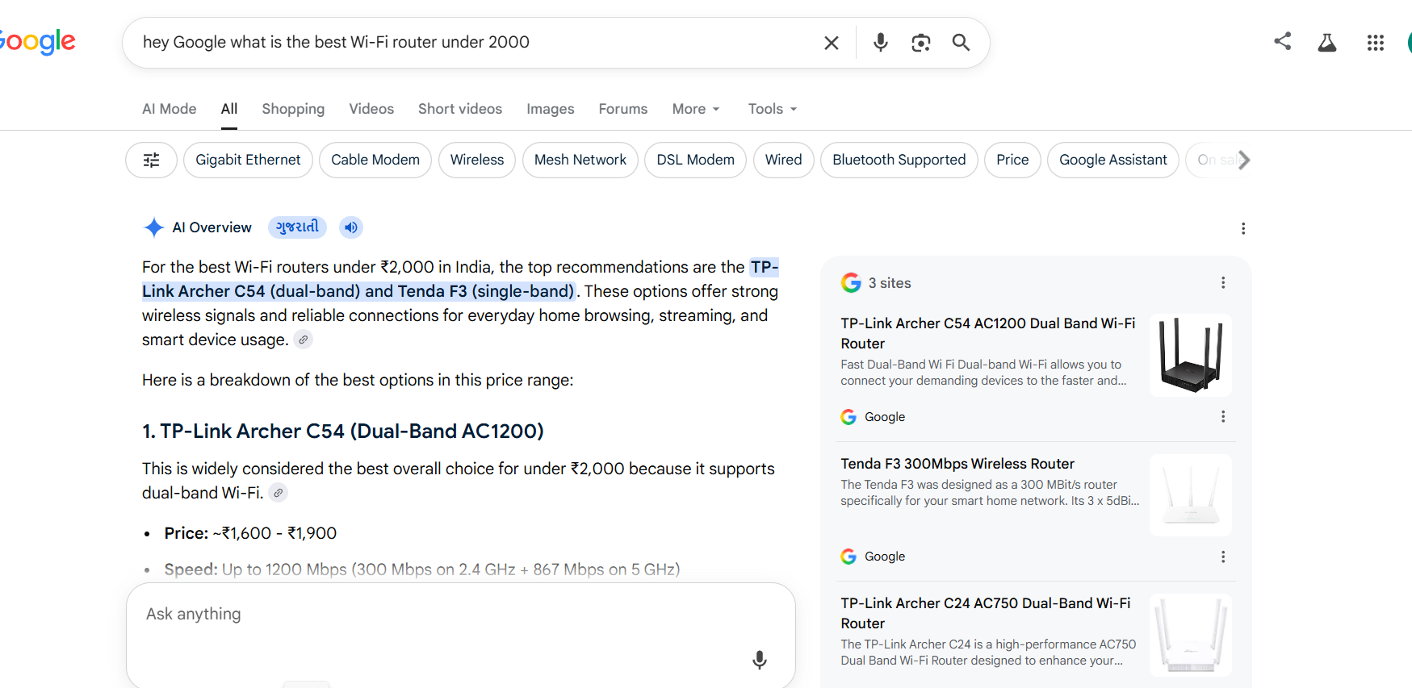
- Answer:8
Five Observations: Amazon vs Google Product Ranking
- Amazon shows products based on ratings, reviews, and sales.
- Google shows products from different websites, not only Amazon.
- Amazon clearly shows price, discount, and delivery date.
- Google helps compare products from many online stores.
- Amazon is mainly for buying products, while Google is for searching and comparing products.

Practical task -4
PRACTICAL TASK: L4 — AI SEO Analysis Task
1.Open ChatGPT (free version) in one browser tab and Google Gemini in another.
2.Ask BOTH: 'What is SEO in 2026? Explain in detail for a beginner in India.'
3.Compare the two answers: (a) Which one is more detailed? (b) Does either mention India-specific examples? (c) Which tools or concepts does each emphasize?
4.Now ask both: 'What websites or sources are you using to answer SEO questions?' Observe which Indian websites (if any) are being cited.
5.Visit one of the cited websites and analyze: (a) What makes their content authoritative? (b) Do they have author bios? (c) Do they use structured data (Schema)?
6.Search on Google: 'What is technical SEO?' — Does an AI Overview appear? Take a screenshot.
7.Write a 300-word analysis: 'How is AI changing the way we should create SEO content in India?' Include at least 3 specific AI SEO strategies you plan to use.
8.Bonus: Use the prompt above to get ChatGPT to evaluate your own answer and suggest improvements.

PRACTICAL TASK: L4 — AI SEO Analysis Task
Open ChatGPT (free version) in one browser tab and Google Gemini in another.
Ask BOTH: 'What is SEO in 2026? Explain in detail for a beginner in India.'
Compare the two answers: (a) Which one is more detailed? (b) Does either mention India-specific examples? (c) Which tools or concepts does each emphasize?
Now ask both: 'What websites or sources are you using to answer SEO questions?' Observe which Indian websites (if any) are being cited.
Visit one of the cited websites and analyse: (a) What makes their content authoritative? (b) Do they have author bios? (c) Do they use structured data (Schema)?
Search on Google: 'What is technical SEO?' — Does an AI Overview appear? Take a screenshot.
Write a 300-word analysis: 'How is AI changing the way we should create SEO content in India?' Include at least 3 specific AI SEO strategies you plan to use.
Bonus: Use the prompt above to get ChatGPT to evaluate your own answer and suggest improvements.
- Answer :1,2,3
Here is a simplified, easy-to-read version of the analysis that you can directly copy and use for your task submission:
(a) Which one is more detailed?
- ChatGPT is more detailed in structure. It acts like a textbook, breaking down every single definition (like crawling, indexing, short-tail vs. long-tail keywords) and even listing future job roles in India.
- Gemini is more detailed in explanation. It uses real-life examples (like comparing SEO to opening a physical shop on a main road) to explain why concepts matter, rather than just listing definitions.
(b) Does either mention India-specific examples?
Yes, both models use India-specific examples, but in different ways:
  - ChatGPT uses India as keywords: It uses Indian terms as quick examples in its lists, like searching for "best interior designer in Ahmedabad" or "Best laptop under 50000".
  - Gemini uses India as real context: It fits India into the actual explanations. For example, it explains that website speed is crucial because internet connection varies between major 5G cities and rural Indian villages, and uses local cities (Mumbai, Jaipur, Delhi) to explain business concepts.
(c) Which tools or concepts does each emphasize?
- ChatGPT emphasizes Structure and Professional Tools: It focuses heavily on the classic types of SEO and lists both free and famous paid tools used by professionals (like Ahrefs and SEMrush). It also emphasizes career paths for freshers.
- Gemini emphasizes AI-Era Changes and Free Tools: It focuses heavily on how SEO has changed in 2026 due to AI-generated summaries. It emphasizes Answer Engine Optimization (AEO) and sticks strictly to 100% free Google tools so a beginner doesn't have to spend any money to start.

- Answer :4
- No Indian websites were cited. The sources mentioned were international websites such as Google Search Central, SEMrush, Ahrefs, Moz, Search Engine Journal, Search Engine Land, Schema.org, and W3C. These are globally recognized SEO resources used by professionals worldwide.
- Answer :5
- Website Chosen: Search Engine Journal
(a) What makes their content authoritative?
- They publish detailed SEO and digital marketing articles.
- Content is written by industry experts and professionals.
- Articles are regularly updated with the latest SEO trends and Google updates.
- The website is widely trusted by SEO professionals worldwide.
(b) Do they have author bios?
- Yes. Most articles include an author name and author bio.
- Readers can view the author's experience and expertise in SEO and digital marketing.
(c) Do they use structured data (Schema)?
- Yes. Search Engine Journal uses structured data (Schema markup).
- Schema helps search engines understand content better and can improve visibility in search results.
Answer:6
- Google Search: "What is Technical SEO?"
Observation:
- Yes, an AI Overview appeared in Google's search results.
- The AI Overview provided a summary explaining Technical SEO, including crawlability, indexability, site speed, and website structure.

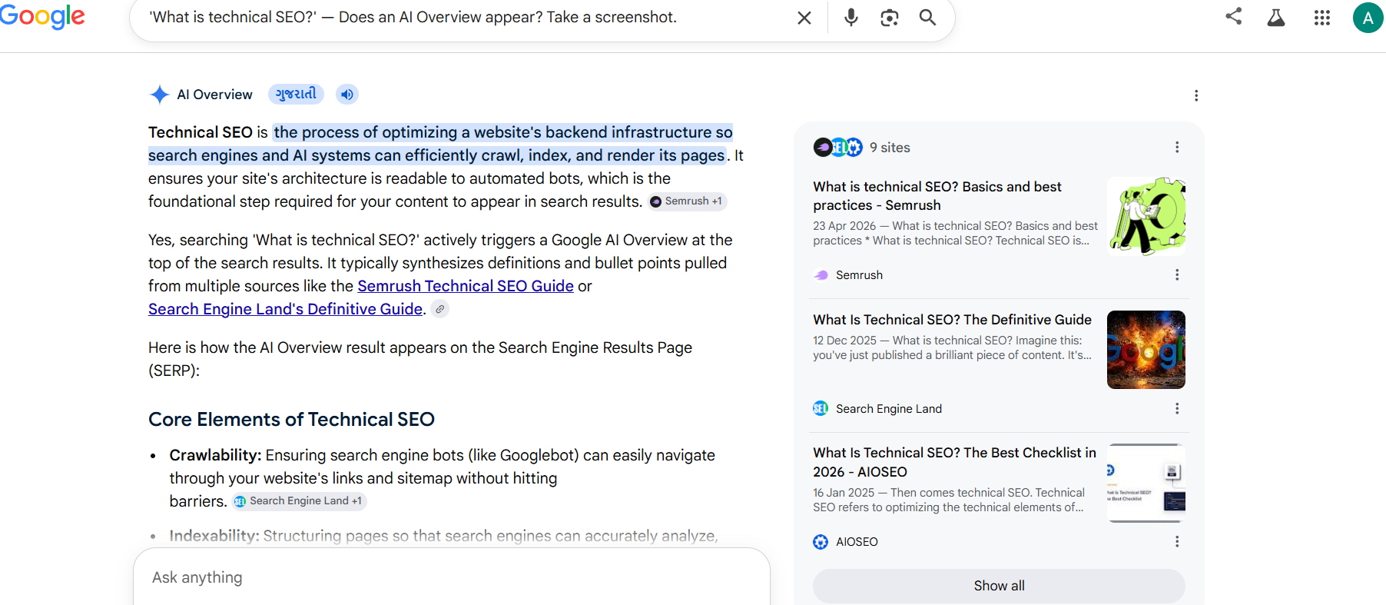
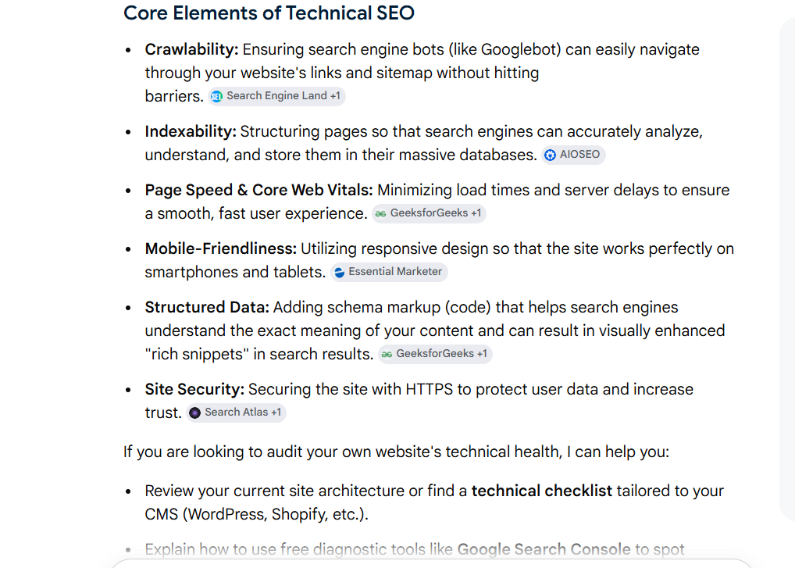

- Answer :7
- AI is changing SEO content creation in India. Earlier, people mainly focused on adding keywords to rank on Google. Now, AI helps search engines understand content better and show the most useful answers to users.
- Because of AI, content creators need to write clear, helpful, and accurate content. Instead of writing only for search engines, we should write for people and answer their questions directly. AI tools also help find popular topics, keywords, and content ideas faster.
- In India, many people search in different languages. AI can help create content in multiple languages, which helps businesses reach more users.
- Three AI SEO Strategies I Plan to Use:
- Use AI tools for keyword research and topic ideas.
- Use AI to improve content quality, headings, and meta descriptions.
- Create simple question-and-answer content that can appear in Google AI Overviews.
- In conclusion, AI is making SEO content smarter and more user-friendly. To succeed in SEO, we should use AI tools while also creating original and useful content for readers.

Quiz
- Answer 1
- SEO is a way to help more people find your chai shop on Google. If someone searches for "chai shop near me" or "best tea in Ahmedabad," SEO helps your shop appear higher in the search results. When your shop is easier to find online, more people can visit and buy from you. Adding correct shop details, photos, and customer reviews helps improve SEO. It is like telling Google about your business so it can show your shop to more customers.
- Answer 2

- Three Stages of How Google Processes Web Content
1. Crawling
Google's bots find information about businesses on the internet.
Example: A chai wala in Ahmedabad adds his shop details on Google Business Profile, and Google finds that information.
2. Indexing
Google saves and organizes the information it finds.
Example: Google stores the chai shop's name, address, photos, reviews, and opening hours.
3. Ranking
Google decides which businesses should appear first in search results.
Example: When someone searches "best chai near me" or "chai shop in Ahmedabad," Google shows the most relevant chai shops at the top of the results.
- Answer 3

- Four Platforms Other Than Google Used as Search Engines
1. YouTube
People search for tutorials, reviews, and entertainment videos. Important for video marketing.
2. Amazon
Users search for products before buying. Important for e-commerce businesses.
3. Instagram
People search for brands, influencers, and local businesses. Useful for social media marketing.
4. LinkedIn
Professionals search for jobs, companies, and industry content. Important for B2B marketing and recruitment.
- Answer 4

Difference Between RankBrain, BERT, and MUM
- RankBrain = Understands search intent.
- BERT = Understands language context.
- MUM = Understands complex topics deeply.
- Answer 5

- A Zero-Click Search happens when Google gives the answer directly on the results page, so users do not need to click any website.
Answer 6

- EEAT stands for:
- Experience – Personal experience with the product.
- Expertise – Knowledge about the product.
- Authoritativeness – Being a trusted source.
- Trustworthiness – Providing honest and accurate information.
- Amazon Example:
- Experience: A customer writes a review after using a mobile phone purchased from Amazon.
- Expertise: A tech expert reviews the phone and explains its features, performance, and specifications.
- Authoritativeness: The review is written by a verified buyer or a well-known technology reviewer.
- Trustworthiness: The review includes both the good and bad points of the product and gives honest information.
- This helps customers trust the information and make better buying decisions.
- Answer 7
7. Five Key Observations from ChatGPT's Answer on "What is SEO in 2026?"
- SEO is not just about using keywords anymore.
- Understanding what users want is very important.
- Helpful and high-quality content ranks better on Google.
- EEAT helps websites gain trust and better rankings.
- SEO now includes videos, images, voice search, and AI search results.
Conclusion:
SEO in 2026 focuses on helping users with useful, trustworthy, and easy-to-understand content.
8

