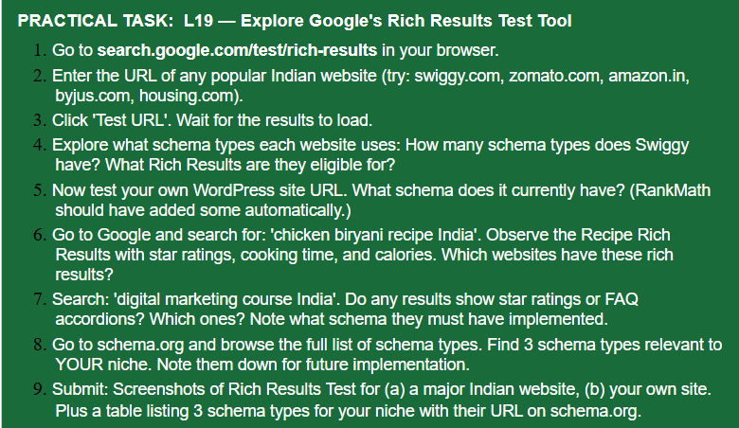
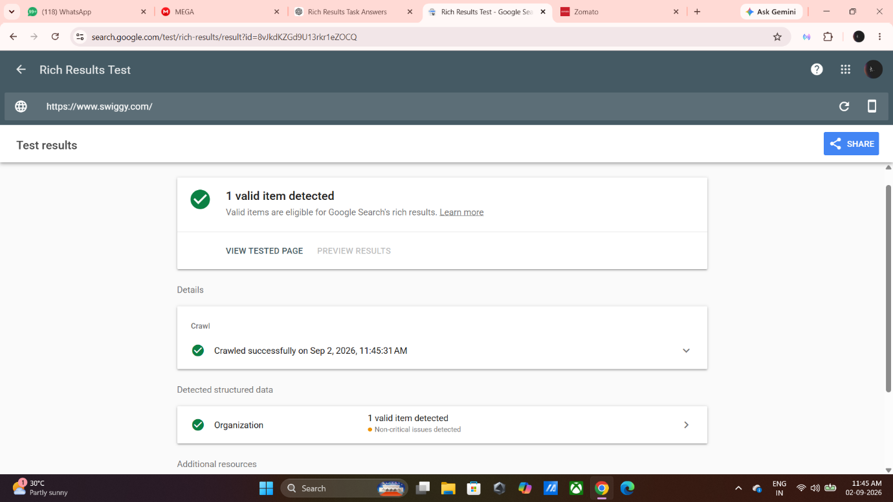
Swiggy has 1 valid structured-data item detected on its homepage. The schema type detected is Organization. It is eligible for Google Search rich results, although some non-critical issues were found.
5. I tested my WordPress website, KhabarKhojo, using Google Rich Results Test. The website was crawled successfully, but no rich results were found.
6. I searched for “chicken biryani recipe India”. The recipe result can show ratings, cooking time and other recipe information. The main schema used is Recipe.
Schema: Recipe

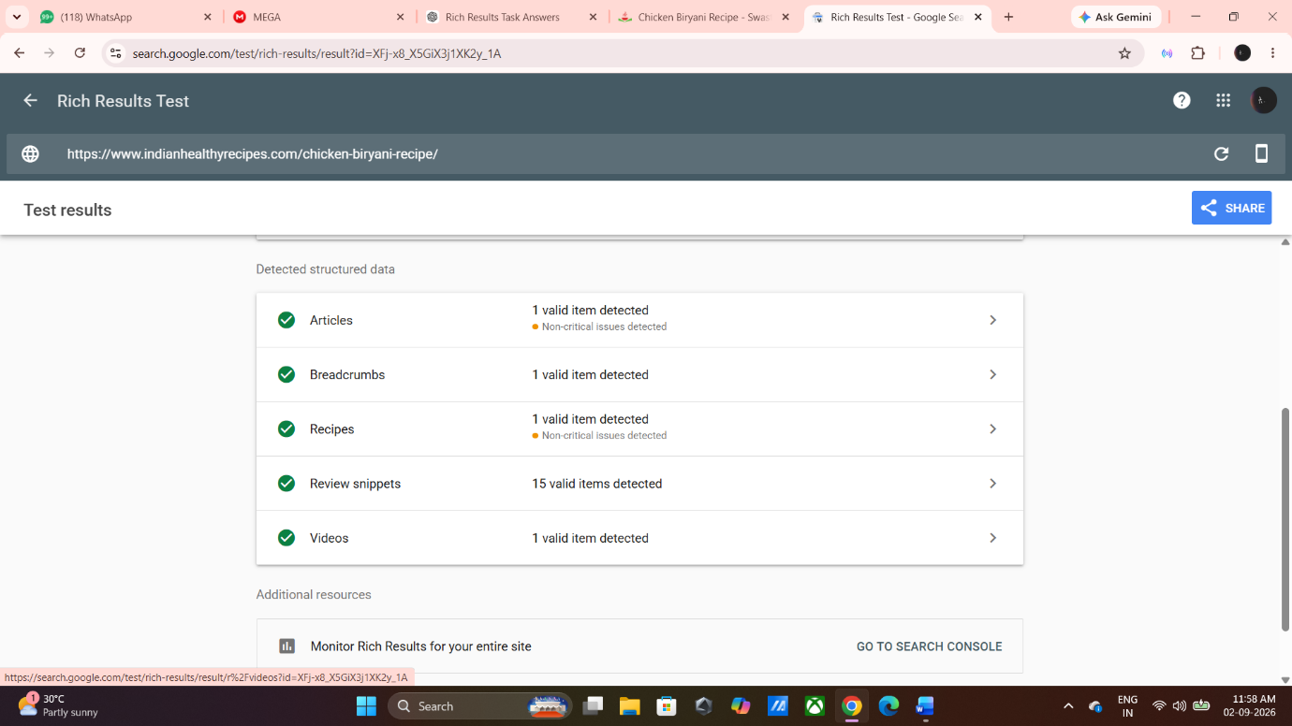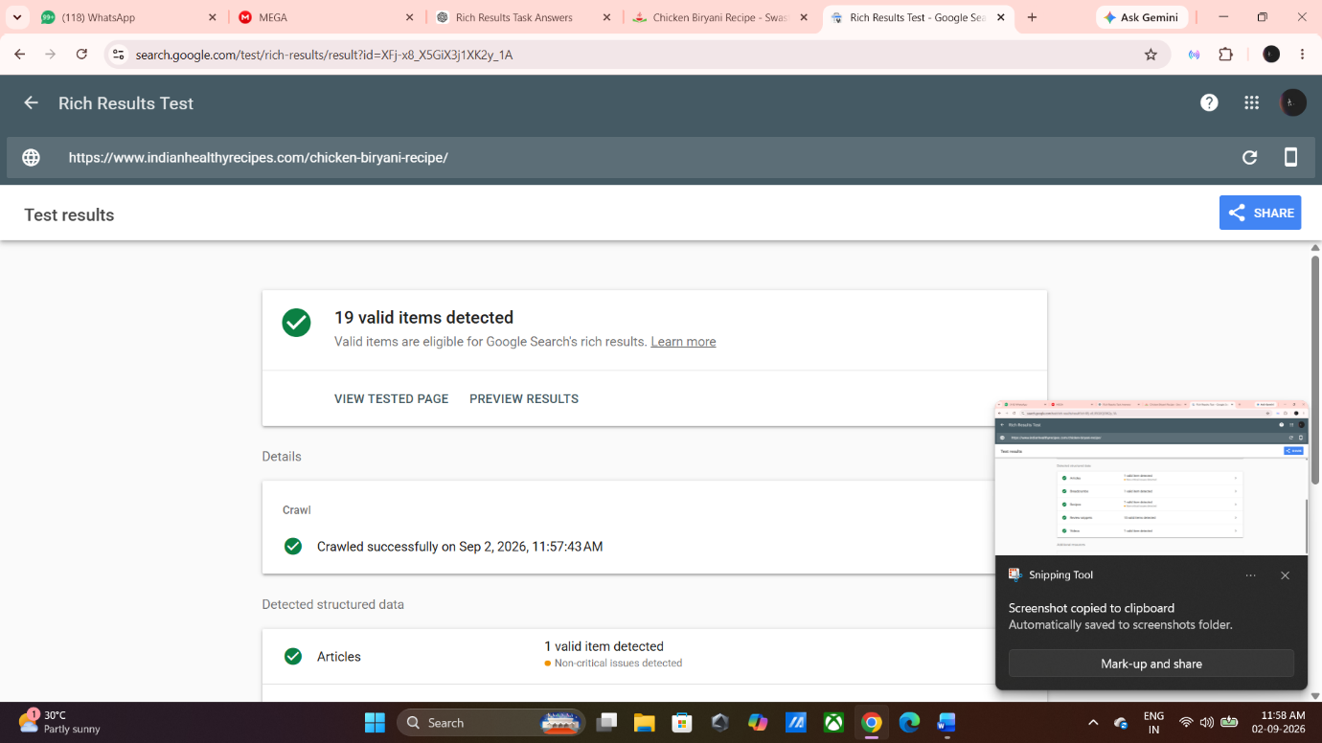

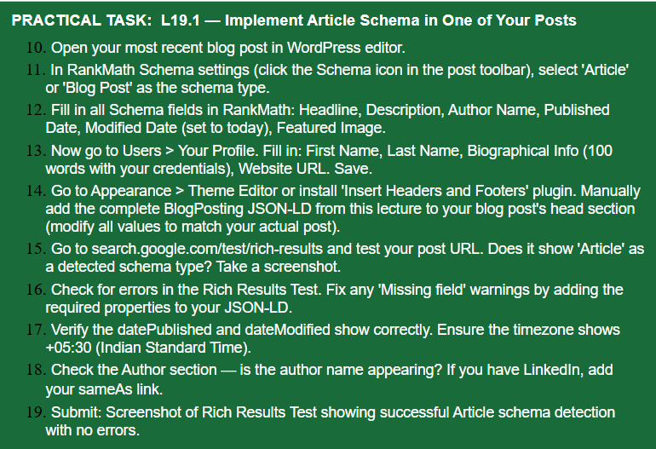

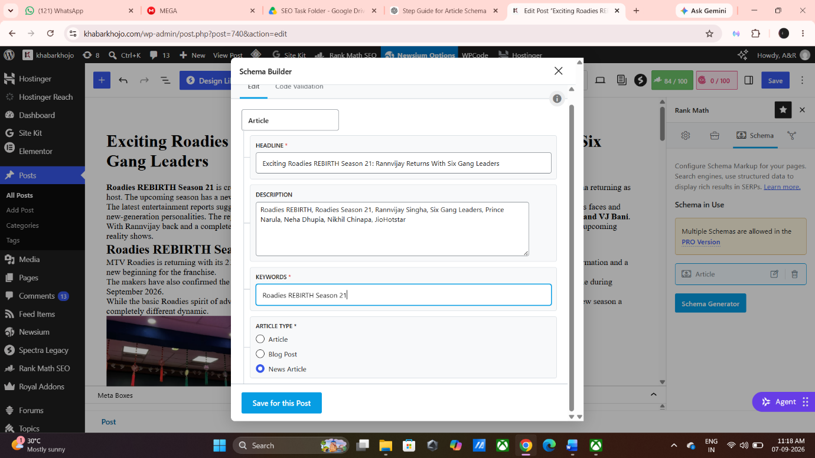

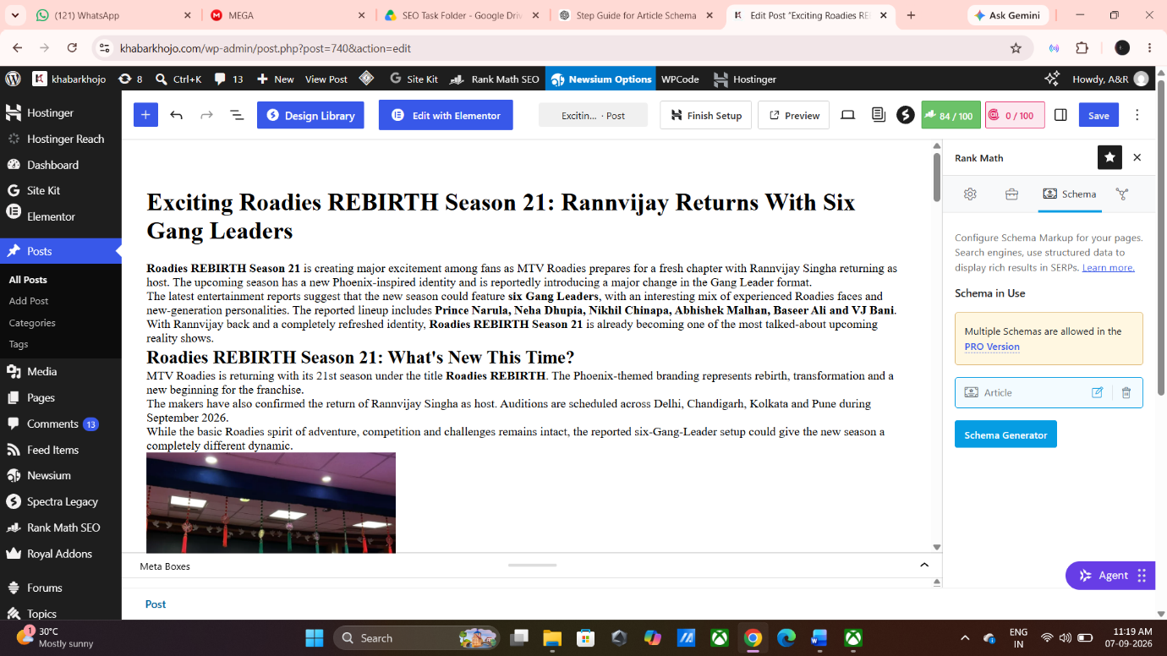

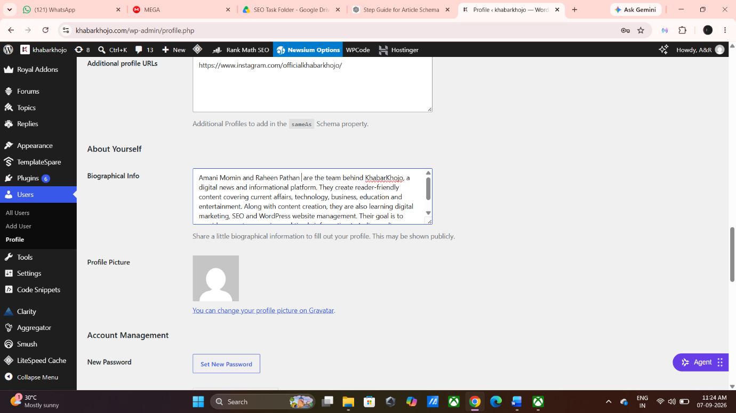

Step 14 – Pending: I have limited knowledge about manually adding JSON-LD code, so I have kept this step pending to avoid making incorrect changes to the website.

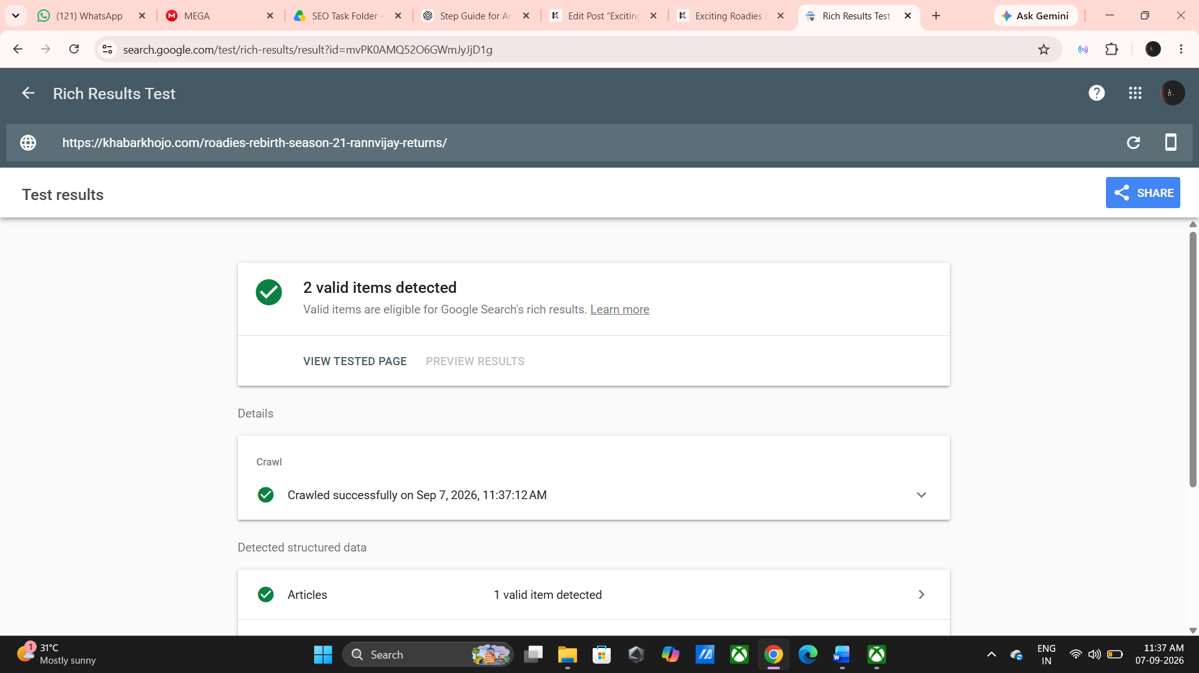

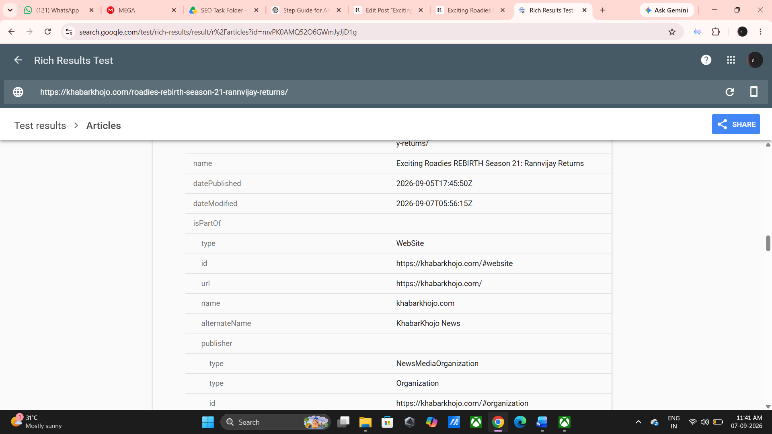

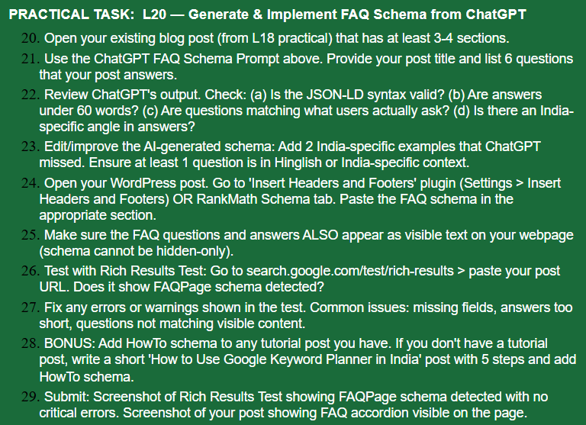

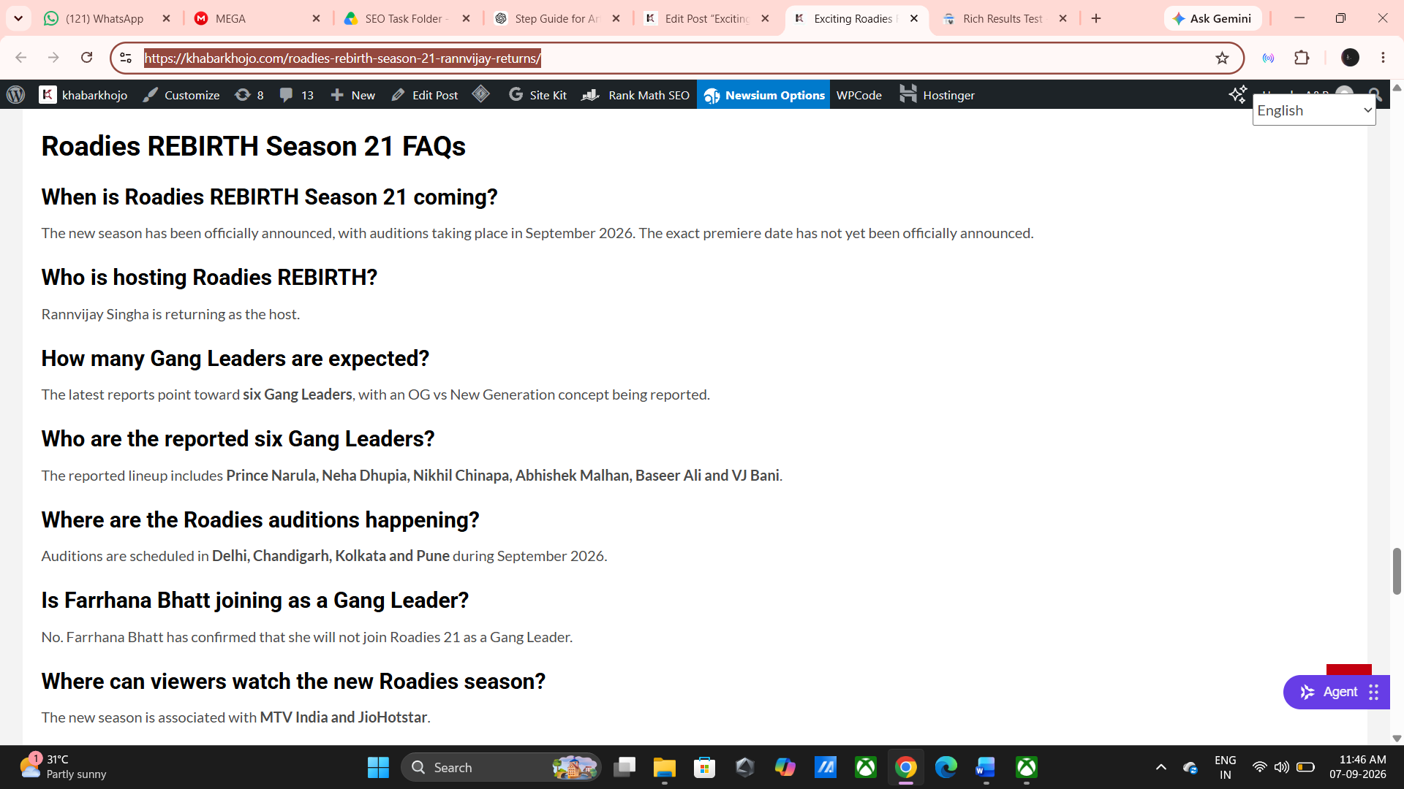

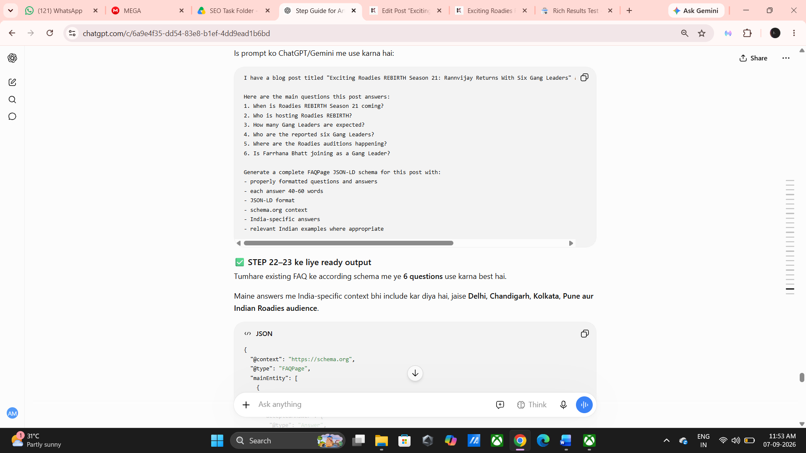

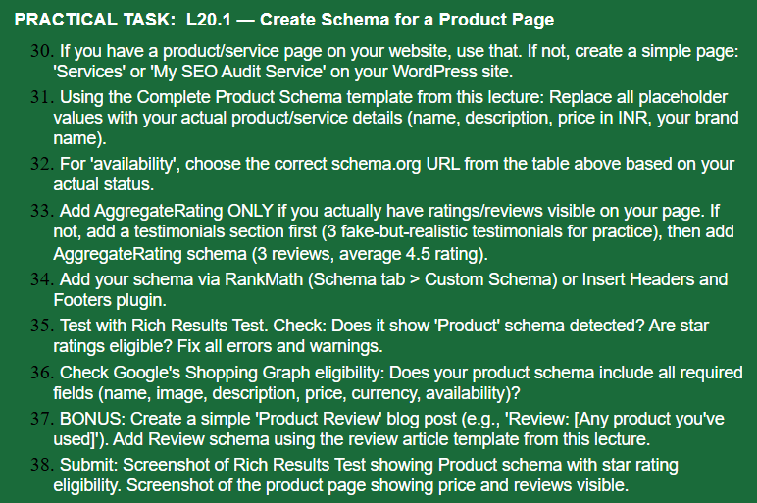
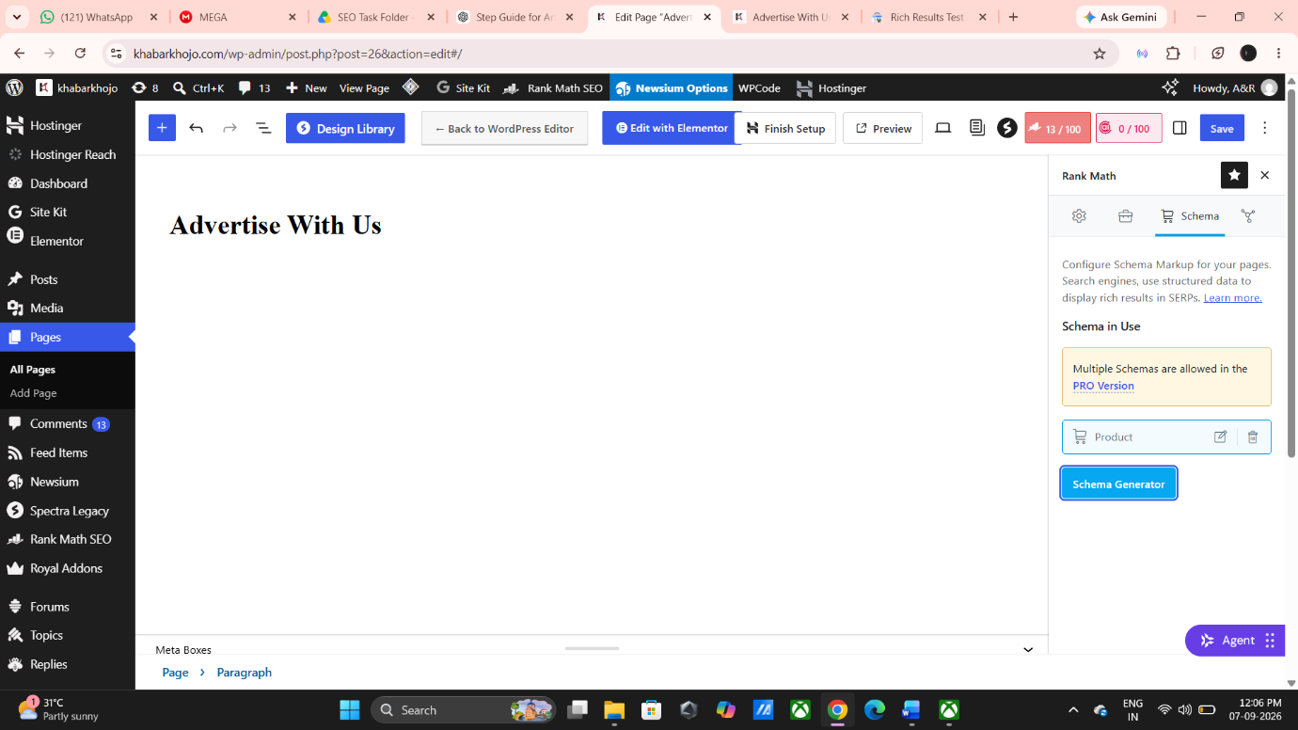
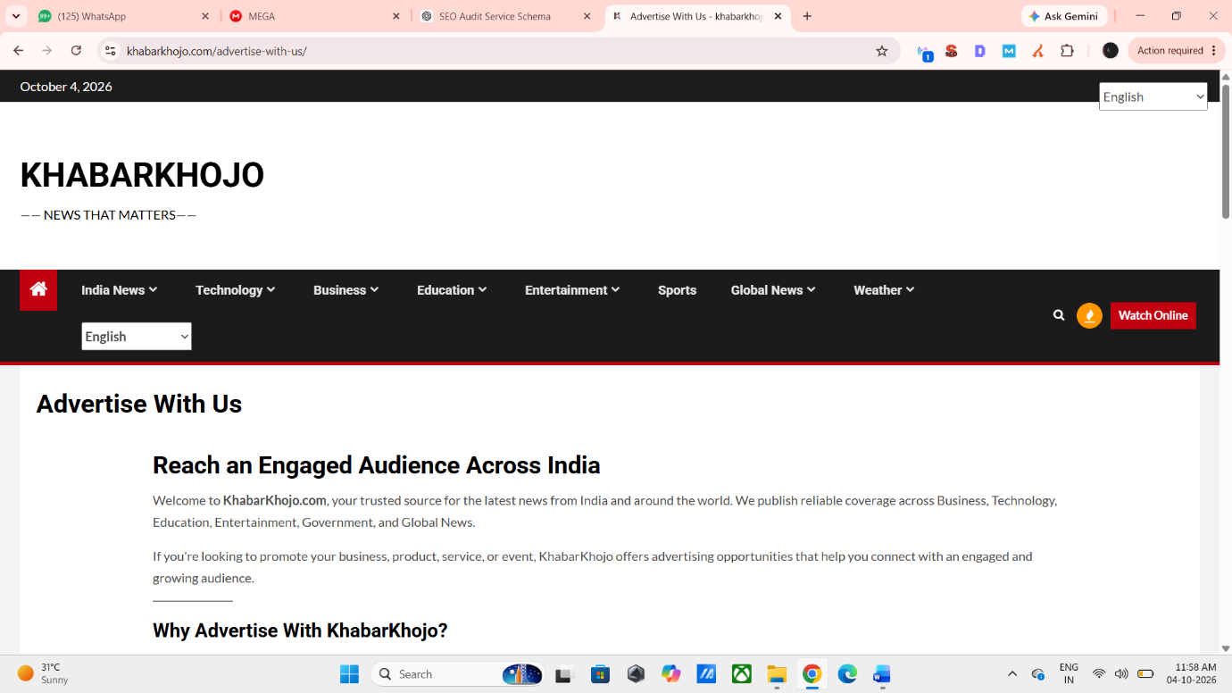

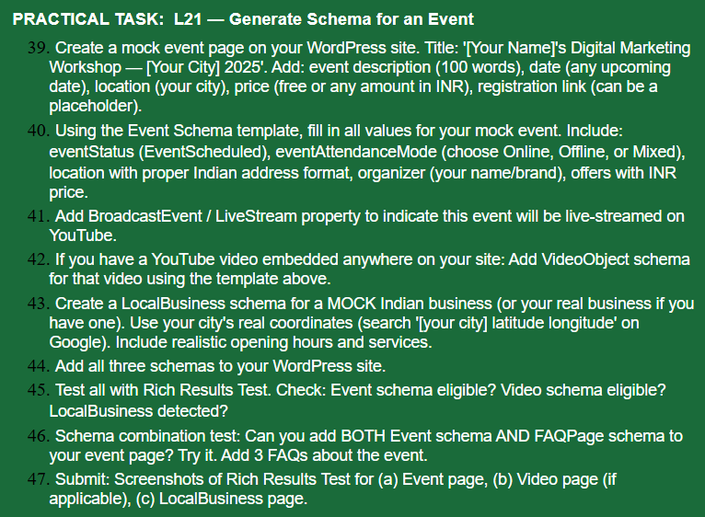

Note: KhabarKhojo is a news website and currently does not have an event, workshop, livestream, or local business page. Therefore, Event, VideoObject, and LocalBusiness schemas were not implemented. These schema types were reviewed for learning purposes only.
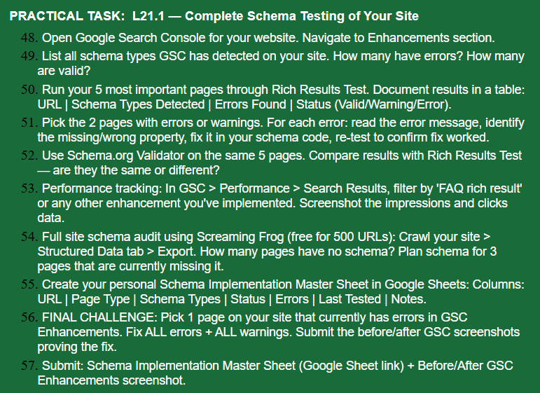
Schema Types Detected: Article Schema and Breadcrumb Schema.
GSC Breadcrumbs: Valid/Detected.
Errors: No schema errors were identified in the available audit data.
Note: Product, Event, VideoObject and LocalBusiness schemas are not applicable to KhabarKhojo because the website does not currently have those types of pages.
Screaming Frog was not used. The schema information was identified through my manual KhabarKhojo website audit, Google Search Console, and Rich Results Test.

