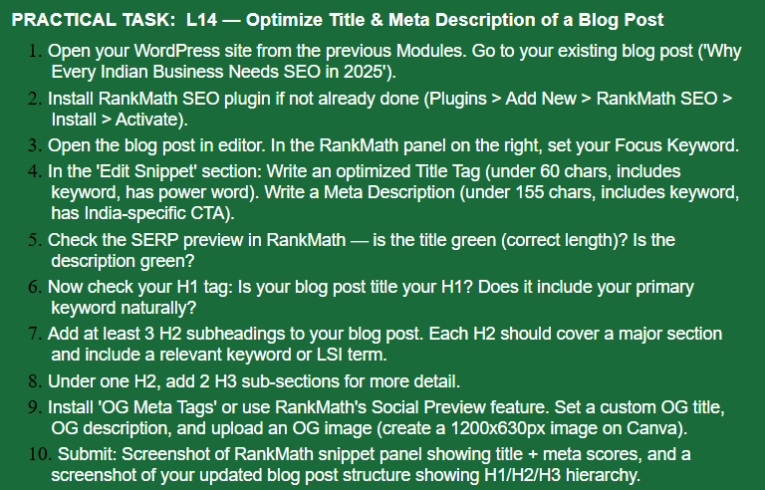

Answer :-


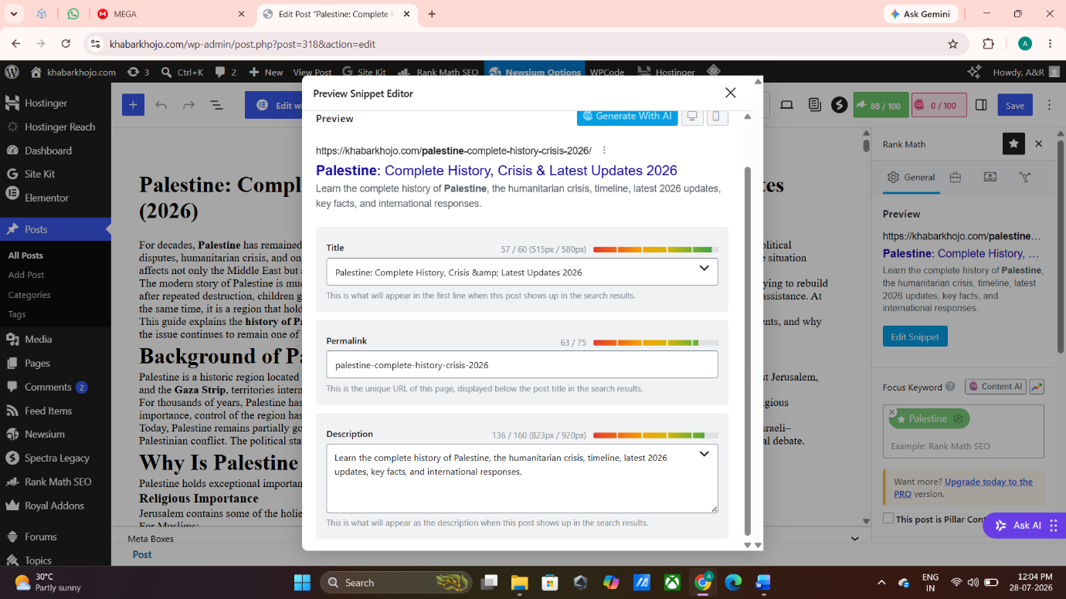



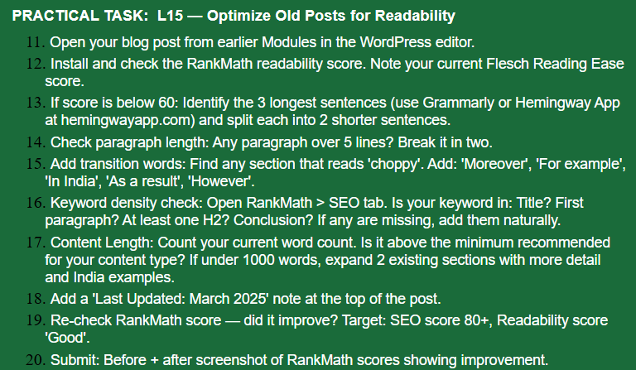



- This blog was analyzed using Rank Math. The initial SEO score was 77, and readability improvements were required.



- The blog was optimized by improving readability, adding internal and external links, and updating SEO elements. The Rank Math score increased from 77 to 83.
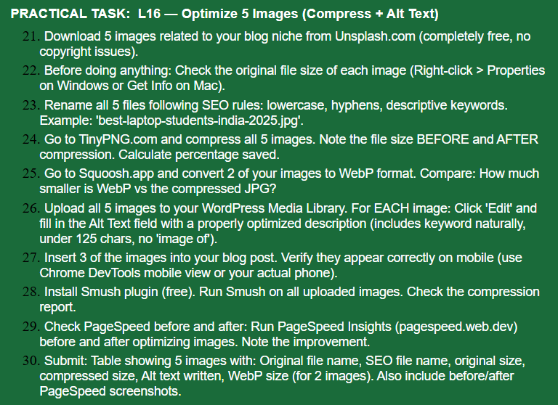
Blog URL:
https://khabarkhojo.com/chatgpt-new-features-openai-ai-update/

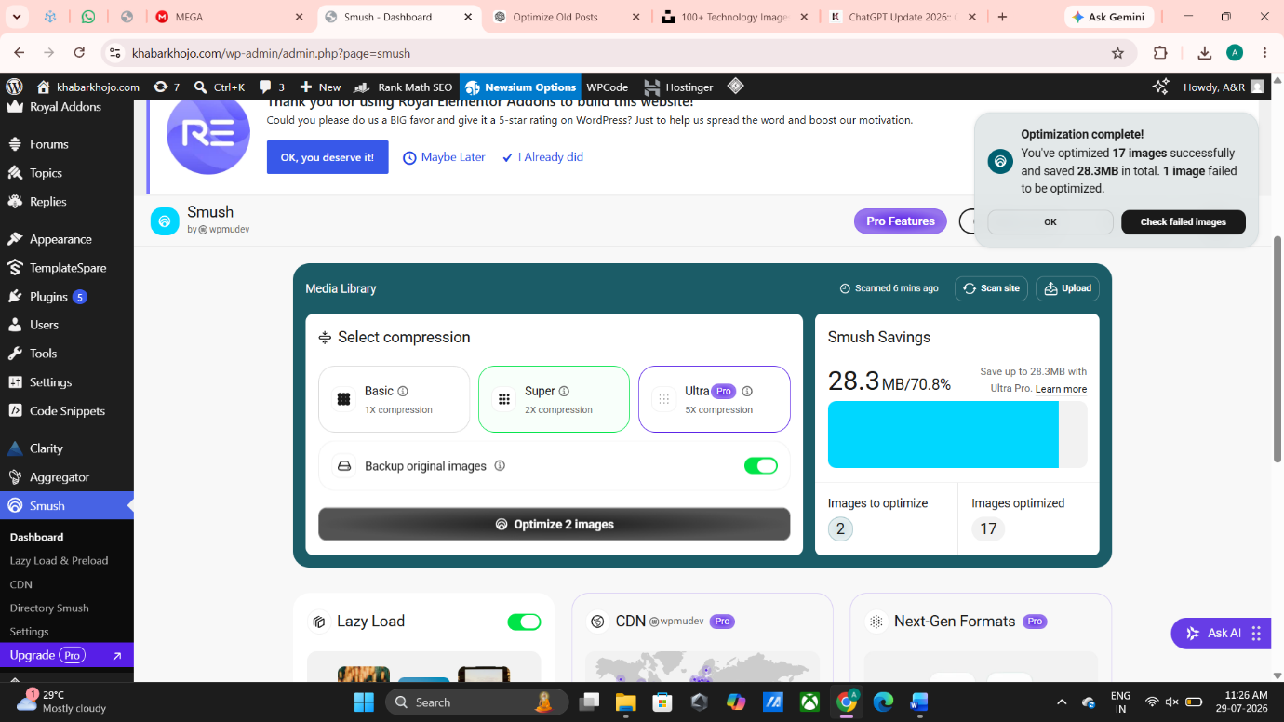
- Images were optimized successfully using the Smush plugin to reduce image size and improve website performance.

- Website performance was checked using Google PageSpeed Insights after image optimization.
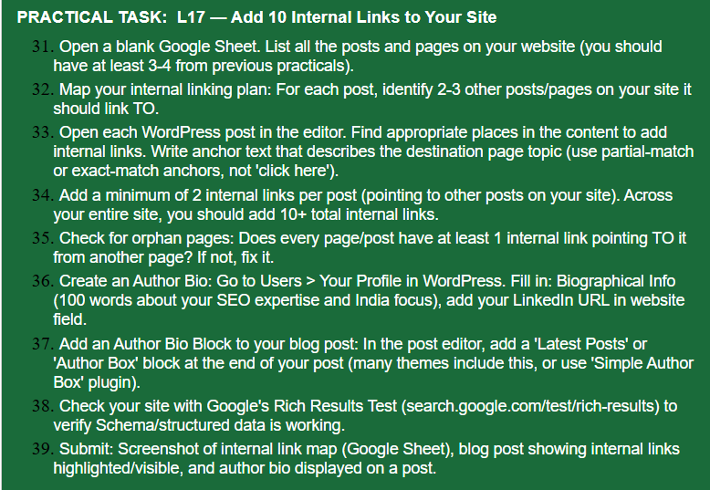

https://docs.google.com/spreadsheets/d/1mQz6VrK3AH1B30IBmZwu4JZdrPIyyfKZN5UPMWtGUuI/edit?usp=sharing
step;36


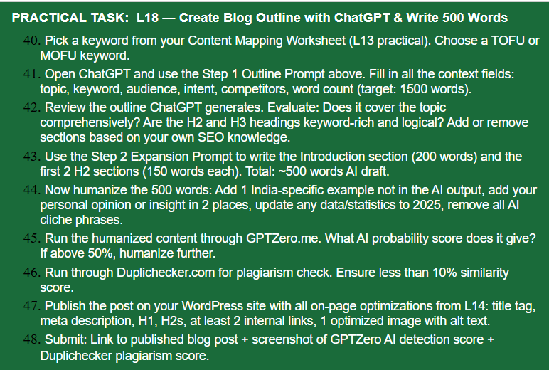

Selected Keyword
Primary Keyword: Ahmedabad Weather
Funnel Stage: TOFU
Topic: Ahmedabad Weather: Latest Forecast, Temperature & Rain Updates
Target Audience: People searching for the latest weather conditions and forecast in Ahmedabad
Search Intent: Informational
Competitors: The Indian Express, Times of India, Hindustan Times
Target Word Count: 1,500 words

Blog Outline
H1: Ahmedabad Weather: Latest Forecast, Temperature & Rain Updates
H2: Ahmedabad Weather Today
- Current temperature
- Weather conditions
- Humidity and wind
H2: Ahmedabad Weather Forecast for the Next Few Days
- Temperature forecast
- Rainfall possibility
- Cloud conditions
- Wind and humidity
H2: Will It Rain in Ahmedabad Today?
H2: Ahmedabad Weather During Different Seasons
- Summer
- Monsoon
- Winter
H2: How Ahmedabad Weather Can Affect Daily Life
H2: How to Stay Updated With Ahmedabad Weather
H2: Frequently Asked Questions

500-Word Humanized Content
Ahmedabad Weather: Latest Forecast, Temperature & Rain Updates
Ahmedabad weather can change throughout the day, especially during summer and monsoon. Knowing the latest temperature, rainfall possibility, humidity and wind conditions can help residents plan their daily activities. Whether it is travelling to work or college, going outside, or planning an outdoor activity, checking the weather forecast can be useful.
Ahmedabad generally experiences hot summers, a monsoon season with increased humidity and rainfall, and relatively cooler winters. However, daily weather conditions can vary, so checking the latest forecast is important before making plans.
Ahmedabad Weather Today
Today's Ahmedabad weather depends on several factors, including temperature, humidity, wind speed and cloud cover. During summer, temperatures can become quite high during the afternoon, while mornings and evenings may be comparatively comfortable.
During the monsoon season, cloudy skies and sudden rainfall can affect daily travel. Heavy rainfall can also cause waterlogging and traffic problems in some parts of the city.
For residents, checking the latest weather update before leaving home can help them prepare for changing conditions.
Ahmedabad Weather Forecast for the Next Few Days
The weather forecast for the coming days provides information about expected temperatures, rainfall and other conditions. Looking at temperature, rain probability, humidity and wind together gives a better understanding of what the weather may feel like.
Temperature Forecast
Ahmedabad's temperature is usually higher during the afternoon and lower during the night and early morning. Seasonal changes can significantly affect the difference between daytime and nighttime temperatures.
Rainfall and Cloud Conditions
During monsoon, Ahmedabad can experience cloudy skies and periods of rainfall. Rainfall intensity may vary across different areas of the city.
Wind and Humidity
Humidity can make warm weather feel more uncomfortable. Wind speed and direction can also influence how the temperature feels during the day.
Will It Rain in Ahmedabad Today?
Rainfall can sometimes be difficult to predict precisely for a specific part of the city. Therefore, residents should check the latest forecast and weather alerts before travelling.
For example, during heavy monsoon rainfall, commuters travelling through Ahmedabad may face slower traffic and temporary waterlogging. Checking weather updates before starting a journey can help people plan their routes and timings.
In my opinion, weather information is most useful when it is presented in a simple and practical way. People generally want to know not only the temperature but also how the weather could affect their daily plans.

WordPress SEO Details
SEO Title:
Ahmedabad Weather Today: Latest Forecast & Rain Updates
Meta Description:
Check Ahmedabad weather today, including temperature, rain forecast, humidity, wind conditions and the latest weather updates.
H1:
Ahmedabad Weather: Latest Forecast, Temperature & Rain Updates
Internal Links:
- India News
- Weather
- Gujarat News
Image Alt Text:
Ahmedabad weather forecast today

