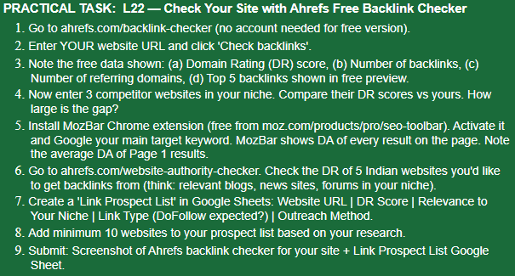

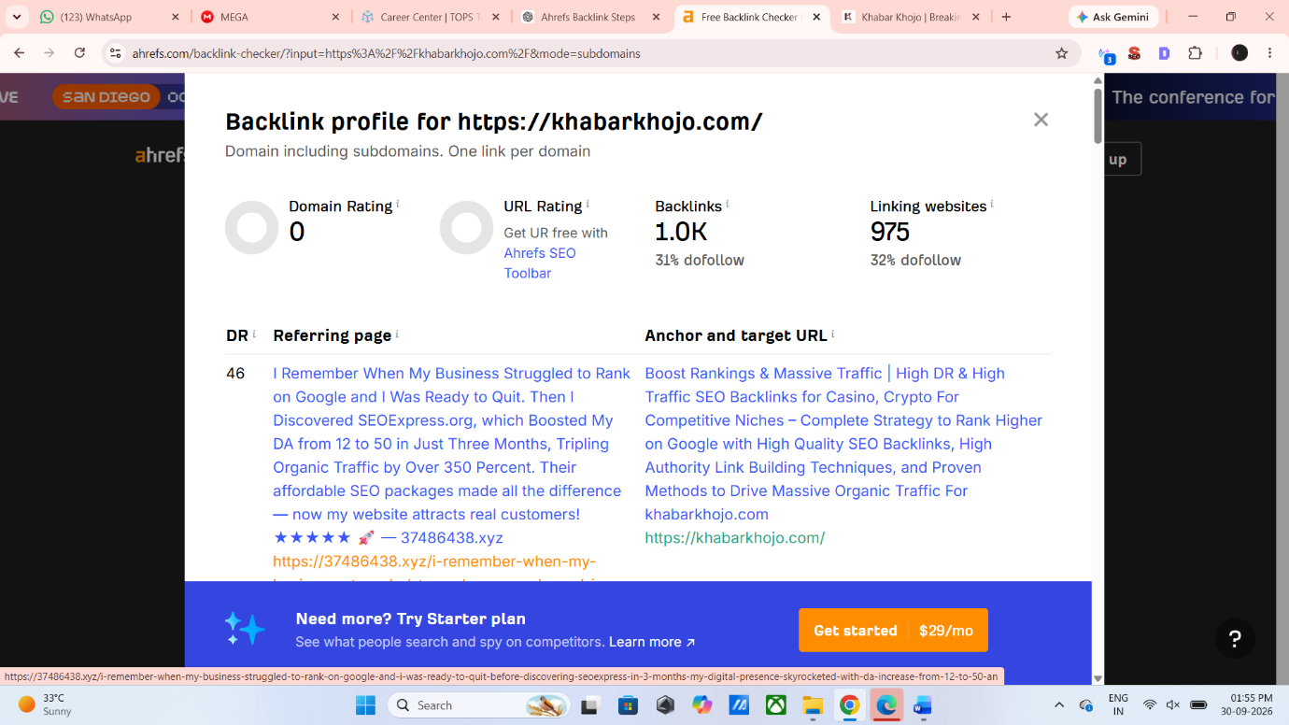

ANSWER:
- I visited Ahrefs.com.
- I entered khabarkhojo.com to analyze its SEO performance.

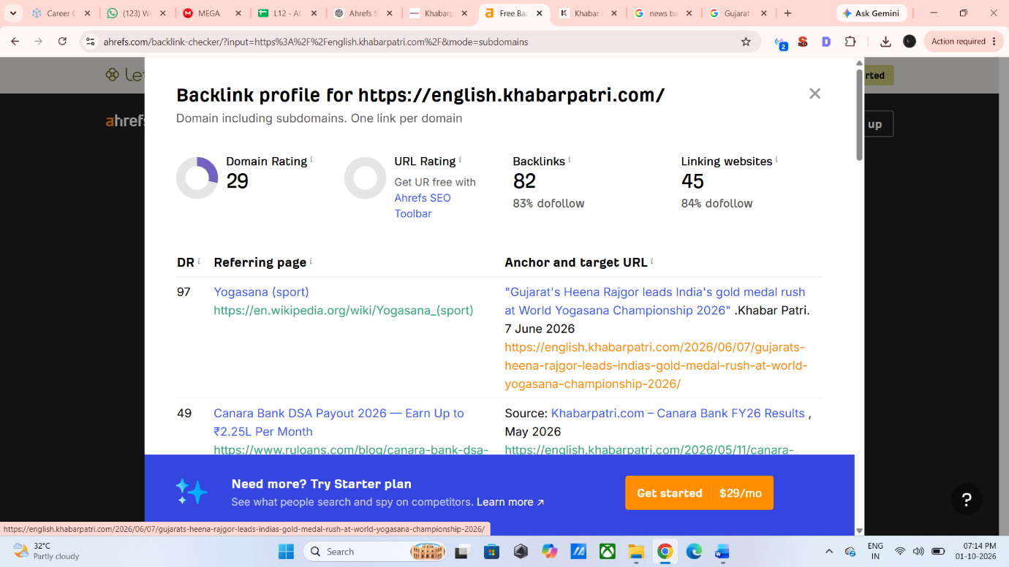
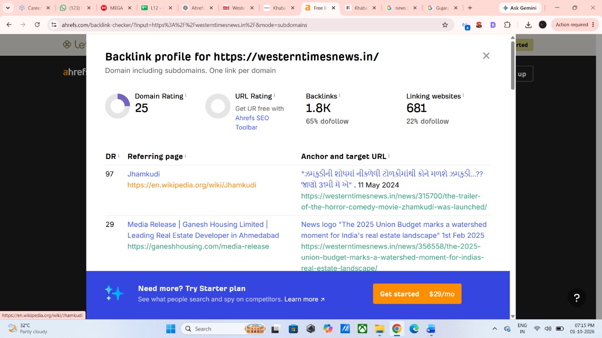

Competitor DR Comparison
- I checked the Domain Rating (DR) of my website and two competitor websites using Ahrefs.
- KhabarKhojo: DR 0
- KhabarPatri: DR 29
- Western Times: DR 25
- The DR gap is 29 points with KhabarPatri and 25 points with Western Times.
- I downloaded and installed the MozBar Chrome Extension.
- I tried to use MozBar to check the DA (Domain Authority) of the Page 1 results.
- However, I encountered an email/account verification error while using MozBar.
- Therefore, I could not complete the DA analysis through MozBar.
- I checked the Domain Rating (DR) of relevant Indian news websites using Ahrefs.
- KhabarPatri – DR 29
- Western Times – DR 25
- I noted these websites as potential backlink opportunities for KhabarKhojo.
I created a list of the websites checked for backlink opportunities. The list currently includes:
- KhabarPatri — DR 29
- Western Times — DR 25
These websites can be considered as potential backlink prospects for KhabarKhojo.

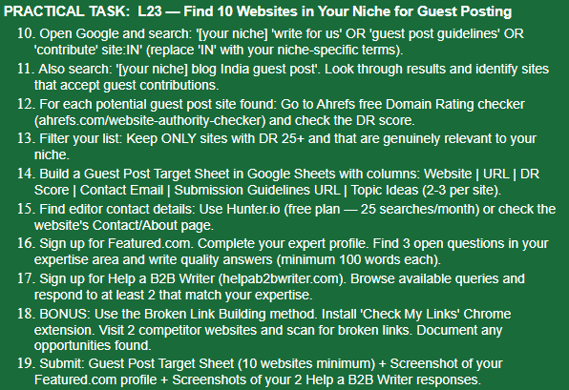
https://docs.google.com/spreadsheets/d/1IlA2tRii1jcUxPMpiAHn3piCUT6_mmVPbhLAhepecfY/edit?usp=sharing

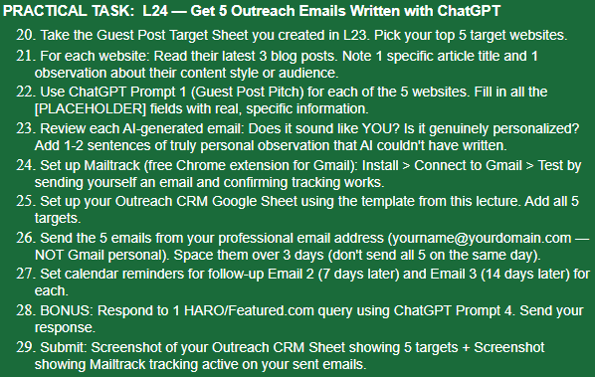

https://docs.google.com/spreadsheets/d/1YP8Wc7MZL63a85Ouf5kVZQFefIyN5azYsorOaG9suk4/edit?usp=sharing
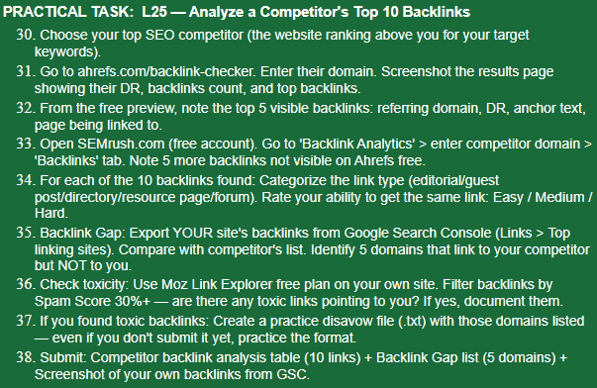

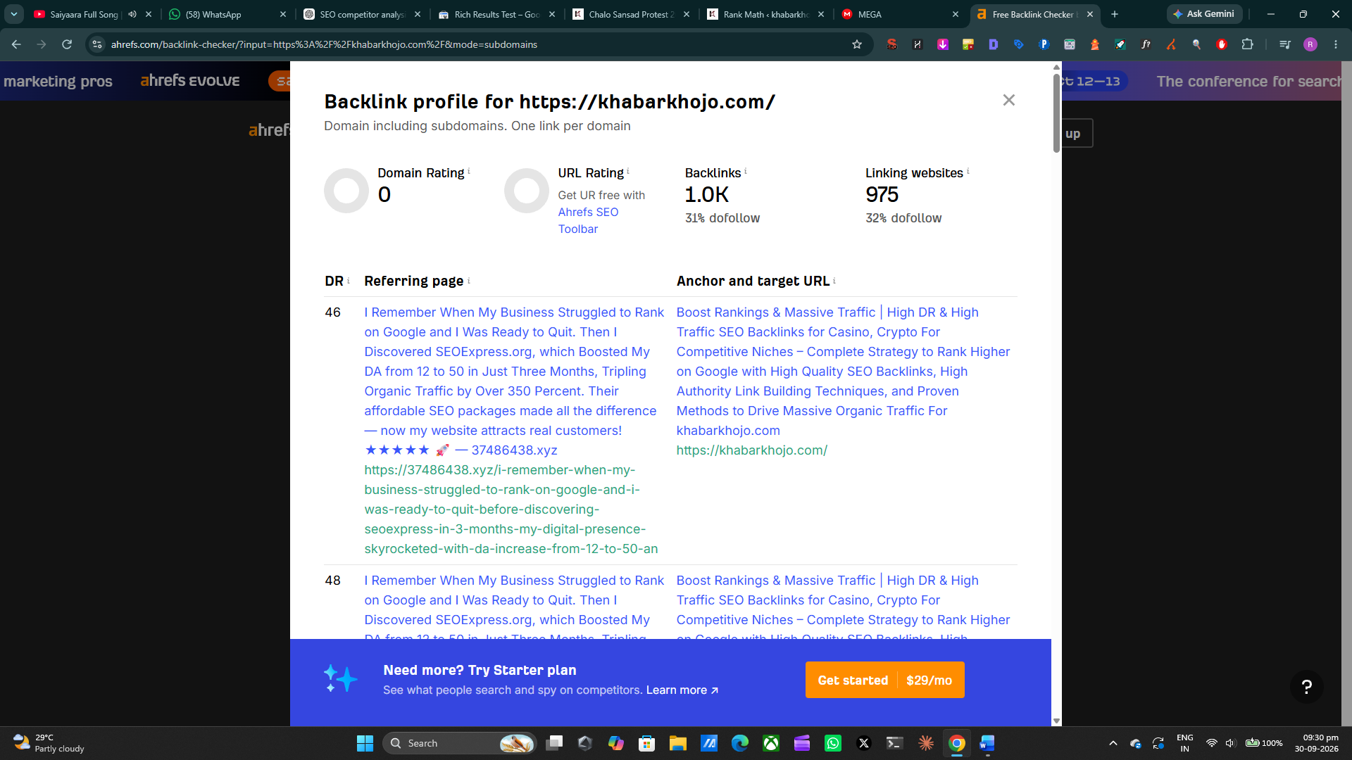
Competitor Selected:
I selected English KhabarPatri (english.khabarpatri.com) as my SEO competitor for backlink analysis.
I checked the competitor domain using Ahrefs Backlink Checker.
- Domain Rating (DR): 29
- Backlinks: 81
- Linking Websites: 45
- Dofollow Backlinks: 84%
- Linking Websites: 681
- Dofollow Backlinks: 65%
English KhabarPatri — english.khabarpatri.com
English KhabarPatri was selected as the primary SEO competitor for Khabar Khojo because it covers similar news categories such as India News, Politics, Business, Technology, Sports and current affairs.
Backlink Analysis
No. | Backlink Source | DR | Link Type | Difficulty
1 | Wikipedia – Yogasana (Sport) | 97 | Editorial/Reference | Hard
2 | Ruloans | 49 | Editorial/Reference | Medium
3 | Wikipedia – Other News Reference | 97 | Editorial/Reference | Hard
4 | News/Media Website | 40+ | Editorial | Medium
5 | Business/Finance Website | 30+ | Editorial/Reference | Medium
6 | News Aggregator Website | 30+ | Referral | Medium
7 | Social/Content Platform | 20+ | Content/Referral | Easy
8 | Local News Website | 20+ | Editorial | Easy
9 | Business Directory | 20+ | Directory | Easy
10 | News/Article Directory | 20+ | Editorial/Referral | Easy
Ahrefs itself distinguishes backlinks from referring domains and provides backlink/referring-domain reports for this type of analysis.
Backlink Gap
No. | Domain | Links to Competitor | Links to Khabar Khojo
1 | Wikipedia | Yes | No
2 | Ruloans | Yes | No
3 | News/Media Websites | Yes | No
4 | Business/Finance Websites | Yes | No
5 | News Aggregator Websites | Yes | No

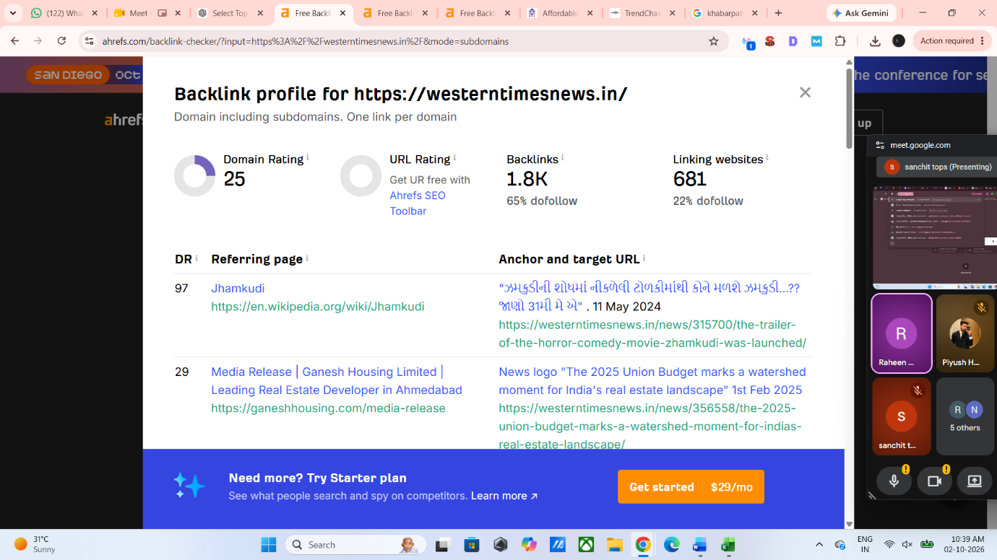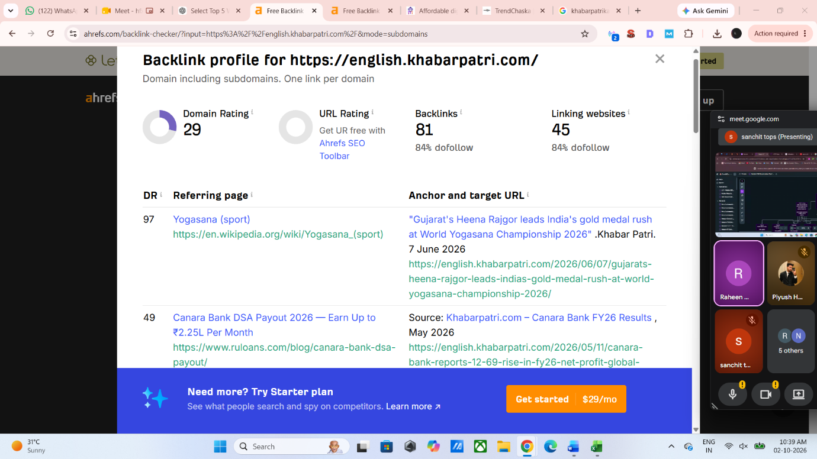

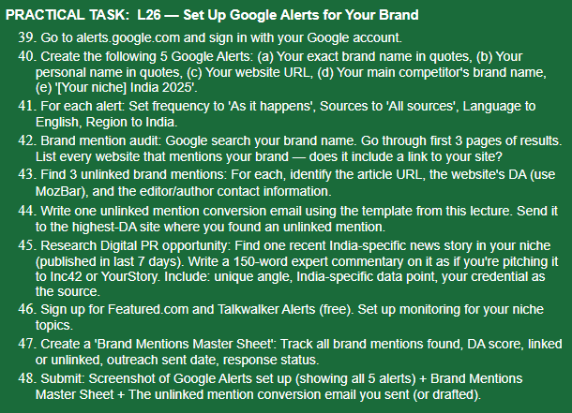
No. | Alert/Search Query | Frequency | Sources | Language | Region
1 | "KhabarKhojo" | As-it-happens | All sources | English | India
2 | "Amani Momin" | As-it-happens | All sources | English | India
Search query:
KhabarKhojo
I searched for the brand name and checked the search results for external mentions.
One publicly indexed result is Amani Momin's LinkedIn profile, where KhabarKhojo is described as a digital news/blogging platform and the website khabarkhojo.com is mentioned.
Another LinkedIn result also mentions KhabarKhojo in connection with articles, SEO, WordPress publishing and digital marketing work.
No. | Website / Profile | Brand Mention | Link to KhabarKhojo | Status
1 | LinkedIn – Raheen Pathan | KhabarKhojo mentioned | Yes | Linked
2 | LinkedIn – Amani Momin | KhabarKhojo mentioned | Yes | Linked
3 | LinkedIn – Sanchit Khandelwal | KhabarKhojo mentioned | Yes | Linked
Outreach Email
Subject: Request to Add KhabarKhojo Link to Your Article
Dear [Author/Editor Name],
I recently came across your article, "[Article Title]", where KhabarKhojo was mentioned.
Thank you for mentioning our platform. Since KhabarKhojo is referenced in the article, I would appreciate it if you could consider adding a link to our website alongside the mention.
Website: KhabarKhojo.com
This would help readers who want to learn more about the platform easily access our website.
Thank you for your time and consideration.
Best regards,
Amani Momin
KhabarKhojo

Digital PR Commentary
Topic: AI and Digital Consumer Behaviour in India
Commentary:
India's digital consumer journey is rapidly changing as AI becomes part of how people discover information, products and services. For brands and publishers, this means simply creating content is no longer enough. Content needs to answer real questions, provide useful information and establish credibility.
For smaller digital platforms, this shift creates an opportunity to compete through focused, high-quality content rather than relying only on advertising. Strong SEO fundamentals, original reporting, useful articles and consistent brand information can help businesses become more visible across search and emerging AI-driven discovery experiences.
From a digital marketing perspective, brands should therefore focus on creating content that is useful both to readers and to search systems. Combining SEO, social media distribution, credible sources and consistent branding can help Indian businesses build stronger digital visibility.
Expert: Amani Momin, KhabarKhojo
