**ReadMe**

The unity scene given below contains our preliminary prototype of Chemistry Lab Environment.

Chemistry Lab → Assets → Scenes → SampleScene.unity

The Five Interaction States of the 3D Manipulation Technique are:

1. Open – Initial State; no grasp and when trigger button is released, hand.type is Affect.Virtual to let pass through objects
2. Closed – when trigger button is pressed, hand.type is Affect.Physical to create collisions with objects
3. Holding – hand reaches (touches) object and trigger button pressed to hold objects
4. Touching – trigger button pressed and touching object
5. Apply – used to turn on and off objects – like flame, by touching the object followed by pressing the grip button.

Given below is the corresponding Virtual Hand State Machine Diagram

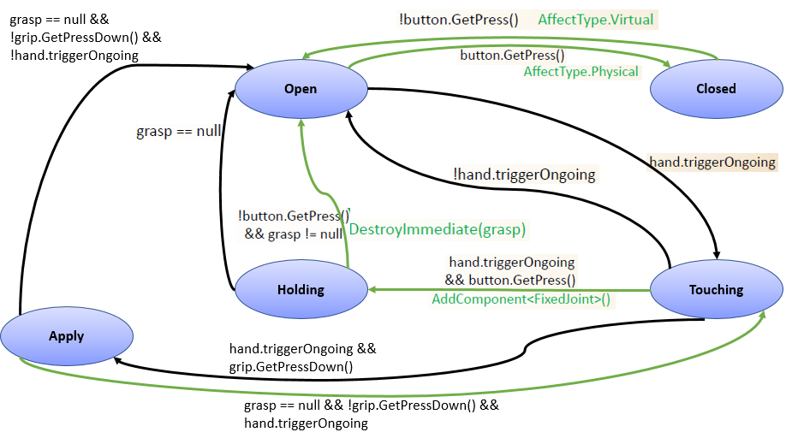

**How to use it with the HTC Vive:**

* The controller joystick is used to control relative direction (forward / backward / left / right) and speed.
* The trigger button required to be pressed to grab/move objects
* The grip button is used to turn on and off objects
* One can test the functionalities in this way:
  + OPEN to CLOSED state and vice-versa: the Trigger Button of the VirtualHand is pressed which enables to collide with objects (in CLOSED state) as opposed to passing through them (in OPEN state) and releasing the Trigger Button.
  + Trigger Button of the VirtualHand is pressed and touch the object, to see it moving (TOUCHING)
  + Touch the object with the VirtualHand and Press the Trigger button, move the Hand in all directions, to grab and move the object along with your hand. (HOLDING)
  + Release the Trigger Button to see the object fall from your hand (OPEN)
  + APPLY state is reached when you TOUCH an object, followed by pressing the grip button down. This functionality has been added to the Bunsen Burner. On touching the Bunsen Burner lighter, followed by pressing the grip button down, turns ON the flame. One can turn OFF the flame by the same steps.

To navigate to these objects, we can use the Travel Technique by pressing the Touchpad Button.

**How to test solubility**

For the mix solutions with soluble/insoluble compounds part we can use the right hand to touch the salt and press the “Trigger Button” to pick the salt and move it and unclick the “Trigger Button” to drop it into the solution.

**How to light Bunsen Burner**

If the burner and water-sink need to turn on/off, you need to make the virtual hand touching on the objects that you want to apply and press the grip button to do so.

**How to do the Flame Test**

To be able to do the Flame test, take the glass rod and touch the corresponding salt. The glass rod changes its color based on the salt it collides with indicating if the user has interacted with the salt.

Place the glass rod with salt in the flame of the Bunsen burner to check for the changing of the color of the flame.