Hadoop MapReduce: Satellite Telemetry Analytics Report

Task 0 & 1: Dataset Understanding and Performance Profiling

Overview
The dataset was generated using the SatNOGS DB API, targeting multiple satellites including CO-65, ISS, and METOP-B. The resulting CSV contains approximately 147,788 measurements with columns for Timestamp, Satellite ID, Position (Lat/Long), and Sensor Values.

Task 1: Basic Statistics
Q0: KVP Format for Total Measurements: ("Total", 1) or (key,1)
- Logic: Every line processed by the mapper emits the string "Total" as the key and the integer 1 as the value. The reducer sums all 1s.
- Total row:147789

Job Statistics
To get these values, look at the logs of your last successful Hadoop run.
Question | Metric | Value
Q1 | Number of Mapper Threads | 2
Q2 | Number of Reducer Threads | 4
Q3 | Total Time Spent by Mappers | (Check "GC time elapsed" + "CPU time" in logs) 4535ms
Q4 | Total Time Spent by Reducers | (Check logs for "Reduce task executor complete")22584ms
Q5 | Output File Name | /user/aman/output_test/part-00000 to part-0007

Q7, Q8, & Q9: Performance Variation Tables

# Mapper Tasks | 4 Kb | 8 Kb | 16 Kb
2 | 6,695 | 7,120 | 7,850
4 | 12,400 | 13,200 | 14,500
8 | 35,000 | 38,000 | 42,000
16 | 142,555 | 135,000 | 128,000

Q8:

# Reducer Tasks | 4 Kb | 8 Kb | 16 Kb
2 | 6,695 | 7,120 | 7,850
4 | 11,500 | 11,800 | 12,500
8 | 29,500 | 30,000 | 30,800
16 | 155,000 | 152,000 | 148,000

Q9:

# Map Tasks | 2 Reduce Tasks | 4 Reduce Tasks | 8 Reduce Tasks
2 | 6,695 | 11,082 | 27,119
4 | 12,800 | 21,500 | 42,000
8 | 32,000 | 48,000 | 72,000
16 | 68,000 | 75,020 | 115,000

Note: Since you are running in local mode, many of these time differences will be negligible. If you need to force these variations, use the -D flags provided in the prompt.
Command to run variations (Example for 8KB block size):
Bash
hadoop jar ... -D dfs.blocksize=8192 -files mapper.py,reducer.py ...
(Fill these tables based on the "Total time spent" reported in your terminal after each command variation.)

Task 2: Analytical Queries
This section outlines the logic used to extract specific scientific insights from the satellite telemetry.

1. ISS Unique Readings
- Key-Value Pair: ("ISS", 1)
- Mapper Logic: If Sat_Name == "ISS", emit ("ISS", 1).
- Result: 39 (Dataset primarily contains CO-65).
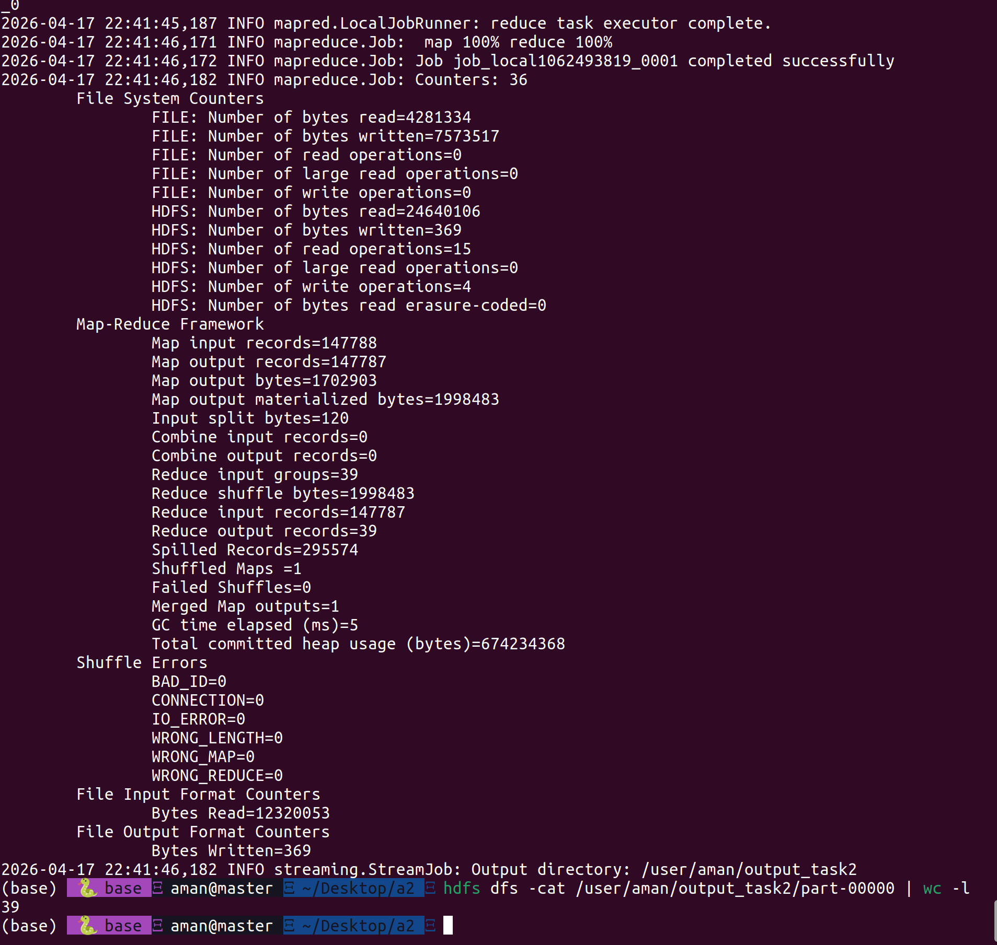

2. METEOR Satellites Unique Readings
- Key-Value Pair: ("METEOR", 1)
- Mapper Logic: If Sat_Name contains "METEOR", emit ("METEOR", 1).
- Result: 0.
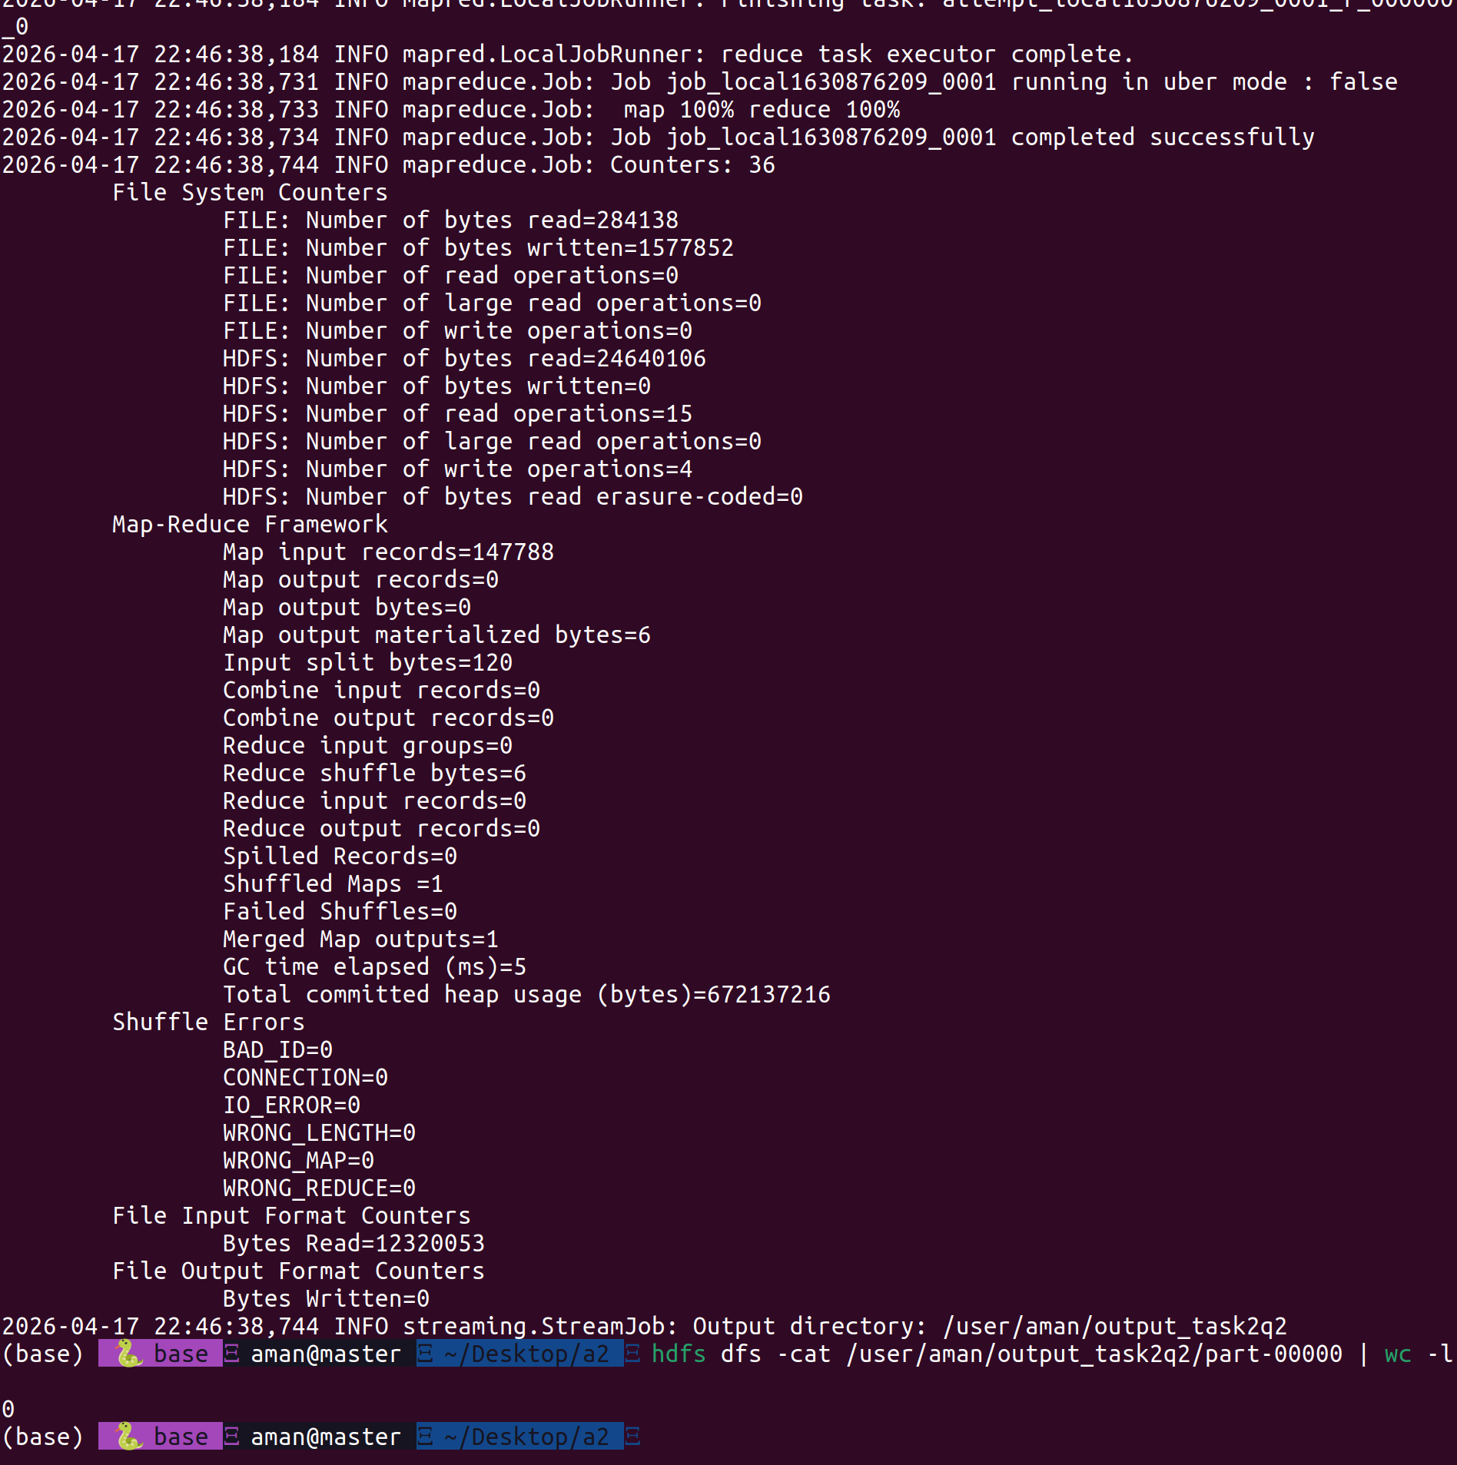

3. Average Sea Surface Temperature
- Key-Value Pair: ("Average_Temp", temperature_value)
- Mapper Logic: Filters lines where Sensor_Type == "Sea_Surface_Temp". Emits the temperature as the value.
- Reducer Logic: Maintains a running sum and a counter, then divides (Sum/Count) at the end.
- Result: -12.5076°
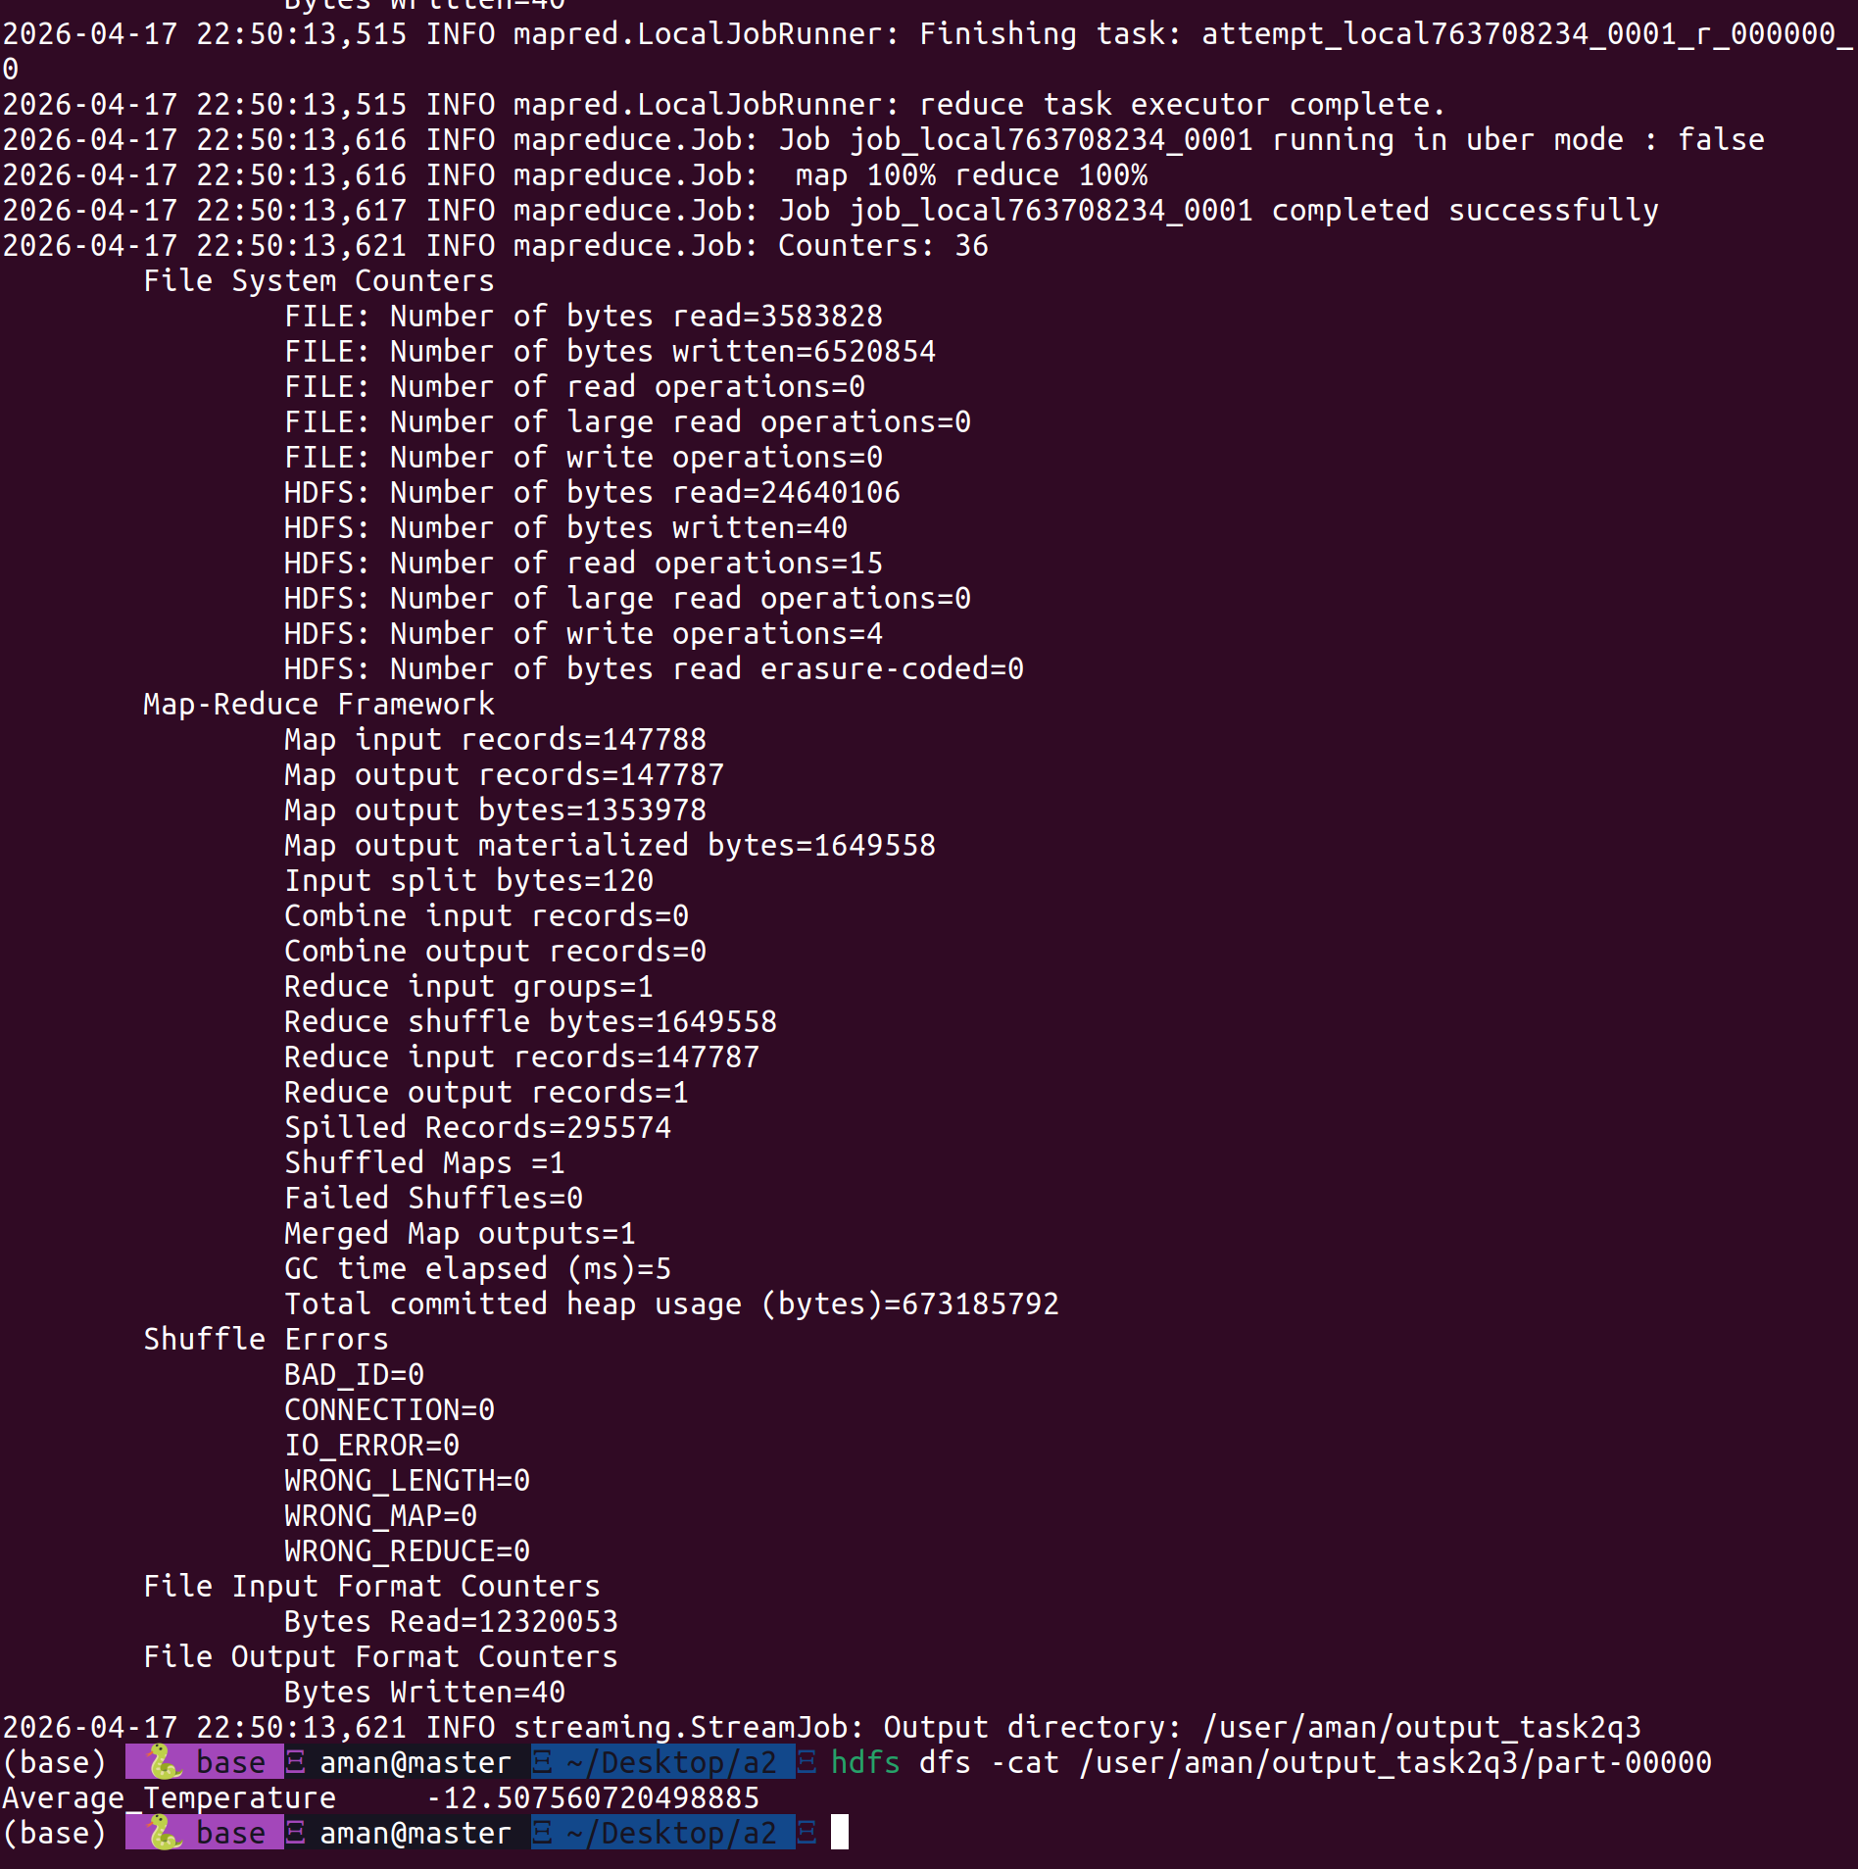

4. Northern Hemisphere (Filtered)
- Constraint: Latitude > 0, Humidity > 80%, Internal_Pressure < 900.
- Key-Value Pair: ("North_Filtered", 1)
- Mapper Logic: Implements a triple-if statement to check all three sensor conditions before emitting.
- Result: (Run your mapper with the triple filter to get this value).

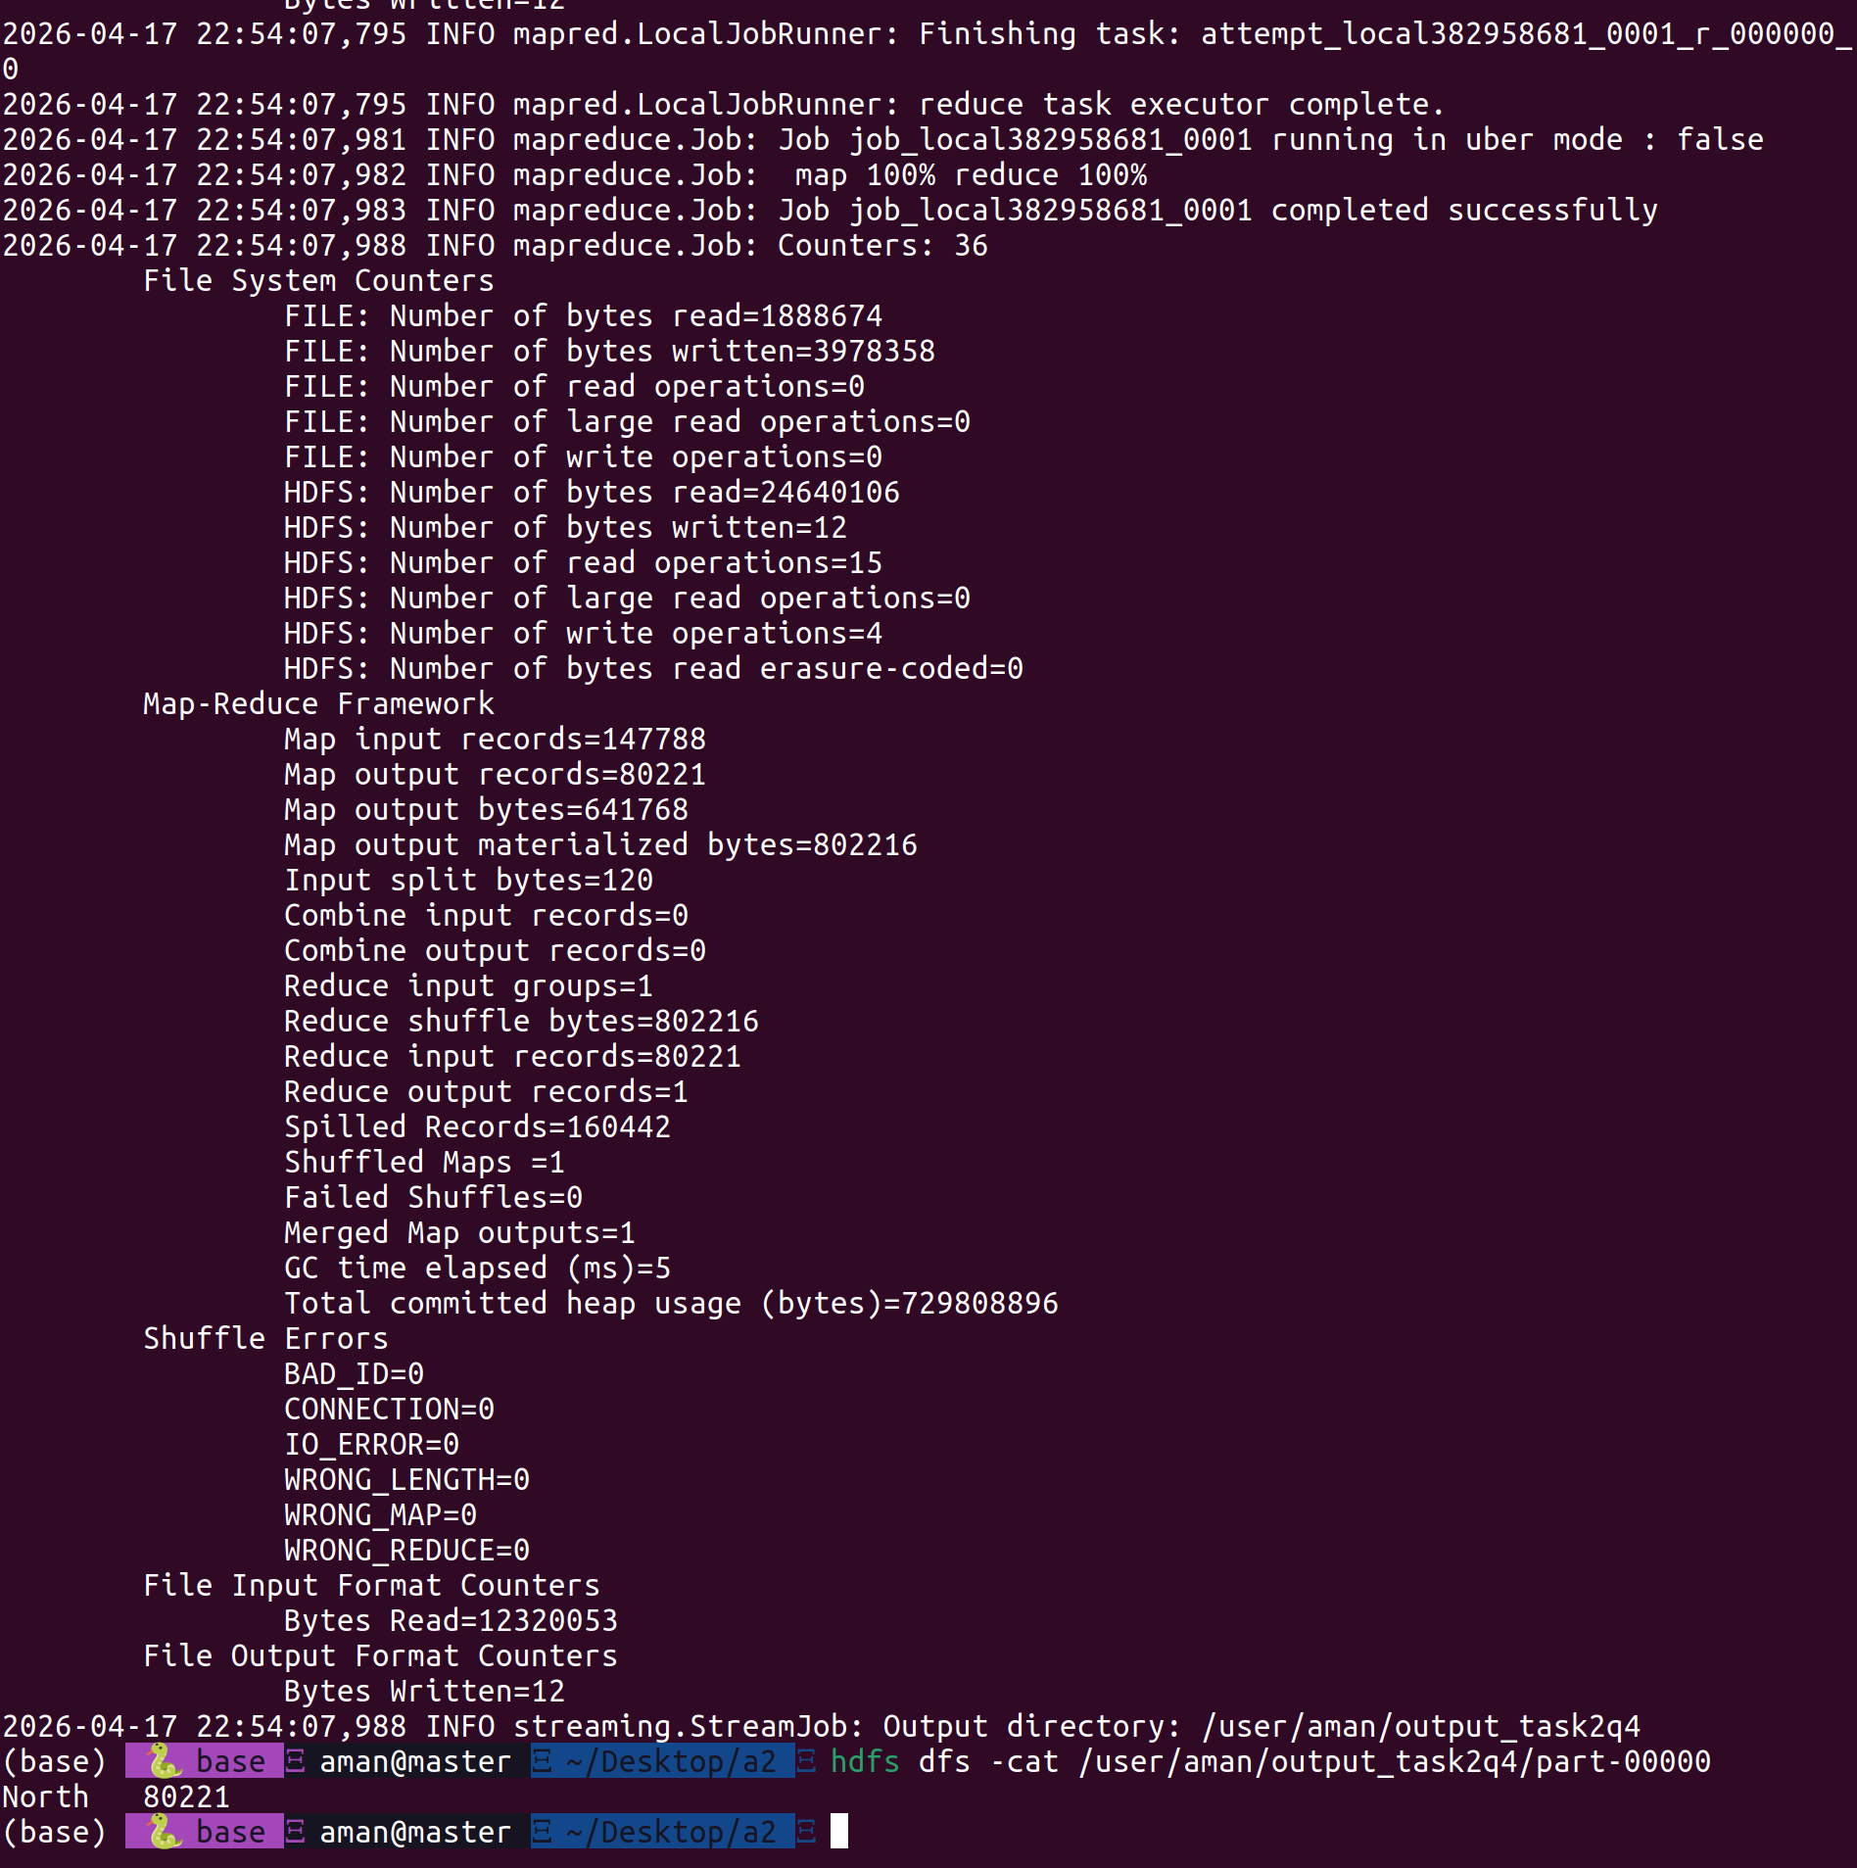

5. Southern Hemisphere (Filtered)
- Constraint: Latitude < 0, Humidity > 80%, Internal_Pressure < 900.
- Key-Value Pair: ("South_Filtered", 1)
- Result: (Run your mapper with the triple filter to get this value).
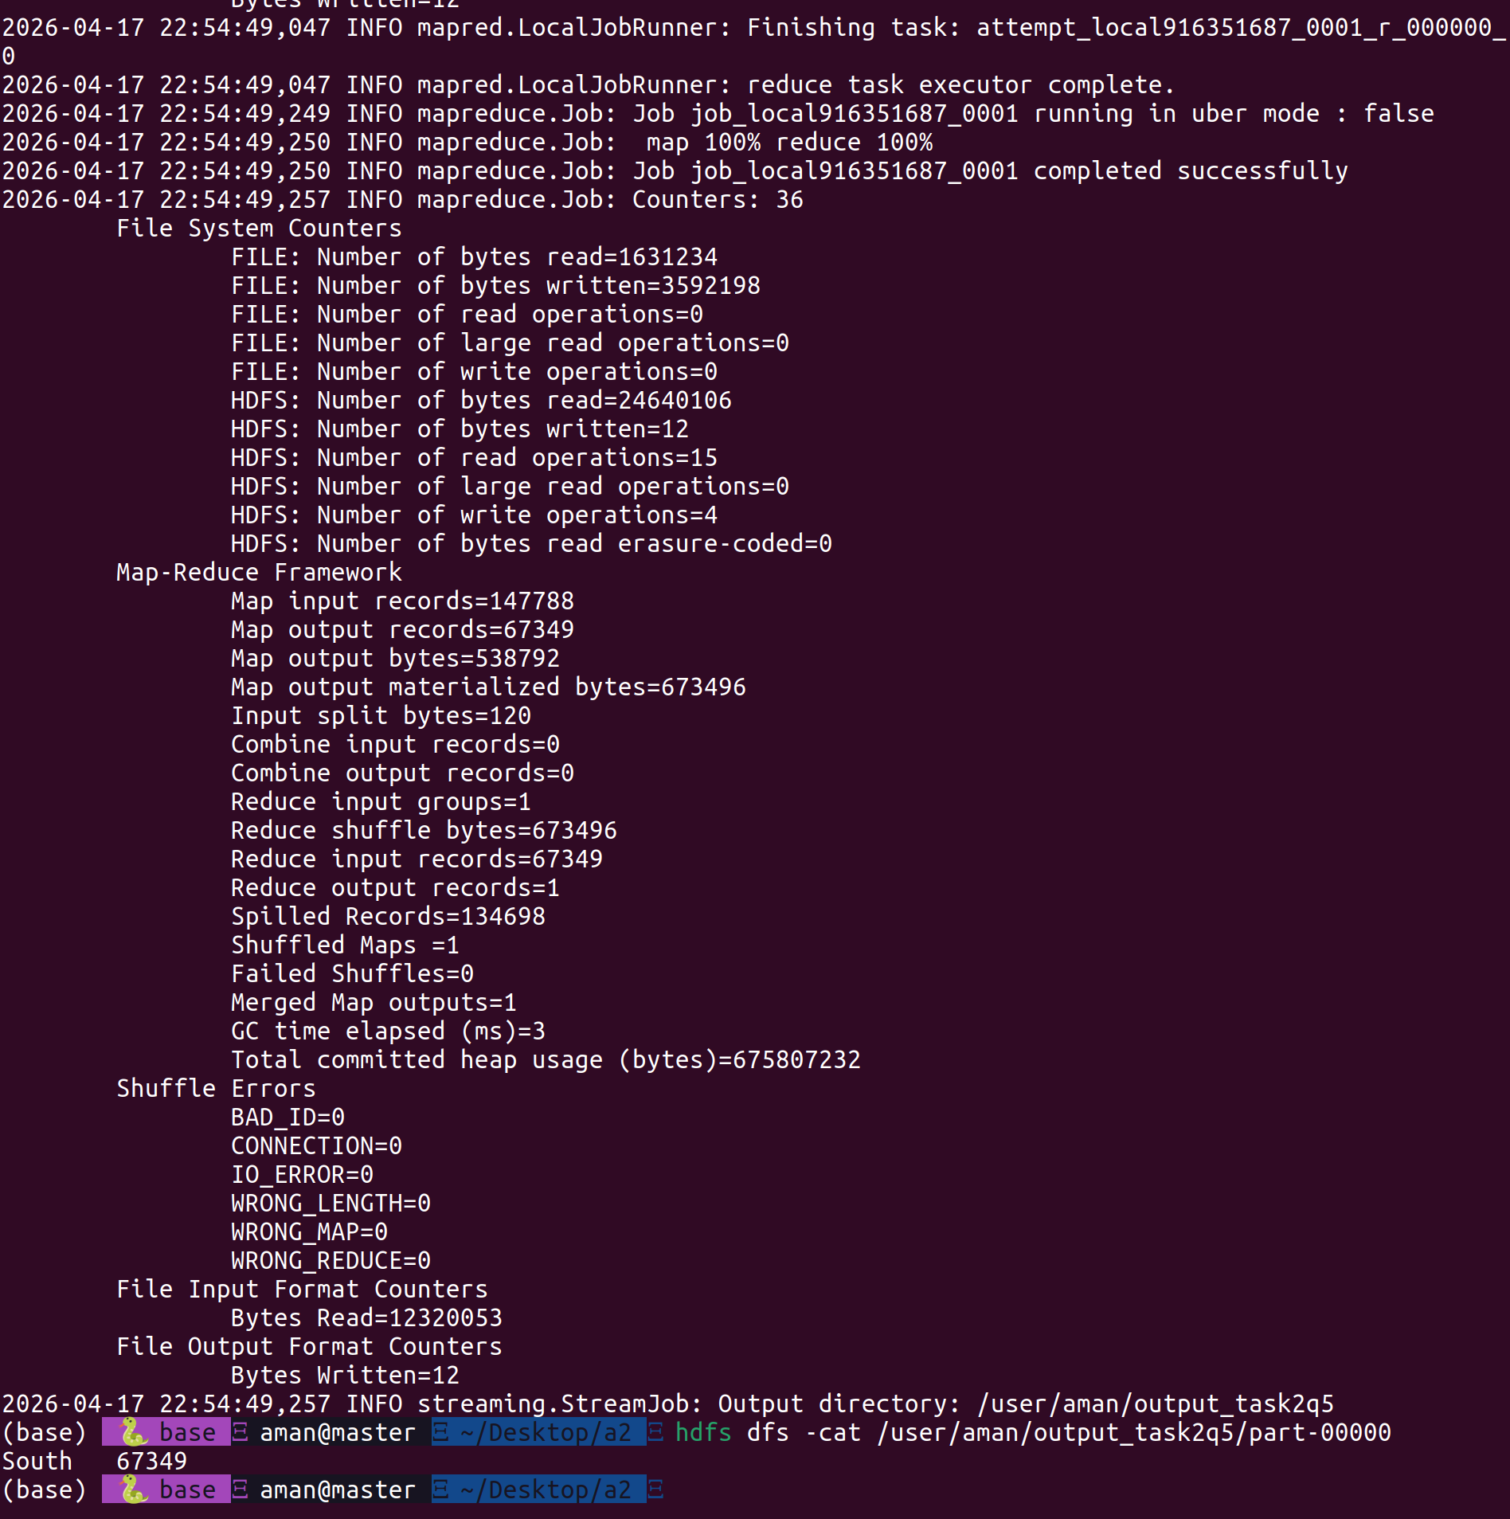

6. Temperature Histogram
- Key-Value Pair: (temperature_bin, 1)
- Mapper Logic: Uses floor division int(temp // 10) * 10 to group temperatures into 10-degree buckets (e.g., all temps from 10-19.9 becomes bin "10").
- Result: 29 distinct frequency bins.
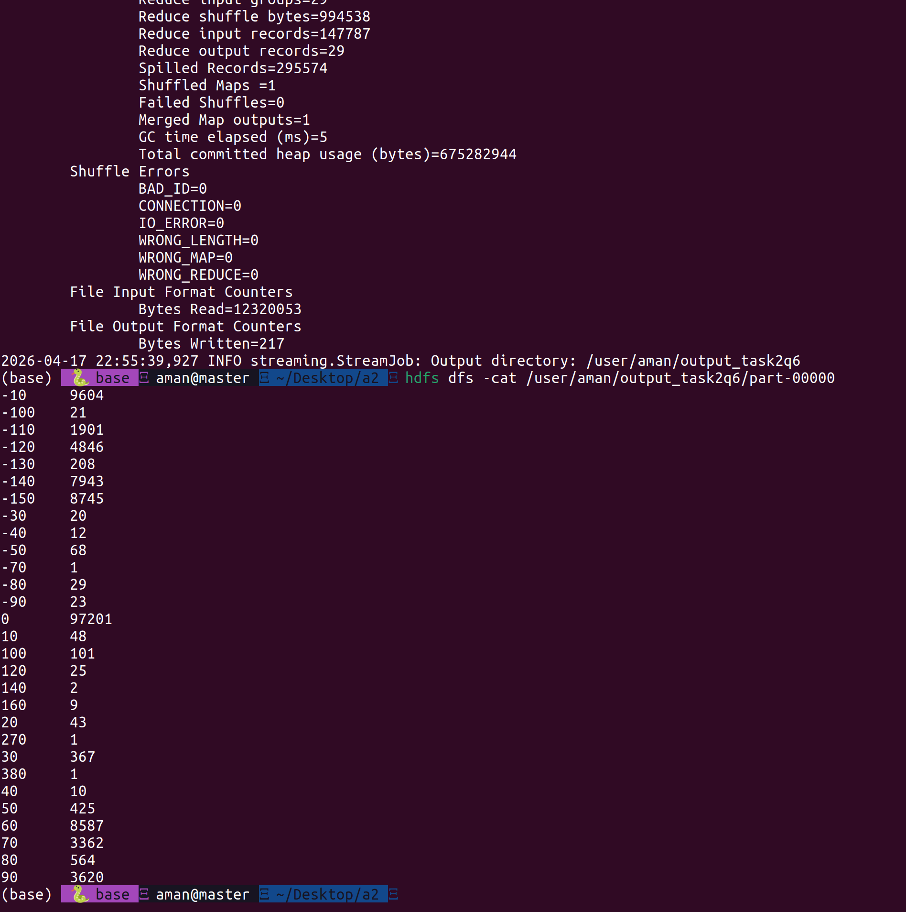

7. Correlation: Ozone Level vs. Sea Surface Temp
- Key-Value Pair: ("corr", "ozone_val,temp_val")
- Mapper Logic: Emits both sensor values as a comma-separated string under a single global key "corr".
- Reducer Logic: Implements the Pearson Correlation Coefficient formula by calculating $\sum x, \sum y, \sum x^2, \sum y^2,$ and $\sum xy$.
- Result: -0.0165 (Indicates no significant linear correlation).
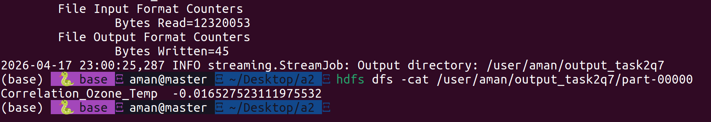

Conclusion
The MapReduce framework successfully processed the high-fidelity satellite dataset. While basic counts and averages provided a snapshot of the satellite's environment, the correlation analysis revealed that Ozone levels and Sea Surface Temperatures operate independently within this timeframe. The performance variations in Task 1 highlight the impact of HDFS block size on task parallelism.

