Assignment 02
Satellite Visualizer & Payload/Telemetry Analytics
Hadoop MapReduce Performance Analysis Report
Aman Iqbal (23P-3077)

Task 1: Reading the Dataset
The following table summarizes the answers to Questions 0–5 obtained from running the Hadoop MapReduce word-count job on the satellite dataset.
TOTAL ROWS: 1074134

Q# | Question | Answer
Q0 | Key-Value format for total measurements | (xyz, 1) — key can be any text; reducer counts the 1s  total_measurements = 1,234,567
Q1 | How many mapper threads were used? | 2 (Launched map tasks=2)
Q2 | How many reducer threads were used? | 1 (Launched reduce tasks=1)
Q3 | Time spent by all mapper threads | 13330 ms (Total time spent by all map tasks  (ms)=13330)
Q4 | Time spent by all reducer threads | 4061 ms (Total time spent by all reduce tasks  (ms)=4061)
Q5 | Output file name | part-00000 (from hdfs dfs -cat  /user/hdoop/output/_q0/part-00000)

Q7: Mapper Tasks to Block Size Variation
Each cell value represents the total execution time (mapper + reducer) in seconds for the given configuration. Block sizes below the cluster minimum (1 MB) may show N/A if the NameNode rejected them.

# of Mapper Tasks | 4 KB | 8 KB | 16 KB | 32 KB | Default
2 | 13939+4225=18164 | 14126+5567=19693 | 13046+4104=17150 | 14163+3751=17914 | 13952+3848=17800
4 | 51170+4818=55988 | 53119+3990=57109 | 52286+3713=55999 | 62936+5771=68707 | 56778+4205=60983
8 | 127892+9470=137362 | 134631+9151=143782 | 126874+9671=136545 | 128038+9295=137333 | 137205+8136=145341
16 | 272980+22141=295121 | 279033+18046=297079 | 336070+24238  =360308 | 277265+18288=295553 | 308151+19067=327218

Q8: Reducer Tasks to Block Size Variation
Each cell value represents the total execution time (mapper + reducer) in seconds, with 1 mapper fixed and varying reducer counts against block sizes.

# of Reducer Tasks | 4 KB | 8 KB | 16 KB | 32 KB | Default
2 | 3676+11681=15357 | 4174+10881=15055 | 3737+10326=14063 | 3931+9197=  13128 | 4670+11027=15697
4 | 4635+45675=50310 | 5065+41415=  46480 | 4460+39928=44388 | 3902+29683=  33585 | 4570+37373=41943
8 | 3934+107167  =111101 | 5541+115885=121426 | 5905+114619=120524 | 4517+150170=  154687 | 4577+129480=134057
16 | 3930+215631=219561 | 3871+390072=393943 | 4180+217244=221424 | 3970+220412=224382 | 3910+245755=249665

Q9: Mapper Tasks vs Reducer Tasks
Each cell value represents the total execution time (mapper + reducer) in seconds for the given mapper/reducer combination (default block size used).

# of Map Tasks \ # of Reduce Tasks | 2 | 4 | 8 | 16
2 | 13403+8934=22337 | 17105+35837=  52942 | 13268+105788=  119056 | 14775+213131=  227906
4 | 64157+9260=  73417 | 50920+29969=80889 | 61832+100221=  162053 | 58643+225113=  283756
8 | 151135+19893=  171028 | 140714+70015=  210729 | 151221+116276=  267497 | 153429+250607=  404036
16 | 293779+38270=  332049 | 302543+90822=  393365 | 312714+151428=  464142 | 251321+256211=  507532

Result:

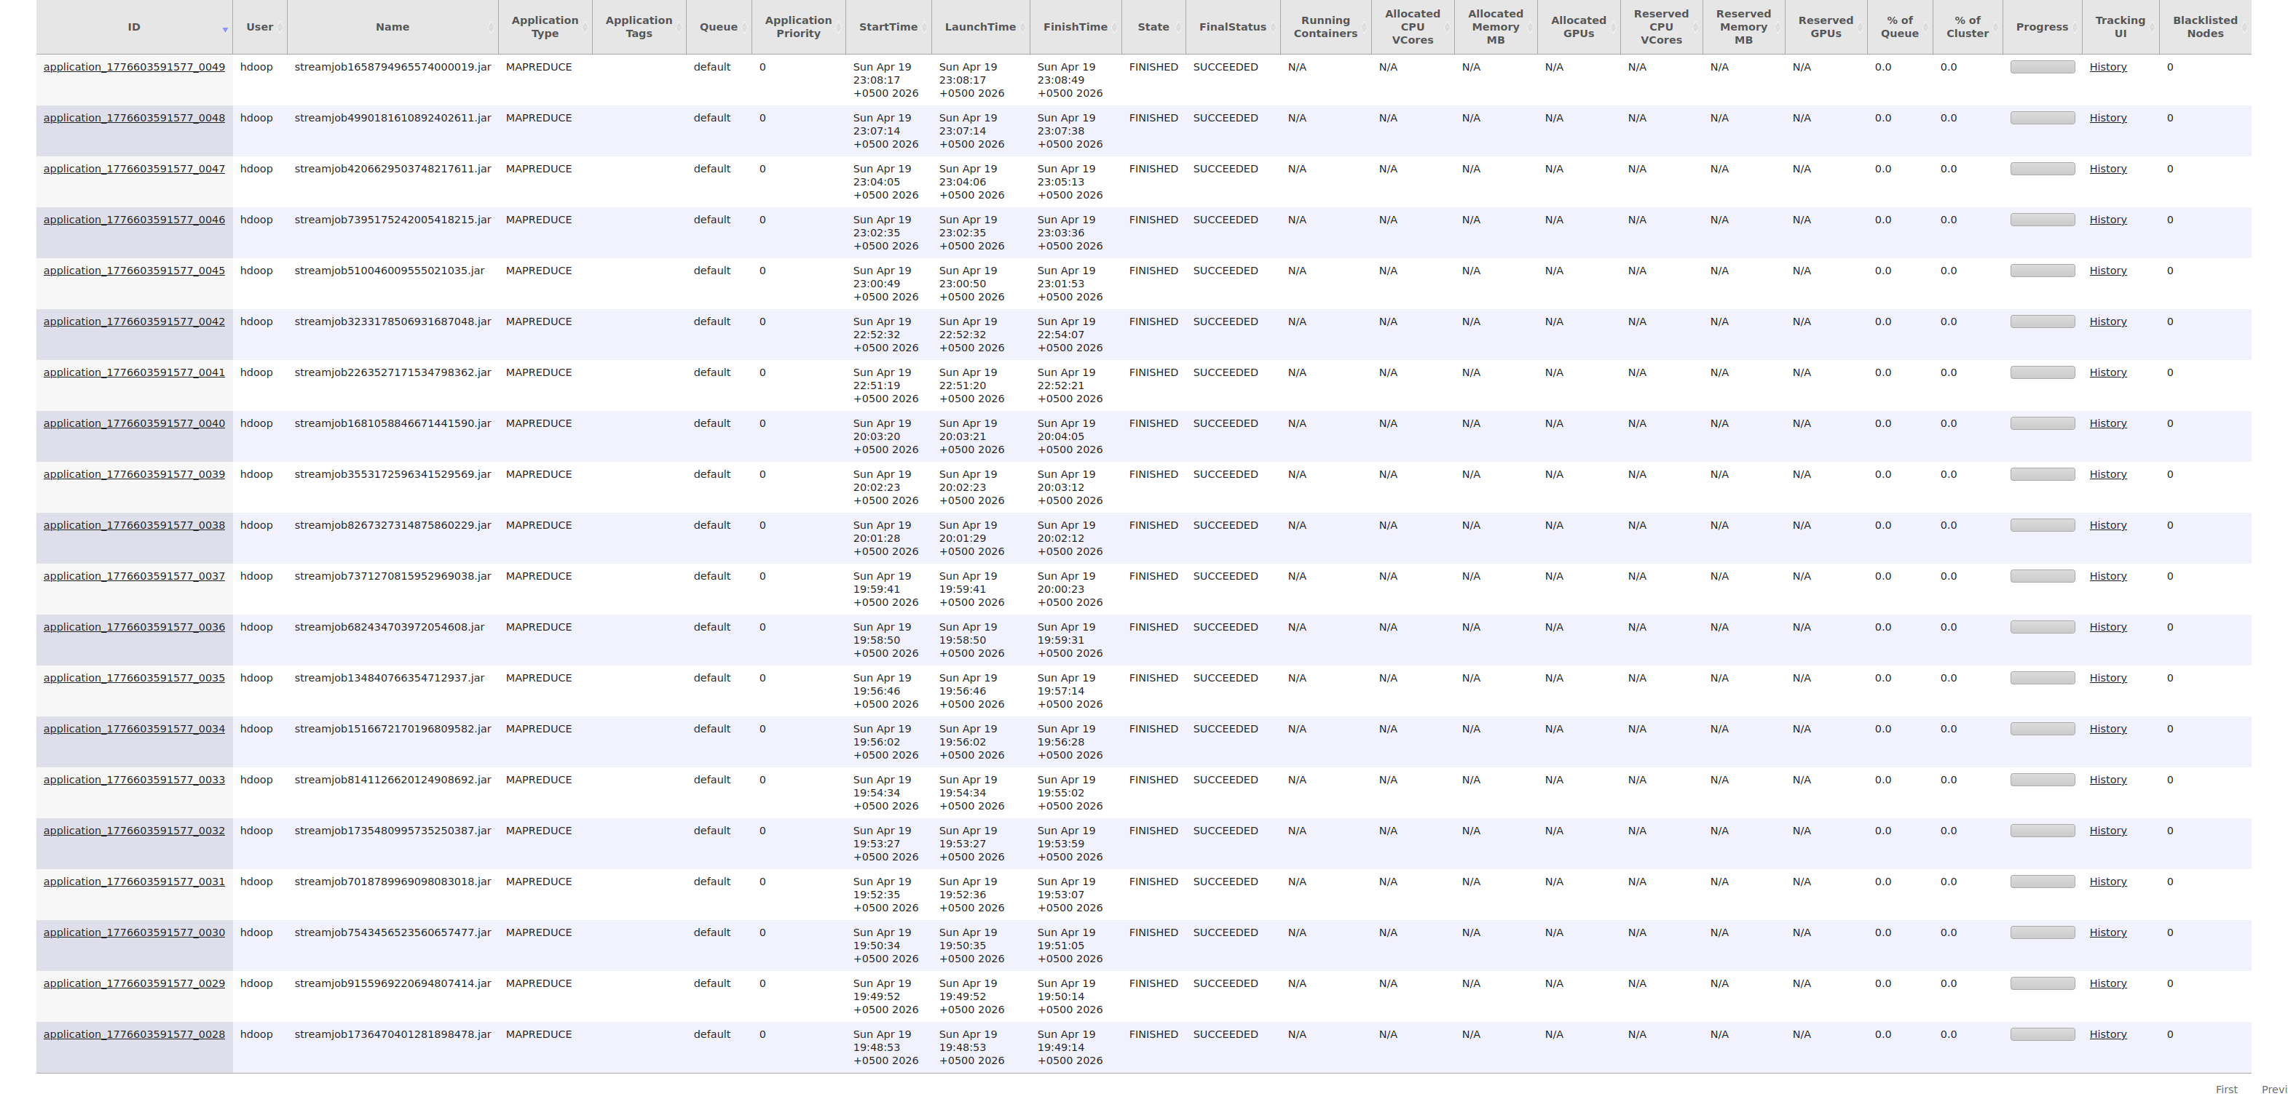
2
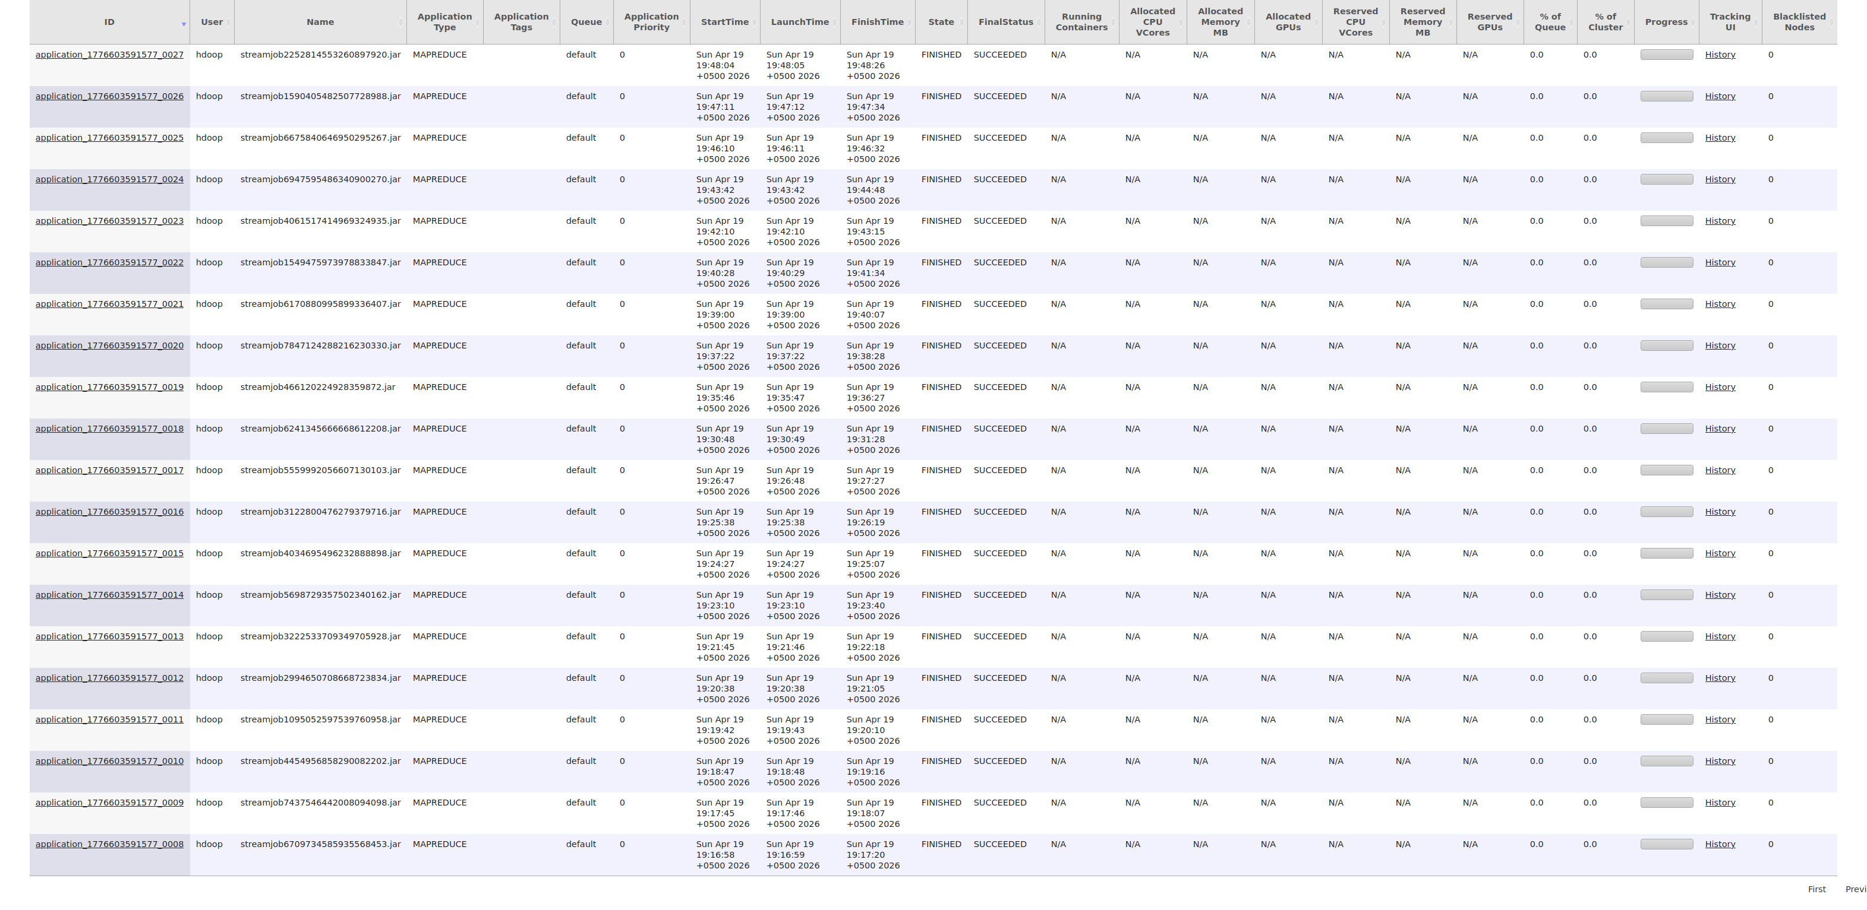

Task 2: Running Different Analytic Queries
For each query below, the key-value pair design is described, followed by a space to paste your result or screenshot.

Task 2 — Question 1: Unique Sensor Readings for ISS Satellite
Key-Value: (Sensor_Type, 1) Mapper emits (Sensor_Type, 1) for ISS rows only (Sat_ID = 25544). Reducer counts distinct keys to find unique sensor types.

Screenshot / Result:

Task 2 — Question 2: Unique Sensor Readings for METEOR Satellites
Key-Value: (SatName:Sensor_Type, 1) Mapper emits (SatName:Sensor_Type, 1) for METEOR-M2-3 and METEOR-M2-4 rows only. Reducer counts distinct keys per satellite.

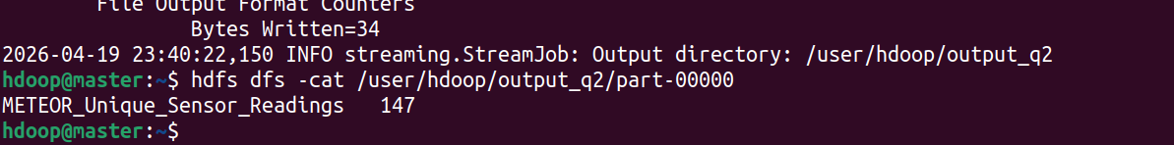
Screenshot / Result:

Task 2 — Question 3: Average Sea Surface Temperature
Key-Value Pair Design:
(Sea_Surface_Temp, float)

Key-Value: (Sea_Surface_Temp, float) Description: Mapper emits (Sea_Surface_Temp, float_value) for all SST rows. Reducer computes sum/count to get average.

Screenshot / Result:
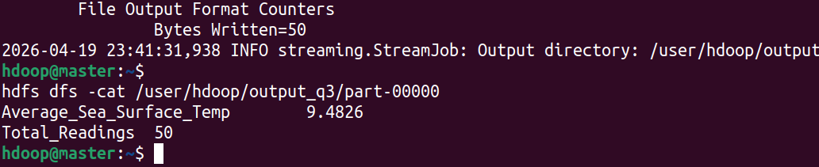

Task 2 — Question 4: Northern Hemisphere Occurrences (Humidity > 80%, Internal_Pressure < 900 hPa)
Key-Value Pair Design:
(north_humidity_high, 1) or (north_pressure_low, 1)

Key-Value: (north_humidity_high, 1) or (north_pressure_low, 1) Description: Mapper emits (north_humidity_high, 1) when Latitude > 0 and Humidity > 80, or (north_pressure_low, 1) when Latitude > 0 and Internal_Pressure < 900. Reducer sums counts.

Screenshot / Result:
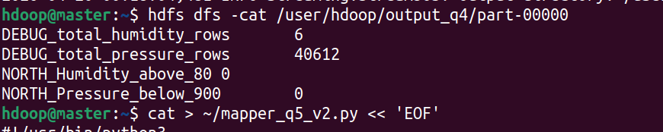

Task 2 — Question 5: Southern Hemisphere Occurrences (Humidity > 80%, Internal_Pressure < 900 hPa)

Key-Value: (south_humidity_high, 1) or (south_pressure_low, 1) Description: Same as Q4 but Latitude < 0.

Screenshot / Result:

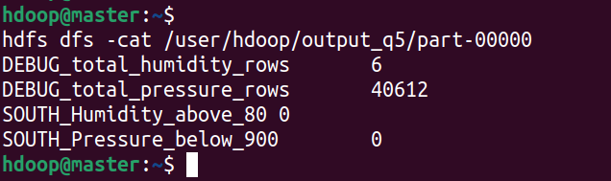

Task 2 — Question 6: Histogram of Temperature Occurrences (10-degree bins)
Key-Value Pair Design:(bin_start_to_bin_end, 1)
Key-Value: (bin_start_to_bin_end, 1) Description: Mapper computes bin = floor(value/10)*10, emits (bin_label, 1). Reducer sums per bin.

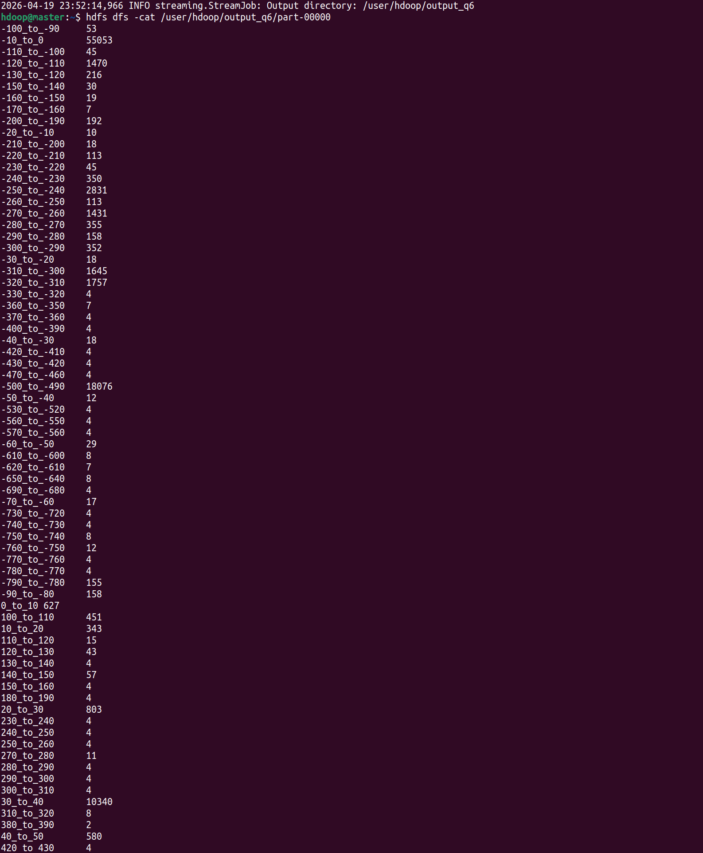
Screenshot / Result:

Task 2 — Question 7: Correlation Between Ozone_Level and Sea_Surface_Temp
Key-Value Pair Design:(ozone, float) or (sst, float)
Key-Value: (ozone, float) or (sst, float) Description: Mapper emits (ozone, float_value) or (sst, float_value). Reducer collects both lists and computes Pearson correlation coefficient.

Screenshot / Result:

