Spark Practice Report

Assignment :3
Submitted by: Aman Iqbal
Roll No : 23P-3077
Subject : Big Data Analytics

TASK 0:
Spark Setup
This section involves setting up Spark 3.5.1 with bundled Hadoop on a single node
and integrating it with Jupyter Notebook. The setup was performed under the
hdoop user, with environment variables configured in .bashrc

Screenshots:

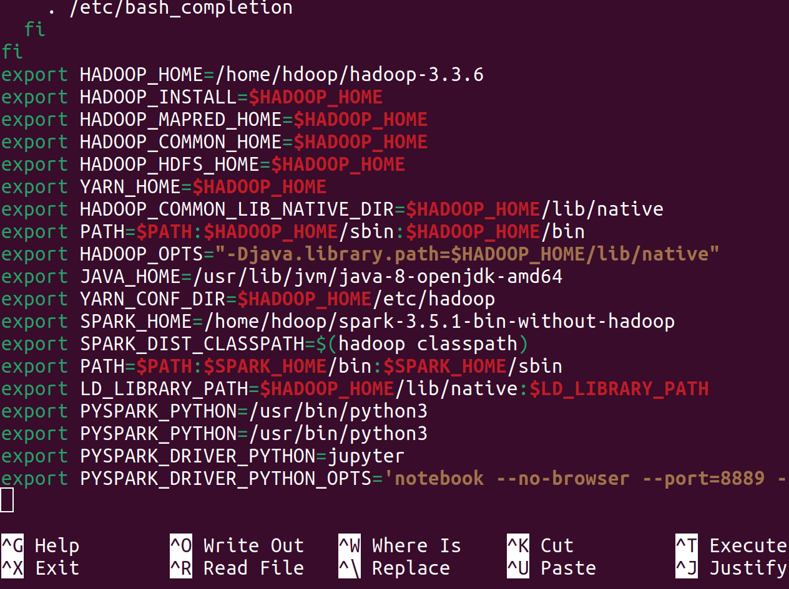
.
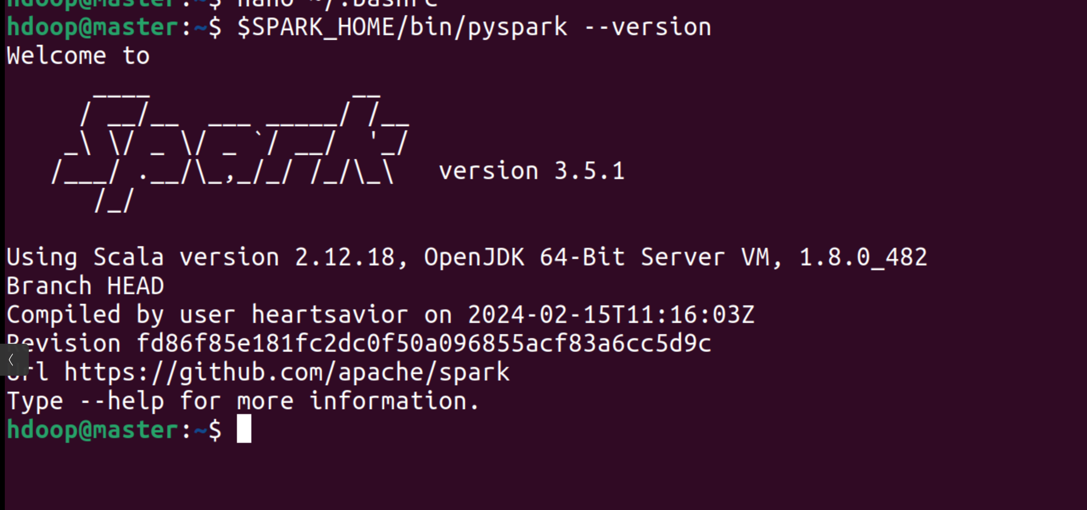
.
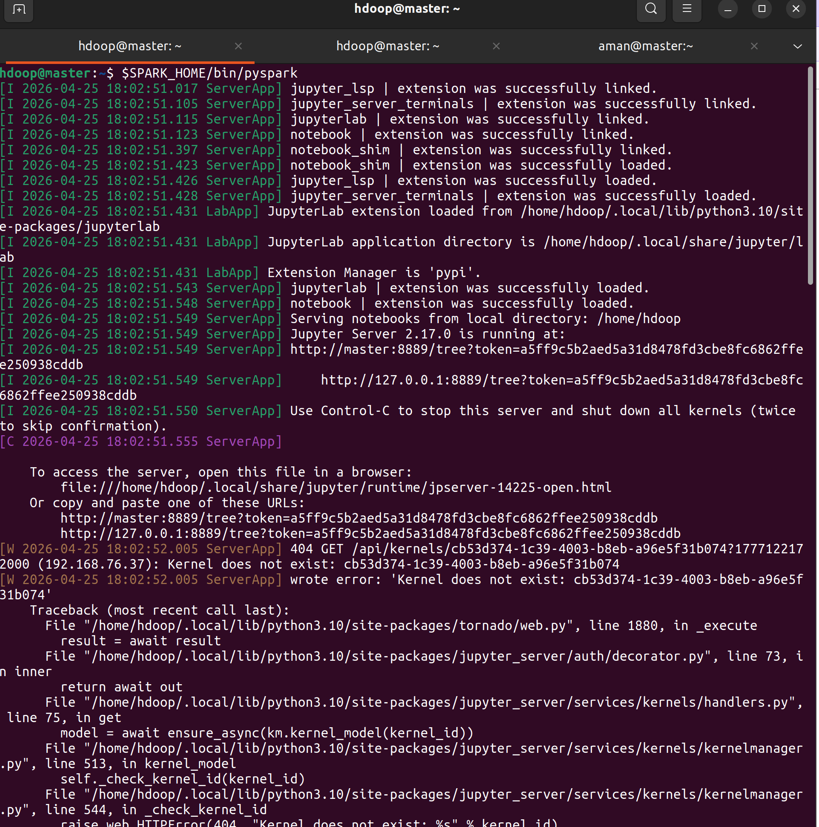
.
.
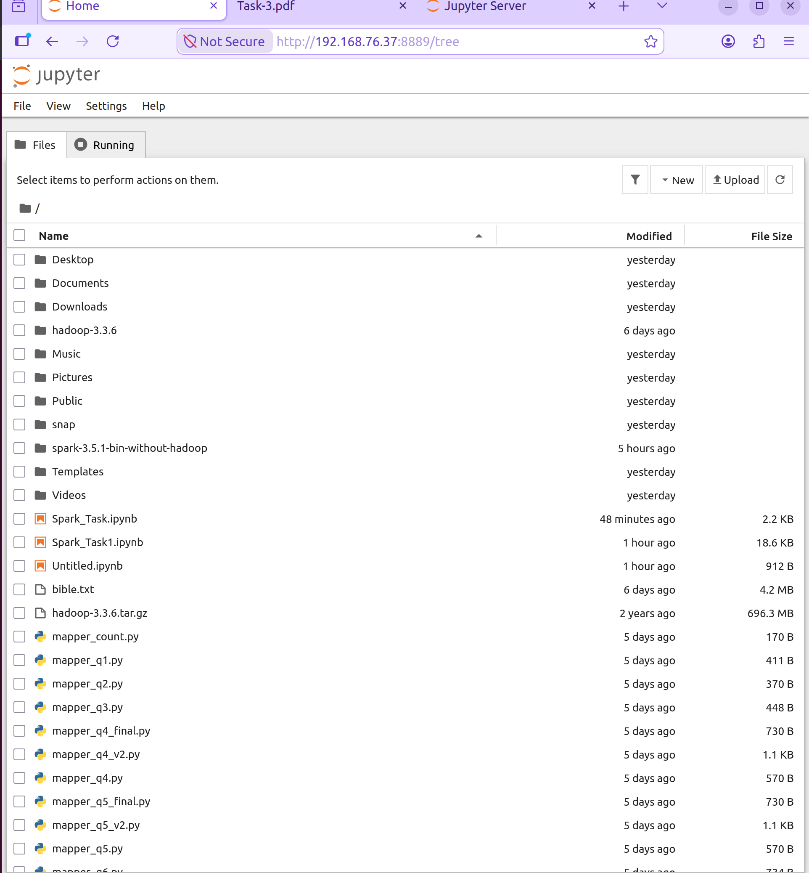

TASK 1:

This task creates and manipulates RDDs using PySpark, performing operations like
partitioning, filtering, and union. The code was executed in a Jupyter notebook
(FINAL.ipynb)

Question
1) What is the URL of Spark UI installed on your machine?
Answer
http://192.168.76.37:4040/jobs/
or
http://localhost:4040/jobs/
or
http://master:4040/jobs/

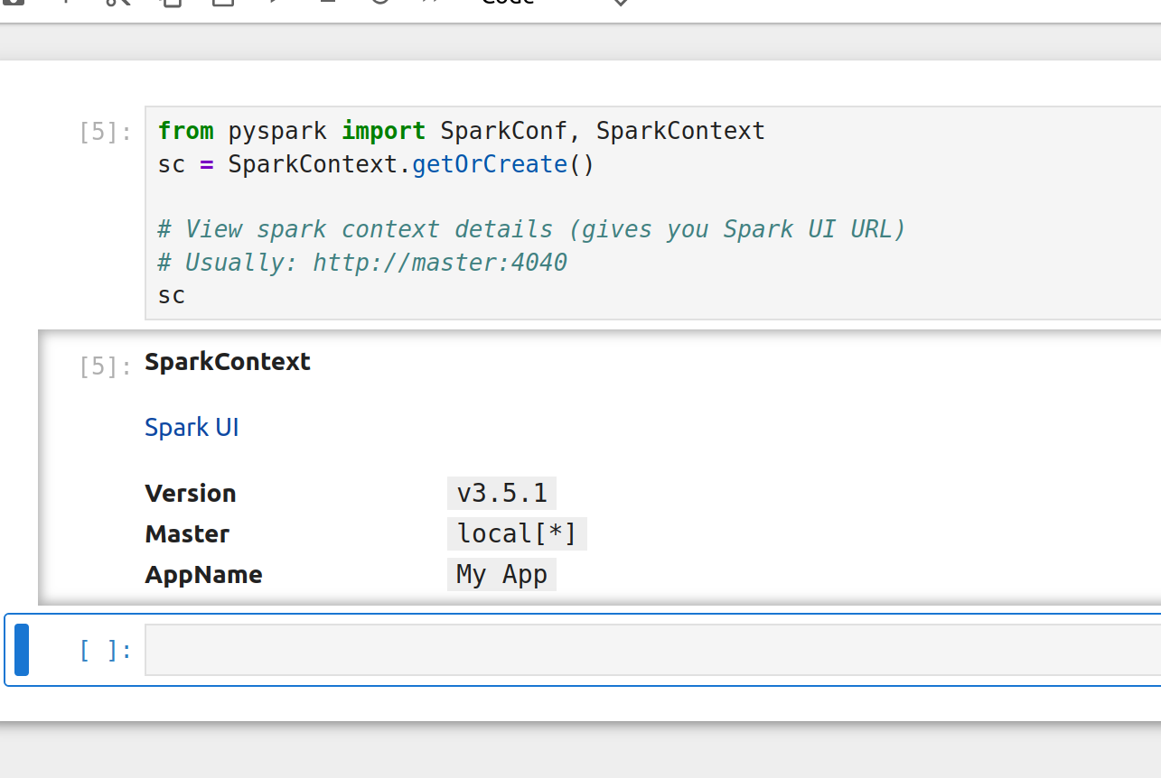

After this, click Spark UI in the output

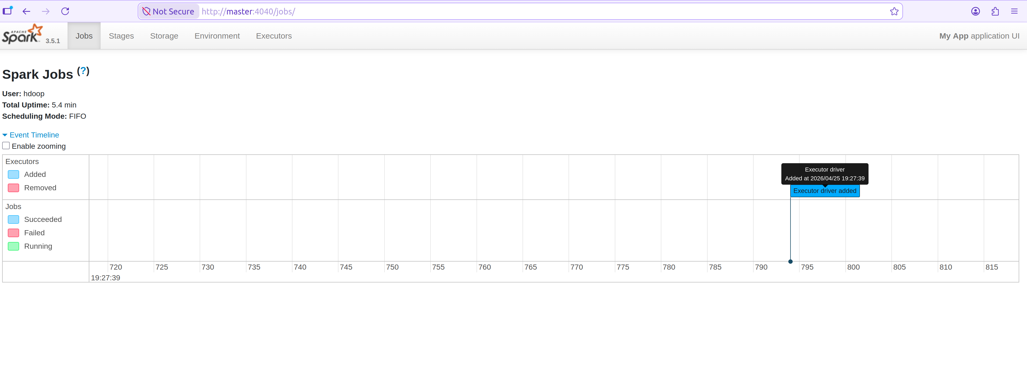

Question
2) What is the class type xRDD object and find the URL of the API documen-
tation to this class type?
Answer
Class type: pyspark.rdd.RDD
URL: https://spark.apache.org/docs/latest/api/python/reference/api/pyspark.RDD.html
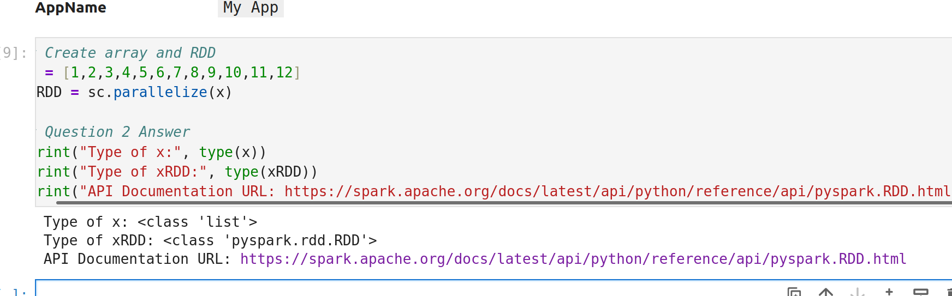

.

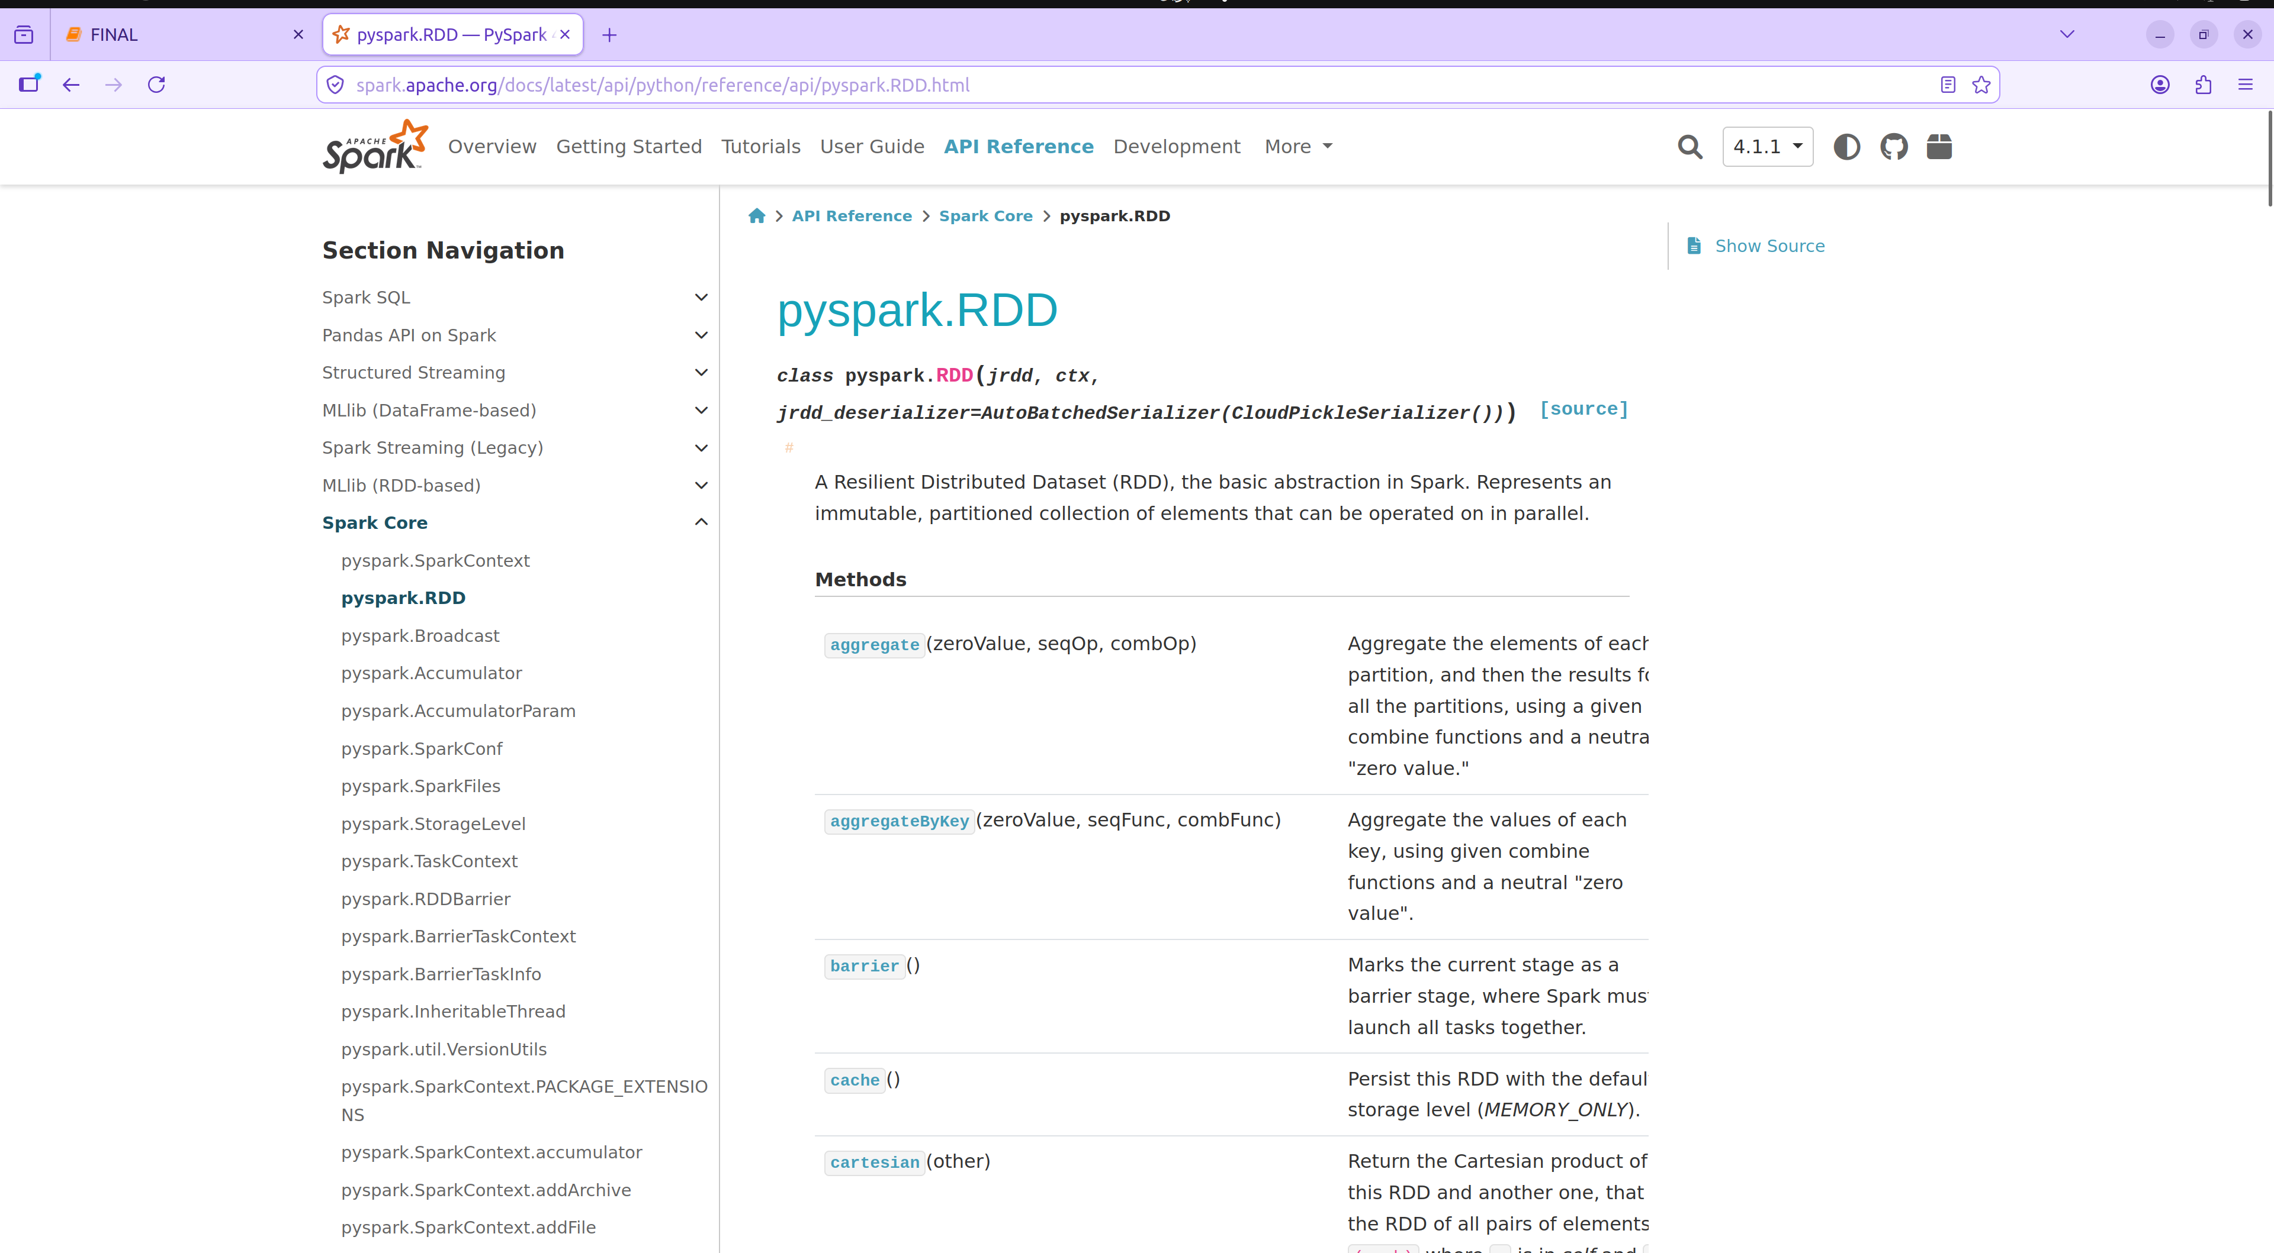

Question
3) From the URL you have found, find what the function glom() does.

The glom() function Returns an RDD created by coalescing all elements
within each partition into a list.
From the PySpark RDD API documentation, glom() transforms each parti-
tion into a list containing all elements of that partition. For example, if an
RDD has two partitions with elements [1, 2] and [3, 4], glom().collect() returns
[[1, 2], [3, 4]

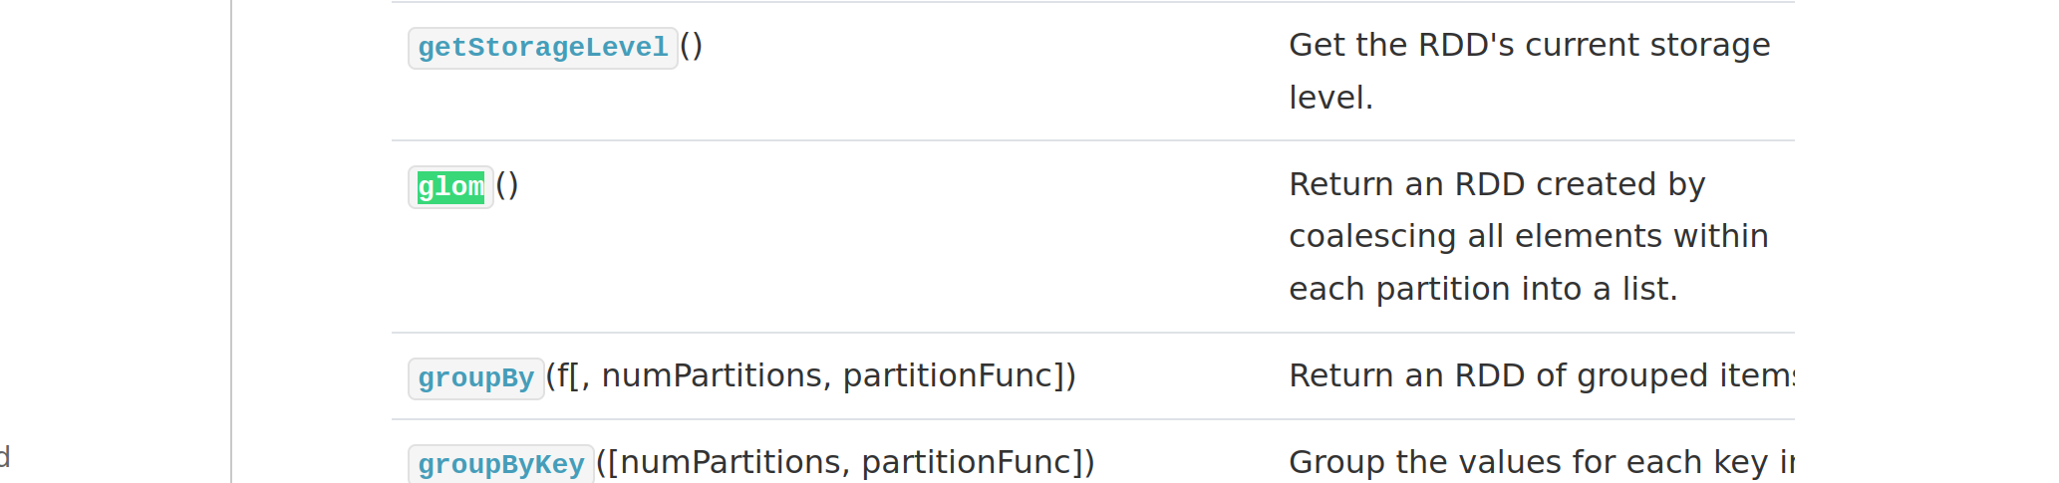

Question
4) What is the difference in output of print(xRDD),
print(xRDD.collect()), and print(xRDD.glom().collect())?
Answer
• print(xRDD)
– Displays RDD metadata (e.g., ParallelCollectionRDD[0]...)
– Does not show actual data in the RDD
• print(xRDD.collect())
– Collects all elements from the RDD to the driver
– Displays the data as a flat list (e.g., [1, 2, 3, ..., 12])
• print(xRDD.glom().collect())
– Collects elements grouped by partitions
– Displays a list of lists, where each sublist represents one partition
(e.g., [[1],[2, 3] [4],[5, 6], ...])

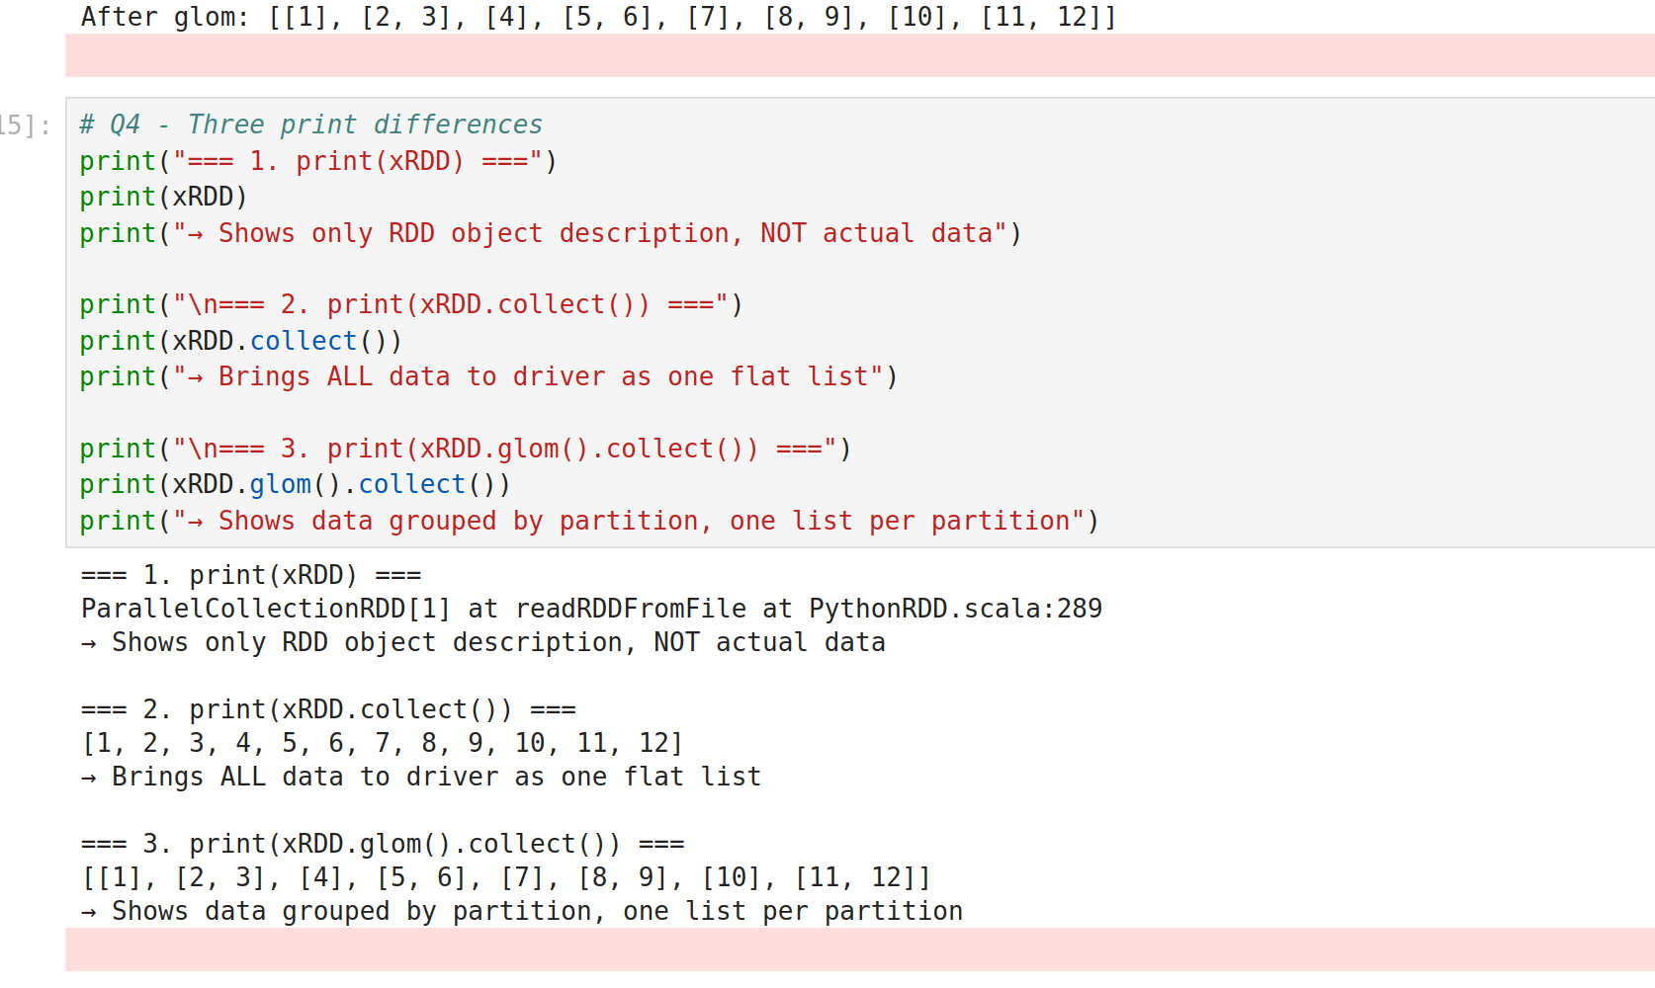

Question
5) Parallelize an array of size 50. What is the default number of partitions
used for this array? Think about what this default number represents.

The default number of partitions for the array of size 50 is 8, as shown by the
output of print(yRDD.getNumPartitions()).
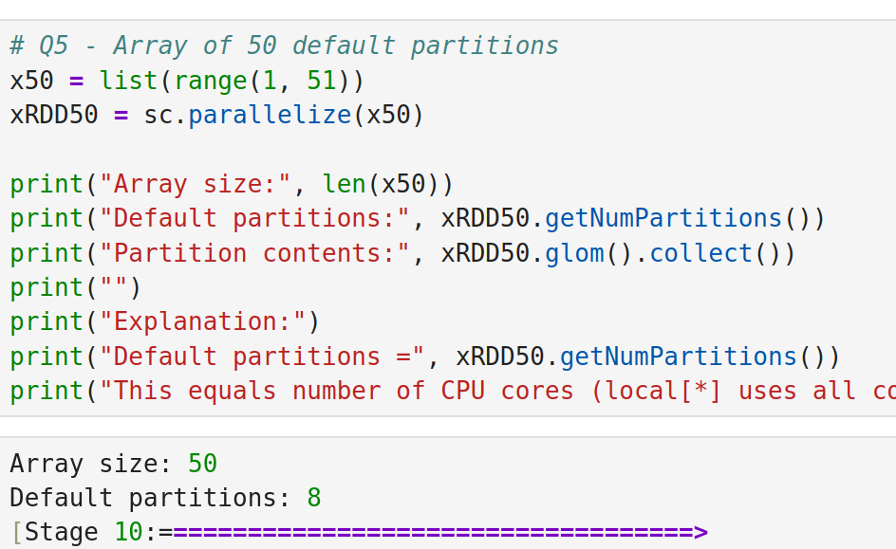

This number represents the degree of parallelism, which is typically set to
the number of CPU cores available on the machine by default in Spark’s local
mode. In this case, it suggests my machine has 8 cores, allowing Spark to
distribute the workload across 8 threads for parallel processing

Question
6) For the array size of 50, repartition it to 7 partitions. Check the composition
of the partitions and report the workload on each thread.
Ans:
Workload: The total number of elements is 50, distributed across 7 partitions.
The workload per thread varies due to Spark’s partitioning algorithm:
• Partition 0: 6 elements, [19, 20, 21, 22, 23, 24]
• Partition 1: 0 elements, []
• Partition 2: 26 elements, [13, 14, 15, 16, 17, 18, 25, 26, 27, 28, 29, 30,
31, 32, 33, 34, 35, 36, 43, 44, 45, 46, 47, 48, 49, 50]
• Partition 3: 6 elements, [1, 2, 3, 4, 5, 6]
• Partition 4: 6 elements, [37, 38, 39, 40, 41, 42]
• Partition 5: 0 elements, []
• Partition 6: 6 elements, [7, 8, 9, 10, 11, 12]
The average workload is approximately 7.14 elements per partition (50 ÷ 7),
but the uneven distribution reflects Spark’s default hash partitioning, which
may not balance perfectly for small datasets

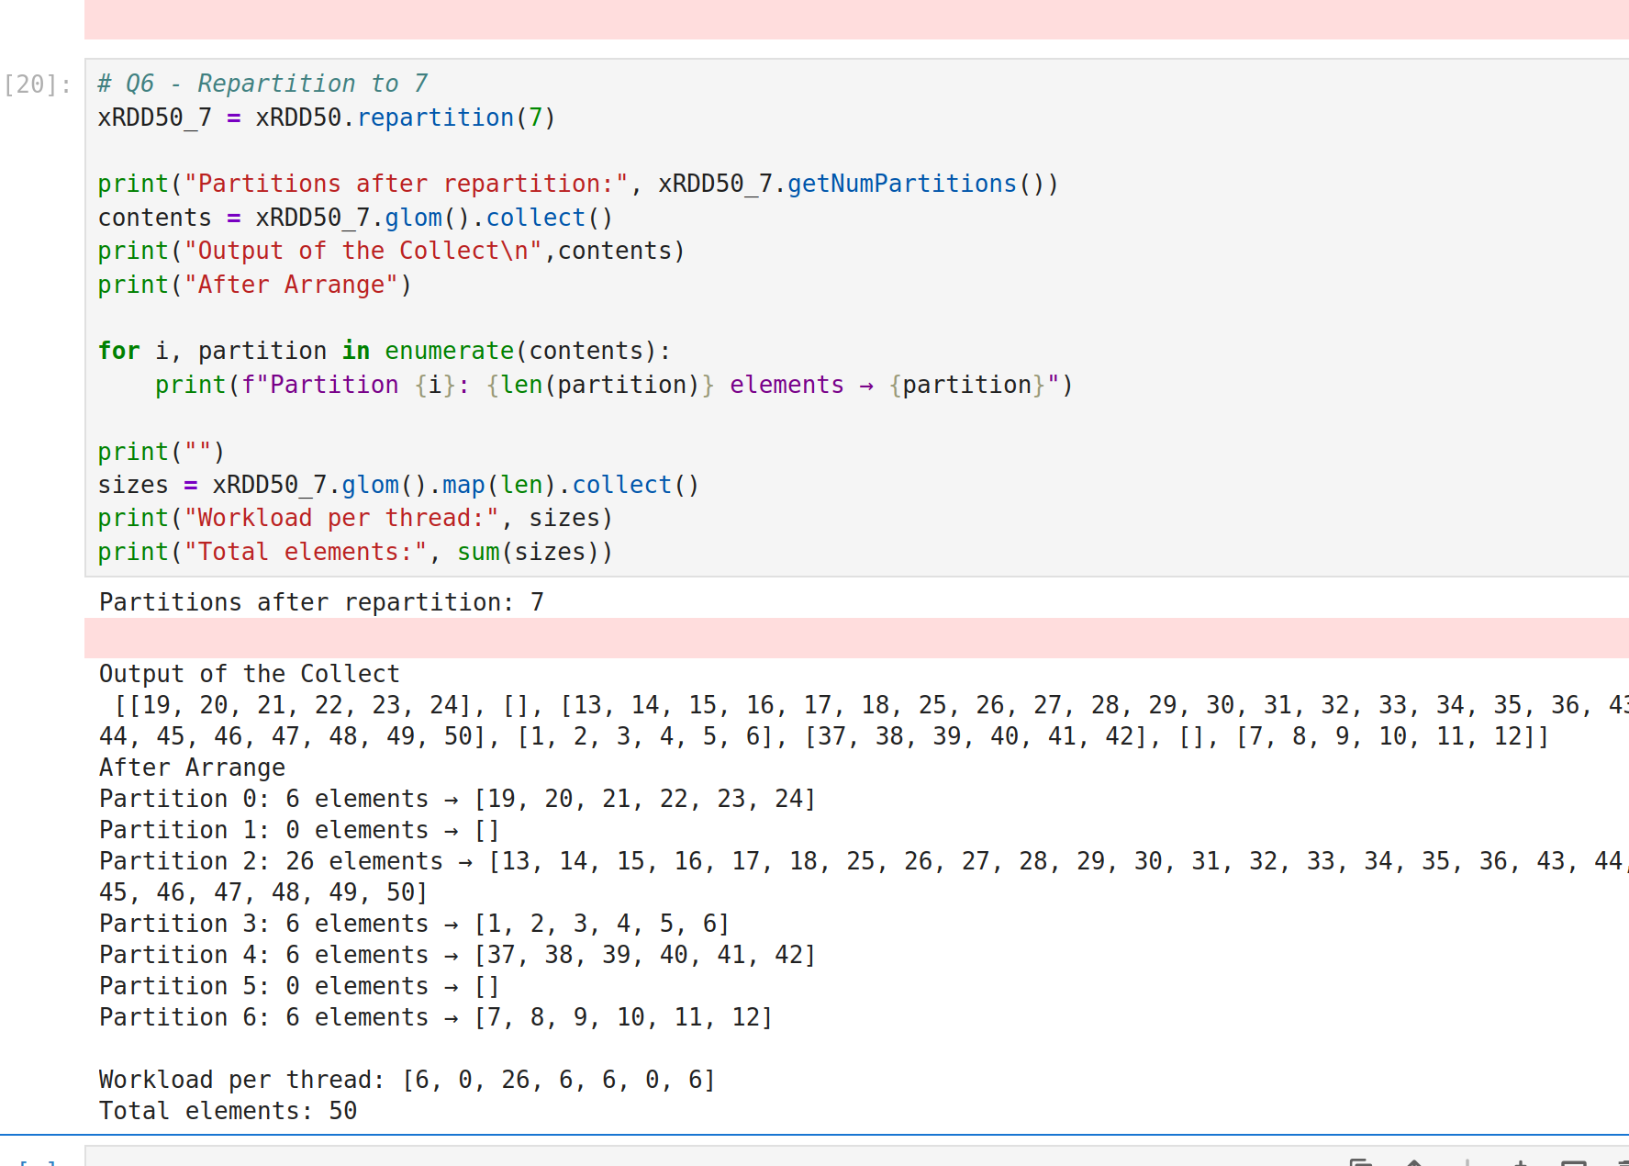

Question
7) Comment on the execution order of partitions.

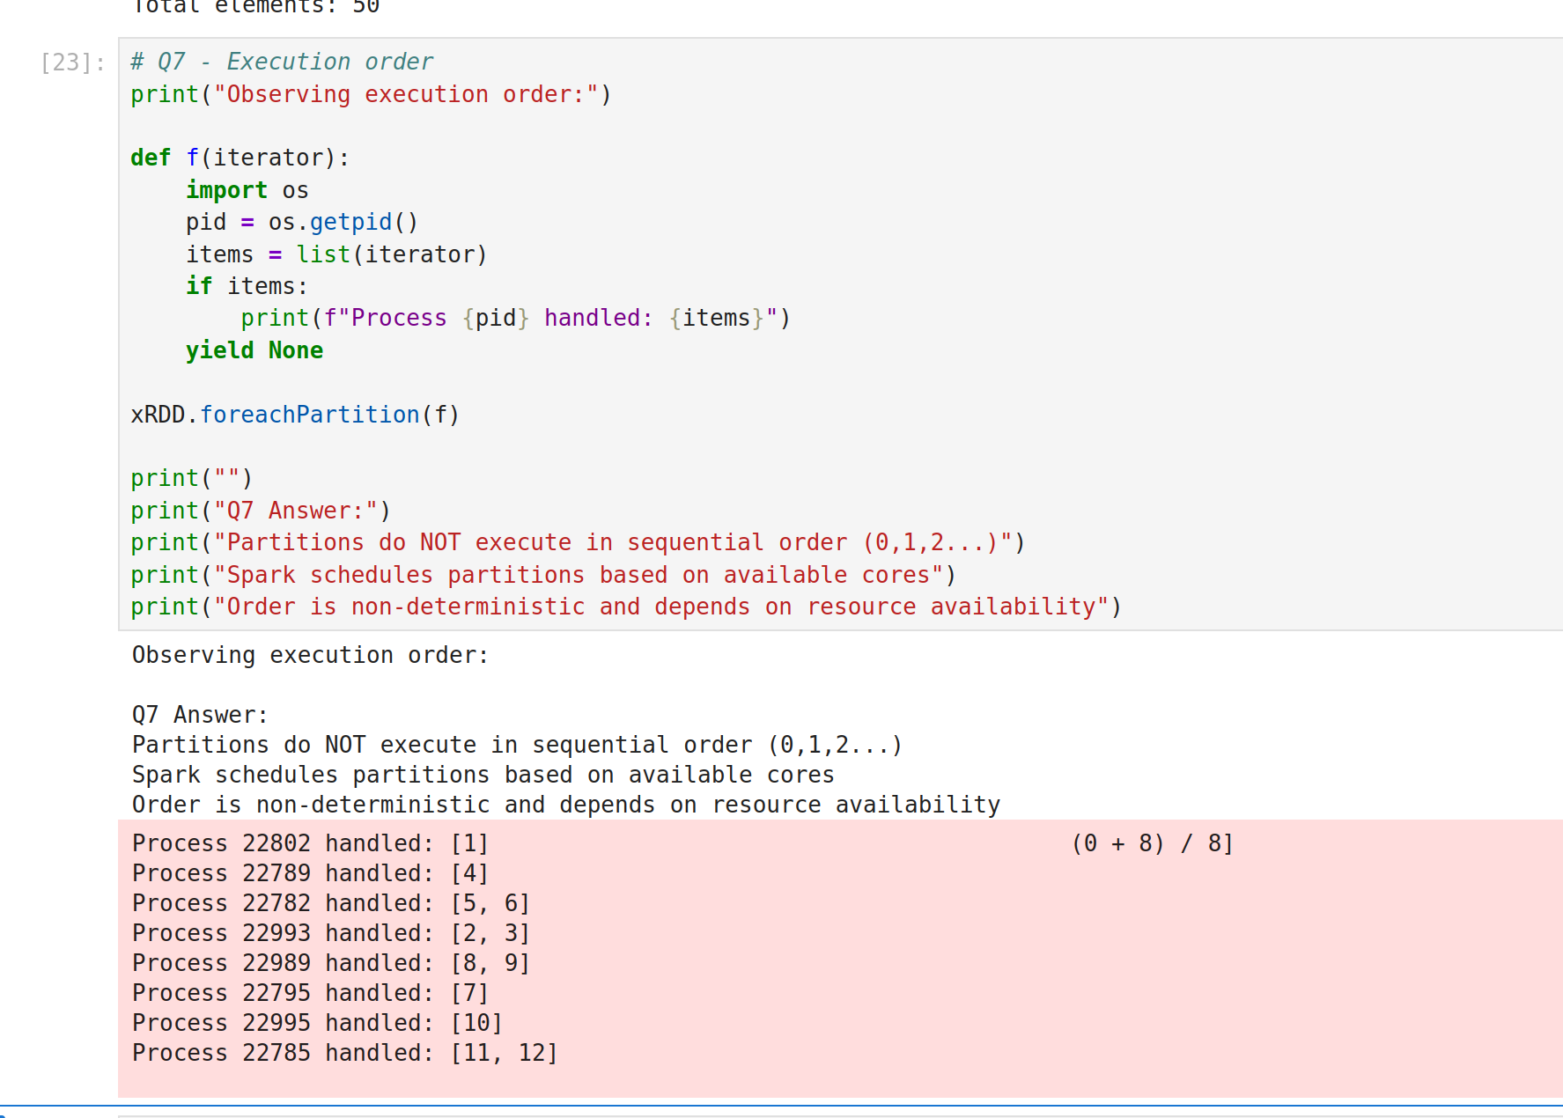
The output of xRDD.foreachPartition(f)
which shows elements printed partition by partition. Spark processes parti-
tions in parallel, but the order of partition execution is non-deterministic and
depends on the scheduler and available resources. You may see partitions
processed in any order (e.g., partition 2 before partition 1).

Question
8) Open the Spark UI and report the Job ID, Job description, and duration (in
seconds) of the most time-consuming job carried out so far.

ANSWER:
The most time-consuming job is:
Job ID: 11
Description: collect at /tmp/ipykernel_18257/252533.py:7
Duration: 3 second
This job corresponds to the print(xRDD.glom().collect())

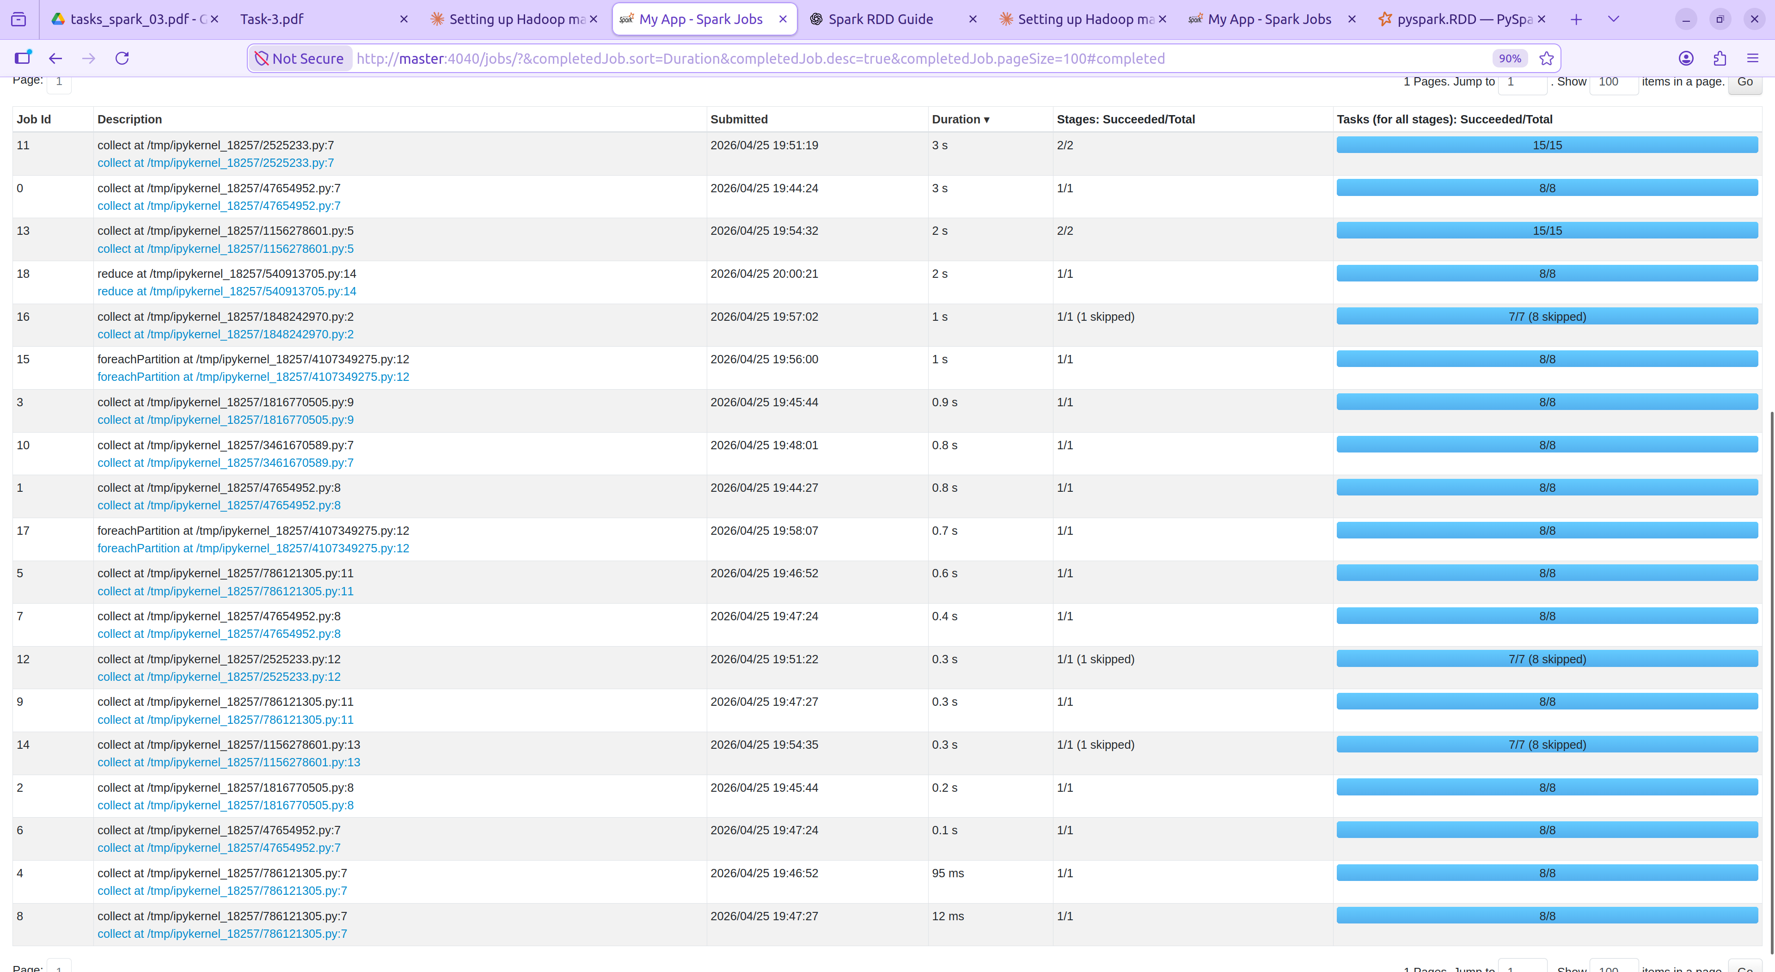

Question
9) From the Spark UI, present the Directed Acyclic Graph visualization for
your foreachPartition() code.
Answer
DAG: Single stage (ParallelCollectionRDD → foreachPartition).
Processes each partition independently

The DAG consists of a single stage where each partition is processed independently using foreachPartition. No shuffle occurs, so all tasks run in parallel within Stage 0.
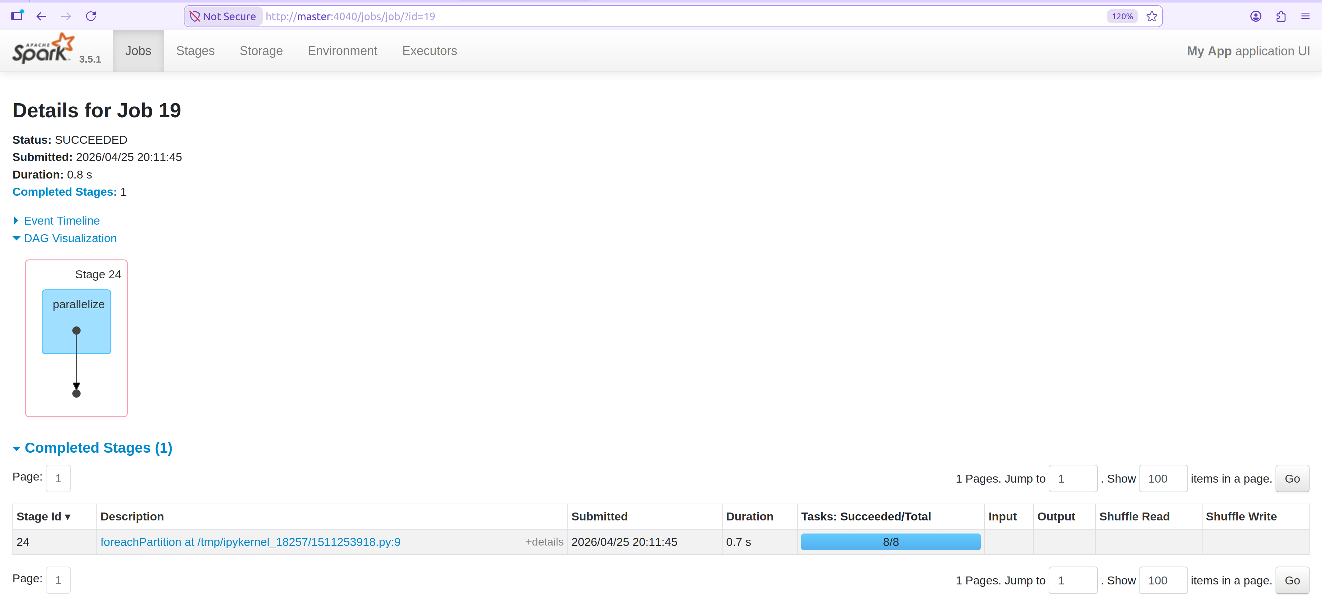

10) Explain what a stage is and how it is numbered.
Answer
A stage in Spark is a set of tasks that can be executed in parallel without
requiring a shuffle (data exchange across nodes). Numbered sequentially
from 0 per job based on their execution order, incrementing globally

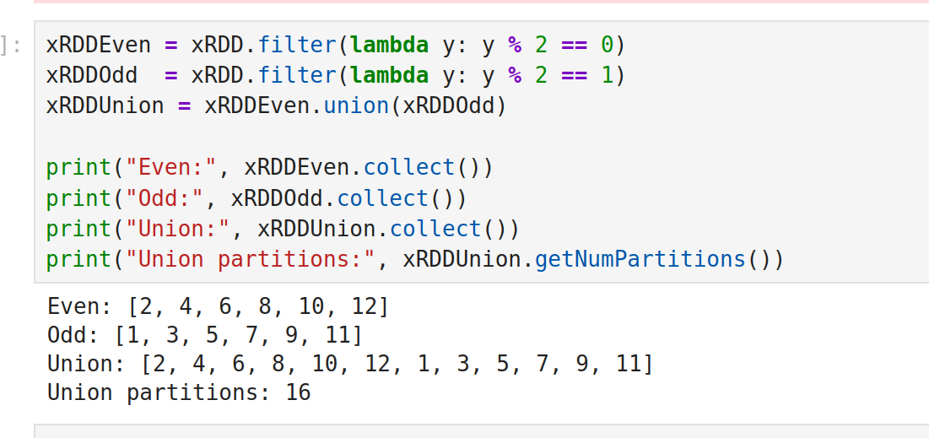
Question
11) From the Spark UI, report the Directed Acyclic Graph visualization for the
Union() code. Report which partition is executed on which machine.
Answer

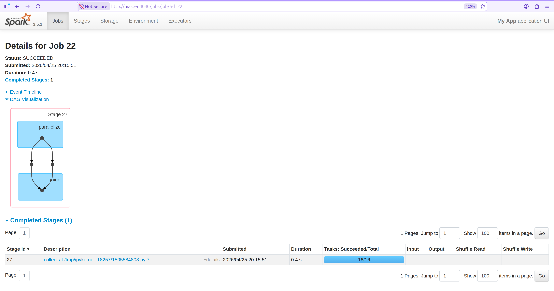
After adding a collect() action to trigger the job, the Directed Acyclic
Graph (DAG) visualization for the union() code was generated in the Spark
UI. The DAG consists of two stages:
• Stage 1: Two parallel filter operations to create xRDDEven and
xRDDOdd from the input RDD.
• Stage 2: A union operation to combine the filtered RDDs, followed by
a collect() action to return the result to the driver.

