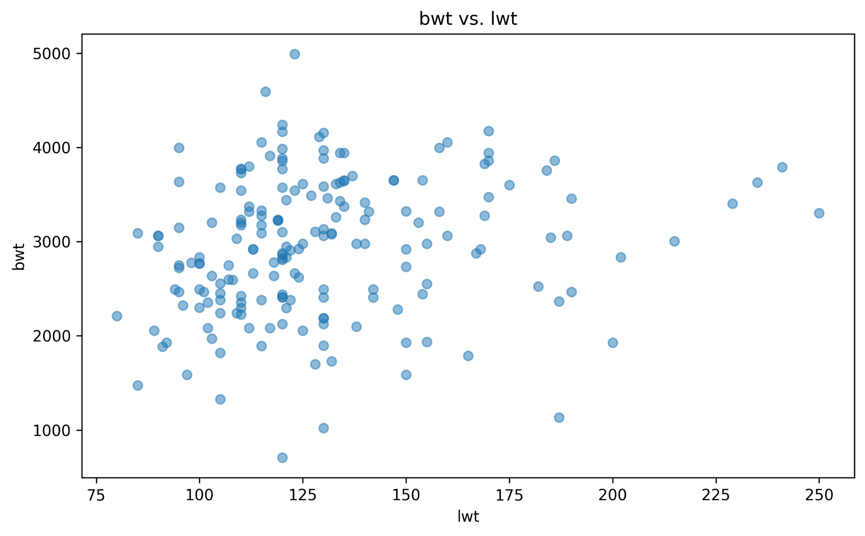

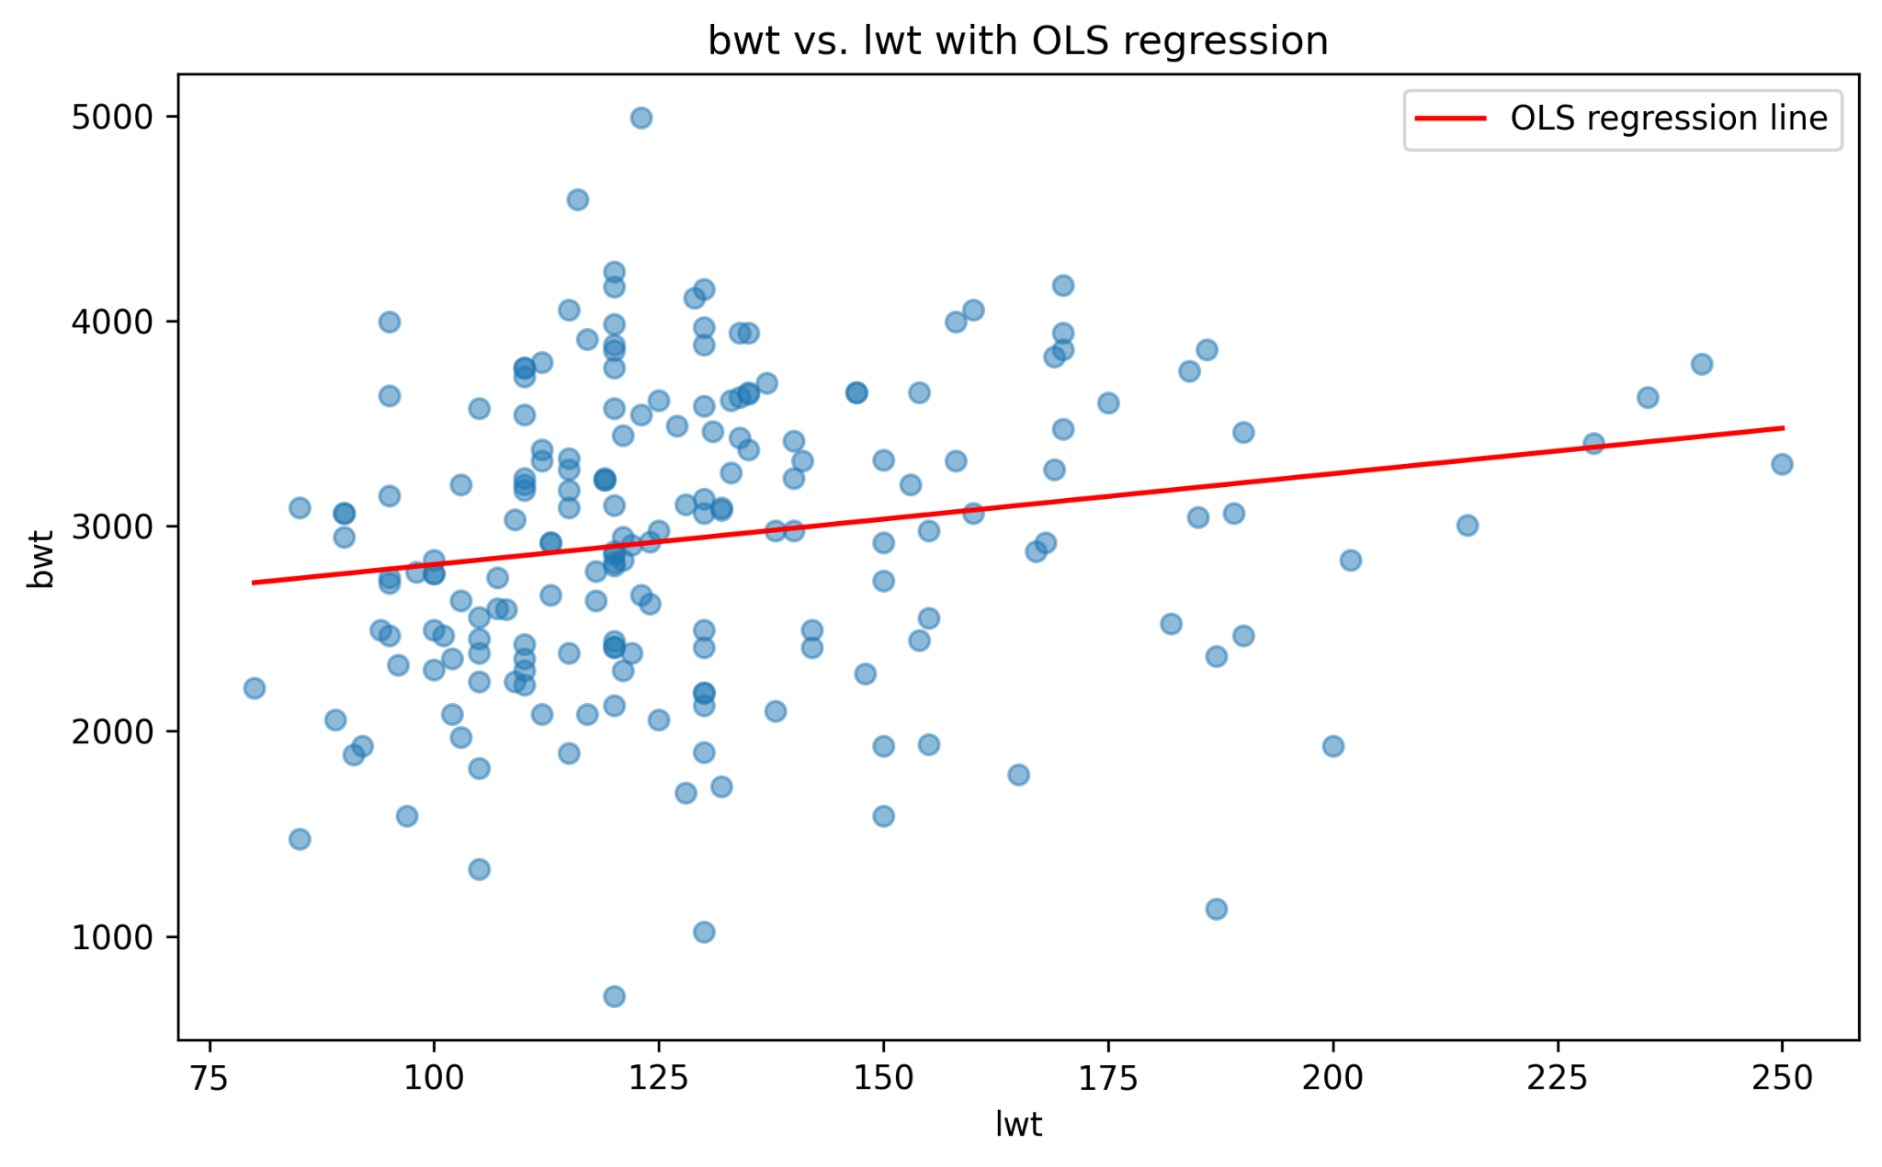

Independent Variable: Mother’s weight in pounds
Dependant Variable: Birthweight in grams

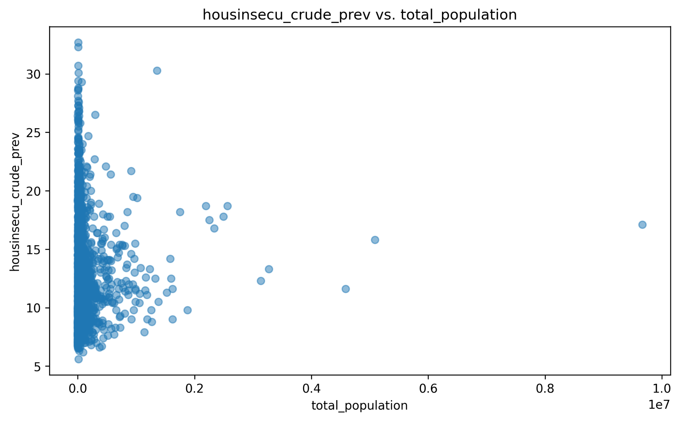
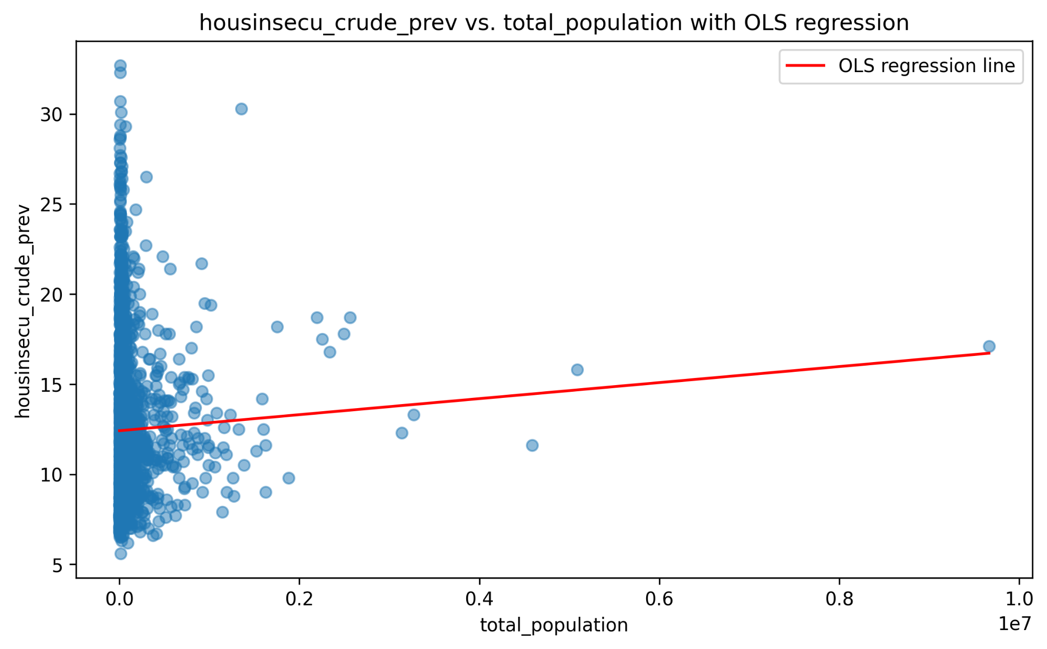
Independent Variable: Total population
Dependant Variable: Housing insecurity prevalence

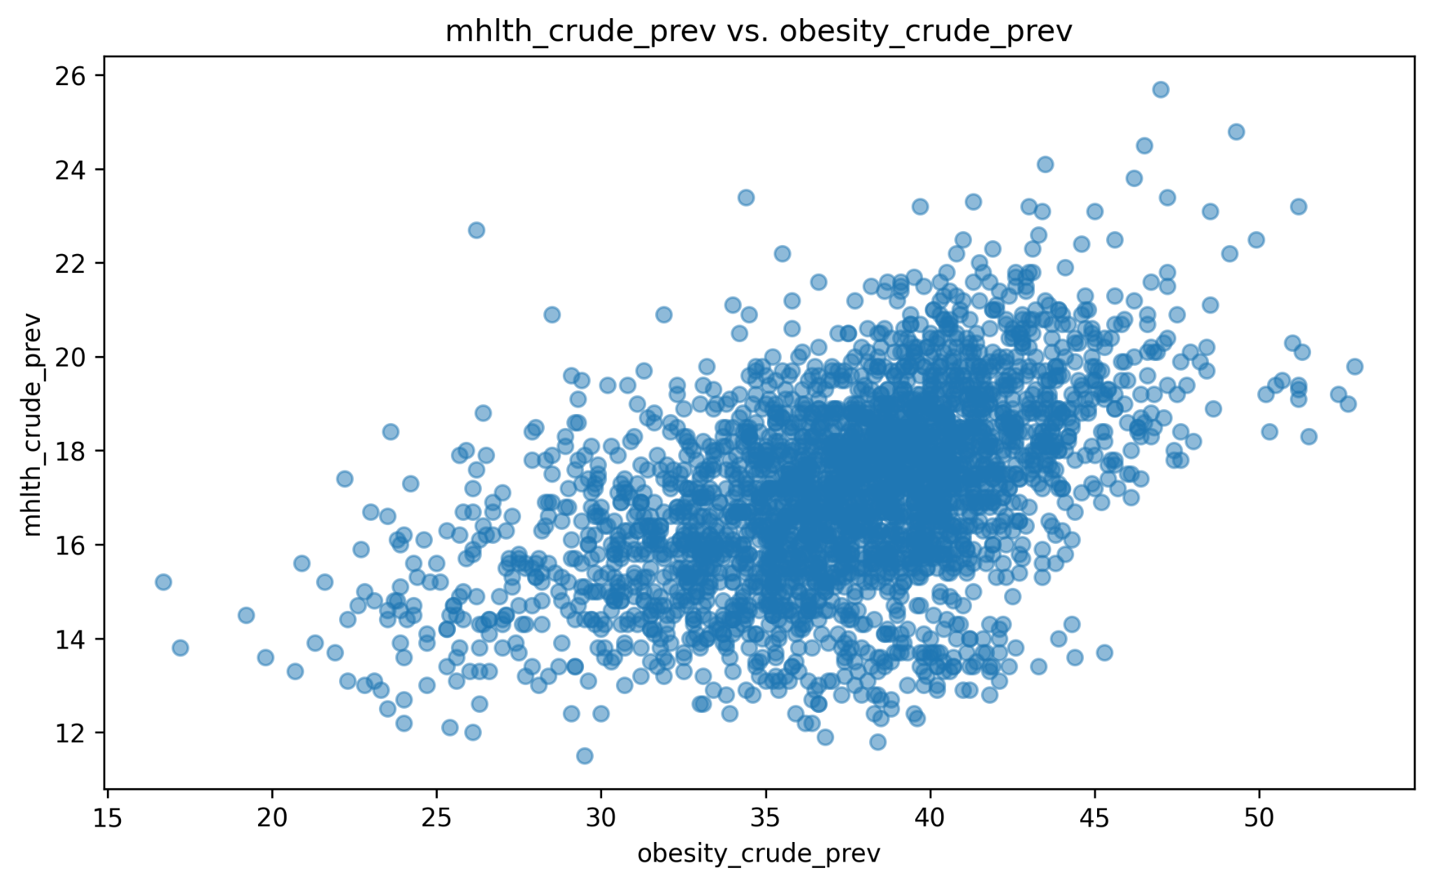
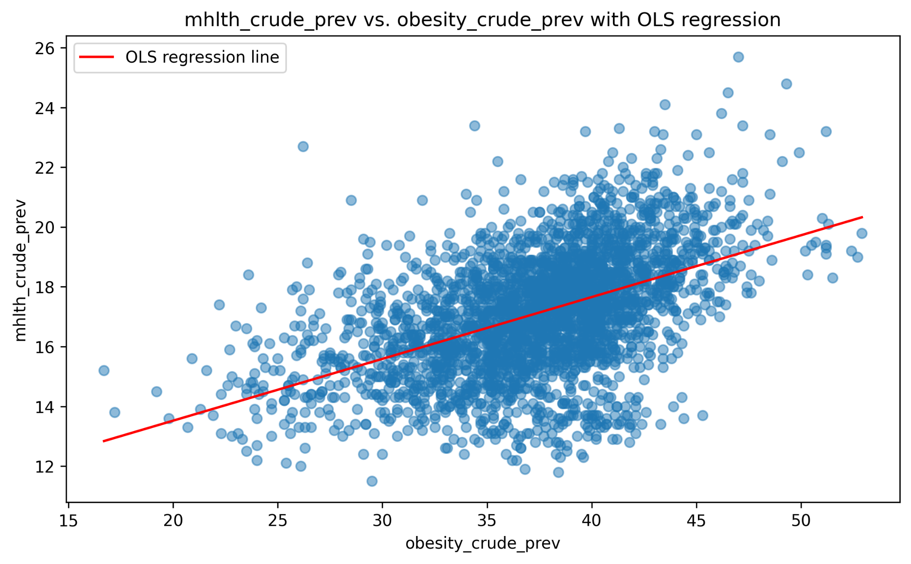
Independent Variable: Obesity prevalence
Dependant Variable: Mental health prevalence

