INDEX

S.NO | EXPERIMENT NAME | Page  No. | DATE | SIGNATURE /  REMARKS
1 | Basic data types and operators: Create a program that prompts the user for their name and age and prints a personalized message. | 1-2
2 | Conditional statements: Create a program that prompts the user for their age and tells them if they can vote in the next election. | 3-4
3 | Loops: Create a program that calculates the  factorial of a number entered by the user using a loop. | 5-6
4 | Lists and arrays: Create a program that prompts the user for a list of numbers and then sorts them in  ascending order. | 7-8
5 | Strings and string manipulation: Create a program  that prompts the user for a string and then prints out the string reversed. | 9-10
6 | Functions: Create a program that defines a function to calculate the area of a circle based on the radius entered by the user. | 11-12
7 | Classes and objects: Create a program that defines a class to represent a car and then creates an object of that class with specific attributes. | 13-14
8 | File input/output: Create a program that reads data from a file and writes it to another file in a different format. | 15-16
9 | Regular expressions: Create a program that uses  regular expressions to find all instances of a specific pattern in a text file. | 17-19
10 | Exception handling: Create a program that prompts the user for two numbers and then divides them,  handling any exceptions that may arise. | 20-21
11 | GUI programming: Create a program that uses a graphical user interface (GUI) to allow the user to  perform simple calculations. | 22-25
12 | Web scraping: Create a program that uses a web  scraping library to extract data from a website and then stores it in a database. | 26-29
13 | Data visualization: Create a program that reads data from a file and then creates a visualization of that data using a data visualization library. | 30-31
14 | Machine learning: Create a program that uses a machine learning library to classify images based  on their content. | 32-34
15 | Networking: Create a program that uses a  networking library to communicate with a server and retrieve data from it. | 35-37

EXPERIMENT - 1
Radhika Goyal
: 08015602722

AIM :

ALGORITHM :

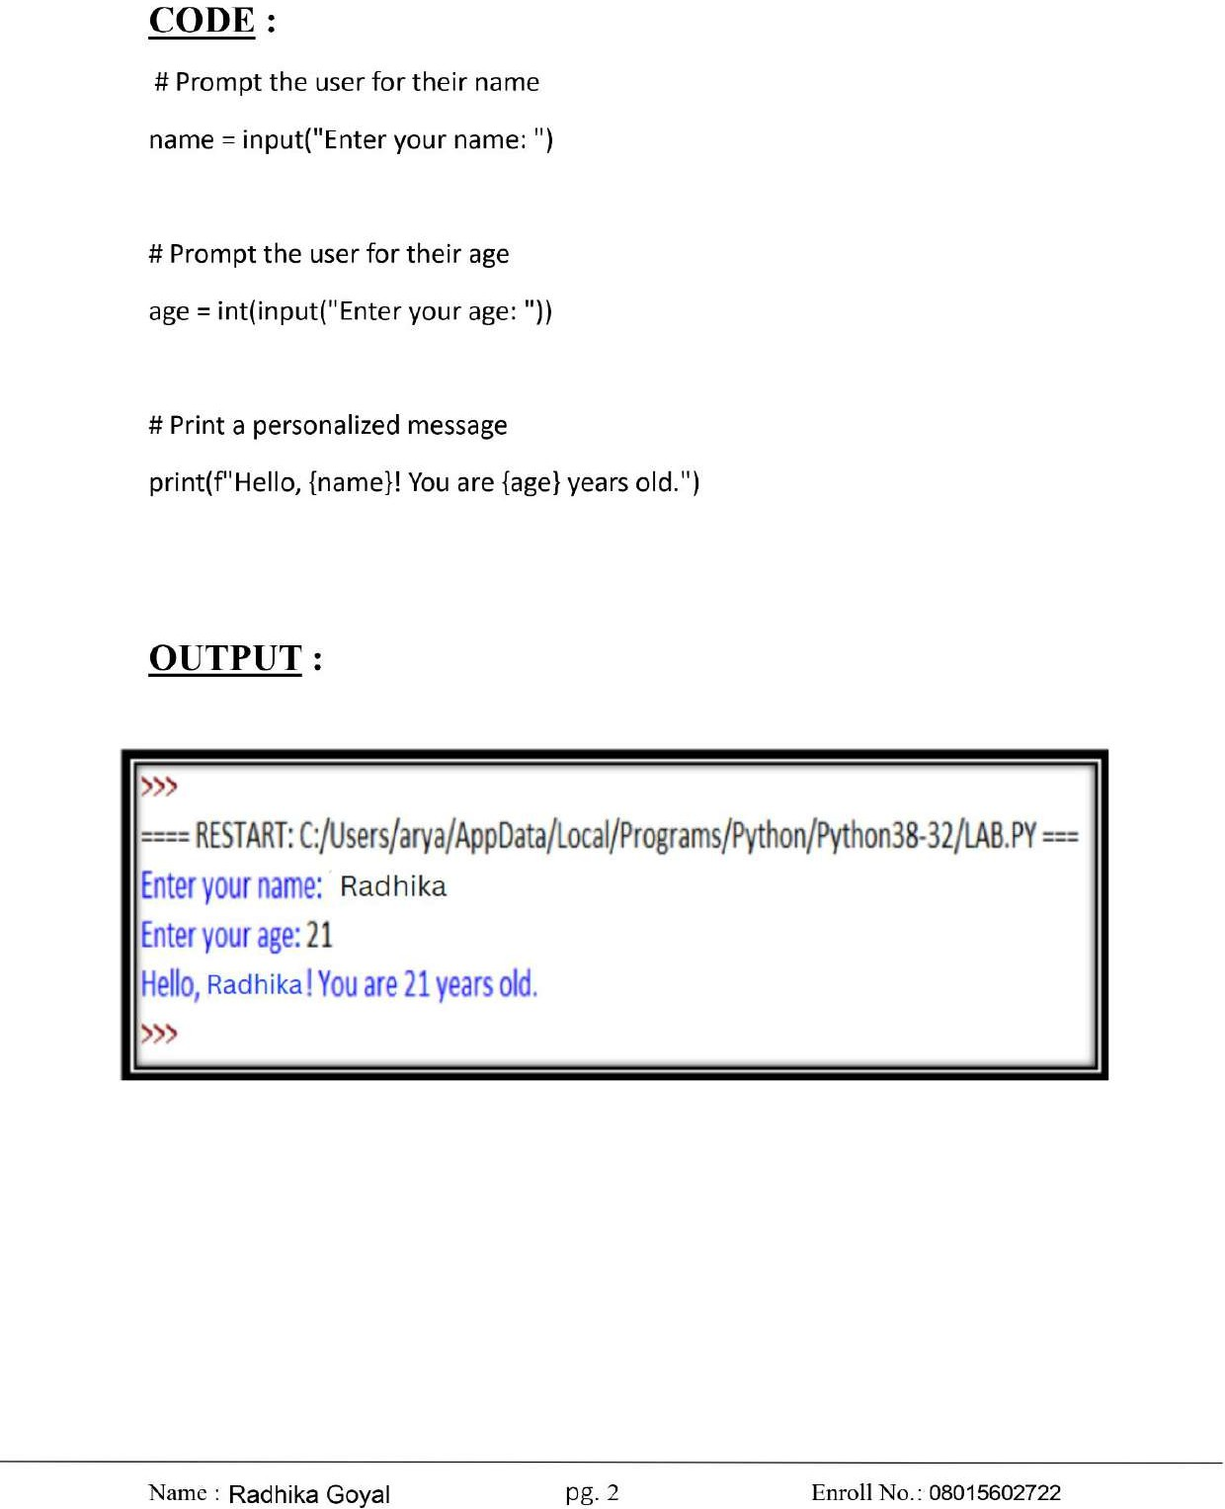

EXPERIMENT - 2
Radhika Goyal
: 08015602722

AIM :

ALGORITHM :

CODE :
Radhika Goyal
: 08015602722
# Prompt the user for their age
age = int(input("Enter your age: "))

# Check voting eligibility if age >= 18:
print("You are eligible to vote in the next election! ") else:
print(f"Sorry, you need to wait {18 - age} more years to vote.")

OUTPUT :

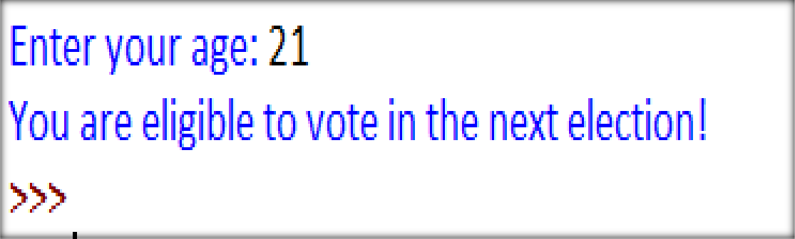

EXPERIMENT - 3
Radhika Goyal
: 08015602722

AIM :

ALGORITHM :

CODE :
Radhika Goyal
: 08015602722
# Prompt the user for a number num = int(input("Enter a number: "))

# Initialize factorial to 1 factorial = 1
# Calculate factorial using a loop if num < 0:
print("Factorial is not defined for negative numbers.") elif num == 0 or num == 1:
print(f"The factorial of {num} is 1.") else:
for i in range(1, num + 1): factorial *= i
print(f"The factorial of {num} is {factorial}.")

OUTPUT :

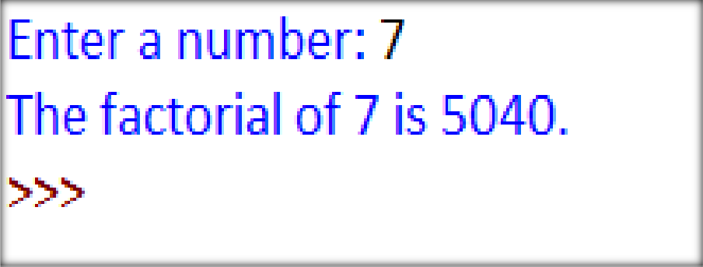

EXPERIMENT - 4
Radhika Goyal
: 08015602722

AIM :

ALGORITHM :

CODE :
Radhika Goyal
: 08015602722
# Prompt the user for a list of numbers
numbers = list(map(int, input("Enter numbers separated by spaces: ").split()))

# Implementing Bubble Sort algorithm n = len(numbers)
for i in range(n):
for j in range(0, n-i-1):
if numbers[j] > numbers[j+1]:
numbers[j], numbers[j+1] = numbers[j+1], numbers[j] # Swap

# Display the sorted list
print("Sorted numbers in ascending order:", numbers)

OUTPUT :

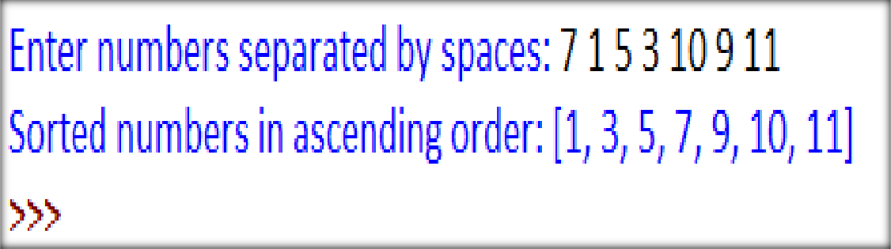

EXPERIMENT - 5
Radhika Goyal
: 08015602722

AIM :

ALGORITHM :

CODE :
: Radhika Goyal
: 08015602722
# Prompt the user for a string user_string = input("Enter a string: ")

# Reverse the string using slicing reversed_string = user_string[::-1]

# Display the reversed string
print("Reversed string:", reversed_string)

OUTPUT :

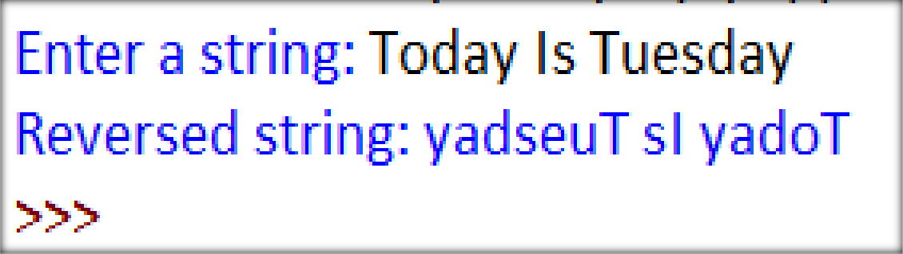

EXPERIMENT - 6
Radhika Goyal
: 08015602722

AIM :

ALGORITHM :

CODE :
Radhika Goyal
: 08015602722
import math # Import math module for π (pi)

# Function to calculate the area of a circle def calculate_area(radius):
return math.pi * radius ** 2

# Prompt the user for the radius
radius = float(input("Enter the radius of the circle: "))

# Call the function and display the result area = calculate_area(radius)
print(f"The area of the circle with radius {radius} is: {area:.2f}")

OUTPUT :

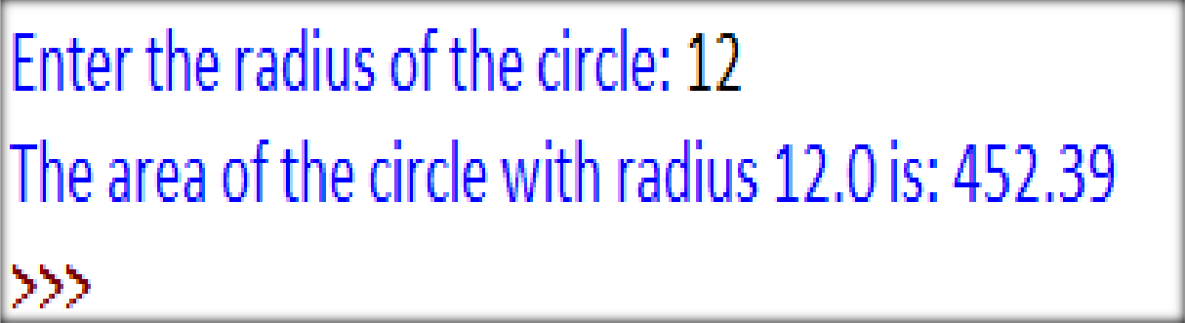

EXPERIMENT - 7
Radhika Goyal
: 08015602722

AIM :

ALGORITHM :

CODE :
Radhika Goyal
: 08015602722
# Define the Car class class Car:
def init (self, brand, model, year, color): self.brand = brand
self.model = model self.year = year self.color = color

def display_info(self):
print(f"Car Details: {self.year} {self.color} {self.brand} {self.model}")

# Create an object of the Car class
my_car = Car("Toyota", "Corolla", 2022, "Blue")

# Call the method to display car details my_car.display_info()

OUTPUT :

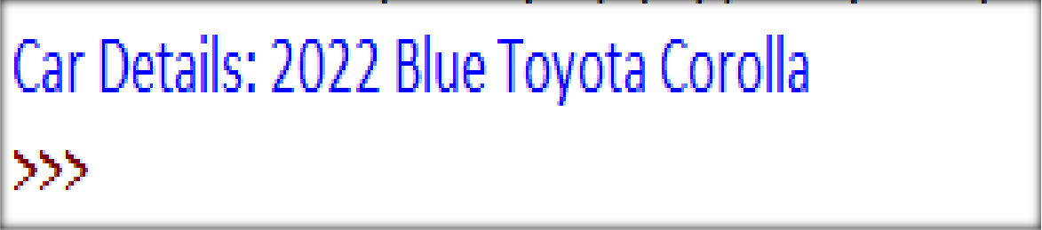

EXPERIMENT - 8
Radhika Goyal
: 08015602722

AIM :

ALGORITHM :

CODE :
: Radhika Goyal
: 08015602722
# Read from input.txt and write to output.txt in uppercase format # Read data from the input file
with open("input.txt", "r") as infile: data = infile.read()
# Process the data (convert to uppercase) processed_data = data.upper()
# Write the processed data to the output file with open("output.txt", "w") as outfile:
outfile.write(processed_data)
print("Data has been successfully processed and written to output.txt")

OUTPUT :
- File: input.txt
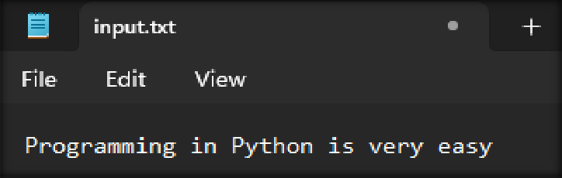
- Python program run output
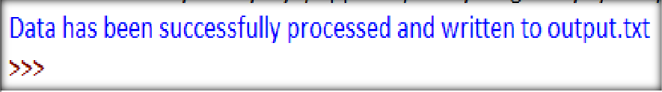

- File: output.txt
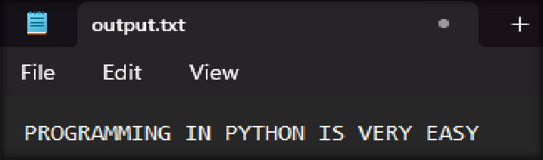

EXPERIMENT - 9
Radhika Goyal
: 08015602722

AIM :

ALGORITHM :

CODE :
Radhika Goyal
: 08015602722

import re

# Define the pattern to search for (e.g., email addresses) pattern = r"[a-zA-Z0-9._%+-]+@[a-zA-Z0-9.-]+\.[a-zA-Z]{2,}"

# Read data from the input file
with open("input.txt", "r") as infile: data = infile.read()

# Find all occurrences of the pattern matches = re.findall(pattern, data)

# Write the matches to an output file with open("output.txt", "w") as outfile:
for match in matches:
outfile.write(match + "\n")
print(f"Found {len(matches)} matches. Results saved in output.txt.")

OUTPUT :
Radhika Goyal
: 08015602722

File: input.txt
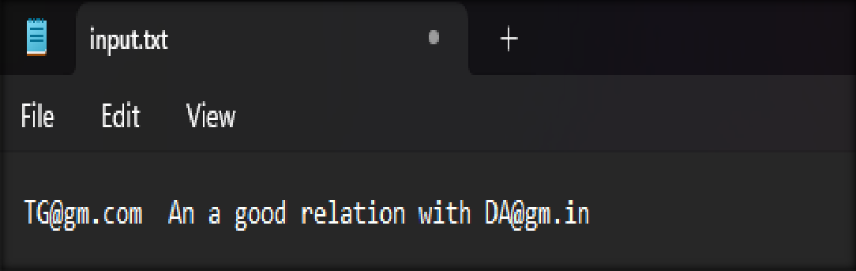

Python program run output
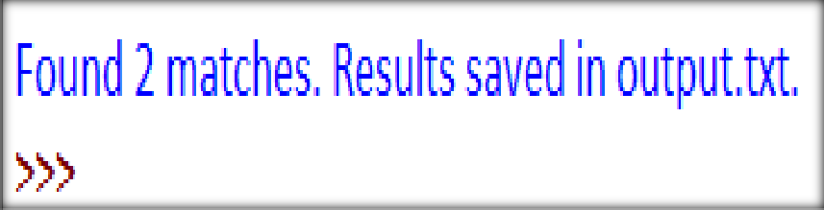

File: output.txt

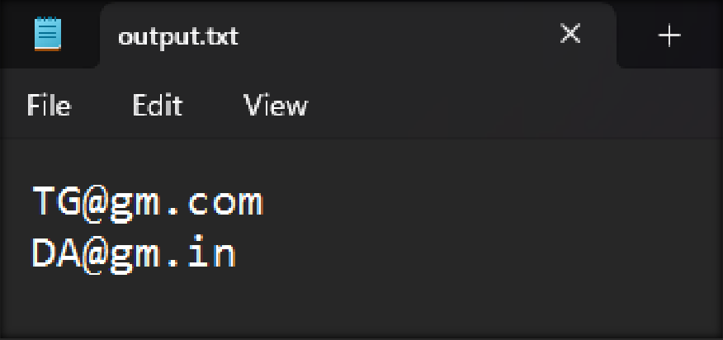

EXPERIMENT - 10
: Radhika Goyal
: 08015602722

AIM :

ALGORITHM :

CODE :
Radhika Goyal
: 08015602722
# Function to divide two numbers with exception handling def safe_division():
try:
# Prompt the user for two numbers
num1 = float(input("Enter the first number: ")) num2 = float(input("Enter the second number: ")) # Perform division
result = num1 / num2 except ValueError:
print("Error: Please enter valid numbers.") except ZeroDivisionError:
print("Error: Division by zero is not allowed.") else:
print(f"Result: {num1} ÷ {num2} = {result}") finally:
print("Thank you for using the division calculator!") # Call the function
safe_division()

OUTPUT :
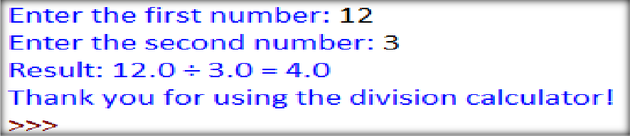
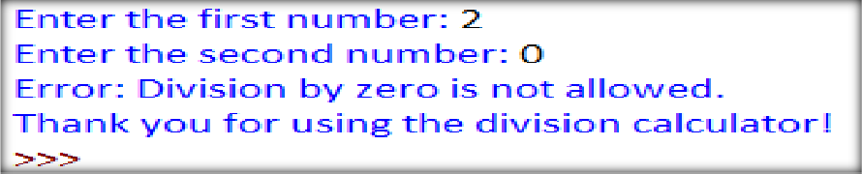

EXPERIMENT - 11
: Radhika Goyal
: 08015602722

AIM :

ALGORITHM :

CODE :
Radhika Goyal
: 08015602722
import tkinter as tk
from tkinter import messagebox
# Function to perform calculations def calculate():
try:
num1 = float(entry1.get()) num2 = float(entry2.get()) operator = operator_var.get() if operator == "+":
result = num1 + num2 elif operator == "-":
result = num1 - num2 elif operator == "*":
result = num1 * num2 elif operator == "/":
if num2 == 0:
raise ZeroDivisionError result = num1 / num2
else:
result = "Invalid Operator"
result_label.config(text=f"Result: {result}") except ValueError:
messagebox.showerror("Input Error", "Please enter valid numbers.") except ZeroDivisionError:
messagebox.showerror("Math Error", "Cannot divide by zero.")

# Create main window root = tk.Tk()
: Radhika Goyal
: 08015602722
root.title("Simple Calculator") root.geometry("300x250")
# Input fields
tk.Label(root, text="Enter first number:").pack() entry1 = tk.Entry(root)
entry1.pack()
tk.Label(root, text="Enter second number:").pack() entry2 = tk.Entry(root)
entry2.pack()
# Operator selection
operator_var = tk.StringVar(value="+") tk.Label(root, text="Select operator:").pack()
operator_menu = tk.OptionMenu(root, operator_var, "+", "-", "*", "/") operator_menu.pack()
# Calculate button
calc_button = tk.Button(root, text="Calculate", command=calculate) calc_button.pack()
# Result display
result_label = tk.Label(root, text="Result: ") result_label.pack()
# Run the application root.mainloop()

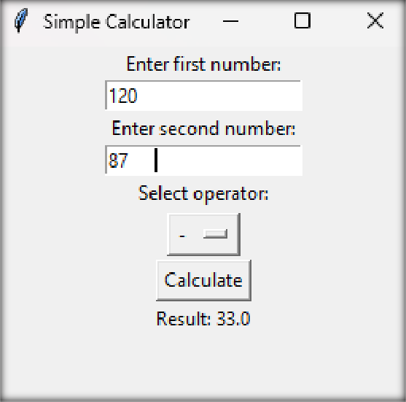
OUTPUT :
Radhika Goyal
: 08015602722

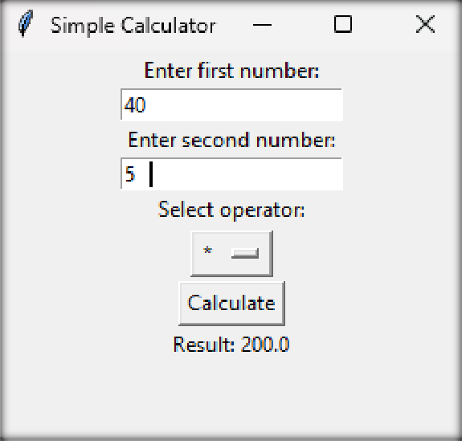

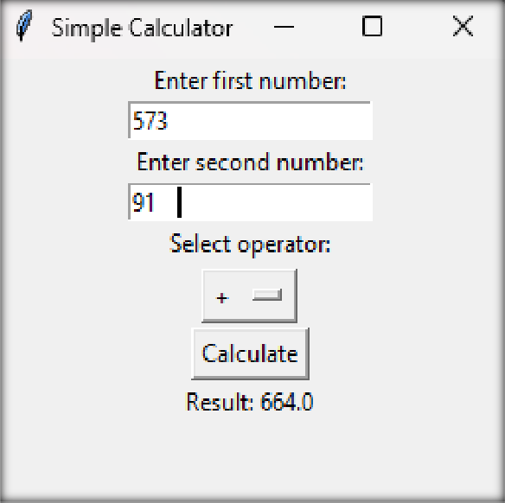
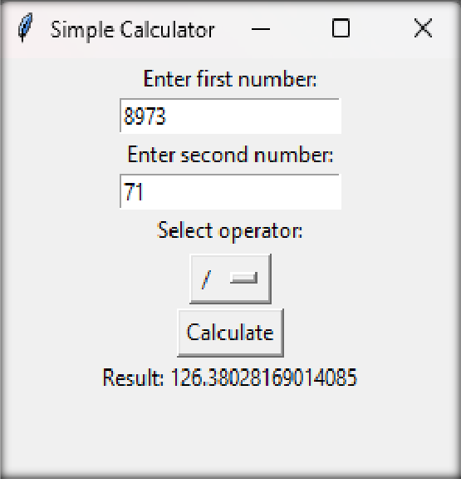

EXPERIMENT - 12
: Radhika Goyal
: 08015602722

AIM :

ALGORITHM :

CODE :
Radhika Goyal
: 08015602722
import requests import sqlite3
from bs4 import BeautifulSoup # Database setup
def create_database():
conn = sqlite3.connect('quotes.db') cursor = conn.cursor()
cursor.execute('''
CREATE TABLE IF NOT EXISTS quotes (
id INTEGER PRIMARY KEY AUTOINCREMENT,
quote TEXT, author TEXT
) ''')
conn.commit() conn.close()

# Scrape quotes from the website def scrape_quotes():
url = "http://quotes.toscrape.com" response = requests.get(url)
if response.status_code != 200:
print("Failed to retrieve the page.") return []
soup = BeautifulSoup(response.text, "html.parser")

quotes_list = []
: Radhika Goyal
: 08015602722
for quote_block in soup.find_all("div", class_="quote"): quote_text = quote_block.find("span", class_="text").text author = quote_block.find("small", class_="author").text quotes_list.append((quote_text, author))
return quotes_list

# Store data in SQLite database def store_data(quotes):
conn = sqlite3.connect('quotes.db') cursor = conn.cursor()
cursor.executemany("INSERT INTO quotes (quote, author) VALUES (?, ?)", quotes) conn.commit()
conn.close()
print("Data stored in database successfully.")

# Run the scraper and store data if name == " main ":
create_database()
quotes = scrape_quotes() if quotes:
store_data(quotes)
print("Scraping and database storage completed!")

For showing store data in file quotes.db
Radhika Goyal
: 08015602722
import pandas as pd
conn = sqlite3.connect("quotes.db")
df = pd.read_sql_query("SELECT * FROM quotes;", conn) conn.close()

# Display the data df.head()

OUTPUT :

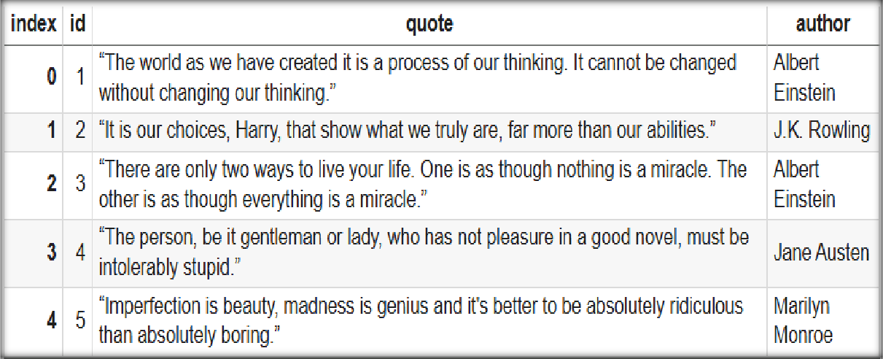

EXPERIMENT - 13
Radhika Goyal
: 08015602722

AIM :

ALGORITHM :

CODE :
: Radhika Goyal
: 08015602722
import pandas as pd
import matplotlib.pyplot as plt # Read data from a CSV file
df = pd.read_csv("data.csv") # Create a bar chart
plt.figure(figsize=(8, 5))
plt.bar(df["Category"], df["Value"], color="skyblue") # Add labels and title
plt.xlabel("Category") plt.ylabel("Value")
plt.title("Data Visualization Example") # Show the visualization
plt.show()

OUTPUT :

data.csv
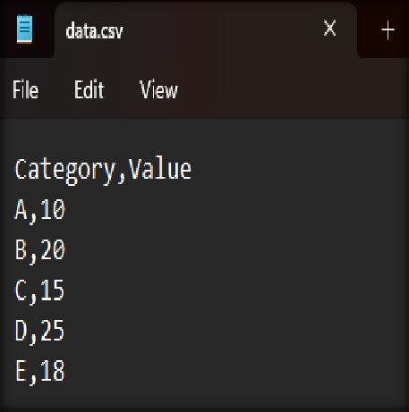
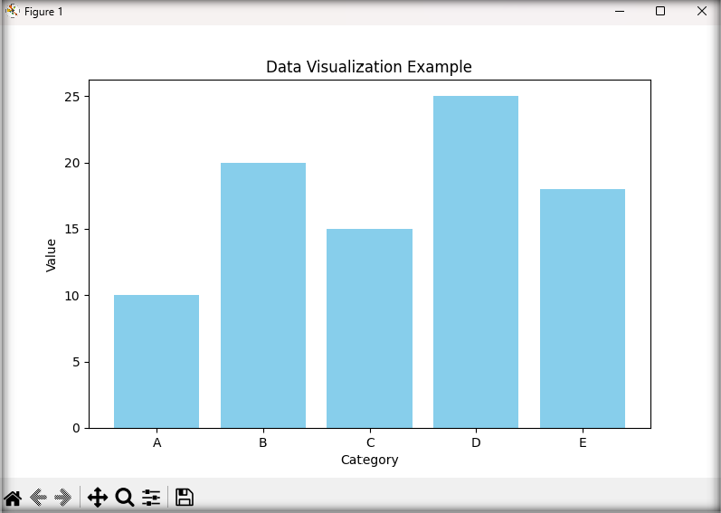

EXPERIMENT - 14
Radhika Goyal
: 08015602722

AIM :

ALGORITHM :

CODE :
Radhika Goyal
: 08015602722

import tensorflow as tf import numpy as np
from tensorflow.keras.applications.mobilenet_v2 import MobileNetV2, preprocess_input, decode_predictions
from tensorflow.keras.preprocessing import image import matplotlib.pyplot as plt

# Load the pre-trained MobileNetV2 model model = MobileNetV2(weights="imagenet")

# Load and preprocess an image def classify_image(img_path):
img = image.load_img(img_path, target_size=(224, 224)) # Resize to model's input size
img_array = image.img_to_array(img)
img_array = np.expand_dims(img_array, axis=0)
img_array = preprocess_input(img_array) # Normalize the image

# Make predictions
predictions = model.predict(img_array)
decoded_predictions = decode_predictions(predictions, top=3)[0] # Get top 3 predictions

# Display image and predictions

plt.imshow(img) plt.axis("off")
Radhika Goyal
: 08015602722
plt.title("Predictions:")
for i, (imagenet_id, label, score) in enumerate(decoded_predictions): plt.text(0, 240 + i * 20, f"{label}: {score:.2f}", fontsize=12, color="blue")
plt.show()

# Example usage (change 'image.jpg' to your actual image path) classify_image("images.jpg")

OUTPUT :

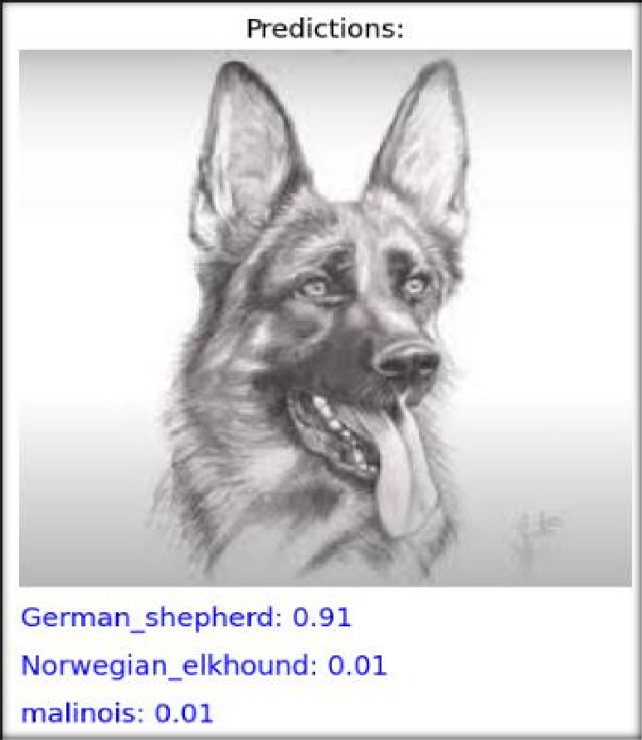

EXPERIMENT - 15
: Radhika Goyal
: 08015602722

AIM :

ALGORITHM :

CODE :
Radhika Goyal
: 08015602722

Server.py
import socket
def start_server():
host = '127.0.0.1' # Localhost
port = 12345 # Port to listen on
server_socket = socket.socket(socket.AF_INET, socket.SOCK_STREAM) server_socket.bind((host, port))
server_socket.listen(1)
print(f"Server started on {host}:{port}") while True:
client_socket, client_address = server_socket.accept() print(f"Connection from {client_address}")
message = "Hello, client! You are connected." client_socket.send(message.encode())
client_socket.close()
if name == " main ":
start_server()

client.py
import socket import socket
def connect_to_server():
host = '127.0.0.1' # Server address port = 12345 # Server port

client_socket = socket.socket(socket.AF_INET, socket.SOCK_STREAM) client_socket.connect((host, port))
Radhika Goyal
: 08015602722

data = client_socket.recv(1024).decode() print(f"Server says: {data}")

client_socket.close()

if name == " main ":
connect_to_server()

OUTPUT :
