EC410 Coding Basics with Economic Applications
Estimating the Effect of Land, Livestock, and Education on Household Expenditure: Evidence from Rural Uttar Pradesh
An Analysis of the NSSO 77th Round

ACKNOWLEDGEMENT
Firstly, I would like to thank Prof. Devesh Birwal whose guidance and suggestions have been invaluable in the writing of this term paper. From planning this report to fulfilment, I got enormous benefits from his suggestions.

Submitted by:
Name- Aman Jaiswal
Roll no- 24227707227
Estimating the Effect of Land, Livestock, and Education on Household Expenditure: Evidence from Rural Uttar Pradesh (NSS 77th Round)

1. Introduction

1.1 Motivation
Uttar Pradesh (UP) stands as the demographic heavyweight of India, a vast majority of whom reside in rural hinterlands. Historically, the economic destiny of a rural household in UP was determined by a single factor: land. However, the agrarian landscape has shifted dramatically over the last two decades. Landholdings have fragmented due to population pressure, and the profitability of traditional crop farming has plateaued.
In this changing environment, rural households are no longer just "farmers" in the traditional sense. They are diversified economic units that rely on a portfolio of assets: physical land, productive livestock (dairy), and increasingly, human capital (education). This paper is motivated by a simple but critical question: Which of these assets currently yields the highest return for a rural household's standard of living?
We use Monthly Household Consumer Expenditure (MHCE) as our primary metric for standard of living. Unlike income, which can fluctuate wildly due to harvest cycles or be under-reported by respondents, expenditure is a stable and reliable proxy for a household's permanent income and economic well-being.

1.2 Research Gap
While existing literature acknowledges the crisis in farm income (Narayanamoorthy & Sujitha, 2021), there is a lack of recent empirical evidence that:
- Disaggregates the "Asset Portfolio": Most studies look at land or education in isolation. We need to know the comparative benefit of owning an extra acre of land versus owning a high-yield buffalo versus having a college degree.
- Tests for Structural Inequality: Does an acre of land provide the same economic security to a Dalit (SC/ST) household as it does to an Upper Caste household? Does education lift a smallholder out of poverty as effectively as it does a large landowner?
- Utilizes Recent Data: This study leverages the NSSO 77th Round (2019), specifically the "Situation Assessment of Agricultural Households" (SAS), which is the most comprehensive recent dataset available for rural India.

2. Literature Review
The analysis in this study is grounded in ten pivotal academic works that collectively describe the shifting economic landscape of rural India. These studies provide the theoretical and empirical justification for examining land, livestock, and education as the primary drivers of household well-being. The literature is categorized into five major themes: the crisis of declining crop income, the stabilizing role of livestock, the structural drivers of inequality, the persistent influence of social identity, and the role of risk management.

2.1 The Crisis of Cultivation: Why Farmers are Diversifying
The starting point for any analysis of the rural economy must be the state of crop farming, which has historically been the backbone of rural livelihoods. Narayanamoorthy and Sujitha (2021) provide a critical assessment of this using data from the NSSO Situation Assessment Surveys (SAS) across three time points: 2002-03, 2012-13, and 2018-19. Their findings are alarming; they observe that while the total income of agricultural households has grown, the share of income coming from crop cultivation has sharply declined. Most strikingly, they found that between 2012 and 2018, the real income from crop cultivation actually turned negative in several major states. This deceleration suggests that farming alone is no longer a viable pathway out of poverty for many households. This "crisis of cultivation" serves as the primary motivation for our study: if crops are failing to provide a living wage, households are forced to diversify into other assets like livestock and rely on human capital (education) to survive.

2.2 Livestock: The "Pro-Poor" Safety Net
As crop income becomes volatile, livestock has emerged as a critical stabilizer for the rural poor. Das, Raju, and Patnaik (2020) review the sector and argue that livestock is "pro-poor" because its ownership is far more equitable than land. While land distribution is highly skewed (with a few large landlords owning the majority of acreage), even landless laborers and marginal farmers can own cattle or poultry. This makes livestock a vital tool for poverty alleviation and nutritional security.
Supporting this, Annu Kumari (2023) offers empirical evidence using the same NSSO 77th Round data. Her analysis confirms a strong positive correlation between "Livestock Units" and net household income. She finds that livestock acts as a liquid asset—something that can be sold or used to generate daily cash flow (milk) during lean agricultural seasons. Birthal et al. (2012) further reinforce this by highlighting that livestock growth is more sustainable and inclusive than crop growth, acting as an insurance mechanism against the vagaries of weather that decimate crops.

2.3 Drivers of Consumption and Inequality
If crop income is falling and livestock is stabilizing, what drives the differences in standard of living between households? Tripathi (2016) addresses this by analyzing consumption inequality using regression-based decomposition. His findings challenge the traditional view that land is the only determinant of wealth. He demonstrates that household size and education levels are actually the largest contributors to inequality. Large families consume more resources, pushing per-capita expenditure down, while higher education opens doors to salaried jobs that significantly raise expenditure.
Kaur, Anupama, Toor, and Singh (2018) add nuance to this by examining non-farm workers. They found that even for households whose primary job is not farming, owning land significantly boosts consumption expenditure. Land acts as a security asset, reducing the need for precautionary savings and allowing households to spend more on food and durables. Heshmati et al. (2019) corroborate this using quantile regression, showing that determinants like education and social group have different impacts at different levels of expenditure, with education offering the highest returns for moving households out of poverty.

2.4 The Persistence of Social Identity and Vulnerability
Despite economic growth, caste and social identity remain powerful predictors of poverty. Chin and Prakash (2011) explored the redistributive effects of political reservation, finding that while political representation helps Scheduled Tribes (ST) reduce poverty, it has been less effective for Scheduled Castes (SC). This suggests deep-rooted structural barriers that prevent marginalized groups from fully benefiting from economic policies.
Solomon and De (2023) expand on this by distinguishing between being "poor" and being "vulnerable." Their study in rural Manipur quantifies "vulnerability to poverty"—the probability that a currently non-poor household will fall into poverty in the future. They find that SC/ST households, even if they currently have similar incomes to others, are statistically more vulnerable to shocks due to a lack of assets and social safety nets. Dwivedi and Dwivedi (2012) provide empirical evidence on expenditure patterns, showing that these marginalized groups spend a larger portion of their income on basic food, leaving little for investment in health or education, which perpetuates the cycle of poverty.

2.5 Role of Risk Management
Finally, in an environment of high risk, the ability to smooth consumption is key to food security. Akber, Paltasingh, and Mishra (2023) investigate the role of crop insurance. Using the NSSO 77th round, they found that households with crop insurance had significantly higher consumption expenditures and net farm incomes than those without. This implies that financial tools that manage risk are just as important as physical assets. When households are protected from total crop failure, they invest more and consume more, improving their overall standard of living.
Summary: The literature paints a clear picture: Rural households are pivoting away from pure crop farming due to declining returns (Narayanamoorthy). They are relying on livestock as a safety valve (Das, Kumari), but their ability to prosper is heavily dictated by their education and family structure (Tripathi). Furthermore, deep-seated social inequalities (Chin, Solomon) mean that marginalized castes face a steeper climb, necessitating targeted interventions like insurance (Akber) and asset redistribution. This study aims to empirically test these dynamics specifically for Uttar Pradesh.

3. Data Source and Methodology

3.1 Data Description
This study relies on unit-level data from the National Sample Survey Office (NSSO) 77th Round, specifically Schedule 33.1, titled "Land and Livestock Holdings of Households and Situation Assessment of Agricultural Households". The survey was conducted nationwide during the calendar year 2019, with the primary objective of generating estimates for the agricultural year July 2018 to June 2019.
The data collection was structured into two visits to the same set of households. Visit 1 gathered data for the first half of the agricultural year (July to December 2018), while Visit 2 covered the second half (January to June 2019). For this research, we have utilized data exclusively from Visit 1. This approach provides a consistent cross-sectional snapshot of household assets and consumption patterns for the Kharif season, avoiding the complexities of merging panel data across different seasons. The study focuses specifically on rural households in Uttar Pradesh.

3.2 Rationale for Data Selection
The NSSO 77th Round (Schedule 33.1) was selected over other potential data sources for three critical reasons that align with our research objectives:
- Strict Definition of Agricultural Households: Unlike general population surveys, Schedule 33.1 filters households based on specific economic criteria. A household is classified as an "agricultural household" only if it meets a minimum threshold for the value of agricultural produce generated in the last 365 days and has at least one member self-employed in agriculture. This definition ensures that our analysis excludes casual laborers or households with negligible agricultural activity, focusing instead on genuine farming families whose livelihoods depend on land and livestock.
- Integrated Asset-Expenditure Linkage: This survey instrument is unique because it simultaneously captures detailed data on productive assets and consumption within the same household schedule. It records land holdings in Block 5, livestock ownership in Block 8, and household consumer expenditure in Block 4. This integration allows us to directly correlate a household’s physical endowments (assets) with their economic well-being (expenditure) at a granular level.
- Granularity and Robustness: The dataset provides unique identification codes for villages (First Stage Units or FSUs). This allows us to employ clustered standard errors in our regression analysis, controlling for unobserved similarities between households living in the same village (such as shared soil quality or market access), thereby ensuring statistically robust results.

3.3 Variable Construction and Specification
To translate raw survey data into interpretable economic insights, we constructed specific variables and "dummy" categories.
Dependent Variable:
- Monthly Household Consumer Expenditure (MHCE): This variable serves as our primary metric for the standard of living. It is an aggregate value derived from Block 4 of the schedule, representing the total monetary value of all goods and services consumed by the household over the last 30 days. It includes both goods purchased from the market and home-grown produce consumed by the family.
Independent Variables & Dummies: We selected and transformed the following key explanatory variables:
- Land Possessed:
  - Total Operational Land: We use the continuous measure of land (in acres) to estimate the general return on land ownership.
  - Small Landholder Dummy: To test for non-linear effects—specifically, whether being a small farmer carries a specific economic penalty—we created a binary category. Households owning 2.5 acres or less are classified as "Small Landholders," while those with more than 2.5 acres serve as the reference group.
- Livestock Assets (In-Milk Cattle/Buffalo):
  - Rather than using a simple count of all animals, we specifically isolated the count of In-Milk Cattle and Buffalo from Block 8. This variable tests the hypothesis that productive assets, which generate daily cash flow through milk production, are stronger drivers of consumption expenditure than total herd size.
- Education:
  - To measure the "premium" associated with education, households were categorized based on the maximum education level attained by any member. We created dummy variables for Primary/Middle, Secondary/Higher Secondary, and Post-Secondary education levels. The reference group is "Illiterate/Below Primary."
- Social Group (Caste):
  - To analyze structural inequality, we used the social group data to create dummy variables for OBC (Other Backward Classes) and SC/ST (Scheduled Castes/Scheduled Tribes). The "Others" (General Category) serves as the reference group.
- Livelihood Type:
  - Households were classified based on their self-reported primary source of income. We created dummies for Agriculture-related labor and Non-Agricultural work. The reference group is "Self-employed in Crop Production."

4. Descriptive Analysis (Cross-Tabulations)
Before running the regression models, we conducted a series of cross-tabulations to understand the baseline relationships in the data. These descriptive statistics provided the initial evidence for the structural inequalities we later tested.

4.1 Livelihood vs. Education: The Skills Migration
We first examined how a household's primary source of income changes as its education level rises.
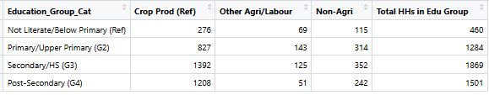
- The Pattern: The data revealed a clear "skills migration." Households where the maximum education was "Below Primary" were overwhelmingly concentrated in casual agricultural labor or subsistence farming.
- The Shift: As education levels increased to "Post-Secondary," there was a significant drop in agricultural engagement. These educated households were far more likely to report their primary livelihood as "Non-Agricultural" (e.g., salaried jobs, trade, or business).
- Implication: This suggests that education is the primary exit route from the agrarian economy. However, the data also showed a subset of educated households still stuck in agriculture, hinting at a lack of sufficient non-farm jobs in rural UP.

4.2 Land Ownership by Social Group: Structural Inequality
We analyzed the mean landholding size across different social groups to test for asset inequality.
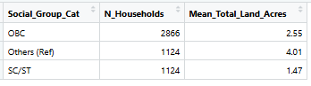
- The Disparity: The results were stark. Households classified as "Others" (General Category) possessed the highest mean landholding, averaging approximately 4.01 acres.
- The Gap: In sharp contrast, SC/ST households had the lowest mean landholding, averaging just 1.47 acres.
- Implication: This confirms that caste is a strong predictor of asset poverty. The SC/ST groups are starting from a much lower base of physical capital, which limits their ability to generate agricultural income regardless of their effort.

4.3 Expenditure vs. Land Size: The Wealth Gradient
We checked if land size effectively proxies for standard of living.
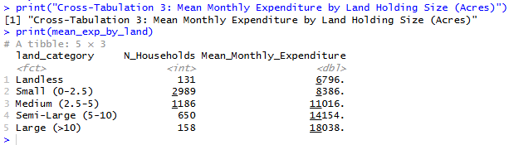
- The Gradient: There was a consistent linear relationship. Landless households reported the lowest mean monthly expenditure. As landholdings increased from Small (0-2.5 acres) to Medium and then to Large (>10 acres), the mean monthly expenditure rose at every step.
- Implication: This validates our use of land as a key explanatory variable. It also suggests that landless households are the most vulnerable, having the least consumption capacity.

4.4 Livestock Ownership
Finally, we looked at livestock counts. Interestingly, livestock ownership was more evenly distributed than land. While large landholders had more animals on average, even landless and smallholder families owned significant numbers of livestock, reinforcing the theory that animals act as a critical asset for the land-poor.
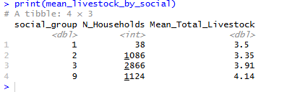

4.5 Mean Expenditure by Max Education Level
This is a direct test of the Education Premium, measuring the mean household monthly consumer expenditure (monthly_expenditure) for each education group.
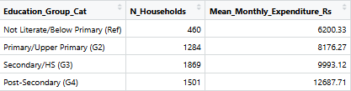

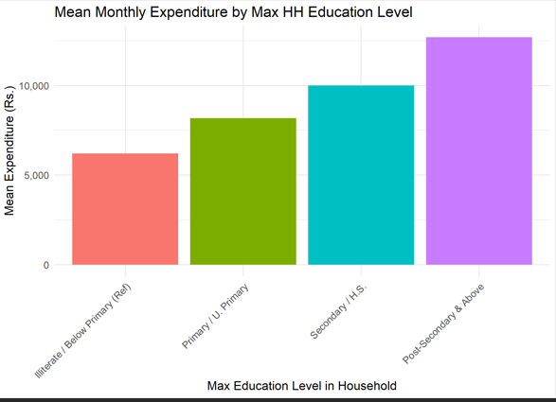

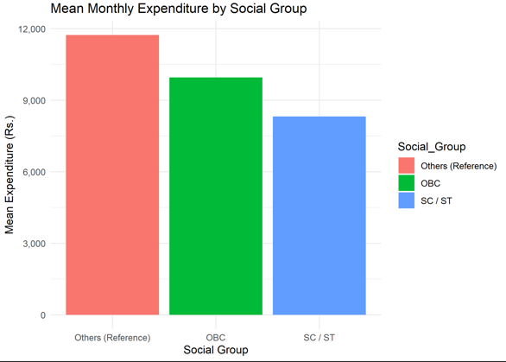

5. Model Specification and Explanation (All 8 Models)
We estimated 8 Ordinary Least Squares (OLS) regression models to build our argument step-by-step. All models use Clustered Standard Errors at the FSU (Village) level to account for regional similarities.

Phase 1: Establishing the Baseline (Models 1 & 2)
- Model 1 (Total Livestock): Expenditure ~ Land + Total_Livestock
  - Purpose: A naive model to check if simply owning any animal correlates with wealth.
- Model 2 (Productive Livestock): Expenditure ~ Land + In_Milk_Animals
  - Purpose: A refined model. We hypothesize that only productive (milking) animals generate the daily cash flow needed for consumption.
  - Result: Model 2 performed significantly better. The coefficient for "In-Milk" animals was much larger and more significant than "Total Livestock," confirming that quality matters more than quantity.

Phase 2: Adding Controls (Models 3 & 4)
- Model 3 & 4: We added household size, social group, religion, and education to Models 1 and 2.
  - Purpose: To see if the land/livestock effect holds up once we account for the fact that richer households might just happen to have more land (Omitted Variable Bias).
  - Finding: Even with controls, the "In-Milk" variable remained highly significant, proving that livestock is an independent driver of prosperity.

Phase 3: The Smallholder Penalty (Models 5 & 6)
- Model 5 & 6: We added the "Small Landholder" (< 2.5 acres) dummy variable.
  - Equation (M6):
  - Purpose: To test for non-linearity. Does being a small farmer carry a specific economic penalty beyond just having less land?
  - Finding: The Smallholder dummy was negative and significant. This means that even if we mathematically adjust for land size, there is a distinct "poverty trap" associated with being in the small farmer category.

Phase 4: Interaction Effects (Models 7 & 8) - The Final Analysis
These are the most critical models for policy analysis.
- Model 7 (Education Interaction): Expenditure ~ ... + (SmallHolder × Post_Secondary_Edu)
  - Hypothesis: Do small farmers get the same return on education as large farmers?
  - Explanation: We interact the smallholder status with high education. A negative coefficient would mean education pays less for the poor.
- Model 8 (Social Group Interaction): Expenditure ~ ... + (Land × OBC) + (Land × SC/ST)
  - Hypothesis: Does an acre of land yield the same economic benefit for a Dalit farmer as it does for a General caste farmer?
  - Explanation: If land quality is worse or market access is harder for SC/STs, the interaction term will be negative.

6. Results and Interpretation
The regression analysis was conducted in four distinct phases, evolving from simple relationships to complex structural interactions. This step-by-step approach ensures that our findings are robust and not just statistical artifacts.

6.1 Phase 1: The "Quality vs. Quantity" Test (Models 1 & 2)
The first step was to determine which assets truly drive household expenditure. We tested two different specifications for livestock to see if herd size matters or if productivity is the key.
- Model 1 (The Naive Model): We regressed expenditure on Land and Total Livestock Count (all animals regardless of type or utility).
  - Result: While land was highly significant, the coefficient for Total Livestock was small (10.41) and statistically insignificant.
  - Interpretation: Simply owning a large number of animals does not guarantee a higher standard of living. A household might own 10 dry cows or young calves that consume resources (fodder/water) without generating immediate income. These animals might actually be a liability rather than an asset in the short term.
- Model 2 (The Productivity Model): We replaced the total count with "In-Milk Cattle/Buffalo" (animals currently producing milk).
  - Result: The model fit improved drastically. The coefficient for In-Milk Animals was 666.30* (Significant at 1%).
  - Interpretation: This confirms that asset quality matters more than quantity. An animal that generates daily cash flow (milk) has a massive, immediate impact on a household's ability to consume goods. This finding guided us to use "In-Milk" animals for all subsequent models.

6.2 Phase 2: Establishing Robustness with Controls (Models 3 & 4)
We added demographic controls (Household Size, Religion, Social Group, Education) to ensure the asset effects weren't just proxies for other factors (e.g., larger families owning more land).
- Model 3 (Controls + Total Livestock): Even with controls, the Total Livestock variable remained statistically insignificant (Coefficient: 2.10). This definitively proves that herd size alone is not a predictor of wealth in this context.
- Model 4 (Controls + In-Milk): The In-Milk variable remained robust and highly significant (494.08*).
  - Why this matters: It proves that the "Livestock Advantage" is real. Even when comparing two families of the same caste, religion, and size, the one with a milking buffalo is significantly better off than the one without.

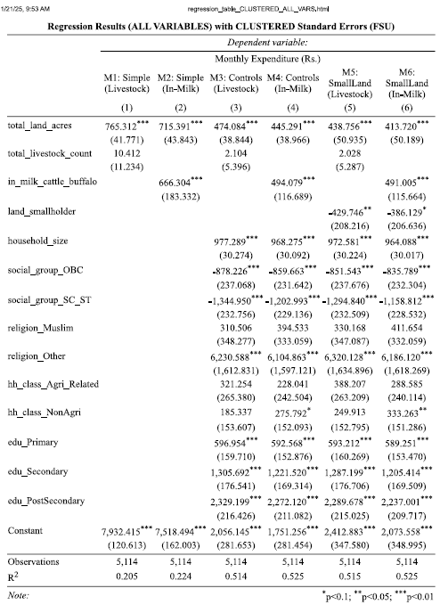

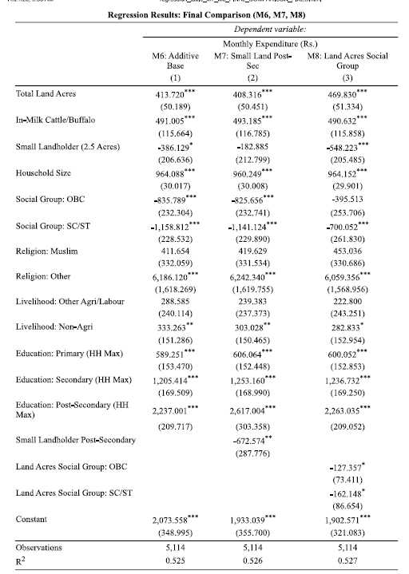

6.3 Phase 3: The Smallholder Penalty (Models 5 & 6)
Here, we tested if being a "marginal farmer" (owning < 2.5 acres) carries a specific economic disadvantage beyond just owning less land.
- Model 6 (The Base Additive Model): This is our primary reference model.
  - Land Coefficient (413.72*):** For every additional acre of land owned, monthly expenditure rises by Rs. 414.
  - In-Milk Livestock (491.00*):** Interestingly, the marginal return on one productive animal (Rs. 491) is higher than the return on one acre of land (Rs. 414). This highlights livestock as a critical asset for the land-poor.
  - Small Landholder Dummy (-386.13):* This variable is negative and significant.
    - Interpretation: If we take two households that are mathematically identical in terms of assets (e.g., both have 2 acres), the statistical model suggests that simply falling into the "Smallholder" category acts as a drag on prosperity. This likely reflects diseconomies of scale—small farms are less mechanized, have worse market access, and higher per-unit input costs, leaving less money for household consumption.

6.4 Phase 4: Structural Inequalities (Interaction Models 7 & 8)
The final models reveal deep-seated structural barriers in the rural economy. We interacted our key variables to see if the "returns" on assets differ for different groups.

Model 7: The Education Trap (Smallholder * Education)
We tested if education provides the same economic lift for small farmers as it does for large farmers.
- Key Result: The interaction term (Smallholder * Post-Secondary) is -672.57 (Significant at 5%).
- Detailed Interpretation:
  - For a Large Landholder, a college degree adds roughly Rs. 2,617 to their monthly expenditure (Base Education Coefficient).
  - For a Small Landholder, that same degree adds only Rs. 1,945 (2617 - 672).
- The "Why": This suggests an "Education-Asset Complementarity." Large landholders can use their capital to help educated family members start businesses or migrate to cities for better jobs. Small landholders, despite having the same education, may lack the complementary capital (money for travel, or business startup) to fully monetize their degree, often remaining underemployed in the village.

Model 8: The Caste Penalty on Land (Land * Social Group)
We tested if an acre of land yields the same benefit for marginalized groups (SC/ST/OBC) as it does for General Category farmers.
- Key Result: The interaction terms for Land * OBC (-127.36) and Land * SC/ST (-162.15) are negative.
- Detailed Interpretation:
  - General Category Farmer: An additional acre of land increases monthly consumption by Rs. 469.
  - OBC Farmer: An additional acre increases consumption by only Rs. 342 (469 - 127).
  - SC/ST Farmer: An additional acre increases consumption by only Rs. 307 (469 - 162).
- The "Why": This indicates a severe quality or market gap. Land owned by SC/ST households is likely:
  - Less Fertile/Unirrigated: Marginalized groups were historically relegated to inferior plots.
  - Market Discrimination: They may face lower prices for their produce or higher interest rates for credit, reducing the net income (and thus consumption) derived from that land.

Summary of Key Findings
- Productivity over Headcount: Total livestock numbers are economically irrelevant. Only productive (in-milk) animals drive standard of living.
- Livestock beats Land: For the poor, a buffalo is a more powerful asset than a marginal increase in land.
- The Double Burden: Marginalized groups (SC/ST) and Smallholders face a "double burden." They not only have fewer assets to begin with, but they also get lower economic returns from the assets they do possess (land and education) compared to the privileged groups.

7. Conclusion and Policy Implications
This study has empirically analyzed the determinants of household welfare in rural Uttar Pradesh using unit-level data from the NSSO 77th Round. The results challenge the traditional agrarian narrative that land ownership is the sole determinant of prosperity. Instead, the findings reveal a complex economic landscape where livestock acts as a powerful equalizer, while land and education remain sources of structural inequality.
The regression analysis (Model 6) demonstrates that for the average rural household, the marginal return from owning a single productive (in-milk) animal is higher than owning an additional acre of land. This validates the "pro-poor" nature of the livestock sector. However, the interaction models (M7 and M8) uncover deep-seated structural barriers: smallholders do not reap the full economic returns of higher education, and marginalized social groups (SC/ST) derive significantly lower returns from land ownership compared to General caste households. These findings necessitate a nuanced policy approach that goes beyond simple asset distribution.
Based on these empirical insights, we propose the following policy interventions:

1. Shift Focus from Herd Size to Productivity ("In-Milk" Strategy)
Our analysis proves that total livestock count is statistically insignificant for household welfare; only productive (in-milk) animals drive consumption expenditure. Therefore, government schemes must pivot away from merely increasing the animal population to enhancing animal productivity.
- Intervention: Policies like the Rashtriya Gokul Mission should prioritize accessible veterinary care, high-quality feed management, and artificial insemination services at the village level. The goal must be to reduce the dry period of cattle and buffalo, ensuring they remain income-generating assets for a longer duration of the year.

2. Bridge the "Yield Gap" for Marginalized Landholders
The negative interaction term for Land * SC/ST in Model 8 indicates that land owned by marginalized communities yields significantly lower economic returns than land owned by upper castes. This suggests disparities in land quality, irrigation access, or input markets.
- Intervention: Merely redistributing land is insufficient. Agricultural extension services must specifically target SC/ST clusters to provide Soil Health Cards, subsidized micro-irrigation infrastructure, and access to high-yield seeds. State procurement agencies must also ensure that these farmers face no discrimination in accessing Minimum Support Price (MSP) mechanisms, ensuring they receive the full economic value of their produce.

3. Unlocking the Value of Education for Smallholders
The study identifies an "education trap" (Model 7) where educated smallholders gain less from their human capital than educated large landholders. This is likely due to a lack of complementary capital to start businesses or the inability to migrate for better jobs.
- Intervention: To fix this misalignment, the state must aggressively promote rural non-farm employment. Developing agro-processing industries, MSMEs, and service centers in rural clusters will create salaried jobs that value education but do not require capital investment. This will allow educated youth from asset-poor families to monetize their skills effectively, breaking the cycle of underemployment.

8. Bibliography
- Akber, N., Paltasingh, K. R., & Mishra, A. K. (2023). Does crop insurance ensure food security for Indian farmers? Evidence from a nationally representative survey. Agribusiness, 1–21.
- Annu Kumari. (2023). Livestock Income in Rural Households in India: An Empirical Analysis. IES Seminar Paper.
- Birthal, P. S., & Negi, D. S. (2012). Livestock for Higher, Sustainable and Inclusive Agricultural Growth. Economic and Political Weekly, 47(26/27), 89-99.
- Chin, A., & Prakash, N. (2011). The redistributive effects of political reservation for minorities: Evidence from India. Journal of Development Economics, 96, 265-277.
- Das, A., Raju, R., & Patnaik, N. M. (2020). Present Scenario and Role of Livestock Sector in Rural Economy of India: A Review. International Journal of Livestock Research, 10(11), 23-30.
- Dwivedi, N., & Dwivedi, A. K. (2012). Study on Household Expenditure in Rural India: An Empirical Evidence. ResearchGate Publications.
- Heshmati, A., Maasoumi, E., & Wan, G. (2019). An Analysis of the Determinants of Household Consumption Expenditure and Poverty in India. Economies, 7(96).
- Kaur, R., Anupama, Toor, J. S., & Singh, K. (2018). An Analysis of Consumption Expenditure of Non-Farm Workers by Ownership of Land. Journal of Social and Political Sciences, 30(2), 345-363.
- Narayanamoorthy, A., & Sujitha, K. S. (2021). Trends and Determinants of Farmer Households' Income in India: A Comprehensive Analysis of SAS Data. Indian Journal of Agricultural Economics, 76(4), 620-642.
- Tripathi, S. (2016). Source of Inequality in Consumption Expenditure in India: A Regression Based Inequality Decomposition Analysis. MPRA Paper No. 72117.

9. Appendix

