WEEK 2 | TECHNICAL REPORT

Exploratory Data Analysis
and Statistical Modeling
Construction Project Performance

Prepared by: Aman Yadav
Internship: Construction Project Data Science Analyst
Reporting period: Week 2 | October 2026
Tools: Python, pandas, NumPy, Matplotlib, Seaborn, scikit-learn
AT A GLANCE
Analysis item | Result
Synthetic project records | 250 projects across 7 project types
Mean schedule delay | 30.52 days
Mean cost overrun | 2.31%
Models evaluated | Schedule delay and cost-overrun multiple linear regression

DATA TRANSPARENCY NOTE
All project records in this Week 2 exercise are simulated using a fixed random seed. Results demonstrate an analytical workflow and are not measurements from real construction projects.

1. Executive Summary
This report explores a simulated dataset of 250 construction projects with 19 fields covering project type and region, duration, cost, procurement, weather, contractor experience, workforce, equipment utilization, material prices and safety incidents. The average simulated schedule delay is 30.52 days (median 31 days). The mean cost overrun is 2.31%, while 3.6% of records exceed a 10% overrun. These are descriptive properties of this synthetic dataset only.
Procurement delay has a positive sample correlation with schedule delay (r = 0.604). Material cost index has a positive sample correlation with cost overrun (r = 0.455). Bridge projects show the highest mean delay (37.21 days) and residential projects the lowest (22.77 days). Correlation and group differences guide investigation but do not establish causation.
Using an 80/20 train-test split with a fixed random state, the schedule-delay regression achieves test MAE 12.15 days and R² 0.582. The cost-overrun regression achieves test MAE 3.01 percentage points and R² 0.180. Cost-overrun prediction is weaker, indicating that the included features leave much variability unexplained even in this training exercise.

2. Objectives and Scope
- Inspect field types, ranges, descriptive statistics, category counts, missing values, duplicate records and potential outliers.
- Create at least three visualizations and interpret how schedule and cost indicators vary with project characteristics.
- Fit two introductory multiple linear regression models and evaluate them on held-out data.
- Translate patterns into practical monitoring ideas while clearly stating assumptions and the synthetic-data limitation.

3. Dataset Overview
Group | Example fields | Analytical use
Outcome KPIs | schedule_delay_days; cost_overrun_pct | Measures of schedule and cost performance
Project context | project_type; state; region | Compare portfolios and represent categories
Planning / resources | planned_duration_days; labor_count; equipment_hours | Describe project scale and resource allocation
Potential drivers | procurement_delay_days; weather_delay_days; material_cost_index; safety_incidents | Candidate explanatory variables

4. EDA Workflow and Data Quality
The workflow reads the CSV, validates record identifiers, checks data completeness and duplicates, converts numerical columns for summary statistics, studies distribution and category-level summaries, flags potential outliers using the 1.5 × IQR rule, and then visualizes candidate relationships. The statistical screen flags records for review rather than automatically deleting them.

4.1 Data audit
Check | Result | Interpretation
Rows × columns | 250 × 19 | 250 simulated records and 19 columns
Missing values | 0 | No missing values in this generated analytical file
Duplicate complete rows | 0 | No exact duplicate rows
Duplicate project IDs | 0 | Each synthetic project ID is unique
Project types | 7 | Seven categories represented

4.2 Selected descriptive statistics
Variable | Mean | Median | Min–Max
Planned duration (days) | 326.9 | 321.5 | 100–638
Actual duration (days) | 357.4 | 351.0 | 123–709
Schedule delay (days) | 30.5 | 31.0 | -35–92
Planned budget (INR lakh) | 4,969.7 | 4,655.9 | 1326–10231
Cost overrun (%) | 2.31 | 2.20 | -6.50–20.53
Procurement delay (days) | 26.1 | 21.0 | 1–90

4.3 Outlier screening
An IQR screening pass flagged the following number of records in selected columns: schedule_delay_days: 4, cost_overrun_pct: 2, procurement_delay_days: 5, material_cost_index: 0. These flags identify unusually low or high values relative to this sample; they are not proof of data errors. A project manager or domain specialist should verify them against source records before any exclusion or correction.
Interpretation rule A clean schema does not guarantee a representative dataset. The records are synthetic and intentionally produced without missing values; real project feeds normally need source validation, unit checks, timestamp checks and review of late or inconsistent updates.

5. Visual EDA Findings

5.1 Schedule-delay distribution
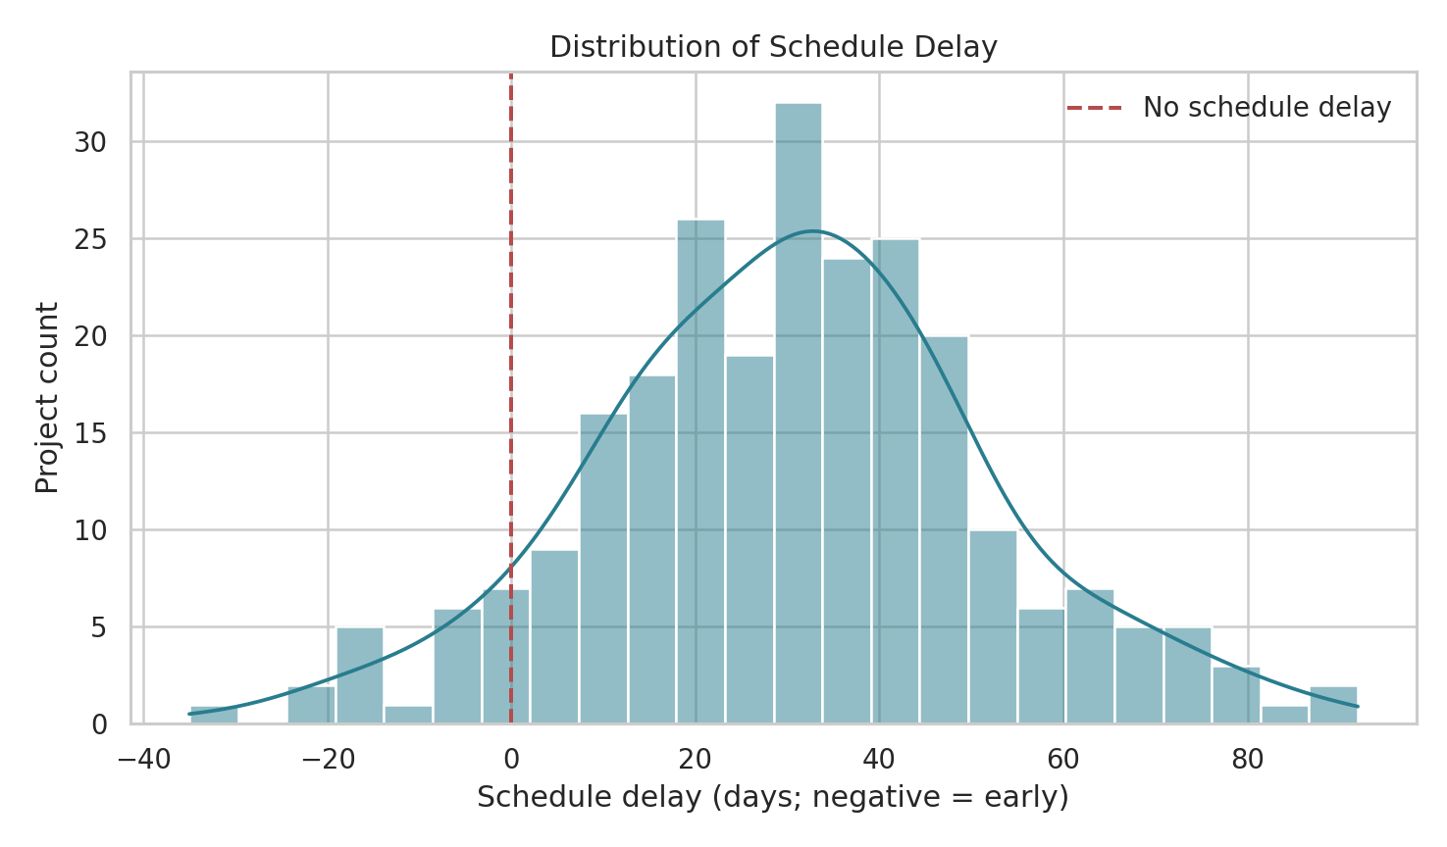
Figure 1. Frequency distribution of simulated schedule delay; negative values indicate completion earlier than plan.
The mean delay is 30.52 days and the median is 31 days. The centre of the distribution is on the delayed side of zero. Only 8.0% of simulated projects have a delay value at or below zero. In an operational dashboard, this distribution would help monitor whether schedule slippage is isolated or widespread and whether the tail of high-delay projects is growing.

5.2 Procurement delay and schedule delay
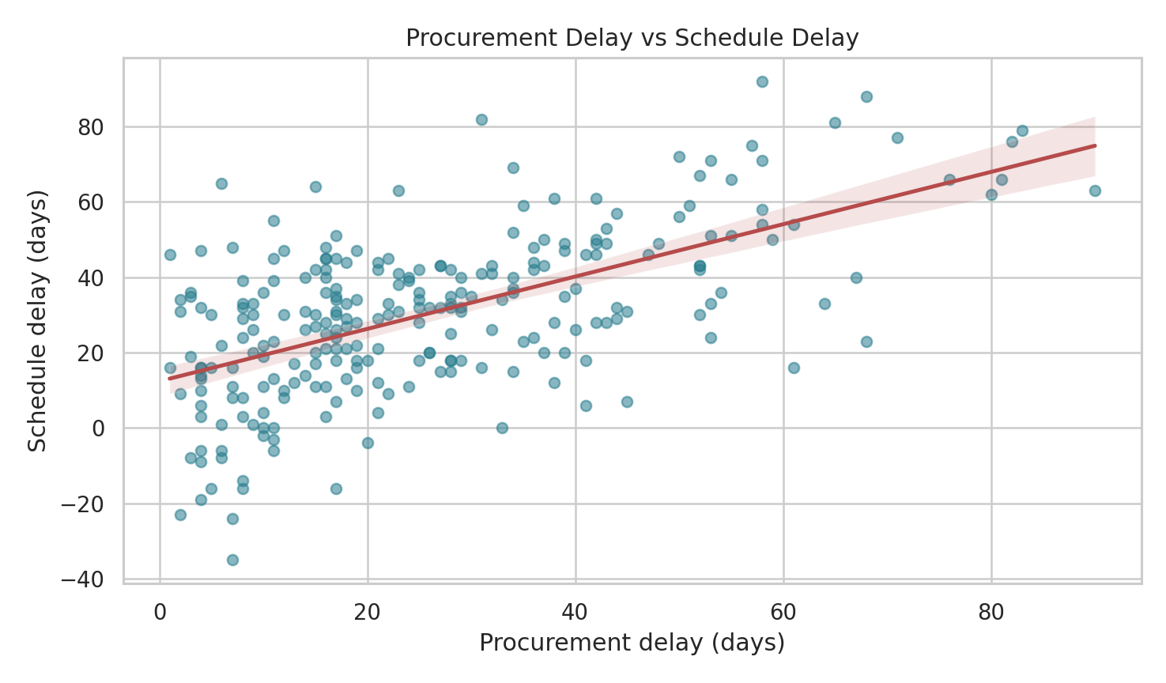
Figure 2. Relationship between procurement delay and schedule delay; line is a simple fitted trend.
The correlation between procurement and schedule delay is 0.604, a positive association in this synthetic sample. Projects with longer procurement delays tend to show larger schedule delays, though the scatter shows variability from other factors. This supports tracking critical materials, supplier lead times and delivery commitments as leading indicators. It does not prove that procurement delay alone causes a given project delay.

5.3 Schedule delay by project type
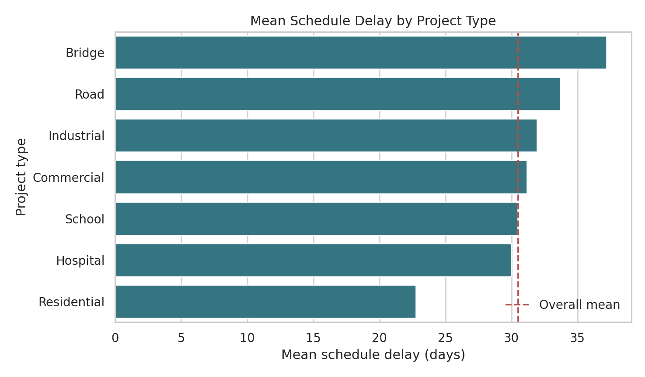
Figure 3. Mean schedule delay by project type. The dashed line indicates the overall sample mean.
Bridge projects have the highest mean delay (37.21 days) among the seven categories, while residential projects have the lowest (22.77 days). The chart is useful for prioritizing questions about complexity, specialist materials, approvals and contractor capacity. Category results should be considered alongside sample counts, site conditions and project scale rather than interpreted as a universal ranking.

5.4 Correlation among selected variables
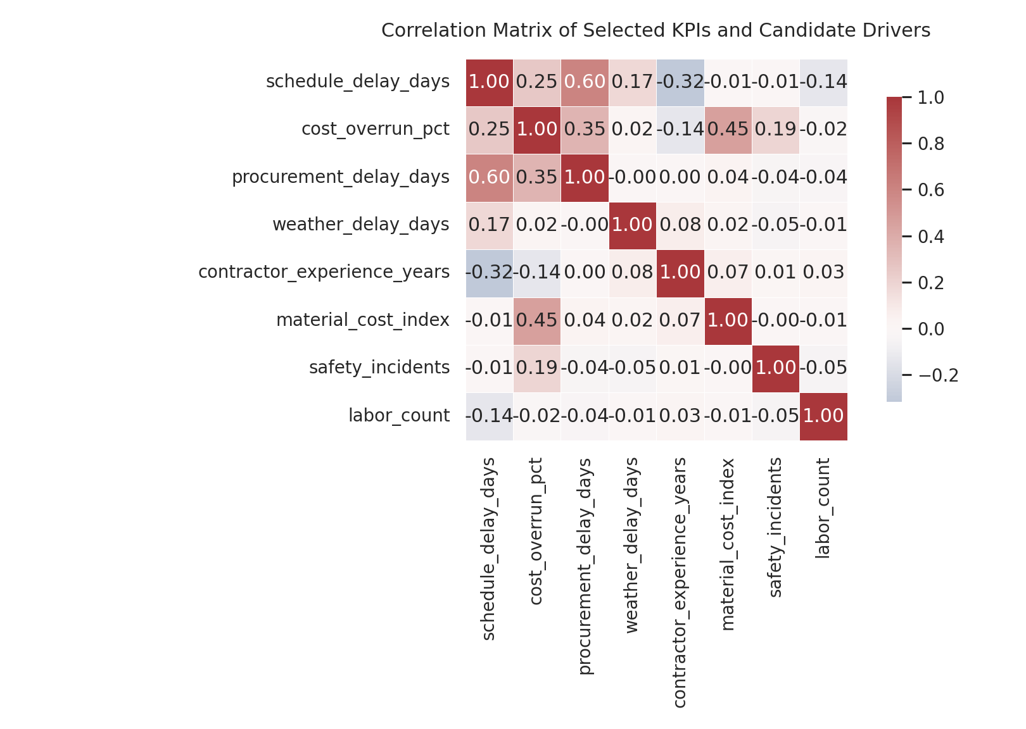
Figure 4. Pearson correlations for selected numeric KPIs and candidate drivers.
The matrix emphasizes a positive association between procurement delay and schedule delay (r = 0.604) and between material cost index and cost overrun (r = 0.455). Correlations are pairwise and do not control for other variables. They are useful for screening and hypothesis formation; regression is used next to examine several recorded predictors together.

5.5 Planned budget and simulated final cost
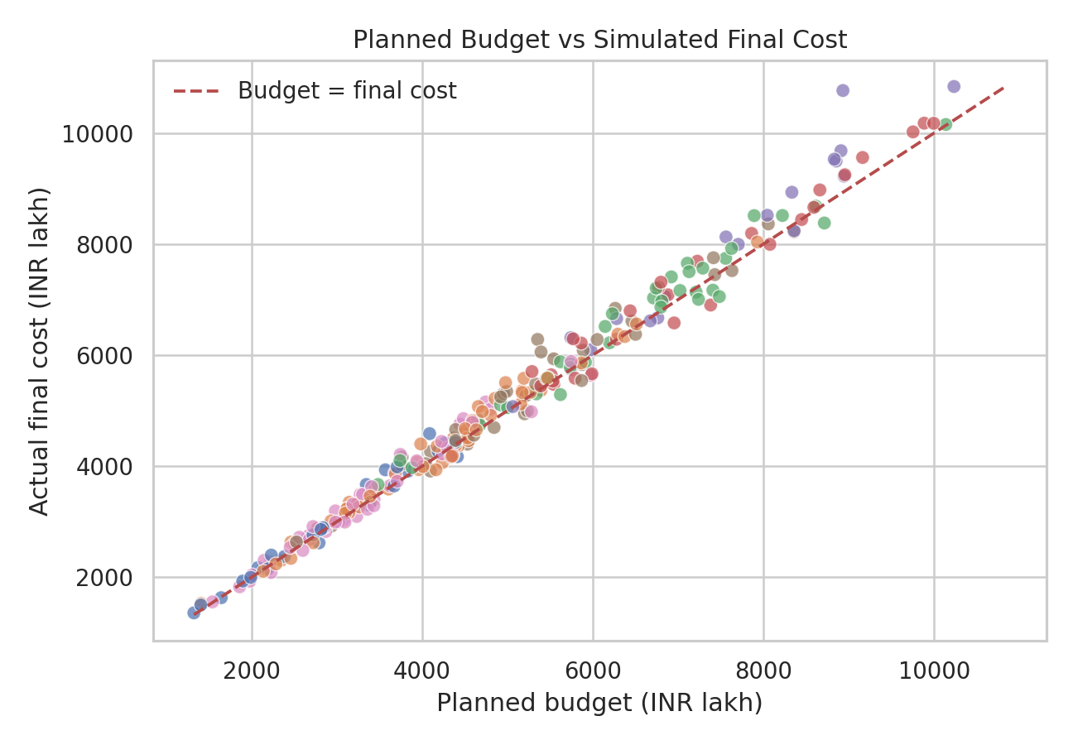
Figure 5. Planned budget versus simulated final cost. Points above the reference line exceed the planned budget.
Most points cluster around the equality line, while points above it indicate a positive cost overrun and points below it indicate a final cost below budget. In practice, this view should be paired with change-order records, inflation assumptions, procurement invoices and cost-to-complete estimates. As the values here are generated from a synthetic formula, the plot is illustrative rather than evidence about actual projects.

5.6 Category-level summary
Project type | N | Mean delay (days) | Mean cost overrun | On-time rate
Bridge | 19 | 37.2 | 5.13% | 0.0%
Road | 56 | 33.7 | 1.93% | 3.6%
Industrial | 36 | 31.9 | 2.30% | 13.9%
Commercial | 38 | 31.2 | 2.58% | 2.6%
School | 26 | 30.5 | 2.39% | 3.9%
Hospital | 28 | 30.0 | 1.87% | 14.3%
Residential | 47 | 22.8 | 1.61% | 14.9%

How to use the comparison Treat the table as a monitoring prompt: validate category definitions, check whether groups have comparable project size and stage, and review individual projects before changing budgets or delivery commitments.

6. Statistical Modeling Approach
Two multiple linear regression models were fitted to illustrate how project characteristics can be used to estimate schedule delay and cost overrun. Predictors include procurement delay, weather delay, contractor experience, labor count, equipment hours, material cost index, safety incidents, project type and region. Categorical variables are one-hot encoded with one reference category dropped. Data was split once into 80% training and 20% test records with random_state=42; the test set contains 50 records.

6.1 Model A: schedule-delay estimation
Target: schedule_delay_days, measured in days. The model estimates the conditional average relationship between the selected predictors and schedule delay. On the held-out set, MAE is 12.15 days, RMSE is 14.54 days and R² is 0.582. MAE gives the typical absolute prediction error; RMSE penalizes larger misses more strongly; R² indicates the share of test-set target variation explained relative to a mean-only baseline.

6.2 Model B: cost-overrun estimation
Target: cost_overrun_pct, measured in percentage points. The test MAE is 3.01 percentage points, RMSE is 3.80 percentage points and R² is 0.180. The relatively low R² indicates that these predictors explain a limited proportion of cost-overrun variation on the held-out synthetic projects. This model would need better cost drivers, project phase detail and further validation before operational use.
Target | Test rows | MAE | RMSE | R² | Interpretation
Schedule delay (days) | 50 | 12.15 days | 14.54 days | 0.582 | Moderate fit for a teaching example
Cost overrun (%) | 50 | 3.01 pp | 3.80 pp | 0.180 | Weak explanatory fit; substantial residual variation

6.3 Conceptual framework
Inputs → model → outputs Project type / region + resource and risk indicators → preprocessing and multiple linear regression → expected schedule delay (days) or cost overrun (percentage points) → human review and mitigation planning.

A linear model is chosen because it is transparent, fast to fit and relatively easy to explain. It assumes the fitted effects are approximately additive and linear over the observed range. Interactions, non-linear terms, robust regression, tree-based models and cross-validation are sensible next comparisons if real data becomes available.

7. Model Interpretation and Decision Support

7.1 Illustrative adjusted coefficients
Model / predictor | Estimated coefficient | Plain-language interpretation
Schedule: procurement delay | +0.680 days/day | An additional procurement-delay day is associated with about 0.68 extra schedule-delay days, holding included features fixed.
Schedule: weather delay | +0.495 days/day | More weather-delay days are associated with additional schedule delay in the fitted model.
Schedule: contractor experience | -0.831 days/year | Higher experience is associated with lower estimated delay, after accounting for included predictors.
Cost: material price index | +0.144 percentage points/index point | Higher material index is associated with higher predicted cost-overrun percentage.
Cost: safety incidents | +0.588 percentage points/incident | More incidents are associated with higher predicted overrun in this model.

Coefficients are conditional associations within this specific simulated dataset and depend on the variables, reference categories and data-generating assumptions. They should not be presented as causal effects or as reliable real-world planning factors.

7.2 Recommendations for a construction management team
- Build a weekly procurement watchlist for critical-path materials; compare promised delivery dates with the construction schedule and document supplier changes.
- Create an early-warning view for schedule slippage that combines procurement, weather, work completion, workforce availability and contractor experience instead of relying on a single KPI.
- Review bridge and road projects individually where this illustrative portfolio shows higher mean delays. Check project complexity, approval dependencies and sample size before applying category-level conclusions.
- Track cost variance at each reporting date and separate material price changes, scope changes, rework, labor productivity and contingency drawdown. The current model has weak cost-overrun R² and should not be used to commit budgets.
- Treat unusual IQR values as investigation flags. Keep an audit trail of whether a value is corrected, retained, capped or excluded, and why.

7.3 Example operational dashboard KPIs
KPI | Definition / check | Decision use
Schedule delay | Actual or forecast finish minus baseline duration | Escalate milestones exceeding project tolerance
Procurement delay | Actual receipt date minus required date | Expedite critical materials or update sequence
Cost overrun % | (Forecast final cost − baseline budget) / baseline budget × 100 | Review cost-to-complete and contingency
Safety incidents | Incident count in a fixed reporting period | Trigger safety review and prevention actions

8. Assumptions, Limitations and Validation Needs
- Synthetic data: every row is simulated. The model metrics and observed patterns cannot be generalized to actual construction sites, contractors, costs or timelines.
- Snapshot structure: the dataset contains one analytical row per project, not weekly repeated observations. It is therefore not suitable for a genuine time-series forecast without timestamped project snapshots.
- Regression assumptions: meaningful linearity, reasonably stable residual variance, independent errors, appropriately represented categories and no severe multicollinearity. Residual plots and domain checks are needed before inference.
- Train-test limitation: one random split gives a single estimate. For future validation, use repeated cross-validation, a time-aware split where project timestamps exist, and an untouched later cohort.
- Omitted variables: design changes, approval cycles, site access, subcontractor capacity, cash flow, rework and local conditions are not fully represented. Missing or inaccurate real-world tracking could alter results.
- Metrics are predictive, not causal. Better model performance does not automatically produce better management decisions; predictions should support, not replace, engineer and project-manager judgment.

9. Reproducibility and Python Workflow
The repository contains a reproducible generator, CSV data, EDA/modeling script, summary outputs and figure files. From the repository root, install the dependencies and run:
python -m pip install -r requirements.txt
python src/generate_week2_simulated_data.py
python src/eda_statistical_modeling.py

Simplified analysis pseudocode
load the synthetic project CSV
validate rows, columns, missing values and duplicate IDs
summarize numeric fields and compare project types
plot delay distributions, candidate relationships and correlations
split predictors/target into training and test sets
one-hot encode categories and fit multiple linear regression
evaluate MAE, RMSE and R-squared on held-out projects
export charts, tables, coefficients and model metrics

10. Conclusion
The analysis demonstrates an end-to-end EDA and introductory modeling workflow for construction performance indicators. Procurement delay is a useful candidate leading indicator for schedule monitoring, while material prices and safety indicators warrant attention in cost reviews. The schedule model performs better than the cost model on the selected hold-out split, but the cost model leaves substantial variability unexplained. The next professional step would be to obtain permissioned, quality-controlled project records with repeated dates, validate business definitions, compare models using time-aware testing and review outputs with construction domain specialists before any operational deployment.
Final reminder This submission is an educational analysis using explicitly simulated data. It demonstrates methods and interpretation; it does not claim that a real construction portfolio has been analyzed.

