WEEK 03 / DATA ANALYSIS & VISUALIZATION
Advanced Data Analysis
and Visualization in Logistics
An exploratory data analysis project using Python, pandas, Matplotlib and Seaborn

Prepared by | Aman Yadav
Programme | YuvaIntern — Logistics Data Analyst Intern
Analysis dataset | 300 synthetic shipment records
Simulated order window | 1 July–30 September 2026
Report date | 16 October 2026

DATA TRANSPARENCY NOTE
This report analyses a reproducibly generated hypothetical dataset. All shipment records, costs, delivery times, regional comparisons, charts and numeric findings are synthetic teaching outputs, not observations from a real company. A public dataset and logistics performance research are referenced for context only.

Portfolio project • Reproducible analysis • No real customer or courier records

01 / OVERVIEW

Executive Summary
This task applies exploratory data analysis (EDA) to a hypothetical logistics operation. A deterministic generator creates 300 synthetic shipments with order and promise timestamps, actual delivery timestamps, distance, weight, package volume, transportation cost, vehicle type, region and first-attempt outcome. Python is used to validate the analytical fields, calculate descriptive statistics and grouped KPIs, inspect pairwise correlations, and produce seven visualizations.
In this simulated sample, 63.3% of shipments are on time, mean order-to-delivery time is 10.05 hours, median delivery time is 8.07 hours, and mean transport cost is INR 1,681.51 per shipment. The East region has the lowest simulated on-time rate (40.0%) and the highest average delay (1.18 hours late), while South has the highest on-time rate (76.4%). These are findings about the generated sample only, not estimates of performance for any actual logistics company.
SHIPMENTS  300 | ON-TIME RATE  63.3% | MEAN DELIVERY  10.05 h
MEDIAN DELIVERY  8.07 h | MEAN COST  INR 1,681.51 | FIRST-ATTEMPT SUCCESS  90.3%

Objectives and business questions
- Describe the distributions and central tendencies of shipment distance, weight, volume, delivery time, delivery delay and transport cost.
- Compare delivery reliability and cost by region and vehicle type without confusing average cost per shipment with cost efficiency.
- Investigate relationships among numeric variables using scatter plots and Pearson correlation.
- Look for weekly variation in shipment counts and on-time delivery, while treating low-volume weeks cautiously.

Scope
Included: descriptive statistics, timestamp consistency checks, grouped KPI summaries, seven static visualizations, interpretation and operational recommendations for further investigation. Excluded: real-time systems, route optimisation, causal inference, forecasting/model training, and claims of actual savings. Those require real, sufficiently documented operational data and additional evaluation.

Data snapshot: central tendency and spread
Measure | Mean | Median | Q1 | Q3 | Min–Max
Distance (km) | 102.39 | 75.00 | 33.67 | 128.55 | 2.40–700.00
Weight (kg) | 63.49 | 22.79 | 9.90 | 66.31 | 0.40–751.68
Volume (m³) | 0.28 | 0.13 | 0.07 | 0.29 | 0.01–2.98
Transport cost (INR) | 1,681.51 | 1,046.32 | 468.33 | 2,005.94 | 31.50–13,181.34
Delivery time (h) | 10.05 | 8.07 | 2.80 | 14.15 | 0.50–55.21
Delay vs promise (h) | -1.45 | -2.07 | -5.31 | 1.85 | -11.90–16.21

Mean transport cost exceeds median cost, showing a right tail driven partly by the synthetic mix of distance and vehicle types. Negative delivery delay means the delivery occurred before the promise timestamp; positive delay means late.

02 / DATA & METHOD

Dataset, Variables and Analytical Method
The dataset contains 300 shipment-level rows generated locally with NumPy using a fixed random seed (20261016). Simulated order timestamps fall between 1 July and 30 September 2026. All shipments in this teaching snapshot have completed delivery, which permits consistent calculation of delivery duration and delay. A row is the unit of analysis; shipment_id is the unique key.
Variable group | Example fields | Purpose
Identifiers & timestamps | shipment_id, order_date, promised_delivery_at, delivered_at | Validate chronology; calculate delivery duration and lateness.
Shipment size | distance_km, shipment_weight_kg, shipment_volume_m3, shipment_units | Describe shipment scale and potential operating complexity.
Cost & service | transport_cost_inr, first_attempt_status | Compare expense and first-attempt outcomes.
Segments | region, vehicle_type | Compare operational patterns across groups.
Derived metrics | delivery_time_hours, delivery_delay_hours, on_time_delivery | Make KPI definitions consistent and analysis reproducible.

Methods applied
- Central tendency and spread: mean, median, standard deviation, quartiles, minimum and maximum.
- Distributional checks: histograms for delivery duration; box plots for delivery delay across regions.
- Segment analysis: grouped summaries of on-time rate, mean delay, average delivery time and transportation cost by region and vehicle.
- Relationship analysis: scatter plot of transport cost against distance and Pearson correlation among selected numeric variables.
- Time aggregation: weekly shipment volume and on-time rate based on order date.

Automated data quality checks
Check | Result | Interpretation
Shipment rows | 300 | Expected synthetic row count
Duplicate shipment IDs | 0 | All IDs unique
Missing cells | 0 | Generated fixture is complete by design
Non-positive distance / negative cost | 0 / 0 | Basic business range checks pass
Timestamp-derived duration mismatches | 0 | Stored duration agrees with timestamps within tolerance

QUALITY LIMITATION
Zero missingness in this generated fixture is a property of the generator, not evidence that real logistics data are usually complete. Real datasets should additionally be assessed for missingness patterns, duplicate business keys, invalid dates, outliers, unit differences and data provenance.

03 / VISUAL ANALYSIS

Delivery Time Distribution and Cost Drivers
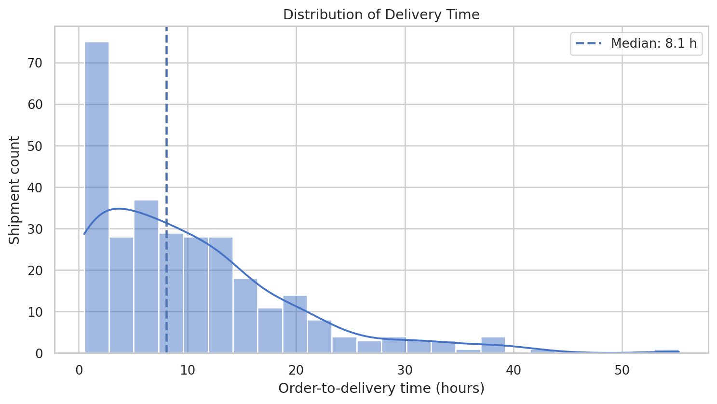
Figure 1. Distribution of order-to-delivery time across 300 synthetic shipments.
Interpretation. Mean delivery time is 10.05 hours and the median is 8.07 hours. The mean sitting above the median, together with a long upper tail, suggests that a smaller group of long-duration shipments pulls the average upward. Operational follow-up should inspect high-duration cases by route length and segment rather than relying on the mean alone.
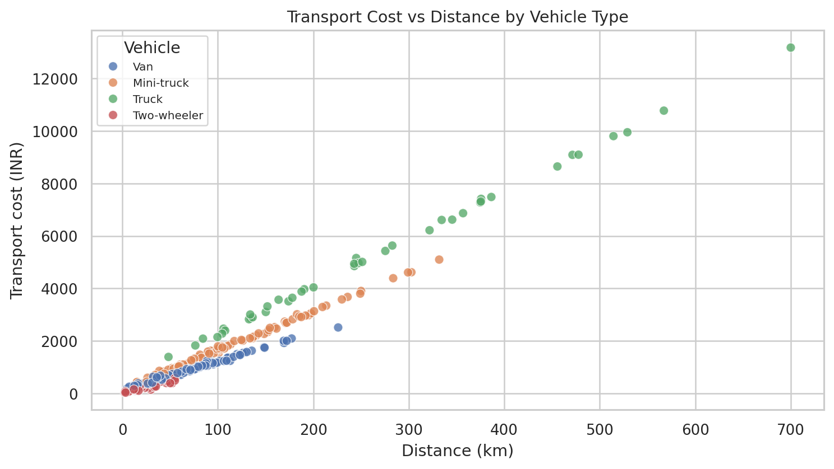
Figure 2. Transport cost versus distance, with vehicle type shown by colour.
Interpretation. Transport cost and distance have a Pearson correlation of r = 0.983 in the generated data. This strong relationship is expected partly because distance is explicitly used in the synthetic cost formula. The chart is useful for showing how cost scales in this scenario, but it is not independent evidence of a real-world causal relationship. Vehicle, weight and package volume should also be considered.

04 / SEGMENT COMPARISONS

Regional Delay and Vehicle Cost Patterns
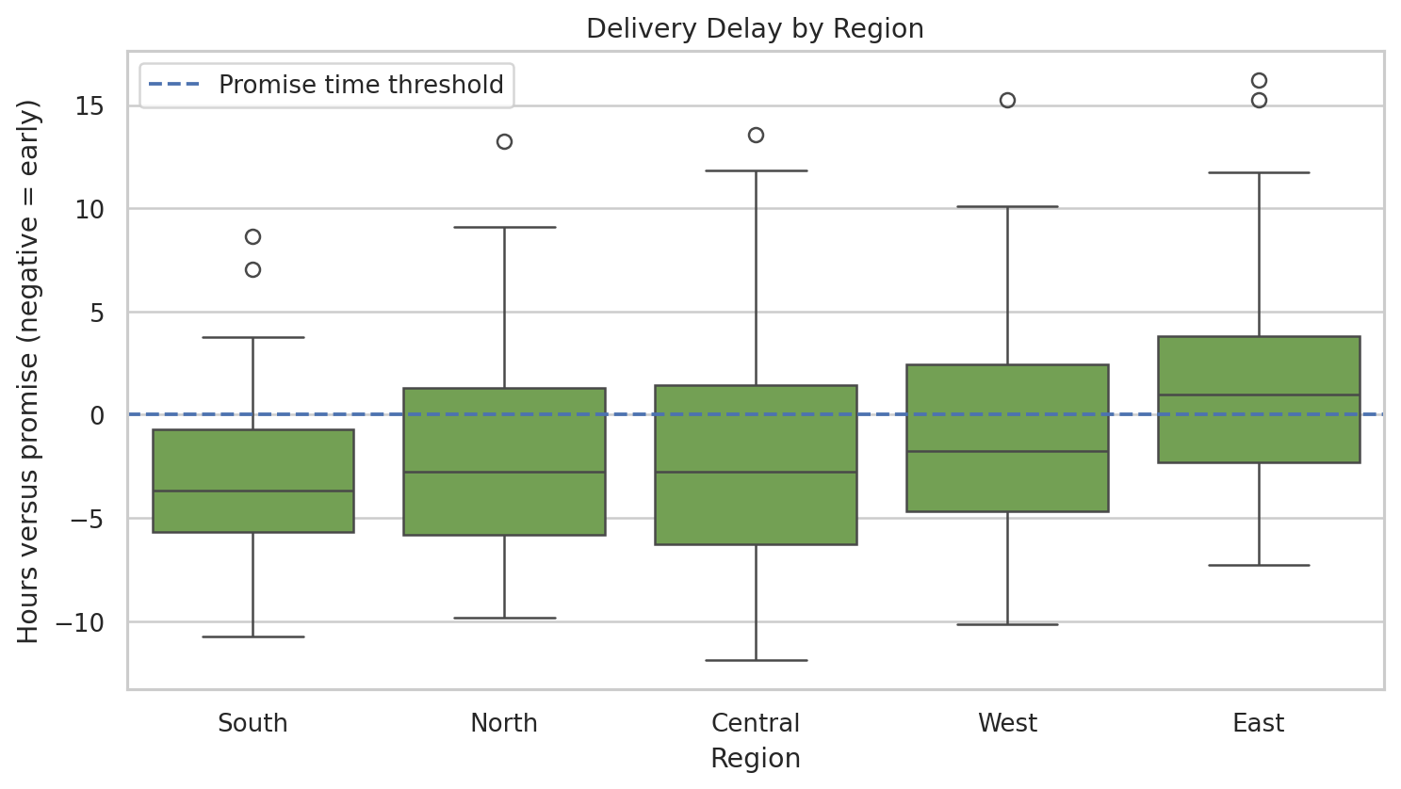
Figure 3. Shipment delay relative to promised delivery time, by region.
Interpretation. The East region has the highest mean delay (+1.18 hours) and the lowest on-time rate (40.0%). South has a negative mean delay (shipments arrive earlier than promise on average) and a 76.4% on-time rate. Box plots show spread and outlying shipment-level delays, so the difference should be investigated at route and volume level before proposing operational changes.
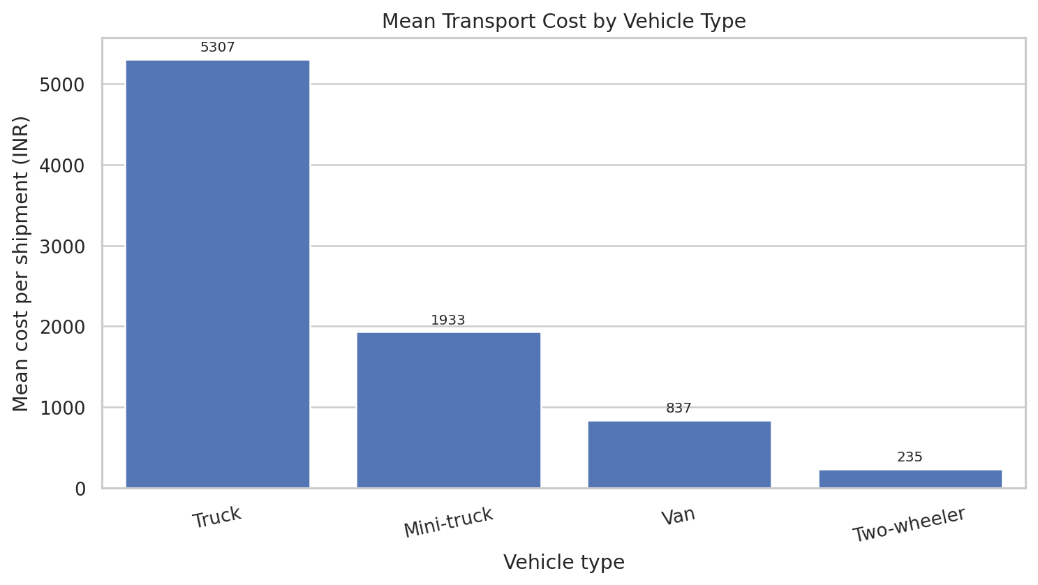
Figure 4. Mean transportation cost per shipment by vehicle type.
Interpretation. Trucks show the highest mean cost per shipment (INR 5,307.35) and two-wheelers the lowest (INR 234.64). The groups do not carry equivalent distances or payloads: average distance is about 266.66 km for trucks versus 22.59 km for two-wheelers. Therefore, the bar chart must not be interpreted as a direct efficiency ranking; compare cost per kilometre, cost per kilogram, service level and route suitability before making a fleet decision.

05 / RELIABILITY & RELATIONSHIPS

On-Time Delivery and Correlation Analysis
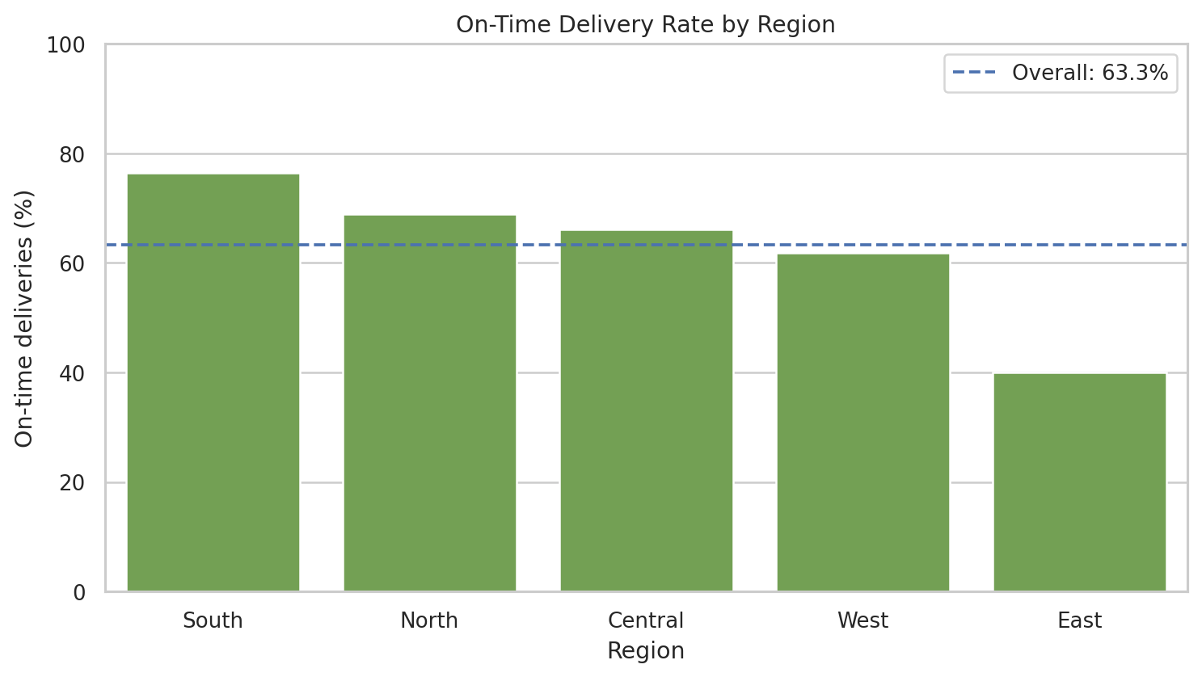
Figure 5. On-time delivery rate by region; dashed line indicates the overall synthetic rate.
Interpretation. The overall simulated on-time rate is 63.3% (190 of 300 shipments). South is highest at 76.4%; East is lowest at 40.0%. The difference supports an investigation priority for the East segment in this example. It does not establish why the gap occurs; promise-setting rules, route mix, delivery cut-offs and operating conditions would need validation in real data.
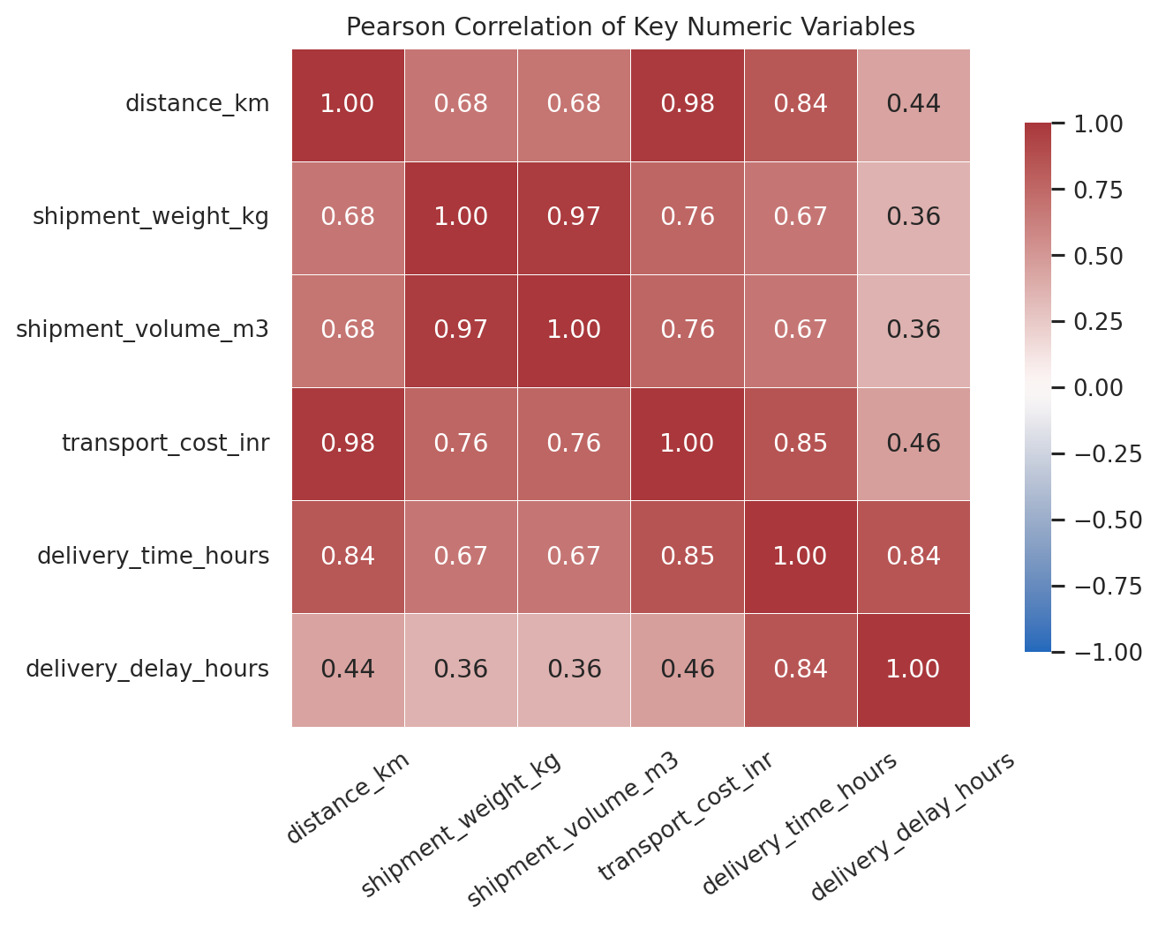
Figure 6. Pearson correlation heatmap for numeric variables.
Interpretation. Distance has a high correlation with transport cost (r = 0.983) and delivery time (r = 0.841). Shipment weight and volume are also highly related (r = 0.972), because volume was generated partly from weight. Delivery time and delay are related by their timestamp definitions. These designed dependencies are teaching examples; correlation alone does not prove cause and effects may be partly built into the simulation.

06 / TRENDS & FINDINGS

Weekly Variation and Consolidated Findings
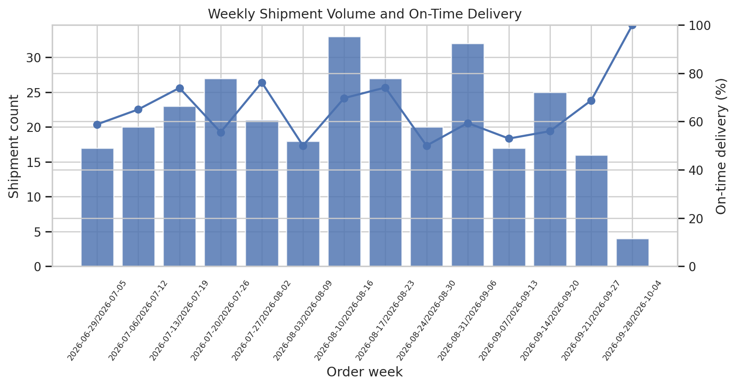
Figure 7. Weekly shipment count and on-time rate, grouped by order date.
Interpretation. The chart illustrates that weekly volume and on-time rate fluctuate in the synthetic sample. The final week bin contains only four orders because the simulated observation window ends on 30 September; its 100% on-time rate is therefore based on very few records and should not be compared with higher-volume weeks without uncertainty context.

Main observations from the synthetic sample
Region | Shipments | On-time | Mean delay | Mean cost / shipment
Central | 53 | 66.0% | -1.97 h | INR 1,754
East | 50 | 40.0% | +1.18 h | INR 2,047
North | 74 | 68.9% | -2.16 h | INR 1,591
South | 55 | 76.4% | -3.08 h | INR 1,468
West | 68 | 61.8% | -0.90 h | INR 1,627

Vehicle | Count | Mean km | Mean cost | Mean INR/km | On-time
Mini-truck | 87 | 119.2 | INR 1,933 | INR 16.99 | 52.9%
Truck | 41 | 266.7 | INR 5,307 | INR 20.71 | 26.8%
Two-wheeler | 42 | 22.6 | INR 235 | INR 11.85 | 76.2%
Van | 130 | 65.1 | INR 837 | INR 14.54 | 77.7%

Reading note: group sizes differ and vehicle types have intentionally different distance and load profiles. A fair operational comparison should normalize cost by distance or payload and should compare similar routes and service requirements.

07 / RECOMMENDATIONS

Actionable Recommendations for Further Investigation
Recommendation | Implementation detail
1. Investigate the East segment | Start with route-level drill-down for late shipments: compare distance bands, order cut-off, promised SLA, vehicle type, and volume. Validate whether the regional gap persists in real records.
2. Report robust delivery statistics | Publish median, interquartile range and upper-percentile delivery duration alongside the mean. Review extreme-duration shipments individually before excluding any observation.
3. Normalize logistics cost | Pair cost per shipment with cost per kilometre and cost per kilogram (where weight is valid). Compare vehicle modes only across comparable route lengths, payloads and promised service levels.
4. Review promise-time definitions | Confirm how promised timestamps are set, including weekends, cut-off times, time zones and rescheduling. A weak promise-time definition can distort on-time KPIs.
5. Monitor weekly sample size | Show order counts with weekly service rates and avoid interpreting small-volume weeks as stable performance. For operational use, add confidence intervals or minimum-sample flags.
6. Validate before action | Re-run the same pipeline on appropriately licensed real data. Check data quality, segment sample sizes and measurement definitions before any staffing, fleet or routing recommendation.

Limitations and assumptions
- All 300 rows are synthetic, generated locally with a fixed seed. The KPI values describe only this teaching fixture.
- Cost was generated using distance, vehicle type, weight, package volume, region adjustments and random noise; therefore some correlations are intentionally embedded in the construction of the data.
- Only completed shipments are present. Pending, cancelled, returned, re-delivered and rescheduled orders are not modelled.
- The analysis is descriptive. There is no causal identification, inferential claim, forecasting model, route optimizer or estimate of potential savings.
- Regional and vehicle differences may be confounded by distance, weight, volume and service commitments; segment-adjusted analysis is required for real decisions.
DECISION SAFEGUARD
Use the reported patterns to demonstrate an analytical workflow, not to make operational decisions about a real carrier. Any real-world recommendation requires verified source data and stakeholder validation.

08 / REPRODUCIBILITY

Run Instructions, Code Illustration and References
The scripts and outputs are included in the companion GitHub-ready project. Run commands from the repository root. Python 3.10+ is recommended; install packages from requirements.txt. The data generator uses a fixed random seed, so the dataset can be recreated deterministically in a compatible environment.
pip install -r requirements.txt
python src/generate_week3_hypothetical_data.py
python src/eda_logistics.py
python tests/test_eda_logistics.py

Representative code used in the analysis
df["order_date"] = pd.to_datetime(df["order_date"])
df["delivered_at"] = pd.to_datetime(df["delivered_at"])
df["delivery_time_hours"] = (
df["delivered_at"] - df["order_date"]
).dt.total_seconds() / 3600
region_kpis = df.groupby("region").agg(
shipment_count=("shipment_id", "count"),
on_time_rate=("on_time_delivery", "mean"),
mean_cost_inr=("transport_cost_inr", "mean")
)

Project outputs
- src/generate_week3_hypothetical_data.py — deterministic 300-row synthetic dataset generator.
- src/eda_logistics.py — validation, summaries, grouped KPIs, correlations and seven figures.
- data/analysis/week3_hypothetical_shipments.csv — generated analytical dataset.
- data/analysis/week3_*.csv and week3_overall_metrics.json — reproducible outputs and checks.
- reports/figures/week3_*.png — embedded charts also available as separate image files.
- tests/test_eda_logistics.py — automated checks for dataset size, ranges, time-derived fields and grouped summaries.

References
[1] Constante, F., Silva, F., & Pereira, A. (2019). DataCo SMART SUPPLY CHAIN FOR BIG DATA ANALYSIS, Version 5. Mendeley Data, DOI 10.17632/8gx2fvg2k6.5. Referenced as a public domain/data-structure context only; records from this dataset were not analysed in this task. https://data.mendeley.com/datasets/8gx2fvg2k6/5
[2] World Bank. (2023). World Bank Releases Logistics Performance Index 2023. Context on logistics reliability, speed and supply-chain performance dimensions. https://www.worldbank.org/en/news/press-release/2023/04/21/world-bank-releases-logistics-performance-index-2023
[3] Matplotlib. Plot types documentation. Reference for plotting distributions and pairwise relationships such as histograms and scatter plots. https://matplotlib.org/stable/plot_types/index
[4] Seaborn. User guide and tutorial. Reference for statistical visualisation techniques including distribution, categorical and relational plots. https://seaborn.pydata.org/tutorial.html
Citation note: public sources contextualize the project and describe the visualisation tools; they do not validate or supply the synthetic shipment-level results shown in this report.

