WEEK 2 / DATA PREPARATION

Data Collection, Cleaning
and Preprocessing
  - A reproducible Python workflow for logistics shipment data

Prepared by | Aman Yadav
Internship | Logistics Data Analyst Intern
Task | Week 2: Data Collection, Cleaning, and Preprocessing
Report date | 16 October 2026

DATA TRANSPARENCY NOTE
DataCo SMART SUPPLY CHAIN is used as the public reference dataset. The input records processed in this report are a small, intentionally imperfect synthetic training fixture created for this project; they are not downloaded DataCo records and do not represent a real logistics company.

Executive Summary
High-quality data preparation is a prerequisite for trustworthy logistics analysis. Missing delivery timestamps, inconsistent categories, malformed dates, duplicated shipment identifiers, invalid numeric values and extreme observations can distort delivery KPIs, cost estimates and later predictive models. This task documents and executes a small, reproducible preprocessing pipeline in Python using pandas.
The public reference selected is DataCo SMART SUPPLY CHAIN FOR BIG DATA ANALYSIS (Constante, Silva, & Pereira, 2019), listed in Mendeley Data. Its description covers supply-chain activities across provisioning, production, sales and commercial distribution. To keep the project lightweight and reproducible on a standard laptop, this Week 2 implementation uses a compact synthetic training fixture designed to demonstrate similar logistics data-quality challenges rather than copying the original source records.
Executed pipeline checkpoint | Observed count
Raw practice rows | 38
Exact duplicate rows removed | 1
Rows sent to manual review | 5
Clean teaching rows exported | 32

1. Objective and Scope
The objective is to simulate a data-preparation workflow for shipment records and demonstrate how each cleaning decision is documented. The deliverable covers raw-data inspection, date and numeric parsing, category standardization, duplicate handling, missing-value treatment, outlier detection, reproducibility, and quality-audit outputs.
- In scope: shipment/order dates, promised and actual delivery timestamps, region, vehicle type, distance, shipment weight, transport cost and first-attempt status.
- Out of scope: live API access, production-system connectivity, route optimization, causal claims, and model training. Those activities require later tasks and appropriately sourced data.

2. Public Reference and Data Collection Simulation
Reference dataset: DataCo SMART SUPPLY CHAIN FOR BIG DATA ANALYSIS, Version 5, DOI 10.17632/8gx2fvg2k6.5. The Mendeley Data record describes structured supply-chain data and associated clickstream data, and identifies provisioning, production, sales and commercial distribution as key activity areas. The public reference informs the project domain and data context; it is not the file cleaned in this exercise.
Reference URL: https://data.mendeley.com/datasets/8gx2fvg2k6/5
Collection simulation: A compact CSV extract was generated locally with 38 synthetic rows and deliberately inserted quality problems. This approach makes the pipeline runnable without downloading a large dataset, while allowing each cleaning decision to be observed and tested.

3. Data Dictionary and Quality Risks
The simulated raw file contains the following shipment-level fields. Raw values are loaded as strings first so parsing decisions can be applied explicitly and invalid values can be audited rather than silently coerced at import.
Field | Meaning | Validation / cleaning rule
shipment_id | Shipment business key | Text; must be present and unique after exact-duplicate removal
order_date | Order creation timestamp | Datetime; required and parseable
promised_delivery_at | Promised delivery timestamp | Datetime; required and parseable
delivered_at | Actual delivery timestamp | Datetime; optional for pending/undelivered shipments
region | Operating region | Category; trim and map known aliases
distance_km | Shipment distance | Positive numeric kilometres
shipment_weight_kg | Shipment weight | Positive numeric kilograms
transport_cost_inr | Recorded transportation cost | Non-negative INR numeric value
vehicle_type | Vehicle/transport class | Standardized category
first_attempt_status | Outcome of first delivery attempt | Success / Failed / Pending / Unknown

Common quality issues and the chosen response
Issue class | Example in the fixture | Treatment
Missing or unparseable values | Blank cells, 'unknown', em dash, or malformed timestamps | Normalize missing tokens, parse with errors='coerce', impute selected numeric variables; do not fabricate actual delivery times
Inconsistent categories | Different casing, surrounding spaces, spelling variants | Trim whitespace and apply explicit canonical mappings; flag/retain unrecognized categories as Unknown or title-cased values
Duplicate records / keys | Exact repeated row and a conflicting repeated shipment_id | Remove exact duplicate rows; route every row sharing a conflicting shipment_id to manual review
Invalid numeric values | Distance/weight ≤ 0; transport cost < 0 | Set invalid measurement to missing, preserve an imputation flag, then apply a documented median rule
Statistical outliers | Extreme distance, weight or cost values | Flag using 1.5×IQR fences and retain for investigation; do not auto-delete potentially legitimate large shipments
Chronology issues | Actual delivery timestamp earlier than order timestamp | Clear the inconsistent delivered_at value, add a flag and leave it missing until source verification

Why data quality matters
A malformed date can invert delay calculations; duplicated keys can overcount shipments; mixed category labels split a single region across multiple groups; and extreme values can dominate averages. Every correction must therefore have a reason, reproducible rule and audit trail. A missing delivered_at is not automatically an error: it can indicate that a shipment has not yet been delivered.

4. Cleaning Workflow
The pipeline is deliberately split into stages. The order matters: exact duplicates are removed before business-key conflicts are assessed, required-field failures are separated before imputation, and outlier flags are created before filling the remaining numeric gaps.
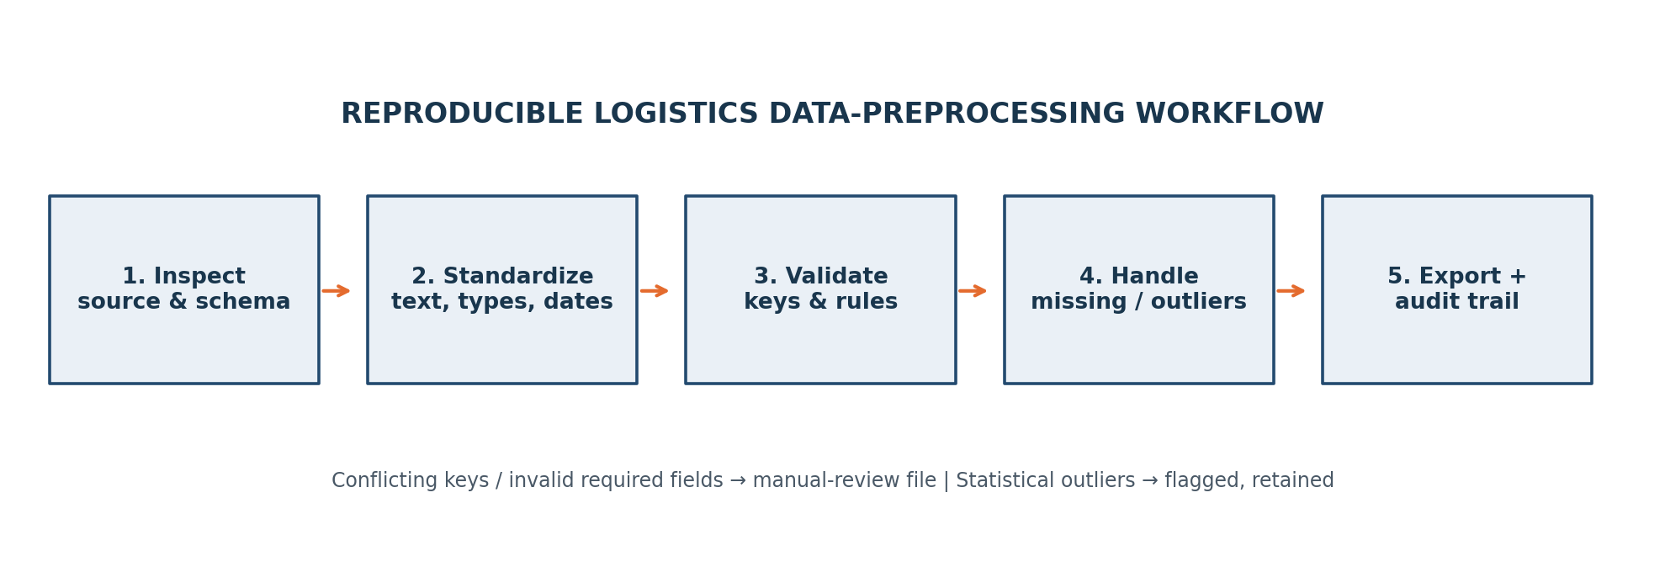
Figure 1. Reproducible processing sequence for the synthetic logistics fixture.

Step-by-step method
Load and inspect: Read all columns as text initially; inspect row/column counts, column names, blank-like tokens, duplicate rows and schema expectations.
Standardize text: Strip surrounding and non-breaking spaces; standardize shipment IDs, region names, vehicle types and first-attempt statuses with explicit maps.
Parse dates and numerics: Convert mixed date formats using pandas datetime parsing with invalid values coerced to missing; parse costs with currency symbols and thousands separators removed.
Validate keys and required fields: Remove exact duplicate rows. Route all conflicting duplicate shipment IDs and rows lacking a valid shipment ID, order date, promised date or region to a manual-review file.
Apply business rules: Distance and weight must be positive; transport cost must be non-negative. Convert invalid measurements to missing while keeping flags that indicate imputation.
Handle missing values: Impute distance with regional median (overall median fallback), weight with overall median, and cost with vehicle-type median (overall median fallback). Leave actual delivery timestamps missing when unobserved or invalid.
Detect outliers: Calculate IQR fences for numeric measures and add Boolean flags. Retain flagged values for review rather than automatically deleting them.
Export and audit: Write cleaned data, manual-review records and a row-count/method audit. Keep paths, assumptions, and run instructions in the repository README.

5. Preprocessing Methods and Rationale

5.1 Missing-value strategy
Numeric imputations are a teaching strategy for the small fixture, not a universal production default. Distance uses the median within region to respect regional operating patterns; weight uses the overall median because the sample is small; transport cost uses the median within vehicle type. If a group median is unavailable, the overall median is used. Imputation flags preserve transparency. For production data, compare imputation with complete-case analysis, missingness indicators, domain rules and model-specific methods before choosing a policy.

5.2 Date parsing and chronology
Order and promised-delivery timestamps are required for interpreting schedule performance. Unparseable required dates are sent to manual review rather than guessed. The actual delivery timestamp remains optional because a shipment may be pending. If an actual delivery timestamp precedes the order timestamp, the timestamp is cleared and an explicit chronology flag is retained for investigation.

5.3 Numeric normalization and category standardization
Currency signs, commas and extra whitespace are removed only to parse the numeric amount; values are not rescaled into a different currency or unit. Region, vehicle and status values are mapped to canonical labels. In this report, 'normalization' means standardizing formats and labels. Statistical feature scaling (for example, z-scores or min-max scaling) is deferred until a modeling task requires it, since it is not necessary for descriptive cleaning itself.

5.4 Python example: parsing and validation
raw = pd.read_csv(input_path, dtype=str, keep_default_na=False)
raw = raw.drop_duplicates(keep="first")

shipments["order_date"] = pd.to_datetime(
shipments["order_date"], format="mixed", errors="coerce"
)
shipments["distance_km"] = pd.to_numeric(
shipments["distance_km"], errors="coerce"
)
invalid_distance = shipments["distance_km"].notna() & (
shipments["distance_km"] <= 0
)
shipments.loc[invalid_distance, "distance_km"] = pd.NA
The complete executable implementation is in src/cleaning_pipeline.py. The snippet above is an explanatory extract; the full script also normalizes currency-formatted values, checks key collisions, saves manual-review records, imputes selected numeric fields and writes an audit CSV.

5.5 Outlier decision
The IQR rule flags values below Q1 − 1.5×IQR or above Q3 + 1.5×IQR. This is a screening rule, not a proof that a value is wrong. In this fixture, extreme distance, weight and transport cost values are preserved in the cleaned dataset with flags so analysts can verify whether they represent data-entry errors, special shipments or valid but unusual cases.

6. Results from the Executed Pipeline
The following counts were produced by running the included Python pipeline on the intentionally imperfect synthetic fixture. They demonstrate code behavior only; they are not performance statistics for any real logistics operator.
Check | Count | Interpretation
Raw rows loaded | 38 | Synthetic rows created for this training exercise
Exact duplicate rows removed | 1 | One exact repeated row removed
Rows sent to manual review | 5 | Conflicting duplicate key and required-field failures
Clean rows exported | 32 | Rows passing required-field and key checks
Distance imputed | 2 | Regional median fallback to overall median
Weight imputed | 1 | Overall median
Transport cost imputed | 2 | Vehicle median fallback to overall median
Delivery chronology issues | 1 | Actual timestamp before order; cleared and flagged
Unparseable delivery timestamps | 1 | Treated as missing and kept visible with a flag

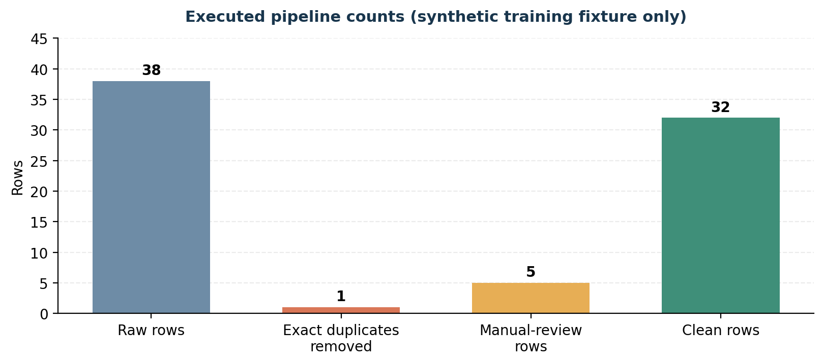
Figure 2. Row-count checkpoints for the synthetic fixture; bars represent counts, not quality scores.

Outlier scan
Metric | IQR flags | Decision
distance_km | 1 | Flagged and retained
shipment_weight_kg | 1 | Flagged and retained
transport_cost_inr | 2 | Flagged and retained

Three actual_delivery timestamp values remained missing after processing. The pipeline does not impute an actual delivery time, because doing so could manufacture delivery outcomes and bias subsequent KPIs. Rows whose required fields or shipment keys could not be trusted were placed in records_for_manual_review.csv with reasons.

7. Reproducibility and Project Outputs
The project is organized so that another analyst can reproduce the cleaning output from the repository root. Use Python 3.10+ and the package versions permitted by requirements.txt. The raw fixture is intentionally unclean; the processed files should be regenerated by running the scripts rather than editing output CSVs by hand.

Run instructions
pip install -r requirements.txt
python src/create_week2_fixture.py
python src/cleaning_pipeline.py
python tests/test_cleaning_pipeline.py

Expected files
Path | Purpose
data/raw/raw_shipments_simulated.csv | 38-row deliberately imperfect synthetic source fixture
data/processed/cleaned_shipments.csv | 32-row cleaned teaching dataset with imputation/outlier flags
data/processed/records_for_manual_review.csv | Rows excluded from analysis, including review reasons
data/processed/cleaning_audit.csv | Counts and interpretations for reproducibility
src/cleaning_pipeline.py | End-to-end pandas preprocessing pipeline
tests/test_cleaning_pipeline.py | Simple checks for output integrity and key rules
reports/figures/ | Generated workflow diagram and count chart used in this report

Hypothetical examples
- Example 1 — category mismatch: ' north ', 'NORTH' and 'North' are mapped to one canonical label, 'North', so groupby results do not split the same region.
- Example 2 — unknown transportation cost: '₹ 1,234.50' can be parsed as 1234.50 INR after removing the currency symbol and thousands separator. An unparseable token such as 'unknown' becomes missing and is imputed using the documented vehicle-level median rule.
- Example 3 — pending delivery: a blank delivered_at remains missing, with delivered_at_missing=True. It is not replaced by the promised date, because promised and actual timestamps have different meanings.

Limitations and next steps
The records are synthetic, small and intentionally designed to contain selected quality issues. The median values and IQR thresholds are therefore demonstrative, not calibrated operational policies. A real implementation should validate the source schema with a data owner; confirm whether each row is an order, package or shipment; define unique-key rules; assess missingness by status and time; document units and timezone; and compare imputation methods against downstream KPI sensitivity. For statistical outliers, review source evidence before changing or excluding values. Before modeling, split train/test data after leakage checks and fit learned preprocessing only on training data.

Conclusion
This task creates a reproducible foundation for later logistics analysis. The pipeline standardizes formats, separates questionable records for review, imputes selected numeric gaps with explicit indicators, preserves unobserved delivery outcomes, flags extreme values and exports an audit trail. These controls improve the interpretability of Week 3 EDA and reduce the risk of basing future recommendations on hidden data-quality defects.

Appendix A. Executed Cleaning Audit
The audit below is generated by the executed pipeline. Counts relate only to the synthetic fixture shipped with this project.
Audit item | Count | Interpretation
Raw synthetic rows loaded | 38 | Rows in raw practice fixture before any cleaning
Exact duplicate rows removed | 1 | Exact row duplicates removed automatically
Rows routed to manual review | 5 | Conflicting business keys or required-field issues; not silently guessed
Clean rows exported | 32 | Rows retained in cleaned teaching dataset
Missing-like raw cells detected | 9 | Counts blank/NA/unknown-style tokens in the raw fixture; not a count of all business errors
Distance values imputed | 2 | Regional median, with overall median fallback
Weight values imputed | 1 | Overall median
Transport cost values imputed | 2 | Vehicle-type median, with overall median fallback
Delivery timestamps missing or invalid after checks | 3 | Retained as missing; no fabricated delivery timestamp
Invalid delivery chronology flags | 1 | Delivery timestamp before order timestamp was cleared and flagged
Unparseable delivered_at values | 1 | Optional timestamp could not be parsed; treated as missing and flagged
IQR outliers flagged: distance_km | 1 | Flagged for investigation; values retained, not automatically deleted
IQR outliers flagged: shipment_weight_kg | 1 | Flagged for investigation; values retained, not automatically deleted
IQR outliers flagged: transport_cost_inr | 2 | Flagged for investigation; values retained, not automatically deleted

References
- Constante, F., Silva, F., & Pereira, A. (2019). DataCo SMART SUPPLY CHAIN FOR BIG DATA ANALYSIS (Version 5). Mendeley Data. https://doi.org/10.17632/8gx2fvg2k6.5
- World Bank. (2023). World Bank releases Logistics Performance Index 2023. https://www.worldbank.org/en/news/press-release/2023/04/21/world-bank-releases-logistics-performance-index-2023
- pandas development team. (n.d.). Working with missing data. pandas documentation. https://pandas.pydata.org/docs/user_guide/missing_data.html
- pandas development team. (n.d.). pandas.to_datetime. pandas documentation. https://pandas.pydata.org/docs/reference/api/pandas.to_datetime.html

